**ROLE OF INFORMATION TECHNOLOGY IN REVOLUTIONISING THE MARKETER’S APPROACH TOWARDS DIGITAL MARKETING: A CASE STUDY OF VOLKSWAGEN**

**Table of Content**

**1. Introduction** **3**

1.1 Research background 3

1.2 Research aim and objectives 3

1.3 Research questions 4

**2. Literature review** **4**

2.1 Effectiveness of digital marketing in the automobile sector 4

2.2 Role of information technology in revolutionising digital marketing 4

2.3 The ways that IT used in revolutionising digital marketing 5

2.4 Potential challenges associated with the application of information technology in digital marketing 5

2.5 Theoretical conceptualisation 6

2.5.1 Technology Acceptance model 6

2.5.2 AIDA model of digital marketing 6

2.6 Research gap 7

**3. Research methodology** **8**

3.1 Research philosophy, approach and design 8

3.2 Data collection and analytical techniques 9

3.3 Ethical considerations 10

**4. Expected results** **10**

**5. Conclusion** **10**

**6. Anticipated timeframe for research completion** **11**

**References** **13**

# **1. Introduction**

## **1.1 Research background**

Volkswagen is perceived as a German based motor vehicle manufacturing company that has gradually gained adequate popularity and became one of the largest automobile companies in the world. This company is able to serve its customers with greater satisfaction by manufacturing high quality and attractively designed cars over more than 70 years. Uninterrupted engagement into innovation seems to bring a salient shift in the marketing strategy of Volkswagen which apparently determines the replacement of digital marketing with conventionality. In effect, the budget of the company for digital marketing rose up to 50% from 25% which is allocated for its traditional marketing mix (Autonews, 2018). Nevertheless, information technology (IT) seems to play an impeccable role in transfiguring digital marketing approaches to a great extent. IT has made digital marketing effective in networking by facilitating communication platforms and infrastructure work.

## **1.2 Research aim and objectives**

This study aims to analyse the role of information technology in revolutionising the current approach of marketers towards digital marketing by taking the real-time case study of Volkswagen into consideration. Contemplating the contribution of the objectives to the accomplishment of this research aim is impeccable, some significant objectives are formed in the section below.

***Objectives***

* To assess the role of IT in revamping the performance of digital marketing for Volkswagen.
* To detect the potential challenges that marketers of Volkswagen are likely to face during the integration of IT into the digital marketing approach.
* To recommend some tactics to the markets of Volkswagen in terms of improving their digital marketing performance through IT integration.

## **1.3 Research questions**

1. What role does IT play in transfiguring the approach of marketers towards digital marketing at Volkswagen?
2. What are the challenges potential to lead the marketers of Volkswagen going through a crisis for integrating IT into their digital marketing approach?
3. What are the strategies that marketers of Volkswagen can follow for revamping their digital marketing practice by putting IT at its core?

# **2. Literature review**

## **2.1 Effectiveness of digital marketing in the automobile sector**

Digital advertising can have a significant impact on the auto sector. In order to reach as many potential customers as possible, automotive manufacturers across the globe have turned to the electronic realm for revamping their marketing tactics. As per the statement of Desai and Vidyapeeth (2019), digital marketing is the only means that helps modern companies to exponentially reach to the global customers and strengthen brand reputation. As a result, automobile firms are succeeding in utilising digital marketing techniques to connect with a greater number of consumers and boost sales. Additionally, the contemplation of intense engagement of modern consumers with the internet connectivity facilitate the automotive companies to take the consumers’ pre-purchasing perspectives into consideration for revamping their manufacturing process and services.

## **2.2 Role of information technology in revolutionising digital marketing**

It seems that business operations and engaging with their customers has been revolutionised by the successful application of information technology (IT) in digital marketing. As per the statement of Peyravi *et al.* (2020), since the main objective of digital marketing is to advertise goods and services via numerous digital channels, including social media, email, search engines, and mobile apps, IT plays a crucial role in facilitating the usage of those channels for the marketers in terms of interaction and building connections with clients. In particular, whereas email marketing enables firms to deliver tailored contents to the mailboxes of their clients, social media platforms give businesses access to a large audience for the promotion of their goods and services. Moreover, the capacity to analyse commercial data is essentially a key advantage of IT in digital marketing.

## **2.3 The ways that IT used in revolutionising digital marketing**

IT is undeniably transforming the concept of digital marketing, which is perceived to be essential to the prosperity of the majority of firms. As per the statement of Van Esch and Stewart Black (2021), Artificial Intelligence (AI) supports digital marketing by assisting companies in the collection of consumer data and the delivery of advertising and recommendations to users who share identical preferences. Despite an increase in the common concerns for consumer privacy, AI is widely appreciated for prospering firms effectively with this facility. Apart from that, Virtual Reality (VR) is another integral aspect of IT sharing its massive contribution to the revolution of digital marketing. As posited by Graesch *et al.* (2021), despite being costly to some extent, many firms have failed to streamline their digital marketing activities under the assistance of VR technology. However, Kang *et al.* (2020) posited that VR is prudent to elevate the digital marketing to another level by simply captivating consumers providing real-time experience of goods and services artificially, prior to their purchases.

## **2.4 Potential challenges associated with the application of information technology in digital marketing**

***Recruitment of the right talent***

It is evident that the continuous advancement of technology is the primary driving force that ensures a rapid prosperity in the growth of the technological market. However, Herhausen *et al.* (2020) mentioned that the labour market on the globe seems to fail to match the supply of adequately knowledgeable and skilled IT talents to the firms. As a result, the majority of companies are suffering from being unable to recruit the right talent in digital marketing.

***Communication management between IT and digital marketing department***

It is worth mentioning that digital marketing is a successful outcome of technological advancements. On the basis of this perspective, it can be said that effective communication between the IT professionals and digital marketers is able to foster an utter success in the field of digital marketing. However, lack of knowledge and skills amongst the professionals creates a massive gap in the communication between them and also hinders the degree of collaboration prominently.

## **2.5 Theoretical conceptualisation**

### **2.5.1 Technology Acceptance model**

In the study of assessing the role of IT in the revolution of digital marketing approach based on the case study of Volkswagen, the theory of Technology Acceptance Model (TAM) is used for ensuring the clarity in understanding about the ways through which IT is influencing digital markets to adopt such cutting-edge technology. As per the statement of Soleimani and Zarafshani (2022), TAM is widely perceived to be a computing system that actively partakes in analysing the degree to which a user is prepared to accept and adopt advanced technology. Therefore, perceived usefulness and perceived ease of use are the two significant factors that are assimilated with this theoretical perspective.

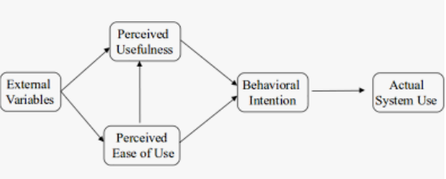

**Figure 1: Technology Acceptance Model**

(Source: Soleimani and Zarafshani, 2022)

### **2.5.2 AIDA model of digital marketing**

Instead of being a decision-making model, the AIDA funnel is more likely to be used as a communications model. As per the statement of Purbaningsih *et al.* (2022), AIDA are the acronyms that stands for awareness, interest, desire and action mainly accounting for boosting the performance of digital marketers in present days. Modern customers tend to engage on numerous platforms, at various points of interaction, and with varying demands for data from diverse sources. Therefore, automobile companies are allowed to adopt this model for strengthening communication with their clients and satisfy them with their vehicles and relevant services that are designed according to the demands and preferences of consumers.

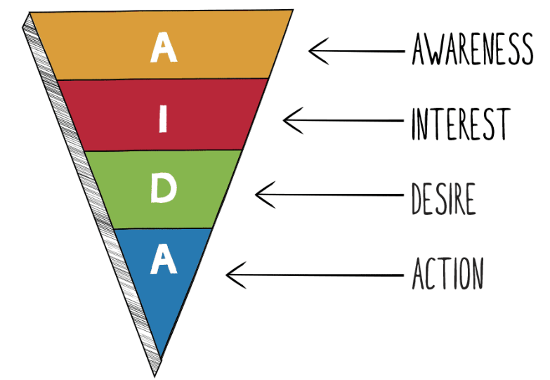

**Figure 2: AIDA model of digital marketing**

(Source: Purbaningsih *et al.* 2022)

## **2.6 Research gap**

Broad literature relevant to digital marketing and the assistance of IT carries out an explicit testimony of numerous studies previously performed concerning identical societal issues. However, lack of accurate information about the role played by IT in revolutionising digital marketing approach and lack of focus on specific real-time instances such as Volkswagen or a particular business market are accounting for creating a salient gap in the existing literature.

# **3. Research methodology**

## **3.1 Research philosophy, approach and design**

In order to find legitimate outcomes and maintain adequate standards of the general excellence of the research, modern studies benefit from a variety of instruments and approaches that are described as research methodology. As a result, research philosophy, approach and design will be appropriately used in the course of assessing the role of information technology in transforming the digital marketing approaches of Volkswagen’s marketers according to the nature and suitability of this study. As per the statement of Tamminen and Poucher (2020), research philosophy can be interpreted as the empirical method of formulating a hypothesis prior to transitioning the process of gathering trustworthy data with this research endeavours. In this context, the use of positivism research philosophy will provide the valid direction to this research as compared to other two research philosophies. Apart from that, contemplation of the primary problem ingrained in the role of IT for transfiguring the digital marketing approach of Volkswagen’s marketers will further opt for deductive approach during the course as the inductive approach is likely to fail in meeting some of the criteria of this research. Additionally, the choice of study design will be made based on the presumptions and careful planning considering this tool enhances the research with a reliable method of data gathering and analysis. It is anticipated that the use of a descriptive research design in this investigation will have an impact on its effectiveness.

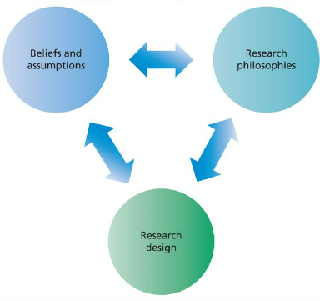

**Figure 3: Research methodology**

(Source: Self-developed)

## **3.2 Data collection and analytical techniques**

The most important components of contemporary research are data collecting and analysis methodologies since they create the groundwork for knowledge creation and give the research a solid aspect. As per the statement of Jentoft and Olsen (2019), data collection approach is an agile way of gathering pertinent information about the subject from numerous sources in order to resolve the study challenge. Yet, this particular investigation will intend to rely on a primary data collection method instead of a secondary one to ensure higher degree of validity and credibility. In the aftermath of data gathering, a thorough analysis of the data is conducted to aid in drawing the research's effective conclusion. Identifying primary data collection technique to be the fundamental process of this study, all the gathered data will be thoroughly analysed by statistical methods.

## **3.3 Ethical considerations**

The study of assessing the role of IT in the revolution of digital marketing approaches at Volkswagen will be performed under a strong influence of ethical considerations. In essence, the ***Data Protection Act 2008*** will be applied in this research to properly maintain the validity and credibility of this research by removing the scope of any deceitful behaviour arousal.

# **4. Expected results**

Although it is undeniable that the concern of digital marketing has attracted numerous research and studies, yet this specific study is innovative for identifying and bridging the gap existing in the previous studies. This study will keep the focus intact on the case study of Volkswagen for thoroughly assessing the role of information technology in remodeling the digital marketing approaches of modern marketers. Moreover, the insertion of factual data will improve the awareness of both the independent and dependent variables including information technology and digital marketing respectively along with the interconnectedness that they share with each other. The formulation of research questions will result in providing accurate and unbiased solutions against the identified societal issues of implementing IT in the digital marketing process. However, the theoretical frameworks of Technology Acceptance model and AIDA model of digital marketing to consolidate the understanding of the causal relationship between the concepts and the variables of the study.

# **5. Conclusion**

In conclusion, it can be said that Volkswagen is one of the largest motor vehicle manufacturing companies that has shifted its traditional marketing mix into digital marketing by increasing the marketing budget from 25% to 50% in 2020. A surge in the demand and usage of digital marketing becomes possible following the interference of information technology. Therefore, this study aims to analyse and evaluate the role of information technology in transfiguring digital marketing approach in recent years. It has benefited Volkswagen in understanding its customers by developing effective communication, yet lack of skilled labour and communication gap between the IT professionals and digital marketers make it challenging for the company to some extent.

# **6. Anticipated timeframe for research completion**

|  |  |  |  |  |  |  |  |  |  |  |  |  |  |  |
| --- | --- | --- | --- | --- | --- | --- | --- | --- | --- | --- | --- | --- | --- | --- |
| **Research activities** | **Projected timeline for completing the project systematically** | | | | | | | | | | | | | |
| **WK1** | **WK2** | **WK3** | **WK4** | **WK5** | **WK6** | **WK7** | **WK8** | **WK9** | **WK10** | **WK11** | **WK12** | **WK13** | **WK14** |
| **An introduction to the context** |  |  |  |  |  |  |  |  |  |  |  |  |  |  |
| **Formation of a research proposal** |  |  |  |  |  |  |  |  |  |  |  |  |  |  |
| **Setting a Critical literature review** |  |  |  |  |  |  |  |  |  |  |  |  |  |  |
| **Choosing the right set of research methodology** |  |  |  |  |  |  |  |  |  |  |  |  |  |  |
| **Collection of relevant data** |  |  |  |  |  |  |  |  |  |  |  |  |  |  |
| **Data representation and in-depth analysis** |  |  |  |  |  |  |  |  |  |  |  |  |  |  |
| **Highlighting final outcome** |  |  |  |  |  |  |  |  |  |  |  |  |  |  |
| **Drafting the conclusion** |  |  |  |  |  |  |  |  |  |  |  |  |  |  |
| **Project submission** |  |  |  |  |  |  |  |  |  |  |  |  |  |  |

**Table 1: Gantt chart for research breakdown structure**

# **References**

Autonews, 2018. VW will boost digital marketing in efficiency drive. Available at: <https://europe.autonews.com/article/20181127/ANE/181129776/vw-will-boost-digital-marketing-in-efficiency-drive> [Accessed on: 10th April, 2023]

Desai, V. and Vidyapeeth, B., 2019. Digital marketing: A review. *International Journal of Trend in Scientific Research and Development*, *5*(5), pp.196-200.

Graesch, J.P., Hensel-Börner, S. and Henseler, J., 2021. Information technology and marketing: an important partnership for decades. *Industrial Management & Data Systems*, *121*(1), pp.123-157.

Herhausen, D., Miočević, D., Morgan, R.E. and Kleijnen, M.H., 2020. The digital marketing capabilities gap. *Industrial Marketing Management*, *90*, pp.276-290.

Jentoft, N. and Olsen, T.S., 2019. Against the flow in data collection: How data triangulation combined with a ‘slow’interview technique enriches data. *Qualitative Social Work*, *18*(2), pp.179-193.

Kang, H.J., Shin, J.H. and Ponto, K., 2020. How 3D virtual reality stores can shape consumer purchase decisions: The roles of informativeness and playfulness. *Journal of Interactive Marketing*, *49*(1), pp.70-85.

Peyravi, B., Nekrošienė, J. and Lobanova, L., 2020. Revolutionised technologies for marketing: Theoretical review with focus on artificial intelligence. *Business: Theory and Practice*, *21*(2), pp.827-834.

Purbaningsih, Y., Putri, S.E., Bangkara, B.A., Nurofik, A. and Zahari, M., 2022. Understanding the AIDA Model in Marketing Small Business in the Digital Age: Opportunities and Challenges. *Budapest International Research and Critics Institute-Journal (BIRCI-Journal)*, *5*(3), pp.19978-19989.

Soleimani, A. and Zarafshani, K., 2022. Factors determining Adoption of Information Technology by Vocational Agricultural Teachers Using Technology Acceptance Model (TAM) in Kermanshah Province. *Iranian Journal of Information Processing and Management*, *26*(4), pp.885-902.

Tamminen, K.A. and Poucher, Z.A., 2020. Research philosophies. In *The Routledge international encyclopedia of sport and exercise psychology* (pp. 535-549). Routledge.

Van Esch, P. and Stewart Black, J., 2021. Artificial intelligence (AI): revolutionizing digital marketing. *Australasian Marketing Journal*, *29*(3), pp.199-203.