**TASK 2: PROJECT REPORT**

**STUDENT ID:**

**Table of Contents**

1. Introduction 2

1.1 Rationale 2

1.2 Scope 4

2. Theoretical Context 4

2.1 Theoretical Background 4

2.2 Research Aim and Objectives 4

2.3 Theoretical Perspective 5

3. Literature Review 6

3.1 Literature Search 6

3.2 Availability of Marketing Strategies on Social Media in UK 6

3.3 Contribution of Social Media towards Customer Attraction in UK 7

3.4 Customer Trends in UK’s Nail Salon Segment 9

3.5 Possible Challenges in Using Social Media for Customer Attraction in a Nail Salon in the UK 10

3.6 Literature Gap 11

4. Methodology 11

5. Plan of Work and Schedule 12

6. Conclusion and Recommendations 13

7. References 14

# 1. Introduction

## 1.1 Rationale

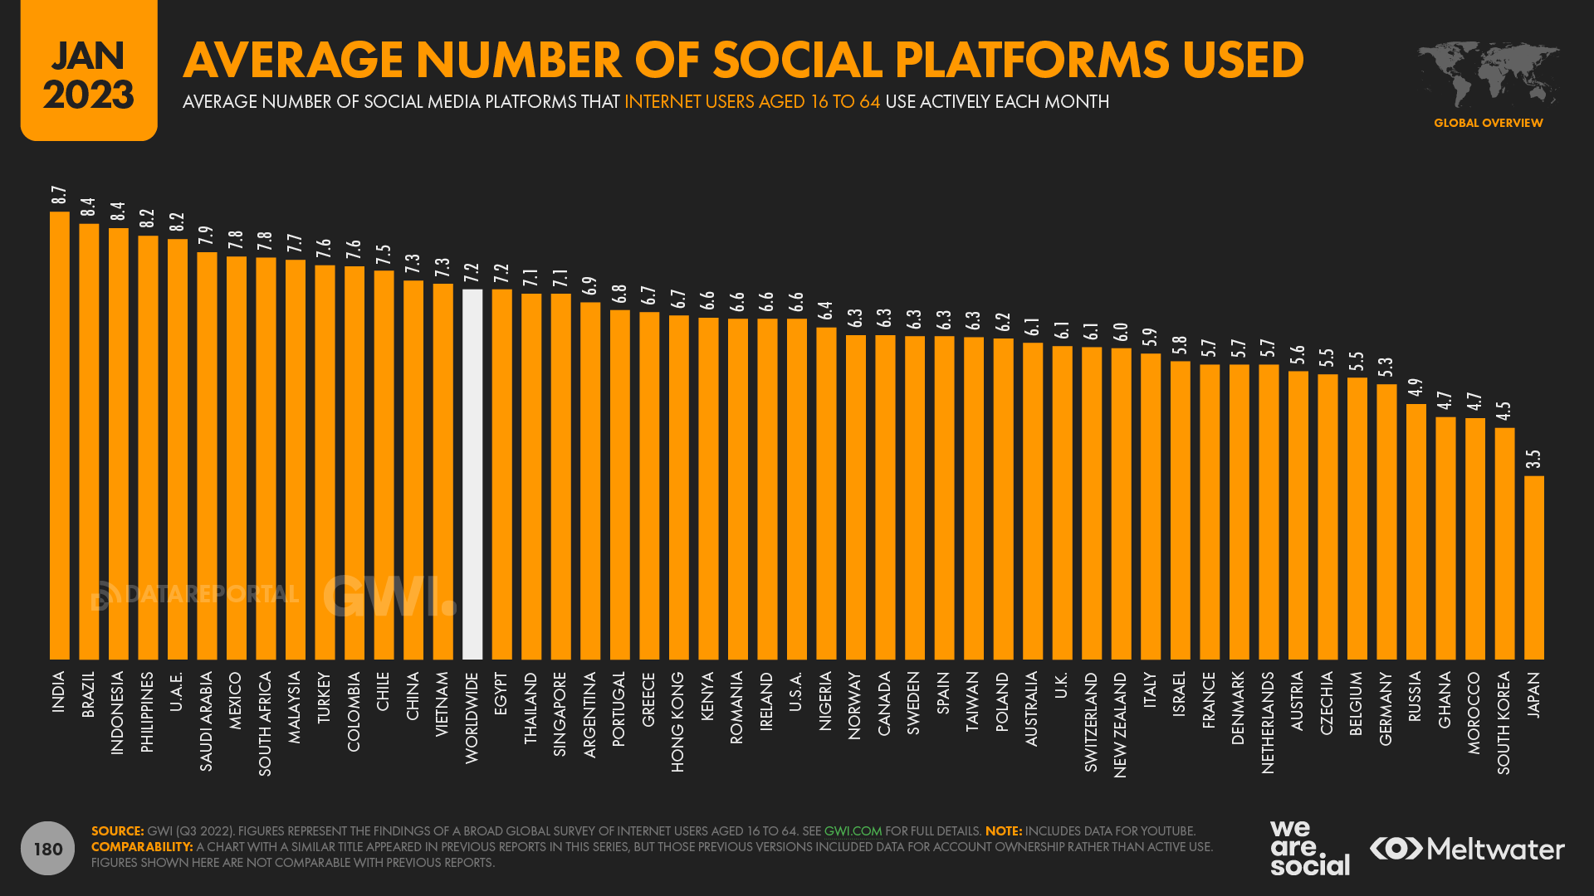

**Figure 1: Average Social Media Platforms Used**

(Source: Sheikh, 2023)

As of 2023, that tends to be an estimation of about 4.89 billion overall users of social media globally. This is accompanied by an average person bouncing between 7 diverse social networks on a monthly scale (Sheikh, 2023). Furthermore, internet users are found to spend about 151 minutes daily on social media with the number of users globally rising by about 3% year-on-year. Findings observed that TikTok emerged as one of the leading emerging social networks following a staggering user growth rate of 100% between 2020-22. Irrespective of slow growth, the attribute of using social media fosters a mass opportunity for advertisers and marketers globally.

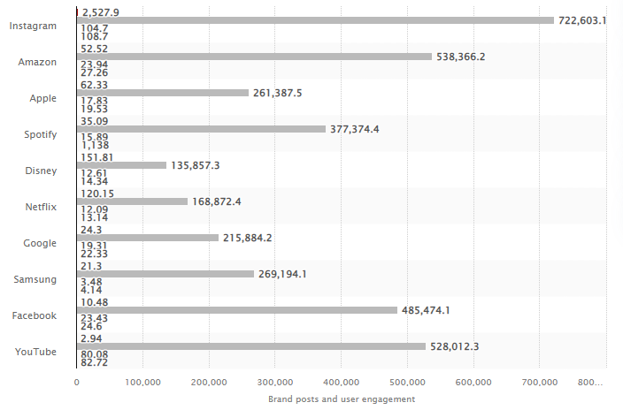

**Figure 2: Loved Social Media Platforms**

(Source: Statista, 2021)

Following the second half of 2019 and leading up to the first half of 2020 the most attributed social media platform among customers was “Instagram”. This is supported by the figures with an accumulated total “love” mentions being 108.7 million (Statista, 2021). It was subject to a generation of about 722 billion relevant impressions along with about 2 billion overall engagements concerning the aforementioned time frame. Projections till 2027 also illustrated a spending generation of about $130.5 billion on social media (Sheikh, 2023). Besides, social media is also currently witnessed to have crossed paid search as an advertising channel with a 25% year-on-year growth.

## 1.2 Scope

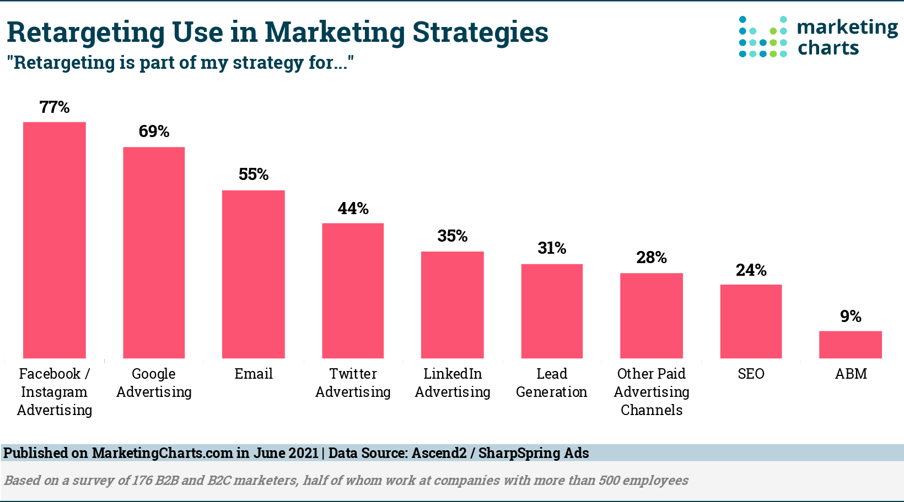

**Figure 3: Retargeted Use of Marketing Strategies**

(Source: Sheikh, 2023)

Advertisement on social media and their subsequent spending is identified to be growing at a steady rate. Concerning an increased range of marketers investing in advertisements, brands are extensively getting ready to invest bigger budgets towards paid marketing strategies for competition. In this context, the total spending regarding social media advertisement is stipulated to be reaching $268 billion in 2023 (Sheikh, 2023). The following can shed light on the potential opportunity for a new brand or outlet to aim at integrating social media platforms as part of its marketing strategies. This will also direct the way for significant opportunities for a new and emerging brand to reach its target customers with efficiency and ease.

# 2. Theoretical Context

## 2.1 Theoretical Background

The Nail Salon is an exclusive nail salon offering varied services such as manicures and pedicures with acrylic, nail treatments and nail art painting. The nail businesses are a fast-growing industry with phenomenal growth from 2005-2012. This new nail beauty salon will be located in the heart of London, Westminster. The area is known for its historical attractions, political importance, the monarchy’s official residence, theatres, restaurants and shopping districts. Social media is a tool developed in the last decade to promote products and services, connect customers with providers, build brand awareness and increase sales.

## 2.2 Research Aim and Objectives

This project aim is to identify how social media can be used for a small nail salon in Westminster, London.

To achieve this aim, the project has focused on the following objectives:

1. Outline and analyse what marketing strategies are available on social media (e.g. Facebook and Instagram)
2. Determine and discuss how does social media contribute to attracting new customers

***Key Areas***

This project focus on what is the role of social media and how to use Facebook and Instagram to promote a small nail salon. The principal question: “Is social media a tool to assist a small nail salon development?” outline and analyse the marketing strategies available on Facebook and Instagram.

Having a social media strategy plan about what platform should be used, posting schedule and the tone of the content influence the opinion of the audience about the nail salon.

Resonate with their needs and engage with customers through live videos, exciting updates or news, special promotions generate more leads, improve customer relationships and contribute to attracting new customers.

## 2.3 Theoretical Perspective

***Technology Acceptance Model (TAM)***

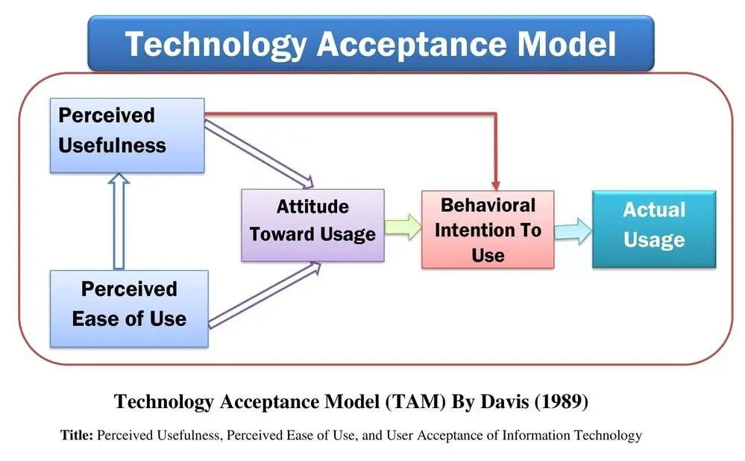

**Figure 4: TAM**(Source: Inspired by Vahdat et al. 2021)

The *“Technology Acceptance Model” (TAM)* is specifically designed to measure the adoption of new technology depending on customer attitude. This refers to a time following the introduction of computers into workplaces with the innovator looking at ways for predicting and explaining system usage. Vahdat et al. (2021, p.187) asserted that perceived usefulness involves no significant effect concerning the attitude of customers towards using social media applications. On the contrary, perceived ease of use, peer and social influence along with intention towards purchase exhibit positive effects towards attitudes. Besides, with social media being internet-based, proposing the TAM as a theoretical framework can be crucial for understanding the extent of technology adaptation among target customers. This will be crucial for this project in understanding the drivers of social media usage behaviour in UK for helping the Nail Salon to choose the relevant platforms.

# 3. Literature Review

## 3.1 Literature Search

The literature review covers books, articles and journals about the influence of social media platforms on the nail industry and its trends and consumer behaviours. Recent research has identified a growing nail market trend of 3.77% (Statista, 2022). The global nail care product market size was valued at over USD 19 billion in 2021, with an expansion rate of 5.2% by 2030 (Market Analysis Report, 2020).

Other research advice about business owners’ challenges in the nail industry: include retaining clients, competition, retaining staff, and educating clientele (NailsMag, 2020). However, researchers’ opinions are pragmatic and see the opportunities in targeting, reaching and scaling new markets throught social media at a lower cost (RBB Communications, 2023). Customers behaviuor and trends can be traced using analitycals tools from social media, and respond accordenly with the content produced.

## 3.2 Availability of Marketing Strategies on Social Media in UK

Based on the rapid proliferation concerning digital technology, social media is emerging as a key marketing strategy for the promotion of business products. Dolega, Rowe and Branagan (2021) put forward that, in 2016, about 99% of British people aged 16-24 highlighted their use of social media sites in the past week. This resulted in the research showing that about 79% of surveyed companies maintain a presence on social media to reach these segments. In addition, about 38% of UK-based organisations were identified to be planning to spend about 20% of their overall advertising budget on social media marketing channels. On this note, Facebook is emerging as one of the leading social media marketing platforms used by small businesses in UK. This is based on published data highlighting that about 44% of online Britons are subject to daily use of Facebook (Cook, 2022). On a parallel note, the instant messaging function and ability to create promotional content make it significantly convenient for customer support.

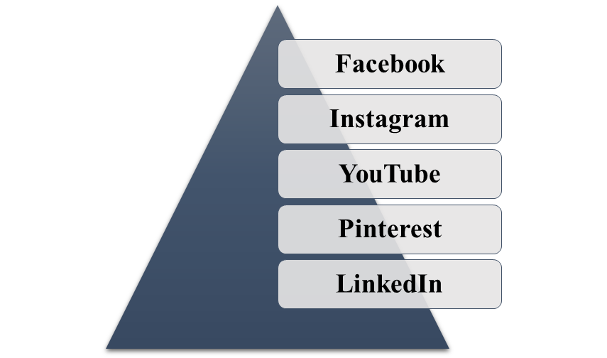

**Figure 5: Common Social Media Marketing Platforms**

(Source: Cook, 2022)

In this view, Instagram emerges as the next in line with a potential scope towards inspiring customers to make purchases. Figures tend to highlight that about 80% of accounts are subject to following a business on Instagram owing to the advantages of videos and still images for product promotion (Cook, 2022). This is also supported by Atkinson, Sumnall and Meadows (2021) establishing that Instagram had a crucial role during the lockdown in UK. The following involved brands quickly adapting towards the changing economic, health, and social context while intensifying their marketing content. Twitter gets identified as another ideal application for small businesses in UK with a range of written content and articles to be shared. Pinterest is also gets identified as another social media marketing platform given its easy and quick experience for customers and prime commercial opportunity for businesses (Cook, 2022). The live function feature promoted by YouTube also contributes towards “in-the-moment” connection for brands with their customer segments.

## 3.3 Contribution of Social Media towards Customer Attraction in UK

A major contribution by social media platforms as part of marketing tools in UK is influencing the purchase pattern and behaviour of customers. brands in UK extensively make use of social media in compliance with the *“Consumer Panic Buying Theory”*. Naeem (2021) presented an example from the COVID-19 pandemic phase where advice and speeches from UK authorities developed a sense of fear and subsequent bulk buying behaviour among customers. This was widely promoted in other nations like USA and China through initiated videos across social media platforms that resulted in people purchasing extra groceries to avoid life uncertainties and threats. Contrary to this, it is also argued that information passed on across social media platforms for influencing customers is often socially interpreted in the form of sensationalism or rumours (Naeem, 2021). It is also in the context of generating other disinformation types with social media offering a window into collective responses.

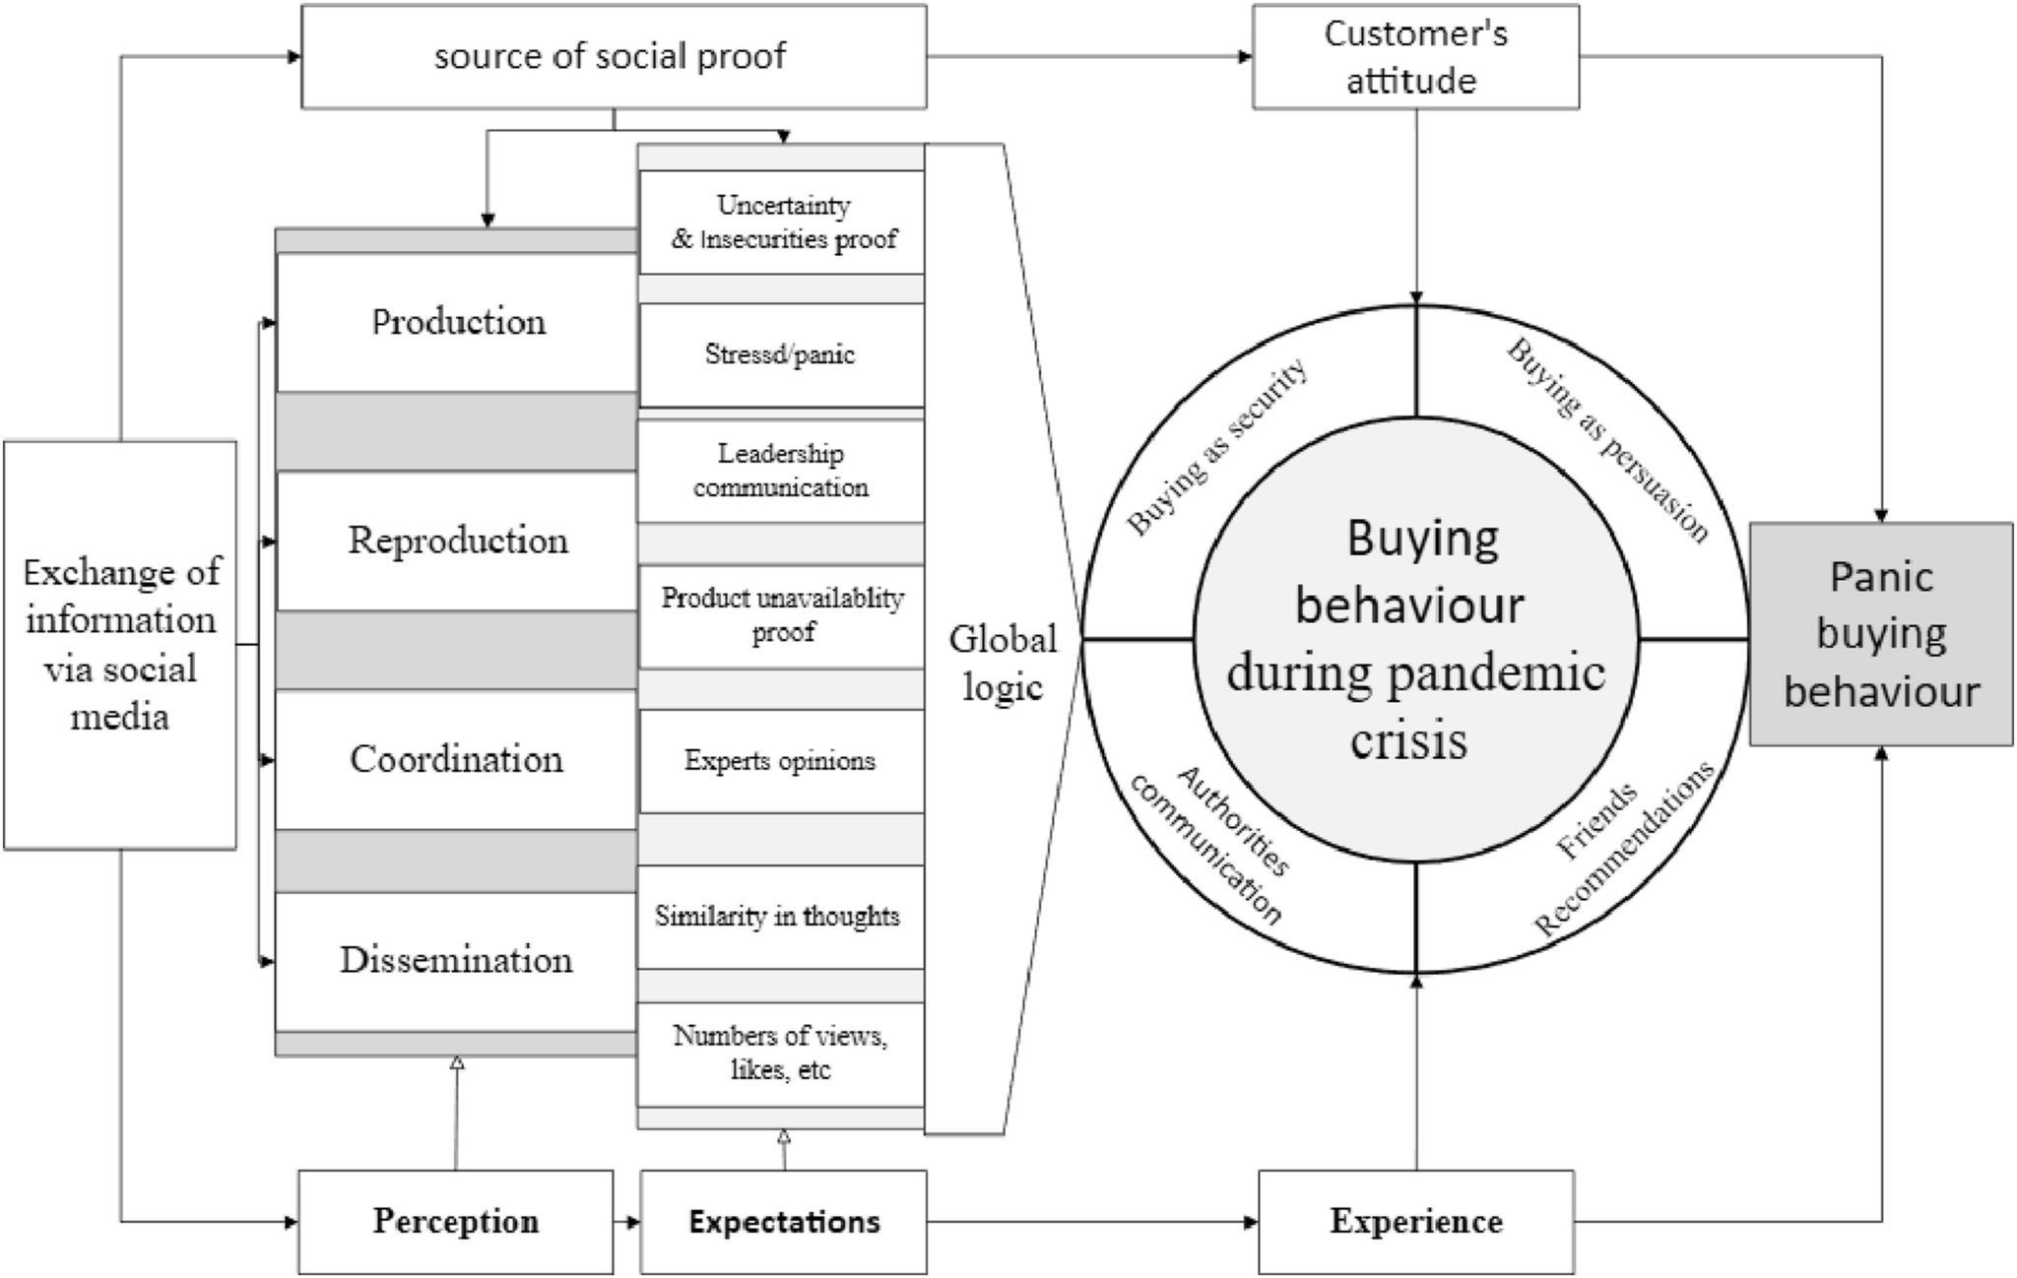

**Figure 6: Consumer Panic Buying Theory**

(Source: Cited by Naeem, 2021)

Relevant to the present time of web-based social networking, the context of visual communication is identified as a key component for public and business communication. The astute features of social networking also hold the ability to pull in numerous interfaces with others. Kujur and Singh (2020) posited that visual communication has a crucial role in engagement behaviour on social media and subsequently adds to sales. This high-quality visual also assists in improved visibility of media sites while also contributing towards a positive customer-brand relationship. The following maintains compliance with the *“Uses and Gratifications Theory”* for the evaluation of customers’ behavioural responses and engagement through social media. Conversely, the excessive impulse purchasing behaviour by Generation Z within the fashion industry of UK is identified to be limited only to females (Djafarova & Bowes, 2021). Although this was found to be a positive factor with the application of Instagram marketing tools, it was most prominent amongst females, unlike males. Yet again, advertisements, user-generated content, and opinion leaders were found to be potential stimuli evoking positive emotions and triggering impulse purchases.

## 3.4 Customer Trends in UK’s Nail Salon Segment

Determine from the previous aspect, it can be undertaken that Instagram as a leading marketing tool is mostly focused on Generation Z females. On a contrasting mode, this can also be identified as a positive aspect for a Nail Salon in UK because the majority of the customer segment will be females. This is concerning the fact that the year 2022 emerged as a big trend for nails involving the viral trends from celebrity nail designs (Murdoch-Smith, 2023). It was followed by manicurists being the most demanding and serving as full-fledged influencers. As an example, subtle chrome emerged as a new trend that got inspired by the ultra-shiny manicure of Hayley Bieber. This is accompanied by “clean girl aesthetics” and “Barely-there French” as updated classic trends (Murdoch-Smith, 2023). Similarly, nail accents and nail jewellery or metallics also emerged promising through Instagram influencers.

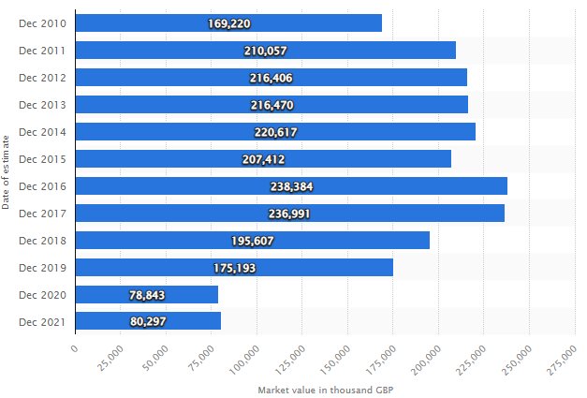

**Figure 7: Market Value of Nail Colour in Britain**

(Source: Petruzzi, 2022)

In addition to this, revenue in the nails segment of the UK is expected to amount to above $0.36 billion in 2023 with an annual growth of 1.98% CAGR. In relation to the figures of the total population, per-person revenue in 2023 is expected to be about $5.18 (Statista, 2023). Consideration of nail service as a potential source of pampering and a corollary of beauty drives a potential opportunity for any emerging nail brand. Adina and Madă (2021, p.1) stated that nail services hold a potential hint of indulgence, vanity, and luxury encompassing pampering treatments. This was better illustrated by Walsh (2012, p.243) with the statement that *“for every one Starbucks retail outlet in the United States, there are more than four nail salons”*. Besides, this emerging trend of nail therapy or beauty therapy also maintains an association with a wider social transformation touching upon individualisation, commodification, self-monitoring, and transformations among Generation Z.

## 3.5 Possible Challenges in Using Social Media for Customer Attraction in a Nail Salon in the UK

A leading challenge for a nail salon segment in the UK market is its fluctuation on grounds of market value concerning nail colour cosmetic products. Addressing a period of 2010-2021, the market value concerning nail cosmetics reached a high point of about £238.4 million in 2016 (Petruzzi, 2022). On the contrary, this value dropped down to about £80.3 million as of December 2021. Summing up to this, the need for standing out against established social competitors is also emerging as a challenge (Barnhart, 2022). It is argued that most industries tend to be extensively crowded with competition, the same being highly prominent in the beauty space.

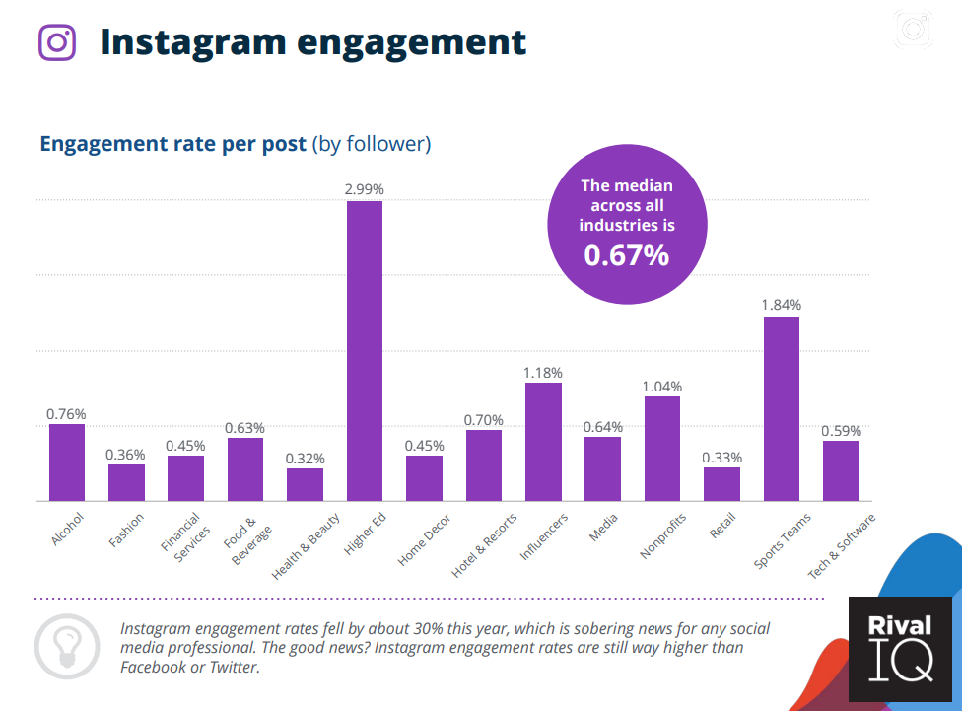

**Figure 8: Falling Engagement Rates on Instagram**

(Source: Barnhart, 2022)

On a further note, falling engagement rates along with reduced post interactions also emerge as challenges for brand accounting for social media marketing. This is based on the understanding that organic engagement concerning social media has been witnessing a downward trend (Barnhart, 2022). It is also supported by figures illustrating that the engagement rate on Instagram has witnessed a plummet of 30% year-on-year. Agung and Darma (2019, p.746) contradicted that lack of sufficient knowledge regarding the systematics of the Instagram algorithm has a potential impact on decreased engagement rate and audiences. This is also accompanied by the time being a crucial challenge concerning the application of an optimal Instagram algorithm for brands.

## 3.6 Literature Gap

The following proposal has accounted for using a range of sources for addressing the objectives. It will also be aiming at carrying out the same during conducting future research work by accessing relevant information sources. This will be positively contributing towards understanding the social media marketing strategies used in UK and how these facilitate customer attraction. There will also be certain sources that can shed light on the role of social media marketing for fashion lovers in UK. Despite these, a major limitation will be insufficient information on how social media might reach out to nail fashion lovers. Although there will be the availability of data to support the application of social media marketing strategies by start-ups or small businesses, aligning the same with nail salons would be challenging.

# 4. Methodology

Referring to outlining and analysing what marketing strategies are available on social media, this project approach will be extensively focused on carrying out secondary qualitative research. Lester, Cho and Lochmiller (2020, p.102) opined that heterogeneity and diversity regarding qualitative research get reflected in the diverse arguments persisting. This accounts for analysing ways regarding establishing a quality and claiming rigour. Reliability and validity of research followed by subsequent outcomes tend to be crucial elements for providing evidence of quality (Hayashi Jr, Abib & Hoppen, 2019, p.98). Yet again, validity is identified to be better evidence concerning quantitative studies, unlike qualitative research. Concerning this, the following study will be subject to using a constructive search strategy as a way of obtaining relevant information regarding this research purpose. The following attribute towards a relevant search strategy will involve the collection of information from already published academic sources and credible websites.

A leading process to be undertaken for this search process will be the use of potential keywords concerning this project. In addition, there will be the implementation of Boolean operators for refining and developing significant phrases to search for the desired information. For example, using “AND” and “OR” will be helping with refining and broadening the search attributes respectively (Hollier, 2020). Relevant to determining and discussing how social media contributes to attracting new customers, this report will account for using significant search criteria. This will be in the form of considerable inclusion and exclusion factors that contribute towards determining the integrity of the collected data (Hornberger & Rangu, 2020). As an illustration, this study will opt for the selection of sources that solely focus on social media marketing. Parallel to this, the study will avoid the use of resources that encompass other marketing strategies like digital marketing, email marketing, or others. Also, this following project work will include choosing sources with complete access, those published in English and with a high impact score.

# 5. Plan of Work and Schedule

**Figure 9: Time Plan** 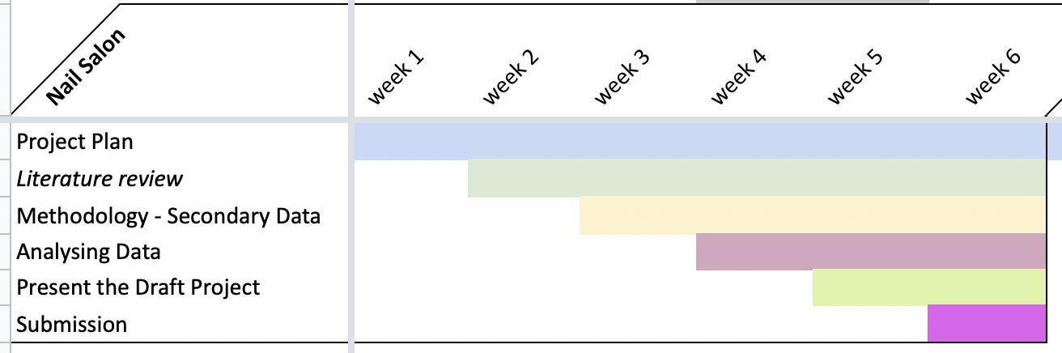

(Source: Self-created)

The plan of work and scheduling concerning this project will involve about a 6-week attribute. A detailed breakdown of this will involve project planning with a significant emphasis on reviewing the literature for weeks 2 to 6. Subsequently, a thorough methodology will be carried out in terms of gathering potential secondary data. This will be the way to analysis of all the collected information and present the same with a preliminary draft. Making relevant corrections will ultimately lead to submission in the final week.

# 6. Conclusion and Recommendations

Marketing through social media involves the potential application of social media networks like Twitter, Instagram, Facebook and others for interacting and connecting with the community and customers. This tends to be carried out through texts, videos, images, or combinations of all. Elicited from this aspect, this proposal report has identified that the execution of social media marketing involves the scope of being carried out organically or with the help of paid-for campaigns. Social media is observed to hold the scope of taking diverse forms based on the medium and platforms being utilised. Although the contents tend to be at the core of social media marketing, its scope extends towards engagement, advertisement, and analysis. In this matter, the following project will be focused on understanding the role of social media marketing strategies for a nail salon. It will aim at assessing if social media can be a potential tool for assisting a small new salon development. This project proposal has deduced that despite some of the potential challenges associated with social media marketing for a Nail Salon business, it can also appear as a potential option. In conclusion, it can be recommended that this new salon business can substantially focus on Instagram as a potential tool given its ability to trigger purchase emotions among Generation Z females.

# 7. References

Statista (2021). *Top brands on social media worldwide 2019-2020, by social rank*. <https://www.statista.com/statistics/275173/most-loved-companies/>

Sheikh, M. (2023). 50+ of the most important social media marketing statistics for 2023. <https://sproutsocial.com/insights/social-media-statistics/>

Vahdat, A., Alizadeh, A., Quach, S., & Hamelin, N. (2021). Would you like to shop via mobile app technology? The technology acceptance model, social factors and purchase intention. *Australasian Marketing Journal*, *29*(2), 187-197. <https://doi.org/10.1016/j.ausmj.2020.01.002>

Lester, J.N., Cho, Y. & Lochmiller, C.R., (2020). Learning to do qualitative data analysis: A starting point. *Human Resource Development Review*, *19*(1), 94-106. <https://doi.org/10.1177/1534484320903890>

Hayashi Jr, P., Abib, G. & Hoppen, N., (2019). Validity in qualitative research: A processual approach. *The Qualitative Report*, *24*(1), 98-112. <https://www.proquest.com/openview/c200412f0d74bd6a137110fb51805eeb/1?pq-origsite=gscholar&cbl=55152>

Hollier, C. (2020). *Research Basics: Using Boolean Operators to Build a Search*. <https://www.ifis.org/en/research-skills-blog/research-basics-boolean-operators>

Hornberger, B., & Rangu, S. (2020). *Designing inclusion and exclusion criteria*. Penn Libraries.

Cook, S. (2022). *What is social media marketing: The ultimate guide*. <https://startups.co.uk/marketing/tips/what-is-social-media-marketing/>

Frampton, N. (2023). *8 steps to create a social media strategy for 2023 (+ free social media planner template)*. <https://www.quayclick.co.uk/8-steps-to-create-a-social-media-strategy-for-2021>

Dolega, L., Rowe, F., & Branagan, E. (2021). Going digital? The impact of social media marketing on retail website traffic, orders and sales. *Journal of Retailing and Consumer Services*, *60*, 102501. <https://doi.org/10.1016/j.jretconser.2021.102501>

Atkinson, A. M., Sumnall, H., & Meadows, B. (2021). ‘We're in this together’: A content analysis of marketing by alcohol brands on Facebook and Instagram during the first UK Lockdown, 2020. *International Journal of Drug Policy*, *98*, 103376. <https://doi.org/10.1016/j.drugpo.2021.103376>

Naeem, M. (2021). Do social media platforms develop consumer panic buying during the fear of Covid-19 pandemic? *Journal of Retailing and Consumer Services*, *58*, 102226. <https://doi.org/10.1016/j.jretconser.2020.102226>

Kujur, F., & Singh, S. (2020). Visual communication and consumer-brand relationship on social networking sites-uses & gratifications theory perspective. *Journal of Theoretical and applied electronic commerce research*, *15*(1), 30-47. <https://doi.org/10.4067/S0718-18762020000100104>

Djafarova, E., & Bowes, T. (2021). ‘Instagram made Me buy it’: Generation Z impulse purchases in the fashion industry. *Journal of Retailing and Consumer Services*, *59*, 102345. <https://doi.org/10.1016/j.jretconser.2020.102345>

Adina, S.B. & Madă, C.S. (2021). Nail service: a therapy or a caprice? *Student Balta Adina*, 1-5. <https://www.researchgate.net/profile/Balta-Adina/post/Nail_services_a_therapy_or_a_caprice/attachment/63a0ee7628b5df6ceff808d4/AS%3A11431281108422315%401671491190285/download/2-Nail+services+a+therapy+or+caprice.pdf>

Petruzzi, D. (2022). *Nail colour cosmetic market value in Great Britain 2010-2021*. <https://www.statista.com/statistics/474987/market-value-nail-color-cosmetic-products-great-britain-uk/>

Statista (2022). *Nails - United Kingdom*. <https://www.statista.com/outlook/cmo/beauty-personal-care/cosmetics/nails/united-kingdom>

Murdoch-Smith, L. (2023). *5 Nail Trends That Are Going To Be Huge In 2023*. <https://www.vogue.co.uk/beauty/article/nail-trends-2023>

Walsh, S. A. (2012). Beyond the polish: An examination of hazardous conditions in nail salons and potential solutions for the industry in New York City. *JL & Pol'y*, *21*, 243. <https://heinonline.org/HOL/LandingPage?handle=hein.journals/jlawp21&div=15&id=&page=>

Barnhart, B. (2022). *8 of the toughest social media marketing challenges (and how to overcome them)*. <https://sproutsocial.com/insights/social-media-challenges/>

Agung, N. F. A., & Darma, G. S. (2019). Opportunities and challenges of Instagram algorithm in improving competitive advantage. *International Journal of Innovative Science and Research Technology*, *4*(1), 743-747. <https://ijisrt.com/wp-content/uploads/2019/03/IJISRT19JA125.pdf>

Brynjolfsson, E., & McAfee, A. (2014) *The second machine age: Work, progress, and prosperity in a time of brilliant technologies*. WW Norton & Company.

Ghauri, P. and Grønhaug, K. (2005) Research Methods in Business Studies: A Practical Guide. 3rd edn. Harlow: Financial Times Prentice Hall.

Kumar, J. A. and Ganesh, L.S. (2009) *Research on knowledge transfer in organizations: a morphology,* Journal of Knowledge Management, Vol. 13 Iss 4 pp. 161 - 174.

Robson, C. (2002) *Real World Research: A Resource for Social Scientists and Practitioner-Researchers. 2nd edn.* Oxford: Blackwell.

Saunders, M., Lewis, P. & Thornhill, A. (2012) Research Methods forBusiness Students. 6th edn. *Pearson Education Limited.*

Talwar, R. (Ed.) (2015) *The future of business*. Fast Future Publishing.

Talwar, R., Wells, S., Whittington, Al, Koury, A., & Romero, M. (2017) *The future reinvented. Reimagining life, society, and business*. Fast Future Publishing.

[**https://www.grandviewresearch.com/industry-analysis/nail-care-products-market-repo**](https://www.grandviewresearch.com/industry-analysis/nail-care-products-market-report)[**rt**](https://www.grandviewresearch.com/industry-analysis/nail-care-products-market-report) **(Access date: 15th March 2023)**

[**https://www.statista.com/outlook/cmo/beauty-personal-care/cosmetics/nails/worldwid**](https://www.statista.com/outlook/cmo/beauty-personal-care/cosmetics/nails/worldwide)[**e**](https://www.statista.com/outlook/cmo/beauty-personal-care/cosmetics/nails/worldwide) **(Access date: 15th March, 2023)**