**ASSESSMENT**

Table of Contents

1.0 Introduction 3

2.0 Brand Introduction 3

2.1 Brand Portfolio and Availability 4

2.2 Brand Elements 5

2.3 Brand Equity 8

2.4 Brand Mantra 9

3.0 International Market Analysis 9

3.1 SLEPT analysis for three culturally distinct markets where the brand can enter 9

3.2 Competitor analysis for each market 13

4.0 Strategy for market entry 15

4.1 Selection and Justification of new international market to Enter 15

4.2 Recommendation of market entry strategy 16

4.3 Recommendation for standardisation or adoption 16

4.4 Intended Points of Parity and Points of Differentiation 18

5.0 Conclusion 18

References 19

# 1.0 Introduction

Another part of the marketing process is brand analysis, which evaluates a brand’s strategy to manoeuvre via methodologies. These methodologies allow a brand to create its own identity and personality, thereby transforming into a message that can be sent to the customers and potential clients. The brand analysis involves a set of steps that allows a brand represented by the organisation to experience initial hurdles. The hurdles can be in the form of negative reviews from certain masses, not used to using its products. It can also receive unexpected positive reviews that can indicate the future potential of the brand. These criteria will be evaluated in this assessment, through the brand ‘Mason Pearson hairbrush’. While this brand is currently available in varied quantities across the UK, the brand is yet to make a considerable mark in other developed and developing regions of the world. Due to this consideration, the brand’s portfolio along with equity creation will be evaluated. That will provide a way towards developing a market analysis for the markets of Indonesia, Qatar, and Bolivia. Alongside this, the market analysis and competitor-related analysis will also be conducted using frameworks, models, and theories that will justify the selection of a single market into which the brand might enter. The entire assessment will have bearings of different scholarly literature and commercial article-backed information.

# 2.0 Brand Introduction

Mason Pearson hairbrushes are renowned for their quality, which is generally handmade through nylon mixtures moulded to have larger teeth, bristle variety, and rounded teeth variety. This allows it to deliver smooth and comfortable action through rounded teeth. The rounded teeth feature of the brands allows effortless gliding through hair locks, without scratching or causing damage to the scalp (Mason Pearson, 2023). However, given the quality of hair around the world, Mason Pearson hairbrushes have modified their portfolio to accommodate both thick hair, thin hair, or simply fine hair. Most importantly, the hairbrushes support unisex requirements that afford men and women a variety of choices.

Within the UK, Mason Pearson's hairbrush became a household name in the 19th century. Since that time, the brand has become popular because of its attainment as the finest hairbrush manufacturer in the country. Also, its regard for old age traditions creates a different emotion in the minds of British customers, that might be difficult to ordain in another country. After incorporation in 1885, the engineer and inventor Mason decided to join hands with Raper Pearson and Gill which allowed small brush-making to flourish within the country (Mason Pearson, 2022). The company has even gained attention due to their tenacity to experiment through innovation. Implementing a pneumatic rubber-cushion-inspired practice, the differences in future combs have changed as distributed by the company. Meanwhile, the current Mason Pearson combs have decided to look across other nations, that might benefit from their hairbrushes. Such combs are only released after considering climate change, water quality, scale type, hair type, and overall hair quality in the markets.

## 2.1 Brand Portfolio and Availability

A brand portfolio can generally be seen as a collection of different brands or sub-brands that might operate under a single corporate umbrella. However, in some brand contexts, the parent organisation simply decides to align its name for full control of its brands. Rather than investing in the brands as a subsidiary. Owning a single type of brand under its primary company name, allows the company to exhibit better control over the products. As a subsidiary, the organisation can have a better arrangement of trademarks (Landyschemist.com, 2022). In the case of Mason Pearson, a branded property-based portfolio is followed by the organisation. That allows them to keep a single brand, but have a variety of combs, hairbrushes, and even pure and non-pure shaving bristle-based brushes. A better demonstration of the product portfolio can be obtained through the below figure 1.

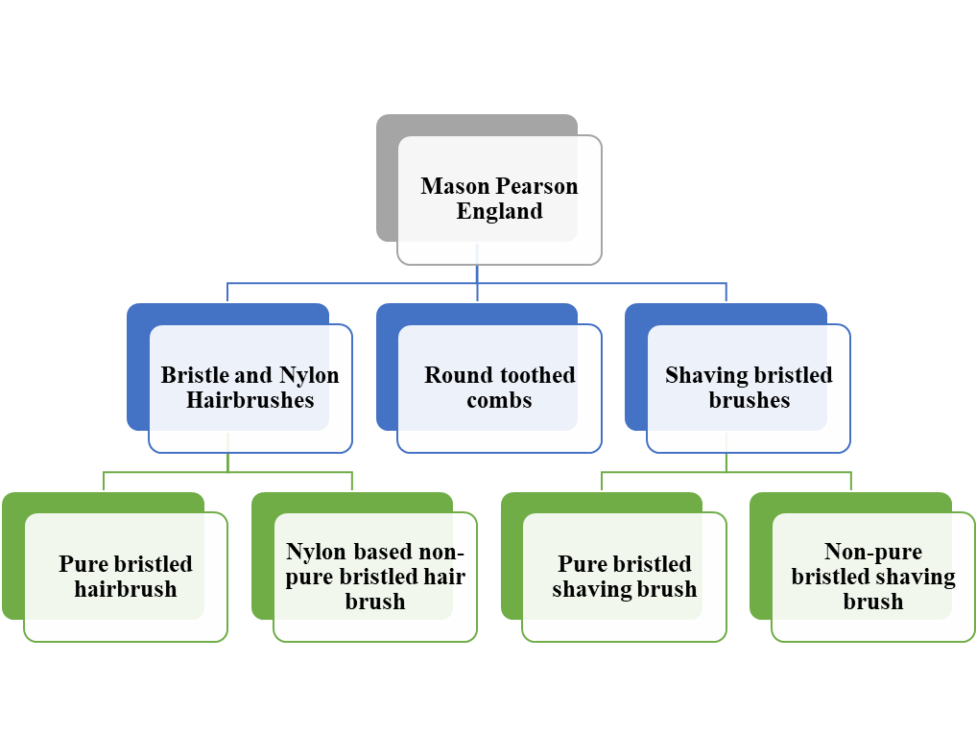

**Figure 1: Brand Portfolio of Mason Pearson**

(Source: Self-created)

## 2.2 Brand elements

Normally, brand elements allow a brand to be distinguished based on its personality and emotion, which it tries to imbue via communications (Hastings, 2022). In the same manner, a total of six brand elements can be applied in the case of Mason Pearson. The explanations can be provided in a below manner.

**Brand voice**

Mason Pearson's personality allows them to stay connected with customers, by trying to understand their emotions. For instance, their brand mission dictates allowing customers to get connected with the appropriate product and provides them with an opportunity to consult with their hair specialists or think about what form of hair brush is preferable (Hastings, 2022). Based on the information received from the query put up on the company website, the organisation decides to create bristled brushes or go forward with toothed variety only.

**Brand Identity**

Certain aspects of a brand might be recognisable to the customer's eyes, which can be in the form of the company's colour palette, logo, or even font letterings. Mason Pearson, in this regard, has its engravings on the bottom part of every kind of hair brush and toothed comb. That distinctly separates the product varieties from the uncommon brush types. Moreover, for understanding the brush type, consumers can look below the neck of the bristles or tooth (Escentual.com, 2022). This part also has an additional engraving that marks the type of comb or brush being used by the organisation. It provides each brush with a cause to be compared separately from each other.

**Brand promise**

Articulating unique value for customers that deliver a wider appeal for the business, allows the latter to stay affirm to their mission statement and vision statement as well. In this case, Mason Pearson's promise of accommodating customers with their required product not only projects them as a caring brand. It also enables them to ensure each customer can fulfil their requirement. For instance, for suiting the ambience especially surrounding girls, Mason Pearson has different colour palettes (Escentual.com, 2022). That includes dark ruby, feminine pink, and others. This engages the individual tastes of customers as well.

**Brand value**

These values are created through guiding principles and beliefs that the company intends to stand by over time. Keeping this in mind, a query is enquired by Mason Pearson from their customers in terms of hair length, hair type, and the personal requirement that can be explained. If the same is somehow not available, then the brand seldom goes on to produce a customer it might have attracted (Ings-Chambers, 2023). This helps Mason Pearson to ensure that they can create a long-lasting impression on the minds of the consumers.

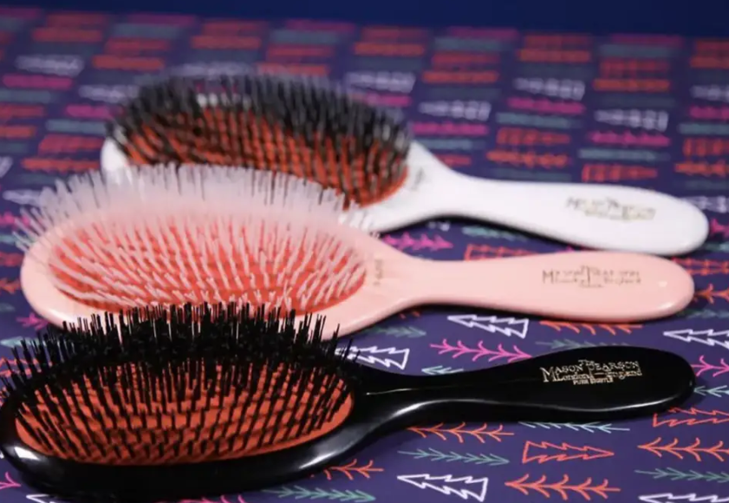

**Figure 2: Mason Pearson bristle hair brushes**

(Source: https://www.insider.com/guides/beauty/mason-pearson-brush-review)

**Brand targets**

Within the UK, where Mason Pearson has its only physical store based in London, they try to connect with the Generation Z culture that is predominant in the beauty and hygiene market. It requires the organisation to create out-of-the-box narratives and campaigns with injected humour, for attracting customers aged from 18-24 (involving both male and female customers). As the haircare market looks to address expectations of functional personal care, by looking at new product availability. It allows the organisation to specifically target these groups in urbanised areas like London, Liverpool, Manchester, Surrey, and even Birmingham.

**Brand position**

Due to the brand being chosen by celebrities across the globe, its pricing strategy remains to be impacted through premium prices. For instance, the average comb price that begins at Mason Pearson starts at $85 for toothed variety combs. However, for hair brushes with different bristle quality, the prices tend to go up to $130 (Stewart, 2021). In some cases, celebrities, stylists, and others recommend good quality bristle hair brushes. That takes the price to over $275 and more. The reputation of the organisation and brand has allowed the prices to be set, due to its 130-year goodwill.

## 2.3 Brand equity

Applying Keller’s brand equity framework, i.e also known as the customer-based brand equity model or CBBE model is designed in a pyramid structure. The scholar Kevin Keller's logic behind the model was that stronger brands can be built by a stronger brand image. This can be orchestrated by generating ideal brand encounters or experiences. That allows each experience centred around the brand to leave consumers with positive thoughts, convictions, as well as emotions. The brand in this regard is likely to provide value that also allows their convictions to spread to others. Four levels within the pyramid layer can be discussed in a below manner.

**Identity:** This brand Mason Pearson is synonymous with luxury, artisanship, and excellence. As a result, the Mason Pearson collection of brushes has been associated with innovation in the manufacturing of quality. Mainly utilising unique pneumatic rubber cushion pads made by hand, the organisation still uses original techniques that allow for efficient brushing. It leads to kind usage in messaging the scalp, whereby the cellulose plastic handle is hand-polished and other sharp edges are removed to support hair brushes permanently

(Ft.com, 2022). Also, coming in Nylon and pure to non-pure bristle forms, the expectations of consumers grow when they experience such elegant planning demonstrated by an organisation for mere hair brushes and combs.

**Meaning:** Subtle meanings within brands provides customers with the assurance that it is meant to do more than simply tidying of things they want tidy through the product. In short, Mason Pearson hairbrushes and combs assure customers that other than detangling their hair it can strengthen hair follicles, smoothen its layers, and minimise breakage (Ft.com, 2022). Certain properties of the combs and hairbrushes are also meant to lift oil from the base of the scalp and distribute oil across the hair shafts. This has an individuality which transcends the brand in the minds of the customers.

**Response:** While the brush design has changed over the years, Mason Pearson's commitment in that regard has affected but little since 1885. Customers prefer its soft-rubber padding that allows their hair to feel naturally easy. Also, another variant of the hairbrush is the Kool-Aid technology, which allows the bristles to go smoothly into the scalp (Stewart, 2021). This by itself triggers oil production and hence drives the attention of several consumers, thereby escalating their interests as a process. This allows the customers to steer clear of companies that provide contributions from 2,00,000 to 3,00,000, for making hairbrushes and combs. It aids the customers to be aware that spending on the right product is worth its weight in gold.

**Relationship:** Having established a 130-year-old heritage within the UK, Mason Pearson has developed an association with customers in such a manner that their absence is felt during the final dressing up (Stewart, 2021). Blogs revolving around Mason Pearson's combing techniques circulate widely on the internet, which results in evoking sentiments from customers about the brand. In a way, this bolsters the brand loyalty the company managed to create over the years.

## 2.4 Brand mantra

This incorporates the main idea leading to the creation of the brand, and channelisation of the brand to more competitive frames of reference. In this case, Mason Pearson hairbrushes and combs guarantee different varieties of its products for all forms of age groups. Their initial success in catering to the needs of generation z customers, allowed them to understand the requirements of other customers separately. This puts price before quality, and flexibility before speed (Landyschemist.com, 2022). The main principle of the brand mantra for the organisation can be provided in a below manner.

|  |  |  |  |
| --- | --- | --- | --- |
| **Mason Pearson’s Brand Mantra** | | | |
|  | **Emotional Modifier** | **Descriptive**  **Modifier** | **Brand**  **Function** |
| **Mason Pearson** | Luxury | Family | Shopping |

The above brand mantra of Mason Pearson is used widely for building its brand essence, which promises seamless service over some time.

# 3.0 International Market Analysis

## 3.1 SLEPT analysis for three culturally distinct markets where the brand can enter

The business environment could be analysed better through the SLEPT framework, which distinctly puts forth findings based on the countries of Indonesia, Qatar, and Bolivia.

**For Indonesia**

**Social Factor:** Firstly, a demographic shift has been experienced in Asia that will become apparent by 2025. According to Mckinsey, 16,000 customers representing countries like Indonesia, Korea, and Thailand expressed their regard for facial care routines over millennials (In-cosmetics, 2020). That allowed using better shaving brushes, beard grooming combs, and other brushes in a better manner.

Secondly, 39% of millennials over 55 years of age, and 23% of others below the age of 55 prefer thick bristle combs with assured quality in Asian countries. As 82% of the masses featuring both males and females have a hair length of medium to long, with few having short hairstyles (In-cosmetics, 2020). This requires good quality combs that can be used by consumers in the countries.

**Legal Factor:** Firstly, issued under the regulation of 31/2019 the compulsory halal labelling law within Indonesia within five years. That will look at each cosmetic or hair care product imported from other countries by testing for prior registrations (Yu Lim, 2019). The registrations of the imported products will ensure halal standards have been followed.

**Economic Factor:** Firstly, the annual inflation rate of Indonesia has gradually slowed during the last seven months before March of 2023. The rate was at 4.97% which was the lowest since August of 2022, even if consumer spending has been a continuous problem within the country (Nikkei Asia, 2023). However, the country experienced GDP growth in the last few years by 5.31% since 2022, which carried out an improvement of income over the market (Nikkei Asia, 2023).

Secondly, there has also been unexpected growth in the service sector and manufacturing industries of Indonesia, which has even impacted the retailing process as well. This accounted for 13% of the total employment, increasing the workforce who received work by 3.3 million since 2013 (AsiaFundManagers.com, 2023). Therefore, this could effectively point to a better distribution of consumables in the country, related to beauty and skincare. The unemployment rate has been declining by 4.1% since 2021.

**Political Factor:** Firstly, Indonesia’s MOT regulation number 70/2015, as released by the Ministry of Trade, has pointed to the importance of obtaining a customs identification number. This allows the swift distribution of products carried out by partner countries into the nation of Indonesia, by filtering for banned materials or restricted goods (Trade.gov, 2022).

Secondly, Article 22 and 23 of the Income tax act of Indonesia, points towards a 22% tax rate on different consumable products (Statista, 2022). These might include cosmetics, hair hygiene-related items, skin products, and other hair-related products (Sudirman, 2022).

**Technological Factor:** Firstly, in terms of hair care products and facial hair grooming kits, Indonesia’s innovative techniques might be yet to surpass research. However, its local organisations have established a culture within the market that supports men’s hair care, through LED light therapies achieved via modern combs (Lim, 2023).

Secondly, the popularity of ionic vibration technologies is also being used in Indonesia, with customers trying to improve their longevity of hair retention irrespective of age. As well as, maintaining overall scalp health that is considered to be important over time. In that case, Mason Pearson is likely to thrive (Lim, 2023).

**For Qatar**

**Social Factor:** Firstly, in a report furnished by First Insight on the Arabian territories, at least 73% indicated from countries like Qatar and UAE that they were willing to pay more for sustainable products (Alexandra Venison, 2022). Also, brands especially those representing beauty, grooming, and other hygiene-related products, needed to be transparent in their communications.

Secondly, beauty brands can achieve criteria for trust by receiving certificates similar to Leaping Bunny, ECOCERT COSMOS, and others (Hukoomi.gov.qa, 2021). These forms of accreditations allow Generation Z customers to pay 10% more on combs, hairbrushes, makeup kits, and others.

**Legal Factor:** First, the Qatar consumer protection law number 8 under the consumer protection law of 2008, looks into the purchase of commodities, services, and others that might have sustained damage after purchase. This assures customers of the products they are assured to receive including combs, hairbrushes, shaving brushes, and others.

**Economic Factor:** Firstly, hurdles received from the inflationary pressure are minimal within Qatar. However, after global events like the recently concluded world cup, the inflationary rate rose to 5.93% year on year (Elgazzar, 2023). However, the price of miscellaneous goods that featured beauty accessories of consumers, including combs, hairbrushes, and others are likely to cost 0.8% less.

Secondly, the revenue from the beauty and personal care market is set to surpass $501.40 million in 2023. The total market contribution is mainly generated by hair care goods, which is supposed to add 5.76% to the CAGR from 2023-2027 (Statista, 2022). The personal care items are also set to create a volume of $225.90 million by 2023.

**Political Factor:** Firstly, as of April 1 of 2011, the Qatar customs registered with the Ministry of Commerce and Industry, require foreign-owned entities operating within the country to declare a wholly owned certification (Trade.gov, 2023). The shipments will include an official certificate of origin, packing lists, and others, without which the shipment will be returned to the country it was distributed from in the first place.

Secondly, a total of 10% tax is applied to an organisation’s total state income, which applies to businesses and not to individual earnings (Hukoomi.gov.qa, 2021). These taxes will thus also be applicable for consumer grooming commodities like combs, hairbrushes, and others.

**Technological Factor:** Firstly, Qatar is among the countries, that have decided to bring about innovation to increase the quality of personal beauty and grooming products. The hairbrushes will have microphones, gyroscopes, and accelerometers among other sensors (Kleinman, 2017). Other than the same, the hair brushes also have an effective use of Wi-Fi and Bluetooth, which allows the device to share information about hair conditions.

Secondly, Qatar consumer markets which are invested in beauty, grooming, and other hair care-related items, expect the products to carry some form of innovation (Kleinman, 2017). For instance, in certain areas of the world, separate space having cloud data backup is contemplated. However, such an idea is yet to be enforced into action.

**For Bolivia**

**Social Factor:** Firstly, the latest report surfaced from Mintel, indicating that almost one in 17% of the US consumers who have moved to Bolivia do not feel inclined towards hair care-related advertisements (Mintel.com, 2021). Also, 25% of generation z consumers want to purchase brands that promote diversity (Mintel.com, 2021).

Secondly, three out of five consumers, or 57% of Americans who have become citizens in Bolivia purchase beauty brands that include combs, hairbrushes, and others and have a responsibility to destigmatise flaws (Statista, 2022). For instance, any local manufacturing faults can be addressed using hairbrushes, combs, and others from other countries.

**Legal Factor:** Firstly, on the April 16 of 2008, President Evo Morales issued a 'Supreme Decree 29519' which regulates competition and consumer protection towards restricting negative influences within the market (Mintel.com, 2021). The decree is instituted by the Bolivian Institute of Metrics and Business Superintendence.

**Economic Factor:** Firstly, the hair care segments in Bolivia bearing different forms of combs, hairbrushes, and hair-related products amount to $146.70 million by 2023. The market is also expected to grow annually by 5.83% CAGR from 2023-2027 (Mintel.com, 2021).

Secondly, the average inflation rate of Bolivia is forecasted to grow by 0.3% from 2022 to 2027. The average inflation estimation is supposed to be around 3.5% till 2027, and this is supposed to affect hair care-related consumables imported from other countries minimally (Statista, 2022). However, there is a limited scope of growth within the market, for foreign consumer goods related to beauty and personal grooming.

**Political Factor:** Firstly, in September 2009, the Bolivian government removed previous fumigation requirements for Cotton fibre imported from other countries like the US. Resolution 162 requires companies from other countries to reconsider the above option, along with other materials like nylon as well (Privacyshield.gov, 2021).

Secondly, all organisations dealing with countries like Bolivia are subject to a 25% tax rate that has been issued by the recent government which are also firm in its commitment to charge imports (Taxsummaries.pwc.com, 2021).

**Technological Factor:** Firstly, due to economic strife Bolivia are yet to impart the application of innovations, strengthening its prowess in hair care and hair grooming products (Nearsure.net, 2023). However, certain companies within the country have decided to install prototypes that can assist in the distribution of consumables.

Secondly, the transmission of information related to consumer goods relating to beauty, haircare, and other grooming-related products is communicated using 12000 miles of fibre optics covering territories since 2019 (Nearsure.net, 2023). Also, in 2021, Entel modernised mobile communication networks in rural countries involving 4g to LTE. A total investment of 17.7 million is to be deployed in 100 localities of the country.

## 3.2 Competitor analysis for each market

A model identified by Michael Porter in 1979, identifies competitive forces that might be used for determining industry-based strengths and weaknesses. These can be elaborated on below manner.

**For Indonesia**

**Bargaining power of buyers:** Considering the current expected trajectory, at least 90 million Indonesians are expected to join the ranks of others by 2030. The rural-to-urban shifting also accounts for 71% of new interest in buying consumable items like combs, hairbrushes, and other related hair care items (Razdan et al., 2014). Considering this, it is likely that the bargaining power of buyers will exist at a higher level. However, if the quality of the product is increased it is likely to cater to the needs of the consuming mass.

**Bargaining power of suppliers:** A report released by Mckinsey, revealed that 52 personal grooming item supplying organisations currently located within China, Indonesia, Saudi Arabia, and UAE, have decided to hike their prices by 14% considering the route-to-market performance sales that grew by 1.9% ahead of other categories (Razdan et al., 2014). However, with better organisations supplying these items entering the countries, the prices might get eased through which Mason Pearson might consolidate better quotations for manufacturing combs and hairbrushes. The bargaining power of suppliers exists but minorly in the country.

**Competitive rivalry:** There is a dearth of competition considering hairbrush makers in Indonesia, but companies like Dalim Fideta Kornesia, Birotika Semesta, and Mattel usually invest themselves in a comb, hairbrush, and other related product manufacturing (Magni, Poh, and Razdan, 2015). The competitive rivalry is poor in the country.

**The threat of substitution:** Certain organisations supplying and manufacturing hairbrushes and combs in Indonesia believe in natural hair brush making. However, innovative hair brushes still exist in the country (Volza.com, 2023). Therefore, there is the negligible substitution of such products.

**The threat of new entrants:** Within this category as well, Indonesian hair brush manufacturers are yet to create problems for other foreign-based companies (Volza.com, 2023). For instance, new entrant companies like Cahaya Merah Delima might create issues, but otherwise, they are least likely to thrive in the market.

**For Qatar**

**Bargaining power of buyers:** Buyers of hair brush products in Qatar have a strong bargaining position, as the Qatar market for domestic and international hair brush brands is robust (MarketResearch.biz, 2022). This poses a challenge to new entrants to the market here.

**Bargaining power of suppliers:** Likewise, the suppliers in the Qatar region are positioned in a competitive bargaining position that is secured through the logistical infrastructure of Qatar for suppliers.

**Competitive rivalry:** The market rivalry present in Qatar for hair brush products is intense, as this complements the high bargaining power of buyers caused by extensive market competition.

**The threat of substitution:** As a hair brush product, it is inherently vulnerable to a threat of substitution as hair combing can be done with different types of combs, such as wooden combs, plastic combs or left to blow dry. However, Mason and Pearson are resilient in this due to the high-quality differentiation of their hairbrush products.

**The threat of new entrants:** The scope for new market entry is easy for new entrants, owing to the low barrier of entry in selling hair brush products. New firms can secure a low-cost investment through e-commerce retailing, exports and other affordable market entry strategies that saturate the market (MarketResearch.biz, 2022).

**For Bolivia**

**Bargaining power of buyers:** Buyers in Bolivia have a limited bargaining position as they are not engaged by diverse hair brush product brands in the domestic market (MarketResearch.biz, 2022). This increases the market prospects for Mason and Pearson here.

**Bargaining power of suppliers:** Suppliers also have a low buying power as the market engagement for hair brush products in Bolivia is limited in scope (MarketResearch.biz, 2022). Therefore, reduced demand equals reduced engagement by businesses, reducing the supply-side bargaining position considerably.

**Competitive rivalry:** Competitive rivalry is also limited in the Bolivian market, as the consumer trends towards hair brush brands present a limited market engagement scope for rivals (MarketResearch.biz, 2022).

**The threat of substitution:** From a utilitarian position, hair brush products come in different types such as wide tooth comb, bristle brushes and roller brushes. This makes the product vulnerable to substitution, which is mitigated by brand awareness and preference by consumers for distinguished brands like Mason and Pearson.

**The threat of new entrants:** This threat is present as the hairbrush market in Bolivia is not fully consolidated by domestic companies or saturated by international rivals.

# 4.0 Strategy for market entry

## 4.1 Selection and Justification of new international market to Enter

Having considered the market analysis in this report, the Qatar market presents the most viable market for entry by Mason Pearson. Firstly, this is due to the high consumer engagement in purchasing personal care products like hair brushes in the Qatar market. Furthermore, the consumer spending power in Qatar is higher than it is in Bolivia (Mastercard, 2022). A similar comparison in favour of Qatar shows its advantage in consumer spending over Indonesia as well (Mastercard, 2022). This is attributed to the consumerism practices of buyers in the Qatar market that minimises the "spending gap between affluent, non-affluent households” (Mastercard, 2022).

Secondly, Mason Pearson as a brand is distinguished by its brand history and high-quality hair brush offerings made in England (Kasparian, 2020). Consumers in Qatar are brand-conscious and exhibit responsive purchase behaviour towards foreign brands with a high-quality reputation (Jamal et al., 2006). Mason Pearson has secured a premium niche for its products as they are associated with international celebrities such as Heidi Klum (Kasparian, 2020). These facts unify the market potential that is present in Qatar, and which can be capitalised on by Mason Pearson due to its differentiated branding advantage. Therefore, this market is recommended over Bolivia and Indonesia to maximise profitability and alignment of consumer behaviour and expectations with the brand identity and offerings.

## 4.2 Recommendation of market entry strategy

**Export strategy**

This strategy is suitable for applying in this scenario, as Mason Pearson is a boutique manufacturer of hair brush products. Its hair brush products do not require an additional personalised sales approach in-store, therefore the resource-intensive Greenfield Investment approach is ruled out for the firm (Chung and Enderwick, 2001). A joint venture would only be suitable if it would lead to a high volume of sales or ease of localisation of operations that justifies such a strategic alliance (Chung and Enderwick, 2001). This is again limited as Mason Pearson products are manufactured in-house, and its existing market position makes it capable of entering Qatar via export channels. The Qatar government is proactive in securing such actions towards ease of doing business, further making this approach beneficial to Mason Pearson (IMF, 2022).

## 4.3 Recommendation for standardisation or adoption

**Marketing Mix framework**

**Product**

The product must remain standardised to offer the same brand experience to consumers in Qatar that distinguishes Mason Pearson as a brand. Adoption or localisation must only be limited to guaranteeing compliance with local consumer norms like Halal-approved certification for consumer goods (Yu Lim, 2019).

**Price**

The price must also be kept uniform with the premium pricing strategy deployed by Mason Pearson in other markets, as the brand's market position and identity make this strategy optimal for engaging the consumers.

**Place**

Qatar has a strong e-commerce digital presence, which allows Mason Pearson to sell its products there through their domestic export partner (The Peninsula Newspaper, 2022). The physical shopping centres in Qatar such as Doha also offer a physical sales channel for the brand to use. This hybrid approach allows Mason Pearson to use hybrid retail strategies to maximise consumer satisfaction (Solis, 2022).

**Promotion**

The brand promotion activities must be standardised to reflect the same quality and distinguished brand identity that Mason Pearson has developed through its market maturity. The actual content of the promotional messages, such as social media promotion, must be adopted to respect local sentiments, beliefs and ideals. This secures an ethical and sustainable quality to brand promotion in the internationalisation context (Javalgi and Russell, 2018).

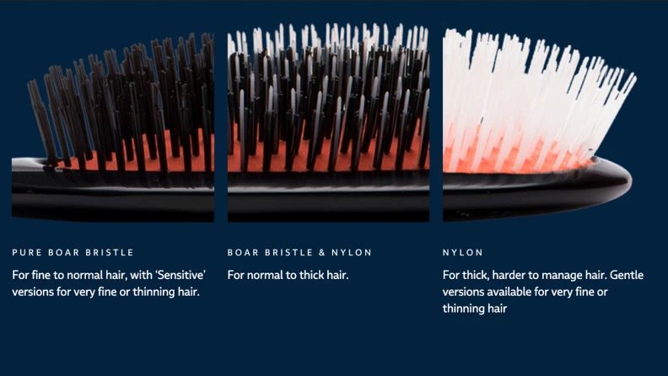

**Figure 3: “Mason Pearson brushes are available in different material types”**

(Source: Kasparian, 2020)

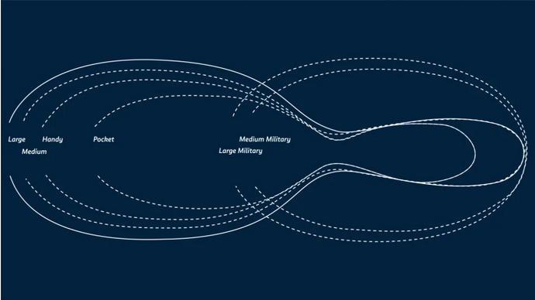

**Figure 4: “Mason Pearson brushes are sold in varying sizes for different hair lengths”**

(Source: Kasparian, 2020)

## 4.4 Intended Points of Parity and Points of Differentiation

**Intended (POP)**

The premium pricing strategy and English heritage of the brand are points of parity, as these qualities are present in rivals like Kent.

**Intended (POD)**

The mainstream product association with celebrities offers consumers the experience of using similar hair brush products as the celebrities. This creates an association of luxury and exclusivity that is an intended point of differentiation for Mason Pearson.

# 5.0 Conclusion

The report has analysed the market entry potential for Mason Pearson in the diverse markets of Qatar, Bolivia and Indonesia. The findings were determined through extensive analysis using models such as CBBE. In selecting the Qatar market, the report correctly determined the market opportunities available for Mason Pearson in Qatar. The export strategy and extent of standardisation ensured Qatari consumers would get the same brand engagement experience while maintaining ethical and inclusive behaviour that underlines a successful internationalisation outcome.

# References

Alexandra Venison (2022). *How Gen Z is Influencing the World of Beauty*. [online] Fashion Trust Arabia. Available at: https://fashiontrustarabia.com/how-gen-z-is-influencing-the-world-of-beauty/ [Accessed 3 Apr. 2023].

AsiaFundManagers.com (2023). *Indonesia consumer spending key to economic growth*. [online] AsiaFundManagers.com. Available at: https://www.asiafundmanagers.com/us/indonesia-consumer-spending-key-to-economic-growth/ [Accessed 3 Apr. 2023].

Chung, H.F.L. and Enderwick, P. (2001). An Investigation of Market Entry Strategy Selection: Exporting vs Foreign Direct Investment Modes—A Home-host Country Scenario. *Asia Pacific Journal of Management*, [online] 18(4), pp.443–460. doi:https://doi.org/10.1023/a:1012871225166.

Elgazzar, F. (2023). *Qatar inflation surges 5.93% following World Cup hosting*. [online] Arab News. Available at: https://www.arabnews.com/node/2233341/business-economy [Accessed 3 Apr. 2023].

Escentual.com (2022). *Mason Pearson Brushes | Buy Online | Authorised Hair Care Stockist*. [online] www.escentual.com. Available at: https://www.escentual.com/mason-pearson-brushes/ [Accessed 3 Apr. 2023].

Ft.com (2022). *The brush that really brushes*. [online] www.ft.com. Available at: https://www.ft.com/content/900c029c-c829-11db-b0dc-000b5df10621 [Accessed 3 Apr. 2023].

Hastings, D. (2022). *Designer Simon Skinner introduces elevated hand-moulded Afro hair combs*. [online] Beauty | LS:N Global. Available at: https://www.lsnglobal.com/beauty/article/29394/designer-simon-skinner-introduces-elevated-hand-moulded-afro-hair-combs [Accessed 3 Apr. 2023].

Hukoomi.gov.qa (2021). *Consumer Rights and Protection*. [online] https://hukoomi.gov.qa. Available at: https://hukoomi.gov.qa/en/article/consumer-rights-and-protection [Accessed 3 Apr. 2023].

Hukoomi.gov.qa (2021). *Qatar’s Tax System*. [online] https://hukoomi.gov.qa. Available at: https://hukoomi.gov.qa/en/article/qatars-tax-system [Accessed 3 Apr. 2023].

IMF (2022). *IMF Staff Completes 2022 Article IV Mission to Qatar*. [online] IMF. Available at: https://www.imf.org/en/News/Articles/2022/03/07/pr2263-imf-staff-completes-2022-article-iv-mission-to-qatar [Accessed 3 Apr. 2023].

In-cosmetics (2020). *Gen Z: What do they look for in personal care & beauty products? | Road to in-cosmetics Asia*. [online] in-cosmetics Connect. Available at: https://connect.in-cosmetics.com/regions/in-cosmetics-asia/gen-z-what-do-they-look-for-in-personal-care/ [Accessed 3 Apr. 2023].

Ings-Chambers, E. (2023). *The True Story Behind the Secretive Maker of the World’s Most Famous Hairbrush*. [online] Allure. Available at: https://www.allure.com/story/mason-pearson-hairbrush-history [Accessed 3 Apr. 2023].

Jamal, A., Davies, F., Chudry, F. and Al-Marri, M. (2006). Profiling consumers: A study of Qatari consumers’ shopping motivations. *Journal of Retailing and Consumer Services*, [online] 13(1), pp.67–80. doi:https://doi.org/10.1016/j.jretconser.2005.08.002.

Javalgi, R.G. and Russell, L.T.M. (2018). International Marketing Ethics: A Literature Review and Research Agenda. *Journal of Business Ethics*, [online] 148(4), pp.703–720. doi:https://doi.org/10.1007/s10551-015-2958-9.

Kasparian, J. (2020). *I tried the hair brush celebrities love—is it really worth $175?* [online] Reviewed. Available at: https://reviewed.usatoday.com/beauty/features/mason-pearson-hairbrush-review-is-it-worth-the-money [Accessed 3 Apr. 2023].

Kleinman, Z. (2017). CES 2017: Smart hairbrush listens for breaking hair. *BBC News*. [online] 4 Jan. Available at: https://www.bbc.com/news/technology-38503932 [Accessed 3 Apr. 2023].

Landyschemist.com (2022). *Mason Pearson | Luxury Hairbrushes and Combs | Landys Chemist*. [online] www.landyschemist.com. Available at: https://www.landyschemist.com/mason-pearson [Accessed 3 Apr. 2023].

Lim, A. (2023). *How to win over… consumers in an increasingly skin-influenced hair care market*. [online] cosmeticsdesign-asia.com. Available at: https://www.cosmeticsdesign-asia.com/Article/2023/02/22/Hair-care-analysis-APAC-trends-in-an-increasingly-skin-influenced-hair-market [Accessed 3 Apr. 2023].

Magni, M., Poh, F. and Razdan, R. (2015). *Best practices in customer and channel management Winning in Indonesia’s consumer-goods market*. [online] *Mckinsey.com*, Atlanta: Mckinsey.com, pp.1–20. Available at: https://www.mckinsey.com/~/media/McKinsey/Locations/Asia/Singapore/Our%20insights/Winning%20in%20Indonesias%20consumer%20goods%20market/Winning%20in%20Indonesias%20consumer%20goods%20market.ashx [Accessed 3 Apr. 2023].

MarketResearch.biz (2022). *Global Hair Brush Market Size, Share-Industry Analysis Report 2026*. [online] MarketResearch.biz. Available at: https://marketresearch.biz/report/hair-brush-market/ [Accessed 3 Apr. 2023].

Mason Pearson (2022). *How to Choose a Hairbrush*. [online] Mason Pearson. Available at: https://masonpearson.com/choosing-a-hairbrush/ [Accessed 3 Apr. 2023].

Mason Pearson (2023). *The History of Mason Pearson Hairbrushes*. [online] Mason Pearson. Available at: https://masonpearson.com/our-history/ [Accessed 3 Apr. 2023].

Mastercard (2022). *Mastercard Economics Institute’s Economic Outlook for 2023: Qatar minimizes spending gap between affluent, non-affluent households*. [online] newsroom.mastercard.com. Available at: https://www.mastercard.com/news/eemea/en/newsroom/press-releases/press-releases/en/2022/december/mastercard-economics-institute-s-economic-outlook-for-2023-qatar-minimizes-spending-gap-between-affluent-non-affluent-households/ [Accessed 3 Apr. 2023].

Mintel.com (2021). *Demand for inclusivity in beauty gets louder*. [online] www.mintel.com. Available at: https://www.mintel.com/press-centre/demand-for-inclusivity-in-beauty-gets-louder-25-of-gen-z-feel-left-out-of-beauty-advertisements/ [Accessed 3 Apr. 2023].

Nearsure.net (2023). *How Bolivia is Becoming a Nearshore Outsourcing Tech Hub Worth Noticing*. [online] www.nearsure.net. Available at: https://www.nearsure.com/blog/how-bolivia-is-becoming-a-nearshore-outsourcing-tech-hub-worth-noticing [Accessed 3 Apr. 2023].

Nikkei Asia (2023). *Indonesia’s inflation hits 7-month low, fell more than expected*. [online] Nikkei Asia. Available at: https://asia.nikkei.com/Economy/Inflation/Indonesia-s-inflation-hits-7-month-low-fell-more-than-expected [Accessed 3 Apr. 2023].

Privacyshield.gov (2021). *Bolivia - Import Requirements and Documentation | Privacy Shield*. [online] www.privacyshield.gov. Available at: https://www.privacyshield.gov/article?id=Bolivia-Import-Requirements-and-Documentation [Accessed 3 Apr. 2023].

Razdan, R., Das, M. and Sohoni, A. (2014). *The evolving Indonesian consumer | McKinsey*. [online] www.mckinsey.com. Available at: https://www.mckinsey.com/capabilities/growth-marketing-and-sales/our-insights/the-evolving-indonesian-consumer [Accessed 3 Apr. 2023].

Solis, B. (2022). *The Future Of Retail Is Hybrid And Unified Around End-To-End Connected Experiences*. [online] Forbes. Available at: https://www.forbes.com/sites/briansolis/2022/02/02/the-future-of-retail-is-hybrid-and-unified-around-end-to-end-connected-experiences/ [Accessed 3 Apr. 2023].

Statista (2022). *Beauty & Personal Care - Qatar | Statista Market Forecast*. [online] Statista. Available at: https://www.statista.com/outlook/cmo/beauty-personal-care/qatar [Accessed 3 Apr. 2023].

Statista (2022). *Bolivia - inflation rate 2027*. [online] Statista. Available at: https://www.statista.com/statistics/440133/inflation-rate-in-bolivia/ [Accessed 3 Apr. 2023].

Statista (2022). *Topic: Employment in Indonesia*. [online] Statista. Available at: https://www.statista.com/topics/9975/employment-in-indonesia/#topicOverview [Accessed 3 Apr. 2023].

Stewart, K. (2021). *This Cult-Favorite Hairbrush Has Been Around For Over 130 Years*. [online] The Zoe Report. Available at: https://www.thezoereport.com/beauty/mason-pearson-hair-brush#:~:text=The%20Mason%20Pearson%20Popular%20Hairbrush [Accessed 3 Apr. 2023].

Sudirman, J. (2022). *Pocket Tax Book Indonesian 2022 Tax Services*. [online] *https://www.pwc.com*, London, England: Pwc.com, pp.1–114. Available at: https://www.pwc.com/id/en/pocket-tax-book/english/pocket-tax-book-2022.pdf [Accessed 3 Apr. 2023].

Taxsummaries.pwc.com (2021). *Bolivia - Corporate - Taxes on corporate income*. [online] taxsummaries.pwc.com. Available at: https://taxsummaries.pwc.com/bolivia/corporate/taxes-on-corporate-income [Accessed 3 Apr. 2023].

The Peninsula Newspaper (2022). *Qatar’s e-commerce sector on growth path*. [online] thepeninsulaqatar.com. Available at: https://thepeninsulaqatar.com/article/10/12/2022/qatars-e-commerce-sector-on-growth-path [Accessed 3 Apr. 2023].

Trade.gov (2022). *Indonesia - Prohibited and Restricted Imports*. [online] www.trade.gov. Available at: https://www.trade.gov/country-commercial-guides/indonesia-prohibited-and-restricted-imports [Accessed 3 Apr. 2023].

Trade.gov (2023). *Qatar - Import Requirements and Documentation*. [online] www.trade.gov. Available at: https://www.trade.gov/country-commercial-guides/qatar-import-requirements-and-documentation [Accessed 3 Apr. 2023].

Volza.com (2023). *Hair brush Suppliers in Indonesia - 21 active & genuine Hair brush manufacturers & exporters directory*. [online] Volza.com. Available at: https://www.volza.com/p/hair-brush/manufacturers/manufacturers-in-indonesia/ [Accessed 3 Apr. 2023].

Weldon, S. (2022). *Celebrities have used the $275 Mason Pearson brush to get shiny hair for over 130 years — and it’s finally on sale for half the price*. [online] Yahoo Life. Available at: https://www.yahoo.com/lifestyle/celebrities-used-275-mason-pearson-172704845.html [Accessed 3 Apr. 2023].

Yu Lim, G. (2019). *Indonesia halal rules: Cosmetics have until 2026 to comply with new law*. [online] cosmeticsdesign-asia.com. Available at: https://www.cosmeticsdesign-asia.com/Article/2019/11/26/Indonesia-halal-rules-Cosmetics-have-until-2026-to-comply-with-new-law [Accessed 3 Apr. 2023].