# 

# 

# 

# 

# 

**DATA-DRIVEN DECISION-MAKING FOR BUSINESS**

**Table of Contents**

Task 1. Introduction and planning 2

Introduction 2

Project Plan 2

Changes in sales performance post-marketing campaign 2

KPIs of BIJ 3

Task 2. Issues related to quality and remedial approaches of data 3

Generic issues in data and its identification 3

Identification of the data problems 4

Task 3. Analysing of data 4

Task 4. Data charting and commentary 5

Task 5. Conclusions and recommendations 9

Conclusion 9

Recommendations 10

Reference list 11

Appendices : 13

# Task 1. Introduction and planning

## Introduction

The use of tools such as digital data, data of the market and other prospects to derive the current or future demand of the existing market is known as data-driven decision-making. According to Sarker (2022), data-driven decisions are generally more specific in nature producing suitable scope for installing an efficient future. It shows exactly what the market wants so that the business can make changes to evolve the appropriate decisions. Businesses that are more focused on data-driven decisions intend to make huge profits and growth. As the project further progresses key performance indicators are discussed of BIJ (Bangles international jewellery). The marketing campaign that was carried out in May 2020 in the UK is researched for the betterment of the analytics improvement of the KPIs.

## Project Plan

Correct planning and right execution are important for all businesses. As mentioned by Breidbach and Maglio, (2020), every business planning requires a few factors but data-driven decisions can be more effective for the business than others. The analysis of the data that is given in the project is derived and put into consideration for making this research project. The entire research is centred around 2018, 2019 & 2020. In order to enhancement the sales performance of BIJ a marketing campaign was performed in the UK in May 2020 and is analysed with research. Businesses backed with proper research plans get more chances of getting successful. Additionally, KPI's scope of improvement is part of the plan to help the research and development.

## Changes in sales performance post-marketing campaign

Marketing campaigns are a way of promoting a company’s product or service to gain more amount of sales via different platforms like social media, tv, radio, newspaper ads and etc. In the words of Katsikeas *et al*. (2022), a marketing campaign is a way of connecting or relating with the need of customers so that they can solve their problems by using the company’s product or services. Marketing campaigns help brands or businesses to make themselves known in the market to get recognition. UK-based companies require top marketing campaigns for their customers to gain a certain level of sales that is targeted after the campaign. As quoted by Zhang *et al*. (2020), the direct connection between customer satisfaction and sales or growth of the company helps the market to be competitive. Every business needs to create its KPIs so that it can sustain efficient productivity in the competitive market.

## KPIs of BIJ

Key performance indicators help companies to evaluate the performance in the business to gain more success. In order to achieve the goals set by the management of the company, key performance indicators are essential for the company. In reference to the words of Calvetti, (2019), the KPIs are directly related to the performance of the company as it measures and evaluate the main factors. Hence, KPI indicates the progress of the company. BIJ is available in the markets of Japan, USA and UK selling different types of products. The company majorly sells bracelets in Japan and necklaces in USA. While UK market gives them more sales of hair bands. BIJ can focus on recent trending fashion trends to make their performance better in all of the markets. This can take forward the sales of the company in future.

# Task 2. Issues related to quality and remedial approaches of data

## Generic issues in data and its identification

BIJ is operating its business in Japan, the USA and the UK and wishes to scale its business. Recently it is having problems with managing the data. Problems regarding data management can lead to difficulties for the company. As opined by Janssen *et al*. (2020), data management issues arise due to not having good quality data, data storage complexity in multiple locations and other data security issues. Quality of data is essential for a business to run, and should therefore be segregated from large volumes of unreasonable information available in the market. This could eventually influence better decision-making for an organisation. As mentioned by Suleiman, (2022), multiple storages of data can lead to miscommunication. In order to function smoothly the company needs to have common ground for storage. Sometimes data gets lost and companies suffer big losses for this mistake.

Identification of the issue helps in the reduction of the problems in data management. A company should solve various generic problems in order to function properly. As suggested by Holzinger *et al*. (2019), measurement of the quality of the data should be included in the process to get high efficiency. Checking whether the data is up to date, incorrect or with not enough data can improve the data quality. There is a scope for improving data storage by cutting down unnecessary storage. As opinionated by Kuz'mina *et al.* (2020), management should employ people with specialised skills to settle the issues of generic data problems. Companies can get more efficient with their research and analytics with more responsible employees.

## Identification of the data problems

BIJ faces data management problems showing the different types of display of data that are not up to the mark causing inefficiency. According to the given data by WFTT, they are providing services to BIJ, which has shown the sales performance of the company. BIJ struggling with data management cannot be efficiently managed due to a huge load of data to be evaluated. Data can be said as a valuable asset to the company and it should be protected. Lack of data is one of the generic problems that should be taken into account. The assignment of data analysts to be more productive could solve this problem. The transparency of data is required to be able to reduce the multiple storage problem also. The complex structure of the organisation can reflect in the sales part. In reference to the words of Shamim *et al*. (2019), efficient use of data management could result in the growth of the company. It will face fewer issues in the future controlling the data. Not having enough data is another generic data problem that companies face. Clarity and transparency in the data lead to efficient decision-making. Businesses tend to have a more clear view when their business decisions are data-driven. In order to achieve the targets the business should invest more in its data management department. The company's issues are reflected in the brand which affects the reputation of the brand. Data problems for different companies are crucial causing significant delay in decision making. There is a major lag in decision making causing delayed operation within organisations. It is a very challenging aspect for organisations to constitute an effective piece of productivity. Thus, enabling an efficient basis of decision making requires to adhere with data collected from clients about their tastes and preferences. Negligible data is filtered to outline an efficient basis of decision for that company. There is a greater scope of business development with such data based decision making system. Appropriating such an informative process for decision making could help to eradicate erroneous outcomes.

# Task 3. Analysing of data

***Table 1: Data and trends in volume and value of sales***

In regard of analysing figures of sales volume and sales value, it could be ascertained that sales volume is reducing. BIJ has experienced a drastic fall in sales of rings in the October. It could be witnessed that this company has not initiated any sales of accessories in Japan during 2019. On the contrary, BIJ has experienced a significant escalation in sales of accessories starting from 6th month. However, this company has witnessed a decrease in its sales of hair bands during October of 2020 in Japan. Similarly, BIJ has witnessed a slight reduction in the sale of necklaces during the year of 2020. This company has also witnessed a sharp fall in sales during the 4th month of 2020. As a result, the sales of jewellery have reached a negligible level. On the contrary, BIJ has witnessed a significant rise in sale of accessories during 1st, 6th, 9th and 12th month of the year 2020. This company might witness double digit growth in volume of sales with enhancement in sales value. **(Refer to appendices 1)**

***Table 2: Categorical performance benchmark comparison***

It could be observed from the table that BIJ is experiencing double digit growth in terms of volume growth during 6th, 7th and 12th month of the year 2018. This company has witnessed a significant enhancement in the 2nd month as compared to 1st month while having same sale volumes. On the contrary, BIJ has witnessed a rise in sales of necklaces during the 6th month of 2018. Similarly, this company is experiencing a rise in sales volume of bracelets in the year 2019 as compared to value of sales. This company has also experienced reduction in sales during 3rd as well as 9th month. Bracelet international jewellery has witnessed a significant rise in sale of hair bands during 6th month of the year 2019 as compared to 5th and 9th month. **(Refer to appendices 2)**

***Table 3: Benchmark comparisons (volume and value of sales)***

In table 3 it could be ascertained the benchmark comparisons of value and volume of sales in Japan, UK and USA. The benchmark comparison displays the sale of bracelets have significantly raised in the 5th, 6th and 7th month. On the contrary, this company has experienced zero sales in hair bands in the UK during 11th and 12th months. BIJ has witnessed a reduction in the sales of necklaces in the 10th month in the USA. However, this company has experienced zero sales in necklaces in the USA in December. The UK market has witnessed a slight reduction in sale figures during December month for the sale of rings. BIJ has witnessed a significant decrease in sales of accessories in November in the USA. It could be witnessed that this company observed a significant decrease in 1st month in all countries. On the contrary, BIJ has witnessed a rise in sales during the September in the market of Japan. **(Refer to appendices 3)**

# Task 4. Data charting and commentary

Data charting may be termed as a process of representation of figures with the help of charts and diagrams. A data analyst may require comparing different charts to compare data sets. According to the viewpoint of Jo *et al*. (2020), data and charting processes are important in to attain a detailed overview on performances of various organisation and person. Some data charting processes like bar graphs, line charts and column charts are used by data analysts to analyse proposed data points.

***Chart 1: Comparison of trends in sales value across markets***

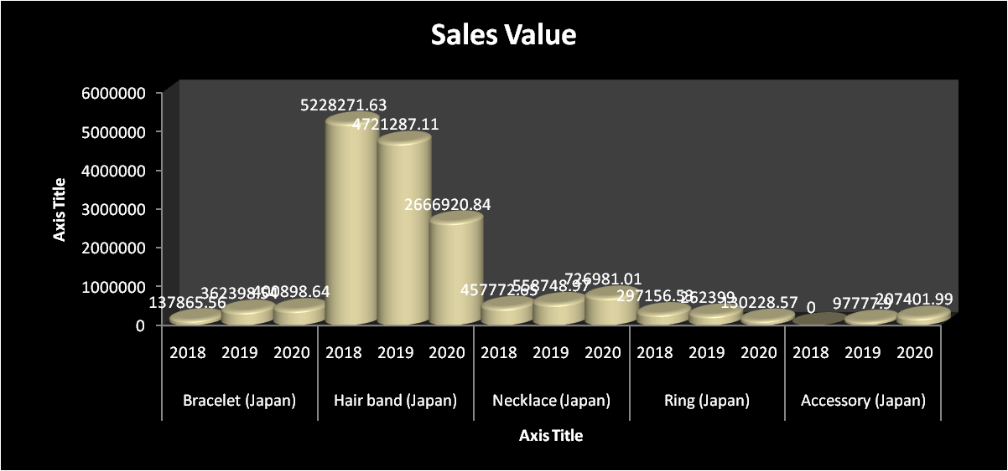

**Figure 1: Sales volumes across the different market**

(Source: Created by author)

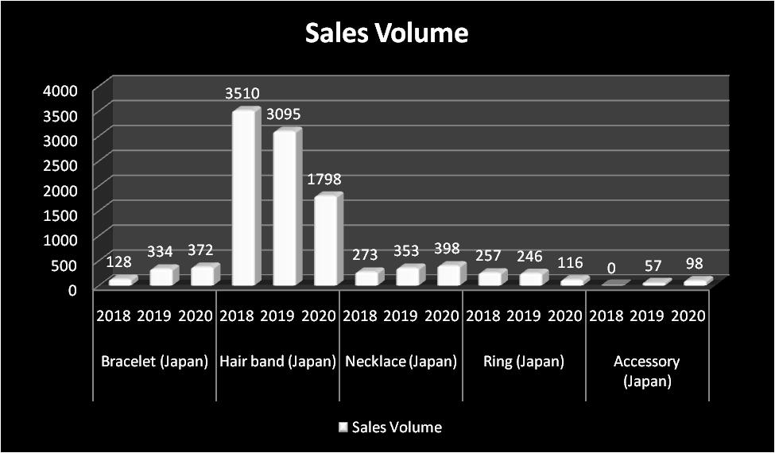

**Figure 2: Sales value of various products**

(Source: Created by author)

It could be easily ascertained from the charts that market in Japan have witnessed a significant rise in selling of hair bands from the year 2018 to 2020. Similarly, BIJ has witnessed a sharp enhancement in the sales of necklaces in the Japan market. On the contrary, this company has witnessed a significant decrease in volume of hair bands during the year 2019. However, both sales volume and sales value of items are almost the same in the Japan market in terms of rate. This company has witnessed a significant decrease in sales of hair bands in 2018 as compared to its value in the Japan market.

***Chart 2: Comparison of categorical performance between markets***

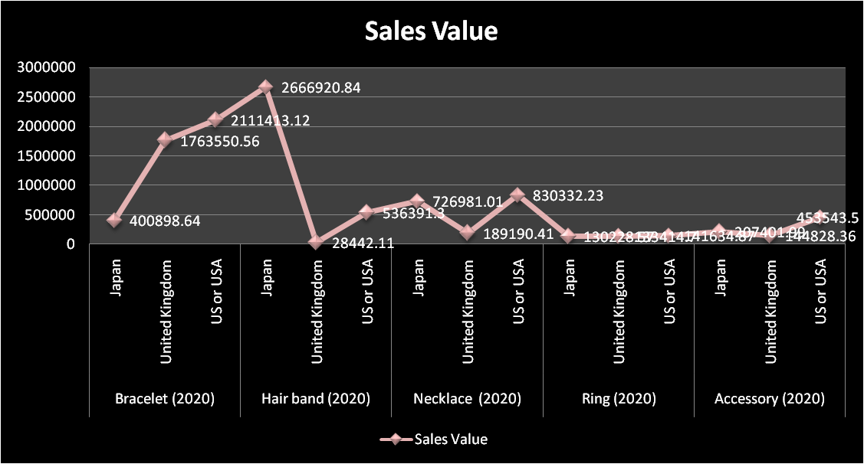

**Figure 3: Sales volume of the markets**

(Source: Created by author)

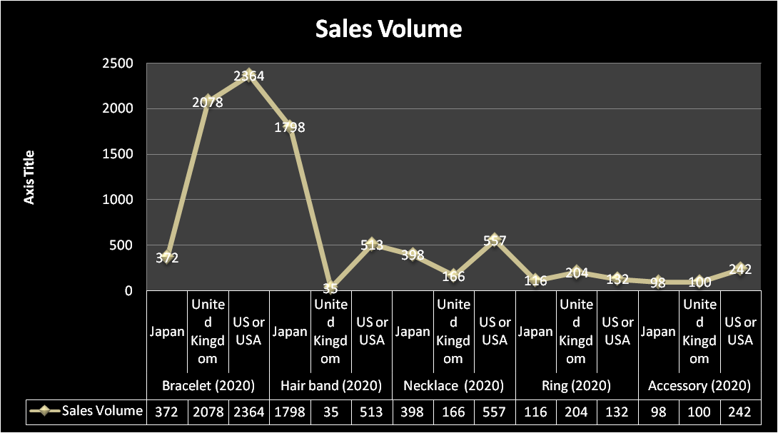

**Figure 4: Sales value within the various markets**

(Source: Created by author)

BIJ has witnessed a low growth rate in sales value in. However, in the case of accessories sales value has more growth rate than sales volume. This company has witnessed enhancement in volume as compared to value in the UK market in case of selling necklaces.

***Chart 3: Effect of marketing campaign in UK market***

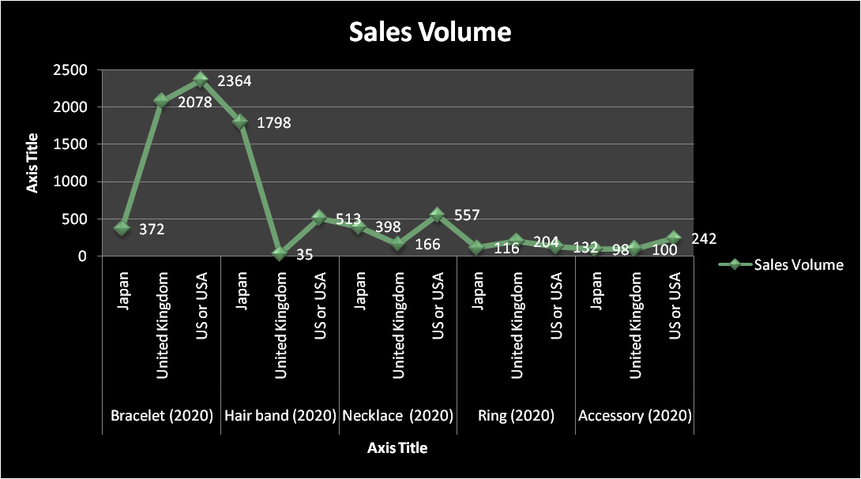

**Figure 5: Success rates in market campaigns**

(Source: Created by author)

It can be observed from the above chart that BIJ has witnessed a significant enhancement in case of bracelet sales. The USA market has witnessed more sales of bracelets as compared to the UK and Japan.. While sale of hair bands in USA market has witnessed more sales. Equal revenue are also witnessed in the Japan market. The USA has witnessed a growth in sales of accessories during 2020.

# Task 5. Conclusions and recommendations

## Conclusion

BIJ is a brand that sells hair bands, necklaces, bracelets, rings and accessories operating in 3 countries Japan, USA and UK. In the project, it is been discussed the success of the marketing campaign that was conducted in UK in May 2020. The introduction describes the data-driven decision-making importance in the business. Later it is discussed the project planning. The project is dependent on the reports of 2018, 2019 & 2020. Businesses being data-driven generally cannot face issues related to decision-making. As BIJ is facing issues regarding data management it has consulted WFTT for the services. Discussion about the key performance indicators has also been done as it evaluates the performance. Elaborated on the concept and importance of the key performance indicators on how it is useful to the company. The effectiveness of the marketing campaign is also taken into consideration in the growth of the business. Generic issues that caused problems for the brand were mentioned in the project. Issues like quality data and multiple storages of data lead to inefficiency of the business. In order to grow efficiency identification of the problems is the primary way to resolve them. Data is a valuable resource and this is why it should be taken seriously. Topics related to data management are described. Data management issues identification with the resolving suggestions are given to be more efficient. The efficient working ability of the employees to work hard and to the point will take the business a long way. Transparency of the data will help the management to be more productive.

## Recommendations

* BIJ can follow emerging trends to acquire customers more effectively.
* As suggested by Alzoubi *et al*. (2022), the brand should introduce more products to its collection to have most of the market essentials in its range of products.
* In order to know more about the customers the brand should run more marketing campaigns so that the potential customers could see the products.
* Transparency of the data should be more important to the management in order to keep the organisation away from future problems.
* Delegation of work in the organisation can be productive.
* As mentioned by Saiz-Rubio and Rovira-Más, (2020), in order to make decisions depending on data the brand should focus on improving data management.
* The brand should focus on customer satisfaction which can give them impressive sales performance time and again.
* Customer data needs to be used effectively for future marketing campaigns on how and what advertisements should be shown to them on internet using social media.

# Reference list

Alzoubi, H., Alshurideh, M., Kurdi, B., Akour, I. and Aziz, R., (2022). Does BLE technology contribute towards improving marketing strategies, customers’ satisfaction and loyalty? The role of open innovation. *International Journal of Data and Network Science, 6*(2), pp.449-460.

Breidbach, C.F. and Maglio, P., (2020). Accountable algorithms? The ethical implications of data-driven business models. *Journal of Service Management, 31*(2), pp.163-185.

Calvetti, D., Gonçalves, M.C., Magalhães, P.N.M. and de Sousa, H.J.C., (2019). Sensing technologies embedding construction workers outcomes/key performance indicators. *Proceedings of the 36th CIB W, 78*, p.2019.

Holzinger, A., Langs, G., Denk, H., Zatloukal, K. and Müller, H., (2019). Causability and explainability of artificial intelligence in medicine. *Wiley Interdisciplinary Reviews: Data Mining and Knowledge Discovery, 9*(4), p.e1312.

Janssen, M., Brous, P., Estevez, E., Barbosa, L.S. and Janowski, T., (2020). Data governance: Organizing data for trustworthy Artificial Intelligence. *Government Information Quarterly, 37*(3), p.101493.

Jo, E.S. and Gebru, T., (2020), January. Lessons from archives: Strategies for collecting sociocultural data in machine learning. In *Proceedings of the 2020 conference on fairness, accountability, and transparency* (pp. 306-316).

Katsikeas, C., Leonidou, L. and Zeriti, A., (2020). Revisiting international marketing strategy in a digital era: Opportunities, challenges, and research directions. *International Marketing Review, 37*(3), pp.405-424.

Kuz'mina, E.V., P'yankova, N.G., Tret'yakova, N.Y.V. and Botsoeva, A.V., (2020). Using Data Analysis Methodology to Foster Professional Competencies in Business Informaticians. *European Journal of Contemporary Education, 9*(1), pp.54-66.

Saiz-Rubio, V. and Rovira-Más, F., (2020). From smart farming towards agriculture 5.0: A review on crop data management. *Agronomy, 10*(2), p.207.

Sarker, I.H., (2022). Smart City Data Science: Towards data-driven smart cities with open research issues. *Internet of Things, 19*, p.100528.

Shamim, S., Zeng, J., Shariq, S.M. and Khan, Z., (2019). Role of big data management in enhancing big data decision-making capability and quality among Chinese firms: A dynamic capabilities view. *Information & Management, 56*(6), p.103135.

Suleiman, A., (2022). Causes and effects of poor communication in the construction industry in the MENA region. *Journal of Civil Engineering and Management, 28*(5), pp.365-376.

Zhang, Q., Cao, M., Zhang, F., Liu, J. and Li, X., (2020). Effects of corporate social responsibility on customer satisfaction and organizational attractiveness: A signaling perspective. *Business ethics: A European review, 29*(1), pp.20-34.

# Appendices :

Appendices 1: Data and trends within sales volume and value

| **Sales and data trends for Japan during 2018** | | |
| --- | --- | --- |
| **Month** | **Sales Volume** | **Sales Value** |
| **Product: Bracelet** | | |
| 1 | 10 | £ 10,280.47 |
| 2 | 12 | £ 12,725.16 |
| 3 | 10 | £ 10,089.68 |
| 4 | 4 | £ 4,519.22 |
| 5 | 9 | £ 11,368.17 |
| 6 | 13 | £ 15,763.67 |
| 7 | 15 | £ 16,635.55 |
| 8 | 6 | £ 5,712.00 |
| 9 | 8 | £ 10,182.08 |
| 10 | 9 | £ 7,964.27 |
| 11 | 9 | £ 9,401.18 |
| 12 | 23 | £ 23,224.11 |
| Product: Hair band | | |
| 1 | 322 | £ 492,215.54 |
| 2 | 348 | £ 513,050.39 |
| 3 | 346 | £ 515,272.89 |
| 4 | 284 | £ 423,523.10 |
| 5 | 230 | £ 365,408.96 |
| 6 | 324 | £ 502,215.14 |
| 7 | 199 | £ 297,981.43 |
| 8 | 215 | £ 313,480.01 |
| 9 | 462 | £ 663,920.04 |
| 10 | 221 | £ 318,727.77 |
| 11 | 202 | £ 291,227.02 |
| 12 | 357 | £ 531,249.34 |
| Product: Necklace | | |
| 1 | 23 | £ 36,795.41 |
| 2 | 25 | £ 43,392.14 |
| 3 | 17 | £ 29,472.50 |
| 4 | 7 | £ 12,601.21 |
| 5 | 22 | £ 39,672.45 |
| 6 | 45 | £ 76,845.31 |
| 7 | 24 | £ 41,029.96 |
| 8 | 20 | £ 38,147.31 |
| 9 | 31 | £ 52,502.59 |
| 10 | 22 | £ 33,534.09 |
| 11 | 19 | £ 26,442.11 |
| 12 | 18 | £ 27,337.57 |
| Product: Ring | | |
| 1 | 19 | £ 21,850.04 |
| 2 | 25 | £ 28,034.75 |
| 3 | 31 | £ 33,793.19 |
| 4 | 18 | £ 19,256.48 |
| 5 | 26 | £ 30,546.18 |
| 6 | 32 | £ 37,469.22 |
| 7 | 14 | £ 16,181.86 |
| 8 | 20 | £ 26,595.92 |
| 9 | 18 | £ 22,024.56 |
| 10 | 2 | £ 2,038.28 |
| 11 | 17 | £ 19,909.29 |
| 12 | 35 | £ 39,456.76 |
| Product: Accessory | | |
| 1 | 0 | £ - |

| **Sales and data trends for Japan during 2019** | | |
| --- | --- | --- |
| **Month** | **Sales Volume** | **Sales Value** |
| **Product: Bracelet** | | |
| 1 | 13 | £ 12,683.20 |
| 2 | 20 | £ 20,232.47 |
| 3 | 36 | £ 36,126.25 |
| 4 | 25 | £ 23,827.37 |
| 5 | 32 | £ 32,874.84 |
| 6 | 42 | £ 52,012.39 |
| 7 | 31 | £ 40,744.00 |
| 8 | 34 | £ 41,061.58 |
| 9 | 33 | £ 33,443.83 |
| 10 | 16 | £ 16,034.52 |
| 11 | 27 | £ 26,764.80 |
| 12 | 25 | £ 26,593.29 |
| **Product: Hair band** | | |
| 1 | 212 | £ 324,076.72 |
| 2 | 221 | £ 328,945.28 |
| 3 | 246 | £ 355,883.25 |
| 4 | 195 | £ 289,676.21 |
| 5 | 175 | £ 285,401.86 |
| 6 | 610 | £ 1,011,205.06 |
| 7 | 262 | £ 404,474.72 |
| 8 | 226 | £ 332,495.85 |
| 9 | 396 | £ 569,779.70 |
| 10 | 177 | £ 246,546.01 |
| 11 | 138 | £ 205,647.86 |
| 12 | 237 | £ 367,154.59 |
| **Product: Necklace** | | |
| 1 | 14 | £ 20,313.88 |
| 2 | 29 | £ 44,172.78 |
| 3 | 39 | £ 61,278.35 |
| 4 | 22 | £ 35,452.94 |
| 5 | 20 | £ 33,427.91 |
| 6 | 39 | £ 58,989.22 |
| 7 | 28 | £ 40,800.90 |
| 8 | 22 | £ 30,904.22 |
| 9 | 27 | £ 36,080.84 |
| 10 | 23 | £ 33,441.42 |
| 11 | 46 | £ 79,273.21 |
| 12 | 44 | £ 84,613.30 |
| **Product: Ring** | | |
| 1 | 28 | £ 29,128.32 |
| 2 | 14 | £ 14,634.34 |
| 3 | 20 | £ 21,571.93 |
| 4 | 10 | £ 11,206.37 |
| 5 | 17 | £ 22,870.04 |
| 6 | 12 | £ 15,631.48 |
| 7 | 24 | £ 29,053.14 |
| 8 | 27 | £ 28,572.01 |
| 9 | 49 | £ 47,400.17 |
| 10 | 15 | £ 13,603.66 |
| 11 | 12 | £ 10,993.32 |
| 12 | 18 | £ 17,734.22 |
| **Product: Accessory** | | |
| 6 | 2 | £ 3,683.88 |
| 7 | 13 | £ 28,479.45 |
| 8 | 9 | £ 13,147.59 |
| 9 | 23 | £ 33,311.02 |
| 10 | 2 | £ 5,744.94 |
| 11 | 3 | £ 4,207.80 |
| 12 | 5 | £ 9,203.22 |

| **Sales and data trends for Japan during 2020** | | |
| --- | --- | --- |
| **Month** | **Sales Volume** | **Sales Value** |
| **Product: Bracelet** | | |
| 1 | 21 | £ 22,205.72 |
| 2 | 25 | £ 31,275.60 |
| 3 | 18 | £ 22,386.66 |
| 4 | 21 | £ 22,056.18 |
| 5 | 45 | £ 48,105.80 |
| 6 | 63 | £ 63,807.54 |
| 7 | 37 | £ 39,614.95 |
| 8 | 31 | £ 32,567.68 |
| 9 | 61 | £ 63,408.15 |
| 10 | 15 | £ 15,452.79 |
| 11 | 19 | £ 18,710.04 |
| 12 | 16 | £ 21,307.53 |
| **Product: Hair band** | | |
| 1 | 178 | £ 272,781.13 |
| 2 | 182 | £ 288,085.47 |
| 3 | 173 | £ 270,693.63 |
| 4 | 152 | £ 229,389.01 |
| 5 | 129 | £ 205,105.00 |
| 6 | 227 | £ 351,005.38 |
| 7 | 101 | £ 150,138.13 |
| 8 | 103 | £ 147,647.34 |
| 9 | 159 | £ 229,632.20 |
| 10 | 92 | £ 121,117.16 |
| 11 | 126 | £ 165,938.05 |
| 12 | 176 | £ 235,388.34 |
| **Product: Necklace** | | |
| 1 | 28 | £ 52,657.18 |
| 2 | 43 | £ 83,387.17 |
| 3 | 46 | £ 87,938.13 |
| 4 | 27 | £ 52,708.24 |
| 5 | 45 | £ 81,597.90 |
| 6 | 69 | £ 121,799.76 |
| 7 | 38 | £ 64,950.64 |
| 8 | 40 | £ 73,558.44 |
| 9 | 29 | £ 51,403.85 |
| 10 | 4 | £ 6,543.34 |
| 11 | 13 | £ 22,741.29 |
| 12 | 16 | £ 27,695.07 |
| **Product: Ring** | | |
| 1 | 5 | £ 5,148.29 |
| 2 | 12 | £ 11,764.69 |
| 3 | 8 | £ 7,852.89 |
| 4 | 1 | £ 884.71 |
| 5 | 6 | £ 9,704.96 |
| 6 | 7 | £ 9,758.18 |
| 7 | 5 | £ 7,019.34 |
| 8 | 11 | £ 12,087.32 |
| 9 | 28 | £ 29,976.81 |
| 10 | 12 | £ 13,227.88 |
| 11 | 9 | £ 9,150.57 |
| 12 | 12 | £ 13,652.93 |
| **Product: Accessory** | | |
| 1 | 1 | £ 1,490.51 |
| 2 | 1 | £ 2,665.25 |
| 3 | 6 | £ 14,466.71 |
| 4 | 9 | £ 21,448.35 |
| 5 | 9 | £ 20,816.52 |
| 6 | 14 | £ 29,299.12 |
| 7 | 5 | £ 10,567.24 |
| 8 | 5 | £ 9,982.45 |
| 9 | 22 | £ 43,837.80 |
| 10 | 8 | £ 16,070.01 |
| 11 | 7 | £ 13,845.56 |
| 12 | 11 | £ 22,912.47 |

Appendices 2: Benchmark comparisons (category performance)

| **Benchmark for categorical performance for Japan during 2018** | | | | |
| --- | --- | --- | --- | --- |
| **Month** | **Sales Volume** | **Sales Value** | **% Volume** | **% Value** |
| **Product: Bracelet** | | |
| 1 | 10 | £ 10,280.47 |  | 8% | 7% |
| 2 | 12 | £ 12,725.16 | 9% | 9% |
| 3 | 10 | £ 10,089.68 | 8% | 7% |
| 4 | 4 | £ 4,519.22 | 3% | 3% |
| 5 | 9 | £ 11,368.17 | 7% | 8% |
| 6 | 13 | £ 15,763.67 | 10% | 11% |
| 7 | 15 | £ 16,635.55 | 12% | 12% |
| 8 | 6 | £ 5,712.00 | 5% | 4% |
| 9 | 8 | £ 10,182.08 | 6% | 7% |
| 10 | 9 | £ 7,964.27 | 7% | 6% |
| 11 | 9 | £ 9,401.18 | 7% | 7% |
| 12 | 23 | £ 23,224.11 | 18% | 17% |
|  | **128** | **137,866** |  |  |
| **Product: Hair band** | | |  |  |
| 1 | 322 | £ 492,215.54 | 9% | 9% |
| 2 | 348 | £ 513,050.39 | 10% | 10% |
| 3 | 346 | £ 515,272.89 | 10% | 10% |
| 4 | 284 | £ 423,523.10 | 8% | 8% |
| 5 | 230 | £ 365,408.96 | 7% | 7% |
| 6 | 324 | £ 502,215.14 | 9% | 10% |
| 7 | 199 | £ 297,981.43 | 6% | 6% |
| 8 | 215 | £ 313,480.01 | 6% | 6% |
| 9 | 462 | £ 663,920.04 | 13% | 13% |
| 10 | 221 | £ 318,727.77 | 6% | 6% |
| 11 | 202 | £ 291,227.02 | 6% | 6% |
| 12 | 357 | £ 531,249.34 | 10% | 10% |
|  | **3,510** | **5,228,272** |  |  |
| **Product: Necklace** | | |  |  |
| 1 | 23 | £ 36,795.41 | 8% | 8% |
| 2 | 25 | £ 43,392.14 | 9% | 9% |
| 3 | 17 | £ 29,472.50 | 6% | 6% |
| 4 | 7 | £ 12,601.21 | 3% | 3% |
| 5 | 22 | £ 39,672.45 | 8% | 9% |
| 6 | 45 | £ 76,845.31 | 16% | 17% |
| 7 | 24 | £ 41,029.96 | 9% | 9% |
| 8 | 20 | £ 38,147.31 | 7% | 8% |
| 9 | 31 | £ 52,502.59 | 11% | 11% |
| 10 | 22 | £ 33,534.09 | 8% | 7% |
| 11 | 19 | £ 26,442.11 | 7% | 6% |
| 12 | 18 | £ 27,337.57 | 7% | 6% |
|  | **273** | **457,773** |  |  |
| **Product: Ring** | | |  |  |
| 1 | 19 | £ 21,850.04 | 7% | 7% |
| 2 | 25 | £ 28,034.75 | 10% | 9% |
| 3 | 31 | £ 33,793.19 | 12% | 11% |
| 4 | 18 | £ 19,256.48 | 7% | 6% |
| 5 | 26 | £ 30,546.18 | 10% | 10% |
| 6 | 32 | £ 37,469.22 | 12% | 13% |
| 7 | 14 | £ 16,181.86 | 5% | 5% |
| 8 | 20 | £ 26,595.92 | 8% | 9% |
| 9 | 18 | £ 22,024.56 | 7% | 7% |
| 10 | 2 | £ 2,038.28 | 1% | 1% |
| 11 | 17 | £ 19,909.29 | 7% | 7% |
| 12 | 35 | £ 39,456.76 | 14% | 13% |
|  | **257** | **297,157** |  |  |
| **Product: Accessory** | | |  |  |
| 1 | 0 | £ - | 0% | 0% |

| **Benchmark for categorical performance for Japan during 2019** | | | | |
| --- | --- | --- | --- | --- |
| **Month** | **Sales Volume** | **Sales Value** | **% Volume** | **% Value** |
| **Product: Bracelet** | | |
| 1 | 13 | £ 12,683.20 |  | 4% | 3% |
| 2 | 20 | £ 20,232.47 | 6% | 6% |
| 3 | 36 | £ 36,126.25 | 11% | 10% |
| 4 | 25 | £ 23,827.37 | 7% | 7% |
| 5 | 32 | £ 32,874.84 | 10% | 9% |
| 6 | 42 | £ 52,012.39 | 13% | 14% |
| 7 | 31 | £ 40,744.00 | 9% | 11% |
| 8 | 34 | £ 41,061.58 | 10% | 11% |
| 9 | 33 | £ 33,443.83 | 10% | 9% |
| 10 | 16 | £ 16,034.52 | 5% | 4% |
| 11 | 27 | £ 26,764.80 | 8% | 7% |
| 12 | 25 | £ 26,593.29 | 7% | 7% |
|  | **334** | **362,399** |  |  |
| **Product: Hair band** | | |  |  |
| 1 | 212 | £ 324,076.72 | 7% | 7% |
| 2 | 221 | £ 328,945.28 | 7% | 7% |
| 3 | 246 | £ 355,883.25 | 8% | 8% |
| 4 | 195 | £ 289,676.21 | 6% | 6% |
| 5 | 175 | £ 285,401.86 | 6% | 6% |
| 6 | 610 | £ 1,011,205.06 | 20% | 21% |
| 7 | 262 | £ 404,474.72 | 8% | 9% |
| 8 | 226 | £ 332,495.85 | 7% | 7% |
| 9 | 396 | £ 569,779.70 | 13% | 12% |
| 10 | 177 | £ 246,546.01 | 6% | 5% |
| 11 | 138 | £ 205,647.86 | 4% | 4% |
| 12 | 237 | £ 367,154.59 | 8% | 8% |
|  | **3,095** | **4,721,287** |  |  |
| **Product: Necklace** | | |  |  |
| 1 | 14 | £ 20,313.88 | 4% | 4% |
| 2 | 29 | £ 44,172.78 | 8% | 8% |
| 3 | 39 | £ 61,278.35 | 11% | 11% |
| 4 | 22 | £ 35,452.94 | 6% | 6% |
| 5 | 20 | £ 33,427.91 | 6% | 6% |
| 6 | 39 | £ 58,989.22 | 11% | 11% |
| 7 | 28 | £ 40,800.90 | 8% | 7% |
| 8 | 22 | £ 30,904.22 | 6% | 6% |
| 9 | 27 | £ 36,080.84 | 8% | 6% |
| 10 | 23 | £ 33,441.42 | 7% | 6% |
| 11 | 46 | £ 79,273.21 | 13% | 14% |
| 12 | 44 | £ 84,613.30 | 12% | 15% |
|  | **353** | **558,749** |  |  |
| **Product: Ring** | | |  |  |
| 1 | 28 | £ 29,128.32 | 11% | 11% |
| 2 | 14 | £ 14,634.34 | 6% | 6% |
| 3 | 20 | £ 21,571.93 | 8% | 8% |
| 4 | 10 | £ 11,206.37 | 4% | 4% |
| 5 | 17 | £ 22,870.04 | 7% | 9% |
| 6 | 12 | £ 15,631.48 | 5% | 6% |
| 7 | 24 | £ 29,053.14 | 10% | 11% |
| 8 | 27 | £ 28,572.01 | 11% | 11% |
| 9 | 49 | £ 47,400.17 | 20% | 18% |
| 10 | 15 | £ 13,603.66 | 6% | 5% |
| 11 | 12 | £ 10,993.32 | 5% | 4% |
| 12 | 18 | £ 17,734.22 | 7% | 7% |
|  | **246** | **262,399** |  |  |
| **Product: Accessory** | | |  |  |
| 6 | 2 | £ 3,683.88 | 4% | 4% |
| 7 | 13 | £ 28,479.45 | 23% | 29% |
| 8 | 9 | £ 13,147.59 | 16% | 13% |
| 9 | 23 | £ 33,311.02 | 40% | 34% |
| 10 | 2 | £ 5,744.94 | 4% | 6% |
| 11 | 3 | £ 4,207.80 | 5% | 4% |
| 12 | 5 | £ 9,203.22 | 9% | 9% |
|  | **57** | **97,778** |  |  |

| **Benchmark for categorical performance for Japan during 2020** | | | | |
| --- | --- | --- | --- | --- |
| **Month** | **Sales Volume** | **Sales Value** | **% Volume** | **% Value** |
| **Product: Bracelet** | | |
| 1 | 21 | £ 22,205.72 |  | 6% | 6% |
| 2 | 25 | £ 31,275.60 | 7% | 8% |
| 3 | 18 | £ 22,386.66 | 5% | 6% |
| 4 | 21 | £ 22,056.18 | 6% | 6% |
| 5 | 45 | £ 48,105.80 | 12% | 12% |
| 6 | 63 | £ 63,807.54 | 17% | 16% |
| 7 | 37 | £ 39,614.95 | 10% | 10% |
| 8 | 31 | £ 32,567.68 | 8% | 8% |
| 9 | 61 | £ 63,408.15 | 16% | 16% |
| 10 | 15 | £ 15,452.79 | 4% | 4% |
| 11 | 19 | £ 18,710.04 | 5% | 5% |
| 12 | 16 | £ 21,307.53 | 4% | 5% |
|  | **372** | **£ 400,898.64** |  |  |
| **Product: Hair band** | | |  |  |
| 1 | 178 | £ 272,781.13 | 10% | 10% |
| 2 | 182 | £ 288,085.47 | 10% | 11% |
| 3 | 173 | £ 270,693.63 | 10% | 10% |
| 4 | 152 | £ 229,389.01 | 8% | 9% |
| 5 | 129 | £ 205,105.00 | 7% | 8% |
| 6 | 227 | £ 351,005.38 | 13% | 13% |
| 7 | 101 | £ 150,138.13 | 6% | 6% |
| 8 | 103 | £ 147,647.34 | 6% | 6% |
| 9 | 159 | £ 229,632.20 | 9% | 9% |
| 10 | 92 | £ 121,117.16 | 5% | 5% |
| 11 | 126 | £ 165,938.05 | 7% | 6% |
| 12 | 176 | £ 235,388.34 | 10% | 9% |
|  | 1,798 | 2,666,921 |  |  |
| **Product: Necklace** | | |  |  |
| 1 | 28 | £ 52,657.18 | 7% | 7% |
| 2 | 43 | £ 83,387.17 | 11% | 11% |
| 3 | 46 | £ 87,938.13 | 12% | 12% |
| 4 | 27 | £ 52,708.24 | 7% | 7% |
| 5 | 45 | £ 81,597.90 | 11% | 11% |
| 6 | 69 | £ 121,799.76 | 17% | 17% |
| 7 | 38 | £ 64,950.64 | 10% | 9% |
| 8 | 40 | £ 73,558.44 | 10% | 10% |
| 9 | 29 | £ 51,403.85 | 7% | 7% |
| 10 | 4 | £ 6,543.34 | 1% | 1% |
| 11 | 13 | £ 22,741.29 | 3% | 3% |
| 12 | 16 | £ 27,695.07 | 4% | 4% |
|  | 398 | 726,981 |  |  |
| **Product: Ring** | | |  |  |
| 1 | 5 | £ 5,148.29 | 4% | 4% |
| 2 | 12 | £ 11,764.69 | 10% | 9% |
| 3 | 8 | £ 7,852.89 | 7% | 6% |
| 4 | 1 | £ 884.71 | 1% | 1% |
| 5 | 6 | £ 9,704.96 | 5% | 7% |
| 6 | 7 | £ 9,758.18 | 6% | 7% |
| 7 | 5 | £ 7,019.34 | 4% | 5% |
| 8 | 11 | £ 12,087.32 | 9% | 9% |
| 9 | 28 | £ 29,976.81 | 24% | 23% |
| 10 | 12 | £ 13,227.88 | 10% | 10% |
| 11 | 9 | £ 9,150.57 | 8% | 7% |
| 12 | 12 | £ 13,652.93 | 10% | 10% |
|  | 116 | 130,229 |  |  |
| **Product: Accessory** | | |  |  |
| 1 | 1 | £ 1,490.51 | 1% | 1% |
| 2 | 1 | £ 2,665.25 | 1% | 1% |
| 3 | 6 | £ 14,466.71 | 6% | 7% |
| 4 | 9 | £ 21,448.35 | 9% | 10% |
| 5 | 9 | £ 20,816.52 | 9% | 10% |
| 6 | 14 | £ 29,299.12 | 14% | 14% |
| 7 | 5 | £ 10,567.24 | 5% | 5% |
| 8 | 5 | £ 9,982.45 | 5% | 5% |
| 9 | 22 | £ 43,837.80 | 22% | 21% |
| 10 | 8 | £ 16,070.01 | 8% | 8% |
| 11 | 7 | £ 13,845.56 | 7% | 7% |
| 12 | 11 | £ 22,912.47 | 11% | 11% |
|  | 98 | 207,402 |  |  |

Appendices 3: Benchmark comparisons (sales volume and value)

| **Benchmark comparisons for sales volume and sales value** | | | | | |
| --- | --- | --- | --- | --- | --- |
| **Japan** | | **United Kingdom** | | **US or USA** | |
| **% Sales Volume** | **% Sales Value** | **% Sales Volume** | **% Sales Value** | **% Sales Volume** | **% Sales Value** |
| **Product: Bracelet** | | | | | |
| 6% | 6% | 6% | 5% | 7% | 8% |
| 7% | 8% | 6% | 5% | 9% | 10% |
| 5% | 6% | 8% | 7% | 8% | 9% |
| 6% | 6% | 7% | 7% | 6% | -8% |
| 12% | 12% | 13% | 14% | 8% | 9% |
| 17% | 16% | 15% | 14% | 13% | 14% |
| 10% | 10% | 11% | 11% | 12% | 13% |
| 8% | 8% | 9% | 8% | 8% | 10% |
| 16% | 16% | 8% | 11% | 11% | 14% |
| 4% | 4% | 6% | 6% | 6% | 7% |
| 5% | 5% | 6% | 7% | 8% | 9% |
| 4% | 5% | 5% | 5% | 4% | 5% |
| **Product: Hair band** | | | | | |
| 10% | 10% | 141% | 164% | 8% | 9% |
| 10% | 11% | 144% | 174% | 10% | 12% |
| 10% | 10% | 137% | 163% | 6% | 7% |
| 8% | 9% | 121% | 138% | 4% | 4% |
| 7% | 8% | 102% | 124% | 10% | 10% |
| 13% | 13% | 180% | 212% | 11% | 11% |
| 6% | 6% | 80% | 90% | 6% | 6% |
| 6% | 6% | 82% | 89% | 6% | 5% |
| 9% | 9% | 126% | 138% | 15% | 14% |
| 5% | 5% | 73% | 73% | 12% | 11% |
| 7% | 6% |  |  | 6% | 6% |
| 10% | 9% |  |  | 5% | 5% |
| **Product: Necklace** | | | | | |
| 7% | 7% | 8% | 8% | 10% | 10% |
| 11% | 11% | 12% | 12% | 13% | 15% |
| 12% | 12% | 14% | 13% | 12% | 12% |
| 7% | 7% | 10% | 9% | 6% | 6% |
| 11% | 11% | 13% | 16% | 11% | 11% |
| 17% | 17% | 11% | 11% | 17% | 16% |
| 10% | 9% | 11% | 12% | 11% | 10% |
| 10% | 10% | 6% | 7% | 9% | 8% |
| 7% | 7% | 9% | 7% | 6% | 6% |
| 1% | 1% | 2% | 2% | 3% | 3% |
| 3% | 3% | 2% | 2% | 3% | 6% |
| 4% | 4% | 2% | 2% |  |  |
| **Product: Ring** | | | | | |
| 4% | 4% | 12% | 12% | 3% | 2% |
| 10% | 9% | 8% | 7% | 9% | 7% |
| 7% | 6% | 10% | 8% | 2% | 3% |
| 1% | 1% | 6% | 6% | 9% | 10% |
| 5% | 7% | 9% | 10% | 11% | 13% |
| 6% | 7% | 8% | 11% | 7% | 8% |
| 4% | 5% | 7% | 9% | 11% | 10% |
| 9% | 9% | 9% | 9% | 3% | 3% |
| 24% | 23% | 25% | 24% | 18% | 18% |
| 10% | 10% | 2% | 2% | 83% | 71% |
| 8% | 7% | 2% | 2% | 9% | 9% |
| 10% | 10% | 1% | 1% | 10% | 10% |
| **Product: Accessory** | | | | | |
| 1% | 1% | 4% | 4% | 1% | 1% |
| 1% | 1% | 9% | 10% | 12% | 13% |
| 6% | 7% | 15% | 16% | 6% | 6% |
| 9% | 10% | 10% | 9% | 6% | 6% |
| 9% | 10% | 9% | 8% | 11% | 11% |
| 14% | 14% | 10% | 10% | 15% | 15% |
| 5% | 5% | 4% | 4% | 12% | 12% |
| 5% | 5% | 11% | 10% | 5% | 4% |
| 22% | 21% | 5% | 5% | 8% | 8% |
| 8% | 8% | 5% | 5% | 7% | 6% |
| 7% | 7% | 10% | 11% | 7% | 8% |
| 11% | 11% | 8% | 8% | 11% | 10% |