Reflection on Academic Research & Writing

Student’s Name:

Student’s ID:

**Table of Contents**

Introduction 3

Reflection on the Learning and Development 3

Continuous Improvement 5

Reflection of Presentation 6

Personal Development Plan 400 8

Conclusion 11

References 13

Appendix 14

# Introduction

The aim of this report is to develop the learning and development process. Based on the learning and development a reflection will impose on this report as per personal experiences. Reflection is an essential factor that helps to express a better understanding based on personal experiences. The self-reflection helps to understand the areas of the topic in a better way (Borelli *et al*., 2023). By providing the opportunity to evaluate and grasp one's feelings, personal reflection may aid in emotion regulation. This may lead to improved coping techniques and increased emotional intelligence. Taking stock of their accomplishments allows individuals to remain focused on their aims and enjoy a sense of accomplishment as they make progress towards their goals.

People who reflect are better equipped to learn from their positive and negative experiences. By analysing what went well and what went poorly, individuals may discover future development possibilities and make better judgements. Reflection may assist individuals in making better decisions by heightening their awareness of their decisions' consequences. It helps individuals to investigate several options and evaluate their decisions with more objectivity. In this regard, this report will focus on reflection on learning and development and provide an explanation of continuous development. In this report, the personal perspective that was based on the experience that was gained during the presentation will be shown. On the basis of my own personal analysis of the reflection that my personal growth plan will force upon me, I will provide this report.

# Reflection on the Learning and Development

**Gibbs Reflection Model**

Gibbs's reflective model applies in order to analyse the personal experiences of the individuals (Adeani, Febriani and Syafryadin, 2020). Through the stages of the Gibbs reflective model, one can evaluate personal experiences from any activity.

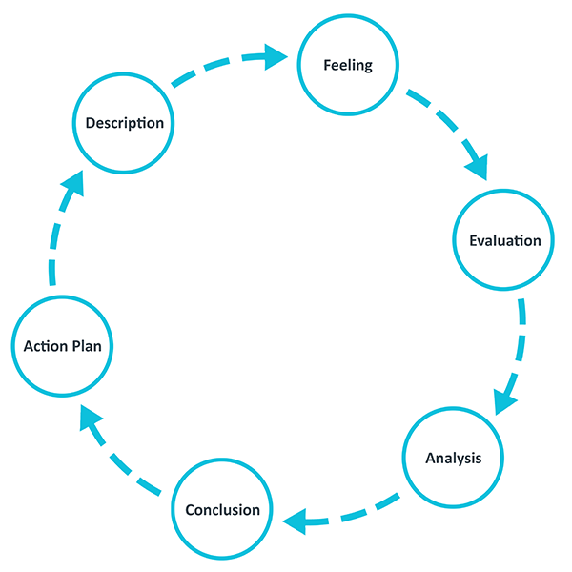

Figure 1: **Gibbs Reflective Model**

(Source: Adeani, Febriani and Syafryadin, 2020)

**Description**

Throughout the module, I have gained various skills that have helped me enhance my knowledge of management. Throughout the module, I have gained a variety of skills that have helped me to enhance my skills in these areas.

**Feeling**

Throughout the module, I have felt better than previous. Because the adaption of better knowledge on the subject has made better confidence in my mind. Through this better understanding, I have learned many new things that have helped me to extend my knowledge positively. On the other hand, I was a little nervous about the new things in the module. Then, with peer support and the professor's support, I can resolve my confusion on those things which help me to solve my nervousness equally.

**Evaluation**

Throughout the module, I have learned many things that have helped me to develop my skills. I have learned better research skills throughout this module. The better research skill has also impacted my critical thinking skills. Critical thinking skill is an essential fact that will help me in my futuristic profession. On the other hand, there are some constraints that existed like a lack of knowledge in time management skills. Therefore, the lack of time management skills created confusion in order to arrange the actions within the proper time. I also felt nervous due to my lack of low confidence level. the low confidence level has created a hustle in order to accept the new things throughout the module.

**Analysis**

As a result of participating in the course, I have improved my research and critical thinking skills, among other capabilities. I have struggled with time management and lacked confidence, both of which made it difficult for me to study. In that case, I have learned many new things like research skills, and better critical thinking skills on contrast I have found many weaknesses that I need to improve through proper planning.

**Conclusion**

I have enhanced my research and critical thinking ability as a consequence of taking the course, among other things. I had trouble managing my time and lacked confidence, which made it challenging for me to study.

**Action Plan**

|  |  |  |
| --- | --- | --- |
| **Skills** | **Way to improve** | **Time Frame** |
| Time Management | Through PDP | **5 Months** |
| Good Confidence Level | Through PDP | **6 Months** |

# Continuous Improvement

As I continue my education in construction management, I will become knowledgeable in the field and develop the skills necessary to successfully manage construction projects. Because of this knowledge, I will have a better understanding of the challenges that construction projects provide, as well as the impacts such projects have on both society and the environment. In addition to this, it will assist in the growth of my project management, communication, problem-solving, and decision-making skills, all of which are essential for achieving success in any field of work. Additionally, the skills that I have improved thanks to this programme, such as inquiry and critical thinking, will be useful for my next courses as well as my ambitions for professional growth. Because of these qualities, I will be able to conduct in-depth research and critically assess content, both of which are essential for both academic success and professional growth. A crucial component of job growth is continuous improvement, and I have a number of goals to advance my construction management expertise.

First and foremost, I want to routinely attend conferences and seminars on construction management. I will be able to learn about the most recent techniques, technology, and trends in the sector and network with other experts by going to such events. Additionally, in order to develop my knowledge and abilities in sustainable building methods, I want to acquire further certifications and credentials in the field of construction management, such as LEED certification.

Lastly, I want to routinely read trade magazines and journals to keep abreast of news and advances in the sector. This will assist me in staying current on new technology, rules, and procedures in the construction sector. Last but not least, I want to explore opportunities where I can put my knowledge and experience in construction management to use, such as participating in building projects as a volunteer or joining associations that are geared towards construction industry professionals. As a result of these opportunities, I will get valuable hands-on experience and be able to acquire a more comprehensive understanding of the industry.

# Reflection of Presentation

Over the course of the presentation, I gained knowledge on the use of BIM technology in the building sector. As a result of the contemplation, I now understand the significance of BIM technology in the building and construction sector. Throughout the course of the presentation, I picked up the knowledge that BIM provides architects with the capability to modify the design in order to take into account any risks associated with future construction. The use of BIM technology has resulted in an increase in the quality of the creation of architectural designs. While creating a building model using BM technology, architects and engineers now have access to a more accurate visual representation of the whole design process. In order to comply with safety rules and pass on-site inspections, contractors may further lead their workers safely through each stage of the workflow while recording the procedure. As a consequence of this, construction managers now have a greater capacity to plan projects, which improves the overall quality of the final product and helps reduce the number of unexpected occurrences that take place throughout the building process.

Over the course of the presentation, I picked up some new information on the benefits of BIM, including the advantages of using 3D technology, increased levels of visibility, and cost reductions. The review that took place during the presentation taught me that the British government has enacted a number of policies, all of which have assisted building organisers in making use of the potential afforded by technology applications related to BIM. The Business Information Modelling (BIM) approach is used by a number of well-known and well-established businesses in the UK and other nations in order to conduct successful business. For the next, I will more focus on the critical analysis and follow the primary analysis in order to get a better result. Additionally, the presentation has helped me to develop my speaking skills that help to understand in which way a presentation can be narrated to others.

# Personal Development Plan

|  |  |  |
| --- | --- | --- |
| **Academic Skills to Develop** | **Plan to Develop Skills** | **Future Implementation** |
| **Time Management** | Time management skills are crucial for both personal and professional development. Hence, in order to develop time management skills, I must first appreciate the worth of time and allocate tasks in the right order. I may create a to-do list or utilize a planner to help me manage daily tasks and goals.  An additional useful method is to break challenging projects into smaller, more achievable tasks and establish completion dates for each task. This helps me prevent procrastinating and ensures that essential tasks are completed on time. During work hours, one must also avoid distractions such as social media and unnecessary phone calls. Setting restrictions and creating a schedule for some tasks might help me remain focused and increase my productivity.  To avoid burnout and maintain focus, it is also essential to take breaks and practise self-care. A good night's sleep and regular exercise might boost my productivity and assist me in achieving my goals.  Finally, I will regularly evaluate and improve my time management strategies in order to develop and hone these skills. In order to improve time management strategies for future development, it is possible to reflect on past successes and challenges to identify areas for improvement. | The proper implementation of the practices of time management will help me to enhance my sense of time management. This will help me to arrange the futuristic works |
| **Good Confidence Level** | It is essential for me to take constant, purposeful efforts towards learning and personal development in order to have a solid foundation of confidence for future growth. I must set attainable goals, split them into manageable steps, and celebrate little triumphs along the way. It is imperative that I challenge my limiting beliefs and negative self-talk in favour of growth mindset exercises and positive self-affirmations. In this situation, I should engage in self-care and maintain a healthy work-life balance, since both may contribute to greater self-assurance and overall wellness. In addition, I must seek out constructive criticism and feedback from reputable sources in order to identify areas for improvement and create doors for my own growth. Remember that building confidence is a process that requires persistence, patience, and self-compassion. | A good confidence level will help me to develop my ability to learn something new for my future carrier that will have a positive impact on my carrier. |

# Conclusion

The report's examination revealed that reflection is a crucial component for conveying a deeper understanding based on personal experiences. Self-reflection aids in a better understanding of the subject areas. Personal reflection may help with emotion control by giving one the chance to assess and understand one's sentiments. This could result in enhanced coping mechanisms and emotional intelligence. This paper has a particular emphasis on learning and growth reflection and provides an explanation of continuous development. This report will convey the author's unique viewpoint, which was shaped by the knowledge received from the presentation. This report's reflection is based on my own interpretation of the reflection.

According to the analysis of the report, the reflection has improved in a number of management-related abilities, including investigation and critical thinking, as well as an understanding of construction management. The author also acknowledges several limitations that might be remedied via careful preparation, such as a lack of time management skills and poor confidence levels. The author has a detailed action plan for enhancing their skills, which includes going to construction management conferences and seminars, getting more certifications and credentials in the industry, reading trade publications, and looking into opportunities to put their knowledge and experience into practice. The author also discusses a presentation they saw where they learned about the advantages of BIM technology in the construction industry. The author gained knowledge of the importance of BIM in the industry, its benefits, and the rules implemented by the British government to help to build organisers and take use of the potential provided by BIM-related technological applications.

# References

Adeani, I.S., Febriani, R.B. and Syafryadin, S., 2020. USING GIBBS’REFLECTIVE CYCLE IN MAKING REFLECTIONS OF LITERARY ANALYSIS. *Indonesian EFL Journal*, *6*(2), pp.139-148.

Borelli, J.L., Kazmierski, K.F., Gaskin, G.E., Kerr, M.L., Smiley, P.A. and Rasmussen, H.F., 2023. Savoring interventions for mothers of young children: Mechanisms linking relational savoring and personal savoring to reflective functioning. *Infant Mental Health Journal*.

# Appendix

