**IMPACT OF CORPORATE PRIVATIZATION ON WORLDWIDE MARKETPLACES**

**Table of Contents**

Introduction 3

Literature Review 5

Methodology 8

Conclusion 11

Reference List 12

# Introduction

***Research Background***

Privatization may lead to a serious virtuous cycle among the employment, productivity, and exports of goods from the organization. Privatization deepens and broadens the capital market resulting from increased listings of marketplaces and regulatory and liquidity infrastructure. The measures of two decades have resulted in a golden age for financial capitalism. Privatization occurs when a government-owned business runs its operation when that property or organization is owned by a private or non-government party. This affects the worldwide marketplaces through the process by which a piece of property or business goes from being owned by the government to making it privately owned. Privatization can have a positive impact on the economy but on a parallel note, it is not devoid of any negative impacts.

***Research Rationale***

*What is the issue?*

There are several firms all over the world, thus considering in the UK, if any such firm that is initially under government running organization transforms into privatization, thus maintain a natural monopoly in the organization. Privatization in some sectors thus impacted low competition to the monopoly of a single firm. One of the most important issues regarding privatization confronts the significant inconvenience of the chances of bribery and corruption. This has led to the privatization of expanding the bridge between poor and rich people.

*Why is the issue?*

The issue is there due to the construction of an organization that is required for the work of the government. Large corporate organizations get government benefits when the employees are at the service and after retirement get a token of gratitude money for their lifetime. Beyond a few other sectors and governmental bodies, the government tries to make a few large organizations be privatized and owned by some multi-millionaire entrepreneur.

*Why is the issue in the present situation?*

The issue is still there in the present situation as the construction of private companies is still on the lookout for developing and creating a new business. Privation of the corporations thus affects the worldwide markets, where the economy and private monopoly seems to be the major issue. Resource exploitation and resource mismanagement can be used to have on hiring people at the lowest wages, by the private sector to prioritize quality.

***Research Aim***

The research aims to focus on the impact of privatization on worldwide marketplaces. The provision thus makes a transition to the economies that would increase employment and productivity. The probability of any corporate firm's export increases, only because of their privatization and the attitude of the risks and profit changes.

***Research Objectives***

* To identify the specific impact of corporate privatization on worldwide marketplaces
* To analyze how corporate firms affect the worldwide marketplaces
* To assess the strategy of achieving success from worldwide marketplaces by corporate privatization
* To evaluate the risks in corporate sectors from worldwide marketplaces
* To mitigate the challenges that are associated with corporate sectors due to worldwide marketplaces

***Research Questions***

* What is the impact of making corporate privatization on worldwide marketplaces?
* How to analyze the corporate firms’ activity that might affect worldwide marketplaces?
* Why is it required for achieving success in worldwide marketplaces by corporate privatization?
* What are the risks associated with the corporate sectors from worldwide marketplaces?
* How can the challenges be mitigated that are associated with corporate sectors due to worldwide marketplaces?

***Research Significance***

The significance of the research is to leverage corporate privatization that would understand the readers' impact on the worldwide marketplace. In consideration of that open economy is also the role of economic governance that thus showed the way of privatization for the increases of the incentives of the Greenfield FDI. This thus considers the reader to get in by the optimal degree of privatization of the corporate firms to attract the FDI which is not very high (Hock et al., 2022). The reader thus understands that there are positive and negative impacts of privatization that would lead the employees of the private companies to be involved in the act of corruption and bribery that might accompany the privatization.

# Literature Review

***The specific impact of corporate privatization on worldwide marketplaces***

According to Bhattacharyya, (2019), privatization is only made from ***“state-owned enterprises”*** (SOE) by the transition of economics that has often been found to improve the employment of many employees and increase the productivity of the organization. This might help in the worldwide marketplace for the policymakers of the fears of employment turnover increment. Privatization thus promotes firm expression to have some positive effect on the level of the analysis revealed by productivity, propensity, and employment. The privatization effect mostly seems to have been changed by the firm's attitude about the profits earned due to the risk of competitive pressure.

On the other hand, Clò et al., (2020), say that privatization mainly occurs from the government-owned business to give away the organization and all its relevant property to become private and run their business from the responsibility of the non-government party or entrepreneur. Privatization is used as a method of allocating the assets that the firm has for functions from the public sector to the becoming the private sector. This appears to have been adopted with the many such political systems that have been spread with every region to be made around the world. The worldwide marketplace thus has the impact due the privatization which can be effective on the way to bring about any such fundamental and structural changes that directly create strong individual incentives.

***How corporate firms affect the worldwide marketplaces***

According to Farazmand, (2020), participation that the global marketplace has on is to help provide the company with the degrees of protection that the events have for diversifying the risk of economic impact. The operations of corporate firms due to their privatization allows the worldwide marketplace to have their business in mitigating the impact of the negative business event in any country or territory. As per becoming privatization the company while progressing into the worldwide market packets thus made to be elastic in complication by the least risky alternative for exporting the goods.

On the contrary Frick et al., (2021), says that corporate privatization has been used for selling domestically produced products from another country. Cultural differences affect the worldwide marketplace that has set with the society with a common set of values that needs to be shared determining what is socially acceptable. Political considerations can also be taken with the set of national consciousness that thus boots with the culture and interests with the set of one country over all other countries. This very much impacts corporate privation with strongly nationalistic countries like New Guinea and Iran.

***The strategy of achieving success in the worldwide marketplaces through corporate privatization***

According to Estrin et al., (2021), the strategy of privatization adopted by corporate firms describes the best decision and implementation for the process by which a piece of property or business goes from being owned by the government to privately own. This process thus helps the state-owned enterprises to save money which thus subsequently increases the efficiency of the company. Overcoming the barriers in the worldwide marketplace and entering into the current market thus put into a condition for the success of the privatization of the company.

On the contrary, Skerritt&Salokangas, (2020), says that corporate privatization would make it possible for private companies to move goods quickly and more efficiently. Success can only be achieved through privatization by aiding in economic growth and deterring government influence. The private bodies do not have any such political agent that thus has a focus on spurring the growth and efficiency within the organization. This gives rise to greater chances of collection and generation of revenues. In the impact of the worldwide market, corporate privatization takes upon airline operations of every nation achieving a major success of corporate privatization.

***The risk involved in corporate sectors from worldwide marketplaces***

According to Gahman et al., (2022), the risk involved with the corporate sectors to be impacted on the worldwide marketplaces needs to be controlled by the risks that are used to leverage unpredictable and seriously damaging consequences. The risks of switching costs and marketing cost is a very critical and vital risk that are associated with the corporate sectors from worldwide marketplaces. State-owned enterprises are taken over by private companies then the switching cost is very much impacted in the economy of the company. The marketing costs that are associated with the first when privatization is implied on the company marketing cost for the business operation increases causing an economic shortfall in their revenue.

On the other hand, Kole, (2021), says that the major risks of the company thus image the international business that would be facing from the political, regulatory, and financial approach for the business. The privatization of any business which serves transportation as their only service to provide to the consumers faces the risk of accident, seizure, theft, breakage, contamination, and loss. This impacted the economy of the organization and thus by privatization, the consequences lead to an impact on worldwide marketplaces.

***The mitigation of challenges that are associated with corporate sectors due to worldwide marketplaces***

According to Athique & Kumar, (2022), the challenges are required to mitigate in corporate sectors for private by following a few guidelines after the privation. The credit risks in the foreign market need to be assessed by grabbing any such opportunities that are approaching the company in providing a big return. It is obvious that the company is looking to expand internationally thus it will have an impact on the worldwide marketplaces. The new markets need to be understood by the company, which would gauge whether the product or service of the company fulfils the needs of the consumers.

As per the views of Thomas et al., (2020), German laws for instance on the creation of bank accounts of many consumers provide guidelines to do the Know Your Customer procedure for private banks to avoid any such risk regarding the tax documentation process. Communication barriers, Understanding the local markets, and cultural differences need to be overcome for the organization that has adopted privatization on worldwide marketplaces. This helps the organization to expand in any market freely for the economic loss of the revenue that the company might regenerate due to the privatization.

***Theoretical framework***

The theoretical framework is administered with the theories of the impact of corporate privation on worldwide marketplaces. The ***“theory of privatization”*** involves the implementation of the control of the public sector enterprises to the private sector enterprises, transfer of ownership, and control & management of the business. Thus privatization can suggest several things that might be used including the migration of things that are made for something from the public sector to the private sector. The increase in efficiency thus makes the tendency to deal with the quality of the range of choices for the innovation required if privatization is booted and the business tends to expand internationally. It thus ultimately raised the profits of the firm for reinvestment, lesser political interference, and healthy competition (Arnove, 2021). The theory of privatization helps to raise the capital market resulting in the awareness of the business and enlarging the investor base. The increased listings improve the regulatory and liquidity of the infrastructure of the business after adopting privatization. Many well-established entrepreneurs believe with the making of privatization thus makes ownership to be automatically made of improving the performance of the business. The theory of privatization helps the state-owned enterprises to have owning the private sector with the economic reform of the present government to start and allow the privatization of the company.

***Literature gap***

The missing or unexplored parts in the article on the impact of corporate privatization thus help with the business of worldwide marketplaces to demonstrate the efficiency of delivering the objectives of the studies. The researcher felt that due to a lack of sequences and study mateiral, there are a few gaps that remain in the literature. The researcher has made secondary data analysis and gathered information from various journals and books, but still felt that the information lagged a few vital points that would make the research quite authentic and appropriate. Thus to bridge the gap this acknowledgment of the research would help to mitigate the analysis of the research appropriately.

# Methodology

***Research Philosophy***

The philosophy of the research is the belief that the researcher has in them for collecting or gathering information. Due to secondary data collection methods, Interpretivism research philosophy is used for the research which encompasses the research philosophers gathered information due to secondary data collection methods.

***Research Approach***

The approach of the research is a procedure to be selected based on the researcher's norms in analyzing, interpreting, and collecting the data. An inductive research approach is being used for the implementation of the research due to secondary data collection methods collected information from various journals and books (ZAFAR & MUHAMMAD, 2022). This approach is followed because it is the early form of the researcher by the tentative hypothesis that can be explored.

***Research Design***

The research design is the blueprint of the scientific approach of the study that has been made for the research of the impact of core privatization on worldwide marketplaces. It includes tools and techniques that have been used in conducting the research. A descriptive research design is being implemented in this research to identify the characteristics, trends, frequencies, and categories of the research to fulfill the context of the study approaches.

***Research Onion***

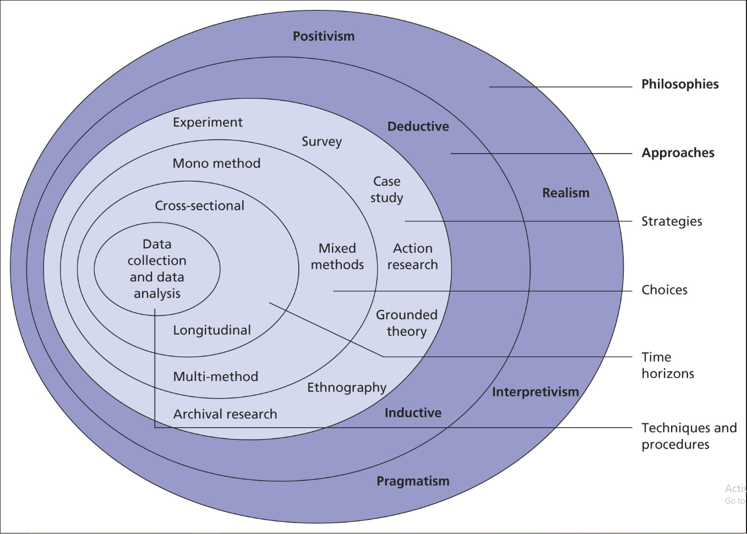

**Figure 1: Research Onion**

(Source: Self-Created)

***Data Collection Methods and Analysis***

The data that is collected for the research is secondary data collection methods with a qualitative approach. The research is being gathered by maintaining the proper way of collecting the data by the means of secondary data collection methods used for the research. The information about the impact of corporate privatization on worldwide marketplaces is being extracted from various journals and thus it has been analyzed properly by the researcher to use the information sequentially for this research.

***Ethical Consideration***

Ethical consideration is the set of principles that are required for the research to be maintained in doing the research more accurately with honesty and integrity. While doing the research the researcher has maintained that direct copying from other sources and allowing others to copy from these sources have been strictly prohibited (Have, 2020). The researchers have also maintained the content to be plagiarism free. The information for the context of the study is being preserved by the maintenance of the Data Protection Act 2018. The inclusion criteria is the journals that is being considered are taken that has published after 2018, and the journals that are published before 2018 are excluded for gathering information for the research. This would help the researcher to maintain pure ethical considerations to complete the research appropriately.

***Gantt Chart***



**Figure 2: Gantt Chart**

(Source: Self-Created)



**Figure 3: Time Horizon**

(Source: Self-Created)

# Conclusion

***Future Scope***

The future scope of the research is the way the research can be dealt with and implemented by the cause to be made in the future. The research in the future can be helped to deal with the worldwide marketplace to have an impact by corporate privatization. The effect thus makes it stronger with higher competitive challenges that other private companies have due to corporate privatization. Import of the preservation thus makes proper penetration for the business that is associated with the lower-price cost margin, where the private sector would rise in the price-cost margin of product market concentration which is very high.

***Recommendations***

The recommendations are as such:

* Private companies after privatization look to expand their business as soon as possible and find a way to gain market penetration for their business. The economic slowdown in the business must be controlled by doing the expansion and starting the branch business with steadfastness.
* The worldwide market gets the benefit, while the privatization of any business takes palace with the effect of adjusting and merging with a strongly competitive sector in the new market. This would help the market to gain competitive markets and improve privatization altogether.
* The company thus determines in adjusting with the alteration to make such policy so that the employees are bound to work under that policy and get such proper stipend. As privatization occurs the company must work on the policies and set their own rules and regulations to improve employee turnover and the company's revenue and one slot simultaneously.

# Reference List

Arnove, R. F. (2021). Globalization, Education and Policy Reforms in Latin America. *Third International Handbook of Globalisation, Education and Policy Research*, 79-90. https://link.springer.com/chapter/10.1007/978-3-030-66003-1_5

Athique, A., & Kumar, A. (2022). Platform ecosystems, market hierarchies, and the megacorp: The case of Reliance Jio. *Media, Culture & Society*, *44*(8), 1420-1436. https://journals.sagepub.com/doi/pdf/10.1177/01634437221127798

Bhattacharyya, S. (2019, June). Are we Heading Towards a Premature Death of Human Sciences?-A Critical Enquiry into Intellectual History (1945-Present). In *Conference Proceedings. The Future of Education 2019*. https://conference.pixel-online.net/library_scheda.php?id_abs=4065

Clò, S., Florio, M., &Rentocchini, F. (2020). Firm ownership, quality of government and innovation: Evidence from patenting in the telecommunication industry. *Research Policy*, *49*(5), 103960. https://www.sciencedirect.com/science/article/pii/S0048733320300408

Estrin, S., Mickiewicz, T., & Wilson, N. (2021). An Appreciation of the Research Career of Mike Wright, 1952-2019. *Foundations and Trends in Entrepreneurship*, *17*(6), 653-683. https://aditum.org/images/article/1645512205JPDI_Galley_Proof.pdf

Farazmand, A. (2020). Trends in public administration reforms: Assessing the past and looking into the future; rationales, approaches, and impacts. *International Journal of Civil Service Reform and Practice*, *5*(1). https://www.astanahubjournal.org/index.php/ijcsrp/article/view/143

Frick, V., Gossen, M., Pentzien, J., Piétron, D., &Tangens, R. (2021). Policies to transform the internet from marketplace to public space. *ÖkologischesWirtschaften-Fachzeitschrift*, *36*(O1), 9-14. https://oekologisches-wirtschaften.de/index.php/oew/article/view/1786

Gahman, L., Smith, S. J., Penados, F., Mohamed, N., Reyes, J. R., & Mohamed, A. (2022). Dispossession, extractive, and violence. In A Beginner's Guide to Building Better Worlds (pp. 58-69). Policy Press. https://onlinelibrary.wiley.com/doi/abs/10.1002/9781119753926.ch9

Have, W. (2020). Transnational privatization and (de) humidification of women's employment in the global export manufacturing-a case study of Hansae Vietnam Co Ltd. https://heinonline.org/hol-cgi-bin/get_pdf.cgi?handle=hein.journals/trnsletho11&section=26

Hock, B., Button, M., & Shepherd, D. (2022). Corruption, Bribery, and Corporate Crime: Victims and Perpetrators. In *The Handbook of Security* (pp. 307-331). Cham: Springer International Publishing. https://heinonline.org/hol-cgi-bin/get_pdf.cgi?handle=hein.journals/vantl53&section=31

Kole, A. (2021). What does the future hold for global stock exchanges after COVID? *USApp–American Politics and Policy Blog*. https://eprints.lse.ac.uk/111758/

Skerritt, C., &Salokangas, M. (2020). Patterns and paths towards privatization in Ireland. *Journal of Educational Administration and History*, *52*(1), 84-99. https://www.tandfonline.com/doi/abs/10.1080/00220620.2019.1689104

Thomas, K. D., Davis, J. F., Wilson, J. A., &Sobande, F. (2020). Repetition or reckoning: confronting racism and racial dynamics in 2020. *Journal of Marketing Management*, *36*(13-14), 1153-1168. https://www.tandfonline.com/doi/full/10.1080/0267257X.2020.1850077

ZAFAR, S., & MUHAMMAD, F. (2022). *Impact of Destructive Leadership and Corporate Governance on ethical practices in the Financial Sector of Pakistan* (Doctoral dissertation, Durham University). http://etheses.dur.ac.uk/14554/