**USING DATA TO BUILD BUSINESS PRACTICE**

Table of Contents

Introduction 3

Discussion 3

Ongoing and passed web clients and web non-clients, by monetary movement, from 2011 to 2020 3

Measurement of location and dispersion 5

Low levels of internet use in Wales and East of England from 2014 to 2020 6

Measurement of location and dispersion 6

Analysis of Internet users and its non-users by the sex and age group 9

Measurement of location and dispersion 12

Comparison of all three data 14

Conclusion 14

Reference list 15

# Introduction

The Working Environment for Public Estimates provided information about web clients in the Collected Domain for the years 2011 through 2020. The number of web users in the UK has dramatically expanded over the previous several years; in 2011, 44 million people, or 77% of the population of the UK, used the internet. In 2020, it increased to 58 million, or 88% of the population. Here the discussion will be made on the three data sets, which are about the users of the internet by the different criteria. There will be a calculation of dispersion and a graphical presentation will be there and results are to be analysed through the table and graphs. a broadband connection is used by the majority of internet users. Up from 77% in 2011, 87% of web customers in 2020 had a solid broadband connection. This suggests that more people in the UK are using high-speed internet connections. A growing proportion of individuals have access to exceptionally fast internet connections, according to data on internet users in the UK, and an increasing percentage of people use the internet daily.

# Discussion

## Ongoing and passed web clients and web non-clients, by monetary movement, from 2011 to 2020

As can be seen in the table, the number of new and returning web customers has consistently increased over time. 23,147 new and 3,493 old people used the internet in 2011. By 2020, this had grown to 27,617 new clients and 4,786 old ones. At the same time, the number of people who did not use the internet decreased (Caldera *et al.* 2019). In 2011, there were 118 non-clients, yet entirely just 65 out in 2020. In 2020, there will be 107 occasional users, down from 84 in 2011. The number of clients classified as "not dynamic" additionally diminished from 2,217 in 2011 to 1,335 in 2020. To wrap things up, the number of clients who are viewed as "dynamic" expanded to 8,071 every 2020 from 2,470 in 2011 (Nascimento *et al.* 2019). This indicates that more and more people are regularly utilising the internet to take advantage of its many benefits.

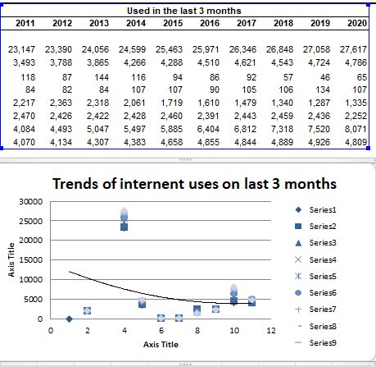

**Figure 1: Trends of uses in last 3 months by economic activity**

(Source: Self-created in Excel)

This suggests that more people are occasionally using the internet rather than just occasionally doing so. The statistics show that the majority of internet users use a fixed broadband connection. In 2020, 87% of web clients included a good broadband relationship, up from 77% in 2011. This implies that the use of high-speed internet connections is growing in the UK. Data on internet users in the UK generally shows that a growing number of people have access to extremely fast internet connections and that a growing percentage of people use the internet every day (Draper and Turow, 2019). This demonstrates a distinct increase of 53.5% and 46.3% in late and sneaked past web clients and web non-clients, respectively. Both new and returning internet users increased by 17.6% between 2011 and 2012 (Desjardins *et la.* 2019). With a drop of 8.1%, the most obviously terrible decay happened someplace in the period somewhere in the range of 2018 and 2019. The greatest decline in web non-clients occurred sometime between 2011 and 2012 when it was 16.2%. With a 5.9% increase, the best increase occurred sometime between 2018 and 2019.

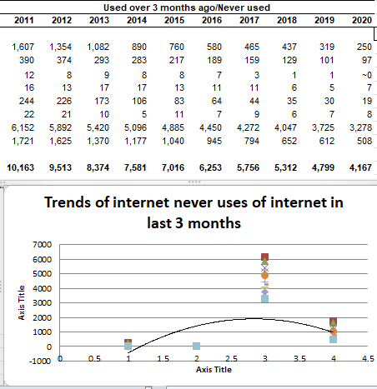

**Figure 2: Trends of never uses in last 3 months by economic activity**

(Source: Self-created in Excel)

### Measurement of location and dispersion

|  |  |  |  |  |  |
| --- | --- | --- | --- | --- | --- |
| Sum | Average | Median | Max | Min | SD |
| 2,62,239 | 13,112 | 12,377 | 27,617 | 250 | 12708.67 |
| 45,116 | 2,256 | 1,942 | 4,786 | 97 | 2108.355 |
| 962 | 51 | 46 | 144 | 1 | 48.15509 |
| 1,122 | 56 | 50 | 134 | 5 | 47.06088 |
| 18,753 | 938 | 766 | 2,363 | 19 | 908.2033 |
| 24,293 | 1,215 | 1,137 | 2,470 | 5 | 1236.093 |
| 1,08,348 | 5,417 | 5,258 | 8,071 | 3,278 | 1331.924 |
| 56,319 | 2,816 | 2,896 | 4,926 | 508 | 1854.984 |

**Table 1: calculation of location and desperation**

(Source: Self-created)

The table displays the statistics, which range from 250 to 27,617 in total. The median values of the data sets are 12,377, 1,942, 46, 50, 766, 1,137, 5,258, and 2,896 correspondingly. 13,112, 2,256, 51, 56, 938, 1,215, 5,417, and 2,816 are the individual means for each set. Last but not least, the relative standard deviations for each set are 12,708.67, 2,108.35, 48.15509, 47.06088, 908.2033, 1236.093, 1,331.924, and 1,854.984 (Raut *et al.* 2019). The informative collections frequently exhibit a wide range of characteristics, and the mean and middle are frequently close to one another. The fact that the standard deviations differ significantly also suggests that the data sets have quite different amounts of variability.

## Low levels of internet use in Wales and East of England from 2014 to 2020

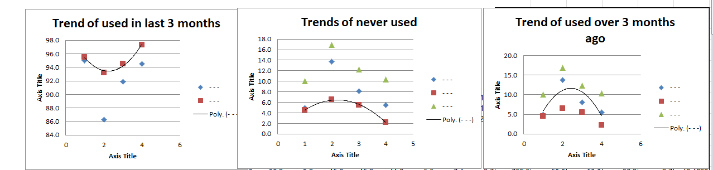

**Figure 3: Trends of all users by geographic location**

(Source: Self-created in Excel)

### Measurement of location and dispersion

|  |  |  |  |  |  |
| --- | --- | --- | --- | --- | --- |
| Sum | Average | Median | Max | Min | SD |
| 698.8 | 49.9 | 49.9 | 92.1 | 7.8 | 40.29105 |
| 699.6 | 50.0 | 50.0 | 92.2 | 7.7 | 41.32221 |
| 699.3 | 50.0 | 49.9 | 95.5 | 4.5 | 43.74564 |
| 699.6 | 50.0 | 50.0 | 93.1 | 6.7 | 42.43727 |
| 299.6 | 49.9 | 50.0 | 87.2 | 12.6 | 39.06004 |
| 699.4 | 50.0 | 49.8 | 91.7 | 8.3 | 40.12273 |
| 399.8 | 50.0 | 49.9 | 93.6 | 6.4 | 43.7936 |
| 400.0 | 50.0 | 50.0 | 90.7 | 9.3 | 42.5791 |
| 400.0 | 50.0 | 50.0 | 92.5 | 7.5 | 41.63148 |
| 699.5 | 50.0 | 50.0 | 93.4 | 6.6 | 38.08187 |
| 299.2 | 49.9 | 49.9 | 91.0 | 8.6 | 43.58962 |
| 699.6 | 50.0 | 50.0 | 93.0 | 6.9 | 42.82001 |
| 398.3 | 49.8 | 50.0 | 94.9 | 5.1 | 44.29819 |
| 399.5 | 49.9 | 50.0 | 94.4 | 5.1 | 46.03055 |
| 700.0 | 50.0 | 50.0 | 96.3 | 3.7 | 42.1632 |
| 699.5 | 50.0 | 50.0 | 98.2 | 1.8 | 42.92012 |
| 299.6 | 49.9 | 50.0 | 89.0 | 10.9 | 40.50109 |
| 399.6 | 50.0 | 50.0 | 92.7 | 7.3 | 44.0573 |
| 400.0 | 50.0 | 50.0 | 95.0 | 5.0 | 44.97158 |
| 399.2 | 49.9 | 49.9 | 97.3 | 2.2 | 48.37582 |
| 399.6 | 50.0 | 50.0 | 90.0 | 10.0 | 40.27754 |
| 699.3 | 50.0 | 50.0 | 90.2 | 9.8 | 38.03933 |
| 699.1 | 49.9 | 49.6 | 97.8 | 2.2 | 38.06164 |
| 698.8 | 49.9 | 49.7 | 92.7 | 7.3 | 39.53374 |
| 698.0 | 49.9 | 49.9 | 89.8 | 10.2 | 34.70054 |
| 699.0 | 49.9 | 49.9 | 89.1 | 10.9 | 35.96213 |
| 698.9 | 49.9 | 49.8 | 92.4 | 7.6 | 34.90801 |
| 698.7 | 49.9 | 50.0 | 89.7 | 10.1 | 36.68832 |
| 700.0 | 50.0 | 50.0 | 90.7 | 9.3 | 38.23325 |
| 700.0 | 50.0 | 50.0 | 95.5 | 4.5 | 40.53819 |
| 698.7 | 49.9 | 49.7 | 95.8 | 4.2 | 39.64779 |
| 699.8 | 50.0 | 50.0 | 94.9 | 5.1 | 42.31522 |
| 700.0 | 50.0 | 50.0 | 94.0 | 6.0 | 40.15051 |
| 699.0 | 49.9 | 50.0 | 88.5 | 10.5 | 34.95862 |

**Table 2: calculation of location and desperation**

(Source: Self-created)

The information table provides estimates of various elements for 20 distinct examples. The sum, average, median, maximum, minimum, and standard deviation (SD) are the features that are measured. The sums for every one of the samples are 698.8 on average, ranging from 299.2 to 700.0 (Raghavan *et al.* 2020). By and large, the scores for each example range from 49.8 to 50.0. Except for one, the remaining examples all have middle upsides of 50.0, and their middle worths are 49.9. The models' average characteristics went from 87.2 to 98.2, with the most significant worth being 92.3. With a mean of 7.9, the Min values of the samples ranged from 4.2 to 12.6. Last but not least, the average Standard Deviation of the samples was 40.4, ranging from 34.7 to 48.4. In most cases, the information table demonstrates that the models are honourably strong in the areas that were evaluated (Weygandt *et al.* 2020). The average attributes are very close to one another, and the degree of values is somewhat, slightly, or nothing at all. The Standard Deviation is the only exception, with a much wider range and a higher average value. This suggests that the models' Standard Deviation may contrast more than their features.

## Analysis of internet users and its non-users by the sex and age group

The level of web non-clients and late web clients in the UK somewhere in the range of 2013 and 2020 is displayed in the table above, separated by age and sex. In general, there has been a steady rise in the proportion of internet non-users and recent and lapsed users in the UK over the past seven years (Singh and El-Kassar, 2019). In 2013, 85.6 per cent of men and 81.1 per cent of ladies were current or past web clients, separately. The proportion of men and women who had not used the internet in a while had increased to 93.1 per cent and 91.1 per cent, respectively, by the year 2020. Throughout recent years, there has likewise been an ascent in the extent of individuals who don't utilise the web. In 2013, the degree of web non-clients among men was 38.4%, while the rate among women was 22.3%. By 2020, men's non-utilization of the web had expanded to 59.4 per cent, while ladies' had expanded to 49.8 per cent.

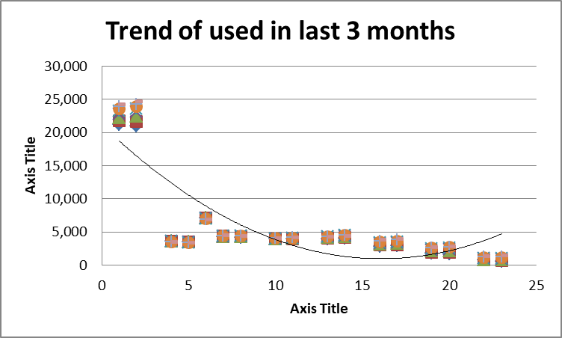

**Figure 4: Trends of the user in the last 3 months by age group and sex**

(Source: Self-created in Excel)

The table provides information on the proportion of recent and lapsed internet users, as well as those who have never used the internet, in the UK, by age group and sex. Overall, it appears that the proportion of recent and lapsed internet users has been decreasing since 2013, while the proportion of those who have never used the internet has been increasing. For example, among males aged 16 to 24, the proportion of recent and lapsed internet users decreased from 5.0% in 2013 to 3.0% in 2020 (Abbas, 2020). Similarly, the proportion of those who have never used the Internet increased from 0.7% in 2013 to 0.2% in 2020. The same pattern is seen for other age groups, with the proportion of recent and lapsed internet users decreasing, while the proportion of those who have never used the internet increases. However, there is some variation across age groups (Ikram *et al.* 2019). For example, among males aged 75 and over, the proportion of recent and lapsed internet users decreased from 5.3% in 2013 to 3.5% in 2020, while the proportion of those who have never used the internet increased from 0.8% in 2013 to 1.1% in 2020.

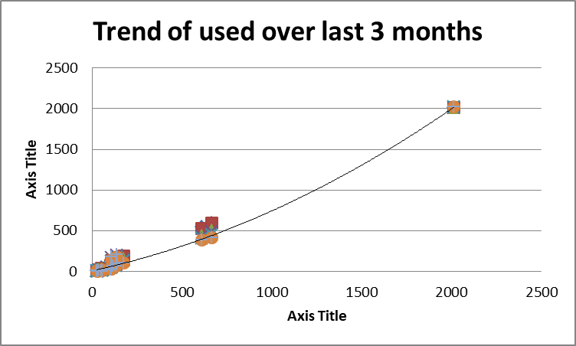

**Figure 5: Trends of a user over the last months by age group and sex**

(Source: Self-created in Excel)

The table shows the number of recent and lapsed Internet users and Internet non-users in the United Kingdom between 2013 and 2020, broken down by age group and sex. Overall, the number of recent Internet users has increased from 2013 to 2020. This trend is observed for all age groups and both sexes (Ferasso *et al.* 2020). The most notable increases have been in the 20-24 and 25-34 age groups for both genders, with the number of recent users more than doubling in both. The number of lapsed Internet users has generally decreased from 2013 to 2020 for all age groups and both sexes. The most significant decreases have occurred in the 45-54 age group for both genders, with the number of lapsed users falling from 828 in 2013 to 478 in 2020 for males, and from 933 in 2013 to 587 in 2020 for females (Bag *et al.* 2021). The number of Internet non-users has decreased in most age groups and both sexes, although there have been some increases, particularly in the 45-54 age group for both genders, with the number of non-users increasing from 977 in 2013 to 1,650 in 2020 for males, and from 1,084 in 2013 to 1,958 in 2020 for females.

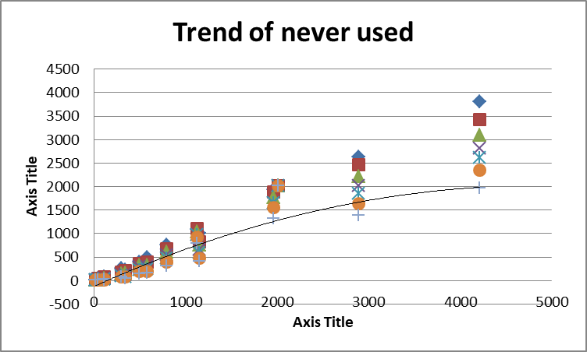

**Figure 6: Trends of never uses in last 3 months by age group and sex**

(Source: Self-created in Excel)

### Measurement of location and dispersion

|  |  |  |  |  |  |
| --- | --- | --- | --- | --- | --- |
| Sum | Average | Median | Max | Min | SD |
|  |  |  |  |  |  |
| 798.1 | 33.3 | 8.3 | 93.1 | 1.5 | 40.7969 |
| 799.0 | 33.3 | 11.1 | 91.1 | 1.5 | 38.70998 |
| 797.2 | 33.2 | 0.5 | 99.5 | 0.1 | 47.45366 |
| 798.0 | 33.3 | 0.5 | 99.6 | 0.0 | 47.61954 |
| 798.2 | 33.3 | 0.6 | 99.4 | 0.1 | 47.30783 |
| 799.1 | 33.3 | 0.8 | 99.6 | 0.2 | 47.42463 |
| 798.3 | 33.3 | 1.3 | 99.0 | 0.3 | 46.63346 |
| 798.9 | 33.3 | 1.3 | 99.2 | 0.2 | 46.71417 |
| 798.2 | 33.3 | 3.0 | 97.5 | 0.7 | 44.49779 |
| 799.0 | 33.3 | 3.2 | 98.4 | 0.4 | 44.67355 |
| 798.9 | 33.3 | 8.6 | 94.5 | 1.7 | 40.34602 |
| 798.9 | 33.3 | 8.3 | 94.6 | 1.6 | 40.19951 |
| 799.0 | 33.3 | 18.7 | 86.6 | 3.0 | 32.58204 |
| 799.3 | 33.3 | 21.3 | 84.4 | 3.0 | 30.32342 |
| 798.8 | 33.3 | 40.9 | 59.4 | 4.5 | 20.48615 |
| 798.4 | 33.3 | 34.0 | 72.5 | 4.4 | 23.8401 |

**Table 3: calculation of location and desperation**

(Source: Self-created)

The instructional collection's layout experiences are displayed in the table above. These summary statistics contain the total, average, median, mode, the maximum, minimum, and standard deviation for each set of data. Each data set's average value ranged from 797.2 to 799.3 (Akpan *et al.* 2022). The median grew from 0.5 to 21.3, and the average for each data process was almost 33.3. Each data set's mode value fell within the ranges of 0.2 and 3.4. The top and lowest quality for each informative collection were 99.6 and 99.5, respectively. Not to mention, the standard deviation ranged from 38.71 to 47.62. The informational index highlights several characteristics, with significant differences separating the best from the worst (Richards *et al.* 2019). The standard deviation values, which show that the data is scattered, likewise exhibit that a few informational collections have more excellent deviation values than others (Hastig and Sodhi, 2020). The summative assessments demonstrate that the educational record contains a wide range of perspectives.

# Comparison of all three data

Each three data sets are different, here the data was somewhat related to each other but their variables are different (Shad *et al.* 2019). Some data is showing the lapsed and internet use by the activity of the economy, by the lower level of geographical location that was, Wales and Seas of England. The third data set is about the use of the internet by the group of age and sex.

# Conclusion

In conclusion, businesses can effectively make use of data to comprehend patterns and trends in the industry, track the performance of their products and services, and pinpoint areas for improvement. Organisations can improve their systems and their overall performance by using the information to illuminate decisions. Data-driven decisions can be used to improve customer service, reduce expenses, and increase productivity. By utilising the power of data, businesses can improve their operations and gain a competitive advantage.

# Reference list

**Journal**

Abbas, J., 2020. Impact of total quality management on Corporate green performance through the mediating role of corporate social responsibility. Journal of Cleaner Production, 242, p.118458.

Akpan, I.J., Udoh, E.A.P. and Adebisi, B., 2022. Small business awareness and adoption of state-of-the-art technologies in emerging and developing markets, and lessons from the COVID-19 pandemic. Journal of Small Business & Entrepreneurship, 34(2), pp.123-140.

Bag, S., Pretorius, J.H.C., Gupta, S. and Dwivedi, Y.K., 2021. Role of institutional pressures and resources in the adoption of big data analytics powered artificial intelligence, sustainable manufacturing practices and circular economy capabilities. Technological Forecasting and Social Change, 163, p.120420.

Caldera, H.T.S., Desha, C. and Dawes, L., 2019. Evaluating the enablers and barriers for successful implementation of sustainable business practice in ‘lean’SMEs. Journal of Cleaner Production, 218, pp.575-590.

Draper, N.A. and Turow, J., 2019. The corporate cultivation of digital resignation. New media & society, 21(8), pp.1824-1839.

Ferasso, M., Beliaeva, T., Kraus, S., Clauss, T. and Ribeiro‐Soriano, D., 2020. Circular economy business models: The state of research and avenues ahead. Business Strategy and the Environment, 29(8), pp.3006-3024.

Hastig, G.M. and Sodhi, M.S., 2020. Blockchain for supply chain traceability: Business requirements and critical success factors. Production and Operations Management, 29(4), pp.935-954.

Ikram, M., Zhou, P., Shah, S.A.A. and Liu, G.Q., 2019. Do environmental management systems help improve corporate sustainable development? Evidence from manufacturing companies in Pakistan. Journal of Cleaner Production, 226, pp.628-641.

Nascimento, D.L.M., Alencastro, V., Quelhas, O.L.G., Caiado, R.G.G., Garza-Reyes, J.A., Rocha-Lona, L. and Tortorella, G., 2019. Exploring Industry 4.0 technologies to enable circular economy practices in a manufacturing context: A business model proposal. Journal of Manufacturing Technology Management, 30(3), pp.607-627.

Raghavan, M., Barocas, S., Kleinberg, J. and Levy, K., 2020, January. Mitigating bias in algorithmic hiring: Evaluating claims and practices. In Proceedings of the 2020 conference on fairness, accountability, and transparency (pp. 469-481).

Raut, R.D., Mangla, S.K., Narwane, V.S., Gardas, B.B., Priyadarshinee, P. and Narkhede, B.E., 2019. Linking big data analytics and operational sustainability practices for sustainable business management. Journal of cleaner production, 224, pp.10-24.

Richards, G., Yeoh, W., Chong, A.Y.L. and Popovič, A., 2019. Business intelligence effectiveness and corporate performance management: an empirical analysis. Journal of Computer Information Systems, 59(2), pp.188-196.

Shad, M.K., Lai, F.W., Fatt, C.L., Klemeš, J.J. and Bokhari, A., 2019. Integrating sustainability reporting into enterprise risk management and its relationship with business performance: A conceptual framework. Journal of Cleaner production, 208, pp.415-425.

Singh, S.K. and El-Kassar, A.N., 2019. Role of big data analytics in developing sustainable capabilities. Journal of cleaner production, 213, pp.1264-1273.

Weygandt, J.J., Kimmel, P.D. and Aly, I.M., 2020. Managerial Accounting: Tools for Business Decision-Making. John Wiley & Sons.

DesJardine, M., Bansal, P. and Yang, Y., 2019. Bouncing back: Building resilience through social and environmental practices in the context of the 2008 global financial crisis. Journal of Management, 45(4), pp.1434-1460.