**Group Consultancy Report - Innovation Assignment**

**Student Name:**

**Student ID:**

# Executive Summary

The Nokia Corporations and their battle for progress are the subject of the report. VRIO, SWOT, and Porter's Five Forces analysis of the present business model of Nokia Corporation reveals that the company faces several difficulties in the current, fiercely competitive market. Since its competitors have caught up in terms of technology and innovation, the company finds it difficult to leverage its resources and capabilities to generate a sustained competitive advantage. However, the company's patent portfolio and its strong brand name represent valuable and rare resources. The Corporation confronts intense rivalry with Apple, Samsung, and Huawei, according to the industry report. Additionally, a business canvas model for some fresh proposals has been included in the aforementioned paper. Additionally included are the recommendations' parameters and duration. From there, it was established that Nokia Corporation should concentrate its efforts in niche markets where it can maintain a competitive edge. Nokia needs to use its limited resources and people more wisely if it hopes to maintain a competitive edge in a highly competitive sector. Nokia may position itself for long-term success by concentrating on particular market segments and increasing its agility.

**Table of Contents**

Executive Summary 2

1.0 Introduction 5

2.0 Application of Theoretical Concept 5

2.1 VRIO Analysis 5

3.0 Industry Analysis 7

3.1 SWOT Analysis 7

3.2 Porter's Five Forces 8

4.0 Market Analysis 9

4.1 4Ps of Marketing Mix 9

5.0 Recommendations 11

5.1 New Business Model Canvas 11

6.0 Conclusion 15

Reference List 16

Appendices 18

1. What Did You Do? 18

2. How Did You Do It? 18

3. How Well Did You Do? 18

4. Identify the Skills That You Have Used to Complete This Assignment and Identify Any New Skills That You Have Started to Develop During the Assignment. 19

5. How Did the Process of Completing the Assignment Enhance These Skills? 19

# 1.0 Introduction

The international consumer electronics, information technology, and telecommunications corporation Nokia Corporation is based in Finland. In 1865, the company was founded and from then the company went through several transformations, including being a major producer of rubber products, before eventually transforming to the telecommunication industry (Nokia, 2023). The company has a long history of innovation and involved many first in the industry. Nokia was the first company to produce a cellular phone with an internal antenna. Moreover, the company introduced a phone with a built-in music player. From the start of the company till the early 2000s, they took over the mobile industry but their struggle starts with the rise of smartphones. In 2004, Nokia sold its mobile phone business to Microsoft and focused on developing networking equipment and services for telecom operators.

Nokia Corporation uses a diverse business model that is spread across multiple sectors of the telecommunications and technology industry. The areas they operate are network, technology, and pioneering invitation, collaborative advantage. Their strategy consists of six pillars and enablers (Nokia, 2023). The pillars define the success of the company and getting there enables them (Appendix 1). The report will describe Nokia Corporation and its struggle for new ideas and business models. This report will give a new business canvas model for the company for their improvement.

# 2.0 Application of Theoretical Concept

## 2.1 VRIO Analysis

VRIO analysisis a framework used to estimate the internal resources and capabilities of the company.

**Value**

With a strong brand name and a history of innovation in the telecommunication industry Nokia Corporation build recognition. It generates significant revenue through licensing agreements and also has a large patent portfolio (Schwarz, 2019). The strong relationship with suppliers and dealers helps the company to reduce the cost of the products. This creates value for the company.

**Rare**

The patent portfolio of Nokia Corporation is rare and is very difficult to replicate. Its brand name and history of innovation are not rare, compared to the other companies (Ding, 2021). The company has strong financial strength and high cultural exposure as well. Its problem-solving skills also make the company rare.

**Imitable**

The patent portfolio of the Nokia Corporation is hard to copy as it is protected by intellectual property law. a unique resource for the business because the accuracy and specifics of the predictions are only known to the top management of the business. Therefore, the company’s marketing communications are a unique resource that has helped the brand to maintain a sustained competitive edge globally.

**Organisation**

It has a strong team working on research and development, and it has been successful in licensing its patents to other businesses. The company has the organisational skills necessary to make the best use of its resources. However, the company has struggled a lot in recent years. Moreover, a good organisational culture makes the company organisationally strong.



(Source: Created By Writer)

# 3.0 Industry Analysis

## 3.1 SWOT Analysis

|  |  |
| --- | --- |
| **Strength** | **Weakness** |
| * Strong brand recognition * strong dealer network * Highly skilled workforce * High level of customer satisfaction * Strong global presence * Significant investment in research and development | * Decline in the mobile phone business * Need more investment in new technologies * In comparison to competitors, the day's inventory is large. * Poor financial planning * dependency on some important consumers |
| **Opportunity** | **Threat** |
| * Emerging markets * 5G networks * Lower inflation rate * New markets are being opened as a result of a government agreement. * Change in taxation policies | * Changing consumer behaviour * Rising pay level * New technologies developed * Different liability laws in different countries * Economic uncertainty |

(Souce: Grünewälder, 2014; Nokia, 2023)

## 3.2 Porter's Five Forces

|  |  |  |
| --- | --- | --- |
| **Factor** | **Description** | **Degree** |
| **Threat of New Entrants** | The telecommunications business required significant capital investment and expertise in technology, making new entrants difficult to enter in the market. Established businesses like Nokia, Ericsson, Huawei, and Cisco dominated the industry, making it difficult for new entrants to capture a share of the market. However, in the present time, the capital and technology remain high. With the increase of developed software and service segments, competition from new players is also high. | **High** |
| **Bargaining Power of Suppliers** | In this industry, the suppliers of raw materials such as semiconductors and circuit boards are huge. The company has several suppliers and alternatives. Therefore, the bargaining power of suppliers is relatively low. | **Low** |
| **Bargaining Power of Buyers** | The bargaining power of buyers has been high due to the number of options available in the market, and they can choose from various suppliers, demanding businesses to differentiate what they offer to remain competitive. Buyers can be selective. They seek out the best things available at the most affordable prices. Over time, this affected Nokia Corporation's earnings. | **High** |
| **The Threat of Substitute Products** | In the telecommunications industry, the threat of substitute products has been significantly high. When a new good or service fulfils equivalent customer needs in different ways, industry profitability declines. | **High** |
| **Competitive Rivalry** | Product characteristics, quality, price, and customer service are all used by businesses to compete. From the start of the industry still, now the rivalry between competitors such as Samsung Electronics, Apple Inc, and Xiaomi Corporation are moderate. | **Moderate** |

(Source: Johnson, Scholes and Whittington, 2008; Marie, 2011; Nokia, 2023)

# 4.0 Market Analysis

## 4.1 4Ps of Marketing Mix

|  |  |
| --- | --- |
| Factor | Description |
| Product | Networking hardware, software, and services are only a few of the goods and services that Nokia Corporation provides. The company's products are made to satisfy the requirements of businesses, consumers, and mobile network operators. Nokia has recently broadened its product line to include new markets including the Internet of Things and 5G networks. In the telecommunications sector, Nokia Corporation provides a variety of goods, such as smartphones, feature phones, and network hardware (Nokia, 2023). The business places a priority on innovation and design, and its products include features like excellent cameras and long battery life. |
| Price | Nokia Corporation markets itself as a premium brand, offering high-quality products with innovative features. For its high-end items, such as its flagship smartphones, the Corporation uses a premium pricing strategy (Nokia, 2023). However, Nokia also sells lower-cost feature phones to clients in emerging areas. |
| Place | Nokia Corporation has a strong presence in emerging regions such as India and Africa, where it has formed relationships with local telecom providers to expand its reach. The business offers its goods through a variety of channels, including Internet stores, physical stores, and telecom providers (Nokia, 2023). To expand its distribution and reach, the Corporation has formed alliances with major technology firms such as Microsoft and Google |
| Promotion | In addition to using digital channels like social media and influencer marketing, they also use conventional advertising mediums including television, print, and outdoor advertising (Grünewälder, 2014). They use a variety of promotional efforts to increase product awareness and sales. Nokia has a significant social media presence, with a large following on platforms like Instagram and Twitter. |

# 5.0 Recommendations

## 5.1 New Business Model Canvas

According to Osterwalder and Pigneur (2010), to improve growth and competitiveness in the dynamic telecommunication industry the company should focus on the ideas described below.

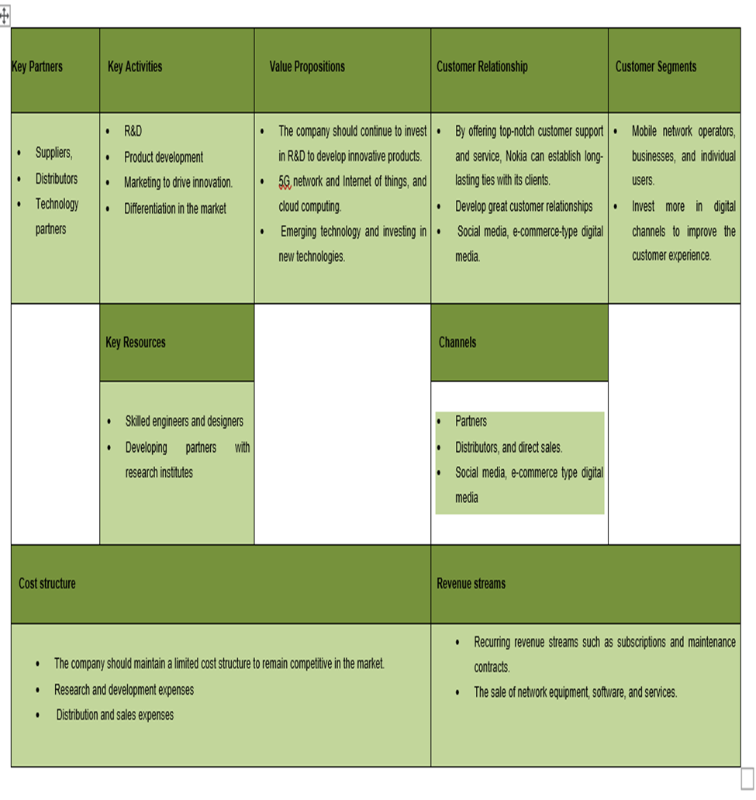

Business Canvas Model

(Source: created by writer)

1. **Value Proposition**

The company should continue to invest in R&D to develop innovative products and services which can change the needs of the customers. For this, the company will be required to focus on emerging technology and investing in new technologies. The business can also enter new markets by utilising its powerful brand and widespread presence (Muhammad, 2022).

1. **Customer Segments**

Nokia Corporation may concentrate on providing services to a range of clientele, including mobile network operators, businesses, and individual users. They should focus more on the customer-centric business model. Successfully reaching these categories, can entail creating specialised marketing plans and sales channels (Muhammad, 2022). Moreover, the company should invest more in digital channels to improve the customer experience.

1. **Channels**

Nokia has access to several distribution channels, including partners, distributors, and direct sales. To enhance the customer experience and offer more individualised service, companies should make investments in digital channels (Muhammad, 2022). The company can leverage social media, e-commerce type digital media to reach customers in innovative ways so that customers can know the offer without going to their website.

1. **Customer Relationship**

By offering top-notch customer support and service, Nokia can establish long-lasting ties with its clients. To promote client loyalty and repeat business, Nokia should give priority to developing great customer relationships. Personalised support like customer service centres, self-service and technical support, can help the company to build a strong connection with their consumer (Bea. N.D.). Moreover, the company can leverage social media, e-commerce type digital media to engage with customers and build loyalty and encourage loyalty.

1. **Key Partners**

To boost its business operations and enter new markets, Nokia can collaborate with a range of businesses, including suppliers, distributors, and technology partners.

1. **Key Activities**

Nokia should focus on key activities such as R&D, product development, and marketing to drive innovation and differentiation in the market (Muhammad, 2022).

1. **Key Resource**

Hiring skilled engineers and designers, developing partners with research institutes and investing in technologies are the key resources of the company where they should invest or improve more.

1. **Cost Structure**

The company should maintain a limited cost structure to remain competitive in the market. This includes research and development, product development and sales and marketing. The reduction of cost can give the company long-term growth and profitability.

1. **Revenue Streams**

The company can generate revenue through recurring revenue streams such as subscriptions and maintenance contracts (Bea. N.D.). By focusing on these key elements, Nokia can create a strong business model that enables it to capitalize on new opportunities in the telecommunications industry and drive growth over the long term.

***Limitations***

The highly competitive nature of the telecommunication industry could make it challenging for Nokia Corporation to differentiate itself and gain market share. Moreover, the rapid technological change could make it difficult for the company to keep up with trends and customer demands. To implicate the recommendation company needs to change some processes and systems which could be difficult for the company for some time. According to the research paper of Ahmed, Hasan and Kamal (2022), the present Brexit, the Ukraine war, and covid give a hard time in the telecommunication industry and manufacturing industry as well. Therefore, the implication of new change can be difficult to make. Moreover, for this reason the laws and regulations are changed in different areas or countries, thus it could be a limitation for the company. There may also be constraints on resources, such as funding and talent, which could simultaneously limit the company's ability to pursue all of these recommendations.

***Timescale for The Change***

The implementation of a new business model canvas could take several years and will require ongoing evaluation and adjustment. Nokia should focus on building partnerships and investing in R&D to drive innovation and differentiate itself from competitors, this can be their short-term goal. For the medium time goal, the company should focus on the customer-centric business model and focus on developing new services. This could be Nokia Corporation’s long-term objective, to prioritise sustainability while continuing to adjust to new trends and technological innovation in the telecommunications sector.

# 6.0 Conclusion

The report is based on the Nokia Corporation and its struggle in the area of improvement. The current business model of Nokia Corporation has been analysed through VRIO, SWOT, and Porter’s Five Force framework, which shows that the company faces several challenges in today’s highly competitive market. After completing the theories such as VRIO Analysis the company struggles to leverage the resource and capabilities to generate sustained competitive advantage, as its competitors have caught up in terms of technology and innovation, but the term of valuable and rare resource lies in the patent portfolio and its strong brand name. From the industry analysis, the company faces strong competition from Apple, Samsung, and Huawei. Moreover, some new recommendations have been also given in the above report as a business canvas model. The recommendations limitations and period are also given. Where it concluded that Nokia Corporation should focus its resources on specific areas of the market where it can sustain a competitive advantage. To create a sustainable competitive edge in a fiercely competitive industry, Nokia needs to more effectively utilise its precious resources and talents. By focusing on specific areas of the market and improving its agility, Nokia can position itself for long-term success.

# Reference List

Ahmed, S., Hasan, M.M. and Kamal, M.R., 2022. Russia–Ukraine crisis: The effects on the European stock market. *European Financial Management*.

Bea, G.H., N.D.HOW DOES SAMSUNG ABLE TO MANAGE SUSTAINABLE CORPORATE BRAND THROUGH CONSUMER LOYALTY? (The customer’s perceived…

Bhandari, K.R., Rana, S., Paul, J. and Salo, J., 2020. Relative exploration and firm performance: Why resource theory alone is not sufficient? *Journal of Business Research*, *118*, pp.363-377.

Ding, Y., 2021, August. Identifying Key Success Factors of International Joint Ventures. In *2021 International Conference on Transformations and Innovations in Business and Education (ICTIBE 2021)* (pp. 250-255). Atlantis Press.

Grünewälder, A., 2014. *Analysis of Nokia‘s Corporate, Business, and Marketing Strategies: Examination of Nokia’s strategy execution in three steps*. diplom. De.

Johnson, G., Scholes, K. and Whittington, R., 2008. *Exploring corporate strategy: Text and cases*. Pearson education.

Marie, A., 2011. Strategic Analysis of Nokia Corporation. *An undergraduate student journal–Volume 3*, p.59.

Muhammad, F., 2022. Pelajaran Rise and Fall Dari Model Bisnis Nokia.

Nokia. 2023. *Get in the Know, now*. [Online]. Available At:<https://www.nokia.com/> . [Accessed On: 07/04/2023]

Nokia. 2023. *Our offices.* [Online]. Available At: <https://www.nokia.com/contact-us/offices/> . [Accessed On: 07/04/2023]

Nokia. 2023. *Our strategy*. [Online]. Available At: <https://www.nokia.com/about-us/strategy/strategy-2023/#:~:text=In%202021%2C%20Nokia%20set%20out,widespread%20digitalization%20is%20gathering%20speed>. [Accessed On: 07/04/2023]

Nokia. 2023. *Product portfolio.* [Online]. Available At: <https://www.nokia.com/networks/products/> . [Accessed On: 07/04/2023].

Nokia. 2023. *We are Nokia.* [Online]. Available At: <https://www.nokia.com/about-us/> . [Accessed On: 07/04/2023]

Nokia. 2023.*Nokia announces first phase of its new strategy, changes to operating model and Group Leadership Team* [Online]. Available At: <https://www.nokia.com/about-us/news/releases/2020/10/29/nokia-announces-first-phase-of-its-new-strategy-changes-to-operating-model-and-group-leadership-team/> . [Accessed On: 07/04/2023]

Osterwalder, A. and Pigneur, Y., 2010. *Business model generation: a handbook for visionaries, game changers, and challengers* (Vol. 1). John Wiley & Sons.

Schwarz, S., 2019. Nokia Go: Future Success Strategy.

# Appendices

## What Did You Do?

Based on the specifications stated in the initial request from Nokia Corporation, I, as a member of the consultant’s group, have carried out a thorough analysis of the internal and external environments of Nokia Corporation using a range of tools and frameworks. To solve these issues, we built a new business canvas model, identified the fundamental causes, and set up a transformation timetable. To assist Nokia Corporation in generating, delivering, and capturing value, we have put up a full consultation report outlining our conclusions and recommendations.

## How Did You Do It?

I initially divided up the jobs and responsibilities depending on the skills and talents of each team member. We have given the most crucial tasks top priority and allocated time for research and analysis to finish the assignment by the deadline. The right tools and frameworks have been used to examine data gathered from various sources to provide a complete picture of Nokia Corporation’s internal and external surroundings. The results and recommendations have then been structured to deliver a detailed consultation report that would be concise and helpful for the customer. We cooperate and communicate well to ensure that the final report was of the highest standard.

## How Well Did You Do?

The success of a project normally agrees with criteria like completing the project deadline, delivering excellent work, and offering practical recommendations that fit the needs of the customer. Some situations that arose during the project have been handled quickly and skilfully to reduce any adverse effects on the outcome. The project's success also depends on our capacity for cooperative work, efficient communication, and maximising each member's unique skills. The performance of my team can be assessed based on our capacity to satisfy the customer's needs and provide value. So, after evaluating this project. My group and I performed well to complete the project.

## Identify the Skills That You Have Used to Complete This Assignment and Identify Any New Skills That You Have Started to Develop During the Assignment.

To complete the assignment everyone has the ability of problem-solving, teamwork, strategic thinking, research and analysis, and good communication. Our group has made use of our current abilities while learning new ones, like mastery of numerous frameworks and analysis tools, creation of a new business canvas model, and development of a timeline for transformation. By using our expertise to solve a problem that the Nokia Corporation faced in the real world, we have also improved our critical thinking abilities. To guarantee that the final report fulfilled the consumer's expectations, we need to collaborate and communicate effectively. This all the skills we have used to complete the assignment.

## How Did the Process of Completing the Assignment Enhance These Skills?

The assignment's completion has improved the consultant team's skills in several ways. My group gained a deeper knowledge of the resource-based view, VRIO analysis, SWOT analysis, Porter's Five Forces analysis, and 4P market analysis frameworks had it conducted an in-depth study and analysis. This has enhanced our capacity for critical thought, problem-solving, and strategic thinking. Our project management capabilities have improved because we developed a new business canvas model and a changing schedule. Our collaboration and communication abilities have improved due to working together and communicating clearly with team members. Finally, my group had the chance to improve our communication skills and receive insightful feedback on our work by presenting the consultancy report to Nokia Corporation.

1. **If you were to undertake a similar group assignment at a future date, what improvements would you make?**

The improvements that I make for a similar group task would include better planning and time management to ensure that deadlines are met, clear roles and obligations for team members, and excellent communication to eliminate confusion or duplication of effort. I also consider using collaboration software and project management tools to improve communication and optimise the work process. As the project advances, I also ask for feedback from the customer and one another to make sure we are fulfilling expectations and to adjust the direction of the project if required.