**LCLM4001**

**Academic Skills (ACS)**

**Time Management**

**Task 2 of 3: Academic report**

**HOW CAN STUDENTS IMPROVE THEIR TIME MANAGEMENT SKILLS?**

**Executive summary**

Time management is an important factor for both students and professionals, as this boosts productivity, reduces stress and helps to maintain work life balance. Students can make proper study plans, can divide tasks into smaller chunks and can focus on decision making in order to improve their time management skills.

**Table of Contents**

Introduction 3

Purpose of the report 3

Reasons why students struggle with time management 3

Importance of time management skills to students and professionals 3

Own time management skills 4

Recommendations 5

Conclusion 6

References 7

# Introduction

Time management skill is important for students as this helps to increase focus and helps improve productivity. The report focuses on reasons for which students struggle with time management along with its importance. Furthermore, this paper sheds light on time management skills by four various time management techniques and tools. Lastly, this paper focuses on the ways by which CertHE business students can improve time management skills.

# Purpose of the report

The purpose of this report is to discuss the procedure by which students can improve their time management skills. Moreover, the purpose of this paper is also to determine the challenges that students face during time management.

# Reasons why students struggle with time management

Struggling to manage time can make obstacles in meeting goals for students. As per the view of Ibrahim and El Zaatari (2020, p.383), lack of discipline is a cause for struggling with time management by students during their studies. Lack of discipline makes hazards in priority setting for students and this hampers time management in an effective manner. On the other hand, another reason for struggling with time management is procrastination or avoiding tasks by students (Utami *et al*. 2020, p7). Such behaviours rise among students due to fear of failure, lack of motivation and more hangout with friends. Besides, according to Kumar (2021, p67), focusing on a fickle thing and not focusing on a point is another reason for poor time management by students. In recent times, students place more focus on social media updates and this disrupted their focus. About 60% of students across the world spend an average 6 hours daily on social media (Statista.com, 2022). This causes mental disruption among students and they struggle with time management.

# Importance of time management skills to students and professionals

Effective time management skills help in accomplishments of bigger results to students and professionals. Time management skills are effective for reduction of stress level among students and professionals and these help to boost confidence level. As per the view of Al-Marri (2019, p.35), good time management skills help to meet deadlines as this helps in implementation of proper planning and this contributes in reduction of stress. Less stress level increases productivity and helps to maintain work life balance. Proper time management skills provide students and professionals time freedom and they can utilise time in doing productive activity and this helps to achieve bigger goals. As per the view of Liu and Da (2020, p.112), time freedom provides opportunity to spend time with family and friends and this helps in the improvement of relationships. Time management skills help in improvement of focus and boost productivity of students and professionals.

# Own time management skills

Time management helps to keep control of work and social activities. I have managed my time during study at UWTSD by allocating time to my study and by balancing my time requirements at various aspects in my life. Moreover, I have applied time management tools such as “Pomodoro technique”and “Eisenhower decision matrix” from my class and “priority matrix” and “task breakdown tool” from my research and reading. I have applied the “Pomodoro technique” in order to break my regular days into smaller chunks as I can maintain my study in UWTSD and my personal working in an appropriate manner. In the view of Ismail et al. (2022, p.75), “pomodoro technique” refers to a time management process based on 25 minute stretches and works are broken into 5 min breaks. This has improved my concentration which has helped me a lot in my study.

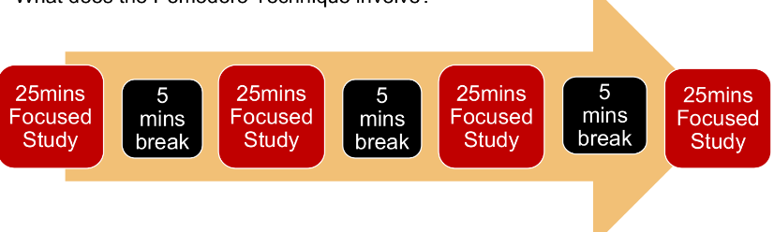

**Figure 1: Pomodoro technique**

(Source: Class material)

I have used the “Eisenhower decision matrix” as this helps me to prioritise and organise my study by urgency and importance. As per the view of Bonnesen et al. (2023, p.1754), “Eisenhower decision matrix” consists of four quadrants which helps to put the hours in important tasks and use time effectively. With the application of this time management tool during my UWTSD study I have divided my tasks according to importance and unimportant and this has helped me to complete my study effectively.

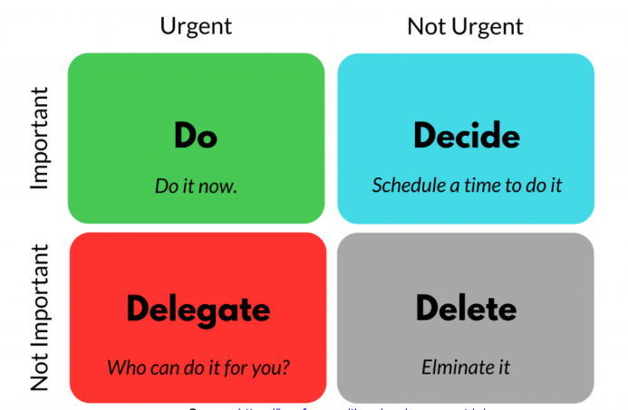

**Figure 2: Eisenhower decision matrix**

(Source: Class material)

I have used a time management tool known as “priority matrix” to prioritise my tasks in my study in UWTSD. As per the view of Khatib et al. (2020, p.4971), “priority matrix” helps in determination of tasks which need smaller energy and provides big outcomes. I have easily met my deadline tasks in my study by using this tool.

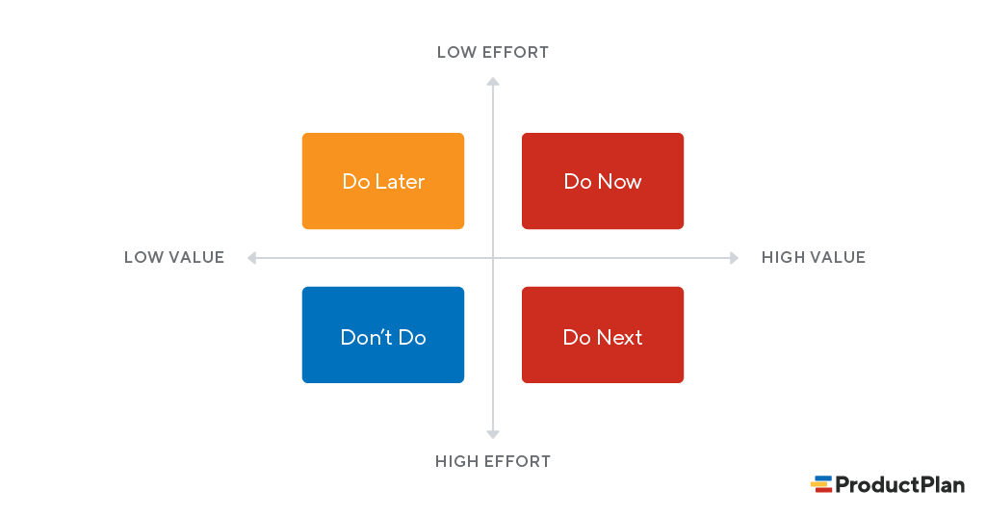

**Figure 3: Priority matrix**

I have used a “task breakdown tool” in my UWTSD study to break large tasks into smaller ones. This has increased my focus on my study and helped me to complete my task in specified time. Improving focus has also reduced my stress as this tool helps me in effective time management.

# Recommendations

Improvement of time management skills is essential for reduction of wastage of time. As per the view of Akhmetshin *et al.* (2019, p.3), in order to improve time management skills students need to make a proper study plan. An appropriate study plan is effective to increase motivation and focus of students towards their study. Moreover, according to Dondi *et al.* (2021, p.25), time management skills of students can also be developed if they divide their tasks into small chunks. This might be helpful for students to make appropriate study goals and they might get visualisation to meet these goals. In the view of Schildkamp (2019, p.257), students might focus on decision making as this is important for improvement of time management skills. This might provide power to students to handle tasks and also helps in improvement of time management skills.

# Conclusion

Time management is an important consideration as this can increase productivity of students. Students and professionals struggle to manage time due to lack of discipline, fear of failure and focusing on fickle things. Various time management tools are effective for students to manage their time in study. Students can make study plans and divide their tasks into small segments for improvement of time management skills.

# References

Akhmetshin, E.M., Mueller, J.E., Yumashev, A.V., Kozachek, A.V., Prikhodko, A.N. and Safonova, E.E., (2019). Acquisition of entrepreneurial skills and competences: Curriculum development and evaluation for higher education. *Journal of Entrepreneurship Education*, *22*(1), pp.1-12.

Al-Marri, S.H., (2019). *Effective time management and Organisational performance: A case study of Qatar non-governmental organisations (NGOs)*.

Bonnesen, C.T., Thygesen, L.C., Rod, N.H., Toftager, M., Madsen, K.R., Jensen, M.P., Rosing, J.A., Wehner, S.K., Due, P. and Krølner, R.F., (2023). Preventing Stress among High School Students in Denmark through the Multicomponent Healthy High School Intervention—The Effectiveness at First Follow-Up. *International Journal of Environmental Research and Public Health*, *20*(3), p.1754.

Dondi, M., Klier, J., Panier, F. and Schubert, J., (2021). Defining the skills citizens will need in the future world of work. *McKinsey & Company*, *25*.

Ibrahim, A. and El Zaatari, W., (2020). The teacher–student relationship and adolescents’ sense of school belonging. *International Journal of Adolescence and Youth*, *25*(1), pp.382-395.

Ismail, N.M., Putri, Z. and Noviyanti, A., (2022). Pomodoro Technique Analysis in Zoom-Based Classrooms. *JEELS (Journal of English Education and Linguistics Studies)*, *9*(1), pp.75-96.

Khatib, M., Al Khudir, K. and De Luca, A., (2020). Task priority matrix at the acceleration level: Collision avoidance under relaxed constraints. *IEEE Robotics and Automation Letters*, *5*(3), pp.4970-4977.

Kumar, S., (2021). Communication Skills and Soft Skills An Integrated Approach.

Liu, H. and Da, S., (2020). The relationships between leisure and happiness-A graphic elicitation method. *Leisure Studies*, *39*(1), pp.111-130.

Schildkamp, K., (2019). Data-based decision-making for school improvement: Research insights and gaps. *Educational research*, *61*(3), pp.257-273.

Statista.com, (2022) *Students spend time on social media.* Available at: <https://www.statista.com/statistics/708477/proportion-of-students-spending-six-or-more-hours-per-week-on-social-media-by-gender-us/> [Accessed on 27th March, 2023]

Utami, M.D., Arbiansyah, T.P.T. and Hidayati, Y.N., (2020). Influence of stress and self regulated learning on academic procrastination. *European Journal of Education Studies*, *7*(7).