**OPERATIONS MANAGEMENT**

**TASK 1**

**Executive Summary**

This operation management report discusses the three organisations such as Accenture, Volkswagen, and HSBC. The entire report is based on four sections and all four sections are discussed different aspects. They have discussed the interrelationship of the operation with the information system as well as human resource management. The operations impact with other functions for these three organisations is also evaluated in this report. The 4 V's model to determine some challenges faced by these companies are elaborate here with proper justification. The sustainable business operation with three major levels Societal Level, Strategic Level, and Operational Level is discussed with Accenture and HSBC brand in this report. The total quality management for Volkswagen is based on ISO9001 and this helps in optimisation of performance as this improves expert knowledge and ability of employees. LEAN approaches in Volkswagen help in improvement of employee engagement and this contributes to a better performance optimisation. The S&OP process helps to manage supply chain relationships as this increases transparency.

Table of Contents

Section 1 4

1(a) Interrelationship of Operations with Human Resource Management and Information Systems 4

Volkswagen 4

Accenture 5

HSBC 5

1(b) Impact of Processes and Operations on Other Functions for Volkswagen 6

Sales and Marketing 6

Product or Service Development 7

Section 2 8

2(a) Application of the ‘Four Vs’ Model for determining the Challenges faced in Operation Management 8

Volkswagen 8

Accenture 8

HSBC 9

2(b) Sustainable Business Operations of Accenture and HSBC 9

Societal Level 9

Strategic Level 10

Operational Level 10

Section 3 10

3(a) Role of Total Quality Management for Performance Optimisation of Volkswagen 10

Role of LEAN Approaches for Performance Optimisation 11

3(b) Benefits and Limitations of the Approaches for Performance Optimisation 12

Section 4 13

4(a) Implementation of Sales and Operations Planning Process in Volkswagen and Accenture 13

4(b) Impact on Supply Chain Relationship 14

References 16

# 

# Section 1

## 1(a) Interrelationship of Operations with Human Resource Management and Information Systems

### Volkswagen

The corporate strategy of Volkswagen is to become a perfect automobile producer as well as to lead on sustainability in the next few years. In terms of meeting the corporate strategy, this organisation will need a resilient, effective, as well as creative workforce to develop as an attractive brand. According to Bag and Gupta, (2020), the human resource and its strategic management have met the expectation in some key areas, and are pursued by the Volkswagen brand. Human resources and operations are related to the fundamental level that is context affecting Volkswagen’s human resources.

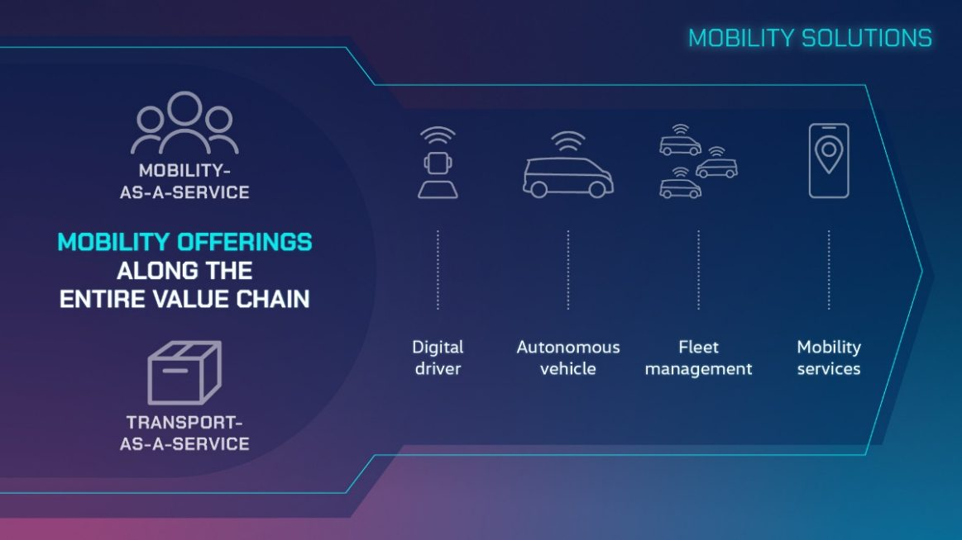

**Figure 1: the mobility solution of Volkswagen**

(Source: Volkswagen, 2023a)

Human resources and operations are related at the fundamental level and the operational context, which frequently moderates the human resource effects such as training, pay, communication, as well as staffing. In the human resource practice of Volkswagen, they focus on comprehensive participation and corporate governance rights for every employee (Khalil and Belitski, 2020). The HR management has provided proper guidance for the workforce of Volkswagen. Using IT as the human resource of this organisation is crucial to meet every kind of organisational demand with such qualified employees supporting their organisation.

### Accenture

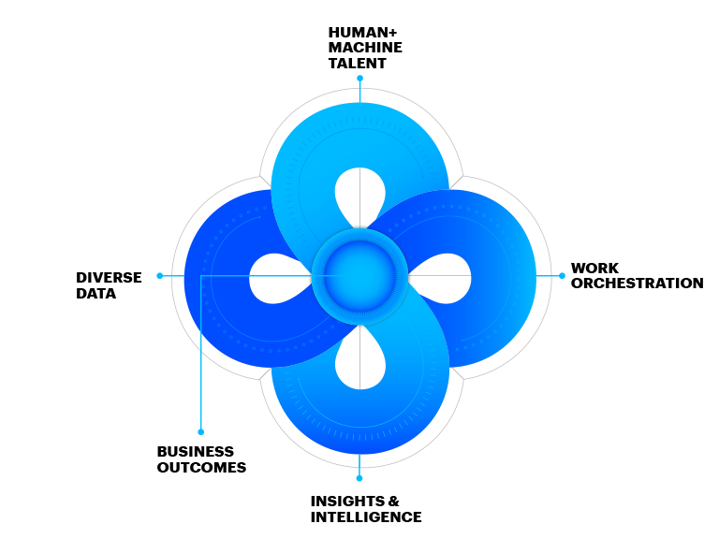

**Figure 2: SynOps power of Accenture**

(Source: Accenture, 2019)

HR operations and the intelligent talent of Accenture's workforce have been triggering such a fresh look to increase the overall workforce performance as well as transforming the HR services while the technologies of Accenture are creating some new HR function opportunities. It has been increasing the entire workforce experience for engaging, attracting, and retaining talent (Accenture.com, 2021). Human resource operations always help the HR leaders and talent to enhance their workforce perforce performance for delivering new business value levels. Using the SynOps power for HR, Accenture creates such consumer-inspired experiences to deliver in a specific moment that is driven by digital engagement, technology, and analytic insights. SAP HANA is the strategic “information system” that is used by Accenture for its working purposes (Ikumoro and Jawad, 2019). The operations in Accenture are mainly focused on employee retention and engagement and management and leadership strategies.

### HSBC

Enhancing globalisation is creating awareness of managers' requirements for being sensitive to the cultural aspect of HRM. The HR management in the HSBC bank has been defined as proper organisational functions, which deal with some problems in HSBC that are either related to management or employees such as hiring, compensation, organisational development and more.

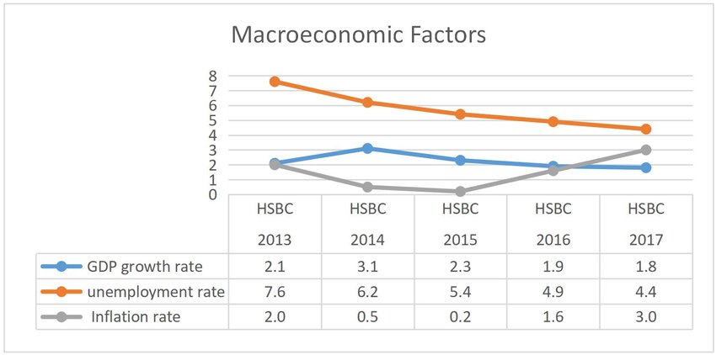

**Figure 3: The macro-economic factors of HSBC**

(Source: Jun 2019)

The primary difference between HR and the operation of HSBC is that this organisation mainly focused on the ethics, legal compliance, and structural organisation of all employees (Chen and Lai, 2019). However, people operations are concerned with strategies and results for effective management and employee engagement. The HR managers of HSBC design, oversee, and implement every process with the human resource department.

## 1(b) Impact of Processes and Operations on Other Functions for Volkswagen

### Sales and Marketing

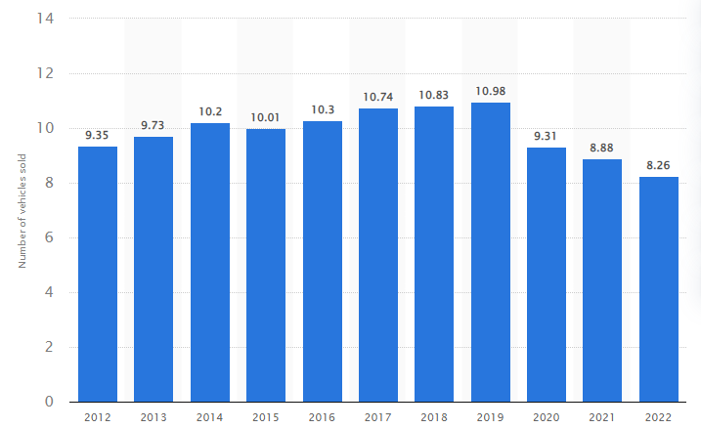

**Figure 4: Vehicle delivery of Volkswagen worldwide**

(Source: Statista, 2019)

As part of its electrification campaigns of Volkswagen, they aim to offer its customers worldwide nearly 70 battery-electric cars and around 6 hybrid models by the year 2030. However, this particular campaign would complement by customer-focused offering, vehicle-related as like customised to charge the infrastructure solutions. The Volkswagen brand, therefore, transformed from an automotive manufacturer to a mobility provider. In the entire car market of Germany, they declined by nearly 10.1% in the reporting period (Annual Report, 2023). The business fleet of their customers accounted for around 16.6% of overall registration. In addition to the individual service of Volkswagen, their timely genuine parts provision is crucial and necessary for assuring their passenger car in after the sales. In the opinion of Das *et al.* (2020), transportation of electrification by Volkswagen is a main area of this organisation. EVS of this organisation is taking over the overall market share of “internal combustion engine vehicles”'.

### Product or Service Development

Volkswagen Group sells passenger cars that are under the Bentley, Audi, Lamborghini, Cupra, Skoda as well as the Volkswagen brands. “Pork Sausage” is the most common product that is sold by Volkswagen (Ikumoro and Jawad, 2019). This group has around 10 brands from 5 European nations.

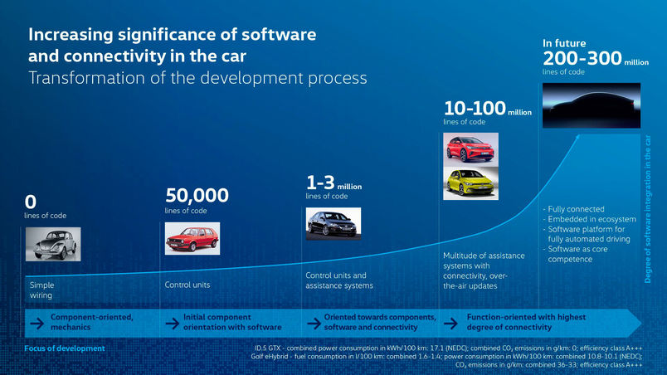

**Figure 5: The development process of Volkswagen and its transformation**

(Source: Volkswagen, 2023)

Transformation towards the technological brands has started such that the development and future development of Volkswagen is shortened by nearly 25% to 40 months from 54 months (Volkswagen, 2023). Several employees are undergoing training in the new work field and more will be done similarly in the years to come. Volkswagen would spend around £800 million on its “Campus Sandkamp” in the next few years (Volkswagen, 2023). However, the ultra-modern and the new development centre would as well raise the vehicle development bar. However, by accelerating the overall development process, it would be focused systematically on the consumer requirements for particular jobs. This brand and all its products are properly assembled, well-equipped, safe, as well as cheap, ultimately making it a preferred brand in the world.

# Section 2

## 2(a) Application of the ‘Four Vs’ Model for determining the Challenges faced in Operation Management

### Volkswagen

This brand has some common issues regarding overheating, but they actually could have ABS failures, coolant leaks, and electrical issues. In terms of controlling the shareholder, there was a crucial structural issue with the VW board, which was the presence of the government as a shareholder. The 4 V's are 4 dimensions, which are determined as fundamentally the nature of business operations. As per the view of Babu *et al.* (2021), it allows Volkswagen to compare, categorise, and understand its structure, nature, approaches, and challenges. On the other hand, Arfat*et al*. (2020) asserted that in the supply chain, big data lies in the middle of each process. Variety, volume, visibility, and variation are four dimensions of the operation. These dimensions could be used for assessing various kinds of business operations as well as understanding how to operate the dimension in an organisation. The operation management of Volkswagen has comprised lean manufacturing to reconfigure the overall manufacturing system.

### Accenture

The Accenture strategy has been operated in technology and business intersection. They bring together their capabilities in technology, business, function strategy, and operation to assist their client to envision that as well support the enterprise as a vast transformation. In the opinion of SAVIĆ, (2020), the operating model in Accenture is a visual representation to deliver value to its external and internal customers. However, the 4 V's model and its volume have a great impact on Accenture and its operational management. Based on their experience with Accenture, they recognized their 4 levels of operation maturity such as efficient, stable, future-ready, and predictive. In terms of understanding the connection between the performance and business operations, Accenture surveyed over 1100 C-suites across 13 industries and 11 countries (Accenture, 2022). Accenture has outlined a path for its greater business performance by thor data and technology, people, and fast-tracking maturity that with the intelligent operation. This brand will be organising the capabilities as market-leading towards some specific services such as consulting and strategy, technology, interactive, and operations.

### HSBC

AI and big data have assisted businesses with their decision-making. They as well assist most organisations to create new processes and products or develop existing ones. As data amount has grown exponentially as well as the data shortage and cost have dropped, artificial intelligence is predicted to have a large potential for the banks (HSBC, 2021). Opening up the opportunity world, HSBC is the value difference that seeks out various perspectives. The strategy of HSBC has supported its ambition for being a preferred global financial partner for its clients.

## 2(b) Sustainable Business Operations of Accenture and HSBC

### 

**Figure 6: Factors affecting HSBC and Accenture’s business operation**

(Source: Influenced by Ukko*et al.* 2019)

### Societal Level

As part of its mission, Accenture has been infusing its sustainability into everything that they do. Through a combination of technology and human ingenuity, Accenture makes sustainability a change of force. However, HSBC aims to achieve “Net Zero” in their supply chain and operations by 2030 (HSBC, 2021). The societal business operation is the perfect economic tool that is addressed to the finance, government, and insurance sector to establish a responsible, sustainable, and social economy in Accenture and HSBC.

### Strategic Level

An operation strategy of a business of HSBC and Accenture is a process of decision-making that particularly shapes a long-term plan of these organisations for achieving all the objectives. This has comprised a particular actions management for taking a particular aspect of the strategic operation. As per the view of Ukko*et al.* (2019), the operation strategy level in Accenture is used to accomplish all the related objectives in sustainable business. However, by developing the operation strategy of Accenture, they could implement and evaluate the effective system for use of many business operations resources.

### Operational Level

The operation management bin HSBC as well Accenture has included three major levels such as operations, strategic, and tactical. This level in Accenture has defined its goals and its tactical level has outlined the proper plan to implement the operational level. However, the operation level of HSBC contains regular operations that are needed for producing all the desired outcomes (Saragih*et al.* 2020). The operation management of HSBC and its sustainability could be categorised into major levels such as strategic management, long-term management, and top-level management.

# Section 3

## 3(a) Role of Total Quality Management for Performance Optimisation of Volkswagen

Total quality management refers to a method to oversee various tasks and activities such as production procedure, recognition of employees’ performance in a company to ensure consistent service. Volkswagen’s total quality management is based on the standard ISO9001 to obtain licence and approval to manufacture and sell vehicles (Volkswagen ag.com, 2022). The total quality management of Volkswagen is part of its future program “TOGETHER- strategy 2025”. TQM helps in performance optimisation for Volkswagen as this inspects the quality of service and helps in system audit. Moreover, TQM plays an important role in Volkswagen as this helps in improvement of expert knowledge and ability of employees which contributes to enhancement of performance. As per the view of Abbas (2020), total quality management helps in quality planning and quality assurance in an organisation. Total quality management plays an essential role as this provides an opportunity to Volkswagen to give vocational training to employees and this helps in proper performance optimisation. Volkswagen aims to improve performance level by 30% in 2025 by total quality management procedure (Volkswagenag.com, 2022). Total quality management helps Volkswagen to provide mutual support and control between various divisions and this helps in performance optimisation.

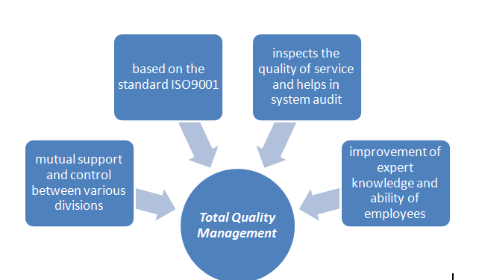

**Figure 7: TQM in Volkswagen**

(Source: Created by author)

### Role of LEAN Approaches for Performance Optimisation

The primary purpose of LEAN approaches is to make values for customers by optimisation of resources. As per the view of Mohan *et al.* (2022), LEAN approaches help business to maximise values and to minimise wastes. LEAN approaches in Volkswagen help in enhancement of commitment of employees and development of manufacturing process which contribute in better performance optimisation. Volkswagen focuses on lean six sigma training program and has adopted LEAN approaches in its manufacturing procedure to remove unuseful steps in production process (Volkswagenag.com, 2022). LEAN approaches help to optimise performance for Volkswagen and thus this company has received “lean and green management award 2019” (Volkswagen-newsroom.com, 2022). LEAN approaches help Volkswagen to increase employee engagement and this has improved the performance level of employees. Moreover, LEAN approaches provide an opportunity to Volkswagen to recognise persistence work and this helps in improvement of performance level as this helps in evaluation of performance. As per the view of Mohan *et al.* (2022), LEAN approaches improve efficiency, reduce waste and increase productivity of an organisation. LEAN approaches help Volkswagen to improve quality and innovation and this contributes in development of performance of employees and the entire company.

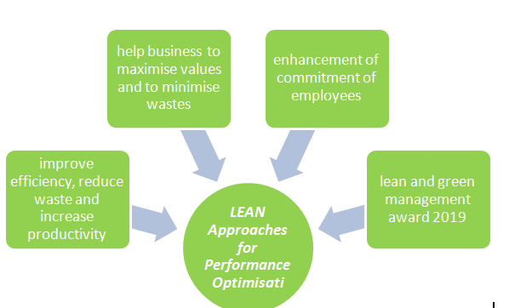

**Figure 8: LEAN approaches in Volkswagen**

(Source: Created by author)

## 3(b) Benefits and Limitations of the Approaches for Performance Optimisation

***Benefits***

TQM is effective for Volkswagen for reduction of costs and increasing profitability of business. Volkswagen has reduced its costs by $3.4 billion and operating return sales increase to 3.4% in 2022 due to TQM (Volkswagenag.com, 2022). On the other hand, LEAN approaches are also effective for Volkswagen for enhancement of efficiency and betterment of performance level. Operating results of Volkswagen have increased to EUR 513 million in 2022 due to adoption of LEAN approaches in its manufacturing procedure (Volkswagenag.com, 2022). Both TQM and LEAN approaches help Volkswagen to increase efficiency and this contributes to a better performance optimisation.

TQM is effective for Volkswagen for promotion of innovative processes which help in better optimisation of performance. Volkswagen Group has focused on new ways of technology development in the deeptech area and its innovation has formed the basis of the global innovation ecosystem (Volkswagenag.com, 2022). Innovation helps in improvement of performance level in Volkswagen. Besides, LEAN approaches help in enhancement of flexibility of business process and this helps in better performance optimisation in Volkswagen.

***Limitation***

TQM and LEAN approaches both have limitations and this has reduced performance optimisation of a company. Volkswagen needs to make a strong commitment to adopt TQM effectively. Without strong commitment, Volkswagen efforts to manage better quality can be hampered and this also can reduce performance optimisation. As per the view of Saffar and Obeidat (2020), commitment in quality management helps in evaluation of processes and this helps to achieve a desired result. However, LEAN approaches need a proper IT system and without proper IT system, proper planning and strategy formulation cannot be adopted by Volkswagen and this might hamper performance optimisation. As per the view of Ikumapayi *et al.* (2020), the IT system in LEAN approaches helps to monitor what is happening in the entire business environment. On the other hand, lack of appropriate resources like human resource and proper framework is another limitation of TQM and this disrupts performance optimisation for Volkswagen. Without appropriate resources, Volkswagen cannot measure the success of TQM and this can hamper performance optimisation for this company. On the contrary, LEAN approaches need operational changes which are not supported by employees. This might make problems in handling of management and can reduce performance optimisation level.

# Section 4

## 4(a) Implementation of Sales and Operations Planning Process in Volkswagen and Accenture

Sales and operations planning process help in alignment of demands, supply and financial planning of a company which helps to meet customers’ expectations. As per the view of Goh and Eldridge (2019), S&OP supports executive decision making and also helps in production and supply planning. Volkswagen focuses on e-mobility and digitisation as an S&OP process. Volkswagen has increased sales rate by about 12.3% in 2022 due to the S&OP process (Volkswagenag.com, 2022). Moreover, Volkswagen deals with decentralisation of the organisation to meet the changes in the global market and this is an important S&OP process in this company (Volkswagenag.com, 2022). This S&OP process in Volkswagen helps in creation of a strong value chain and to balance demand and supply which helps in meeting customers’ expectations. As per the view of Özkanlısoy and Akkartal (2021), S&OP process helps businesses in adoption of appropriate strategy and helps to maintain proper marketing and communication. Volkswagen focuses on creation of a new team platform as an effective S&OP procedure to meet the demands of the market. Customers of Volkswagen wants EV and this is meet by this company with new team platform. This new team platform is effective for this company to determine the demands of customers and this helps in meeting their expectations. Moreover, the S&OP process in Volkswagen helps in the improvement of transparency of the business procedure and this helps to meet customers' demand.

The S&OP process in Accenture is an important consideration as this helps in reviewing the present planning procedure and determination of gaps. As per the view of Strandberg and Åsenius (2022), the S&OP process in planning infrastructure and determining demand and supply variability. Accenture focuses on conceptual models for its S&OP process. Accenture deals with cultural mindset as a S&OP process for making an efficient team (Accenture.com, 2022). This helps to support communication with employees and thus helps in meeting their expectations. Moreover, Accenture focuses on an appropriate S&OP team which helps in effective decision and planning which helps to meet customers’ demand. An effective decision and planning helps to maintain a balance between demand and supply. This helps to meet expectations of customers as this helps to build a collaborative mindset among employees in this company.

## 4(b) Impact on Supply Chain Relationship

Supply chain management refers to the process of management of flow of goods, data and finance from procurement of raw materials to final destination of a product. As per the view of Kumar *et al.* (2020), supply chain management consists of various elements such as procurement, operation, distribution and integration. With implementation of the S&OP process by Volkswagen, this company focuses on supply chain relationships in an effective manner as this helps in optimisation of the supply chain process. Volkswagen deals with removal of error in supply chain procedure and maintaining of social and ecological standards to make a good relationship in its supply chain process (Volkswagen-newsroom.com, 2022). However, implementation of the S&OP provides an opportunity to Volkswagen to use block chain technology in its supply chain process which helps to increase transparency of the supply chain. Improvement of the supply chain helps Volkswagen to maintain a good relationship in its supply chain procedure. Volkswagen has collaborated with Minesspider in 2019 to evaluate the supply chain procedure of this company (Volkswagen-newsroom.com, 2022). Moreover, Volkswagen has focused on digitisation of its supply chain procedure to increase transparency and to maintain a good relationship. S&OP helps Volkswagen in appropriate demand planning and supply planning and this helps to maintain a better supply chain relationship. However, proper commitments required by Volkswagen for implementation of S&OP. Otherwise, less commitment might not be effective for making relationships in the supply chain.

Accenture increases its visibility in the supply chain network by implementation of the S&OP process which helps to make a good relationship in the supply chain. However, transparent operation is required by Accenture to increase visibility, else if this can reduce relationships in the supply chain. Accenture deals with better decisions in the supply chain process to mitigate risks and manage disruption in supply chain procedure (Accenture.com, 2022). On the other hand, Accenture makes digital transformation of its supply chain procedure through its S&OP process and this helps to manage supply chain relationships in an appropriate manner.

# References

6sigma.us, (2022) *LEAN approaches in Volkswagen* Available at: <https://www.6sigma.us/customer/volkswagen/#:~:text=Volkswagen%20and%20over%205%2C000%20organizations,Lean%20and%20Six%20Sigma%20methodologies>. [Accessed on 3rd April, 2023]

Abbas, J., (2020). Impact of total quality management on corporate green performance through the mediating role of corporate social responsibility. *Journal of Cleaner Production*, *242*, p.118458.

Accenture (2022). *Accenture | New insights. Tangible outcomes. New Applied Now*. [online] www.accenture.com. Available at: https://www.accenture.com [Accessed on: 10 April 2023].

Accenture.com (2021). *SynOps for Talent and HR*. [online] www.accenture.com. Available at: https://www.accenture.com/in-en/services/business-process-services/talent-hr-outsourcing [Accessed on: 10 April 2023].

Accenture.com, (2022) *S&OP process in Accenture* Available at: <https://www.accenture.com/us-en/insight-driving-growth-competitiveness-consumer-companies> [Accessed on 3rd April, 2023]

Accenture.com, (2022) *Supply chain relationship in Accenture* Available at: <https://www.accenture.com/us-en/insights/supply-chain-operations/supply-chain-management-operations-index#:~:text=We%20help%20clients%20create%20enduring,business%2C%20society%20and%20the%20planet.&text=Visibility%20elevates%20supply%20networks%20to,and%20performance%E2%80%94and%20much%20more>. [Accessed on 3rd April, 2023]

Annual Report (2023). *Sales and Marketing - Volkswagen Group Annual Report 2021*. [online] annualreport2021.volkswagenag.com. Available at: https://annualreport2021.volkswagenag.com/group-management-report/sustainable-value-enhancement/sales-and-marketing.html [Accessed on: 10 April 2023].

Annual Report 2018.volkswagen ag.com, (2022) *Quality management of Volkswagen* Available at: <https://annualreport2018.volkswagenag.com/group-management-report/sustainable-value-enhancement/group-quality-management.html> [Accessed on 3rd April, 2023]

Arfat, Y., Usman, S., Mehmood, R. and Katib, I., (2020). Big data for smart infrastructure design: Opportunities and challenges. *Smart Infrastructure and Applications: Foundations for Smarter Cities and Societies*, pp.491-518.

Babu, M.M., Rahman, M., Alam, A. and Dey, B.L., (2021). Exploring big data-driven innovation in the manufacturing sector: evidence from UK firms. *Annals of Operations Research*, pp.1-28.

Bag, S. and Gupta, S., (2020). Examining the effect of green human capital availability in adoption of reverse logistics and remanufacturing operations performance. *International Journal of Manpower*, *41*(7), pp.1097-1117.

Chen, Y. and Lai, J., (2019), May. Information and Personal Networking in Decision-making Process: the Case of HSBC. In *2019 International Conference on Management, Education Technology and Economics (ICMETE 2019)* (pp. 523-526). Atlantis Press.

Das, H.S., Rahman, M.M., Li, S. and Tan, C.W., (2020). Electric vehicles standards, charging infrastructure, and impact on grid integration: A technological review. *Renewable and Sustainable Energy Reviews*, *120*, p.109618.

Goh, S.H. and Eldridge, S., (2019). Sales and Operations Planning: The effect of coordination mechanisms on supply chain performance. *International Journal of Production Economics*, *214*, pp.80-94.

HSBC (2021). *Purpose, values and strategy | HSBC Holdings plc*. [online] www.hsbc.com. Available at: https://www.hsbc.com/who-we-are/purpose-values-and-strategy [Accessed 10 Apr. 2023].

Ikumapayi, O.M., Akinlabi, E.T., Mwema, F.M. and Ogbonna, O.S., (2020). Six sigma versus lean manufacturing–An overview. *Materials Today: Proceedings*, *26*, pp.3275-3281.

Ikumoro, A.O. and Jawad, M.S., (2019). Intention to use intelligent conversational agents in e-commerce among Malaysian SMEs: an integrated conceptual framework based on tri-theories including unified theory of acceptance, use of technology (UTAUT), and TOE. *International Journal of Academic Research in Business and Social Sciences*, *9*(11), pp.205-235.

Jun, F., (2019). *Study of Relationship Between Credit Risk (Non-Performing Finance Ratio) and Internal and External Factors in HSBC Bank*. SSRN.

Khalil, S. and Belitski, M., (2020). Dynamic capabilities for firm performance under the information technology governance framework. *European Business Review*, *32*(2), pp.129-157.

Kumar, R., Ganapathy, L., Gokhale, R. and Tiwari, M.K., (2020). Quantitative approaches for the integration of production and distribution planning in the supply chain: a systematic literature review. *International Journal of Production Research*, *58*(11), pp.3527-3553.

Mohan, J., Rathi, R., Kaswan, M.S. and Nain, S.S., (2022). Green lean six sigma journey: Conceptualization and realization. *Materials Today: Proceedings*, *50*, pp.1991-1998.

Mohan, J., Rathi, R., Kaswan, M.S. and Nain, S.S., (2022). Green lean six sigma journey: Conceptualization and realization. *Materials Today: Proceedings*, *50*, pp.1991-1998.

Özkanlısoy, Ö. and Akkartal, E., (2021). Digital transformation in supply chains: Current applications, contributions and challenges. *Business & Management Studies: An International Journal*, *9*(1), pp.32-55.

Saffar, N. and Obeidat, A., (2020). The effect of total quality management practices on employee performance: The moderating role of knowledge sharing. *Management Science Letters*, *10*(1), pp.77-90.

Saragih, J., Tarigan, A., Silalahi, E.F., Wardati, J. and Pratama, I., (2020). Supply chain operational capability and supply chain operational performance: Does the supply chain management and supply chain integration matters. *Int. J Sup. Chain. Mgt Vol*, *9*(4), pp.1222-1229.

SAVIĆ, D., (2020). RETHINKING THE ROLE OF INFORMATION IN THE FOURTH INDUSTRIAL REVOLUTION. *THE IMPACTS OF DIGITAL TRANSFORMATION*, p.35.

Statista (2019). *Volkswagen car sales 2018 | Statista*. [online] www.statista.com. Available at: https://www.statista.com/statistics/272049/worldwide-vehicle-sales-of-volkswagen-since-2006/ [Accessed 10 Apr. 2023].

Strandberg, E. and Åsenius, I., (2022). Managing Demand Variability by Distinguishing Between Internal and External Variability: Investigating the Requirements for Managing Demand through Demand Shaping in B2B Companies.

Ukko, J., Nasiri, M., Saunila, M. and Rantala, T., (2019). Sustainability strategy as a moderator in the relationship between digital business strategy and financial performance. *Journal of Cleaner Production*, *236*, p.117626.

Volkswagen (2023a). *Mobility Solutions*. [online] www.volkswagenag.com. Available at: https://www.volkswagenag.com/en/strategy/mobility-solutions.html# [Accessed on: 10 April 2023].

Volkswagenag.com, (2022) *innovation in Volkswagen* Available at: <https://www.volkswagenag.com/en/group/group-innovation.html#:~:text=Since%202019%2C%20Volkswagen%20Group%20Innovation,in%20the%20Deep%20Tech%20area>. [Accessed on 3rd April, 2023]

Volkswagenag.com, (2022) *Sales and operations planning process of Volkswagen* Available at: <https://www.volkswagenag.com/en/strategy.html#:~:text=With%20the%20Group%20strategy%20NEW,into%20a%20software%2Doriented%20company>. [Accessed on 3rd April, 2023]

Volkswagenag.com, (2022) *Volkswagen Group* Available at: [https://www.volkswagenag.com/en/news/stories/2019/02/productivity-and-efficiency-at-volkswagen-production.html#](https://www.volkswagenag.com/en/news/stories/2019/02/productivity-and-efficiency-at-volkswagen-production.html) [Accessed on 3rd April, 2023]

Volkswagenag.com, (2022) *Volkswagen improves cost efficiency and economic efficiency in a tough environment* Avilable at: <https://www.volkswagenag.com/en/news/2022/05/Volkswagen_improves_cost_efficiency_and_economic_efficiency_in_a_tough_environment.html> [Accessed on 3rd April, 2023]

Volkswagen-newsroom.com, (2022) *Supply chain relationship in Volkswagen* Avilable at: m<https://www.volkswagen-newsroom.com/en/press-releases/from-mine-to-factory-volkswagen-makes-supply-chain-transparent-with-blockchain-4883> [Accessed on 3rd April, 2023]

Volkswagen-newsroom.com, (2022) *Volkswagen plant Wolfsburg receives environmental "Lean and Green Management Award"* Available at: <https://www.volkswagen-newsroom.com/en/press-releases/volkswagen-plant-wolfsburg-receives-environmental-lean-and-green-management-award-5400> [Accessed on 3rd April, 2023]