**ANALYZING BIG DATA**

Table of Contents

TASK 1: 3

TASK 2: 6

TASK 3: 8

TASK 4: 10

TASK 5: 18

Reference list 20

# TASK 1:

Amazon is one of the organizations and the American company that is focusing on e-commerce, online advertising, cloud computing, digital streaming, and artificial intelligence. It is mainly a public type of organization, where which was founded by Jeff Bezos in the year of 1994. The headquarters are in Washington and Virginia, US, and they serve worldwide. The key people of this organization are Jeff Bezos, and Andy Jassy, where Jeff Bezos is the chairman of the company and Andy Jassy is the president and CEO of the company. The ducted range of the organization includes "EchoFire TabletFire TVFire OSKindle”. “Amazon.com, Amazon Appstore,  Amazon Music, Amazon Luna, Amazon Pay, Amazon Prime, Amazon Prime, Amazon Prime Video, Twitch, Ring, and Amazon Web Services” are among the company's services. The revenue of this organization is US$513.98 billion in the year 2022, where in this same year the operating income is US$12.25 billion, and the net income is US$−2.72 billion. They have a long list of the subsidiaries such as “A9.com, AbeBooks, Alexa Internet, Amazon.com, Amazon Air, Amazon Books, Amazon Fresh, Amazon Games, Amazon Lab126, Amazon Logistics, Amazon Pharmacy, Amazon Publishing, Amazon Robotics, Amazon Studios, AWS, Audible, Blink, Body Labs, Book Depository, ComiXology, Digital Photography Review, Eero LLC, Goodreads, Graphiq, IMDb, MGM Holdings, PillPack, Ring, Souq.com, Twitch Interactive, Whole Foods Market, Woot, Zappos, and Zoox”. They serve worldwide through a huge number of employees such as 1,541,000, whereas in the US only this number is 950000. In this assignment, the main discussion will be based on the weekly sales of the Amazon organization, where there are different dependent factors that are related to the increase or decrease of organizational weekly sales. In this particular dataset from Amazon, the various dependent factors are listed as separate variables and include "store, date, weekly sales, holiday flag, temperature, fuel price, CPI, and unemployment." The dependent variable among these is weekly sales, while the other variables are "store, date, holiday flag, temperature, fuel price, CPI, and unemployment".

**Data gathering, data filtering, and the data integration**

This section on the data collection, data filtering, and data integration process will describe the phases of data integration as well as the data gathering, filtering, and integration processes in great depth. Data gathering is one of the most important elements in the decision-making process and is necessary for data analysis. The data collecting or data gathering in this circumstance must be effective because it will be utilized to assess the data for the company and make efficient management and organizational transformation decisions. The dataset for this assignment will be acquired from the Kaggle website and collected there as part of the secondary data collection procedure. One of the crucial processes in data management and decision-making is data filtering, which requires the right data for data analysis (Raut, *et al.* 2019). Given that the downloaded dataset contains a number of variables that must be filtered in accordance with the demands and requests, the data filtering process must be taken into account in this case. Because there are several variables and a requirement to arrange the data in accordance with the criteria, data filtering is essential for this project and for this dataset. One of the crucial processes in data management and decision-making, where data analysis requires the proper data, is data integration. The data integration method is used in this circumstance to combine data from many sources, which is advantageous since it makes the data easily accessible to systems. Weekly sales are the dependent variable in this collection of data; additional variables include store, date, holiday flag, temperature, fuel price, CPI, and unemployment. The variables in this data set are "store, date, weekly sales, holiday flag, temperature, fuel price, CPI, and unemployment," among many more. The shop component is represented by the store number, the date component by the sales week, the weekly sales component by the sales of the particular store, and the holiday flag component by the holiday "whether or not this week is a special holiday week The "temperature on the day of sale," "cost of fuel in the area," "prevailing consumer price index," and "prevailing unemployment rate" are each considered factors of temperature. The terms "current consumer price index" and "current unemployment rate" are used to describe the factors of gasoline cost and unemployment, respectively ". This dataset from Amazon displays the company's weekly sales, making it easier for them to make decisions on how to increase sales and promote growth. The weekly sales are the dependent variable in this dataset, together with "store, date, holiday flag, temperature, fuel price, CPI, and unemployment." Store, date, weekly sales, holiday flag, temperature, and CPI are just a few of the many elements that make up this data (Rehman, et al. 2022). The data representations of the shop correspond to the store number, the date to the week of sales, the weekly sales to the sales of the particular store, and the holiday flag to "whether it's a special holiday week or not No holiday week, Week 1, Week 0," The temperature information is the "temperature on the day of sale," the fuel cost information is the "regional cost of petrol," the CPI information is the "prevailing consumer price index," and the unemployment information is the "prevailing unemployment rate."

**Research question**

The specific business question of the organization will be answered through this assessment, and the question is How to improve weekly sales of the organization, this question is based on the five secondary questions, which are discussed below.

* How are organizational weekly sales associated with the temperature?
* How are organizational weekly sales associated with the holiday flag?
* How are organizational weekly sales associated with the fuel price?
* How are organizational weekly sales associated with the CPI?
* How are organizational weekly sales associated with unemployment?

# TASK 2:

Since the process of data analysis is addressed in this area of data modeling, a wide range of topics will be covered. These numerous sections include the use of statistical programs like SPSS and Excel, the selection and justification of data modeling in light of the case study, and an explanation of the choices made in response to the findings. The debate will center on the data modeling and research objectives in the section on the selection and justification of data modeling in light of the case study. The discussion in the section on using statistical programs like SPSS and Excel will be based on the output of those programs (Saggi, M.K. and Jain, 2019). The debate will center on the researcher's conclusions and wise decisions for the company in the section of the explanation of the decisions based on results.

* **Deciding on and arguing in favor of data modeling in light of the case study**

The discussion will be focused on the data modeling and research objectives in this section of the selection and justification of data modeling based on the case study. Data modeling will do several types of analysis, such as one-way ANOVA, one-sample T-test, regression coefficient, and others, using SPSS software.

* **Using statistical software such as SPSS and Excel**

The use of statistical software like SPSS and Excel will be explained in this section based on the outcomes of those programs. Descriptive statistics, one-way ANOVA, one sample T-test, regression coefficient, and other statistical tables were utilized to examine the organization's data using the SPSS statistical program.

**Discussion area of questions**

The specific business question of the organization will be answered in this assessment, and the question is How to improve weekly sales of the organization, and this question is based on the five secondary questions. The first secondary question refers to the organizational weekly sales and their relation to the temperature. The second secondary question refers to the organizational weekly sales and their relation to the holiday flag. The third secondary question refers to the organizational weekly sales and their relation to the fuel price. The fourth secondary question refers to the organizational weekly sales and their relation to the CPI. The fifth secondary question refers to organizational weekly sales and their relation to unemployment.

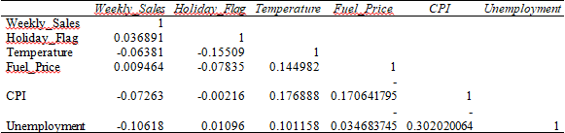

**Figure 1: Correlation between the variables**

(Source: Excel)

This correlation table proves that there is a strong relationship between weekly sales along with these five different variables. This correlation table contains different variables such as weekly sales, holiday flag, temperature, fuel price, CPI, and unemployment. These five questions have been seen in a single graph, where the correlation value of weekly sales is 1 in relation to holiday flag, temperature, fuel price, CPI, and unemployment. The correlation value of the holiday flag in relation to weekly sales, temperature, fuel price, CPI, and unemployment. is 0.036891. The correlation value of temperature in relation to weekly sales, holiday flag, fuel price, CPI, and unemployment is -0.06381, the correlation value of fuel price in relation to weekly sales, holiday flag, temperature, CPI, and unemployment is 0.009464, the correlation value of CPI in relation to weekly sales, holiday flag, temperature, fuel price, and unemployment is -0.07263, and the correlation value of unemployment in relation to weekly sales, holiday flag, temperature, fuel price, and CPI is -0.10618.

# TASK 3:

When data is necessary for data analysis, it is important to explore the data. This is one of the key components of data handling because good data handling and successful decision-making for the business depend on accurate data preparation, and therefore effective decision-making will increase organizational effectiveness. This review of the data exploration process will cover a variety of topics, such as data filtering and data integration tactics. A discussion of the data representative analysis and the generalizability and constraints of the combined dataset are both included in the data exploration process.

* **Representation of the data**

In this part of the data representativeness section, the study of data representatives will be in-depth. Data representativeness is referred to in this assignment as being crucial, as this dataset from Amazon represents the weekly sales of Amazon for the business, making it simpler for them to decide how to boost sales and foster growth. The dependent variable in this data is the weekly sales, and the other variables are "store, date, holiday flag, temperature, fuel price, CPI, and unemployment." There are many variables that are data representative in this data, including "store, date, weekly sales, holiday flag, temperature, and CPI" (Rehman, *et al.* 2022). The data representations of store refer to the store number, the data representations of date to the week of sales, the data representations of weekly sales to the sales of the specific store, and the data representations of holiday flag to "whether the week is a special holiday week 1 - Holiday week 0 - Non-holiday week," The temperature data refers to the "temperature on the day of sale," the fuel price data refers to the "cost of gasoline in the region," the CPI data refers to the "prevailing consumer price index," and the unemployment data refers to the "prevailing unemployment rate."

* **The constraints and generalizability of the combined dataset**

This section of the paper, "Generalisability and constraints of the integrated dataset," will go into great length regarding the generalizability and constraints of the integrated dataset. One of the key components of data analysis is the generalisability of the integrated dataset, where different general abilities of this integrated dataset exist. One of the core components of data analysis is examining the constraints of the integrated dataset. There are several restrictions on the combined dataset. The application of the dataset for other target variables, such as mileage or city, where the store number, the sales week, the sales of the specific given store, and "whether the week is a special holiday week 1 - Holiday week 0 - Non-holiday week" are applicable, is also included in the generalizability of this integrated dataset. One of the core components of data analysis is examining the constraints of the integrated dataset when several bounds exist (Saggi and Jain, 2018). The "temperature on the day of sale," "cost of fuel in the area," "current consumer price index," and "current unemployment rate" are some of the limits on this integrated dataset.

# TASK 4:

The issue formulation, which consists of five questions and five graphs displaying the answers to those questions, will be the main focus of this part. The first graph, which comprises two series: series 1 and series 2, shows the association between Amazon's weekly sales and temperature. The temperature and weekly sales at Amazon are covered in the first of these two series. The first graph illustrates the long-term, dependable correlation between Amazon's weekly sales and the average temperature in the region. The second graph, which comprises two series 1 and series 2, shows the connection between Amazon's weekly sales and holiday flags. These two series' first installment discusses seasonal aspects as well as Amazon's weekly sales. The second visual graph reveals the strong correlation that existed throughout the promotional period between Amazon's weekly sales and holiday flags. The final graph, which incorporates information from Series 1 and Series 2, shows the connection between Amazon's weekly sales and fuel prices. The first of these two series discusses the cost of petrol and Amazon's weekly promotions. The final graphic graph illustrates the strong correlation between Amazon's weekly sales and the time period's petrol prices. The fourth graph, which comprises two series 1 and series 2, shows the correlation between Amazon's weekly sales and CPI. These two series' initial installment examines Amazon's weekly sales and the CPI (Novak *et al.* 2021). The fourth graph shows the period's strong correlation between Amazon's weekly sales and the CPI. The final graph, which combines series 1 and 2, illustrates the relationship between Amazon's weekly sales and unemployment. The first of these two series covers the unemployment rate and Amazon's weekly sales. The fifth visual graph illustrates the strong correlation between unemployment throughout the time period and Amazon's weekly sales. The relationship between Amazon's weekly sales and temperature is depicted in the first graph, which has two series, where series 1 and Series 2. The temperature and Amazon's weekly sales are covered in the first of these two series. The first graphic graph shows how closely Amazon's weekly sales over the time period correlated with the local temperature. The weekly Amazon sales factor and temperature are correlated in this statistics chart. It has been noted that the Amazon firm's weekly sales are associated with its holiday flag, where the rise in local temperatures helped the company increase its sales.

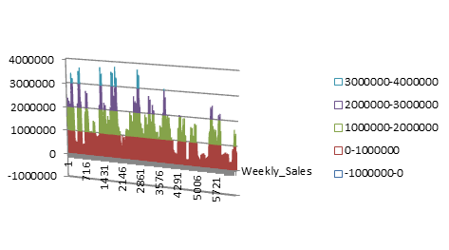

**Figure 2: Weekly sales affected by Temperature**

(Source: Excel)

The relationship between Amazon's weekly sales and temperature is depicted in the first graph, which has two series, where series 1 and Series 2. The temperature and Amazon's weekly sales are covered in the first of these two series. The first graphic graph shows how closely Amazon's weekly sales over the time period correlated with the local temperature. The weekly Amazon sales factor and temperature are correlated in this statistics chart. It has been noted that the Amazon firm's weekly sales are associated with its holiday flag, where the rise in local temperatures helped the company increase its sales.

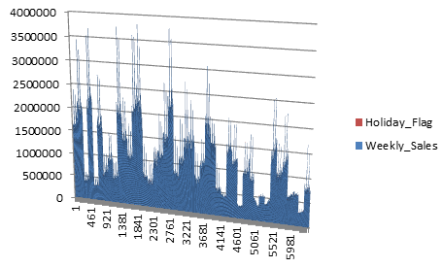

**Figure 3: Weekly sales affected by Holiday Flag**

(Source: Excel)

The relationship between Amazon's weekly sales and holiday flags is depicted in the second graph, which includes two series, series 1 and Series 2. The first of these two series talks on seasonal indicators and Amazon's weekly sales. The second graph shows how closely Amazon's weekly sales and holiday flags during the promotional period correlate. A correlation between the weekly Amazon sales factor and the holiday flag component is displayed in this statistical graph (ur Rehman, *et al.* 2019). While a holiday flag with a score of 0 indicates reduced organizational sales, one with a score of 1 or 2 allowed the organization to increase sales. It has been noted that the weekly sales of the Amazon company are influenced by the local climate.

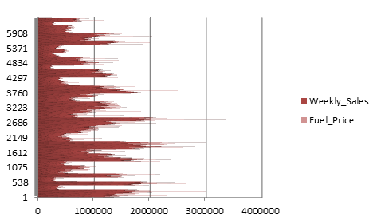

**Figure 4: Weekly sales affected by Fuel price**

(Source: Excel)

The third graph demonstrates the correlation between Amazon's weekly sales and the cost of fuel by combining two series, such Series 1 and Series 2. These two series first installment talks about Amazon's weekly sales and fuel expenses. The third visual graph demonstrates the long-term, significant relationship between fuel prices and Amazon's weekly sales. A link between the weekly Amazon sales component and the cost of fuel is depicted in this data graph. The local fuel price and the Amazon company's weekly sales have been found to be connected, with the organization's sales rising as the local fuel price rises.

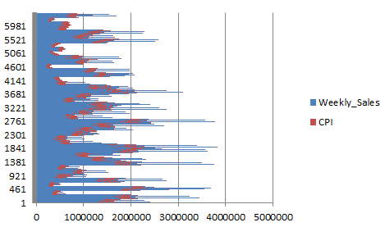

**Figure 5: Weekly sales affected by CPI**

(Source: Excel)

The association between Amazon's weekly sales and CPI is seen in the fourth graph, which has two series, series 1 and Series 2. The first of these two series analyzes the weekly sales on Amazon and CPI. The fourth visual depicts how closely Amazon's weekly sales and the CPI have been correlated throughout time. This statistical diagram illustrates the association between the CPI and the Amazon weekly sales component (Raut, *et al*. 2019). The "Prevailing Consumer Pricing Index" and Amazon organization's weekly sales have been seen to be correlated, with the organization's sales rising as the "Prevailing Consumer Price Index" declined.

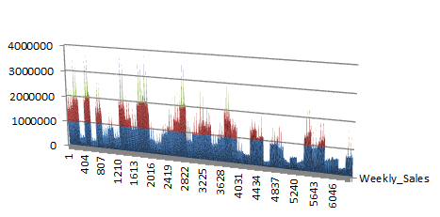

**Figure 6: Weekly sales affected by Unemployment**

(Source: Excel)

The fifth graph shows the relationship between Amazon's weekly sales and unemployment. It consists of two series, similar to series 1 and series 2. The first installment of these two series talks about joblessness and Amazon's weekly sales. The fifth visual graph demonstrates the strong relationship between Amazon's weekly sales and unemployment during the time period. The weekly Amazon sales factor and unemployment are correlated in this data graph. The "Prevailing unemployment rate" and the Amazon firm's weekly sales have been found to be associated, and the corporation has been able to reduce the "Prevailing unemployment rate" by increasing corporate sales.

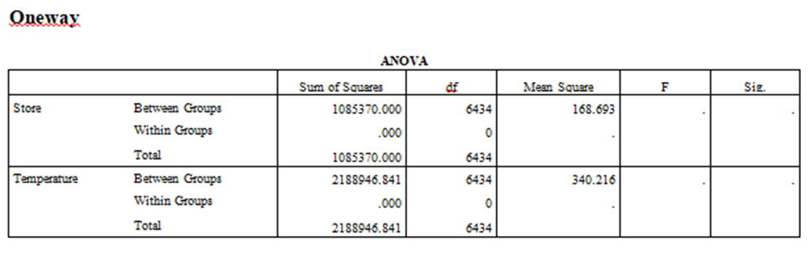

**Figure 7: One-way ANOVA statistics**

(Source: SPSS)

For "Store, Date, Weekly Sales, Holiday Flag, Temperature, Fuel Price, CPI, and Unemployment," "df values for between groups, df values for within groups, df values for total," "mean squares values for the between groups, mean squares values for the within for the between groups," "F value," and "sum of squares value for between groups," among other variables, one-way ANOVA statistics show a range of values. The sum of squares for the "between groups value," "within groups value," and "total value" values for the factor of the store is 1085370.000,.000, and 1085370.000, respectively. Df values for the total, within groups, and between groups are 6434, 0 correspondingly. Between groups, the "mean squares value" is 168.693, the "F value for between groups" is 0, and the "sig value" is also 0. The "sum of squares for between groups value," "sum of squares for within groups value," and "sum of squares for total value" for the temperature factor are, in that order, 2188946.841,.000, 2188946.841, and 2188946.841 (He *et al.* 2018). Df values for the total, within groups, and between groups are 6434, 0 correspondingly. Between-groups "mean squares value" is 340.216; "F value for between groups" is 0.; and "sig value" is 0.

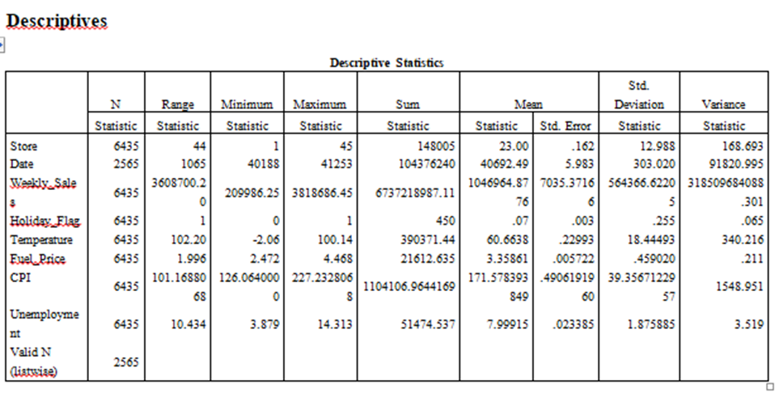

**Figure 8: Descriptive statistics**

(Source: SPSS)

For "Store, Date, Weekly Sales, Holiday Flag, Temperature, Fuel Price, CPI, and Unemployment," descriptive statistics provide a number of values, including "N statistic value," "range statistic value," "minimum statistic value," "maximum statistic value," "sum statistic value," "mean statistics value," "mean standard error value," "standard deviation statistic value," and "variance statistic value." The "N statistic value," "range statistic value," "minimum statistic value," "maximum statistic value," "sum statistic value," "variance statistic value," and "N statistic value" for the Store factor are 6435, 44, 1, 45, 148005, 23.00,.162, 12.988, and 168.693, respectively. The related "range statistic value," "minimum statistic value," "maximum statistic value," "sum statistic value," "variance statistic value," and "N statistic value" for the date factor are 2565, 1065, 40188, 41253, 104376240, 40692.49, 5.983, 303.020, and 91820.995 (Ardito *et al.* 2018). In order, 6435, 3608700.20, 209986.25, 3818686.45, 6737218987.11, 1046964.8776, 7035.37166, 564366.62205, and 318509684088.301 are the "N statistic value," "range statistic value," "minimum statistic value," "maximum statistic value," "sum statistic value," "variance statistic value," and "N statistic value" for the weekly sales factor. The range statistic value, minimum statistic value, maximum statistic value, sum statistic value, variance statistic value, and N statistic value for the holiday flag factor are, in that order: 6435, 1, 0, 1, 450,.07,.003,.255, and.065. The corresponding "range statistic value," "minimum statistic value," "maximum statistic value," "sum statistic value," "variance statistic value," and "N statistic value" for the temperature factor are 6435, 102.20, -2.06, 100.14, 390371.44, 60.6638,.22993, 18.44493, and 340.216. The corresponding "range statistic value," "minimum statistic value," "maximum statistic value," "sum statistic value," "variance statistic value," and "N statistic value" for the gasoline price factor are 6435, 1.996, 2.472, 4.468, 21612.635, 3.35861,.005722,.459020, and.211. The "range statistic value," "minimum statistic value," "maximum statistic value," "sum statistic value," "variance statistic value," and "N statistic value" for the CPI factor are 6435, 101.1688068, 126.0640000, 227.2328068, 1104106.9644169, 171.578393849,.4906191960, 39.3567122957, and 1548.951, respectively (Choi, *et al.* 2019). The corresponding "N statistic values" for the unemployment component are 6435, 10.434, 3.879, 14.313, 51474.537, 7.99915,.023385, 1.875885, and 3.519. Further included are the "range statistic value," "minimum statistic value," "maximum statistic value," "sum statistic value," "variance statistic value," and "N statistic value."

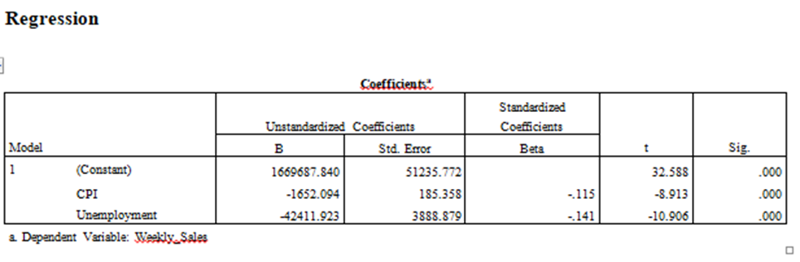

**Figure 9: Regression coefficient statistics**

(Source: SPSS)

The regression coefficient statistics include "B statistic value of Unstandardized Coefficients, the standard error value of Unstandardized Coefficients, the beta value of Standardized Coefficients, t value, and sig value," among other values for "Store, Date, Weekly Sales, Holiday Flag, Temperature, Fuel Price, CPI, and Unemployment." The factor of weekly sales has the following values: a "t value" of 32.588, a "sig value" of.000, a "B statistic value of Unstandardized Coefficients" of 1669687.840, a "standard error value of Unstandardized Coefficients" of 51235.772, a "Beta value of Standardized Coefficients" of nil. The "B statistic value of Unstandardized Coefficients" for the CPI factor is equal to -1652.094, the "standard error value of Unstandardized Coefficients" to 185.358, the "Beta value of Standardized Coefficients" to -.115, the "t value" to -8.913, and the "sig value" to.000 (Dong and Yang, 2020). With a "B statistic value of unstandardized coefficients" of -42411.923, a "standard error value of unstandardized coefficients" of 3888.879, a "Beta value of standardized coefficients" of -.141, a "t value" of -10.906, and a "sig value" of.000, the unemployment factor has several statistical properties.

# TASK 5:

The discussion will be focused on the research's findings and wise choices for the organization in this area of the explanation of decision-making based on outcomes. This statistical analysis over the course of the study demonstrates the close relationship between Amazon's weekly sales and the region's mean temperature. This statistical research shows a significant relationship between Amazon's weekly sales and holiday flags in terms of the promotional period. This statistical analysis demonstrates the significant association between the price of fuel and Amazon's weekly sales during the study period. This statistical analysis demonstrates the CPI's strong relationship with Amazon's weekly sales over the studied time frame. The statistical analysis reveals a significant correlation between Amazon's weekly sales and the applicable unemployment rate. This statistical analysis shows a correlation between Amazon's weekly sales component and the outside temperature. It has been discovered that the local temperature affects the Amazon organization's weekly sales, with holiday flags with values of 0 assisting the company in increasing sales and 1 or 2 indicating lower organizational sales. This statistical investigation found a correlation between the weekly Amazon sales factor and holiday flag sales (Misra, *et al*. 2019). It has been noticed that Amazon organization's weekly sales are tied to the organization's holiday flag and that the introduction of temporary features helped the organization improve sales. This statistical analysis shows a correlation between the weekly Amazon sales component and the price of petrol. It has been discovered that there is a relationship between the local fuel price and the Amazon corporation's weekly sales, with the latter increasing as the local fuel price does. This statistical investigation reveals a relationship between the CPI and the Amazon weekly sales component. It has been observed that the "Prevailing consumer price index" and Amazon organization's weekly sales are associated, with the organization's sales increasing and the index declining. This statistical investigation found a relationship between unemployment and Amazon's weekly sales component. The "Prevailing unemployment rate" and the Amazon firm's weekly sales have been linked, and the corporation was able to lower the "Prevailing unemployment rate" thanks to an increase in corporate sales. Every year, Amazon holds a number of promotional deals with discounts (Mavragani, *et al.* 2018). The Super Bowl, Labor Day, Thanksgiving, and Christmas are the four biggest holidays that are preceded by these markdowns. Five times greater weight is given to the evaluation of the weeks that include certain holidays than to the evaluation of the weeks that don't.

**Conclusion and recommendation based on the findings**

The main focus of this section's recommendations will be on the many organizational decision-making techniques that can be used to the benefit of the organization. By putting this suggestion into action, the organization will be better equipped to make decisions that are advantageous from an organizational perspective to enhance organizational development. Several recommendations or potential improvements to organizational decision-making have been made in light of the analysis's preliminary findings. Every year, Amazon holds a variety of unique discount sales. “The Super Bowl, Labor Day, Thanksgiving, and Christmas are the four biggest holidays that are preceded by these markdowns” (Rehman, *et al.* 2018). Five times greater weight is given to the evaluation of these weeks that include some holidays than to the evaluation of the weeks that don't. To help with the success of this work, these are discussed in greater depth below.

* The corporation occasionally needs to close more agreements in order to attract customers and increase sales.
* Consumers must be regarded as a resource and must provide promotional bargains on the products that would increase business sales.

# Reference list

**Journal**

Ardito, L., Scuotto, V., Del Giudice, M. and Petruzzelli, A.M., 2018. A bibliometric analysis of research on Big Data analytics for business and management. *Management Decision*.

Black, K., 2019. *Business statistics: for contemporary decision making*. John Wiley & Sons.

Choi, T.M., Wallace, S.W. and Wang, Y., 2018. Big data analytics in operations management. *Production and Operations Management*, *27*(10), pp.1868-1883.

Ciampi, F., Demi, S., Magrini, A., Marzi, G. and Papa, A., 2021. Exploring the impact of big data analytics capabilities on business model innovation: The mediating role of entrepreneurial orientation. *Journal of Business Research*, *123*, pp.1-13.

Dong, J.Q. and Yang, C.H., 2020. The business value of big data analytics: A systems-theoretic approach and empirical test. *Information & Management*, *57*(1), p.103124.

He, W., Zhang, W., Tian, X., Tao, R. and Akula, V., 2018. Identifying customer knowledge on social media through data analytics. *Journal of Enterprise Information Management*.

Mavragani, A., Ochoa, G. and Tsagarakis, K.P., 2018. Assessing the methods, tools, and statistical approaches in Google Trends research: a systematic review. *Journal of Medical Internet Research*, *20*(11), p.e9366.

Misra, B.B., Langefeld, C., Olivier, M. and Cox, L.A., 2019. Integrated omics: tools, advances, and future approaches. *Journal of molecular endocrinology*, *62*(1), pp.R21-R45.

Novak, A., Bennett, D. and Kliestik, T., 2021. Product Decision-Making Information Systems, Real-Time Sensor Networks, and Artificial Intelligence Driven Big Data Analytics in Sustainable Industry 4.0. *Economics, Management & Financial Markets*, *16*(2).

Raut, R.D., Mangla, S.K., Narwane, V.S., Gardas, B.B., Priyadarshinee, P. and Narkhede, B.E., 2019. Linking big data analytics and operational sustainability practices for sustainable business management. *Journal of cleaner production*, *224*, pp.10-24.

Rehman, A., Naz, S. and Razzak, I., 2022. Leveraging big data analytics in healthcare enhancement: trends, challenges, and opportunities. *Multimedia Systems*, *28*(4), pp.1339-1371.

Saggi, M.K. and Jain, S., 2018. A survey towards integration of big data analytics to big insights for value-creation. *Information Processing & Management*, *54*(5), pp.758-790.

ur Rehman, M.H., Yaqoob, I., Salah, K., Imran, M., Jayaraman, P.P. and Perera, C., 2019. The role of big data analytics in the industrial Internet of Things. *Future Generation Computer Systems*, *99*, pp.247-259.