

**BMO0273**

**FUNDAMENTALS OF LEADERSHIP**

**Individual coursework**

**2.** **Table of Contents**

1. Introduction (Effective leadership) 2

2. Using influence and power as a leader 2

2.1 Reward power base 2

2.2 Expert power base 3

3. Leadership Approaches 4

4. Leadership Communication 5

4.1 Best Practices of effective leadership communication 5

4.2 Challenges of leading virtual teams 7

5. Leadership and motivating others 7

6. Leadership and emotional intelligence 9

6.1 Role of emotional intelligence (EQ) in effective leadership 9

7. Conclusion 10

8. References 12

# 1. Introduction (Effective leadership)

The concept of leadership clearly establishes monitoring and management of human resources in an organisation by an individual or team. Effective leadership in recent years due to changing work patterns like work-from-home and virtual working has become critically important for global businesses. In simpler words, leadership is the ability of a group or an individual to guide or influence organisational members. Additionally, leadership is often considered an attribute tied to an individual’s seniority, hierarchical ranking, or title. In connection with this, effective leadership is an ability of a leader to execute an organisational vision and develop a sustainable work culture. Establishing a workplace environment in which employees are permitted to contribute meaningfully to achievement of both employee and employer goals is primarily ensured by an effective leader. The most evident qualities of effective leadership comprise capability to motivate individuals, be trustworthy, be willing to listen, be decisive, be competent, understand company goals selflessly, and have strong communication skills.

# 2. Using influence and power as a leader

## 2.1 Reward power base

A reward power base is a formal power or authority given to an organisational leader for giving out rewards to other employees based on their performance. According to Al-Amiri Rahima & Ahmed (2020), reward power is a position power which describes a source of power that is dependent on a leader’s position in the firm. For instance, a supervisor or manager who provides incentives to employees with higher performance is a reward power. Similarly, as stated by Nahum & Carmeli (2020), reward power is an ability to reward employees in return for following leaders' instructions and efficiency to attain company’s goals. Reward power is mostly used by leaders for motivating teams and organisational members to perform better.

Proving performance rewards like promotions, increments, and incentives motivate employees to perform more efficiently in favour of organisational benefits and overall operational growth. For instance, an organisational manager may be capable of raising reward, bonuses, promotions, and even providing simple feedback to employees for meeting expectations and goals of the firm. As argued by Dong et al., (2020), reward power is often misused by leaders to favour a few employees due to personal connectedness leading to unethical practices within an organisation. This is because reward power is solely managed and controlled by leaders in a firm without hierarchical interference. However, the rewards can improve or increase employees' intentions to perform by motivating them with personal benefits against their contribution to company’s growth and development (Al-Amiri Rahima & Ahmed, 2020). Therefore, a reward power base is an appropriate base to be adopted by effective leaders to influence work performance of employees and motivate them to perform better.

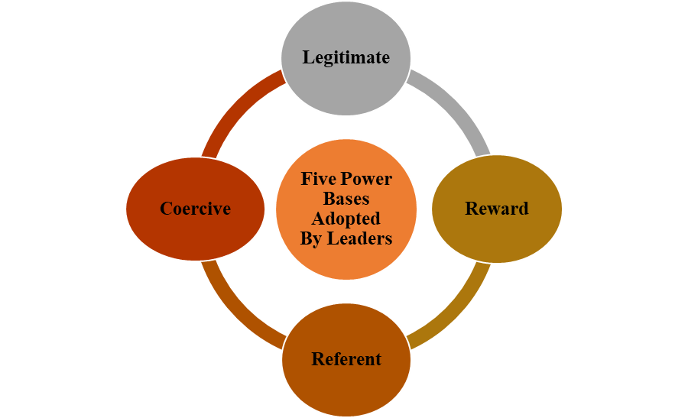

**Figure 1: Power Bases Adopted by Leaders**

(Source: Created by Author)

## 2.2 Expert power base

An export power base comprises having expertise in specific areas by leaders and confidently sharing the knowledge with other employees in an organisational culture. According to Bouncken et al., (2020), expert power is when an individual exudes and uses specialisation skills to help other employees or own team members. This leads to development of trust among the workforce in their leaders motivating them to take guidance or advice in decision-making. Additionally, expert power is an ability possessed by an employee regardless of title or seniority to showcase expertise in a situation or subject. For instance, if a single employee in a department knows the way to run software, then the employee with expert knowledge can guide other employees using expertise power (indeed.com, 2023). Expertise power might help a department diversify its skills permitting the department to handle projects and challenges independently. Hence, expertise power can be suitably adopted by leaders to improve skill diversity and inclusivity in the workplace.

# 3. Leadership Approaches

Situational leadership refers to adoption of various leadership styles depending on situation or need of an organisation to improve operational effectiveness. According to Yukl et al., (2019), situational leadership was introduced in 1969 believing that there is no leadership style that fits every changing organisational situation. In this context, situational leadership is suitable to be adopted by leaders as it enables leaders to control possible outcomes effectively. Situational leadership implies that leaders are able to control possible outcomes of a task because they are capable of influencing organisational directions in all aspects including across, upwards, and down. Additionally, leaders adopting situational leadership think proactively considering ways in which team or other organisational members might respond to a situation. For instance, situational leadership is a leader adapting approaches on basis of team member needs or expectations. Team members might be less experienced, and require more guidance as compared to others with more knowledge or capability of working independently.

Situational leadership also permits leaders to grow their skills and leadership competencies by adopting various styles depending on present or future situations. In organisational context, Tesco’s leaders adopted transformational leadership for managing complexities in business due to COVID-19 and technological changes shifting from its traditional democratic leadership style (tescoplc.com, 2023). Situational leadership helps organisational leaders to improve decision-making along with team inclusivity by adapting to different leadership styles in changing a company’s environment. Furthermore, as stated by Lei, Ha & Le (2020), situational leadership is most effective leadership form because it accounts for various skills and confidence levels among team members. This results in effective delivery of appropriate direction and support amount provided by situational leaders. The model of situational leadership incorporates four styles based on selling, delegating, telling, and participating (Pancasila, Haryono & Sulistyo, 2020). Thus, this indicates that situational leadership is an effective leadership approach to be adopted by organisational leaders for improving participation of every member in organisational decision-making.

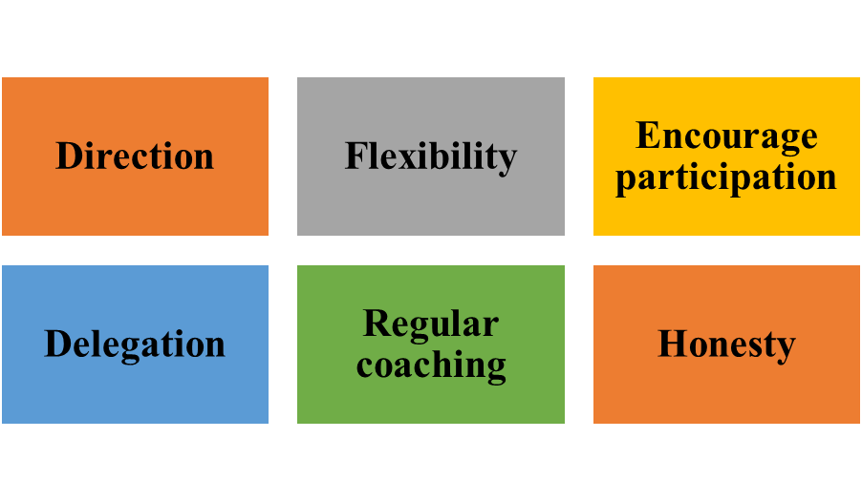

**Figure 2: Common traits of situational leaders**

(Source: Created by Author)

Situational leadership is an effective style to develop trust among team or company members to depend on leaders for effective problem-solving in every situation. Moreover, situational leadership permits sustainable operational development and growth by adopting different capabilities that align best with ongoing challenges or situations. As argued by Alefari, Almanei & Salonitis (2020), situational leadership allows adoption of different styles often lacking considering importance of various leadership styles leading to inappropriate selection of leadership approaches. However, situational leadership is most suitable for global organisations that focus on constant change and development to improve operational effectiveness. For instance, giant UK retailer, Sainsbury’s emphasises technological advancements and operational digitalisation (Sainsbury’s.com, 2023). The brand to accompany its operational changes has recently adopted situational leadership shifting from its preferences of using democratic leadership. Therefore, situational leadership is extensively an effective leadership approach to be adopted by leaders for implanting appropriate problem-solving and decision-making.

# 4. Leadership Communication

## 4.1 Best Practices of effective leadership communication

***Valuing transparency***

Effective leaders essentially need to value transparency for establishing an inclusive workplace culture. According to Ataguba & Ataguba (2020), transparency in operational practices using effective communication improves overall work quality and performance of businesses due to appropriate information flow. Effective leaders focus on valuing transparency and ensuring that it is put into practice. Furthermore, experts believe leaders demonstrating transparency strive to actualise their goals and effectively communicate. Similarly, as mentioned by Dirani et al., (2020), being transparent with an organisational team or employees helps build sustainable relationships that are developed on trust and honesty. Valuing transparency also enables leaders to understand expectations and needs of employees through establishment of open two-way communication. Hence, leading to improved team performances and improved work efficiency.

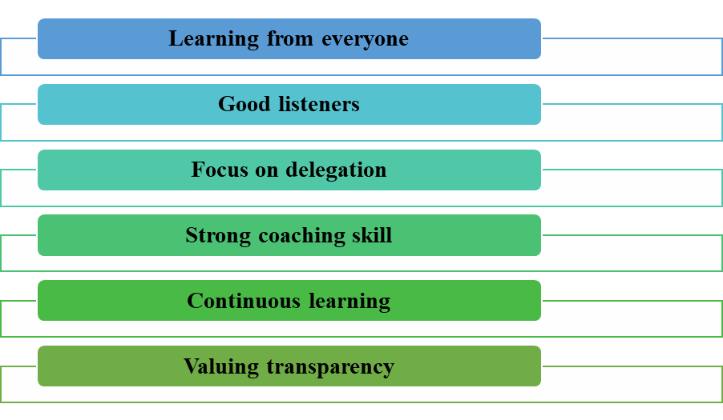

**Figure 3: Best Practices of effective leadership communication**

(Source: Created by author)

***Continuous learning***

Effective leaders are aware of significance of constant knowledge development and training for which they believe in concert of continuous learning. As quoted by Meng & Berger, (2019), to become an effective communicator, is is essential to know that communication skills development is an in-progress state. Leaders have to strive regularly for becoming an improved version of them. Additionally, several courses are available that help leaders to learn daily concerning communication skills development. Furthermore, as quoted by Newman & Ford (2021), continuous learning helps leaders to understand the changing need for various language learning and communication approach development. For instance, increasing cross-cultural diversity in recent years has made it important for leaders to learn both global and local market languages. In this regard, Walmart operating globally needs to deploy leaders with fluency in English as well as local market language like Chinese or Japanese (Pancasila, Haryono & Sulistyo, 2020). Therefore, continuous learning is one of the best practices of effective leadership communication.

## 4.2 Challenges of leading virtual teams

Virtual team incurs most significant challenge: lack of office culture that influences performance of employees to a great extent. Lack of office culture imposes a restriction of disrupted environment or internet connectivity leading to blockage in appropriate work operations (Kaushik & Guleria, 2020). Employees often have to face disturbances like transport noise, internet glitches, and family members during work due to lack of appropriate office culture. It becomes difficult for managers or leaders to create an effective workplace culture due to lack of an office environment. This results in reduced communication and connectedness between employee and employer weakens relationship building and employee retention capacity of business leaders.

Another significant challenge faced by leaders in managing virtual teams is difference in communication style that leads to communication gaps. Moreover, colleagues or team may pass days without communicating to each other and it’s likely possible that they might not meet in person (Zeuge et al., 2020). This often leads to disconnectedness between organisational departments disrupting the overall operations and productivity efficiency of a business. Every employee has a different preference to communicate like email, telephonic, instant messaging, or social media communication. Therefore, leaders need to effectively manage virtual teams through establishment of appropriate communication style and creating a structure that supports team collaboration.

# 5. Leadership and motivating others

***Expectancy theory***

The expectancy theory proposes that individuals in an organisation are motivated to perform in an improved way if they know that their additional performance is rewarded and recognised. For instance, businesses using performance-based remuneration or pay might expect performance improvement (Durrant, Gong & Howard, 2021). Expectancy theory is based on three basic elements that are instrumentality, expectancy, and valence. The theory is used by leaders to motivate workforce by expressing trust in performance and ability of employees to handle their duties, despite recognition of control and difficulty. The leaders can use expectancy theory to reward high-performing individuals or teams and encourage others to improve performance and efforts (Osuigwe, 2022). The theory not only motivates employees to perform better but also guides them with appropriate ways to be undertaken for improving performance and gaining rewards like appraisal along with promotions. Thus, expectancy theory can be effectively used by leaders to motivate employees for attaining common organisational goals and increase productivity with improved individual performance.

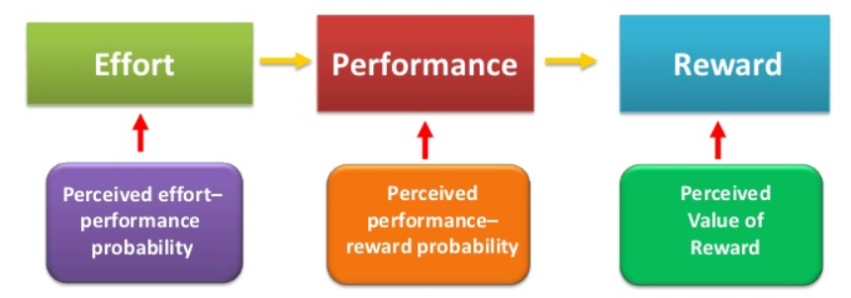

**Figure 4: Expectancy theory of motivation**

(Source: Created by author)

The most sustainable way to implement expectancy theory in organisational behaviour is to align employee promises with management and company policies. According to Mehboob & Othman (2020), putting trust in individual employee capabilities is a suitable way through which leaders implement expectancy theory to motivate teams or employees. However, expectancy theory often avoids employee needs and expectations that are essential to be aligned with organisational policies to improve employee performance. As argued by Heslina & Syahruni (2021), leaders mostly use expectancy theory by making the required performance achievable but challenging to motivate employees to take risks and perform better. Additionally, aligning operational tasks with a person’s skill set is another effective way that leads to employee motivation using expectancy theory as every individual feels confident in performing the tasks allocated. Expectancy theory is often used by organisational leaders to make correlation between reward clear and performance so that every performance of individuals or groups is recognised.

Expectancy theory is essential for identifying skill sets and needs of employees supporting them to grow and feel motivated to perform better in favour of organisational goal attainment. As mentioned by Kenny (2019), the expectancy theory states that employees are motivated to gather appropriate tools and get jobs done more efficiently including resource and raw material usage. This, in turn helps businesses to improve resource usage efficiency leading to improved profitability and operational cost reduction. Similarly, as stated by Cote (2019), motivating multigenerational and diversified workforce can be effectively established by leaders using expectancy theory. Hence, expectancy theory is identified to be most effective theory to be used by business leaders to motivate employees.

# 6. Leadership and emotional intelligence

## 6.1 Role of emotional intelligence (EQ) in effective leadership

Emotional intelligence in leadership is important because it increases accountability, builds trustworthy relationships, improves self-awareness, and fosters communication. Furthermore, emotional intelligence helps leaders to process their emotions more positively that permits addressing challenges more efficiently (Görgens-Ekermans& Roux, 2021). High emotional intelligence not only supports effective leadership but also promotes leaders to help employees to improve their EQ. Leaders are solely responsible for motivating employees to develop their skills and competencies that can be supported by high emotional intelligence possessed by leaders. For instance, working for someone who is generous, kind, confident, and respectful makes employees feel heard, valuable, protected, and appreciated. Thus, providing motivation to employees helps companies in developing profitability and productivity of the business in process of attaining organisational goals.

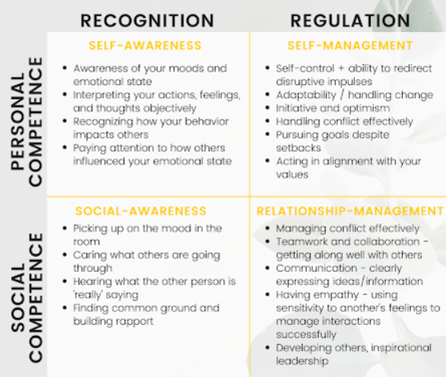

**Figure 5: Role of emotional intelligence in effective leadership**

(Source: businessleadershiptoday, 2023)

Emotional intelligence enables leaders to handle and develop interpersonal relationships empathetically and judiciously. Additionally, as quoted by Gómez-Leal et al., (2022), the ability of leaders to connect emotionally with workforce is improved and leading with emotional intelligence is necessary for leadership effectiveness. EQ plays a significant role in motivating leaders to consider employee issues and expectations on emotional grounds improving organisational relationships. As opined by Haricharan (2022), leaders with high EQ often fail to implement hierarchical power leading to disrupted operations or reduced employee performance. However, emotional intelligence in recent years due to impact of COVID-19 pandemic on physical and mental health of employees has become an important capability to be possessed by leaders. Furthermore, emotional intelligence has been identified to be the ability of identifying and regulating one’s emotions along with understanding emotions of others in workplace. This helps develop an empathetic leader capable of guiding teams undertaking personal concerns. A high EQ supports leaders to minimise team stress, build relationships, improve job satisfaction, and defuse conflicts more efficiently.

# 7. Conclusion

It has been concluded that expectancy theory is considered to be a belief that if an individual increases their efforts to perform efficiently, their rewards might rise. Moreover, expectancy theory is also effectively used by leaders for measuring individual employee performances in a team or group enabling them to make appropriate training strategies. This study summarises that effective leadership is influenced by various factors like role of emotional intelligence, leadership approaches, and communication. Effective leadership is essential for accessing appropriate power bases and motivating employees to perform better. Therefore, expectancy theory has been evaluated to be most effective theory to be undertaken by leaders for motivating workforce and becoming effective leaders. Additionally, reward and expert power bases have been identified to be most suitable power bases to be applied by organisational leaders to become effective. This is because both power bases help connect leaders with employees, motivating them to improve performance.

# 8. References

Al Amiri, N., Rahima, R. E. A., & Ahmed, G. (2020). Leadership styles and organizational knowledge management activities: A systematic review. *Gadjah Mada International Journal of Business*, *22*(3), 250-275.http://research.skylineuniversity.ac.ae/id/eprint/100/1/40.pdf

Alefari, M., Almanei, M., &Salonitis, K. (2020). Lean manufacturing, leadership and employees: the case of UAE SME manufacturing companies. *Production & Manufacturing Research*, *8*(1), 222-243.https://www.tandfonline.com/doi/pdf/10.1080/21693277.2020.1781704?needAccess=true&role=button

Ataguba, O. A., &Ataguba, J. E. (2020). Social determinants of health: the role of effective communication in the COVID-19 pandemic in developing countries. *Global health action*, *13*(1), 1788263.https://www.tandfonline.com/doi/pdf/10.1080/16549716.2020.1788263?needAccess=true&role=button

Bouncken, R. B., Fredrich, V., Ritala, P., & Kraus, S. (2020). Value-creation-capture-equilibrium in new product development alliances: a matter of coopetition, expert power, and alliance importance. *Industrial Marketing Management*, *90*, 648-662.https://dro.dur.ac.uk/30584/1/30584.pdf

businessleadershiptoday.com (2023). *Emotional Intelligence Is an Important Part of Strong Leadership. Business leadership today.* https://businessleadershiptoday.com/emotional-intelligence-is-an-important-part-of-strong-leadership/#:~:text=Emotional%20intelligence%20is%20important%20in,to%20address%20challenges%20more%20effectively.

Cote, R. (2019). Motivating Multigenerational Employees: Is There a Difference?. *Journal of Leadership, Accountability and Ethics*, *16*(2), 15-29. http://m.www.na-businesspress.com/JLAE/JLAE16-2/CoterR_16_2_.pdf

Dirani, K. M., Abadi, M., Alizadeh, A., Barhate, B., Garza, R. C., Gunasekara, N., ... &Majzun, Z. (2020). Leadership competencies and the essential role of human resource development in times of crisis: a response to Covid-19 pandemic. *Human Resource Development International*, *23*(4), 380-394.https://www.researchgate.net/profile/Mehrangiz-Abadi/publication/342876269_Leadership_competencies_and_the_essential_role_of_human_resource_development_in_times_of_crisis_a_response_to_Covid-19_pandemic/links/5f681fc8a6fdcc008631d32f/Leadership-competencies-and-the-essential-role-of-human-resource-development-in-times-of-crisis-a-response-to-Covid-19-pandemic.pdf

Dong, Y., Jiang, J., Rong, Y., & Yang, B. (2020). LMX differentiation and voice behavior: A resource-conservation framework. *Journal of Leadership & Organizational Studies*, *27*(3), 307-322. https://www.researchgate.net/profile/Yan-Rong/publication/339924847_LMX_Differentiation_and_Voice_Behavior_A_Resource-Conservation_Framework/links/61b954ab1d88475981ee84be/LMX-Differentiation-and-Voice-Behavior-A-Resource-Conservation-Framework.pdf

Durrant, J., Gong, J. J., & Howard, J. (2021). In the nick of time: Performance-based compensation and proactive responses to the Tax Cuts and Jobs Act. *Journal of Management Accounting Research*, *33*(1), 53-74. https://tax.unc.edu/wp-content/uploads/2020/04/Durrant-Gong-Howard-WP-2020.pdf

Gómez-Leal, R., Holzer, A. A., Bradley, C., Fernández-Berrocal, P., & Patti, J. (2022). The relationship between emotional intelligence and leadership in school leaders: A systematic review. *Cambridge Journal of Education*, *52*(1), 1-21. https://www.researchgate.net/profile/Janet-Patti/publication/352409286_The_relationship_between_emotional_intelligence_and_leadership_in_school_leaders_a_systematic_review/links/6126691fb266254415a6fdc5/The-relationship-between-emotional-intelligence-and-leadership-in-school-leaders-a-systematic-review.pdf

Görgens-Ekermans, G., & Roux, C. (2021). Revisiting the emotional intelligence and transformational leadership debate:(How) does emotional intelligence matter to effective leadership?. *SA Journal of Human Resource Management*, *19*, 1279.https://journals.co.za/doi/pdf/10.4102/sajhrm.v19i0.1279

Hamid, F. A., Widodo, S. E., &Buchdadi, A. D. (2022). The influence of transformational leadership, emotional intelligence, organizational climate, and teamwork, towards organizational citizenship behavior of civil servants. *International Journal for Applied Information Management*, *2*(3), 26-39.https://ijaim.net/journal/index.php/ijaim/article/download/35/39

Haricharan, S. J. (2022). Is the leadership performance of public service executive managers related to their emotional intelligence?. *SA Journal of Human Resource Management*, *20*, 1773.https://sajhrm.co.za/index.php/sajhrm/article/download/1773/2876

Heslina, H., &Syahruni, A. (2021). The influence of information technology, human resources competency and employee engagement on performance of employees. *Golden Ratio of Human Resource Management*, *1*(1), 01-12.https://goldenratio.id/index.php/grhrm/article/download/100/75

indeed.com (2023). *What is expert power?. Indeed.*https://www.indeed.com/career-advice/career-development/expert-power#:~:text=Expert%20power%20is%20the%20ability,expert%20power%20in%20that%20situation.

Kaushik, M., &Guleria, N. (2020). The impact of pandemic COVID-19 in workplace. *European Journal of Business and Management*, *12*(15), 1-10. https://www.researchgate.net/profile/Neha-Guleria-2/publication/353659460_The_Impact_of_Pandemic_COVID_-19_in_Workplace/links/6109085c1ca20f6f86f718be/The-Impact-of-Pandemic-COVID-19-in-Workplace.pdf

Kenny S, V. (2019). *Employee productivity and organizational performance: A theoretical perspective*. https://mpra.ub.uni-muenchen.de/93294/1/MPRA_paper_93294.pdf

Lei, H., Ha, A. T. L., & Le, P. B. (2020). How ethical leadership cultivates radical and incremental innovation: the mediating role of tacit and explicit knowledge sharing. *Journal of Business & Industrial Marketing*, *35*(5), 849-862.https://www.researchgate.net/profile/Le-Ba-Phong/publication/338040212_How_ethical_leadership_cultivates_radical_and_incremental_innovation_the_mediating_role_of_tacit_and_explicit_knowledge_sharing/links/60bc8db892851cb13d7edd3a/How-ethical-leadership-cultivates-radical-and-incremental-innovation-the-mediating-role-of-tacit-and-explicit-knowledge-sharing.pdf

Mehboob, F., & Othman, N. (2020). Examining the links leading to behavioral support for change: An expectancy theory perspective. *International Journal of Social Sciences and Economic Review*, *2*(4), 1-08. http://ijsser.com/index.php/ijsser/article/download/78/42

Meng, J., & Berger, B. K. (2019). The impact of organizational culture and leadership performance on PR professionals’ job satisfaction: Testing the joint mediating effects of engagement and trust. *Public Relations Review*, *45*(1), 64-75. https://fardapaper.ir/mohavaha/uploads/2020/09/Fardapaper-The-impact-of-organizational-culture-and-leadership-performance-on-PR-professionals%E2%80%99-job-satisfaction-Testing-the-joint-mediating-effects-of-engagement-and-trust.pdf

Nahum, N., &Carmeli, A. (2020). Leadership style in a board of directors: implications of involvement in the strategic decision-making process. *Journal of Management and Governance*, *24*(1), 199-227. http://www.israeli-corporate-governance.org/files/content/banner/Nurit_Nahum_Nurit_Nahum_Leadership_Style_in_a_Board_of_Directors_JMG_2019.pdf

Newman, S. A., & Ford, R. C. (2021). Five steps to leading your team in the virtual COVID-19 workplace. *Organizational Dynamics*, *50*(1), 100802. https://www.academia.edu/download/94232863/j.orgdyn.2020.10080220221114-1-hty0hc.pdf

Osuigwe, O. C. (2022). *Effect Of Reward Management System And Organizational Sustainability In Manufacturing Firms Anambra State*. https://seahipaj.org/journals-ci/june-2022/IJIFER/full/IJIFER-J-3-2022.pdf

Pancasila, I., Haryono, S., &Sulistyo, B. A. (2020). Effects of work motivation and leadership toward work satisfaction and employee performance: Evidence from Indonesia. *The Journal of Asian Finance, Economics and Business*, *7*(6), 387-397.https://www.koreascience.or.kr/article/JAKO202017764018192.pdf

Sainsbury’s.com (2023). *About Us.* Sainsbury’s Plc. https://www.about.sainsburys.co.uk/about-us

tescoplc.om (2023). *Board, Board Committees and Executive Committee. Tesco Plc.* https://www.tescoplc.com/about/board-board-committees-and-executive-committee/executive-committee/

Yukl, G., Mahsud, R., Prussia, G., & Hassan, S. (2019). Effectiveness of broad and specific leadership behaviors. *Personnel Review*. https://www.researchgate.net/profile/Gary-Yukl/publication/331697650_Effectiveness_of_broad_and_specific_leadership_behaviors/links/5c8d05c845851564fae0f8b0/Effectiveness-of-broad-and-specific-leadership-behaviors.pdf

Zeuge, A., Oschinsky, F., Weigel, A., Schlechtinger, M., & Niehaves, B. (2020). Leading Virtual Teams–A Literature Review. *Von https://www. microsoft. com/en-us/research/uploads/prod/2020/07/NFW-Zeuge-et-al. pdf am*, *3*, 2020. https://www.researchgate.net/profile/Andreas-Weigel/publication/343473371_Leading_Virtual_Teams_-A_Literature_Review/links/5f2bcb6392851cd302dfc180/Leading-Virtual-Teams-A-Literature-Review.pdf