**THM-115**

**DEVISING A DIGITAL MARKETING STRATEGY**

**Element I**

**Executive Summary**

This report consists of Tourism Ireland and Tourism New Zealand enterprises strategies for the digital marketing development. The report has discovered the current strategies implemented by the enterprises as well as the strategies which can be implemented in the future. Therefore, the theories of digital marketing are also explored in this report for the enhancement of the image in the digital platforms.

Table of Contents

Introduction 3

Critical Analysis 3

Critically compare the strategies of the chosen SMEs in the Tourism and Hospitality sector 3

Principles and practices of digital marketing in the tourism and hospitality industry 8

3i Principle of Digital Marketing 8

4 Key Principles of Digital Marketing 9

Customer-led Positioning Theory 11

Ansoff Matrix Theory 11

Conclusion and Recommendation 12

References 14

# Introduction

The aim of this report is to analyse the sustainability challenges which small and medium enterprises face in the hospitality and tourism industry. The canalisation of the challenges will be useful in devising a strategic marketing plan for the selected companies. Digital marketing is useful for increasing brand awareness and improving user experience. In the tourism and hospitality industry, it is necessary to implement digital marketing strategies as the businesses in this industry are heavily dependent on the brand image. Moreover, digital marketing is an essential part of the tourism and hospitality industry as it allows efficient and effective promotion of the destinations while showcasing the travelling facilities to the targeted customers.

Using social media platforms as a marketing strategy is also useful as it reaches more customers than the traditional marketing policies. In this report, two tourism enterprises have been selected in order to critically compare the marketing strategies of these organisations. The marketing strategies of Tourism New Zealand and Tourism Ireland will be compared and evaluated in this report to gain insight of the strategies. Furthermore, a brief background of the chosen companies will be discussed and strategies for increasing future sustainability will be also recommended in this report.

# Critical Analysis

# Critically compare the strategies of the chosen SMEs in the Tourism and Hospitality sector

Digital marketing in the tourism and hospitality sector refers to the proper use of digital channels such as social media marketing, email marketing, and promoting websites in order to sell the hospitality services. Design and development of the websites is a necessary step in the implementation of the digital strategies as the websites are searched by the customers and tourists. As per the view of Haris *et al.* (2022), websites create the initial brand image for the consumers thus it is important to create a well organised website. Tourism Ireland has optimised the marketing strategy to showcase the environmental beauty of the island as a holiday destination. The brand delivers marketing programs in twenty markets all over the world which helps the enterprise reach a global audience of 600 million each year (tourismireland.com, 2023).

On the other hand, Tourism New Zealand takes part in the domestic campaigns for the Australian marketing activity. The enterprise also uses global digital strategies in order to target travel agents in nine global markets (tourismnewzealand.com, 2023). The comparative study of the marketing strategies of these two enterprises provides insight into the digital implementations which can be useful for sustainability. Moreover, Tourism New Zealand works offshore in order to encourage the targeted market. The company also prioritises regional growth through advertising and social media events; however, the past “Good Morning World” campaign negatively affected the overall image of the enterprise. As the approach was overtly rational causing the emotional equity of the brand to erode.

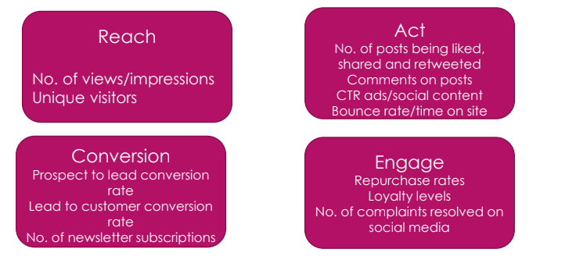

**Figure 1: Four Parts of Digital Marketing**

(Source: Lecture Notes)

The visual library is a central place for all the assets of Tourism New Zealand, as it helps by supporting the industry and promoting the destination for the visitors. As Tourism New Zealand has major competitions in the tourism and hospitality market such as Destination NSW, Events Queensland and Bayer Australia, it is vital that the brand starts to implement digital strategies to eliminate competition. Tourism New Zealand leads in the marketing sector as it invites individuals to take part and collaborate in the marketing campaigns. As commented by Kar and Harichandan (2022), involving the general public in the marketing strategies is a sustainable method. The enterprise also prioritises maintaining the environmental sustainability of New Zealand by collaborating with influential environmentalists in the social media to impact the greater public (tourismnewzealand.com, 2023).

Tourism New Zealand also offers a commission free platform for the collaborators which allows the contributors to promote various products with the brand. The website was visited by 41 million consumers in the year 2021, which resulted in referrals of over 3.2 million in the tourism industry (forbes.com, 2023). On the other hand, Tourism Ireland is more focused on the traditional marketing strategies such as campaigns which involve a large group of individuals.

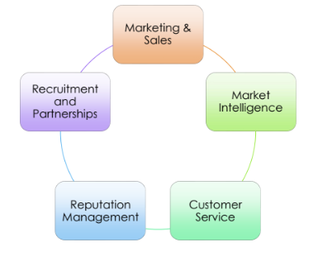

**Figure 2: Strategic implementation of digital marketing**

(Source: Lecture Notes)

The enterprise promotes the campaigns on the online and television platforms as well. Furthermore, the latest “Fill your heart with Ireland” campaign is inviting potential collaborators on the market which increases opportunities for the enterprise (tourismireland.com, 2023). The brand is promoting this through digital platforms such as across TV and Digital channels in order to showcase the authentic visitor experience provided by the enterprise. As Ireland has increased the air capacity in 2023 it has become easier for the brand to digitally promote such events. The treatment of the digital marketing strategies ensures the digital improvement of the enterprise.

However, Tourism Ireland focuses on the priority markets such as the U.S, Germany and France as these countries provide the majority of the visitors (tourismireland.com, 2023). The brand also directs the marketing strategies towards overseas travel and provides overseas programs, in the year 2022 the company created thousands of overseas opportunities for the potential visitors. This exposure led to an estimated worth of €610/£545 million which is equivalent to the advertising cost (tourismireland.com, 2023). However, following the previously guided path of digital marketing affect the enterprise, as it is necessary to implement the strategies in a unique manner. It can be determined from the case study that as the enterprise shifted the strategies from ideation to execution the lack of proper influencer in each sector was a major drawback.

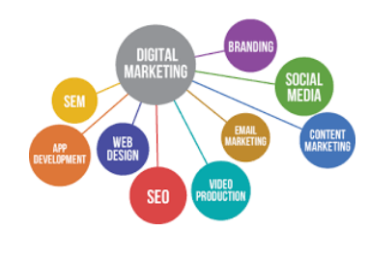

**Figure 3: Digital Marketing**

(Source: Lecture Notes)

Tourism New Zealand has faced setbacks from implementing the same strategy at a global level. It is necessary that digital marketing strategies are selected based on the targeted customers and the regional attractions of the destination which attracts the visitors. The enterprise has to prioritise the historical, cultural and natural factors which interest the visitors. Similarly, Tourism Ireland has faced the downsides of digital marketing strategies as well; showcasing only traditional attractions of the country reduces the number of visitors who are interested in the environmental beauty. As per the view of Kurniawan (2022), digital marketing in the tourism sector requires the proper analysis of the factors which need to be showcased for attracting various genres of tourists. It is also necessary for both the enterprises in this study to focus more on the social media ROI in order to fully comprehend the profit and loss of the marketing strategy. As commented by Jasin (2022), social media is an essential tool in the digital marketing of the tourism sector as the environmental, cultural and traditional attractions help in making shareable content. Tourism New Zealand attempted to invest the local resources in the digital marketing campaigns by provisioning that the local guides will be useful for authentic experience. However, this method did not work out accordingly as the majority of the visitors were not comfortable with the beaten paths which the local individuals prefer.

Tourism Ireland on the other hand has successfully implemented the digital marketing strategies as the enterprise focuses on the sustainability of the business. The enterprise prioritises the consumers, media activity and trade for achieving greater exposure in the digital market, media familiarisation and publicity (tourismireland.com, 2023). Moreover, Tourism Ireland has marketing plans in 2023 for rebuilding overseas tourism and has secured a budget of £70 million (tourismireland.com, 2023). The enterprise has also decided to implement more global strategies as well as newer promotional social media campaigns. As tourism is the greatest indigenous industry in the economy of Ireland providing over €10 billion as the largest regional recruiter, it is an extremely competitive market (itic.ie, 2023). Mitigating the challenges in this market requires the tourism and hospitality enterprises to have unique and advanced digital marketing strategies. Similarly, the tourism sector in New Zealand generates $10.0 billion direct value to the GDP of the country (stats.govt.nz, 2023). Therefore, the tourism and hospitality industry of the country is competitive which requires Tourism New Zealand to build a strong online brand image.

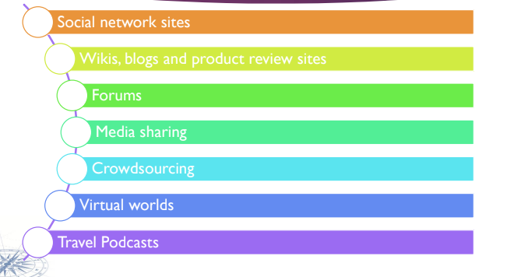

**Figure 4: Tools of social media marketing implementation**

(Source: Lecture Notes)

This study indicates that it is essential to have a digital marketing plan in order to increase sustainability of the tourism and hospitality enterprises. As commented by Efthymiou et al. (2022), digital marketing is the greatest tool for the hotels and tourism hospitality facilities. It is recommended to have a strong presence online which includes search engines such as Google as well as social sites such as Facebook. This strategy is appropriate for Tourism New Zealand as these are free sites which allow companies to advertise the services at a minimum price, it is a cost-effective method. However, it is also necessary to maintain an official website of the enterprise which will strictly promote and highlight the facilities provided for the customers including offers and customer query related solutions. Another way to optimise the online tools is to create and follow social media trends as it reaches a large number of individuals globally. This strategy has to be followed by Tourism Ireland as it lacks presence in the social media platforms. Social media is also a good strategy for gathering the feedback of the consumers and resolving the issues they are facing.

# Principles and practices of digital marketing in the tourism and hospitality industry

There are principles of digital marketing which are the key components of growth in the SME’s. In the implementation process of digital marketing it is necessary to understand the range of digital hardware and digital opportunities. On the other hand, it is also essential to gain understanding of the developmental stages in the multi channel platforms. As this is a complicated process the impact of it can be massive on the tourism and hospitality sector, thus, it is necessary to maintain some principles in the practices of digital marketing. The principles are important as these are applicable in every aspect of digital marketing globally. However, these principles are only useful along with other necessary marketing measures which have to be implemented such as enhancing activities on the digital platforms increasing communication with the consumers.

## 3i Principle of Digital Marketing

The three primary principles are initiation, iteration and integration, which collectively known as the 3i principle of digital marketing. These principles are designers for the steps of digital marketing starting from the strategic planning to campaigns. The 3i of digital marketing principles can be described as the initiation factor is based on the customer, according to this theory from the planning to the implementation all the decisions need to be dependent on the consumer. As per the view of Ovuakporaye (2022), the customer is of utmost importance in the implementation of digital marketing. The second statement of the theory is iterating which emphasises on the necessity of tweaking certain changes in the digital marketing plan as user feedback requires. Lastly, the third statement of the theory is about making efforts on the digital channels to gain results as it is greater than the individual marketing channels.

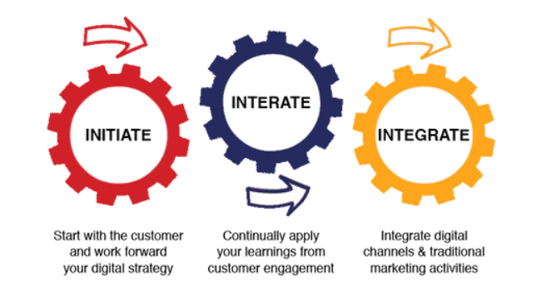

**Figure 5: Principles of Digital Marketing**

(Source: Ovuakporaye, 2022)

This theory is a backward strategy which prioritises and analyses the customer feedback before implementing the changes in the enterprise digitally. Eventually the stages are completed through careful consideration for the customer and their needs. Understanding the principles of digital marketing can be useful for enhancing responsible marketing strategies which are sustainable. These principles can be used for the digital development of Tourism New Zealand as it holds major campaigns and globally promotes these campaigns on the digital platforms. As commented by Abin and Sujianto (2022), a digital campaign has to be made with the consideration for the customer’s needs, this procedure can enhance the range of customers affecting the enterprises overall performance. Moreover, this theory is better suited for Tourism New Zealand as it ensures tourist satisfaction and increases the rate of recommendation of the service of the tourism. However, there are other principles of digital marketing which focus on digital campaigns which are more suitable for Tourism Ireland such as the 4 key principles of digital marketing.

## 4 Key Principles of Digital Marketing

The four key principles of digital marketing are attracting the customers, engaging the customers, ensuring conversion of the visitors to consumers and sustaining the existing customers. This theory states that the first key principle on which digital marketing is dependent is attracting the customers. Email marketing, social media posts SEO optimisations are all part of making the services provided by the company present as more attractive. As per the view of Ruohonen (2022), blogs, articles and mobile based web designs are basic strategies to attract the consumers. On the other hand the second part of this theory is based on keeping the customers engaged, once the users reach the company website it is essential that the visitors come back to the websites. Similarly, it has to be ensured that the regular emails build a significant communication between the company and the customer. Understanding that social media is a powerful tool and that its application in digital marketing of hospitality and tourism businesses can be profitable is essential. The third stage of this theory requires the enterprises to convert the visitors to customers through the implementation of CTA structures which invites the visitors to get involved in the actionable features of the website.

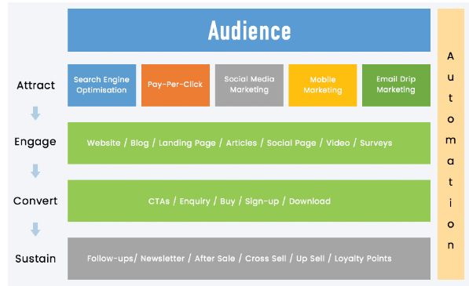

**Figure 6: The 4 Key Principles of Digital Marketing**

(Source: Ruohonen, 2022)

As more one time visitors of the social media pages get involved in the company's digital channels, it increases the chances of them turning into consumers actively making purchases. Increasing sustainability has to be done in a strategic manner as the conversion is made it is necessary to retain those consumers. This strategy can be useful for Tourism Ireland as it requires more efforts in the online presence of the enterprise. However, these structures have to be implemented in a step by step strategic process. As in the year 2023, Tourism Ireland has rolled out an extensive program budget of €78 million (tourismireland.com, 2023). Therefore, the enterprise has to implement the global campaigns through the digital platforms in order to make the process more accessible for the customers. However, there are various theories which can be used in order to devise a digital marketing plan such as the customer-led positioning theory of digital marketing and Ansoff Matrix theory.

## Customer-led Positioning Theory

The customer led positioning theory suggests that the act of listening has to be actively maintained in digital marketing. Creating products or providing services which keeps the customer unsatisfied is baseless according to this theory. Tourism New Zealand can implement this theory as the agency is focused on promoting the scenic satisfaction of the country which attracts the tourists. As per the view of Monesi and Belgiawan (2023), it is essential that the marketers take the customers as the guide towards achieving the ultimate sustainability of the services. The theory states that the customer provides the best insight for the changes that are necessary in the businesses. Furthermore, the theory suggests that the enterprises which are growing through the digital market have to focus on four activities which are acquired, convert, retain and grow.

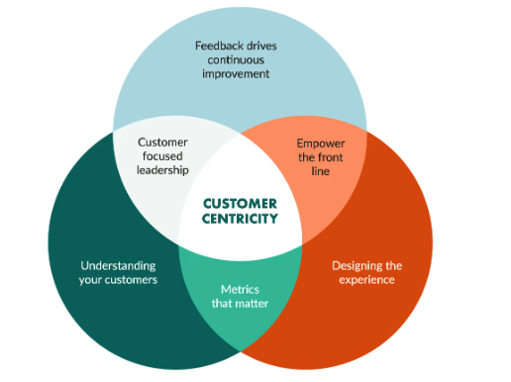

**Figure 7:** **Customer-led Positioning Theory**

(Source: Monesi and Belgiawan, 2023)

This theory can be effective for Tourism New Zealand as the enterprise is focusing on growing the rate of digital ROI (Return of Investment); a customer based approach is the best strategy.

## Ansoff Matrix Theory

The Ansoff model is a grid format which is essential for the digital marketers as it helps in the growth of revenue through the development of new products and services in order to tap into the new markets. According to this theory a company can grow through the development of the new products in the existing market or the company can launch in the new market with the pre existing products. As per the view of Derzhavska (2023), the Ansoff matrix has to be implemented in four strategic methods such as market penetration, market development, product and development and diversification. Therefore, it can be determined that this theory can be implemented by Tourism Ireland as the enterprise is focusing on the Remote Influencer campaigns.

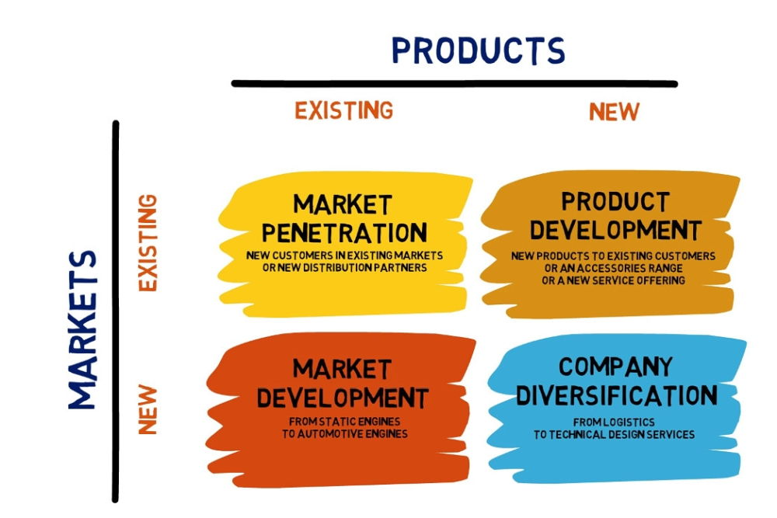

**Figure 8: Ansoff Matrix Theory**

(Source: Derzhavska, 2023)

The enterprise is bringing influencers in the marketing projects as it is a sure fire way to achieve the goals in a short time span. As the Ansoff matrix suggests focusing on the alternative new projects it is the most useful for the enterprise.

# Conclusion and Recommendation

It can be determined in conclusion to this study that Tourism New Zealand and Tourism Ireland both have implemented digital marketing along with the traditional marketing methods in order to increase the sustainability of the services in the market. Both enterprises have been holding campaigns and necessary digital presence in the online platforms however; this has led to a few drawbacks as well. It was discovered in the study that the campaigns held by Tourism New Zealand have been unable to align with the company’s extensive goals. Moreover, this study proves that the digital strategy has to be devised in a step by step process.

I recommend that the enterprise puts in more effort in the implementation process as it is necessary to carefully digitalise the existing marketing strategies as well as introducing new and unique developmental strategies. I have gained insight into the two enterprises and its marketing strategies, from which I have concluded that Tourism Ireland lacks online presence. Therefore, in my opinion, it has to be increased in order to make the services of the agency known to the targeted customers. The performance based challenges which Tourism Ireland has faced in the future, in my opinion, can be mitigated through the expansion of the company in the digital platforms. I have realised that pausing other marketing and communications for the digital marketing implementation process has harmed the business of Tourism Ireland. Therefore, I would recommend that the policies need to be implemented while maintaining the pre existing extensive strategies.

# References

Abin, M.R. and Sujianto, A.E., (2022). INTERACTIVE DIGITAL MARKETING IN IMPROVING CUSTOMER SATISFACTION IN ISLAMIC EDUCATION INSTITUTIONS IN MAN 1 BLITAR. *International Journal of Business, Economics and Education Research (IJBEER),* 1(1), pp.1-6.

Derzhavska, A., (2023). Research of Scientific Approaches to Assessing the Effectiveness of Corporate Enterprise Product Strategy. *Technology Audit and Production Reserves*, 1(4), p.69.

Efthymiou, L., Orphanidou, Y., Droussiotis, P. and Morphitis, A., (2022), April. Sustainability Initiatives in Cypriot Hotels and the way Forward Through Digital Marketing Communication. In *CMC2022, 26th Corporate and Marketing Communications Conference: 18-20 APRIL 2022* (pp. 140-150).

forbes.com (2023), *new-zealand-launches-first-campaign-in-two-years-thats-aimed-at-seekers* Available at: https://www.forbes.com/sites/micheleherrmann/2022/08/23/tourism-new-zealand-launches-first-campaign-in-two-years-thats-aimed-at-seekers/ [Accessed on: 26.04.23]

Haris, M., Nasir, N. and Cheema, S., (2022). The Impact of Social Media Activities on Emotional Attachment with the Mediating Role of Brand Image and Brand Commitment of Retail Sector. *Review of Education, Administration & Law, 5*(2), pp.173-188.

itic.ie (2023), *Tourism* Available at: https://www.itic.ie/about-us/#:~:text=Tourism%20is%20Ireland's%20largest%20indigenous,(source%3A%20CSO%202019) [Accessed on: 26.04.23]

Jasin, M., (2022). How The Role of online and viral marketing and competitiveness ability on business performance of SMEs. *Journal of Information Systems and Management (JISMA),* 1(2), pp.28-35.

Kar, S.K. and Harichandan, S., (2022). Green marketing innovation and sustainable consumption: A bibliometric analysis. *Journal of Cleaner Production, 361*, p.132290.

Kurniawan, A., (2022). Digital Marketing-Based Tourism Planning Policy in Order to Realize Regional Tourism Competitiveness. *Journal* *of Industrial Engineering & Management Research, 3(*6), pp.185-190.

Monesi, L.A. and Belgiawan, P.F., (2023). *Factors Influencing Customer Purchase Intention in B2B Telecommunication Industry.*

Ovuakporaye, K., (2022). The Impact, Comparison and Usefulness of Digital Marketing Communications Tools on Organizational Profit Maximization Using Facebook. *Asian Journal of Research in Computer Science, 13*(4), pp.46-64.

Ruohonen, T., (2022). *Consumers' online shopping motivation.*

stats.govt.nz (2023), *information-releases tourism-satellite-account-year-ended-march* Available at: https://www.stats.govt.nz/information-releases/tourism-satellite-account-year-ended-march-2022/[Accessed on: 26.04.23]

tourismireland.com (2023), *tourism-ireland-s-new-campaign-set-to-win-hearts-around-the-world* Available at: https://www.tourismireland.com/news-and-press-releases/press-releases/article/tourism-ireland-s-new-campaign-set-to-win-hearts-around-the-world!#:~:text=The%20'Fill%20your%20heart%20with,and%20experience%20those%20for%20themselves[Accessed on: 26.04.23]

tourismireland.com (2023), *news-and-press-releases* Available at: https://www.tourismireland.com/news-and-press-releases/press-releases/article/tourism-ireland-launches-2023-marketing-plans#:~:text=Tourism%20Ireland%20aims%20to%20rebuild,by%20focusing%20on%20markets%20that[Accessed on: 26.04.23]

tourismireland.com (2023), *Tourism Ireland* Available at: https://www.tourismireland.com/what-we-do#:~:text=Tourism%20Ireland%20is%20responsible%20for,over%20600%20million%20each%20year [Accessed on: 26.04.23]

tourismireland.com (2023), *tourism-ireland-launches-2023-marketing-plans* Available at: https://www.tourismireland.com/news-and-press-releases/press-releases/article/tourism-ireland-launches-2023-marketing-plans#:~:text=Tourism%20Ireland%20will%20embed%20sustainability,as%20in%20sales%20opportunities%20overseas[Accessed on: 26.04.23]

tourismireland.com (2023), *tourism-ireland-launches-2023-marketing-plans* Available at: https://www.tourismireland.com/news-and-press-releases/press-releases/article/tourism-ireland-launches-2023-marketing-plans-(ni-version) [Accessed on: 26.04.23]

tourismnewzealand.com (2023), *Tourism Ireland* Available at: https://www.tourismnewzealand.com/[Accessed on: 26.04.23]

tourismnewzealand.com (2023), *Work with Us* Available at: https://www.tourismnewzealand.com/work-with-us/marketing-activity/[Accessed on: 26.04.23]