

**RESEARCH TITLE: - AI TECHNOLOGY TRANSFER BETWEEN INDIA AND GERMANY**

**STUDENT NAME: -**

**STUDENT NUMBER: -**

**DATE: -**

**Table of Contents**

1. Introduction 2

Background 2

Scope 3

2. Initial Situation 3

Problem Statement 3

Rationale 3

3. State of Research 5

Literature Research 5

Gap Analysis 6

4. Research Goal 6

Aim 6

Objectives 6

Questions 7

5. Approach 7

Methodology 7

References 9

# 1. Introduction

## Background

Artificial intelligence or AI has once been subject to the imaginations of people with the main plot being science fiction movies. AI accounts for referring to the ability of Machines or computers towards mimicking the competencies of human minds (Thormundsson, 2022c). This includes learning from previous experience for understanding in responding to languages, problems and decisions. The following AI capabilities like conversational inter basis and computer vision have involved being embedded across diverse industries and their standard business operations. On this note, the most prominent operations and sectors involving AI in their operations are high telecommunications and take brands along with healthcare and pharmaceuticals and financial services.

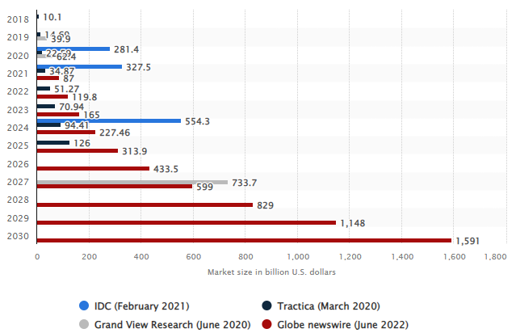

**Figure 1: AI Market Size**

(Source: Thormundsson, 2022b)

The global market revenue for AI is forecasted to be growing significantly between the tenure of 2018-2030. This is based on the projection that the Global market of AI will be reaching a size of over half a trillion dollars by 2024 (Thormundsson, 2022b). The same is also accompanied by other research studies suggesting the market to be growing to over $1.5 trillion by 2030. The existing market race for AI is potentially being led by IBM with enthusiasm concerning this technology and its applications substantially rising. This is also in compliance with increased funding of AI started globally in terms of $1 billion in 2013 to $8.5 billion in 2020.

## Scope

AI is being massively utilised for service operations along with the development of products and services concerning functions in the telecom and high-tech sector. This is supported by respective findings from respondents with 45 and 34% respectively (Thormundsson, 2022a). Adoption of AI is also found to be prominently increasing in financial services, human resources, and manufacturing among others. Determined from this aspect, addressing the component of AI as knowledge transfer in logistics will be a major source of future contribution.

# 2. Initial Situation

## Problem Statement

A leading problem statement concerning this research study is the significant need for sustainability in healthcare and logistics accomplished with the help of AI knowledge transfer.

It is relevant to the context that fostering scope for AI can pay if the weight was decreasing potential logistics costs. With the digitisation of logistics becoming more prevalent, using data for driving processes and decision-making is also stipulated to be increasing.

## Rationale

AI is identified to be gaining the most fractions in business areas accounting for creating major values. For instance, AI is widely being used in the retail sector for sales and marketing processes with 52% of respondents supporting this fact (Chui, 2018). Furthermore, about 58% of surveyed respondents highlight that about one-tenth of their digital budgets are subject to AI. It is also followed by the belief that AI investments are expected to be increasing in the coming years, as supported by 71% of the respondents. This is also supported by the findings from business functions illustrating that about 47% believe AI adoption has a significant value for supply chain management and logistics operations (Chui, 2018). Contrary to this, 29% believe AI has a moderate value for logistics and supply chain management.

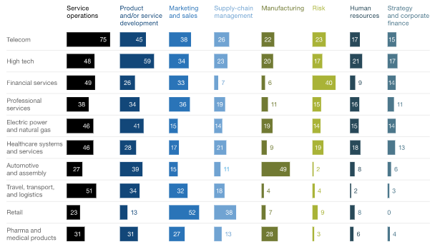

**Figure 2: Business Functions Adopting AI**

(Source: Chui, 2018)

Concerning the need for sustainability in supply chain operations, the adoption of AI is emerging as a prominent aspect. This AI knowledge transfer is identified as a potential future strategy existing between India and Germany for securing sustainability in healthcare practices (Economic Times, 2022). The following attribute is expected to drive the way towards the effective capacity building by targeting a considerable number of sectors. In this contact, AI is also contributing towards demand prediction with the help of its forecasting abilities. AI logistics software can be crucial towards predicting demand audit lining searches in advance (Shaha, 2020). The following leverages sufficient time to transporters for effective planning of efficient vehicles and routes while avoiding the risk of possible bottlenecks. Referring to this conducting the following study will have a prominent impact towards understanding the contribution of AI towards logistics operations.

# 3. State of Research

## Literature Research

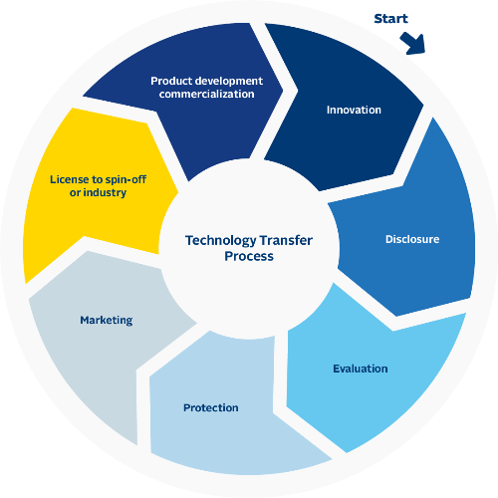

**Figure 3: Technology Transfer**

(Source: Influenced by Subih, Nueangnong & Pokkasut, 2019)

Technology transfer is attributed to the process of conveying results that stem from technology and scientific research to wider society and the concerned market. This also involves correlation with associated procedures and skills, thus being an intrinsic part of innovation processes concerning technologies. However, Subih, Nueangnong & Pokkasut (2019) also argued that transferring new technology across nations can be a complex process and requires a detailed attribute. The application of digital technology towards the development of new products makes it substantially possible towards carrying out information research and analysing competitive development. Pyataeva et al. (2022) put forward that key drivers concerning this innovation economy involve resources, knowledge, knowledge databases, and human capital. This constant desire for innovation is significantly driven by the need for improved products in addition to the development and adoption of new technologies.

Following a rise in research output and revenues concerning AI comma worldwide competition between China Europe, and the United States has been heating up. Present-day involvement of AI aims the basis of computer systems in terms of handling a range of operations like smartphone translations voice recognition piloting driverless transport, robotics control and others. Accessing vast datasets that can be used for training machine-learning systems serves as a major advantage for China and US (Savage, 2020). On the contrary, Europe maintains stringent data laws that are subject to protecting the privacy of people. Yet again, Europe holds the risk of limiting its resources concerning the training of AI algorithms, thereby making it unlikely towards producing sophisticated AI. Da Silva, Kovaleski & Pagani (2019) pointed out that technology transfer is fundamental in the supply chain for steering the absorption and dissemination of technologies towards diverse stages. This requirement directs the need for AI inclusion given the real-time visibility changes and persistent collaboration in the supply chain and logistics operations.

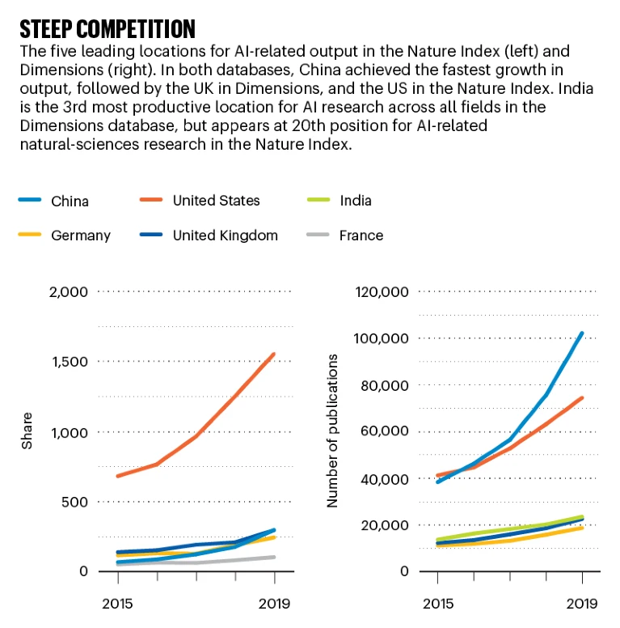

**Figure 4: Leading Nations with AI-based Output**

(Source: Cited by Savage, 2020)

## Gap Analysis

A considerable literature gap witnessed and expected to be further incurred is the lack of sufficient sources addressing AI technology transfer. This is also accompanied by a potential downside being a limited emphasis on studies addressing the significance of AI technology transfer in logistics operations. In this matter, the following research work will be subject to eliminating this gap with primary responses from participants.

# 4. Research Goal

## Aim

This research is aimed at understanding the contribution of AI technology transfer between India and Germany towards sustainable logistics operations.

## Objectives

* To assess the emerging concept of AI technology transfer between India and Germany.
* To investigate driving factors concerning the need for AI technology transfer for sustainable logistics operations.
* To identify possible challenges associated with AI technology transfer for sustainability and logistics.
* To recommend future strategies regarding AI technology transfer to secure effective logistics operations.

## Questions

1. What is the concept of AI technology transfer between India and Germany?
2. What are the driving factors concerning the need for AI technology transfer for sustainable logistics operations?
3. What are the possible challenges associated with AI technology transfer for sustainability and logistics?
4. What future strategies can be recommended regarding AI technology transfer to secure effective logistics operations?

# 5. Approach

## Methodology

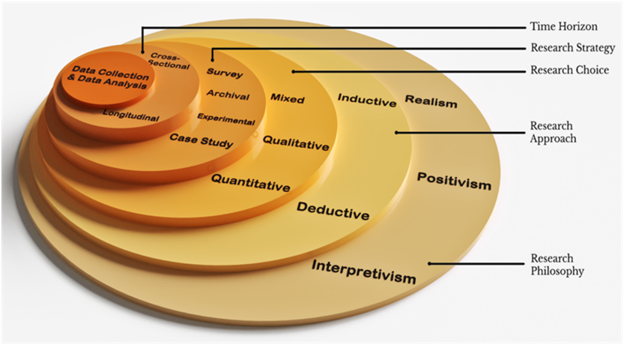

**Figure 5: Research Onion**

(Source: Saunders, Thornhill & Lewis, 2019)

This research will involve compliance with the research onion framework for developing a desired methodology for this study. According to Saunders, Thornhill & Lewis (2019), research onion helps with developing a robust methodology for addressing the research objectives. On this note, to assess the emerging concept of AI technology transfer between India and Germany, an *interpretivism* philosophy will be used. This will prove crucial for this research work in avoiding generalisation of the subject while also establishing a clear linkage among the research variables. Alharahsheh & Pius (2020) opined that interpretivism enables scope for researchers to treat a certain addressed subject as unique. This will also include the *inductive* approach as a way of developing new opinions and concepts regarding driving factors concerning the need for AI technology transfer for sustainable logistics operations. The following adherence will leverage an edge for this study to use perceptions and narrations for assessing patterns of data.

In this view, identifying possible challenges associated with AI technology transfer for sustainability and logistics will entail a *grounded theory* strategy. The aspect of grounded theory tends to adapt well to ambiguity and eclectic data (Holloway & Schwartz, 2018). However, this might also hold the risk of missing out on broad high-level patterns. This sense of accuracy and moderate simplicity will also be made effective with the inclusion of *multi-method* choices. This involves the use of diverse data sources with potential scope for triangulation of the data and methods (Al-Ababneh, 2020). Referring to this, this study will account for using data of qualitative nature. It will include both secondary and primary data in terms of information from published academic sources and interviews respectively. About 6 UK-based managers in the healthcare sector will be approached for understanding the role of AI technology transfer in logistics. All the collected data will include thematic analysis for thorough interpretation to recommend future strategies regarding AI technology transfer to secure effective logistics operations.

# References

Al-Ababneh, M.M., (2020). Linking ontology, epistemology and research methodology. *Science & Philosophy*, *8*(1), 75-91. Available online at: https://papers.ssrn.com/sol3/papers.cfm?abstract_id=3708935, last checked 12/04/2023.

Alharahsheh, H.H. & Pius, A., (2020). A review of key paradigms: Positivism VS interpretivism. *Global Academic Journal of Humanities and Social Sciences*, *2*(3), 39-43. Available online at: https://gajrc.com/media/articles/GAJHSS_23_39-43_VMGJbOK.pdf, last checked 12/04/2023.

Chui, M. (2018). AI adoption advances, but foundational barriers remain. Available online at: <https://www.mckinsey.com/featured-insights/artificial-intelligence/ai-adoption-advances-but-foundational-barriers-remain>, last checked 10/04/2023.

Da Silva, V. L., Kovaleski, J. L., & Pagani, R. N. (2019). Technology transfer in the supply chain oriented to industry 4.0: a literature review. *Technology Analysis & Strategic Management*, *31*(5), 546-562. Available online at: https://www.tandfonline.com/doi/abs/10.1080/09537325.2018.1524135, last checked 14/04/2023.

Economic Times (2022). *India, Germany to work together on AI research and its application in sustainability and healthcare*. Available online at: https://government.economictimes.indiatimes.com/news/technology/india-germany-to-work-together-on-ai-research-and-its-application-in-sustainability-and-healthcare/91303079, last checked 11/04/2023.

Holloway, E.L. & Schwartz, H.L., (2018). Drawing from the margins: grounded theory research design and EDI studies. *Handbook of research methods in diversity management, equality and inclusion at work*, 497-528. Available online at: https://www.elgaronline.com/display/edcoll/9781783476077/9781783476077.00032.xml, last checked 12/04/2023.

Pyataeva, O., Ustinova, L., Evdokimova, M., Khvorostyanaya, A., & Gavrilyuk, A. (2022, March). Digitalization of Technology Transfer for High-Technology Products. In *Digital and Information Technologies in Economics and Management: Proceedings of the International Scientific and Practical Conference" Digital and Information Technologies in Economics and Management"(DITEM2021)* (pp. 15-26). Cham: Springer International Publishing. Available online at: https://link.springer.com/chapter/10.1007/978-3-030-97730-6_2, last checked 13/04/2023.

Saunders, M., Thornhill, A. & Lewis, P. (2019). *Methods for Business Students (8th edition)*. Pearson Education: London.

Savage, N. (2020). The race to the top among the world's leaders in artificial intelligence. *Nature*, *588*(7837), S102-S102. Available online at: https://www.nature.com/articles/d41586-020-03409-8, last checked 14/04/2023.

Shaha, K. (2022). *Leveraging AI to decrease potential logistics costs*. Available online at: https://timesofindia.indiatimes.com/blogs/voices/leveraging-ai-to-decrease-potential-logistics-costs/, last checked 11/04/2023.

Subih, A. A. S. H., Nueangnong, V., & Pokkasut, A. (2019). Technology transfer vis-a-vis artificial intelligence. *Sumedha Journal of Management*, *8*(3), 399-407. Available online at: https://www.indianjournals.com/ijor.aspx?target=ijor:sjm&volume=8&issue=3&article=045, last checked 13/04/2023.

Thormundsson, B. (2022). *AI adoption in organisations worldwide 2021, by industry and function*. Available online at: <https://www.statista.com/statistics/1112982/ai-adoption-worldwide-industry-function/>, last checked 10/04/2023.

Thormundsson, B. (2022). *Artificial Intelligence (AI) market size/revenue comparisons 2018-2030*. Available online at: <https://www.statista.com/statistics/941835/artificial-intelligence-market-size-revenue-comparisons/>, last checked 10/04/2023.

Thormundsson, B. (2022). *Artificial Intelligence (AI) worldwide - Statistics & Facts*. Available online at: <https://www.statista.com/topics/3104/artificial-intelligence-ai-worldwide/#topicOverview>, last checked 10/04/2023.