**HOW THE SUCCESS STORIES OF FEMALE CEOS HAVE TRANSFORMED THE DIMENSIONS OF BUSINESSES AROUND THE WORLD**

**Declarations**

I confirm that this research work on “How the success stories of female CEOS have transformed the dimensions of business across the world” is completed as part of the degree at London South Bank University.

It is my own independent research, excluding ideas or words that are taken from past literary sources, which are referenced in the text.

**Student signature**

**Abstract**

The research focuses on the success stories of female CEOs and their contribution in transforming the business landscape. The introduction chapter demonstrates the aim and objectives to develop the research, after figuring out success stories and data on female CEOs. Furthermore, background of the research and rationale also given to get a better understanding on the importance of the topic.Significance of female CEOs to handle different dimensions of business are described and defined. Challenges faced by female CEOs in achieving higher posts along with strategies are presented in the Literature review section. Evaluating different business dimensions that are handled by a CEO of an organisation, the attributes found by different authors included firm reputation and performance, employee-turnover rate reduction and international footprints. Over all these dimensions a CEP has some control and is effectively known to dive these attributes towards organisational success.

Different types of theories are stated in this research to know about the theoretical perspectives of female CEOS. Thomas Carlyle’s Great Man theory, The Behavioural Theory by John B. Watson and The Transformational Leadership theory have been stated below in theoretical perspectives. To know about the gap in literature few aspects have been stated in this research.

Methodology chapter has discussed some crucial methods used in this research. There has been a secondary qualitative methodology across the entire research. The research also followed the interpretivism philosophy, inductive approach, descriptive design, and the grounded research strategy. The secondary qualitative method has suggested developing a thematic analysis for this research. All the collected data for this research are trustable and authentic.

The fourth chapter has demonstrated major findings that are gained by above mention methods. Findings are done here by using thematic analysis. There have taken six major themes regarding the research objectives. This chapter includes the analysis of the gathered secondary data regarding the importance of the female CEOs in the business growth. This chapter includes effective analysis regarding the transformation of the female CEOs in the business process. This chapter has helped to identify the importance of female CEOs in the business growth.

The fifth chapter focuses on the overall outcome of this entire research. Moreover, four objectives of this research are linked with the findings and analysis chapter as well as the literature review chapter, which has been discussed in this chapter. The entire chapter as well sheds light on the proper strategies to develop the business dimensions by female CEOs. The future scope and the research limitations are also elaborated here in this last chapter.

Table of Contents

Chapter 1: Introduction 7

1.0 Introduction 7

1.1 Background of the research 7

1.2 Research Aim and objectives 9

1.3 Research questions 9

1.4 Rationale 10

1.5 Problem statement 11

1.6 Significance of the research 11

1.7 Dissertation structure 11

1.8 Summary 12

Chapter 2: Literature Review 13

2.0 Introduction 13

2.1 Conceptual Framework 14

2.2 Conceptualising different business dimensions handled by the CEOs 14

2.3 Success Factors of the female CEOs Around the World to transform their businesses 15

2.4 Significance of Female CEOs to handle different dimensions of the Business 17

2.5 Challenges Faced by the Female CEOs while managing different Business Dimensions 18

2.6 Recommended strategies undertaken by Female CEOs to Reduce the Challenges 19

2.7 Theoretical Perspectives 20

2.8 Gap in Literature 21

2.9 Summary 21

Chapter 3: Research Methodology 22

3.0 Introduction 22

3.1 Research Onion 22

3.2 Research Philosophy 23

3.3 Research Approach 23

3.4 Research Strategy 24

3.5 Research Design 24

3.6 Sampling Techniques 25

3.7 Research Choice 25

3.8 Time Horizon 25

3.9 Data Collection 25

3.10 Data Analysis 26

3.11 Validity and Reliability 26

3.12 Ethical Consideration 26

3.13 Summary 27

Chapter 4: Data Analysis and Findings 27

4.0 Introduction 27

4.1 Secondary Qualitative Data Analysis- Thematic Analysis 27

Theme 1: Transformation of female CEOs by analysing their success stories 27

Theme 2: Teamwork, Cost Management, and Time Management skills are success factors driven by female CEOs in their business 28

Theme 3: Lack of mentor and sponsorship, difficult expectations, and unconscious bias are some challenges faced by female CEOs during their work time in business 30

Theme 4: Enhancing organisation collaboration and developing financial performance could undertake by female CEOs to reduce the challenges in their business 31

Theme 5: Diverse problem-solving and high employee engagement are the major roles of a female CEO in the business 32

Theme 6: Generating more revenue and high stock price is crucial to transform the success stories of female CEOs 33

4.2 Key Findings 34

4.3 Discussion 35

4.4 Summary 38

Chapter 5: Conclusion and Recommendation 39

5.0 Conclusion 39

5.1 Linking with Objectives 40

5.2 Recommendations 41

5.3 Research Limitations 41

5.4 Future Scope 42

Reference 43

Appendices 52

Appendix 1: Time Frame 52

Appendix 2: Thematic Table 54

**List of Figures**

Figure 1.1: “Directorships in FTSE 100 companies that are helped by women” 8

Figure 1.2: “FTSE 100 directorships in the United Kingdom from 2016 to 2020” 9

Figure 1.3: “Number of female CEOs at Fortune 500 companies and female-led companies with the highest 2021 revenues” 10

Figure 1.4: Structure of Dissertation 11

Figure 2.1 Conceptual framework 14

Figure 2.2: Increasing progress in technology companies under women directorship 18

Figure 3.1: Research Onion 22

Figure 4.1: Building a strong network by female leaders 29

Figure 4.2: Leadership role percentage by Gender 30

Figure 4.3: Startups percentage with women in leadership positions 32

Figure 4.4: Employee experience of female leaders 33

Figure 4.5: Women CEOs in top industries 34

Figure 4.6: Emotion shift by men and women in their leadership 36

Figure 4.7: Shift in the men and women CEO with their leadership styles 37

# Chapter 1: Introduction

## 1.0 Introduction

Female CEOs have a significant positive impact in business and on company innovation. Researchers have found that companies with female CEOs are more open to change and they are also focused on research and development more. Women CEOs in the C-suite prefer less risk-taking moves which helps companies to gain long term sustainability(Rowlands, 2019). The study also represents success stories of companies led by female CEOs. The purpose of this research is to define the success stories of female CEOs and their impact in transforming business dimensions around the world. This part of the research demonstrates the background of the research and justifies the purpose and importance of developing this study.

## 1.1 Background of the research

Female CEOs in recent times have changed the dimension of businesses majorly in terms of innovation and change. It has been found that female CEOs are more focused and poised on promoting motivation and well-being which further helps in driving success. However, British top teams have improved and promoted gender equality since 2010, there are still very few female CEOs in FTSE 250 companies. Government report confirms that there are only 9 female CEOs in the FTSE 100 (Theguardian.com, 2021). For instance, Severn Trent, one of the biggest water supply companies, became the first blue-chip public company that had a female CEO Helen Miles replaced James Bowling (Brightnetwork.co.uk, 2022). Her appointment made the water company the first FTSE 100-listed business and projects to have 70% female board members.

Another biggest achievement of Angela Ahrendts recently had a significant impact in the business dimensions. She became one of the four female CEOs of a FTSE 100 company. She transformed Burberry from a business decline of £2 billion to £7 billion profit with vigour and prestige (Brightnetwork.co.uk, 2022). Hence, with more and more success stories of female CEOs, emergence had a significant influence amongst the stereotypes that promoted male for CEOs and believed females to be more suited for softer and people oriented jobs like HR and PR. FTSE companies have pushed the numbers of female CEOs and their campaigns projected 25 female CEOs in the FTSE 100 by 2025 (Businessleader.co.uk, 2022). Although women are rarely being appointed as directors, the numbers of female directors and leaders are increasing. Meanwhile, there are 85 companies in the FTSE 100 that have more than 60% male board members, the numbers of female directors are increasing slowly and a significant increase is observed in the year 2022.

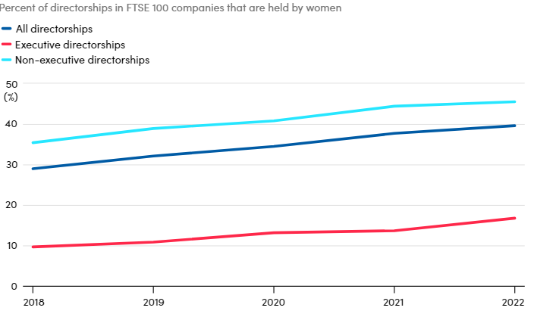

#### Figure 1.1: “Directorships in FTSE 100 companies that are helped by women”

(Source: Businessleader.co.uk, 2022)

The numbers of female CEOs in the FTSE companies in the UK have observed a significant increase which has helped in enhancing the business dimensions through bringing innovation and change. Based on the study of O'Toole (2021), female leaders are more inclined towards promoting well-being and continuous development to gain competitive advantage which is the key to achieve success in the current complex and competitive business environment. In 2021, around 18 female CEOs were positioned in the ‘FTSE 250’ and ‘FTSE 100’ companies (Peoplemanagement.co.uk, 2022). However, the numbers are the same as it was in the year 2021. The total number of female directorships is fewer than male directorships between the year 2016 to 2020 (Vinnicombe*et al.* 2020). Thus, the generation of women directorships needs to increase in order to change the dimensions to promote equal pay and gender equality.

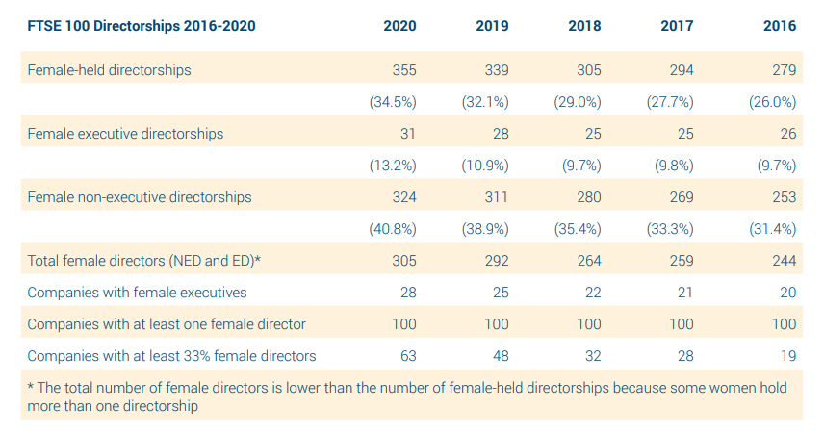

#### Figure 1.2: “FTSE 100 directorships in the United Kingdom from 2016 to 2020”

(Source: Vinnicombe*et al.* 2020)

## 1.2 Research Aim and objectives

This study aims to elaborate on the success factors of the female CEOs which made them overcome the challenges they face in their regular leadership activities ensuring the success of the business.

* To analyse the transformation brought by female CEOs by analysing their success stories.
* To critically evaluate the success factors which have driven the female CEOs to transform different dimensions of their businesses
* To examine the challenges faced by female CEOs while managing their businesses.
* To recommend viable strategies that can be undertaken by the female CEOs to mitigate their challenges.

## 1.3 Research questions

* What are the contributions of female CEOs all around the world to make considerable transformations in different dimensions of a business?
* What are the success factors which have driven successful transformations led by female CEOs?
* What challenges are faced by female CEOs while they manage their business?
* How can female CEOs mitigate the challenges they face in the management of their businesses?

## 1.4 Rationale

Female directors accelerate change and can help in achieving success through becoming more open to transformation and development. Women leaders are majorly changing the dynamics of the businesses and making companies more successful and changing the culture of the businesses. The issue has been identified that gender pay gap and fewer opportunities have impacted negatively in the business world(Cook*et al.* 2019). Research shows that in 279 multinational companies in the UK demonstrates 13 million employees where only 29% C-suite positions of CEO roles, 29% of the vice president and 34% senior manager are held by women (Forbes.com, 2019). Furthermore, it has been identified that women are around 21% less likely to get promoted as directors and women in the US are 40% less likely to be hired as managers.

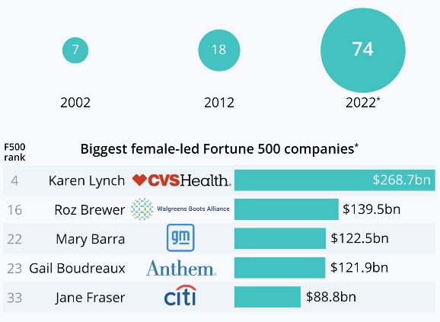

#### Figure 1.3: “Number of female CEOs at Fortune 500 companies and female-led companies with the highest 2021 revenues”

(Source: Statista.com, 2022)

On the contrary, recent studies of 2022 have confirmed that female CEOs at Fortune 500 companies have observed the highest growth and profit ratios. 74 numbers of female CEOs are deployed at “highest-grossing companies” (Statista.com, 2022). Though, the new high still represents only 15% female directorships at the top public businesses. Highest echelons of the business environment are emerging from the business run by female directors(Hechavarria*et al.* 2019). For example, Karen Lynch has taken the lead at “CVS Health”transformed the companyas one of the “biggest in Fortune 500 history”. The company generated $268.7 billion revenues in 2021 in the healthcare and pharmacy chain, making it the company “fourth biggest public business” (Statista.com, 2022). Furthermore, in 2019 General Motors ranked 13 with CEO Mary Barra and became the “third-biggest Fortune 500 Company” and the 22nd biggest overall. Thus, the female CEOs' success stories are changing the business dimensions through transformation and innovation.

## 1.5 Problem statement

The highest achievements and with the increasing success stories of female CEOs changing dimensions of the businesses still represent fewer numbers of female CEOs due to unfair treatment and gender pay gap.

## 1.6 Significance of the research

The research helps to determine the success stories of the female CEOs and how they have transformed the business scenarios. There are excruciating the female CEOS in the UK and their success journey which have shifted the business landscape. The research helps to demonstrate the growth led by female CEOs through overcoming hardships and gender pay gap issues.

## 1.7 Dissertation structure

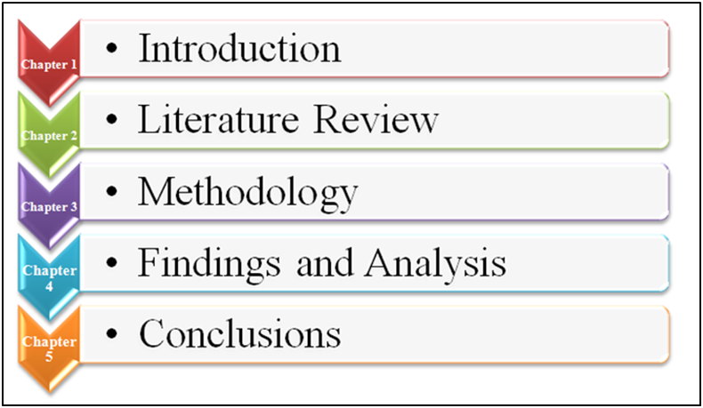

#### Figure 1.4: Structure of Dissertation

(Created by author)

## 1.8 Summary

This part of the research helps to signify the success stories of female CEOs that has majorly changed the dimensions of businesses. Furthermore, fewer opportunities and significant gender pay gap created barriers which have been overcome by female leaders and aching great success.

# Chapter 2: Literature Review

## 2.0 Introduction

A literature review is the discussion of secondary sources of literature in a critical manner based on evaluation of a particular subject matter. Generally, a literature review is done to find out almost all existing and relevant information about some specific topic-based variables. In this discussion the topic hopes to analyse the dimensions of business transformation by the hands and influence of the female CEOs around the world. Thus, this topic expires on different dimensions of influence of CEOs in a business and the impact of the famine gender in these dimensions. A further exploration of literature also hopes to discuss female entrepreneurship-based success factors, significance of the process and further recommendation of strategies for improvement.

## 2.1 Conceptual Framework

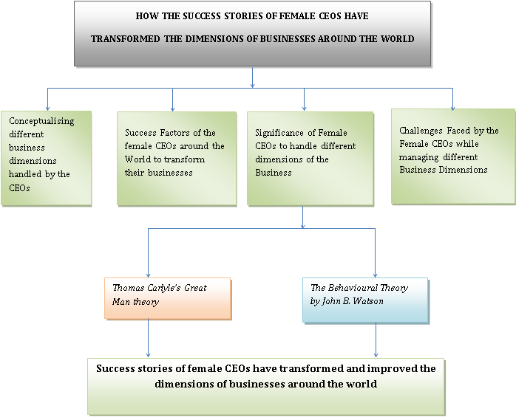

#### Figure 2.1 Conceptual framework

(Source: self-developed)

## 2.2 Conceptualising different business dimensions handled by the CEOs

A CEO being the head of an organisational operation has to be responsible for a multitude of organisational duties and responsibilities. Therefore, the operational dimensions of a CEO is also significantly vast. However, based on organisational dimensions and its image of responsibilities, the dimensions of a CEO should include Finance-driven, culture-driven, company representativeness, corporate innovator and business executor. A CEO must attend to all these dimensional roles be completely dedicated towards an organisational operation.

In an alternative discussion. A CEO has to be responsible for firm reputation and performance. Thus, firm reputation and firm performance can be considered potential attributes or dimensions of a CEO’s effectiveness. According to Andreini *et al.* (2021), a CEO is responsible for firm reputation as they are directly accountable for collaborating and collecting with the different stakeholders. Maintenance of proper reputation with the stakeholders can not only improve CEO-stakeholder relationship but can also improve a firm’s reputation with better engagement of the both. Similarly, the clarity maintained between a CEO and its stakeholders can improve firm performance as well.

This case is however a bit different in family-managed films. In a family-managed firm a dimension of good relationship between the stakeholders can already be seen. On a contrary note, Kammerlander *et al.* (2022), the operational tone of family-managed films is quite different from regular firms. In this case the operational dimensions for the CEO become much easier due to an already established relationship. The direct effect of this can be seen in reduction of employee turnover rates of the firm which can also be considered as a dimension of interest for organisational success. Low employee turnover addresses a better work and production process making it one of the indirect effects of family-managed film-based CEOs.

One other dimension of a global organisation that is handled by the CEOs can be considered as the firm’s international footprint. After all, it is the CEOs that decide how much global footprint an organisation can acquire or what steps should be taken to attain the same in a desired amount of time. The findings of Békés *et al.* (2021) suggests that A CEOs international experience ultimately decides the firm's international experience and its pathway. The more innovative and experienced a CEO is, the more positive results the organisation can attain. Thus, the international footprint of an organisation is also a dimension handled by the CEOs.

## 2.3 Success Factors of the female CEOs Around the World to transform their businesses

The female CEOs around the world have taken a vital part in the transformation process of the business due to their huge success rate regarding business expansion and profitability. According to the views of Fuhrmans (2020), the female CEOs from all over the world have performed well in the collaboration process due to efficient convincing quality with effective communication quality. The female CEOs are efficient to expand the business in different foreign markets by ensuring effective communication flow during the business meetings. On the contrary Piggott and Matthews (2020) have mentioned that, the female CEOs are more efficient for the maintenance of the organisational structure. As the effective understanding regarding the requirements of the employees have decreased in recent years. The female CEOs are emotionally intelligent and provide clear insights regarding the requirements in a busy working schedule. This is helpful to enhance the rate of employee satisfaction which is essential to enhance the productivity of the organisation. Female CEOs are efficient to identify the issues regarding the working process of the organisations by examining the feedback of the workforce of the organisation.

The female CEOs are efficient for multidimensional work processes that helps them to enhance the work process of the organisation by taking care of different teams of the organisation. As mentioned by Igbukolu (2022), the female CEOs have the potentiality to examine different departments of the organisation to ensure proper flow of resources for the productions. This is helpful to enhance the productivity of the organisation by ensuring the success rate of the work process. The emotional intelligence among the female CEOs is helpful for them to encourage the employees to provide more dedication regarding the work process. Similarly Carli (2020) has stated that, the female CEOs have the capability to take care of the emotional and health factors of the employees. This is helpful to maintain good will of the organisation among the work forces. This is helpful to ensure active engagement of the employees.

Organisational growth by ensuring the proper supply chain management process is possible by the efficiency of the female CEOs of maintaining good relations with suppliers. According to the views of Kronsbein et al. (2022), the female CEOs are efficient to ensure the sociability and teamwork among the employees of the organisation. This is helpful to maintain effective organisational culture that is effective for business growth. The collaboration of businesses includes effective collaborative work of multiple teams. The female CEOs of the business organisations have the efficiency to enhance the collaboration process by encouraging employees and the managers. The effective communication skills of the Female CEOs helps them to ensure the success of the business meetings to ensure collaboration with different organisations. Similarly Ran et al. (2021) have mentioned that the female CEOs are efficient to enhance the organisational growth by using effective emotional intelligence for the work process of the organisations. This is essential to enhance the outcome of the business productions accordingly by considering the market demand of different foreign countries.

## 2.4 Significance of Female CEOs to handle different dimensions of the Business

Female CEOs have achieved greater success due to their utmost clarity in vision and determination to change the dynamics of the corporate world. Female CEOs have a greater impact in sales and help in sustaining growth. It has been identified that female CEOs tend to increase sales by 3.7% (Flabbi *et al.* 2019). Furthermore, female directors are more focused on growth and are majorly adaptable to change. The current environment is rapidly changing and revolutionary changes are accelerating the growth of the global environment. Therefore, in this case female CEOs are majorly important and required in organisations to create the environment of the company more flexible and adaptive to change and sustain growth through bringing innovations. Based on the study of Kang *et al.* (2019), female business owners are more concerned and have more ability to understand the needs of the consumers which helps in creating effective decisions.

The major significance of female CEOs is that they are mostly incredible in understanding employee needs and tends to increase employee satisfaction level which further impacts positively in the productivity level. According to the study of Huaman-Ramirez *et al.* (2021), satisfied employees tend to become more motivated and deliver adequate and expected productivity. Furthermore, companies that are owned by Female CEOs have more satisfied and loyal employees (Taheri *et al.* 2020). It further increases their performance level and determination in accomplishing tasks with expected outcomes. Moreover, large technology companies are experiencing steady progress in increasing the female workforce (Deloitte.com, 2021). Therefore, it can be determined that female CEOs are majorly effective for perceiving growth of a company. On the contrary, senior management posts are mostly held by male employees (Jackson *et al.* 2022). Additionally, gender discrimination can be seen in most of the organisations in the UK and gender pay gap is a significant issue which became a barrier in their career growth.

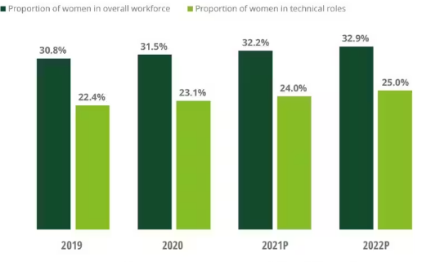

#### Figure 2.2: Increasing progress in technology companies under women directorship

(Source: Deloitte.com, 2021)

Female CEOs have the potential of achieving greater things through effective problem solving skills which help organisations to overcome barriers while operating business in the complex and growing industries. For instance, “Milena Mondini de Focatiis, Admiral Group, Amanda Blanc, Aviva, Jette Nygaard-Andersen, Entain, Emma Walmsley, GSK” and many more are some examples of popular female CEOs that has upgraded company’s growth majorly and helped in obtaining success (Theguardian.com, 2023). Furthermore, women have more innovative ideas which help companies to bring innovation and revolutionary changes that can increase the company’s growth. Thus, it can be determined that female CEOs are majorly helpful in handling different dimensions of businesses.

## 2.5 Challenges Faced by the Female CEOs while managing different Business Dimensions

Female CEOs have incredible quality to lead teams and achieve expected outcomes through innovation. Based on the study of Spencer *et al.* (2019), gender discrimination is one of the key issues of each organisation that affects female employees mostly. Furthermore, women get very less opportunity than men in the corporate world to obtain higher positions. This is due to the gender discrimination and certain stereotypical mentality of men that females are mostly soft and incapable of handling critical and stressful situations. For instance, Lingerie group Boux Avenue has reported its major gender pay gap by 75.7% which affected the numbers of female workers in the company (Theguardian.com, 2019). Therefore, due to stereotypical mentality, females get very less opportunity to perceive greater things. Additionally, female CEOs majorly face gender discrimination as well as gender pay gap and certain stereotypical mentality of individuals they are being portrayed as less important. On the other hand, male lead firms are being replaced with female CEOs and the organisation is receiving great profits.

The lack of equality in the workplace impacts negatively in the growth for females in the corporate world (Adamson and Kelan, 2019). Therefore, it can be determined that analysing the major contributions of females elaborates the hardships that they have to go through before obtaining a successful position. Furthermore, there are some employees who are unwilling to follow orders from female CEOs (Fuhrmans, 2020). Individuals with stereotypical mentality provide fewer opportunities before providing an equal chance. Furthermore, combating this issue is majorly important and necessary in order to accelerate the growth of the business world. However, female CEOs have achieved greater things through fighting their way to the top. Thus, it can be depicted that female CEOs face several challenges while managing different dimensions of business.

## 2.6 Recommended strategies undertaken by Female CEOs to Reduce the Challenges

Female CEOs experience several challenges while conducting business and to lead a team or to achieve higher posts. Certain strategies can be obtained by female CEOs in order to reduce the challenges. Based on the study of Lim and Chung (2021), female CEOs need to become more confident and need to become more confident in order to fight their way through the top. Furthermore, it can be determined that female CEOs need to become more adaptable to their individuality and combat the hardships and the unfairness in the corporate world with ethical justifications and with their strong effective presence. For instance, an organisation that has a major gender pay gap and gender discrimination which affects the female employees and increases stress and further results in fewer female employees in that organisation. However, in this case if the female employees fight for their rights and show their extreme growth and success can help them to change the stereotypical mentalities.

Identification of appropriate companies that will care about their female workers and companies that support female growth can be the best choice for female effective candidates to succeed in their careers. According to the study of Cambrea *et al.* (2020), female CEOs need to implement training and sessions to increase knowledge and to eliminate discrimination in the workplace. Additionally, CSR strategies, SGD goals compliance, imposing equality and various techniques can be obtained by female CEOs to increase their supremacy. Thus, it can help them in conducting business with loyal and effective employees.

## 2.7 Theoretical Perspectives

Entrepreneurs have qualities inherited inside them from before as leadership qualities. Attention to detail qualities and team management qualities are with them. As opined by Alade and Windapo, (2021), ***Thomas Carlyle’s Great Man theory*** suggests that entrepreneurs have natural abilities to lead, delegate work, and inspire the people around them. Leaders have a positive impact on the people around them. This theory can be helpful in this project as female CEOs have the required abilities to be leaders and change the perspective of the working culture. The qualities mentioned are also inherited in the Female CEOs from their respective background which helps them progress towards success.

On the other hand, in reference to the words of Sawaean and Ali, (2020), ***The Behavioural Theory by John B. Watson*** suggests that entrepreneurs or leaders are created by training and developing the skills they will learn. Thus, the Female CEOs can be made by introducing them to the skills like communication skills, time management skills, analytical skills, the power of thinking creatively, strategic thinking and more. As per Apriana *et al*., (2019), according to this theory in order to build a great entrepreneur they should learn the skills even if they have natural abilities or not. Female CEOs will definitely benefit from these skills which are mentioned as it will help them in making decisions wisely.

As mentioned by Sedyastuti *et al*., (2021), ***The Transformational Leadership theory*** states that improvement in the organisation can be gained by changing a few things which are required to do so. The important factors can be influenced by positive changes in the organisation. Female CEOs also can be productive in their own way of working. The leadership skills which create a positive impact on the organisation can also be taught to female entrepreneurs for their betterment of them. Leading female entrepreneurs do the required changes within themselves also to have an effective working environment in the organisation.

## 2.8 Gap in Literature

The importance of female has been discussed in previous research but the significance of female CEOs to handle the different dimension of the business has not been discussed in other research. In this project, it is discussed briefly how significant it is for female CEOs. In this project, the issues faced by the female CEOs are elaborated which have not been discussed in the literature before. There are strategies and methods mentioned in this project for female CEOs to handle problems and resolve them. The recommendations are given in this project to handle the problems hassle-free.

## 2.9 Summary

Different behavioural and leadership theories have been discussed in this chapter, emphasising the scope of success attained by female CEOs across diverse industries. Relevant literature from past literary works has been collaborated in this chapter to interpret the common scope of challenges and strategies. Significant contribution of female CEOs has been described to prepare an effective idea about their leadership aspects. Different business dimensions handled by CEOs are also inculcated within this research to optimise an effective imagery of their responsibilities. This could eventually develop a suitable diagnosis about evolution of female CEOs within organisational framework. There is a suitable scope of understanding developed through discussion of different behavioural aspects both from individual and social perspectives.

# Chapter 3: Research Methodology

## 3.0 Introduction

The research methodology explains how any researcher would intend to carry out the entire research. It is a systematic as well as logical process to solve the issues regarding the research. This chapter details the research approach for ensuring a relevant and valid outcome that addresses the research aim and objectives. This section of this research highlights major aspects regarding the research method that followed as well covered throughout the entire study. This chapter aims to gain research insight into the topic and as well verify all the major facts regarding the topic. However, the methodology provides a particular process analysis and identifies the cause and effect of the relationship. It has been determined as a proper method, which would be used for collecting data and it includes the overall research analysis collusion.

## 3.1 Research Onion

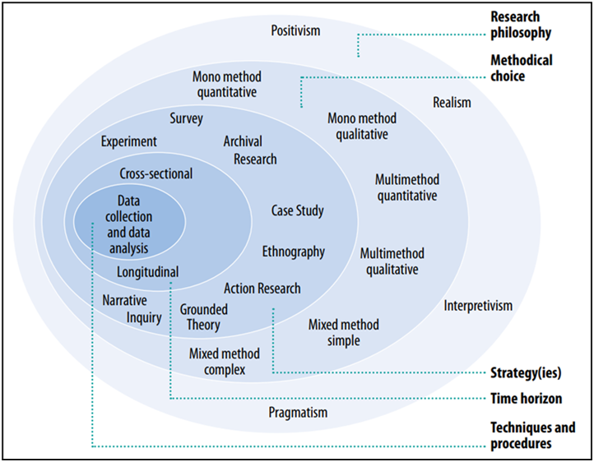

#### Figure 3.1: Research Onion

(Source: Saunders *et al*. 2019)

## 3.2 Research Philosophy

One of the crucial factors of the methodology is research philosophy, which is discussed initially in this chapter. Generally, the critical type of philosophy is used within most research work. Those are positivism, realism, and interpretivism research philosophy. In the positivism philosophy, all the researchers could analyse several factors quantitatively and enhance the overall study based on a few assumptions with existing evidence. The interpretivism research has not followed the quantitative approach rather it follows the qualitative approach (HR and Aithal, 2022). On the other hand, realism philosophy is mainly based on the crucial assumption about various research layers. In realism philosophy, all the researchers have the liberty to think separately as well as be free to reach a new way and direction of the research (Irshaidat, 2022). In order to follow the realism philosophy, researchers are capable of evaluating all the factors in an argumentative manner.

This research has followed the “interpretivism research philosophy” as this philosophy has gained relevant facts related to coherent structure for describing the success factor of female CEOs. Referring to recognizing the concept of the success story of female CEOs, this study has focused on the use of interpretivism philosophy. This philosophy is involved in compliance with the epistemological point of view in the ontological paradigm (Saunders *et al*. 2019). However, interpretivism philosophy proved to be an advantageous use of simple theories and concepts with such emphasis on interpretations for enhancement of new understanding about this research. The other two philosophies discussed above are not appropriate for this research as these are to deal with less surface-level and reliable data to conduct this research.

## 3.3 Research Approach

This is another crucial part of the methodology that also helps researchers for supporting data, which has been extracted from research regarding supporting the research aim. The two most common approaches followed by any research are inductive and deductive research approaches. As per the view of Walter and Ophir (2019), the inductive approach has mostly been followed by researchers to enhance new ideas in new research cases where the entire research has been subject to exploring new information. This approach is based on a practical and innovative viewpoint.

The deductive approach is also a good option to improve all the conclusive evidence and all researchers used this approach regarding the aim and objectives. This research has followed the inductive research approach. In the opinion of Eger and Hjerm (2022), this approach is very helpful for this research for generalising all the collected data. It also explores phenomena with patterns and themes that generate the overall conclusion with the future prediction. The other approach has not been followed here due to falsified data involvement of the entire datasets.

## 3.4 Research Strategy

This method has referred to a particular technique that is followed for conducting the overall research. In terms of meeting all the objectives, it is significant to choose the perfect strategy. According to Saunders, most of the research could be developed with seven strategies. Those strategies are archival, experiment, ethnography, action, grounded, case study, and survey. However, the research quality could as well ensure while selecting the appropriate research strategy. As cited by Chun *et al.* (2019), this research has followed the grounded research strategy to fulfil the research work. This strategy is useful for this research as it provides sequential and explicit guidance to conduct qualitative research.

## 3.5 Research Design

In order to conduct research successfully, all the researchers need to follow a systematic way. However, following a perfect framework as well as protocol are also significant for the research to fulfil the objectives and aims of the research. In this aspect, this could be mentioned that, generally three major research designs are followed by researchers regarding study requirements. Those research designs are exploratory, explanatory, and descriptive. According to Doyle *et al.* (2020), the exploratory design is recognized as being the perfect choice to explore several factors from the last analysed variables. Explanatory design is efficient for discussing such predefined factors in the current study scenario. However, the descriptive research design is rich in several viewpoints. This research has followed the descriptive design as it mentioned the relevant factors regarding this research (Aggarwal and Ranganathan, 2019). In this aspect, a lot of information is extracted to support the female CEOs for supporting their business dimensions.

## 3.6 Sampling Techniques

In this research, researchers are taking an excursion and inclusion process to sample the dataset from secondary sources. They have taken around 40-50 peer-reviewed articles to conduct the research successfully. Out of those articles around 20-25 articles are taken with relevant and factual datasets that are as well considered for being included in the entire research. According to inclusion criteria, all the peer-reviewed articles and journals taken after 2018 were from trustable sources only. As per exclusion criteria, any sources that are published before 2018 have been excluded strictly.

## 3.7 Research Choice

This section is based on deciding the use of data types in the entire research. In most cases, three different options of research choices are used by researchers such as mixed, mono, and multi-method. Choosing a mono method is about choosing just one data type between qualitative and quantitative (Wong *et al.* 2020). On the other hand, the mixed method used both qualitative and quantitative methods. However, the multi-method used one qualitative and one quantitative method. This research has followed the mono method, as it has followed just the qualitative method over the entire research.

## 3.8 Time Horizon

This part of the methodology refers to the total time length that would be expected to own the total investment before being required to access the fund. It also defines a proper time frame as a cross-sectional or short-term study that particularly involves data collection at a specific time point (Ogg, 2020). This research has followed the cross-sectional study, as the investigators' horizon has measured the outcome with all the researchers at similar time points. This particular strategy was used just to collect information at a single time point. The cross-sectional study is time-consuming and cheap compared to other strategies. ***[Refer to Appendix]***

## 3.9 Data Collection

This is the most important section of any research to collect information regarding the topic. The research's future and success depend on this part. Data collection is linked with an appropriate sampling process and it could state that two different types of data such as primary and secondary are used in research. This research has followed the secondary data collection technique. According to Rauvola *et al.* (2019), secondary qualitative data has been used here to test the existing data by secondary authentic sources from online websites, Google Scholar, Pubmed, and Proquest. The primary methods are avoided in this research just for taking huge time and costs.

## 3.10 Data Analysis

It refers to a particular process that systematically uses the logical method for depicting, condensing, and evaluating data. However, two types of data analysis are used in most of the research such as quantitative and qualitative. In quantitative analysis, they used the survey and statistical analysis. On the other hand, the qualitative analysis used thematic analysis to conduct the research appropriately. This research has followed a qualitative analysis by conducting a thematic analysis (Braun and Clarke, 2019). All the themes regarding this analysis are based on the research objectives. This analysis helps researchers by creating 6 significant themes regarding the research topic.

## 3.11 Validity and Reliability

The validity has referred to specific methods to gather information as well as tailoring the related data to bring out reliable, standardised, as well as high-quality research by data analysis. However, validity is the data accuracy, while reliability is the consistency of collected data from reliable sources (Poitras *et al.* 2019). The data validity has taken place in this research by maintaining the citation used from the journals, The reliability has also maintained data from the authentic articles that are published since 2019 and also crediting authors with appropriate citations.

## 3.12 Ethical Consideration

Ethical aspects have also been maintained in this entire research through appropriate protocols maintaining. The rules and ethics are major things in conducting research properly. In secondary qualitative research, all the articles and journals were chosen perfectly for conducting thematic analysis. Trustable and reliable data sources have been considered while choosing journals for this research. This research has followed the “Copyright, Designs, and Patents Act 1988 (c. 48)” and “Data Protection Act 2018 (c.12)” to make proper research (Wylde *et al.* 2022). Copyright of any sources has not been breached here and authentic referencing along with acknowledgement has followed in this research.

## 3.13 Summary

This is a major chapter that used appropriate methods for conducting the research successfully. Research design, approach, and philosophy are discussed with proper justification. Discussion of every aspect of this research is mentioned here with proper data sources. It has been that secondary research has followed here thoroughly. The qualitative process along with secondary research has been used here by conducting thematic analysis. The time plan of this research has followed the proper time point taken by the researchers to complete this study.

# Chapter 4: Data Analysis and Findings

## 4.0 Introduction

The data analysis and finding is the most crucial part of the research as it helps to analyse the gathered data accordingly by considering the subject of the research process. In this chapter the analysis and findings have been made to emphasise the importance of female CEOs in the business growth process. This chapter includes multiple themes to underpin the importance of the female CEOs to enhance the business growth. This research has been conducted by using the secondary data anal,ygtsis process that has ensured accurate data regarding the efficiency of the female CEOs for maintaining the business process.

## 4.1 Secondary Qualitative Data Analysis- Thematic Analysis

### Theme 1: Transformation of female CEOs by analysing their success stories

The transformation of the female CEOs refers to the process of up gradation of the female CEOs regarding the process of the business activities and productions. As mentioned by Zhang *et al.* (2022), female CEOs have maintained the balance between explorative and exploitative behaviours by assessing information from the analysis of the success stories of other female CEOs. This is helpful for them to ensure the success of the business productions by enhancing the profitability rate of the business companies. Furthermore, the analysis of success stories has helped the female CEOs to enhance the ambidextrous behaviour among them. This is helpful to enhance the business production rate of the companies accordingly by considering the demand of the customers from different foreign countries. This has enhanced the success rate of the female CEOs regarding the business collaboration and growth.

The transformation process of the female CEOs has helped them to develop the skill of managing operational risks. According to the views of Martín‐Ugedo *et al.* (2018), the female CEOs are effective to enhance the profitability of the business companies by managing the risks regarding the business productions. This is helpful to ensure the proper delivery of manufactured products by considering the demand of the customers. On the other hand, the analysis of the success stories has helped the female CEOs to grow the quality of leading major corporations. According to the views of Fitzsimmons *et al.* (2019), the female CEOs have developed their management qualities by considering the demand of the markets and the customers from different foreign countries. This is helpful to enhance the business profitability.

In recent years the female CEOs have improved their emotional intelligence regarding the work process of the business companies. In the views of Buckalew *et al.* (2019), the female CEOs have performed better by enhancing their emotional intelligence by accessing information from the analysis of the success stories. The improvement of the emotional intelligence among CEOs is helpful to identify the issues of the employees regarding the work process of the organisations. This is helpful to enhance the productivity of the business organisations to ensure the profitability of the business companies. The female employees have enhanced their quality of managing and encouraging employees by accessing information regarding the success stories of other female CEOs.

### Theme 2: Teamwork, Cost Management, and Time Management skills are success factors driven by female CEOs in their business

All CEOs require communicating with their employees by using easy-to-understand language and they require knowing how to foster open-mindedness and collaboration among subordinates for growing the business. As per the view of Aránega *et al.* (2023), the skills that should be required for a female CEO include teamwork, cost management, time management skills, and more. In terms of finding talented employees in future, they would require all these skills for developing their team and business. In order to launch a transformation effort on a proper footing, cost management is major in the short term particularly. In the opinion of Rodrigues *et al.* (2021), the leading drivers for any organisation are recovering from the “TSR (Total shareholder returns)” deterioration, which is a cost-cutting effort. The proper teamwork of any female CEO has made them different from others. A successful leader's traits include determination, confidence, vision, and empowerment. Most of the female CEOs communicate with their employees by using concise language and it is a great teamwork skill to develop the business easily.

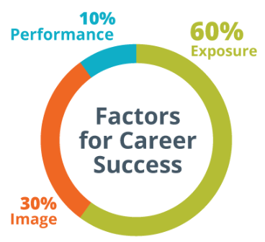

#### Figure 4.1: Building a strong network by female leaders

(Source: Byham, 2023)

It is important to have proper time management skills for every CEO including female CEOs. This skill is something that several people have wanted to develop at their work. The largest factor of a female leader is exposure in her career success which represents around 60% (Byham, 2023). The major thing to the time management skill is knowing the actual deadlines as well as setting reminders. In work time, it should create a proper routine that would make sense for the CEO's position as a woman. As cited by Ferreras-Garcia *et al.* (2021), creating a daily planner and giving a specific time limit for every task is the perfect way to be a successful CEO for a woman. In a perfect work sense, proper team time management would govern how a CEO runs the entire project as well as how all the team members would complete the tasks properly.

### Theme 3: Lack of mentor and sponsorship, difficult expectations, and unconscious bias are some challenges faced by female CEOs during their work time in business

Providing women with mentors is such a meaningful way to assist all of them advances their personal careers. Mentors provide every woman with proper guidance to navigate her career as well as advice on their skill enhancement (Al Naqbi, 2023). However, women tend to be under-sponsored and over-mentored. Though opportunities for mentorship abound, just 32% of white women and around 26% of women are saying that they have access to sponsorship (Scheepers and Mahlangu, 2022). Inequity and correcting need have changed the organisational culture. The culture has started at the top as well as women leaders could take such steps in their organisations (Erskine *et al.* 2021). Women leaders and CEOs could investigate some formal “sponsorship opportunities”, which exist in their organisation. Even in most of the senior positions, most of the women are likely reporting to feel forces on the “balance respect” that with likability.

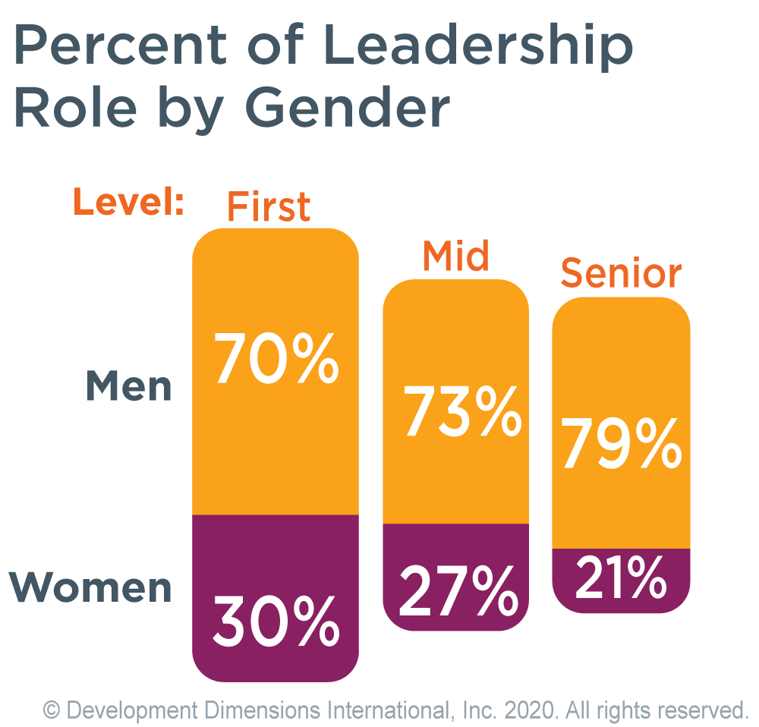

#### Figure 4.2: Leadership role percentage by Gender

(Source: Byham, 2023)

Even if the physical attributes, generally unconscious bias is associated with the female leader that is often unconsciously and is linked less well with money. They have an inverse relationship with women with their gender bias. From the above image, it shows that the gender bias among women seniors or leaders is 21%. Less gender bias is opposed to the women who particularly work outside of the home because they enjoy respect from society and family. According to Al Naqbi (2023), unconscious bias has affected every person including female leaders. This is particularly triggered through the brain automatically by making such a quick assessment and judgement. All female CEOs and leaders are influenced by personal experiences, backgrounds, cultural contexts, and societal stereotypes. The lack of women has contributed to differentials in gender wages with all the women CEOs in the world on average earning 64% (Silberg and Manyika, 2019). This is a mental association that is based on gender bias, and it is unconsciously learned from norms, traditions, culture, values, and experience.

### Theme 4: Enhancing organisation collaboration and developing financial performance could undertake by female CEOs to reduce the challenges in their business

Investing in economic empowerment has been a direct path to gender equality, economic growth, and poverty eradication. All the women CEOs are making enormous contributions to the economies whether in farms or business. According to Brunetti *et al.* (2020), better financial health in an organisation has led to better job opportunities, more development and growth, and higher productivity. The impact magnitude is substantial as a female CEO would enhance the sales of every employee by around 3.7% (Flabbi *et al.* 2019). The overall performance of an organisation that is led by a women CEO has enhanced with female workers' pay. This particular result has followed from a specific assumption that most female CEOs are much better at processing information regarding the productivity of female leaders. Thus, females employed wages by the women CEOs that are sensitive to individual productivity to deliver the first implication.

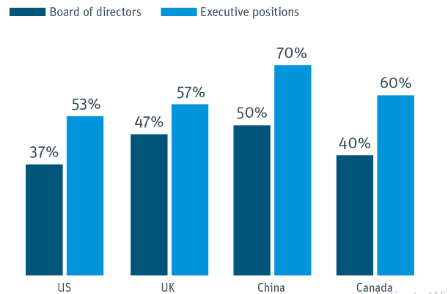

#### Figure 4.3: Startups percentage with women in leadership positions

(Source: Influenced by Brunetti *et al.* 2020)

The employees are necessary to the success of an organisation, and this is paramount that all of them feel respected, safe, and valuable. The proper team culture has dictates how employees work and behave together under female CEOs. This is significant for setting a tone by making the perfect attitudes and values. It defines proper expectations for communications and responsibilities and also influences how employees work into a common target (Al Mashhadani, 2021). An organisation with perfect collaboration could develop productivity in the workplace, as every individual has to understand their responsibilities. Through the collaboration, the business under women CEO may as well focus on developing the trust and communication among all their employees for ensuring the perfect teamwork (Dadanlar and Abebe, 2020). However, learning different methods of collaboration to implement in their workplace could also assist them to influence how all the employees would work together for achieving the target of their organisations.

### Theme 5: Diverse problem-solving and high employee engagement are the major roles of a female CEO in the business

Having women in the roles of leadership could assist organisations to forge a much deeper connection as well with all the customers that inspire other female employees as well as boost employee engagement. Enhancing diversity is also a major benefit during the skills shortages as companies have the proper access to the broader “talent pool”. An organisation that has such gender diversity, which is around 21% more likely, has experiencing average profitability (Tortilla *et al.* 2022). Moreover, most of the companies with ethnically and culturally diverse teams were 33% likely to see better profits. On the other hand, gender diversity in the workplace particularly means that most of the employees are likely to have different experiences and abilities.

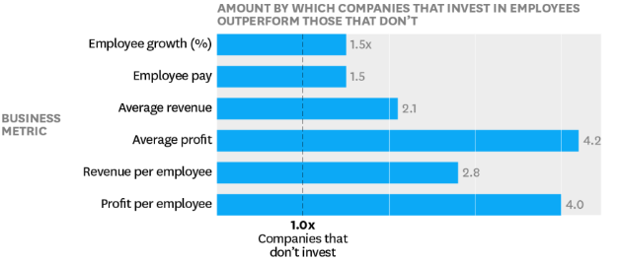

#### Figure 4.4: Employee experience of female leaders

(Source: Influence by Tortia *et al.* 2022)

Moreover, employees in an organisation with much greater diversity will have access to several views that are useful to accomplish and outline a perfect business strategy (Kang *et al.* 2021). Encourage the female team leaders for selecting a diverse group for a particular project for ensuring that gender does not separate as naturally. Female leaders are adaptable and flexible and frequently display a blend of participative, transformational, and democratic leadership. According to Siddiqui and Sahar (2019), having females in the team is meant to benefit from various viewpoints as well as approaches that would come from various life experiences. A perspectives multiplicity could as well spark innovation and creativity, and also assist organisations to seize and spot new opportunities.

### Theme 6: Generating more revenue and high stock price is crucial to transform the success stories of female CEOs

Female-led organisations grow much faster, generate some extra revenue, as well as have high stock prices. All the female leaders have existed on average one year earlier. Moreover, from an economic standpoint, this is crucial for having more women CEOs. However, Female-led organisations as well have much happier employees. As per the view of Birindelli *et al.* (2019), successful leader traits include determination, confidence, vision, and empowerment. In recent times, female CEOs are much more profitable as compared to others. Most of the leading females are proven they have such innovative ideas as well as new plans that could change the overall course regarding society for much better.

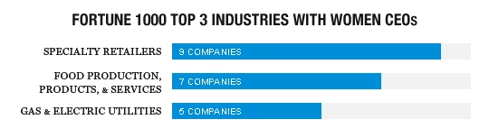

#### Figure 4.5: Women CEOs in top industries

(Source: Influenced by Neely 2020)

Female leads now generate more revenue as compared to men CEOs. From an economic standpoint, this is critical for having many more women CEOs in most of the organisations. The entire corporate world has made considerable strides in the perfect direction in the journey into diversity and equality. In the opinion of Neely (2020), it is undoubtedly the right of female leaders and their campaigns to thank the overall progress of high stock prices. Cumming (2022), asserted that nearly 87% of the Fortune 500 companies in 2021 with the women CEOs had reported above-average profits. Most female CEOs nowadays are great at collaboration that looks like their sales team to meet the objectives or may allow for sufficient flexibility in accommodating their several employees.

## 4.2 Key Findings

Female CEOs are effective to enhance the profitability of business companies by managing the risks regarding business productions. It is helpful to enhance the business production rate of the companies accordingly by considering the demand of customers from different foreign countries. However, a transformation of the female CEOs refers to the process of up gradation of the female CEOs regarding the process of business activities and productions. The analysis of success stories has helped the female CEOs to enhance their ambidextrous behaviour among them. Teamwork, cost management, and time management skills are some major skills that should be needed for the female CEO to develop their business. The proper teamwork of any female CEO has made them different from others. A successful leader's traits include determination, confidence, vision, and empowerment. Creating a daily planner and giving a specific time limit for every task is the perfect way to be a successful CEO for a woman.

The time management skills of female CEOs help to develop their business properly. Mentorship abounds opportunities for female leaders to help them to change the overall organisational culture. Women leaders and CEOs could investigate some formal “sponsorship opportunities”, which exist in their organisation. Less gender bias is opposed to the women who particularly work outside of the home because they enjoy respect from society and family. Unconscious bias has affected every person including female leaders. This is particularly triggered through the brain automatically by making such a quick assessment and judgement. The lack of women has contributed to differentials in gender wages with all the women CEOs in the world on average earning 64% (Silberg and Manyika, 2019). All the women CEOs are making enormous contributions to the economies whether in farms or business. The overall performance of an organisation that is led by a women CEO has enhanced with female workers' pay.

A proper team culture dictates how employees work and behave together under female CEOs. Through collaboration, the business under the women CEO may as well focus on developing trust and communication among all their employees for ensuring perfect teamwork. Enhancing diversity is also a major benefit during the skills shortages as companies have the proper access to the broader “talent pool”. Gender diversity in the workplace particularly means that most of the employees are likely to have different experiences and abilities. Female leaders are adaptable and flexible and frequently display a blend of participative, transformational, and democratic leadership. A perspectives multiplicity could as well spark innovation and creativity, and also assist organisations to seize and spot new opportunities. Female CEOs are much more profitable as compared to others. Most of the leading females are proven they have such innovative ideas as well as new plans that could change the overall course regarding society for much better. It is undoubtedly the right of female leaders and their campaigns to thank the overall progress of high stock prices.

## 4.3 Discussion

Women are majorly underrepresented as CEOs globally. However, it slightly enhanced the overall share to around 5.4% in the year 2022 as compared to 5% in 2021 (Spglobal 2022). Organisations that are based on female leaders grow faster than compared to men leaders. The magnitude of the effect is substantial as a women leader would enhance the percentage of the overall sales for the organisations. When most women would be empowered in the organisations, each person would get benefits (Doyle *et al.* 2020). The female CEOs help to develop productivity, increase collaboration, as well as inspire overall organisational dedication. Female CEOs display more empathy, adaptability, and diversity in their personal leadership style which are consistent with much of the emerging theories. As per natural language and sentiment processing, it has conducted the call transcript of the female leaders in multiple organisations.

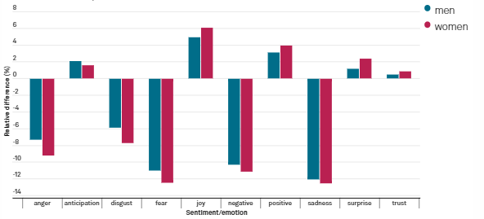

#### Figure 4.6: Emotion shift by men and women in their leadership

(Source: Spglobal 2022)

There are some requirements for being a CEO and that includes sociability, learning smoke-specific things, teamwork, time management skills, creativity, solid communication skills, and erudition. In terms of finding a talented employee in the near future, all the female CEOs require all these skills for them as well as everyone in their team (Cho *et al.* 2019). Despite the entrepreneurship gap between men and women, it is vastly considered that female leaders in the entire business have particular qualities that make a perfect entrepreneur as compared to men. Although the risks have taken a defining quality of entrepreneurs, several business CEOs overestimate their capacity for coping with the future. However, female leaders are likely to include their coworkers which underlie the overall decision-making. Female CEOs are generally more supportive as well as inclusive of the employees who personally make some effort to develop their work.

All educated people seek opportunities everywhere that particularly offer career growth as well as resources for the perfect lifestyle. It is very common throughout age and gender groups. Despite the laws on women's safety as well as their security in their workplace, they still face several challenges. As per the view of Shakeel *et al.* (2020), most female leaders face decreased consequences. It is not the proper case for every woman. The gender disparity indicates the variations in pay between women and men in their respective workplaces. There are many other challenges faced by female CEOS during their workplace and work time. The lack of mentorship as well as sponsorship is a major challenge for them. On the other hand, the expectation of female leaders is high as compared to men and for that reason; it has been difficult for them to improve themselves in a CEO position.

Embracing individuality is a major strategy to reduce the above-mentioned challenges faced by female CEOs in their workplace. From mothers to CEOs, every interviewer has separate stories for sharing of people who personally had been inspired as well as those who were unanimous in their view. As cited by Malik *et al.* (2020), role models have played a crucial role in female leaders' aspiring in their career progress. Female entrepreneurs are very proud of their own success in no small part because of the myriad challenges that they should overcome to make their dreams a reality. According to Ullah *et al.* (2020), for all women leaders, all challenges are particularly magnified. They face a traditional mentality prevalent in several businesses, especially entrepreneurship. On the other hand, developing financial programs could mitigate the facing challenges by female CEOs. Increasing the organisation's collaboration is a unique strategy that helps most female leaders to develop their positions by mitigating facing challenges.

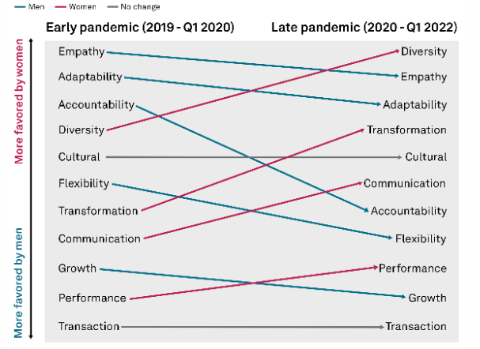

#### Figure 4.7: Shift in the men and women CEO with their leadership styles

(Source: Spglobal 2022)

In terms of being successful in the current business, female CEOs require some great collaboration. Most of the organisations with female leaders at C-level have profits that would certainly surpass those organisations led by men leaders (Mooney 2020). Organisations with female CEOs have more success as compared to men that produce such “superior stock price performance”. Moreover, companies with women CEOs had around 25% of annualised return as well over the eight years (Forbes, 2022). The female leaders are multidimensional, and they tend to use both sides' brains simultaneously. They also tend to connect their brains with ease, which means all of them could be thought in logical, linear, and serial manner at similar times. It has allowed female CEOs to use their brains simultaneously, while men tend to use every hemisphere sequentially.

Rising female entrepreneurship is an inspiring trend, which has gained momentum in recent times. However, driven by desire for creating a meaningful change as well as bringing such innovative solutions to different sectors, female leaders are enhancing and becoming the new face of business leadership (Adamson and Kelan, 2019). From the tech start-ups to manufacturing and retail sectors, women CEOs are now leading their organisations with ambition and passions, proving that everything is possible at the time they put their minds to the business. All these transformational female leaders seized their opportunities for success and growth that set an example for other entrepreneurs who aspire around the entire world.

## 4.4 Summary

In this chapter, thematic analysis has been conducted for collecting as well as analysing the secondary qualitative data. Findings are being obtained from qualitative analysis that highlights the positiveness of the female CEOs. Six major themes are developed in this chapter and analyses of these themes are done by relevant literature support to research topics. All themes are developed in a particular way so that researchers would be capable of managing on meeting the research objectives. Theme analysis has been done by focusing on the crucial research question, which has been well-developed previously. However, analysis has enhanced in such a way that researchers could be capable of justifying the statement regarding roles facing issues and implementing strategizing of those issues by female CEOs in their business.

# Chapter 5: Conclusion and Recommendation

## 5.0 Conclusion

From the entire research, it can be concluded that female CEOs have changed the business dimensions crucially as per change and innovation in business. British top teams have improved and promoted gender equality since 2010, there are still very few female CEOs in FTSE 250 companies. Helen Miles was the female CEO of Severn Trent organisation which became the first blue-chip public company. Female leaders are more inclined towards promoting well-being and continuous development to gain competitive advantage which is the key to achieving success in the current complex and competitive business environment. Female leaders are vastly changing the business dynamics and making most companies more changing and successful in the business culture.

Gender discrimination can be seen in most organisations in the UK and the gender pay gap is a significant issue that became a barrier to their career growth. Female CEOs have such potential to achieve much greater things through effective skills in problem-solving that help organisations to overcome barriers. However, female CEOs majorly face gender discrimination as well as the gender pay gap and certain stereotypical mentality of individuals who are being portrayed as less important. Thomas Carlyle’s Great Man theory and The Behavioural Theory by John B. Watson are two major theories that are helpful to female CEOs as per their capabilities to change the working culture perspectives. The Transformational Leadership theory is also helpful in developing the organisation to gain the proper leader for their organisation. Female CEOs also can be productive in their way of working. The leadership skills which create a positive impact on the organisation can also be taught to female entrepreneurs for their betterment of them.

The interpretivism philosophy is focused on the direct experience as well as it helps to determine issues that are faced by female CEOs. Various factors regarding improving female leaders in most organisations are identified by the interpretivism philosophy. The inductive approach is helpful for this research for generalising all the collected data. This approach also explores phenomena with patterns and themes that generate the overall conclusion with the future prediction. A descriptive research design has followed throughout this research to make phenomenon research regarding female CEOs all over the world. All the sources used in this research are authentic and trustable and all sources are taken from secondary sources such as Google Scholar, Pubmed, and Proquest.

The entire research has followed the secondary qualitative method by conducting the thematic analysis by developing six related themes. All six themes are based on the research objectives and provide proper justifications for the role of female CEOs and the facing challenges in the organisations. The discussion of these themes is also discussed properly along with providing enough evidence.

## 5.1 Linking with Objectives

This research has dealt with four objectives. All these objectives are linked with the literature review chapter as well as linked with the findings and analysis chapter.

***Objective 1:*** The first objective is based on analysing the transformation that is brought by female CEOs as per their success stories. This objective has linked with the 2.2 part of the literature review chapter. This section has discussed the success factors of all female CEOs in transforming their business. Moreover, this objective is also linked with the findings chapter, and in the 4.1 part of this chapter, the first object is linked.

***Objective 2:*** The second objective is focused on the success factors of female CEOs that they drive to transform various business dimensions. This particular objective is linked with the 2.3 part of the literature review chapter as it mainly focuses on the female CEO’s success factor all over the world. However, this objective is also linked with cChapter4 and particularly with 4.1.

***Objective 3:*** The third objective is crucial to examine the facing challenges by all the female CEOs during managing their entire business. This objective has been linked with 2.5 parts of the literature review chapter. This section has discussed all kinds of challenges that are particularly faced by female CEOs in the whole world. This specific objective as well follows Chapter 4. In 4.1 part of this objective is linked with discussing the facing challenges by female CEOs.

***Objective 4:*** The last objective is based on recommending some appropriate strategies undertaken by female CEOs to reduce the challenges that they face during their work time. The fourth objective is linked with 2.6 of the literature review with proper justification about the strategies. Moreover, chapter 4 also discusses this objective in the 4.1 part.

## 5.2 Recommendations

**Enhancing Economic Empowerment of Female CEOs**

Females remain under-represented entrepreneurs in the business. Fostering entrepreneurship is a major policy target for the governments of every country in the world that share the expectation of high entrepreneurial activity (Ullah *et al.* 2021). The larger economic empowerment of females and gender equality in the leadership (such as CEO) are crucial elements of gender initiative to enhance the policy for better, stronger, and fairer growth. The efficient economic empowerment for all females has happened when they enjoy their own rights for controlling that capability to manage risks (Ullah *et al.* 2020). The economic empowerment of all female CEOs has increased their working skill.

**Transforming C-suite to Develop Women Leaders**

Adding female leaders to the C-suite has changed how an organisation thinks. The organisation with female CEOs and several female seniors is profitable, socially responsible, has perfect customer experiences, and provides safety during work. As per the view of Ganijee, (2019), the capability is to be clear which a necessary skill for most females in leadership is. They should be clear every time about the expectations and goals so that employees who are led by female CEOs know how to assist them to achieve their targets. In terms of having a C-suite position, it is considered the most powerful member of the organisation (Newton *et al.* 2023). This has been set as a strategy that makes a high-stakes decision as well as ensures day-to-day operations while completing the strategic goals of the organisation.

## 5.3 Research Limitations

This research deals with the success factors of female CEOs all over the world to transform their businesses. This entire research paper has focused on the secondary methodology to gather wider data and information related to the success factors of female CEOs. Therefore, there is a lack of reliable information about facing issues with female CEOs during their business transformation. The research also lacks the proper information about the current data that will be faced by researchers in 2023. The secondary method has provided a wide range of information and it is particularly confusing among all the researchers regarding useful data.

The research has been estimated to conduct the study at a particular time, but secondary data analysis has delayed the research delivery. Thus, time is the major limitation of this research that is faced by the researchers. There is another limitation that arises in this study is a discrepancy in the funds to conduct the findings and analysis chapter. The different domains of the secondary method consist of proper data that is paid as well as due to fund discrepancy. These are some limitations that could be overcome by the researchers to develop the future scope of this research paper.

## 5.4 Future Scope

The research could focus on the analysis of male CEOs and also on understanding the actual comparison between male and female CEOs. Moreover, it as well could be efficient to make such a comparative analysis between male and female CEOs. Overall analysis might as well provide a proper overview of the crisis of female CEOs and that could also increase the effectiveness of this entire research. The entire research could focus on the primary methodology for achieving authentic and up-to-date information related to the crisis in female CEOs. Along with that, the research as well focuses on the honest CEOs crisis all over the world. These might develop the research quality.

# Reference

Adamson, M. and Kelan, E.K., (2019). ‘Female heroes’: celebrity executives as postfeminist role models. British Journal of Management, 30(4), pp.981-996.

Adamson, M. and Kelan, E.K., (2019). ‘Female heroes’: celebrity executives as postfeminist role models. *British Journal of Management*, *30*(4), pp.981-996.

Aggarwal, R. and Ranganathan, P., (2019). Study designs: Part 2–descriptive studies. *Perspectives in clinical research*, *10*(1), p.34.

Al Naqbi, S., (2023). Reflecting on Leadership Experiences: The Positive and Negative Journeys of Women in Leadership.

Alade, K. and Windapo, A.O., (2021). Developing effective 4IR leadership framework for construction organisations. Engineering, Construction and Architectural Management, 28(5), pp.1377-1396.

Almashhadani, M., (2021). Internal Control Mechanisms, CSR, and Profitability: A. *International Journal of Business and Management Invention*, *10*(12), pp.38-43.

Andreini, D., Fetscherin, M. and Zarantonello, L., (2021). How a CEO’s personality, performance, and leadership predict advertising credibility: conceptualizing and measuring CEO brand image. *Journal of Advertising Research, 61(1),* pp.110-124.

Apriana, D., Kristiawan, M. and Wardiah, D., (2019). Headmaster’s competency in preparing vocational school students for entrepreneurship. International Journal of Scientific & Technology Research, 8(8), pp.1316-1330.2

Aránega, A.Y., Montesinos, C.G. and del Val Núñez, M.T., (2023). Towards an entrepreneurial leadership based on kindness in a digital age. *Journal of Business Research*, *159*, p.113747.

Available at: https://www.nber.org/system/files/working_papers/w22877/w22877.pdf [Accessed on: 25th April, 2023]

Békés, G., Benito, G.R., Castellani, D. and Muraközy, B., (2021). Into the unknown: The extent and boldness of firms' international footprint. *Global Strategy Journal, 11(3)*, pp.468-493.

Birindelli, G., Iannuzzi, A.P. and Savioli, M., (2019). The impact of women leaders on environmental performance: Evidence on gender diversity in banks. *Corporate Social Responsibility and Environmental Management*, *26*(6), pp.1485-1499.

Braun, V. and Clarke, V., (2019). Reflecting on reflexive thematic analysis. *Qualitative research in sport, exercise and health*, *11*(4), pp.589-597.

Brightnetwork.co.uk (2022), *Top female leaders and how they got there;* Available at: https://www.brightnetwork.co.uk/equal-opportunities-menu/top-female-leaders-and-how-they-got-there/ [Accessed on: 12th April, 2023]

Brunetti, F., Matt, D.T., Bonfanti, A., De Longhi, A., Pedrini, G. and Orzes, G., (2020). Digital transformation challenges: strategies emerging from a multi-stakeholder approach. *The TQM Journal*, *32*(4), pp.697-724.

Buckalew, E., Konstantinopoulos, A., Russell, J. and El-Sherbini, S., (2019). The future of female CEOs and their glass ceiling. *Journal of Business Studies Quarterly*, *3*(4), p.145.

Businessleader.co.uk (2022), *Women account for just 6% of FTSE 100 CEOs – and are paid far less;* Available at: https://www.businessleader.co.uk/women-account-for-just-6-of-ftse-100-ceos-and-are-paid-far-less/ [Accessed on: 12th April, 2023]

Byham, T.M. (2023). *How Women Leaders Can Build Strong Networks for Success*. [online] www.ddiworld.com. Available at: https://www.ddiworld.com/blog/how-women-leaders-can-build-strong-networks [Accessed on: 28 April 2023].

Byham, T.M. (2023). *How Women Leaders Can Build Strong Networks for Success*. [online] www.ddiworld.com. Available at: https://www.ddiworld.com/blog/how-women-leaders-can-build-strong-networks [Accessed on: 28 April 2023].

Cambrea, D.R., Tenuta, P. and Vastola, V., (2020). Female directors and corporate cash holdings: monitoring vs executive roles. Management Decision, 58(2), pp.295-312.

Carli, L.L., (2020). Women, gender equality and COVID-19. *Gender in Management: An International Journal*, *35*(7/8), pp.647-655.

Cho, Y., Park, J., Han, S.J. and Ho, Y., (2019). “A woman CEO? You’d better think twice!”: Exploring career challenges of women CEOs at multinational corporations in South Korea. *Career Development International*.

Chun Tie, Y., Birks, M. and Francis, K., (2019). Grounded theory research: A design framework for novice researchers. *SAGE open medicine*, *7*, p.2050312118822927.

Cook, A., Ingersoll, A.R. and Glass, C., (2019). Gender gaps at the top: Does board composition affect executive compensation?. Human Relations, 72(8), pp.1292-1314.

Cumming, A. (2022). *Research shows companies with female CEOs are more profitable - Business Leader News*. [online] www.businessleader.co.uk. Available at: https://www.businessleader.co.uk/research-shows-companies-female-ceo-more-profitable/#:~:text=Recent%20research%20has%20revealed%20that [Accessed 28 Apr. 2023].

Dadanlar, H.H. and Abebe, M.A., (2020). Female CEO leadership and the likelihood of corporate diversity misconduct: Evidence from S&P 500 firms. *Journal of Business Research*, *118*, pp.398-405.

Deloitte.com (2021), *Women in the tech industry: Gaining ground, but facing new headwinds;* Available at: https://www2.deloitte.com/us/en/insights/industry/technology/technology-media-and-telecom-predictions/2022/statistics-show-women-in-technology-are-facing-new-headwinds.html [Accessed on: 25th April, 2023]

Doyle, L., McCabe, C., Keogh, B., Brady, A. and McCann, M., (2020). An overview of the qualitative descriptive design within nursing research. *Journal of Research in Nursing*, *25*(5), pp.443-455.

Eger, M.A. and Hjerm, M., (2022). Identifying varieties of nationalism: A critique of a purely inductive approach. *Nations and Nationalism*, *28*(1), pp.341-352.

Erskine, S.E., Archibold, E.E. and Bilimoria, D., (2021). Afro-Diasporic women navigating the black ceiling: Individual, relational, and organizational strategies. *Business Horizons*, *64*(1), pp.37-50.

Ferreras-Garcia, R., Hernández-Lara, A.B. and Serradell-López, E., (2021). Gender and learning results: a study on their relationship in entrepreneurship education and business plans. *Studies in Higher Education*, *46*(11), pp.2355-2370.

Fitzsimmons, T.W., Callan, V.J. and Paulsen, N., (2019). Gender disparity in the C-suite: Do male and female CEOs differ in how they reached the top?. *The Leadership Quarterly*, *25*(2), pp.245-266.

Flabbi, L., Macis, M., Moro, A. and Schivardi, F. (2019). Do Female Executives Make a Difference? The Impact of Female Leadership on Gender Gaps and Firm Performance. *SSRN Electronic Journal*, [online] pp.1–32. doi:https://doi.org/10.2139/ssrn.2520777.

Flabbi, L., Macis, M., Moro, A. and Schivardi, F., (2019). Do female executives make a difference? The impact of female leadership on gender gaps and firm performance. The Economic Journal, 129(622), pp.2390-2423.

Forbes (2022). *Council Post: Five Reasons Why Women Can Make Great CEOs*. [online] www.forbes.com. Available at: https://www.forbes.com/sites/theyec/2022/03/17/five-reasons-why-women-can-make-great-ceos/?sh=6a48c5b06833 [Accessed on: 28 April 2023].

Forbes.com (2019), *How Women Leaders Change Company Dynamics;* Available at: https://www.forbes.com/sites/kweilinellingrud/2019/01/30/how-women-leaders-change-company-dynamics/?sh=45c8c6c34733 [Accessed on: 12th April, 2023]

Fuhrmans, V., (2020). Where are all the women CEOs. Wall Street Journal.

Fuhrmans, V., (2020). Where are all the women CEOs. *Wall Street Journal*.

Ganijee, K., (2019). Fostering Transformational Leadership in Asian Americans: How to Reach the C-Suite.

Hechavarria, D., Bullough, A., Brush, C. and Edelman, L., (2019). High‐growth women’s entrepreneurship: Fueling social and economic development. Journal of Small Business Management, 57(1), pp.5-13.

HR, G. and Aithal, P.S., (2022). Why is it Called Doctor of Philosophy and Why Choosing Appropriate Research Philosophical Paradigm is Indispensable During Ph. D. Program in India?. *International Journal of Philosophy and Languages (IJPL)*, *1*(1), pp.42-58.

Huaman-Ramirez, R. and Merunka, D., (2021). Celebrity CEOs’ credibility, image of their brands and consumer materialism. Journal of Consumer Marketing, 38(6), pp.638-651.

Igbukolu, N.V., (2022). *The role of women in International Management: Challenges and Practices. a case study of women in top-level management in the Nigerian banking industry* (Doctoral dissertation, Dublin, National College of Ireland).

Irshaidat, R., (2022). Interpretivism vs. positivism in political marketing research. *Journal of Political Marketing*, *21*(2), pp.126-160.

Jackson, S.C., Agoglia, C.P. and Piercey, M.D., (2022). Do Investors Prefer Female CEOs in Activist-Targeted Firms? The Role of CEO Gender, Shareholder Activism Type, and Earnings Guidance Disclosure. The Role of CEO Gender, Shareholder Activism Type, and Earnings Guidance Disclosure (April 5, 2022).

Kammerlander, N., Menges, J., Herhausen, D., Kipfelsberger, P. and Bruch, H., (2022). How family CEOs affect employees’ feelings and behaviors: A study on positive emotions. *Long Range Planning*, p.102209.

Kang, J.A., Hubbard, G.T. and Hong, S., (2019). Gender and credibility in branded storytelling. Gender in Management: An International Journal.

Kang, T.W., Sinha, P.N., Park, C.I. and Lee, Y.K., (2021). Exploring the intra entrepreneurship-employee engagement-creativity linkage and the diverse effects of gender and marital status. *Frontiers in Psychology*, *12*, p.736914.

Kronsbein, K., Belovski, M. and Burke, J., (2022). Retired High-Flyers: Exploring the Impact of Accomplishment on Well-being in Retired Female CEOs. *Work, Aging and Retirement*.

Lim, M.H. and Chung, J.Y., (2021). The effects of female chief executive officers on corporate social responsibility. Managerial and Decision Economics, 42(5), pp.1235-1247.

Malik, F., Wang, F., Naseem, M.A., Ikram, A. and Ali, S., (2020). Determinants of corporate social responsibility related to CEO attributes: An empirical study. *Sage Open*, *10*(1), p.2158244019899093.

Martín‐Ugedo, J.F., Mínguez‐Vera, A. and Palma‐Martos, L., (2018). Female CEOs, returns and risk in Spanish publishing firms. *European Management Review*, *15*(1), pp.111-120.

Mooney, S.K., (2020). Gender research in hospitality and tourism management: time to change the guard. *International Journal of Contemporary Hospitality Management*, *32*(5), pp.1861-1879.

Neely, M.T., (2020). The portfolio ideal worker: Insecurity and inequality in the new economy. *Qualitative Sociology*, *43*, pp.271-296.

Newton, W., Bazemore, A. and Peterson, L., (2023). From the American Board of Family Medicine: Developing Leadership in a Time of Transformation. *Annals of Family Medicine*, *21*(1), p.89.

Ogg, J.G., (2020). Geomagnetic polarity time scale. In *Geologic time scale 2020* (pp. 159-192). Elsevier.

O'Toole, E., (2021). The Confidence to Lead: Stories from Female Entrepreneurs (Doctoral dissertation, Dartmouth College).

Peoplemanagement.co.uk (2022), *Only 47 women hold executive directorships at FTSE 250 companies in ‘appalling’ lack of progress, study shows;* Available at: https://www.peoplemanagement.co.uk/article/1804815/47-women-hold-executive-directorships-ftse-250-companies-appalling-lack-progress-study-shows [Accessed on: 12th April, 2023]

Piggott, L.V. and Matthews, J.J., (2020). Gender, leadership, and governance in English national governing bodies of sport: Formal structures, rules, and processes. *Journal of Sport Management*, *35*(4), pp.338-351.

Poitras, I., Dupuis, F., Bielmann, M., Campeau-Lecours, A., Mercier, C., Bouyer, L.J. and Roy, J.S., (2019). Validity and reliability of wearable sensors for joint angle estimation: A systematic review. *Sensors*, *19*(7), p.1555.

Ran, Z., Gul, A., Akbar, A., Haider, S.A., Zeeshan, A. and Akbar, M., (2021). Role of gender-based emotional intelligence in corporate financial decision-making. *Psychology research and behavior management*, pp.2231-2244.

Rauvola, R.S., Vega, D.M. and Lavigne, K.N., (2019). Compassion fatigue, secondary traumatic stress, and vicarious traumatization: A qualitative review and research agenda. *Occupational Health Science*, *3*, pp.297-336.

Rodrigues, M., Franco, M., Silva, R. and Oliveira, C., (2021). Success factors of SMEs: empirical study guided by dynamic capabilities and resources-based view. *Sustainability*, *13*(21), p.12301.

Rowlands, S., (2019). Women’s Journeys to the C-Suite and the Emotional Component of Success. Discourses on Business Education at the College Level: On the Boundaries of Content and Praxis, p.9.

Sawaean, F. and Ali, K., (2020). The impact of entrepreneurial leadership and learning orientation on organizational performance of SMEs: The mediating role of innovation capacity. Management Science Letters, 10(2), pp.369-380.

Scheepers, C.B. and Mahlangu, R., (2022). Male executives' experiences of mentoring Black African women in South Africa. *Equality, Diversity and Inclusion: An International Journal*, *41*(9), pp.47-69.

Sedyastuti, K., Suwarni, E., Rahadi, D.R. and Handayani, M.A., (2021), April. Human Resources Competency at Micro, Small and Medium Enterprises in Palembang Songket Industry. In 2nd Annual Conference on Social Science and Humanities (ANCOSH 2020) (pp. 248-251). Atlantis Press.

Shakeel, M., Yaokuang, L. and Gohar, A., (2020). Identifying the entrepreneurial success factors and the performance of women-owned businesses in Pakistan: The moderating role of national culture. *Sage Open*, *10*(2), p.2158244020919520.

Siddiqui, D.A. and Sahar, N., (2019). The impact of training & development and communication on employee engagement–A study of banking sector.

Silberg, J. and Manyika, J., (2019). Notes from the AI frontier: Tackling bias in AI (and in humans). *McKinsey Global Institute*, *1*(6).

Spencer, S.M., Blazek, E.S. and Orr, J.E., (2019). Bolstering the female CEO pipeline: Equalizing the playing field and igniting women’s potential as top-level leaders. Business Horizons, 62(5), pp.567-577.

Spglobal (2022). *Women CEOs: Leadership for a Diverse Future*. [online] www.spglobal.com. Available at: https://www.spglobal.com/esg/insights/featured/special-editorial/women-ceos-leadership-for-a-diverse-future [Accessed 28 Apr. 2023].

Statista.com (2022), *Only 15 Percent of CEOs At Fortune 500 Companies Are Female;* Available at: https://www.statista.com/chart/13995/female-ceos-in-fortune-500-companies/ [Accessed on: 12th April, 2023]

Taheri, R.H., Miah, M.S. and Kamaruzzaman, M., (2020). Impact of working environment on job satisfaction. European Journal of Business and Management Research, 5(6).

Theguardian.com (2019), *The UK companies reporting the biggest gender pay gaps;* Available at: https://www.theguardian.com/society/2018/apr/05/the-uk-companies-reporting-the-biggest-gender-pay-gaps [Accessed on: 25th April, 2023]

Theguardian.com (2021), *Only eight of UK’s top 100 companies headed by women, report says;* Available at: https://www.theguardian.com/business/2021/oct/07/only-eight-of-uks-top-100-companies-headed-by-women-report-says [Accessed on: 12th April, 2023]

Theguardian.com (2023), *Diageo appoints Debra Crew as its first female chief executive;* Available at: https://www.theguardian.com/business/2023/mar/28/diageo-debra-crew-chief-executive-ftse-100 [Accessed on: 25th April, 2023]

Tortia, E.C., Gago, M., Degavre, F. and Poledrini, S., (2022). Worker involvement and performance in Italian social enterprises: The role of motivations, gender and workload. *Sustainability*, *14*(2), p.1022.

Ullah, I., Fang, H. and Jebran, K., (2020). Do gender diversity and CEO gender enhance firm’s value? Evidence from an emerging economy. *Corporate Governance: The International Journal of Business in Society*, *20*(1), pp.44-66.

Ullah, I., Fang, H. and Jebran, K., (2020). Do gender diversity and CEO gender enhance firm’s value? Evidence from an emerging economy. *Corporate Governance: The International Journal of Business in Society*, *20*(1), pp.44-66.

Ullah, I., Majeed, M.A. and Fang, H.X., (2021). Female CEOs and corporate investment efficiency: Evidence from China. *Borsa Istanbul Review*, *21*(2), pp.161-174.

Vinnicombe, S., Doldor, E., Battista, V. and Tessaro, M., (2020). The female FTSE board report 2020: Taking targets seriously.

Walter, D. and Ophir, Y., (2019). News frame analysis: An inductive mixed-method computational approach. *Communication Methods and Measures*, *13*(4), pp.248-266.

Wong, C.W., Chan, Y.S., Jeevanandam, J., Pal, K., Bechelany, M., Abd Elkodous, M. and El-Sayyad, G.S., (2020). Response surface methodology optimization of mono-dispersed MgO nanoparticles fabricated by ultrasonic-assisted sol–gel method for outstanding antimicrobial and antibiofilm activities. *Journal of Cluster Science*, *31*, pp.367-389.

Wylde, V., Rawindaran, N., Lawrence, J., Balasubramanian, R., Prakash, E., Jayal, A., Khan, I., Hewage, C. and Platts, J., (2022). Cybersecurity, data privacy and blockchain: A review. *SN Computer Science*, *3*(2), p.127.

Zhang, G., Jia, Z. and Yan, S., (2022). Does gender matter? The relationship comparison of strategic leadership on organizational ambidextrous behavior between male and female CEOs. *Sustainability*, *14*(14), p.8559.

# Appendices

## Appendix 1: Time Frame

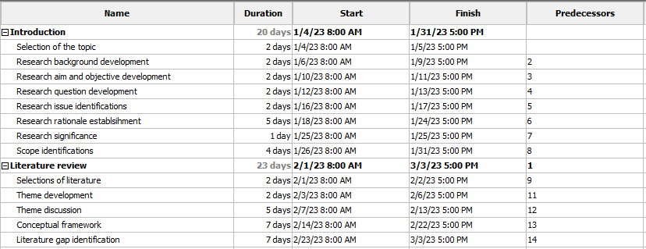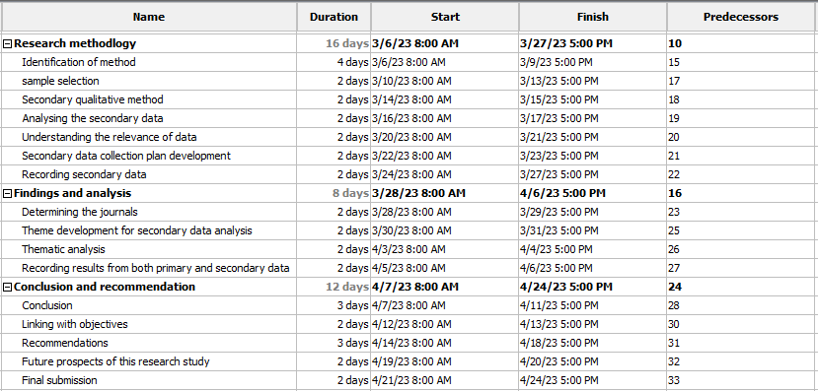



(Source: Self-developed)

## Appendix 2: Thematic Table

| **Themes** | **Article** | **Authors** | **Year** |
| --- | --- | --- | --- |
| ***Transformation of female CEOs by analysing their success stories*** | The future of female CEOs and their glass ceiling. *Journal of Business Studies Quarterly*, *3*(4) | Buckalew, E., Konstantinopoulos, A., Russell, J. and El-Sherbini, S., | 2019 |
| Gender disparity in the C-suite: Do male and female CEOs differ in how they reached the top?. *The Leadership Quarterly*, *25*(2), | Fitzsimmons, T.W., Callan, V.J. and Paulsen, N., | 2019 |
| Female CEOs, returns and risk in Spanish publishing firms. *European Management Review*, *15*(1), | Martín‐Ugedo, J.F., Mínguez‐Vera, A. and Palma‐Martos, L., | 2018 |
| Does gender matter? The relationship comparison of strategic leadership on organizational ambidextrous behavior between male and female CEOs. *Sustainability*, *14*(14), | Zhang, G., Jia, Z. and Yan, S., | 2022 |
| ***Teamwork, Cost Management, and Time Management skills are success factors driven by female CEOs in their business*** | Towards an entrepreneurial leadership based on kindness in a digital age. *Journal of Business Research*, *159*, | Aránega, A.Y., Montesinos, C.G. and del Val Núñez, M.T., | 2023 |
| Success factors of SMEs: empirical study guided by dynamic capabilities and resources-based view. *Sustainability*, *13*(21), | Rodrigues, M., Franco, M., Silva, R. and Oliveira, C., | 2021 |
| Gender and learning results: a study on their relationship in entrepreneurship education and business plans. *Studies in Higher Education*, *46*(11) | Ferreras-Garcia, R., Hernández-Lara, A.B. and Serradell-López, E., | 2021 |
| *How Women Leaders Can Build Strong Networks for Success*. | Byham, T.M. | 2023 |
| ***Lack of mentor and sponsorship, difficult expectations, and unconscious bias are some challenges faced by female CEOs during their work time in business*** | Reflecting on Leadership Experiences: The Positive and Negative Journeys of Women in Leadership | Al Naqbi, S., | 2023 |
| Male executives' experiences of mentoring Black African women in South Africa. *Equality, Diversity and Inclusion: An International Journal*, *41*(9), | Scheepers, C.B. and Mahlangu, R., | 2022 |
| Afro-Diasporic women navigating the black ceiling: Individual, relational, and organizational strategies. *Business Horizons*, *64*(1) | Erskine, S.E., Archibold, E.E. and Bilimoria, D., | 2021 |
| Notes from the AI frontier: Tackling bias in AI (and in humans). *McKinsey Global Institute*, *1*(6) | Silberg, J. and Manyika, J., | 2019 |
| *How Women Leaders Can Build Strong Networks for Success*. | Byham, T.M. | 2023 |
| ***Enhancing organisation collaboration and developing financial performance could undertake by female CEOs to reduce the challenges in their business*** | Do Female Executives Make a Difference? The Impact of Female Leadership on Gender Gaps and Firm Performance. *SSRN Electronic Journal*, | Flabbi, L., Macis, M., Moro, A. and Schivardi, F. | 2019 |
| Digital transformation challenges: strategies emerging from a multi-stakeholder approach. *The TQM Journal*, *32*(4), | Brunetti, F., Matt, D.T., Bonfanti, A., De Longhi, A., Pedrini, G. and Orzes, G., | 2020 |
| Internal Control Mechanisms, CSR, and Profitability: A. *International Journal of Business and Management Invention*, *10*(12) | Almashhadani, M., | 2021 |
| Female CEO leadership and the likelihood of corporate diversity misconduct: Evidence from S&P 500 firms. *Journal of Business Research*, *118* | Dadanlar, H.H. and Abebe, M.A., | 2020 |
| ***Diverse problem-solving and high employee engagement are the major roles of a female CEO in the business*** | Worker involvement and performance in Italian social enterprises: The role of motivations, gender and workload. *Sustainability*, *14*(2) | Tortia, E.C., Gago, M., Degavre, F. and Poledrini, S., | 2022 |
| Exploring the intra entrepreneurship-employee engagement-creativity linkage and the diverse effects of gender and marital status. *Frontiers in Psychology*, *12*, | Kang, T.W., Sinha, P.N., Park, C.I. and Lee, Y.K., | 2021 |
| The impact of training & development and communication on employee engagement–A study of banking sector. | Siddiqui, D.A. and Sahar, N., | 2019 |
| ***Generating more revenue and high stock price is crucial to transform the success stories of female CEOs*** | *Research shows companies with female CEOs are more profitable - Business Leader News*. | Cumming, A. | 2022 |
| The impact of women leaders on environmental performance: Evidence on gender diversity in banks. *Corporate Social Responsibility and Environmental Management*, *26*(6) | Birindelli, G., Iannuzzi, A.P. and Savioli, M., | 2019 |
| The portfolio ideal worker: Insecurity and inequality in the new economy. *Qualitative Sociology*, *43* | Neely, M.T., | 2020 |