**Cross-Management Portfolio**

**Table of Contents**

**1.0 Introduction** **2**

**2.0 Leadership and organisational effectiveness** **2**

2.1 Analysing Leadership and organisational effectiveness 2

2.2 Analysing Leadership of Apple and its organisational effectiveness 3

**3. Leadership and Organisational Change** **5**

3.1 Analysing Leadership and Organisational Change 5

3.2 Analysing Leadership and organisational change of Apple 6

**4. Leadership, power and Decision making** **8**

4.1 Analysing the Leadership, power and Decision Making 8

4.2 Analysing the Leadership, power and Decision-making of Apple’s Leadership 10

**5.0 Recommendations for Improvement Apple company’s leadership effectiveness** **11**

**6.0 Conclusion** **13**

**7.0 Reference List** **15**

**8.0 Appendices** **18**

Appendix 1: Personal Development Plan 18

# 1.0 Introduction

The current topic is about leadership and managing people in an organisational setting. The topic first of all discusses Leadership and organisational effectiveness, here the focus is on analysing the manner in which Apple’s leadership contributed towards the organisation’s effectiveness. The next thing that discusses is regarding the aspects of leadership and its role in bringing organisational change. The third topic of discussion in the current report is the importance of the power and authority of a leader in the decision-making of Apple. Finally, a set of recommendations is provided to improve the company’s leadership. Also, a personal development plan is provided.

# 2.0 Leadership and organisational effectiveness

## 2.1 Analysing Leadership and organisational effectiveness

It is critical to recognise that strong leadership abilities are quite rare. Furthermore, the characteristics of a leader that support organisational success are more important in terms of organisational sustainability. Bielińska (2021) realised that the regular running of an organisation might be impeded in the absence of carefully planned leadership tactics. In addition, when an ineffective leader controls the firm, the organisational structure might become uneven. It eventually leads to institutional disarray and staff dissatisfaction Strong leadership constitutes the core of any organisation for long-term vision, regardless of whether the firm is small or vast in scale. Thus, “leadership”, according to Hristov and Ramkissoon (2016), serves a number of functions and encompasses a wide range of tasks in maintaining the seamless operation of an organisation. An effective leader has the ability to influence, persuade, and negotiate with a wide range of stakeholders. Vuorinen and Martinsuo, (2019) claim that only a few persons have the personality to influence many stakeholders. According to the current notion of situational leadership, anyone in leadership has to act in response to conditions (Meier, 2016). Of course, the numerous problems that workers provide to an authority figure may render bargaining difficult. However, depending on the circumstances, a leader may impact people and preserve workplace discipline. As a consequence, workers' work performance may improve as a result. Furthermore, in some cases, altering the remuneration system is sufficient to boost strategic objective attainment. As a result of a leader's persuasive ability, individual and corporate ambitions are united.

It is critical to recognise that strategic leadership describes how senior executives impact the organisational atmosphere. Strategic leadership, on the other hand, is critical in determining the firm's financial success and survival. Demir, Wennberg, and McKelvie (2017) emphasise the necessity of strategic leadership since senior executives affect the firm's strategic goals. Bolman and Deal (2017), on the other hand, demonstrate how wise leaders' aims may have an influence on organizational structures. Furthermore, leadership enhances business culture, as well as staff skills and motivation. Successful leaders, on the opposite conjunction, recognise that in order for a team to work well, everyone on the team must interact successfully. Leadership contributes to team development by inspiring employees and guaranteeing every employee feels valued. Furthermore, when members of teams and work subgroups contribute to the collective effort, they feel appreciated. When organizations are scattered, a major problem arises. This structure differs in that instead of being involved with the same area, leaders must complete additional steps. Leadership must use extra vigilance in order to guarantee that the team working remotely interacts correctly. Leadership must concentrate on policy change while utilising all aspects of web-based video conferencing programs and cameras, such as polls and interviews. The leader facilitates meetings that improve engagement and lead to organisational performance. Furthermore, leaders model excellent behaviour and positive work ethics in order to inspire others to share their ideals. It is critical to recognise that workplace disagreements are inescapable in today's world. Differences of opinion and conflicts are unavoidable when an organisation's stakeholder base grows. Xuecheng, Iqbal, and Saina (2022) emphasise the need for a leader to comprehend the situation and address any concerns. As a result, it is possible to conclude that a leader plays an important role in the organisation's orientation and direction. This factor establishes the organisation's vision and goal and aids in its long-term viability. As a result, an effective leadership style influences and ensures the success and economic growth of both the organisation and its personnel.

## 2.2 Analysing Leadership of Apple and its organisational effectiveness

The story of Apple begins with the hands of Steve Jobs and surprisingly in the early years, the much of success story of Apple began by collaborating with its arch-rival Microsoft. However, the success story of Apple is a long journey, and in the technology field, the position of the company changes frequently. Apple gained much of its success in the globalised age when it focussed on Apple iPod and iPhone. Under Steve Jobs' leadership, one of the crucial decisions was to critically assess Apple's existing position and shortcomings (Yoffie and Cusumano, 2021). Apple was on the verge of bankruptcy, and an examination found that the company's product portfolio was overburdened with hundreds of goods. However, such items were part of the same line of products and had no evident product difference due to the product mix. As a result, the firm faced fierce competition and financial ruin. According to Gansky (2017), several analysts attacked the company's policies and leadership. However, Steve Jobs, who was acutely aware of the situation, took several tactical and strategic moves that placed Apple on its current course. The emphasis was heavily on the creation and launch of sophisticated products in order to salvage Apple. However, in addition to focusing on product development strategy, Apple's leadership also prioritised new market expansion strategy and internationalisation in other areas. Furthermore, the business reinvented the brand as a luxury electronics and information technology brand. The crisis management initiatives, such as employment cuts and reducing the number of desktop models from 15 to one, were critical decisions. Furthermore, tactical measures such as deleting portable and handheld versions and consolidating them into a single laptop were used. Furthermore, removing all printers and other accessories was a risky action. Under Steve Jobs' direction, the whole supply chain was redesigned and offshored to Taiwan, and numerous suppliers were expelled from Apple.

It is also critical to recognise that with a smaller product line built in Asia, the leadership was more focused on reducing overall inventory. Apple concentrated on e-commerce, and under Steve Jobs' leadership, the company launched a new Webshop (Podolny and Hansen, 2020). This was a game-changing direct-to-customer selling approach in e-commerce. This technique enabled Apple to offer items directly to consumers, eliminating the need for wholesalers and dealers. Steve Jobs' leadership talents saved Apple from bankruptcy by streamlining its product portfolio. It also refocused attention on achieving long-term objectives. Apple's fate was altered by its focus on innovation and the production of game-changing devices such as the iPad and iPhone. It is critical to comprehend the value of simplifying. Furthermore, Steve Jobs' leadership strategy acts as a role model blueprint for all leaders. The leadership under Steve Jobs demonstrated how to improve organisational success by actively participating in operations and various roles, checking in on team members, and much more.

# 3. Leadership and Organisational change

## 3.1 Analysing Leadership and Organisational change

It is critical to recognise that "change" from an organisational standpoint is the transformation of a particular pattern to another, one procedure to another, or a shift in viewpoint. Change in business, on the other hand, is frequently considered a negative factor since it affects a significant component of its organisation. Furthermore, change is an element of developing human wants, which correlates to evolving market desires (Nandram and Bindlish, 2017). Changes in human and organisational culture, as well as changes in technology or infrastructure, are examples of such transformations. However, an organisational change management approach helps a company to a successful resolution. A change, in general, is a long process that includes a planning phase, an execution phase, and a feedback phase. Organizations are now operating in a VUCA environment, which appears to be an appropriate justification for the current instability (Nandram and Bindlish, 2017). To avoid the VUCA environment, the financial and social surroundings, as well as the leadership necessary to manage them, must be efficiently navigated. Volatility abounds in today's world, where changes are often violent and unpredictable. Satitha claims that predicting their lifespan is very difficult. As a result, it is critical for a leader to provide their staff members with strategies and programs that will benefit them in the long run. However, the difficulty is not limited to the volatile character; the element of uncertainty also exists (Popova et al., 2020). Such ambiguities are inherent in reforms, preventing leaders from drawing on previous experiences and lessons acquired.

Aside from the unclear nature of the changes, there is a high level of complication in the mitigating strategies to welcome change. The problem for executives is that firms are surrounded by incomprehensible big datasets. With so much information and a multitude of factors and interwoven aspects, deciding on options to accept change is challenging. According to Lewin's method of managing organisational change, the leader plays an essential role in the "unfreeze" stage, when the leader's communication aids in the preparation for the transformation to take place (Hussain et al., 2018). Unlike managers, the vision of the person in charge is most important in formulating strategic transformation guidelines. Schot and Steinmueller (2016) believe that complex transformative change must be suitably scoped. Furthermore, to function successfully, a broad degree of change must occur when adequate resources have been allocated and incorporated. Schot and Steinmueller (2016) also believes that every endeavour should be associated with every other project and that the outcome of all activities should be synergistic. Employee and consumer attitudes are motivated by incentives, and attempts to sell the benefits of strategically repositioned services must be coordinated. If the attempts are not coordinated, the results might be fatal. Furthermore, a corporation must concentrate on efficiently communicating with clients. It is necessary to match with the freshly required capabilities and those providing the services. As per Burke (2017), during a transformation process, the focus must be harmonious, according to the Managerial Grid Theory of Leadership. Based on this idea, and combining components of Lewin's theory, suggests that when enduring change, a leader should focus more on people development and less on organisational performance.

## 3.2 Analysing Leadership and organisational change of Apple

According to Kim (2020), one of the most important parts of organisational transformation is Apple's leadership. The fact that Apple saved itself from extinction and converted itself into the world's largest technological firm is an example of excellent change management. Apple has used complex change management throughout the organization, including team restructuring, supplier controls, product restructuring, operational restructuring, and financial restructuring. However, the stages to attaining organisational change management are mostly credited to Steve Jobs' leadership talents. The most important part of change is the significance of ongoing innovation. Understanding and meeting client wants was the primary impetus for its organisational development amid the shifting conditions in the market. According to Kim (2020), Apple's organizational approach to change management is viewed as an essential response in order to survive in this competitive setting. Apple's leadership has recently recognised the problems that arise. Furthermore, the leadership made use of technology to better comprehend the ever-evolving competitive landscape and the needs of the target consumer. It is critical to recognise that releasing and creating a new product necessitates technological changes inside the organisation. According to Kim (2020), the organisation must have an innovative attitude. Furthermore, Apple needed to establish key competencies again in order to start new production or reallocate current manufacturing. According to Birkel et al. (2019), this sort of transition was most noticeable when the corporation entered the media sector, supplying iPods to music-loving customers. Despite the fact that the notion existed while Sony also launched the Walkman. Furthermore, there were actually approximately fifty mobile mp3 players accessible throughout the United States, and no company had come close to anything like the Walkman's domination. However, iPod won the contest against Walkman because of an appealing, simple gadget supported by clever software. As can be observed, such a competitive atmosphere required Apple's leadership to choose devices with basic functions for the audience. Furthermore, technical advances in the corporation were implemented during Steve Jobs' leadership. However, the such transition was not limited to the technical department, but also to the finance, design, marketing, and other areas. According to Teece, Peteraf, and Leih (2016) under Steve Jobs' leadership, the necessary adjustments were being driven to build a flexible organizational approach. Such an adaptable approach to management was capable of changing in response to market demands.

The leadership’s focus on embedding the sense of adopting constant changes has largely been helped by the Human Resource Management of the firm. The policies and the guidelines set by the leadership of Apple have helped in focusing on skill development and behavioural development of the workforce. The basic strategies of motivation such as incentivising change management are not effective in modern times. The VUCA environment showed that the changes must also have to be reactive as the changes are often unforeseeable. Thus, it can be concluded that the leadership of Apple was able to handle the changes in the external environment and also embedded the culture of continuous improvement and proactive change management to have a competitive advantage.

# 4. Leadership, power and decision making

## 4.1 Analysing the Leadership, power and Decision Making

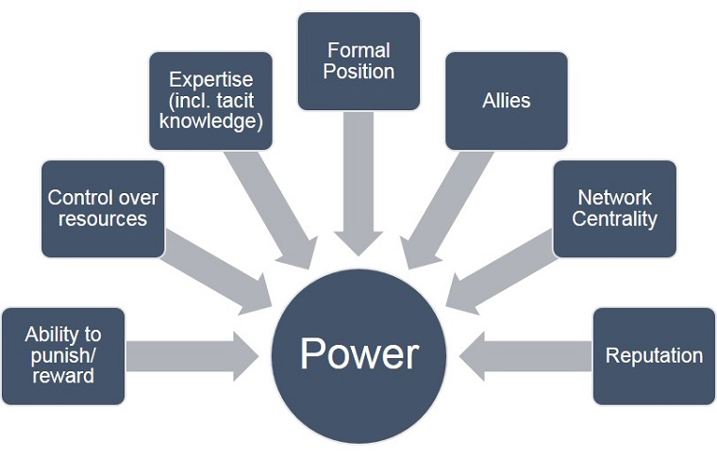

**Figure 1: Power of a Leader**

(Source: Jordan, Lavanchy and Stehli, 2022)

According to Grundmann (2017), the difficulty is whether a person in a position of authority can make better judgements or not. A series of tests have been conducted to investigate how power, both conscious and unconscious cognition, influences decision-making. Furthermore, a preliminary study has shed light on how unconscious thought might play a crucial part in problem resolution. Leaders frequently make swift and confident decisions when thinking about an issue unintentionally while focusing on something else. This component is closely related to the outstanding Man Theory, which argues that outstanding leaders are born with specific characteristics, one of which is problem-solving. However, being willing to make a decision is not the same as finding a viable answer. Also, according to Alvesson, and Einola (2019), some leaders are excessively focused on the minutiae of the situation. Such leaders frequently examine every option but are unable to see the larger picture. The unconscious approach to successful decision-making is insightful, but addressing problems is only one half of the equation; aligning stakeholders and persuading them to make a choice is the task of "Power."

Woods (2016), believes that understanding the notion of power and decision-making is essential for understanding the function of leadership. Also, according to Woods (2016), decision-making is frequently understood as a set of interactions between the decision-maker, the surroundings, behaviours, and objectives. Such partnerships, however, tend to emerge in a dynamic atmosphere when there is an urgency for immediate changes inside the business. Furthermore, any number of decision components must be appropriately examined in order to produce a sensible conclusion. According to Woods (2016), choices are outcome-oriented, which implies that a decision is either beneficial or detrimental based on the organization's capacity to make changes and produce results that assist the organisation go forward in the long run.

Power becomes relevant in the context of stakeholder management. People with power are usually found at the top of the stakeholder matrix. The critical difficulty, though, is determining whether a leader is a mediator between those powerful external stakeholders or whether they are persons in power and authority themselves. According to Dansoh et al., (2020), the organisation's decision-maker encompasses all those people who, via their involvement, have the ability to change the outcome of a decision. As a result, decision-making in organisations can be either participatory or authoritarian. Wang, Hou and Li (2022) underline the significance of decision-making involvement in any organisation. Within the limitations of role prescription provided by rational design, such participatory decision-making is wanted by the organisation. Member's values, which are predicated on societal positions both inside and exterior of the company, may limit participation.

Michel Foucault in his study that power can either be good or bad depending upon its role within the organisation. Also, power can be categorised as hard power or soft power within an organisation. However, in terms of a leader’s power, it is the ability to engage stakeholders and make them follow a decision that the stakeholders cannot revoke. In current times, power is most generally characterised as the generation of "intended effect (Outram, 2017)" However, it is critical to note that the connection between power and authority under this notion comprises a leader committed to making certain changes within a constrained setting. However, the "intended effect" always happens to the environment, whether it be people or commodities. In this situation, the leader wields authority while simultaneously being a part of the surroundings. As a result, power might be said to exist in the leader's ability to effect this transformed connection.

Wang, Hou and Li (2022) stress the significance of authority and influence in organisational leadership. It is critical to remember that power does not imply decision-making. This is due to the fact that in order to implement specific rules and processes, one must have power over the stakeholders. While power and authority may appear to be synonymous in ordinary parlance, they are not. For effective leadership, both power as well as authority must be considered. According to Ruggi (2018), authority is just the legal enforceability features of having official powers to deliver instructions. Thus, the leader's decision-making capacity is founded on problem-solving abilities, the ability to effect change, and formal decision-making authority.

## 4.2 Analysing the Leadership, power and Decision-making of Apple’s Leadership

The leadership of Apple can be categorised into two distinct categories based upon the leaders, where the first is the “Steve Jobs era” and the second is the “Post Steve Jobs era”. It is vital to remember that Steve Jobs has authoritative power and was an autocratic leader who believed in quality management, working systems harmoniously, and continuous improvement through innovation. Although innovation has been the salient feature in both leadership categories, the way in which the company is being dictated is different. Tim Cook follows a participative leadership style and also is a flagbearer of Apple’s success to become the most valued company in the world. However, under the leadership of Steve Jobs, a great level of transformation took place in order to revive the company. According to Richard Branson, Steve Jobs' leadership style was autocratic since he had a keen eye for detail when it came to processes.

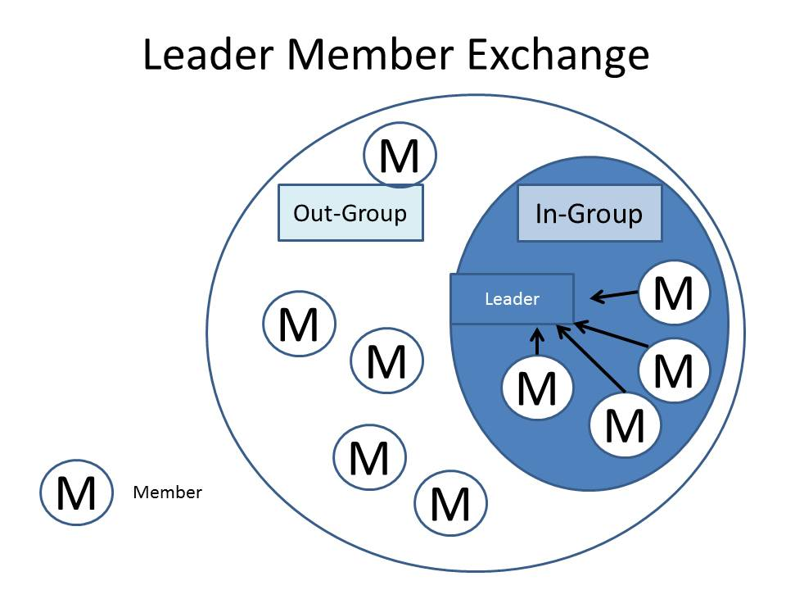

**Figure 2: LMX Exchange Theory**

(Source: Martz, 2016)

Based on the LMX Theory of Leadership, it is critical to comprehend how Steve Jobs surrounded himself with like-minded individuals or "ingroups" to follow his direction. However, based solely on this notion, Tim Cook stressed the "outgroup" members and included them in the organisation's success. Under Steve Jobs' leadership, the concept of innovation was centred on the combination of multiple brilliant ideas to produce a better product. It is critical to remember that creatives frequently believe their innovations are apparent. However, as mentioned by Leenders and Dolfsma (2016), some of the greatest inventions in history have resulted from the notion of merging one idea with another to produce a fresh product.

# 5.0 Recommendations for Improvement Apple company’s leadership effectiveness

* **Carry SWOT analysis with respect to future threats and existing weaknesses.**

It is important to understand that leadership is not limited to one function or one job role. It includes responsibilities that transcend beyond the traditional job role. One of the key methods to enhance leadership in the contemporary style is to first analyse the strength, weaknesses, opportunities and threats for the company. While doing such strategic analysis, the company is recommended to critically utilise public opinions and feedback from a diverse range of stakeholders. Such a satisfaction survey usually brings out the key issues and core strengths of the company. However, as this is a strategic tool, the focus must be on making weaknesses into strengths and using strengths and opportunities to minimise the threats.

* **Cater to new segments and focus on new pricing strategies.**

It has been observed that Apple has certain weaknesses in its long-run growth strategy. The fact that Apple focuses particularly on the premium segment, and for the last five years the product designs are almost the same, such a strategy will reduce the attractiveness of the products. Furthermore, Apple is yet to explore developing nations as the key barrier is their high price. Their products never focus on the middle-income economy persons. The leadership of the company definitely need to focus on how the company can develop products for other financial segments. It is high time that Apple can no longer sustain itself in the market with the same old high-price strategy as the technology industry is not the same as the luxury fashion industry.

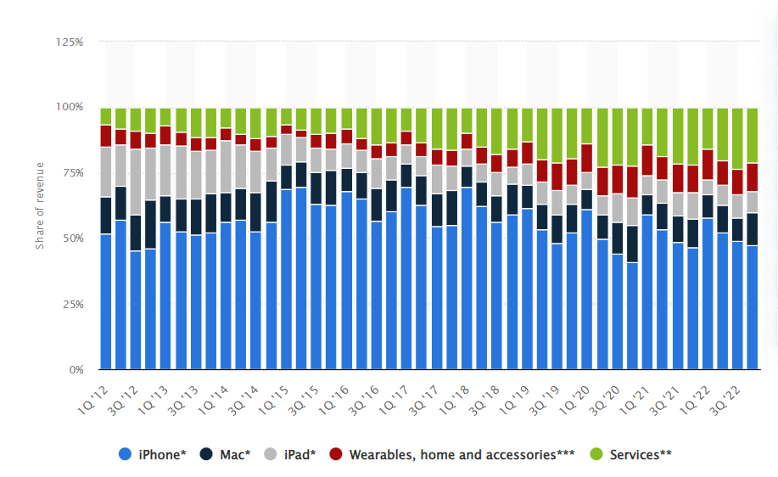

**Figure 3: Apple's revenue share by category of products in 2022**

(Source: Laricchia, 2022)

According to the image, Apple's iPhone sales amounted to around 47% of the company's total income. The essential point is that it accounts for the majority of all Apple goods. Furthermore, Apple's services, in addition to smartwatches, homes, and accessories, have done successfully throughout the years, contributing considerably to the firm's road to becoming a $2 trillion corporation. The fundamental issue, however, is that the customer attitude is tightly geared towards the adoption of the greatest value items, and over the years, Apple has ceased substantial innovation in favour of focusing only on process optimisation. Thus, in order to keep and retain consumers, leaders must seek ways to reduce product pricing in low-income countries. It may also concentrate on developing items that are easily accessible to new client segments.

* **Focusing on long-term goals: Standardising supply chain through vertical integration and choosing India as their strategic partner for production**

Apple's management will need to create long-term goals in order to enhance operations. Long-term goals are strategic in nature, but can also be tactical at times. To cut expenses, the corporation must prioritise production automation. Long-term goals that are solid will assist workers to consider the future results when doing their separate job duties. Because the present competitive landscape is turbulent and full of uncertainty, focusing on the long term will allow the organisation to gain an even greater competitive advantage. Vertical integration across the supply chain is required to achieve operational sustainability and reduce operational expenses.

# 6.0 Conclusion

The study concludes that Apple’s leadership has played a vital role in the organisation’s effectiveness. The report highlights that the current environment is VUCA and managing change in the VUCA environment is challenging for any leader. However, under the leadership of Steve Jobs, the company has overcome several critical problems that could have led to bankruptcy if bold decisions were not made. The final aspect is that Apple’s leadership is divided into the Steve Jobs era and the “post Job era”. As a result, in both cases, the company uses innovation as a tool to improve the organisation. However, the recommendations that have been provided are strictly towards conducting a SWOT analysis, choosing long-term goals and reviewing business strategies related to price and new segments.

# 7.0 Reference List

Alvesson, M., & Einola, K. (2019). Warning for excessive positivity: Authentic leadership and other traps in leadership studies. *The Leadership Quarterly*, *30*(4), 383-395.

Bielińska, I. (2021). Council Post: How To Embrace Constant Change In A VUCA World. *Forbes*. [online] 23 Aug. Available at: https://www.forbes.com/sites/forbescoachescouncil/2021/08/23/how-to-embrace-constant-change-in-a-vuca-world/?sh=7696fb3e273a [Accessed 9 Apr. 2023].

Birkel, H. S., Veile, J. W., Müller, J. M., Hartmann, E., & Voigt, K. I. (2019). Development of a risk framework for Industry 4.0 in the context of sustainability for established manufacturers. *Sustainability*, *11*(2), 384.

Bolman, L. G., & Deal, T. E. (2017). *Reframing organizations: Artistry, choice, and leadership*. John Wiley & Sons.

Burke, W. W. (2017). *Organization change: Theory and practice*. Sage publications.

Dansoh, A., Frimpong, S., Ampratwum, G., Dennis Oppong, G., & Osei-Kyei, R. (2020). Exploring the role of traditional authorities in managing the public as stakeholders on PPP projects: a case study. *International Journal of Construction Management*, *20*(6), 628-641.

Demir, R., Wennberg, K., & McKelvie, A. (2017). The strategic management of high-growth firms: A review and theoretical conceptualization. *Long range planning*, *50*(4), 431-456.

Gansky, A. E. (2017). *Myths and legends of the anti-corporation: a history of Apple, Inc., 1976–1997*.

Grundmann, R. (2017). The problem of expertise in knowledge societies. *Minerva*, *55*(1), 25-48.

Hristov, D., & Ramkissoon, H. (2016). Leadership in destination management organisations. *Annals of Tourism Research*, *61*(C), 230-234.

Hussain, S. T., Lei, S., Akram, T., Haider, M. J., Hussain, S. H., & Ali, M. (2018). Kurt Lewin's change model: A critical review of the role of leadership and employee involvement in organizational change. *Journal of Innovation & Knowledge*, *3*(3), 123-127.

Jordan, J., Lavanchy, M. and Stehli, S. (2022). *Power, Stress And Your Leadership - Forbes India*. [online] Forbes India. Available at: https://www.forbesindia.com/article/imd-business-school/power-stress-and-your-leadership/48953/1 [Accessed 9 Apr. 2023].

Kim, H. (2020). Comparison of Strategic Leadership: Steve Jobs and Tim Cook. *Business and Management Studies*, *6*(3), 17-25.

Laricchia, F. (2022). *Apple sales revenue share by product 2012-2022 | Statista*. [online] Statista. Available at: https://www.statista.com/statistics/382260/segments-share-revenue-of-apple/ [Accessed 9 Apr. 2023].

Leenders, R. T., & Dolfsma, W. A. (2016). Social networks for innovation and new product development. *Journal of Product Innovation Management*, *33*(2), 123-131.

Martz, H. (2016). *Chapter 7: Leader-Member Exchange Theory – HLM*. [online] Baylor.edu. Available at: https://blogs.baylor.edu/harmony_martz/2016/09/22/chapter-7-leader-member-exchange-theory/ [Accessed 9 Apr. 2023].

Meier, D. (2016). Situational leadership theory as a foundation for a blended learning framework. *Journal of Education and Practice*, *7*(10), 25-30.

Nandram, S. S., & Bindlish, P. K. (2017). Introduction to VUCA. *Managing VUCA through integrative self-management: How to cope with volatility, uncertainty, complexity and ambiguity in organizational behavior*, 3-14.

Outram, A. S. (2017). *Post-colonialism, indigenous power and resource management: does s33 of the Resource Management Act 1991 have its intended effect for iwi authorities?* .

Podolny, J. M., & Hansen, M. T. (2020). How Apple is organized for innovation. *Harvard Business Review*, *98*(6), 86-95.

Popova, N., Kataiev, A., Nevertii, A., Kryvoruchko, O., & Skrynkovskyi, R. (2020). Marketing aspects of innovative development of business organizations in the sphere of production, trade, transport, and logistics in VUCA conditions. *Studies of Applied Economics*, *38*(4).

Ruggie, J. G. (2018). Multinationals as global institution: Power, authority and relative autonomy. *Regulation & Governance*, *12*(3), 317-333.

Schot, J., & Steinmueller, W. E. (2016). Framing innovation policy for transformative change: Innovation policy 3.0. *SPRU Science Policy Research Unit, University of Sussex: Brighton, UK*.

Teece, D., Peteraf, M., & Leih, S. (2016). Dynamic capabilities and organizational agility: Risk, uncertainty, and strategy in the innovation economy. *California management review*, *58*(4), 13-35.

Vuorinen, L., & Martinsuo, M. (2019). Value-oriented stakeholder influence on infrastructure projects. *International Journal of Project Management*, *37*(5), 750-766.

Wang, Q., Hou, H., & Li, Z. (2022). Participative Leadership: A Literature Review and Prospects for Future Research. *Frontiers in Psychology*, *13*.

Woods, P. A. (2016). Authority, power and distributed leadership. *Management in Education*, *30*(4), 155-160.

Xuecheng, W., Iqbal, Q., & Saina, B. (2022). Factors Affecting Employee’s Retention: Integration of Situational Leadership With Social Exchange Theory. *Frontiers in Psychology*, *13*.

Yoffie, D. B., & Cusumano, M. A. (2021). *Strategy Rules: Five Timeless Lessons from Bill Gates, Andy Grove, and Steve Jobs*.

# 8.0 Appendices

## Appendix 1: Personal Development Plan

|  |
| --- |
| **Personal Development Plan** |

|  |  |  |  |
| --- | --- | --- | --- |
| **Name:** |  | | |
| Covering the period from: |  | To |  |

|  |
| --- |
| **My Goals:** *To improve my leadership skills* |

|  |  |  |  |  |
| --- | --- | --- | --- | --- |
| **What do I want/need to learn?** | **What will I do to achieve this?** | **What resources or support will I need?** | **What will my success criteria be?** | **Target dates for review and completion.**  **How have I chosen these dates?** |
| Improve communication skills | Hire a mentor. | Mentor. | Fluent English communication with good gestures and posture. | 2 months. |
| Improve problem-solving skills | I will solve case studies from HBS case studies. | Case Study Subscription from the HBS website. | Able to solve problems accurately. | 6 months |
| Improve negotiation and persuasion skills | I will undergo training in Human Resources and Marketing to improve my people management and persuasion skill. | Register for Training and Internships. | Completing the internship program. | 12 months. |