**Strategic Marketing Entrepreneurship**

**7BUS2040-0901-2022**

**ASSIGNMENT 2- INDIVIDUAL LAUNCH PLAN DISCUSSION**

**Executive summary**

The study develops a launch plan for University of Hertfordshire Business School to develop their learning aspects. Peer teaching is selected for the UH to deliver better learning outcomes for their students. The business model canvas for proposed service is formed in this study. Furthermore, a proper launch plan along with stakeholder analysis is given. A channel for the announcement of the new service is selected to get the best outcome. The SMART objectives of this service are to develop skills and collaboration of students and to achieve goal 4 of UN SDG. 4P marketing mix is used to comprehend the opportunity of the service. About 12000 GBP investment is forecasted where about 11500 GBP will be used as overall expenditure of launching plan execution.

**Table of Contents**

1.0 New Product/service recommendation 3

2.0 Business Model (Business Model Canvas) 3

3.0 Form of ownership 4

4.0 Stakeholder Analysis 4

5.0 Launch Plan 5

5.1 Proposed date and channel of communication used for the announcement 5

5.2 Brand and positioning 6

5.3Business and marketing objectives (SMART) 6

5.4 Marketing Mix 7

5.5 Budget 7

5.6 Measures and Control 8

5.7 time-scaled plan 8

5.8 Creative Promotional Message 8

5.9 Investment/Funding/Budget 9

Reference 10

# 1.0 New Product/service recommendation

Strategic marketing launch plans can help bring better opportunities to organisations. New service that can be majorly helpful for University of Hertfordshire Business School is ***peer teaching*.** Peer teaching refers to the idea of a student or a group of students and teachers teaching other students and teachers (Gunawan and Nurbianta, 2020). Furthermore, peer teaching can not only help increase the learning aspects once but twice. A scheduled group study activity time can be allocated once a week for students. The major feature of this activity is that it will help increase and improve learning aspects and help build interpersonal relationships within a diversified culture of Hertfordshire Business School.

# 2.0 Business Model (Business Model Canvas)

|  |  |  |  |
| --- | --- | --- | --- |
| **Key partners**   * University of Hertfordshire Business School * Parents of students | **Key activities**   * Peer Teaching * Debate * Coaching * Peer performance reviews | **Value propositions**   * Students can think globally * Skill gaining * Enterprise learning | **Customer segments**  Low performing and average students who seek admission in “University of Hertfordshire Business School” |
|
| **Key resources**   * Peer Teachers * Collaborative Channel * Social Media Influence * Smart Cl | **Channels**   * Online Channel- social media * Offline Channel-University Classroom | **Customer relations**  An interactive relation with students | |
| **Revenue streams**   * Usage fee * Subscription fee | | |
| **Cost structure**  Fixed costs | | | |

Business model canvas refers to tools utilised for key resources, actors, target customers, financial matters, channel involved, value proposition and other matters of product (Taipale-Erävala *et al.* 2020). These matters have been taken into consideration for Peer teaching service designed for “University of Hertfordshire Business School”.

# 3.0 Form of ownership

Form of ownership are the elements of business that helps in regulating and operating ways to get best outcomes. Based on the study of Eldar (2020), the five major forms of ownership are public and private limited company, limited liability partnership, partnership firm and sole proprietorship. In this case, Hertfordshire Business School might consider partnership to spread the awareness of the benefits of peer teaching and getting resources as much as possible from other institutes. Peer teaching can be implemented by the UH through forming partnerships with other schools, Universities, and institutes of the UK to work as a team and using various resources to enhance the skills and providing training to their teachers.

# 4.0 Stakeholder Analysis

Stakeholders are an important element in businesses which determines proper operation with support and benefits. In this case the major stakeholders of UH in order to implement peer teaching are; students, teachers, institution authorities, business partners, consumers, investors, and parents. Proper engagement of the stakeholders is important and in order to launch the new service of peer teaching the organisation might consider keeping satisfied their students, parents and teachers. Furthermore, managing students, partners and teachers closely. Additionally, keep their consumers, students, partners informed and monitor partners and students. According to the study of Gramatiuk *et al.* (2022), stakeholder analysis is a major factor which helps businesses to get support and overcome challenges that can harm the business operation. In this case the organisation might consider effectively managing their stakeholders and keep informed their students, partners, and parents of the students to get adequate support and determination.

Businesses can get immense support especially in the current scenario of intensified competition (Moldoveanu and Narayandas, 2019). Similarly, students need adequate and strategic ways to get educated and enhance their knowledge. Therefore, the process needs to be hassle free and risk free which requires proper engagement of each stakeholder of UH.

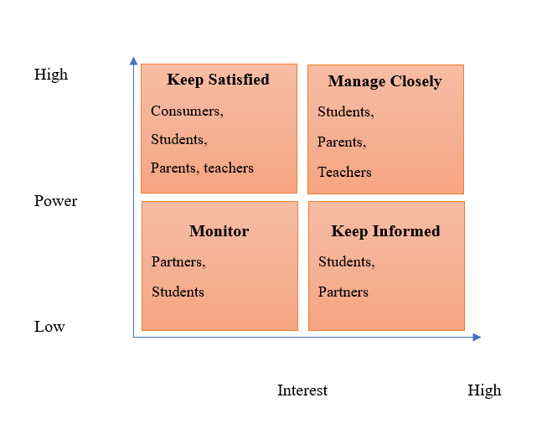

**Figure 1: Stakeholder Analysis**

(Source: Created by taking ideas from Gramatiuk *et al.* 2022)

# 5.0 Launch Plan

## 5.1 Proposed date and channel of communication used for the announcement

The launch of the new service of peer teaching is set on the 3rd May, 2023 and needs to confirm an adequate channel of communication in order to deliver the announcement which is fixated on social media and on the University's website. Announcement of the new service and program on the channel of social media will ensure as much as students and the interested parties involved know about the service.

## 5.2 Brand and positioning

The brand and positioning strategy for launching peer teaching can be followed by adapting advanced technologies such as; AI and data analytics to measure the student’s satisfaction level on adapting the new service. Furthermore, it can be determined that the service can be launched through social media announcement and needs to spread its benefits first in order to get a good position in the education industry. Moreover, analysing the benefits of students through the new service and program of peer teaching can help enhance the brand reputation and image to gather more effective positioning of it.

## 5.3Business and marketing objectives (SMART)

**Objective 1: To deliver a distinctive and high-quality education to students**

|  |  |
| --- | --- |
| Specific | Use peer teaching staffs to provide quality education |
| Measurable | Development of debating opportunity for students |
| Achievable | Improvement in students’ confidence and motivation to compete with global students |
| Relevant | Development of highly interactive peer learning classroom |
| Time | 6 months |

**Objective 2: To develop skills and collaborative approach of students**

|  |  |
| --- | --- |
| Specific | Support students in being collaborative and create bond with others |
| Measurable | Improving communication and relationship among students |
| Achievable | Creation of a distinct career pathway |
| Relevant | Development of soft skills and technical skills of students |
| Time | 3 months |

**Objective 3: To achieve Goal 4 that is “quality education” of United Nations**

|  |  |
| --- | --- |
| Specific | Make a positive change in student’s livelihood |
| Measurable | Students having academic excellence |
| Achievable | Deliver education to underprivileged students |
| Relevant | Provide education to all types of students with different merits |
| Time | 2 months |

## 5.4 Marketing Mix

|  |  |
| --- | --- |
| Product/Service | Peer Teaching |
| Price | About £2,000 every year |
| Place | University of Hertfordshire Business School (UHBS), UK |
| Promotion | Online (Social Media channel including Instagram, Facebook and Twitter) |

Marketing mix helps a company to comprehend the actual service or product offered to customers (Othman *et al.* 2020). In this case, 4Ps of marketing mix has been used to understand key offerings of peer teaching service. Here service is peer teaching and for that reason about £2,000 costs have been set per year. UHBS of UK is the place where the service will be launched and the service will be promoted in online medium.

## 5.5 Budget

|  |  |
| --- | --- |
| **Expenses** | **Amount** |
| Teaching Stuffs | £ 2,000.00 |
| Technology | £ 2,500.00 |
| Marketing | £ 3,000.00 |
| Classroom infrastructure | £ 4,000.00 |
| ***Total Expenses*** | ***£ 11,500.00*** |

Total budget for this service has been developed as 11500 GBP. As stated by Chugunov and Makohon (2020), budgeting helps in reaching the long-term financial goal of a new product. Among the decided budget, 2000 GBP is allocated as expenditure in teaching staffs, 2500 GBP for technology, 3000 GBP for marketing and 4000 GBP for classroom infrastructure. Total counted investment amount will be about 12000 GBP. Therefore, the net balance will be 500 GBP, which refers to surpassing the budget.

## 5.6 Measures and Control

The budget has been prepared by doing in-depth market research. After completion of this budget, a *standard regulated monitoring process* will be applied to monitor and control profit and revenue margin of peer teaching service delivery.

## 5.7 time-scaled plan

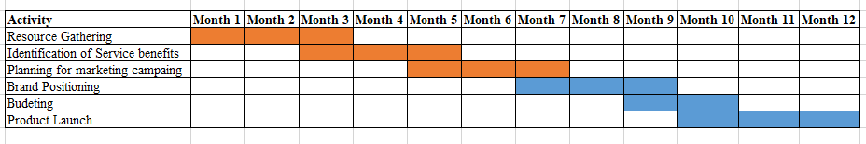

**Figure 1: Time Scale Plan (Gantt chart)**

(Source: Created by author)

## 5.8 Creative Promotional Message

***Promotional Message***

Education for all, peer teaching service of UHBS offers a new learning experience for lower-mediocre students.

***Social Media Platform***

Facebook is the social media platform that will be used to share this creative message. Main motive of this message is to promote awareness in education for all.

## 5.9 Investment/Funding/Budget

An amount of 12000 GBP can be considered as a total investment amount for peer teaching service. Total investment will be done by UHBS individually. A self-funding programme will be used for funding this service effectively. Overall allocated budget will be 12000 GBP and this budget forecast depicts that there is a minimum chance of a budget deficit.

# Reference

Chatman, J.E., Johnson, A., White, E. and Bell, R.L., (2020). The leader as effective communicator. *American Journal of Management*, *20*(2), pp.22-32.

Eldar, O., (2020). Designing business forms of ownership. Review, 106(4), pp.937-1005.

Gramatiuk, S., Sarkisian, T., Kozlakidis, Z. and Sargsyan, K., (2022). Governance and Stakeholder Analysis. In *Biobanks in Low-and Middle-Income Countries: Relevance, Setup and Management* (pp. 73-79). Cham: Springer International Publishing.

Gunawan, H. and Nurbianta, N., (2020). Upgrading Speaking Ability Through Peer Teaching Technique. Journal of English Education and Linguistics, 1(1), pp.32-44.

Moldoveanu, M. and Narayandas, D., (2019). The future of leadership development. *Harvard business review*, *97*(2), pp.40-48.

SonmezCakir, F. and Adiguzel, Z., (2020). Analysis of leader effectiveness in organization and knowledge sharing behavior on employees and organization. *Sage Open*, *10*(1), p.2158244020914634.