**GREEN CRIMINOLOGY: CLIMATE CHANGE**

Table of Contents

Assignment 2: Portfolio 2

Introduction 2

Methodology 2

Literature Review 4

Discussion 7

Conclusion 9

Portfolio of supporting material 9

References 10

# Assignment 2: Portfolio

## Introduction

Climate change has been a global issue which is one of the major complications that the world has been facing. Human activities have been the key reason which is crucial to consider as the implication of climate change is continued in enhancing implications in nature. Emissions of GHG, carbon and burning fossil fuel has been a key reason for causing climate change that has impacted the environment in the UK. This portfolio report focuses on the climate issues that have been faced in the UK and the impacts of increasing temperature that have been key in indicating change in the climate. In this portfolio, the specific focus has been given to London and recent meteorological changes that have been observed due to the implication of climate change.

During the summer of 2022, London and UK experienced the highest heat in July as the city has been hit with impactful heat waves due to rapid changes in the climate. On 19th July 2022, 40℃ has been recorded in Lincolnshire which depicts the extreme weather (Bbc.com, 2022). Therefore, in this regard, it has become one of the key priorities to analyse the reason behind this irregular implication in the temperature. Furthermore, the frequency of rainfall has also been changed regarding the city which is also a detrimental effect of climate change. Prolonged summer and flash flooding has also been observed considering the performance in environmental implications this has been crucial considering the current scenario in nature that focuses on analysing. According to the opinion of Nicholls *et al.* (2021), flooding of coastal areas have also been occurring due to rapid change in climate that is caused by implications on the global change of climate. In this regard, it is often stated that natural resources are mostly used in mitigating natural issues which have been key in developing key issues.

## Methodology

**Topic Formulation**

The topic of climate change has been crucial considering the current scenario and key issues which have been used in this portfolio in order to develop a key research regarding implications of global change in environment. Climate change in UK has developed environmental, social and economical issues that are crucial considering the impacts that have been evident. Furthermore, it can be stated that farming in the UK has also been impacted since the crops have been heavily impacted due to changes in rainfall frequency and heat waves (Malhi *et al.* 2021). Therefore, it has been essential to formulate the topic of climate change which is essential considering the implication in understanding its effects and exploring mitigation options. Climate change in UK has also led to drought that is detrimental for both the community and the environment as it impacts on the local water sources. It has been essential to consider that information that is being retrieved from secondary authentic sources which are essential in analysing secondary sources (Ghadge *et al.* 2020). The resources that are used are mostly official and reputed that are instrumental considering the key items that are being used in this portfolio. The topic of climate change has been chosen because of the relevance of the topic considering implication in UK.

**Data Collection**

The secondary data has been collected from authentic government reports, journals, city government reports and weather forecasts, global databases, and online news bulletins. Furthermore, it has been important to enhance the scope of authenticity of information that has been used in this portfolio. Evidence has also been provided for enhancing the genuineness which is key in delivering the project and is also crucial in analysing implications within the report. Thus, the information that has been used to support the claim has been genuine and authentic.

Most of the data has been collected from government publications that are key in analysing implications of the report. The climate data are retrieved from the official web pages and climate reports from the National Meteorological Service which is the official information centre in UK. Moreover, the data has also been retrieved from the Office of National Statistics and the government website of UK which are also key sources of information. This information is important in supporting key claims that are mentioned in this portfolio.

**Data Availability**

Data that are been available from online sources are important that is important to implicate understanding implications and statistical information. In this regard, it can be stated that data are crucial in accessing the information that is important to support the claims that are made in the portfolio. Furthermore, it is important to note that accessibility of the data is crucial in this regard to support the claims in understanding to focus on information retrieval.

**Data Sources**

Assistance of authentic journal articles has also been sought which is key in analysing information regarding climate change. Moreover, global meteorological reports have also been implicated in the portfolio that has been essential in analysing climate change in UK. The data sources that are considered in terms of analysing the core outcome of the report that helps in developing implications within the sources that are used in this portfolio to support the respective claims. UK’s official information, government website and yearly report have been key in forming the portfolio.

**Accessibility of Information**

The data that have been retrieved from secondary sources such as government reports, institutional statements and organisational reports have been accessed by maintaining ethical approach to enhance the reliability of information. Most information has been accessed that does not require any funding that helps in analysing the information that is used in understanding implications of climate change.

## Literature Review

**Concept of Climate Change**

The concepts and fundamental implications of climate change have made individuals aware of the impacts which are detrimental to nature. Environmental changes over the years have been key in understanding the scale of environmental practices and man-made impacts on nature have also been significant. This also contributes in developing a vivid understanding of environmental effects considering the belief of the individuals that are crucial to obtain individual perceptions. As per the opinion of Lee *et al.* (2020), perception of climate change has been crucial to understanding implications within the youth as their conceptualisation regarding climate change is clear. According to the opinion of Huber (2020), the attitude of individuals to address the issues of environment has a detrimental impact on countries’ social, economic and environmental aspects. In this regard, it can be stated that individual perspective of climate change is often misjudged considering the association of humans with the climate change approach. Furthermore, it is established that UK population has the relevant and possible idea of climate change that further impacts on the daily lifestyles of the residents.

**Factors affecting Climate change**

Generation of electricity and burning fossil fuel has been key in analysing performance in terms of developing implications within the transformational approach that is important to reduce changes in the environment. Furthermore, deforestation has also been a considerable factor in terms of enhancing systems with environmental implications that have been detrimental to nature. According to the opinion of Friess *et al.* (2020), deforestation has reduced the capability of trees to resist soil erosion that has been crucial in terms of developing natural implications and growth factors. In this regard, it can be stated that hydrological capability of the roots of large trees is also helpful in terms of enhancing the living and growth of the trees. This has also been impacted by climate change, by focusing on the life cycle of the trees. This is important to understand that afforestation can help to reduce the issue of overheating in the nature that are help which helps in understanding implications of the nature. In this regard, it is important to state that implications within the environmental options have are also crucial considering implication in terms of current scenario and constraints that have been key in assessing the implications within the nature. It is also important to consider to energy which impacts on developing consumption.

Usage of fossil fuels for energy consumption has also been a crucial factor to consider in terms of climate change. This is also important to focus on that burning fossil fuels have been key in impacting the quality of air that has affected climate change. Consuming excessive fossil fuel impacts generation of Carbon monoxide (CO) and Nitrogen Oxide (NO2), which are crucial in implicating the environmental implication. According to the opinion of Perera *et al.* (2019), burning fossil fuels have also exhibited detrimental impacts on public health and its synergic effects are observed that implicates the environment. Thus, it has been observed that crucial factors and human-induced complications also impact climate change which has been crucial considering the change in nature.

**Impacts of Climate Change**

A hotter atmosphere and increased levels of carbon dioxide in the air have also impacted agriculture which directly relates to the growth of economic structure of UK. More heat waves have been observed considering implications. Intense rainfall and lack of rainfall have been developed considering the natural hazards such as floods and blizzards that have become more common. As per the opinion of Pour *et al.* (2020), urban floods and the frequency of their occurrence have been crucial in terms of assessing the impacts of climate change. In this regard, it is also important to state that the number of flood recurrences has negatively impacted the habitats.

Floods are detrimental considering the impacts such as damage and loss of properties and infrastructures. Furthermore, it has been important to analyse the impacts of pests on crops and developing plant diseases due to the implication of climate change. As per the opinion of Malhi *et al.* (2021), water resources are negatively impacted due to climate change which focuses on implicating enhancing performances of climate change. In other words, the impacted water resources have been crucial for the crops to develop implications within the growth of natural vegetation. This natural vegetation and plants help in maintaining sustainability of nature which is further indicative considering its importance in society. Furthermore, this is important to focus on retrieving water sources and helps in contributing to develop the storage of fresh water.

UK has also faced a severe rise in temperature in summer earlier in 2022, which can also be considered as the impact of climate change. According to the data provided by the National Meteorological Service in the UK, the average temperature in 2022 has been 10.03°C, which is important to focus on implications regarding environmental impacts (Metoffice.gov.uk, 2022). Hence, it is important to state that UK’s steady hike in temperature has been key in analysing key implications which are important considering performance. In this regard, it is often implicated that climate change has been key to control the temperature which is essential in analysing the temperature.

**Theoretical Perspective of Climate Change**

***Greenhouse Theory of Climate change***

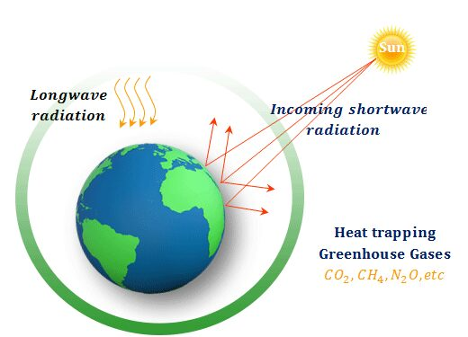

**Figure 1: Greenhouse Theory of Climate change**

(Source: Influenced by Ghadge *et al.* 2020)

The Greenhouse Theory of Climate change has been crucial in analysing the impact of climate change by stabilising the equilibrium by warming the surface of the earth and decreasing the temperature of the stratosphere. In this aspect, it is important to state that predicted changes in nature have been crucial in terms of developing implications within nature. According to the opinion of Ghadge *et al.* (2020), this is important to focus on enhancing key approaches that are important to consider implications which are important to focus on considering implications regarding climate change. The greenhouse gases include Ozone and other gases and it contributes in trapping the heat which impacts nature. The equilibrium of temperature is important to consider the implications within the performances that are key to analyse changes in terms of implicating on the environment. Climate change has also been implicated in the environment and helps in analysing the impacts on the environment. This theory is also important to exhibit the impact of Greenhouse gases that are important to assessment of climate change.

## Discussion

The information that is retrieved from official reports, statements and governmental circulars is analysed in this section of the portfolio. It has been observed from the findings and literature review that climate change has been one of the key issues currently, considering the pace and impact of the phenomena. Climate change has been directly impacting human lifestyle and the ecosystem which is meant to be sustained by environment friendly activities. In UK, fluctuation in temperature such as hotter and prolonged summers and wetter winters has been observed due to the rapid climate change. The reason behind the heat waves that have been observed in the UK in the summer of 2022 has been the heat that is trapped in hard surfaces such as buildings and infrastructures. Lack of vegetation and greenery has also been a key reason which enhances the scope of warming. According to the opinion of Franco and Borras (2019), the land use policy in developed countries has been key in understanding the implication within the implication. These are important in analysing difficult interconnections that have been crucial in developing implications within managing nature that have been key in addressing the concern regarding greeneries. Hence, reduced plantation of greeneries has accelerated the process of global warming that is impacting the lives of individuals residing in UK.

The unprecedented occurrence of El Niño can also be referred to as a global phenomenon impacted by climate change. The temperature rose due to the warming of the surface in the ocean which led to an overall rise of temperature in the UK. The irregularity of this kind of environmental circumstance is most likely to enhance the temperature in European contexts (Theguardian.com, 2023). Therefore, considering this sudden occurrence of El Niño and heating of the northern hemisphere has ensured that 2024 can be hotter and have the possibility to break previous temperature records. Thus, crops and vegetation can get damaged considering implication of hotter summers and lack of rain. This helps in analysing implications that forecasted developing the environmental implications considering climate changes. Biologists have also expressed their concerns regarding the lives of microorganisms which have been crucial in analysing the key changes that are faced due to changes in the climate.

In developing implications due to climate change, the most prominent impact that has been observed through the rapid transition is that soil erosion and rising level of seawater have impacted the living of microorganisms. As per the opinion of Jansson and Hofmockel (2020), the fertility of soil has been lost due to the wrong agricultural practices, irregular rainfalls and droughts. Extreme heat has been key in identifying implications in soil that has led to destruction of soil organisms that are impacting on developing fertility of soil. In this regard, it can be stated that climate change has impacted the environment and in UK the impact has been felt more directly through human-induced practices that are detrimental to nature. In other words, it is essential to observe that external drivers that impact nature also impact the economy of the country as production and manufacturing has been a key driver for climate change. As per the comment by Nordhaus (2019), climate change has become a threat to economy as it has been crucial to understand the shift in human-induced activities that leads to climate change. Therefore, it can be referred to that implication helps in analysing fundamental essentiality of human-induced actions that are responsible for climate change. Despite enhanced technological excellence, humans have failed in controlling environmental approaches and climate transformations.

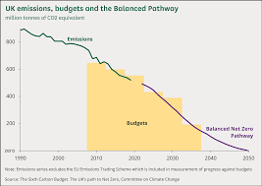

**Figure 2: Emission Budget in UK**

(Source: Parliament.uk, 2022)

The carbon emission and burning of systematic approach have been key in understanding involvement of carbon emission that is key in understanding implications of climate change. Organisations in the UK have been engaged in mitigating the risks by reducing their carbon emission that has been crucial for their CSR approaches. In this regard, this can be stated that firms have developed their priorities to focus on sustainable practices which further impacts understanding implications. According to the opinion of Barnes *et al.* (2020), socio-cognitive involvement in performance has been important for understanding the intensity of the environments in organisations. Hence, in UK the companies are enhancing implications in developing their response towards climate change and understanding climate engagements.

It is important to suggest key recommendations that are crucial for mitigating climate issues which are important to be concerned about. It can be recommended that sustainably designed buildings can be built in terms of developing individual involvement which is important to release less carbon during construction. The usage of electric vehicles can also be a crucial recommendation to cease energy consumption as it is essential to develop implications. The governmental approach in UK can also be consulted considering implications to achieve net zero carbon emissions within a determined period of time that can also influence in the understanding of key involvements in response to climate changes.

## Conclusion

The portfolio concluded by stating that climate change in UK and specifically London which has been facing crucial environmental issues have also been impacted by heat waves that contribute to mitigate issues in environment. This portfolio has been created by developing information from authentic sources. In this regard, it can be stated that climate change and its implication within London and its adjacent areas help in understanding implications within the performance that analyse the implications that help in mitigating the issues.

It has been discussed in this portfolio that climate change has been impacting the water resources, vegetation and organisms which have been key in understanding implication transitions in climate change. In this context, this can be stated governmental approaches have also been undertaken to understand the global implication that is crucial to analyse involvements of enhancing the scope of climate change. Human living and its survival can be considered to be at stake if the issues of climate change are not resolved considering the current implication. This crucial implication on nature is important to be addressed by the appropriate authority considering the changes and resource management. Hence, it is crucial to understand the involvement of governments that are key in addressing issues of climate that help in developing scope for a better and greener world.

## Portfolio of supporting material

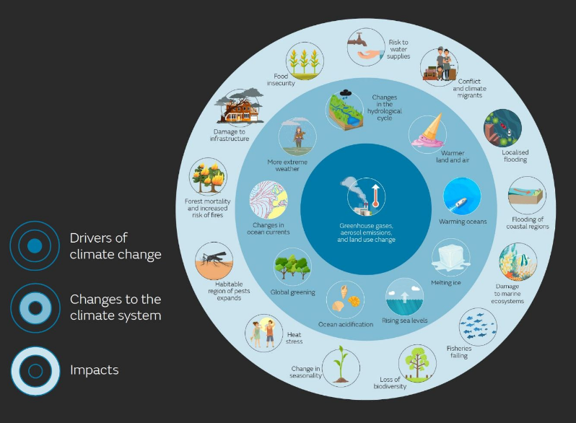

**Figure 3: Impact of Climate Change on London**

(Source: Metoffice.gov.uk, 2023)

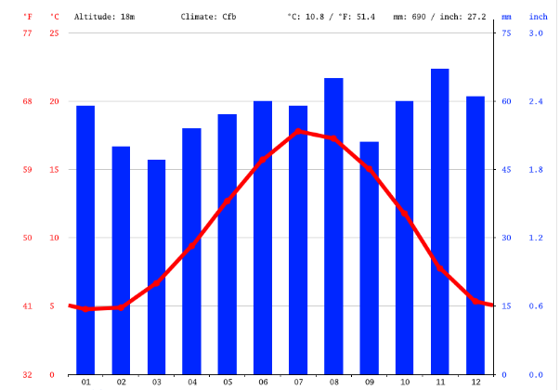

**Figure 4: Temperature and Rainfall implication in London in 2022**

(Source: Climate-data.org, 2022)

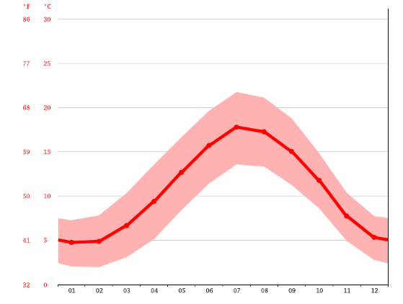

**Figure 5: Temperature changes in London in 2022**

(Source: Climate-data.org, 2022)

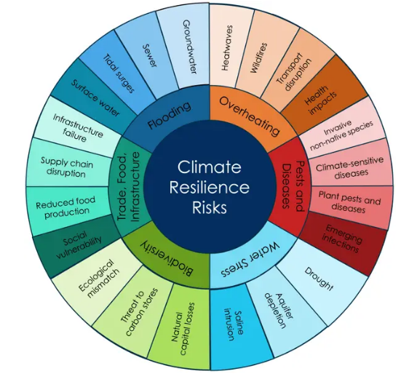

**Figure 6: Climate resilience risks and solutions**

(Source: Cityoflondon.gov.uk, 2022)

# References

Barnes, M.L., Wang, P., Cinner, J.E., Graham, N.A., Guerrero, A.M., Jasny, L., Lau, J., Sutcliffe, S.R. and Zamborain-Mason, J., (2020). Social determinants of adaptive and transformative responses to climate change. *Nature Climate Change, 10(*9), pp.823-828.

Bbc.com (2022). *Climate change: Summer 2022 smashed dozens of UK records*. Available at:   https://www.bbc.com/news/science-environment-63244353 [Accessed on: 12 April 2023]

Franco, J.C. and Borras Jr, S.M., (2019). Grey areas in green grabbing: Subtle and indirect interconnections between climate change politics and land grabs and their implications for research. *Land use policy, 84*, pp.192-199.

Friess, D.A., Krauss, K.W., Taillardat, P., Adame, M.F., Yando, E.S., Cameron, C., Sasmito, S.D. and Sillanpää, M., (2020). Mangrove blue carbon in the face of deforestation, climate change and restoration. *Annual Plant Reviews, 3*(10.1002), p.9781119312994.

Ghadge, A., Wurtmann, H. and Seuring, S., (2020). Managing climate change risks in global supply chains: a review and research agenda. *International Journal of Production Research, 58*(1), pp.44-64.

Huber, R.A., (2020). The role of populist attitudes in explaining climate change skepticism and support for environmental protection. *Environmental Politics, 29*(6), pp.959-982.

Jansson, J.K. and Hofmockel, K.S., (2020). Soil microbiomes and climate change. *Nature Reviews Microbiology, 18*(1), pp.35-46.

Lee, K., Gjersoe, N., O'Neill, S. and Barnett, J., (2020). Youth perceptions of climate change: A narrative synthesis. *Wiley Interdisciplinary Reviews: Climate Change, 11*(3), p.e641.

Malhi, G.S., Kaur, M. and Kaushik, P., (2021). Impact of climate change on agriculture and its mitigation strategies: A review. *Sustainability*, 13(3), p.1318.

Metoffice.gov.uk (2022). *Climate change drives UK’s first year over 10°C.* Available at:  https://www.metoffice.gov.uk/about-us/press-office/news/weather-and-climate/2023/climate-change-drives-uks-first-year-over-10c#:~:text=Influence%20of%20climate%20change&text=The%20full%20annual%20UK%20mean,records%20dating%20back%20to%201884. [Accessed on: 12 April 2023]

Nicholls, R.J., Lincke, D., Hinkel, J., Brown, S., Vafeidis, A.T., Meyssignac, B., Hanson, S.E., Merkens, J.L. and Fang, J., (2021). A global analysis of subsidence, relative sea-level change and coastal flood exposure. *Nature Climate Change, 11*(4), pp.338-342.

Nordhaus, W., (2019). Climate change: The ultimate challenge for economics. *American Economic Review, 109*(6), pp.1991-2014.

Parliament.uk (2022). *UK and global emissions and temperature trends* Available at: https://commonslibrary.parliament.uk/uk-and-global-emissions-and-temperature-trends/  [Accessed on: 12 April 2023]

Perera, F., Ashrafi, A., Kinney, P. and Mills, D., (2019). Towards a fuller assessment of benefits to children's health of reducing air pollution and mitigating climate change due to fossil fuel combustion. *Environmental research, 172*, pp.55-72.

Pour, S.H., Abd Wahab, A.K., Shahid, S., Asaduzzaman, M. and Dewan, A., (2020). Low impact development techniques to mitigate the impacts of climate-change-induced urban floods: Current trends, issues and challenges. *Sustainable Cities and Society, 62,* p.102373.

Theguardian.com. (2023). *Snow amber warning issued for parts of England amid sub-zero temperatures.* Available at:   https://www.theguardian.com/uk-news/2023/mar/08/uk-snow-disrupts-flights-after-coldest-night-of-year [Accessed on: 12 April 2023]

Theguardian.com. (2023). *Warning of unprecedented heatwaves as El Niño set to return in 2023.* Available at:   https://www.theguardian.com/environment/2023/jan/16/return-of-el-nino-will-cause-off-the-chart-temperature-rise-climate-crisis#:~:text=The%20return%20of%20the%20El,unprecedented%20heatwaves%2C%20scientists%20have%20warned. [Accessed on: 12 April 2023]