ASSIGNMENT

(CRITICAL EVALUATION OF BRANDED DIGITAL MARKETING STRATEGY)

# Abstract

M&S operates its business activities across the globe. The company delivers products according to the varied preferences of its customers and conducts a customer-centric business which adds to their satisfaction. In order to understand their needs and showcase its huge variety of products, the company leverages digital platforms in order to attract customers and reach a wide range of audience. This report discusses the digital marketing strategy of the company and sheds light on its vast network of operations.

**Table of Contents**

Abstract 1

1. Introduction 3

2. Critical evaluation of branded digital marketing strategy 3

3. Critical assessment of the theoretical framework 5

4. Digital marketing strategy and marketing mix analysis 7

5. Conclusion and recommendation 11

References: 12

# 1. Introduction

Marks and Spencer (M&S) are a multinational company that deals in clothing and accessories. The company unveiled an advertising campaign in the Christmas of 2022. The company designs its advertisements in order to grab the attention of consumers. This assignment discusses this particular marketing strategy of M&S. The report evaluated the Branded digital marketing strategy of M&S. It critically assesses the different theoretical frameworks that are applicable to the strategy used by M&S. It discusses the digital marketing strategy and the marketing mix in detail. It further makes recommendations to improve the strategy.

# 2. Critical evaluation of branded digital marketing strategy

The advertisement starts with a boy who is eager to give a Christmas present to his parents. He gives a handmade card reading “lie-in-voucher”. After the gift is opened, the family moves to another area in the house where they find a choir singing songs outside the window. The screen then moves to another family which shows a man giving a gift to a woman. Throughout the advertisement, multiple families are giving gifts to their family members. The advert emphasises togetherness and celebrating Christmas. At the end of the advertisement, a message flashes on the bottom of the screen which says that M&S is donating £1 mn to the Neighbourly Foundation which is aimed at supporting communities (Smith, 2022).

The branded strategy for digital marketing by M&S is basically an approach for marketing their products using digital channels. It allows the company to promote its brand, products and services developed by the company in front of its target audience. The strategy for the Christmas campaign by the focus company involves a 360-channel mix. This includes LED light bulbs. The advertisement was put up on digital billboards across the United Kingdom in order to recharge the potential consumers of the company. This approach of the company to campaign enables it to be visible to avoid a range of customers belonging to different backgrounds. This will help the company to increase its audience as well as generate greater engagement of customers.

Alongside traditional advertising channels, the company has used several digital media platforms such as Twitter, YouTube, Facebook and Instagram. Making use of these channels has enabled the company to promote itself in a wider area of the market as well as connect to consumers more. This helps in increasing the brand visibility of the company as well as spreading awareness among potential customers about their new products and services (CHUN *et al.,* 2020).

The advertisement also shows real-life community groups performing a song in a chorus. The diverse group of individuals present in the advertisement clearly indicates the importance of inclusivity and highlights the importance of being together. It demonstrates one of the main objectives of M&S. The company is committed to working with a diverse group of individuals and hires employees from diverse backgrounds. Due to the fact that the company operates in multiple nations, it gives a lot of preference to developing a culturally inclusive workspace which is reflected in the advertisement. This sends a positive message to the consumer that the company is mindful of societal issues and is making consistent efforts to contribute to the development of society.

The partnership of the company with Neighbourly has further contributed to the development of a positive brand identity in the market. Leveraging the power of social media and digital marketing, the company has been able to promote its charitable efforts as well (Desai and Vidyapeeth, 2019). This creates a positive outlook for the company. Sharing the vision of building goodwill of the company will not only contribute towards the value and reputation of M&S but also help the company to gain loyal customers. With the increased awareness of inclusivity as well as charitable efforts among the consumers of the company, the marketing strategy of the company will have a positive impact on the overall business of M&S.

Another key factor in the marketing strategy for the campaign by M&S is the use of community groups in the choir as well as the message of funding £1 million to the local community of the UK. This approach will not only strengthen the foundation of the company in the market but will also have a greater impact on the reputation of the company in terms of supporting the local community. As a result of this, the company will be able to increase its customer engagement as well as contribute towards its corporate social responsibilities as well.

The inclusion of community-based groups as well as the portrayal of individuals from diverse cultures in the advertisement will reflect the organisation's objectives and values of the company (Busca and Bertrandias, 2020). M&S has made efforts to include a varied group of internal and external stakeholders in its business who will long for a wide cultural background. The online advertisement of the company in winter 2022 showcases the efforts of the company in becoming a tolerant and culturally-inclusive company.

Digital marketing strategy is a way of involving digital channels in order to promote the brand identity and brand product as well as outlook to the target market. This also includes the creation and execution of campaigns that incorporate the techniques of social media marketing. Since the advertisement was released on social media channels, it had a huge number of followers. This had a positive impact on the company. The sales of the company had increased due to its digital marketing plan. A good marketing strategy for a company enables it to attract customers and also is able to develop the interest of customers in terms of making purchases from the brand (Anshari *et al.*, 2019). Therefore, due to the high applicability of the marketing advertisement of the target company, it will have a huge impact on the development of a wider audience of the company. This ultimately contributes towards increasing the sales and capital revenue of the company. Increased engagement of customers helps the company to gain loyal customers who repeatedly purchase products and services offered by M&S.

However, on the other hand, creating such a high-quality advertisement which incorporates a diverse group of individuals can ultimately be an expensive process. It has the capability of developing returns on investment of the company if not instantly but gradually. This can impact the cost of budgeting its marketing strategy due to the increased involvement and sophistication of the advertisement. Furthermore, some customers can also find the advertisement overly manipulative due to the inclusion of high-quality motions of the individual involved in the advertisement (He *et al.*, 2022). This can have a negative impact on customer engagement as well as create controversies around the company in the market. This will not only impact customer engagement but also the engagement of stakeholders and investors of the company. Furthermore, the online marketing strategy of M&S can look like being overly generous. The advertisement promotes togetherness by portraying a sense of community and generosity. This can potentially cause misinterpretation of the message of the campaign and can be thought of as an advertisement for a commercial purpose.

# 3. Critical assessment of the theoretical framework

There are several theories of Branded Digital Marketing Strategy (BDMS) which include Brand Equity, Customer behaviour and Emotion branding. The advertisement of M&S used an amalgamation of all of the aforementioned theories in its campaign.

***Brand equity:*** This theory focuses on developing an image of the brand in the mind of the customers. Through advertising and marketing strategies, companies develop the value of the brand by incorporating a diverse group of individuals. Based on this particular theory, companies reach out to their customers beyond the tangible features offered by their products and services. M&S has made efficient use of digital marketing strategies in order to build a brand reputation and equity by telling a story and through visual branding. This was an attempt by the company to develop a strong emotional connection with its consumers and earn their loyalty. Creating a consistent and clear identity of the brand across digital marketing channels enables the company to establish a positive reputation (Dumitriu *et al.,* 2019). This leads the company to increase its sales and have positive word-of-mouth advertising as well.

Creating brand awareness is one of the key aspects of brand equity. Consumers are made aware of the brand through advertisements on online platforms. This is done before the development of any perception of the consumer towards the brand. The marketing strategies on digital platforms enable companies to increase awareness of the brands and the products they offer to the target market. It also helps in developing a brand image in the minds of consumers. Companies designed their products, in order to influence customers into making purchases. It also keeps a special focus on creating long-term loyalty with the customers.

***Customer behaviour:*** This is a framework that is essential and effective to BDMS. This theory focuses on understanding the ways in which customers make decisions as well as identifying factors that influence their purchase habits. Based on the understanding of these factors, the marketing team develops strategies that resonate with the customers of the company in order to drive customer engagement and increase the sales of the products in the market (Chopra *et al.*, 2021). One of the key factors that are involved in this particular theory is the process of making decisions by the consumers. There are several stages which include the recognition of the problem, evaluation of alternatives of a product, gathering information about the product as well as making decisions of purchase based on the gathered information. Understanding these stages, businesses make use of that theory in order to create content for advertising that is able to fulfil specific requirements and provide resolution to the concerns of the consumers. Other important factors involved in the theory are motivation and perception. This theory focuses on understanding factors that contribute to the motivation of consumers in terms of making purchases (Loxton *et al.,* 2020). It evaluates the functional needs that are the products that are able to perform a specific task as well as the emotional needs which are capable of contributing to the sense of fulfilment of the consumers. This theory focuses on the development of the perception of consumers in terms of the brand. It focuses on developing marketing strategies that are able to contribute to the advertisement through word of mouth. In addition to that, marketers also develop consumer perception through brand messaging, user-generated content and others. The fact that consumers are influenced by their surroundings and social networks, this theory enables marketers to generate content that is designed to attract consumers by keeping a focus on the demographic factors of the group to which the customer belongs as well as their cultural community.

***Emotional Branding-*** In this particular theoretical framework, organisations put a lot of focus into the practice of developing a brand identity that enables the company to connect with its customers on an emotional level (Poels and Dewitte, 2019). The emotional connection helps in developing a strong relationship with the consumers as well as contributes towards gaining the loyalty of consumers. This results in the customers making repeated purchases from the brand which adds to the revenue of the company. The basic theory around emotional branding is levied on the fact that consumers invest their hard-earned money in purchasing the experiences that the product offers instead of just buying the product and the services offered by a company. Therefore, creating a brand identity that actually resonates with the emotional level of the consumers helps the organisation to develop a strong bond with the customers that go beyond business benefits. Delving into the details of emotional branding it can be found that businesses put a lot of effort into storytelling in order to create a sense of connection with the consumers by evoking their emotions.

*M&S* has used all the above theories in its marketing strategy in order to develop an advertisement based on cultural inclusivity that will be able to evolve the emotions of those belonging to a diverse culture and willing to experience equal rights and acceptance from society. The company has started the consumers skillfully by understanding the emotional demands of the consumers. The visual representation of the choirs as well as the individuals involved in the advertisement include people belonging to different cultural backgrounds following different beliefs and coming from different races. Inclusive and open advertisement is capable of capturing the attention of consumers (Hackley and Hackley, 2021). It is also able to resonate with the demands of the consumers in terms of being accepted in society. By working with the foundation neighbourly, the company has created a brand image which follows the theory of brand equity of digital marketing strategy. The advertisement creates a positive outlook for the brand which contributes towards the development of a positive brand reputation in the market. This will result in positive word of mouth which will ultimately increase the engagement of consumers with M&S. This influences the behaviour of the customers in the market as well as has a direct impact on the decisions they make regarding the purchase of products from M&S.

# 4. Digital marketing strategy and marketing mix analysis

The BDMS of M&S has been developed by keeping in mind the creation of a strong emotional connection with the consumers of the target audience. The company has developed a strong strategy and advertises it in a way that enables M&S to build brand equity in the market. The strategy is capable of offering exceptional value to the company by making use of a digital platform for showcasing the campaign. The company has used its digital platform which includes its online website and its social media profiles on Instagram and other similar digital platforms. The advertisement of the company basically serves as a primary touchpoint with which consumers on digital platforms can connect easily (Duyen, 2021). In addition to that, based on the understanding of the company in terms of customer behaviour and purchasing habits, the company designs the website by making use of artificial intelligence which is capable of providing personalized recommendations to consumers. The artificial intelligence analyses the previous contents viewed by the consumer as well as the history of purchases made by them (Ameen *et al.*, 2021). Based on this analysis, it makes predictions and provides recommendations of products to the consumer. In this way, M&S uses the customer behaviour theory as well along with other theories to market its product. The Company has also used storytelling in its advertising campaign to reach out to the emotions of the customers. Using real-life community groups in the advertisement, the company has been able to earn the trust and loyalty of the consumers.

There are 7Ps’ in the online marketing strategies for Marks and Spencer for its home and clothing for the Christmas occasion. The 7Ps of digital marketing strategies are Product, Price, Promotion, Place, People, Packaging, and Process. The business sustainability and overall growth of the business are quite dependent on the effective marketing strategies of the company.

A wide range of products and services are available by Marks and Spencer. All kinds of illuminated brand clothes for men, women, and children are available. They have different collections of fashion for all gender, and ages and they also encourage the culture and festivity taste for all the community (Barmina *et al*., 2019). The latest design of clothes and people may upgrade themselves according to the taste of fashion depending on the demographic. Along with the clothes, Marks and Spencers also provide equal enthusiasm for grooming articles like perfumes, body deodorants, and body oils too. Moreover, there are several categories of one article like mattresses, beddings, and pillow sets which are also available in a wide range of categories. This reveals the strong backbone structure of the company that serves people globally with a wide range of products. The digital promotions of those products help the company to increase its customer base. More the people know about the products, the more the rate of sales is generated.

Marks and Spencer have their pricing strategies for their wide range of products and services. Their pricing depends on the (McGruer, 2020) demographic and cultural point of view. Marks and Spencer have a global business and pricing depends on the country's perspective which is a complex task to do. The pricing depends on the inflation rate, and the current economy of the place, and lots of documentation is needed for that. In order to engrave more and more customers, the company offers lucrative (marks and spencer.uk.com,2023) discounts (even a 50% discounted rate on the occasion). The company may earn revenue too from online channels. Google Adsense, Meta (Facebook), Twitter, and Instagram (Marroncelli and Braithwaite, 2022) are some of the biggest platforms with millions of active users per month. The choice of the right platform with a good customer base and such platforms are needed for the digital promotion of the products.

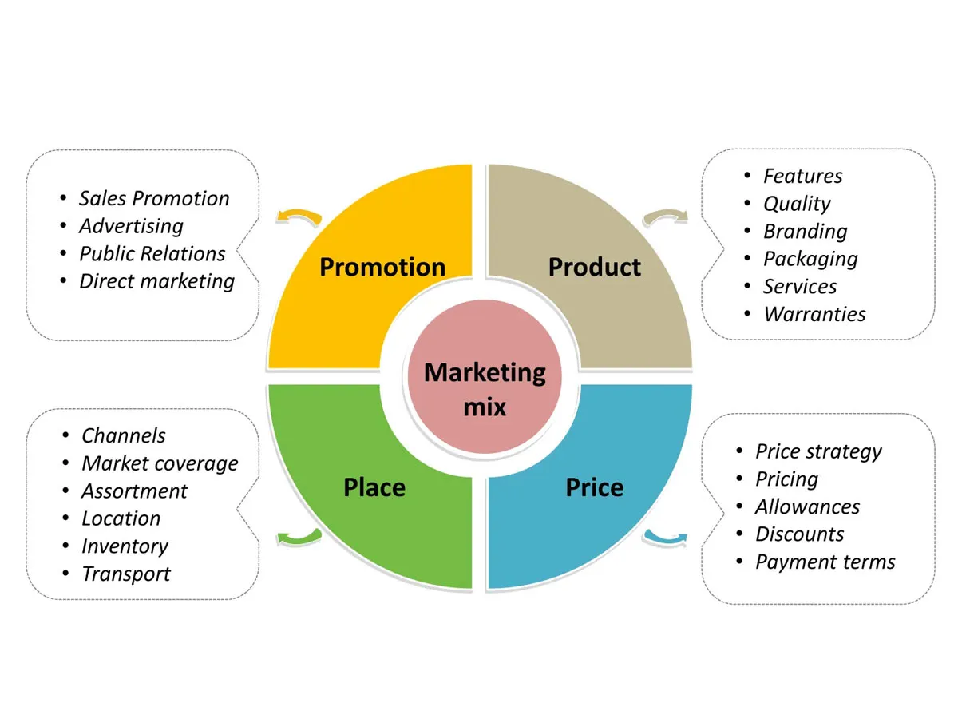

**Figure 1: 7Ps’ of Marketing Mix**

(Source: Joshi *et al*., 2022)

Promotion is one of the important factors to display all kinds of products in front of the public. The promotion must convey a good and effective message to the people which is called good advertising. Google Adsense (Youtube), Meta, and Twitter may display their digital and promotional advertisement in a periodical manner and people may know about their goods and services. There are some people who may subscribe to their channel too and with Adsense, the company may achieve (Joshi *et al*., 2022) a part of the revenue too. The Search Engine Optimization (SEO) of the websites may increase their Google ranking and with definite keywords, people may find Marks and Spencer in the top ten list of the search engine.

The place and people depend on the demographic location and cultural heritage varies from person to person. For instant, people in the United Kingdom and Christmas and new year's Eve are important festivals of the year. The structure of the advertisement is made in such a way that it provides holistic nature for the culture (Choudhary and Piparo, 2020) and people love such a company who respects their old cultural heritage. The referral bonus is one of the lucrative offers for existing customers to take more customers inside the company database.

The packaging of the products and company tends to encourage the sustainable nature of their process and operation. The usage of cellulose and less polymer (Kim *et al*., 2019) in their packaging provides the very facts of sustainable development of the environment. In their existing supply chain model (SCM), the company follows the strict rule of zero emission of carbon by the year 2030. The CSR (Corporate Social Responsibility) of the company and several novel approaches (like reusing recycled products) help those people to buy brand products who cannot afford to buy expensive new articles (Majid, 2020). The logistic movement of the company and the reduction of the transportation network also help the company to invest more in the digital environment. Thus, the company opens their services to all who can buy its product according to its financial structure.

Marketing Mix Analysis

The company always incurs an effective marketing mix for all kinds of operations to promote its business in the digital platform. There is always an investment associated with digital advertisement and the extra facility is, the company may also earn their revenue from the active subscribers in their channel through Google Adsense. The customer provides comments on their page and those reviews may help the other customers to be sure and verify the product they want to buy. The implementation of AI (Artificial intelligence) and Big data help customers to see just the specific products (Verhoef and Bijmolt, 2019) they are looking for. A wide range of flexibilities is provided (payment gateway, product catalogues, and digital cart) which help the customer to buy goods by saving a significant amount of time. Digital catalogues help customers to view their specific products as per their needs.

# 5. Conclusion and recommendation

The company Marks and Spencer spread their network globally to service the people with a wide range of their products. Although there are several challenges in digital marketing campaigns too. The most significant challenges are data privacy and data safety for the company and their customers. The payment gateways are integrated with their own applications and websites as well the integration of the digital cart too. Customers may lose their finance and other records if there is a malware attack in the gateway. This may provide a negative impact on the company. The company may add a subsequent layer of defender programs in their websites that keep the user's information (RM and Berry,2020) encrypted and safe. The unwanted malware attack and data breach may leak the customer's information into the wrong channels and this may provide a serious impact on the overall business and financial structure of the company.

Digital advertisement always contains the probability of spammers in the comment section and unscrupulous users may put negative feedback about a good product which may provide hindrance for other customers to buy the products. As a result, the company may suffer financial loss with the expected forecast about the product life cycle. The company may verify the users before enlisting and regular updating of the customer base may eliminate the problem. While most people now buy products from online mediums which come to them through digital advertisement, the implementation of modern technology like AI, big data analytics, and data mining can be done too. The data generated by the big data may be used by the AI to display the user’s specific product in the suggestion box. The company may adopt the principles of Green Supply Chain Management (GSCM) in its existing supply chain and logistics movement. People love such organizations which encourage sustainable development for the environment. Although, there are always time and costs associated with the updated supply chain for the company. Through the implementation of effective marketing strategies and goals, the company Marks and Spencer acquires the desired goal by serving millions of customers.

# References:

Ameen, N., Tarhini, A., Reppel, A. And Anand, A., 2021. Customer experiences in the age of artificial intelligence. Computers in Human Behavior, 114, p.106548.

Anshari, M., Almunawar, M.N., Lim, S.A. And Al-Mudimigh, A., 2019. Customer relationship management and big data enabled: Personalization & customization of services. Applied Computing and Informatics, 15(2), pp.94-101.

Barmina, E.A., Mestanko, N.A. And Skidan, O.G., 2019, May. Creolized texts used as the instrument of digital marketing. In 1st International Scientific Conference" Modern Management Trends and the Digital Economy: from Regional Development to Global Economic Growth"(MTDE 2019) (pp. 525-528). Atlantis Press.

Busca, L. And Bertrandias, L., 2020. A framework for digital marketing research: investigating the four cultural eras of digital marketing. Journal of Interactive Marketing, 49(1), pp.1-19.

Chopra, A., Avhad, V. And Jaju, A.S., 2021. Influencer marketing: An exploratory study to identify antecedents of consumer behavior of millennial. Business Perspectives and Research, 9(1), pp.77-91.

Choudhary, B. And Piparo, T.L., 2020 Case Study–Strategy 2020 for M&S.

CHUN, T.Y., LEE, D.K. And PARK, N.H., 2020. The effect of marketing activities on the brand recognition, brand familiarity, and purchase intention on the SNS of franchise companies. The Journal of Asian Finance, Economics and Business, 7(11), pp.955-966.

Desai, V. And Vidyapeeth, B., 2019. Digital marketing: A review. International Journal of Trend in Scientific Research and Development, 5(5), pp.196-200.

Dumitriu, D., Militaru, G., Deselnicu, D.C., Niculescu, A. And Popescu, M.A.M., 2019. A perspective over modern SMEs: Managing brand equity, growth and sustainability through digital marketing tools and techniques. Sustainability, 11(7), p.2111.

Duyen, N., 2021. How Digital Marketing adds value to Customer Experience.

Hackley, R.A. And Hackley, C., 2021. Advertising and promotion. Advertising and Promotion, pp.1-424.

He, S., Hollenbeck, B. And Proserpio, D., 2022. The market for fake reviews. Marketing Science, 41(5), pp.896-921.

Joshi, N., Gabhane, D. And Somashekhar, C., 2022. How Social Media Marketing is Helping in Customer Retention and Customer Engagement: A Case of Marks and Spencer. ECS Transactions, 107(1), p.17027.

Kim, M.Y., Moon, S. And Iacobucci, D., 2019. The influence of global brand distribution on brand popularity on social media. Journal of International Marketing, 27(4), pp.22-38.

Loxton, M., Truskett, R., Scarf, B., Sindone, L., Baldry, G. And Zhao, Y., 2020. Consumer behaviour during crises: Preliminary research on how coronavirus has manifested consumer panic buying, herd mentality, changing discretionary spending and the role of the media in influencing behaviour. Journal of risk and financial management, 13(8), p.166.

Majid, J., 2020. The Power of Celebrity as a Medium of Coercing Behaviour-A Marks and Spencer’s Case Study. Journal of Business and Social Science Review, 1(3), pp.29-38.

Marksandspencer.uk.com, 2023. available at: <https://www.marksandspencer.uk.com>

Marroncelli, R. And Braithwaite, N., 2022. # insta-fashion: how the digital revolution has affected celebrity culture and the British fashion retail landscape. Fashion Practice, 14(1), pp.124-150.

McGruer, D., 2020. Dynamic digital marketing: Master the world of online and social media marketing to grow your business. John Wiley & Sons.

Poels, K. And Dewitte, S., 2019. The role of emotions in advertising: A call to action. Journal of Advertising, 48(1), pp.81-90.

RM, M.V. And Berry, M.,2020 Digital Marketing Fundamentals.

Smith, S. 2022. Marks & Spencer Unveils 2022 Christmas campaign, TheIndustry.fashion. Available at: https://www.theindustry.fashion/marks-spencer-unveils-2022-christmas-campaign/ (Accessed: April 10, 2023).

Verhoef, P.C. And Bijmolt, T.H., 2019. Marketing perspectives on digital business models: A framework and overview of the special issue. International Journal of Research in Marketing, 36(3), pp.341-349.