**2171: THE ENTREPRENEURIAL DECISION MAKER**

Word count: 3643

**Table of Contents**

1. Introduction 3

2. Need for the business 3

3. Commercial Market Outlook 5

3.1 Industry Overview 5

3.2 Sales and stores 6

3.3 Customer Perception 7

3.4 Books and Publishing 7

3.5 Competitor analysis 8

3.6 Age distribution of readers in Germany 8

3.7 Sales fluctuations 9

3.8 The e-book markets 10

4. Three options for expansion 11

5. Recommendation for the business 14

6. Conclusion 15

Reference list 16

Appendices 20

Appendix 1: Commercial Market Outlook 20

# 1. Introduction

Entrepreneurial decision making can be considered as the choices made by the entrepreneurs while seeking to exploit market opportunities for business growth. For this entrepreneur have to readily identify market conditions and have to make decisions of expansion or retraction according to it (Palalic *et al.* 2021). In this case a similar evaluation has been made concerning entrepreneurial decision-making practices based on evaluating existing market conditions. Bookish is a bookshop having its roots in the UK and operating since 2010. By 2017, the company moved to its own personal business space at Crickhowell, starting with about 6,000 carefully selected books. In the same year Bookish also opened a cracking cafe adjacent to their services, with the help of local suppliers (Book-ish.co.uk, 2023). Their current services include hosting book clubs, discussion groups and dame nights. The company also recently has been involved in an e-commerce service as well. This particular study will evaluate the current internal and external environmental conditions of the company and will recommend upon potential entrepreneurial improvement practices.

# 2. Need for the business

A data-driven decision-making culture is an organisational culture where the workforce uses analytics and statistics to evaluate current conditions of the market. Then the analytics are used to optimise the processes of the organisation and to accomplish certain tasks according to situational needs (Nadj *et al.* 2020). A complete data-driven decision-making process involves developing an all-important strategy, identifying key areas, data-targeting, data collection and analysis and finally turning the analytics into actions(Johnson *et al.* 2019). A company needs to adapt to all the sequential steps to ensure implementing a complete data-driven decision-making culture.

For Bookish UK, their overall mission and vision of their operations are reflected through their own philosophy statement. As per their own words Bookish want to connect people to books, help children in developing a lifelong practice of reading and establish themselves as passionate booksellers (Book-ish.co.uk, 2023). Due to this consideration the main purpose of their operations is to help keep the importance of book reading in the minds of their customers. This is a part of their all-important strategy and it's their generic goal as a whole. Bookish can also develop a customer satisfaction strategy to ensure better business performance.

The next step of expanding based on a data-driven decision-making process is to identify key areas where the business can expand upon. For this, Bookish has been expanding their collection of books along with having different subjects of books in their collections. However, Bookish have special preferences for taking non-fiction books on the basis of topics of local interests. Their priority is also at buying books that are part of wholesale and are under a Batch stock control system. This makes their books more authentic and quality controlled (Book-ish.co.uk, 2023). However, to give local authors priority, the company also take books from local authors providing non-fiction books that have been under a wholesale distribution, published by a traditional publisher. This is also a part of their data-targeting process as well. Bookish filters their target markets from which it collects books to maintain the desired quality and quantity of books in their stocks by selecting and deselecting authors and their publications. Data targeting on customer age and preferences can help them refine their book collection.

For expanding their business further than just book selling, Bookish ventures into targeting potential readers as customers with several facilities alongside book buying and reading. For this purpose, the company also stocks a huge range of gifts, games and gift cards for their book lovers, curated by their team of passionate booksellers (Book-ish.co.uk, 2023). Bookish sell event-tickets, subscription boxes, and gives virtual tours to the buyers as a part of additional book related services. Thus, the company is able to develop a better data-targeting practice through the evaluation of their customer preferences.

The next step in their data-driven decision-making culture implementation involves collecting the data of their customer preferences and using them to create a further expansion of business. Their personal data collection process is guided by several principles developed by their own. One of these guidelines include contacting individual sellers and buyers through emails rather than contacting in person. This helps them exchange a larger amount of data in a quicker manner and gives them time to think about the actions (Book-ish.co.uk, 2023). The company also primarily requires a synopsis of the book before buying it from a wholesaler for a quick decision-making process to be considered. Thus, Bookish are able to effectively involve themselves in data-collection and analytics before implementing an action.

The final part of their data-driven decision-making culture implementation involves implementing actions according to the needs of the customers. Bookish have been implementing actions for a different field-based expansion since 2017 with the opening of a cracking cafe. Their market analytics has shown that the customers like to enjoy some snacks and drink caffeine while reading and reading books. Thus, the establishment of the cafe diner was a calculated marketing move. As their floor in Wales hosts only local book lovers, thus their market strategy was also driven by acquiring local suppliers or their cafe. Their local providers included Brecon Beacons, Cashell’s, Black Mountain Roast, Chester’s Wine Merchants, Emily’s Kitchen and Pip’s Hot Chocolate(Book-ish.co.uk, 2023). The rationale behind Bookish, thriving in the market, is because the company is not only a bookshop but have a holistic community endeavour.

As a part of their community endeavour and act in providing community services and a healthy mindset as a part of their actions. Organising local events is a crucial part of community engagement. These events infused with community interests are able to gather a significant crowd, leading to community interactions (Stevenson, 2020). However, some businesses use local events as a tool for business development. As book reading is concurrently getting out of fashion, local libraries and bookstores are engaging themselves in organising community events to keep the traditional approach alive (Chad and Bartlett, 2021). Bookish is no exception. Bookish organises several events almost twice a week related to book reading, book launches, young-adult book clubs and so on (Book-ish.co.uk, 2023). These events are essential to ensure the attraction of minds towards traditional practices of reading books.

Concerning a general rationale of bookshop services, an engagement towards reading books, is essential, especially for the youth (Jerrim and Moss, 2019). Therefore, the establishment of Bookish and its entrepreneurial expansion in Germany is essential. However, to develop a book reading habit communally, additional engagement services are also essential and therefore, Bookish engaging in additional services such as cafe services and event hosting is also significant as per need of the data-driven culture of modern society.

# 3. Commercial Market Outlook

## 3.1 Industry Overview

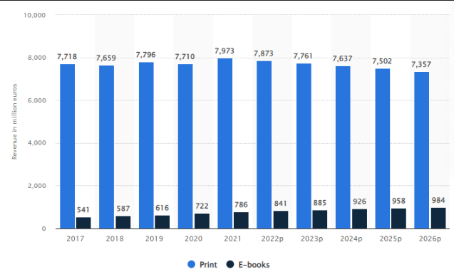

**Figure 1: Revenue of German book market**

(Source: Statista.com, 2022)

Considering the strategies of market expansion for Bookish, the company can expand their market to Germany. It is important to analyse the marketing trends in book and publication industry that is key to analyse the market. In 2021, German book market generated revenue of 7.9 million euros from printed books and approximately 790 million euros from e-books (Statista.com, 2022). It is also observed that the sales of e-book sales have also increased in recent times.

## 3.2 Sales and stores

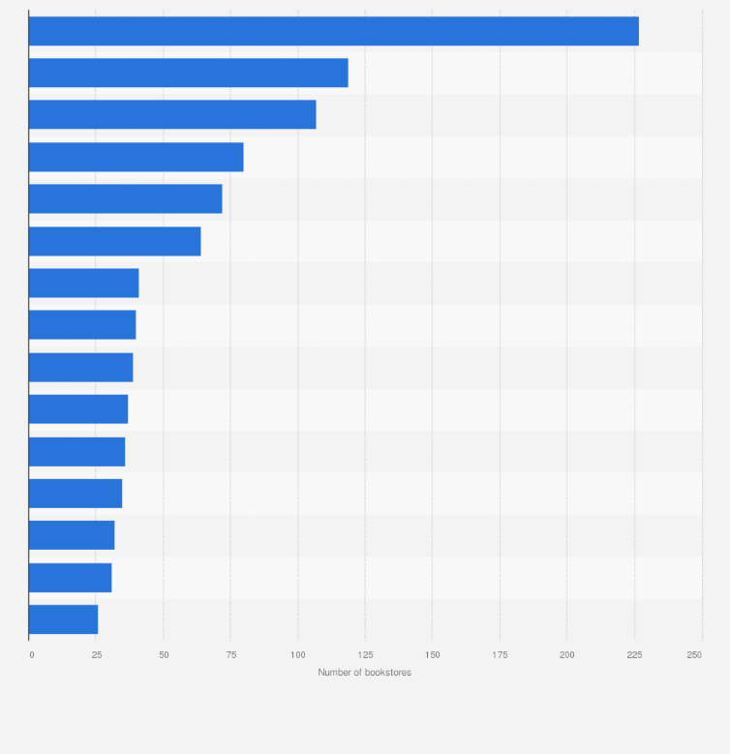

**Figure 2: German Cities with most number of bookstores**

(Source: Statista.com, 2022)

The German capital, Berlin has the highest number of bookstores in Germany. According to information retrieved in 2020, the number of bookstores in Berlin is 227. In the adjacent areas such as Bavaria and Hamburg, also have an increased number of bookstores 119 and 107 respectively (Statista.com, 2022). Therefore, it can be effective for Bookish to expand its business in this industry where the company has the scope to achieve profitability. In this regard, it is important for Bookish to consider the competition within the industry. There are a higher number of independent stores such as Thalia, Weltbild and Hugundubel in Germany that have a higher number of chains of stores in Germany.

## 3.3 Customer Perception

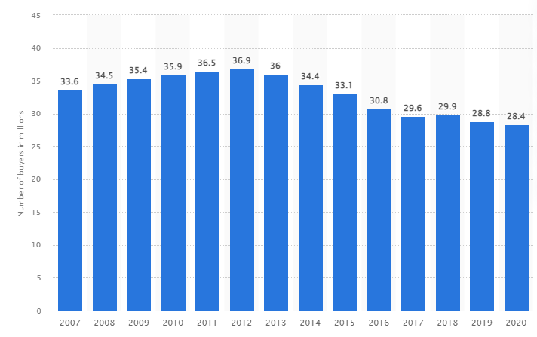

**Figure 3: Number of book buyers in Germany in 2020**

(Source: Statista.com, 2022)

Developing forecasting is important for businesses to enhance customer perception which helps in understanding market situations and trends that are key in developing the overall forecast of the business. In Germany, there were approximately 28.4 million buyers in 2020 (Statista.com, 2022). This shows that in Germany there is positive scope for enhancing business for Bookish as there are inclined readers. However, in recent times due to digitalisation, it is observed that readers are preferring ebooks more than printed books. In 2021, more than 38 million ebooks were sold in the German book market (Statista.com, 2022). This highlights that readers are shifting their reading preferences as they are using advanced technology to read books.

## 3.4 Books and Publishing

German book sales have experienced a decline in recent years as per the implication of Covid-19. In this regard, it is important to understand the reason for declining book sales which has helped in developing implications. In 2020, book sales in Germany declined by 9% and it have been observed that after 2004, book sales in Germany have recorded a significant decline (Statista.com, 2022). Therefore, it is important for the bookish to understand key implications of publishing.

## 3.5 Competitor analysis

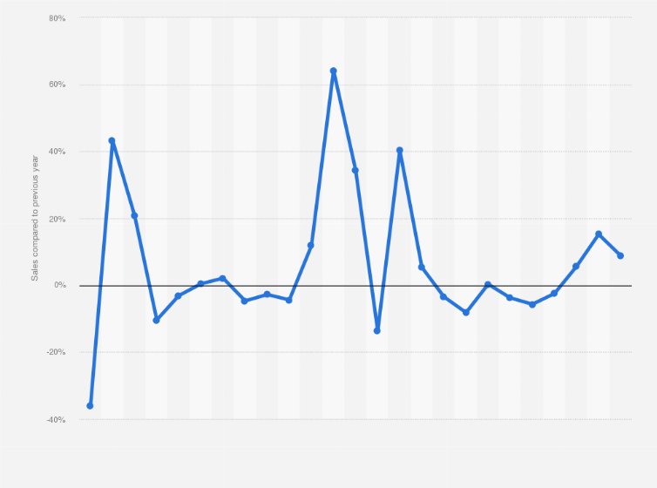

**Figure 4: German Bookstore industry revenue generation in 2023**

(Source: Statista.com, 2022)

German bookstore retailers Hugendubel, Dussmann and Ocelot can give Bookish tough competition that can potentially impact the revenue generation of the industry. In 2023, the sales in German book retail increased by 8.8% which indicates the sales in book industry (Statista.com, 2022). Therefore it is essential to analyse the implication of competitors in the market.

## 3.6 Age distribution of readers in Germany

A global survey conducted on different age groups in Germany shows that book reading habits are the most common in the middle-aged men and women. The statistics showed that individuals aged between 50 to 59 years old buy the most books. Until the age group of 60, each age group buys more books than the age group before them. This indicates that with age the consideration for buying books in Germany increases (Wordsrated.com, 2021). The next highest book buying age group is seen with the group of higher than 70 years of age. The children having an age group of 10-19 years buy the least number of books. Young adults have a mediocre buying behaviour. Bookish can focus on targeting the older generation for maximum exposure of their book selling operations in Germany.

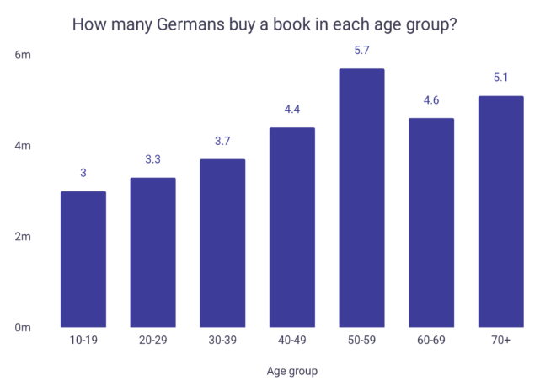

**Figure 5: percentage of individuals interested in buying books in germany by age group**

(Source: Wordsrated.com, 2021)

## 3.7 Sales fluctuations

The market of books sales in Germany was seen overall falling by 2.1%. In 2022, the sales volume was done by about 3.2%. The partial cause of this is expected to be the inflation rate increase in the country. The inflation rate as of 2022, was seen increasing to about 8.7% (Su *et al.* 2022). This was the highest inflation rate seen since the Cold War in 1990. Due to this a potential loss in retail traffic was seen at about 20%. Due to this book sales have also dropped a significant amount. Sales of fictional books dropped about 4.3%. Non-fictional book sales dropped down 8.7%. Guidebook sales declined by about 6.8% (Publishingperspectives.com, 2023). Travel books sales dropped to a major 13.4%. This indicates an overall decline in the selling of physical copies of books in the country.

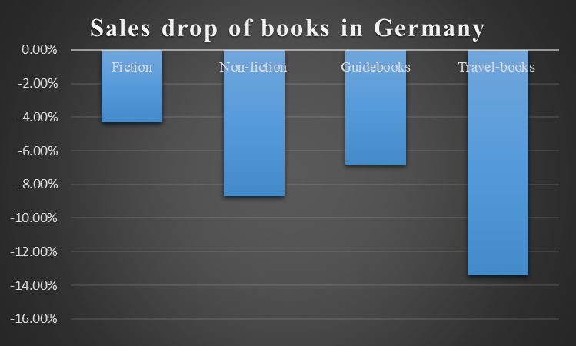

**Figure 6: Sales drop of different book categories in Germany**

(Source: Inspired by Publishingperspectives.com, 2023)

## 3.8 The e-book markets

With the years, the number of e-books reading in the country has only increased. In 2010, the sales volume of e-books in 2010 was 1.9 million. Within 10 years, the volume increased exponentially to 35.8 million. An almost 10-fold increase of sales in e-books has been seen in the span of a decade. By the end of 2021, the volume increased to 38 million (Statista.com, 2022). An increase in e-book sales would only mean a decrease in physical book reading habits.

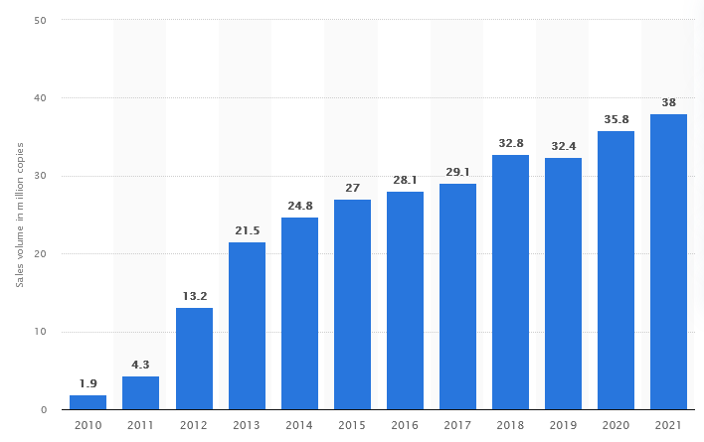

**Figure 7: Sales volume increase of e-books in Germany over the years**

(Source: Statista.com, 2022)

# 4. Three options for expansion

Business expansion is an important part of organisations that helps them to perceive growth and achieve greater success. Based on the study of Wang *et al.* (2023), businesses need to identify the most effective mode of business expansion in order to acquire major benefits. In this case, the company Bookish might consider undertaking certain appropriate modes and options to expand their business in Germany. It has been identified that there are five major options for businesses to enter into new markets in order to expand their business, such as; exporting, licensing, partnering, acquisition and joint venture (Blackburne and Buckley, 2019). Bookish can consider one market entry mode to expand their business in the Germany market and two other options for their business growth. The options are;

***A) Licensing and Franchising***

Licensing and Franchising is an effective option for businesses that operate in the information sector. According to the study of Hartanto and Ratnawati (2020), Licensing and Franchising refers to the mode of entry that is defined to give the permit of another company to a foreign country to sell and produce goods for the primary company. Therefore, in this case the company Bookish might consider obtaining a licensing and franchising option to enter the market of Germany. There are more than 2000 publishing houses in Germany (Oecd.org, 2019). Thus, the options for Bookish companies are vast in Germany to choose one publishing house to sell their products and provide the permit to produce and manufacture their products. Moreover, certain major book publishing companies in Germany are; Taschen Books, DOM publishers, Focus Magazin Verlag GmbH and Springer Verlag GmbH (Publishersglobal.com, 2019). Thus, the company can easily franchise and create a licence in order to expand their business. One of the major benefits of this business expansion mode is that it can majorly help in fast execution with low cost and low risk of operating a business in a new market. Thus, this method can be majorly beneficial for Bookish to enter into the international market.

Licensing and Franchising can majorly help the company to get the access of the already established company in Germany and get the benefits of the well-known company consumer base. Therefore, it can increase the consumer base of the company Bookish and can majorly help in accessing the vast population of Germany and perceived advantage of expansion of their business without taking the risk of conducting business in an unknown market.

***B) Build up sales channels outside of the company walls***

Sales channels are an effective way to expand the network to outsource products and deliver service in a cost effective way to maximise profits. Moreover, the company Bookish might also consider expanding their networking ways to extend their marketing and sales channel. It has been identified that Germany has major book publishing companies and generated revenue approximately 590.1 million euros in the year 2020 (Statista.com, 2022). The ranking of the major book publishing companies in the Germany are given below;

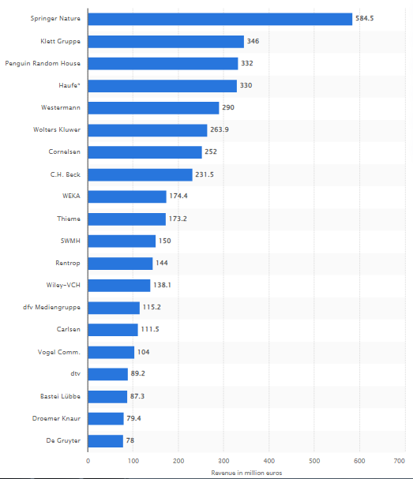

**Figure 8: “Ranking of leading publishing companies based on revenue in Germany in 2021”**

(Source: Statista.com, 2022)

The company Bookish can consider Springer Nature as the company ranked the most amongst the publishing companies in Germany. Therefore, it can majorly increase the sales networking channels for the company and can also help in attracting large numbers of consumers, who are majorly interested in purchasing books from Bookish and get the exclusive services. Based on the study of Karamaşa *et al.* (2020), outsourcing strategy is an effective way that can be obtained by the company to extend their business in the market of Germany. It can be determined that sales channels are majorly effective in creating effective ways to spread the awareness of the company products and can also help in increasing the reputation of the company through their efficient ways of conducting business. As per the view of Chimhowu *et al.* (2019), investing in external partnerships can help in creating impressive networks that can further help in distributing the company products as widely as possible. Therefore, it has been identified that the company needs to effectively enhance their company core values to make the sales channels underrated the importance of maintaining quality and value. Thus, building sales channels in Germany can help Bookish to undertake significant options that can help in distributing their products.

***C) Offering new solutions to new consumers***

Differentiation is an important factor for businesses which helps in gaining competitive advantage. Bookish in order to expand their business in Germany can consider producing different solutions to the issues that the information sector is expanding in Germany. It has been identified that the consumers of Germany who are majorly inclined to purchase books and are in to reading, the company can provide exclusive options of unlocking books in their websites instead of purchasing; they can get the aces to read the book through sharing or reading everyday which will unlock chapters of a book day by day. Therefore, it will not only help the company to increase consumer engagement for the website but also it will increase the interest of consumers. As opined by Li *et al.* (2020), consumers tend to obtain free stuff and get excited to perceive free services. Hence, at first the company can gain consumers interest through providing free books and reading options and after establishing their business the company can set their pricing range as per the market rate.

Offering new options to the consumers of Germany can help the company to attract new consumers. Small gift packages and notes can also be sent by the company to get their consumers interested and have a great experience while purchasing from Bookish. The company needs to identify cost effective solutions and improve their social media advertisement techniques to acquire consumers. Therefore, it can help the company to spread awareness about their company to the majority of the population of Germany. As opined by Prasad (2020), accommodating with exclusive promotion techniques and referral and personalised offers can help attract consumers. The company might consider offering exclusive benefits to their buyers in order to enhance their company reputation and gain recognition. Thus, in order to expand the business of Bookish it might consider offering different solutions and services to increase the brand effectiveness.

# 5. Recommendation for the business

Businesses need to obtain effective options for expansion which can help the company to support growth. It can be determined that the company Bookish might consider obtaining franchising and licensing to expound their business and enter the market Germany with their exclusive products and services. Franchising and licensing can majorly help the company to obtain a significant solution to the complex economic conditions and to avoid economic factors from affecting the company growth (Hurwitz, 2020). It can be determined that franchising and licensing is one of the most effective new market entry modes which include the lowest risks of failure. Hence, this technique can not only help the company to hold control of their production but also can help in attracting the advantages of the sole company that operates exclusively in Germany. Furthermore, in this case it can be determined that analysing the market risks and the inflation rate of Germany, implies that Bookish can be mostly beneficial through obtaining franchising and licensing. The inflation rate of Germany is +7.4% in March 2023 (Destatis.de, 2023). Therefore, high cost and high prices which can impose a threat for new companies to enter in the German market. However, obtaining licensing and franchising can help Bookish to enter the German market with the minimum investment and can get most of the benefits.

Bookish can identify major sales channels to deliver their products and taking a franchise of a publishing house in Germany can help the company to get the consumer base and knowledge of conducting business in the new market. Therefore, franchising can also help in receiving market experts of Germany who are well-aware of the consumer tendencies and purchasing behaviour that can help Bookish to divert their operation and include offerings that can help in impressing the consumer base of Germany. Moreover, it can also be determined that as per the ranking of the publishing houses of Germany, the company Bookish might consider franchising with Springer Nature. Thus, it can help the company to perceive greater success. According to a survey it can be determined that 30.7 million German people have stated that they like to read at least once a month (Statista.com, 2022). Hence, franchising in Germany can help Bookish to target the vast population of Germany and get major benefits through their exclusive marketing strategies. The company, while undertaking the business expansion options of franchising and licensing, might also consider developing their company website marketing and can majorly focus on their social media to track their acquired German consumers. Thus, the through monetisation can help the company to get crucial information from German population to track their success in Germany.

# 6. Conclusion

The evaluation made so far indicates that Bookish has a well-established business conducted in Wales, UK. Similar to several bookstore services, Bookish also provides additional services of event management, cafe services along with rewards and gifts service to attract and encourage customers for book reading. Their main goals are based on a community engagement which Bookish can follow in their expansion in Germany as well. The environment of Germany indicates the possibility of sales among elderly individuals. Their new strategy for expansion may include creating a franchise with licensing, building sales channels outside company walls and offering new services to customers. The first suggestion has been primarily recommended so that arising market risks can be shared and mitigated in a quick and easy manner.

# Reference list

Blackburne, G.D. and Buckley, P.J., (2019). The international business incubator as a foreign market entry mode. Long Range Planning, 52(1), pp.32-50.

Book-ish.co.uk, (2023). *Author Submissions[online]*. Available at: https://www.book-ish.co.uk/authors-2/ [Accessed on: 22 April, 2023]

Book-ish.co.uk, (2023). *Calendar powered by The Events Calendar[online]*. Available at:https://www.book-ish.co.uk/events/ [Accessed on: 22 April, 2023]

Book-ish.co.uk, (2023). *FEELING A LITTLE BOOK-ISH? [online]*. Available at:https://www.book-ish.co.uk/#:~:text=Our%20philosophy%20is%20simple%3A%20we,a%20 team%20 of%20 passionate%20 booksellers.[Accessed on: 22 April, 2023]

Book-ish.co.uk, (2023). *THE BOOK-ISH STORY [online]*. Available at: https://www.book-ish.co.uk/about-us/ [Accessed on: 22 April, 2023]

Chad, K. and Bartlett, S., (2021). Community engagement solutions for public libraries.

Chimhowu, A.O., Hulme, D. and Munro, L.T., (2019). The ‘New’national development planning and global development goals: Processes and partnerships. World Development, 120, pp.76-89.

Destatis.de (2023), *Inflation rate at +7.4% in March 2023;* Available at: https://www.destatis.de/EN/Press/2023/04/PE23_145_611.html#:~:text=WIESBADEN%20%E2%88%92The%20inflation%20rate%20in,rate%20had%20been%20%2B8.7%25. [Accessed on: 25th April, 2023]

Hartanto, H. and Ratnawati, E.T.R., (2020). Legal protection on franchise as business alternative development. Unram Law Review, 4(2), pp.123-137.

Hurwitz, A., (2020). Managing the Proliferation of Global Franchise Regulation. FRANCHISE LJ, 40, pp.43-49.

Jerrim, J. and Moss, G., (2019). The link between fiction and teenagers’ reading skills: International evidence from the OECD PISA study. *British Educational Research Journal, 45(1)*, pp.181-200.

Johnson, D.S., Muzellec, L., Sihi, D. and Zahay, D., (2019). The marketing organization’s journey to become data-driven. Journal of Research in Interactive Marketing.

Karamaşa, Ç., Demir, E., Memiş, S. and Korucuk, S., (2020). Weighting the factors affecting logistics outsourcing. Infinite Study.

Li, Z., Sha, Y., Song, X., Yang, K., ZHao, K., Jiang, Z. and Zhang, Q., (2020). Impact of risk perception on customer purchase behavior: a meta-analysis. Journal of Business & Industrial Marketing, 35(1), pp.76-96.

Nadj, M., Maedche, A. and Schieder, C., (2020). The effect of interactive analytical dashboard features on situation awareness and task performance. *Decision support systems, 135*, p.113322.

Oecd.org (2019), *Publishing;* Available at: https://www.oecd.org/about/publishing/ [Accessed on: 25th April, 2023]

Palalic, R., Ramadani, V., Mariam Gilani, S., Gërguri-Rashiti, S. and Dana, L.P., (2021). Social media and consumer buying behavior decision: what entrepreneurs should know?. *Management Decision, 59(6)*, pp.1249-1270.

Prasad, L.M., (2020). Principles and practice of management. Sultan Chand & Sons.

Publishersglobal.com (2019), *Germany: List of German Publishers;* Available at: https://www.publishersglobal.com/directory/germany/publishers-in-germany [Accessed on: 25th April, 2023]

Publishingperspectives.com, (2023). *German Book Sales in 2022: A Market Down 2.1 Percent[online]*. Available at: https://publishingperspectives.com/2023/01/germanys-borsenverein-2022-book-sales-down-2-1-percent/ [Accessed on: 22 April, 2023]

Statista.com (2022), *Number of people reading books in Germany from 2018-2022, by frequency;* Available at: https://www.statista.com/statistics/380433/books-frequency-of-reading-germany/ [Accessed on: 25th April, 2023]

Statista.com (2022), *Ranking of leading publishing companies based on revenue in Germany in 2021;* Available at: https://www.statista.com/statistics/382908/leading-publishers-germany/ [Accessed on: 25th April, 2023]

Statista.com (2022). Sales development in book retail in Germany from February 2020 to February 2023. Available at: https://www.statista.com/statistics/1239043/sales-book-retail-development-germany/ [Accessed on: 13 April 2022]

Statista.com (2022). Number of book buyers in Germany from 2007 to 2020. Available at: https://www.statista.com/statistics/1100596/book-buyers-number-germany/ [Accessed on: 13 April 2022]

Statista.com (2022). Year-on-year sales in retail bookstores in Germany from 2004 to 2020. Available at: https://www.statista.com/statistics/1100699/sales-retail-bookstores-year-on-year-germany/ [Accessed on: 13 April 2022]

Statista.com (2022). *Book market revenue in Germany from 2017 to 2026.* Available at: https://www.statista.com/statistics/386884/book-market-revenue-germany/ [Accessed on: 13 April 2022]

Statista.com (2022). Ranking of cities with the highest number of bookstores in Germany in 2020. Available at: https://www.statista.com/statistics/1100637/number-of-bookstores-cities-ranking-germany/ [Accessed on: 13 April 2022]

Statista.com (2022). Sales volume of e-books on the consumer market in Germany from 2010 to 2021. Available at: https://www.statista.com/statistics/385750/e-book-market-key-figures-germany/ [Accessed on: 13 April 2022]

Statista.com, (2022). *Sales volume of e-books on the consumer market in Germany from 2010 to 2021*. Available at: https://www.statista.com/statistics/385750/e-book-market-key-figures-germany/ [Accessed on: 22 April, 2023]

Stevenson, N., (2020). Having a say? The potential of local events as a tool for community engagement. *Event Management, 24(4)*, pp.435-445.

Su, C.W., Dai, K., Ullah, S. and Andlib, Z., (2022). COVID-19 pandemic and unemployment dynamics in European economies. *Economic Research-Ekonomska Istraživanja, 35(1)*, pp.1752-1764.

Wang, L., Chen, K., Chiu, M.C. and Wong, H.Y., (2023). Optimal Expansion of Business Opportunity. European Journal of Operational Research.

Wordsrated.com, (2021). By age group. Available at:https://wordsrated.com/reading-habits-germany/ [Accessed on: 22 April, 2023]

# Appendices

## Appendix 1: Commercial Market Outlook

