''Critically assess the commonly held belief that tourism should be regarded as a human right.''

Table of Contents

Introduction 3

Discussion 3

Conclusion 6

Reference 7

Appendices 8

Appendix 1: Revenue of the Tourism Sector 8

Appendix 2: Countries with the highest poverty rates 9

# Introduction

In the present essay, the assessment of the holding belief of tourism that should be regarded as a human right has stated that human activities and tourism are familiarly intertwined with human rights. It has helped in representing the national tourism which occurs within geographical boundaries and human-centric activities get complex with human rights. The GDP margin and the development of the tourism sectors have obtained more opportunities thus social inequalities are prevalent in the tourism sectors. The ethics in the tourism industry and maintaining human rights is also evaluated in the present section. The tourism industry has grown with the support of human beings. It has been observed every year over a billion people travel for relaxation, fun, experience new adventures and others. As the tourism industry has gradually grown, the issue of human rights has emerged. Tourism involves cross-cultural interaction among different nations’ people and helps in building a better understanding. The present study has included the relationship between tourism and environment which has been changed accordingly. Geographical boundaries and human-centric activities have been developed. It has stated the social inequality and helped to understand the market-related policies in order to control and influence the economy. Also, tourism has helped in representing new places and increased the number of tourists.

# Discussion

**Concept of Tourism in Association with Human Rights**

The term tourism refers to the idea that an individual travels from one location to the others primarily to seek pleasure. Tourism can be distinguished into two sects - national tourism and international tourism. National tourism occurs when a person travels within the geographical boundaries of his or her own nation (Collins-Kreiner *et al.* 2020). On the other hand, international tourism occurs when a person travels abroad and crosses the geographical boundaries of his country (Kozak. and Buhalis, 2029). Therefore, tourism is a human-centric activity and quite naturally it becomes intricately interwoven with the concepts of “human rights''. Human rights are a set of rights, which are inherent to all human beings regardless of their colour, race, sex, ethnicity, nationality, religion, or any other type of status (Un.org, 2023). Therefore, the notions of human rights in the context of tourism refer to the idea that every individual regardless of this caste, creed, gender or any other status has a right to tourism. Moreover, tourism influences the life of local communities by creating job opportunities and strengthening the socioeconomic status of a country. The rights to natural resources like water are often influenced by tourism. Therefore, it can be noted here that tourism is intricately related to human rights.

**Tourism and Social Inequality**

The concept of social inequality has been extended to tourism because social inequality is quite prevalent in the tourism sector. Social inequality in the tourism sector has been created because of the differences in the financial status of individuals. It has been argued by Speake and Kennedy (2019) that tourism is utilised as a tool for showing social status and maintenance of social standards and class. The tourism sector is a major part of the world economy, and it has been projected that the annual GDP of the tourism industry will exceed 924.27 billion by 2025 (Statista, 20223). It has been observed by Ntounis *et al.* (2022) that the economy of several countries is heavily dependent on their tourism sector because during COVID-19 when there were restrictions on tourism, the economy of several countries severely suffered. Thus, tourism is being leveraged by countries as a tool of economic affluence. Therefore, it is quite apparent that the expenses of tourism are quite high and unaffordable for millions of people. Especially, in developing and underdeveloped countries where millions of people come below the poverty rate and fail to afford the expenses of travel. Thus, it can be stated here that tourism is limited to those who are economically affluent. Thus, the concept of human rights is violated in the tourism sector because tourism is limited to those who are economically affluent. Thus, only a certain section of people get to travel around the world and enjoy cultural and natural landscapes. ***[Refer to Appendix 1]***

**Consumerism in Tourism**

The concept of "Consumerism" in the tourism industry refers to the idea that the tourism sector is highly dependent on the consumption of travellers. It has been argued by Kaufmann and Panni (2019) that Consumerism in the tourism industry suggests that there would have been no tourism industry if there were no travellers. However, in this regard, it is important to note here that the consumers i.e. the travellers in this industry belong to a specific social stratum, which consists of rich people. Thus, "Consumerism" is heavily limited to a certain class of people and this is a direct violation of the concept of human rights. When the focus is shifted to under-industry, it can be seen that other industries are highly diversified in terms of their consumer base. Whereas the tourism industry relies on affluent consumers.

Tourism is only similar to other industries in the sense that consumers of the tourism industry buy products. Although the product does not come in a tangible form, it does come in an intangible form. It has been argued by Higgins *et al.* (2019) that people travel to experience the cultural diversity of different places and there is an interaction between the host culture and the travellers' culture in tourism. However, the culture of the host, that is the place where travellers visit remains intact and the interaction is so mild that no culture gets affected. In this regard, it is important to note that only a certain section of people get to experience and enjoy other cultures. Whereas, a large section of society doesn't get the opportunity to meet and experience other cultures. Now, the question arises: what is the position of poor people in tourism? It has been argued by Scheyvens and Hughes (2019) that tourism does not uplift the poor, rather it excludes the poor from the very realm of tourism. However, it can be seen that the poor living in famous tourist destinations are exploited for their labour and in return, they do not get adequate and proper wages. Thus, it can be stated here that the tourism sector is on the one hand excluding the poor on the other hand it includes the poor only for their labour and just to exploit them. The earnings from the tourism industry are even centralised and the profits from the tourism industry are not used for the elevation of the poor.

**Center and Margin**

The right to travel is a concept that has been centralised around the rich and the poor have been outcasted. The concept of centre and margin is prevalent in the tourism sector, where the rich are at the centre and enjoy all rights to tourism, and the poor are at the margin and are deprived of their rights to tourism. This signifies that tourism is not accessible to everyone and the right to tourism needs to be bought with money and it is not provided for free. From the perspective of human rights, everyone should be provided with equal opportunities to travel because everyone has the right to experience the diverse culture of the world. However, in reality, rights tourism emerges from money. If an individual has money, he has the right to travel, if he has not he is marginalised and deprived of the tourism right.

**Multiculturalism and Tourism**

Thus, so far it has been realised that tourism is beyond the rich of the poor and the deprived. However, human rights activities argue that tourism should be made and included under human rights. The importance of tourism to be included in human rights is multifaceted. It has been argued by Jamal (2019) that if tourism promotes multiculturalism then tourism should be made equalised among everyone. The purpose of tourism is predominantly to experience other cultures. This purpose is highly justified in the sense that cultural interaction can help to remove the concept of culturally superior or culturally inferior (Liu *et al* 2020). Thus, via tourism cultural interaction can be promoted on one hand and on the other multiculturalism can be embraced. However, the concern of human rights activists is that if tourism is limited to the reach of rich people, how can tourism be a tool to promote multiculturalism? Therefore, they urge that the mission of tourism to promote multiculturalism can only be accomplished when tourism rights are equal for everyone. Especially, in most African countries and Asian countries, where the percentage of poor people is excessively high, people cannot even afford national tourism. The idea of international tourism is of no sense to them and thus they do not get to experience other cultures. ***[Refer to Appendix 2]***

The major benefit of tourism is that it creates job opportunities and promotes the growth of a country. However, in this case, it can be seen that people prefer to travel to developed nations or nearly developed nations. Thus, what happens is that developed countries become richer and the underdeveloped countries remain in the same position. The concept of "centre and margin” is applicable here as well. It is because the developed nations are at the centre of attraction for tourism, while the underdeveloped nations are at the margins and do not witness much traffic in tourism. It has been argued by Roman *et al.* (2020) that tourism traffic is significantly high in Western countries in comparison with African countries. This signifies that tourism relies on modernism and countries that are modernised capture the attention of the tourists.

After the above discussion, it has been revealed that tourism is an essential part of life, it promotes cultural unity and emotional and mental pleasure and even it significantly contributes to the economic growth of a country. However, tourism traffic is more prevalent in developed countries with modern infrastructures. Therefore, the light of tourism is less prevalent in underdeveloped countries, where most poor people live. Human rights cannot be associated with tourism at present, because through this study, it has been found that the right to tourism needs to be purchased and the ones who cannot afford it, simply cannot enjoy it. However, the purpose of tourism is truly noble and it can be promoted on a large scale so that the earth can be a better place altogether. Tourism in order to become a human right demands certain parameters like the upliftment of the poor, development of underdeveloped countries and equal distribution of resources. The world is essentially beautiful, but only a certain section of people get to experience this and this is not fair on the part of the marginalised. Therefore, global initiatives should be taken to ensure that every individual gets access to tourism.

**Tourism Ethics and Human Rights**

Tourism ethics refers to the consequences and impacts of tourism on the environment and society. From an ethical point of view, tourism can benefit the local communities and local people of a tourist destination. Therefore, the tourism industry can be more ethical when attempts are taken to develop the socio-economic condition of local people and communities. Moreover, sustainable tourism is a part of ethical tourism, where measures are taken to protect the environment from the activities of tourists.

Tourism is related to several aspects of human rights, which are the right to participation, information and different decision-making processes. Moreover, rights to health, food and housing are affected by tourism. In addition, protection against discrimination, exploitation and forced labour are intricately related to tourism.

**Conclusion**

From the above study, it can be concluded as travel is known as a legal right and it includes reasonable limitations. Through tourism ethics, it has become necessary to incorporate human rights into the discourse. Tourism can be is mainly distinguish between two parts such as national and international tourism. The development of tourism reduces poverty and increases the income distribution process. During the Covid-19 pandemic situation, tourists were affected very much and it created many restrictions among travellers. It has become easy for the tourism industry to become highly dependent on the consumption of travellers. Consumerism indicates a certain group of people and also a concept of human rights. It has also been observed the centre and the margin where the centre is known for having more power, ability and influence rather than the margin. The process of managing the tourism process and the ethics are also related to human rights that need special attention to maintain properly. It has increased the disadvantages of tourism management. It can be said tourism helps in offering great opportunities for the purpose of an emerging economy and also having human rights in order to develop and make more tourism in the country. Social inequality is extended to tourism as it is prevalent in the sectors of tourism. The main idea of the tourism sector is highly dependent on travellers. It helps in increasing the revenue structure of the country on frequent visits of travellers.

# Reference

Jamal, T., 2019. Justice and ethics in tourism. Routledge.

Higgins-Desbiolles, F., Carnicelli, S., Krolikowski, C., Wijesinghe, G. and Boluk, K., 2019. Degrowing tourism: Rethinking tourism. Journal of Sustainable Tourism.

Scheyvens, R. and Hughes, E., 2019. Can tourism help to “end poverty in all its forms everywhere”? The challenge of tourism addressing SDG1. Journal of Sustainable Tourism.

Ntounis, N., Parker, C., Skinner, H., Steadman, C. and Warnaby, G., 2022. Tourism and Hospitality industry resilience during the Covid-19 pandemic: Evidence from England. Current Issues in Tourism, 25(1), pp.46-59.

Speake, J. and Kennedy, V., 2019. Changing aesthetics and the affluent elite in urban tourism place making. Tourism geographies, pp.1-22.

Roman, M., Roman, M. and Niedziółka, A., 2020. Spatial diversity of tourism in the countries of the European Union. Sustainability, 12(7), p.2713.

Kaufmann, H.R. and Panni, M.F.A.K. eds., 2019. Handbook of Research on Contemporary Consumerism. IGI Global.

Un.org, 2023. Peace, dignity and equality on a healthy planet. Available at: <https://www.un.org/en/> (Accessed on: 2023)

Collins-Kreiner, Noga, and Yael Ram. "National tourism strategies during the Covid-19 pandemic." Annals of tourism research (2020).

Kozak, M. and Buhalis, D., 2019. Cross–border tourism destination marketing: Prerequisites and critical success factors. Journal of Destination Marketing & Management, 14, p.100392.

Liu, J., Pan, H. and Zheng, S., 2019. Tourism development, environment and policies: Differences between domestic and international tourists. Sustainability, 11(5), p.1390.

# Appendices

## Appendix 1: Revenue of the Tourism Sector

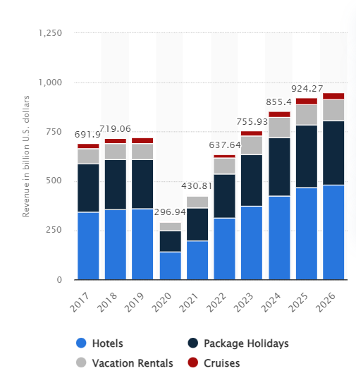

(Source: https://www.statista.com/forecasts/1238973/revenue-in-the-travel-and-tourism-market-worldwide)

## Appendix 2: Countries with the highest poverty rates

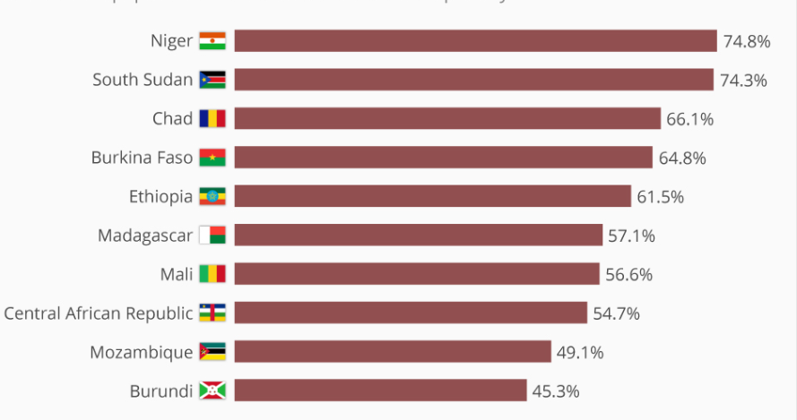

(Source: https://www.statista.com/chart/18677/share-of-the-population-in-severe-multidimensional-poverty/?