**STRATEGIC PROJECT RISK MANAGEMENT**

Table of Contents

Case Study 1: Decision tree analysis 2

1.1 Case Analysis 2

1.2 Recommendation 3

Case Study 2: Quantitative risk analysis 4

a) Profit and loss for a given demand 4

b) Sensitivity to profit to demand 5

c) Access price per copy 5

d) Profit for each scenario, and the highest profit and lowest profit 6

Case Study 3: Regression 7

a. Regression equation development 7

a) Annual income as an independent variable 7

b) Household size as an independent variable 8

c) The variable that is in terms of predictor is better of the annual charges of credit card 8

b. Regression equation with annual income and household size as the independent variable 9

c. Predicted annual credit card charge for a 5-person household 10

d. Need for other independent variables that could be added to the model with additional variables 11

Case Study 4: Risk, governance, ethics, and Sustainability 11

a) Ethics issues raised by Smith’s conduct 11

b) The risk associated with Smith's Behavior 12

c) Prevention process of Smith's conduct 13

d) Opinion regarding sustainability in the financial sector 14

Reference list 15

Appendices 18

# Case Study 1: Decision tree analysis

## 1.1 Case Analysis

In this assignment, the data provided to a project manager of a reputed University to make a decision tree to determine the project's usefulness. A decision tree is a workflow or cost flow chart that reflects the model. This tree-looking model chart is used to determine the project outcome, project outlining and costs to be proved potential (Willumsen *et al.* 2019). The consequences are complex to make and could be simpler to understand. Costs, opportunity costs and future project outcomes are determined in a decision tree.

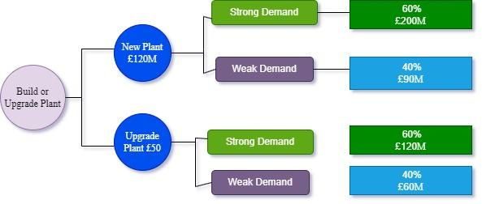

**Figure 1: Decision Tree**

(Source: Self-created in Draw.io)

From the above figure, it is observed that the company has two options of either build a new plant for £120m or upgrade the existing plant using £50m. The company meets both strong and weak demands. For the new plant as per strong demand, there is a 60% chance of earning £200m and a 40% chance of earning £90m. The EMV of the new building is £80m in strong demand and the EMV of new plant in weak demand is -£30m (Jiang *et al.* 2021). For the plan of upgrading the plant as per strong demand earning is £120m and 40% chance of generating revenue £60m in weak demand. The EMV of the upgraded plant is £70m in strong demand and £10m for weak demand.

## 1.2 Recommendation

The decision tree is showing that the outcomes of the project planning and cost calculation and the effect on revenue to adopt either plan. In the case of a new plant as per EMV, there are chances of a loss of £30m but if the plan succeeded the company can earn £80m. And if the company goes for the upgradation of the existing plant either way of strong or weak demand company can generate £70m and £10m respectively. The profit is guaranteed in the upgradation of the plant. So the company should adopt the planning of upgradation of the plant as only investing £50m company can generate £70m revenue. Hence the recommendation is clear about the upgradation of the existing plant. Although there may be debates about new technology and innovation, it is appropriate to advise that the company is not prepared for those things after monitoring and analyzing market data.

# Case Study 2: Quantitative risk analysis

## Profit and loss for a given demand

**Figure 2: Profit and loss for a given demand**

(Source: In MS Word Self created)

Through the use of the below formula, the calculation of profit and loss is going to be done.

“Profit / Loss = (Access Price - Variable Cost) * Demand - Fixed cost”

For 3500 copies demand the profit and loss is -£20000 or (£46 - £6)*3500 - £160000 = -£20000

That is the reason with a demand loss that is anticipated is -£20000. [***Referred to appendix 1]***

## Sensitivity to profit to demand

**Figure 3: Profit and loss for a given demand**

(Source: In MS Word Self created)

A table is created for the calculation of this, where in column A the demand is present, and in column B profit and loss is present. In this regard from row B 23 to B28, the demand gets increased by 200, from 1000 to 6000. From £40000 to £240000 the profit and loss value has increased, and the formula that is used in this regard is (£46 - £6)* each demand individually in column A (Shad *et al.* 2019). In this regard, profit and loss grew by £8000 at each level at the time when demand climbed by 200. [***Referred to appendix 2]***

## Access price per copy

The per copy access price that must be charged by the publisher is £52 to “break even” with the demand of 3500 copies. [***Referred to appendix 3]***

## Profit for each scenario, and the highest profit and lowest profit

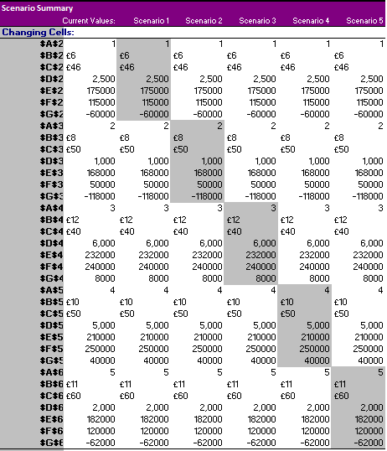

**Figure 4: Profit for each scenario, and the highest profit and lowest profit**

(Source: In MS Excel self created)

For case 1, the loss is calculated as £600,000. The loss in scenario 2 is calculated to be -£118,000. For scenario 3 the profit is derived from £8000. For scenario 4 the profit is derived £40000, and for scenario 5 the profit is derived -at £62000.

The yielding is done in the scenario that is high in terms of profit is the fourth scenario, and the yielding is done in the scenario in terms of profit that is very low in the second scenario. .

# Case Study 3: Regression

## a. Regression equation development

### a) Annual income as an independent variable

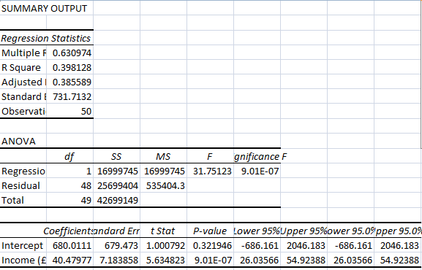

**Figure 5: Annual income as an independent variable**

(Source: In MS Excel self created)

In this regard, annual income as an independent variable is taken, and in the form of the dependent variable, the amount charged from the credit card is taken. In this regard “Multiple R” is determined as 0.630974. “R square” is determined as 0.398128 (Durst *et al.* 2019). “Adjusted R square” is determined as 0.385589. “Standard error” is determined as 731.7132, and the “observations” value is 50.

### b) Household size as an independent variable

### 

**Figure 6: Household size as an independent variable**

(Source: In MS Excel self created)

In this regard, household size as an independent variable is taken, and in the form of the dependent variable, the amount charged from the credit card is taken (Gurtu and Johny, 2021). In this regard “Multiple R” is determined as 0.646462, “R square” is determined as 0.417913, “Adjusted R Square” is determined as 0.405786, “standard error” is determined as 7193.5863, and “observations” value is present in this regard is 50.

### c) The variable that is in terms of predictor is better of the annual charges of credit card

The discussion is made above of two regression equations, and from that it is visible that using the household size regression equation in the form independent variable is a better predictor of charges of the annual credit card. Due to the fact that its coefficient of determination, or "R Square," is higher 0.417913 than that of the equation utilizing yearly income as the independent variable, which has a lower value of "R square" 0.398128.. From this, it is understood that the size of the household is a good predictor of charges of “annual credit cards” rather than “annual income”.

## b. Regression equation with annual income and household size as the independent variable

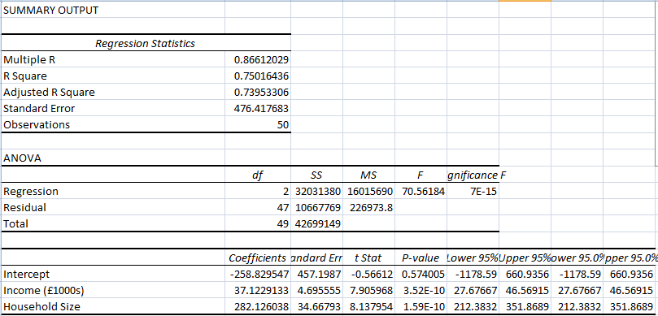

**Figure 7: Household size and income together as an independent variable**

(Source: In MS Excel self created)

In this regression equation, annual income and household size are taken in the form of the independent variable, and the dependent variable amount charged from the credit card is taken.

**Figure 8: Relationship between income, household size and credit card charges**

(Source: In MS Excel self created)

In this regard, the “Multiple R” value is determined as 0.86612, the “R square” value is determined as 0.750164, the “Adjusted R square” value is determined as 0.739533, the “standard error” is determined as 476.4177, and the number of observation is present in this regard is 50.

## c. Predicted annual credit card charge for a 5-person household

**Figure 9: Predicted annual credit card charge for a 5-person household**

(Source: In MS Excel self created)

In this multiple linear regression model the value of the “R square” is 0.750164, and it indicates that the variation is present at 75%. From that, by the household size and income variation the charged amount is explained. Both household size and income are the major predictors of charged amount with a 0.574005 value.

The annual regression equation is “Annual credit card charge=-258.83+37.1*37122.91+282.126*5

The predicted annual credit card charge for a 5-person household with an annual income of $70000 is £1378929.

## d. Need for other independent variables that could be added to the model with additional variables

The data that is provided depends on that the yearly income, size of the household, and yearly charges of credit card data is collected. The sample size in this regard is taken 50 (Saeidi *et al.* 2019). However, the presence of an independent variable is also noticed that could affect the credit card clients charged amount, and these variables are added to the model to improve the prediction accuracy. In this regard, the additional variables that are very much helpful are age, gender, education, occupation, marital status, credit score, and location.

Through these additional variables the addition to the model cloud help in the accuracy improvement of the predictions, and regarding the factors more comprehensive understanding is developed of the factors that influence the amount charged by the clients of the credit card.

# Case Study 4: Risk, governance, ethics, and Sustainability

## Ethics issues raised by Smith’s conduct

There are many ethical issues raised through Smith's conduct and these are mentioned here. The issues are related to the protection of data, confidentiality breaches, interest conflicts, resource misuse, and transparency lack.

To copy the data of the company onto the portable hard drive is Smith’s decision without proper security and authorization measures and because of this in privacy and confidentiality a major risk is possessed of the customers of the company (Baryannis *et al.* 2019). The sensitive information access is provided to him in the form of a part of his role of the job. Outside the network of the company, this information is copied, which increases the data breach risk, misuse, and theft.

The confidentiality and trust have been breached by Smith of his clients that are in the company B is placed. By taking the data outside the secure system of the company and own purpose using it, in contravention, Smith has acted of the security policy of the company and professional obligation to keep private confidential information.

To complete his assignment on time Smith is under very much pressure, and his in-home personal device is wanted to be used by him. To complete tasks quickly his desire has increased, and because of this, this type of decision is taken by him. By this, he also wanted to fulfil his professional obligation, In this regard between his convenience, and duties a conflict has arisen.

The resources of the company are misused by Smith by taking the data, that the belonging of the company outside the network of the office, and for the completion of the tasks he is using a local library computer (Grima *et al.* 2020). This causes a compromise of data, and to the policy of the company, it is a breach.

To the manager, information is not provided by Smith, and from this manager, he has not taken any authorization before the data copying, and leaving the information of the company vulnerable to damage, theft, and misuse. The transparency lack undermines the governance structure of the company, and its ability to risk management. It includes privacy and security.

Towards the compliance, reputation, and governance for the company implication is present from these ethical issues, with required regulation. It includes the Data Protection Act of the UK and for his actions disciplinary actions are going to be faced by Smith.

## The risk associated with Smith's Behavior

There are various associated with the behavior of Smith are it includes breaches of data, violations of data, unauthorized access, intellectual property, and ethical issues. By copying the sensitive data of customers onto a portable hard drive, Smith has exposed potentially the data to unauthorized access or theft (Martins *et al.* 2019). Serious consequences will occur for the company and the customer both. An example of it is the loss of trust of customers, and identity theft.

Taking the data of the customer to home, and outside the office taking the work are the major actions that are taken by Smith. This also disrupts the regulation, and privacy law that is by the company is needed to keep the information of the customer secure and confidential.

At a local library by using a computer the data of the customer might get exposed by Smith to access that is not authorized (Winge *et al.* 2019). In computer other people who have access he also does not know, including who has stored the data in it.

If a portable hard drive, and laptop get stolen of Smith then the intellectual property of the company also gets stolen or lost. It includes proprietary information and confidential data. Because of this, the competitive advantage of the company gets down or is lost significantly.

Ethical concerns are also raised from the actions of Smith because the procedures, and policies of the company are violated by him by taking the data out of the office and exposing it to a major risk to security. To the disciplinary actions it moves forward, and from his superiors, and colleagues he will be not trusted anymore.

## Prevention process of Smith's conduct

From happening again in the future to prevent Smith’s conduct various measures are going to be taken by his organization to ensure proper management of risk, practices of sustainability, ethics, and governance. This rise of five major risks that might happen in this situation with the suggested measures to mitigate them is mentioned here.

The five major risks in this regard are the risk of data security, the risk of data privacy, the risk of compliance, the risk of intellectual property, and the risk of ethics. Through the sensitive information copied to his personal hard drive, at risks, the data is put by Smith (Al and Nobanee, 2019). This risk happens because there is a major chance is present that the data unauthorized way the data is going to be accessed, lost, or stolen, For the mitigation of these risks the strict policies must be imposed regarding sensitive information handling. It includes secure storage and encryption requirement.

By accessing the information of the customer outside the office without the proper authorization, Smith might have done the violation of regulations, and privacy laws of data. For this risk mitigation, clear procedures, and policies must be present within the company in place regarding the use, and access of the data (Pedrini and Ferri, 2019). It includes creating data privacy responsibilities by providing training for employees.

To complete a report at a local library by using a computer the regulatory requirements or policies are violated by Smith. For this risk mitigation, clear procedures, and policies must be present within the company in this regard in terms of the company data's acceptable use with the system. In this regard, it is also needed to be made sure that awareness among the employees must be present regarding the major consequences, and policies of non-compliance.

By copying the data of the company in his personal hard drive, the intellectual rights of the property might have been violated by Smith. Because of this the confidentiality agreement of the company also gets breached. For the mitigation of this risk, clear procedures and policies must be present within the company in place regarding the confidentiality and intellectual property (Kurbonov 2021). It must be ensured in this regard that regarding the major consequences and policies of non-compliance, the employees must remain aware.

By copying the data into his personal hard drive and for the report using a public computer, Smith might have acted unethically by putting at risk the information of the customer. By doing this the data privacy law is also violated by him. For the mitigation of this risk, clear policies must be present within the company with the procedures in place regarding ethical conduct, and it must be ensured that regarding these policies employees are aware, and they must be aware of non-compliance potential consequences. If judged on an overall basis, in the future to prevent these types of happenings risk management, sustainability practices, ethics, and governance must be prioritized (Jung and Song, 2020). The implementation of procedures, and policies for data privacy, and security, regarding their responsibilities training the employees that relate to the access, and use of data, and ensuring that the employees must stay aware of the major consequences of non-compliance with regulatory requirements and policies of the company.

## Opinion regarding sustainability in the financial sector

In the form of a major aspect, the presence of sustainability is noticed, and it must be considered in all industries of the organizations. It also includes the sector of finance. In this case study the support facility is provided by the organization where Smith works to people who are facing difficulties regarding finance. Regarding personal information, a large database is maintained of the customers. Fie this type of organization it is very much required that they have appropriate measures in position to safeguard the information of the company, by complying with the protection regulation of the data (Kamiya *et al.* 2021)In addition to that by Smith the actions that are taken to complete his project within the provided deadline have raised many sustainability questions regarding the operation of his organization. In this regard, it is very much understandable that Smith is in a very pressure to complete his deadline, but the information that is very much sensitive of the data of the customer that is copied into the portable hard drive of the company without the proper authorization has raised many concerns regarding the data governance practice of this company, In this regard the fact is present that on the local computer Smith is very much dependent for his completion of the work highlights the organization needs to provide its employees with proper resources to carry out their work with the risk practices restoration that might compromise the sensitive information security.

Furthermore, a major impact is present from the financial sector on the society and environment, and for organizations, it is very much important in this regard to consider the practices of sustainability. Carbon footprint reduction, ensuring investing responsibly, and social responsibility promotion are included in it, Sustainability is prioritized by those organizations are from the perception of the public, and the image of the brand is likely to get benefited. Because of this loyalty of the customers will get increase, and in the long run organizations will be able to stay in a profitable state.

From the discussion above it is very well understood that in the sector of finance, sustainability plays a major role and responsible practices must be prioritized that give importance to customer information security and promote environmental responsibility. By doing this more sustainable model of business is built by them, and in the stakeholders eyes their reputation also gets enhanced very much.

# Reference list

**Journal**

Al Muhairi, M. and Nobanee, H., 2019. Sustainable financial management. *Available at SSRN 3472417*.

Baryannis, G., Validi, S., Dani, S. and Antoniou, G., 2019. Supply chain risk management and artificial intelligence: state of the art and future research directions. *International Journal of Production Research*, *57*(7), pp.2179-2202.

Durst, S., Hinteregger, C. and Zieba, M., 2019. The linkage between knowledge risk management and organizational performance. *Journal of Business Research*, *105*, pp.1-10.

Grima, S., Dalli Gonzi, R. and Thalassinos, E., 2020. The impact of COVID-19 on Malta and it’s economy and sustainable strategies.

Gurtu, A. and Johny, J., 2021. Supply chain risk management: Literature review. *Risks*, *9*(1), p.16.

Jiang, W., Martek, I., Hosseini, M.R. and Chen, C., 2021. Political risk management of foreign direct investment in infrastructure projects: Bibliometric-qualitative analyses of research in developing countries. *Engineering, Construction and Architectural Management*, *28*(1), pp.125-153.

Jung, J. and Song, J., 2020. Integrating Climate Change into Development Cooperation-Korea’s Experience.

Kamiya, S., Kang, J.K., Kim, J., Milidonis, A. and Stulz, R.M., 2021. Risk management, firm reputation, and the impact of successful cyberattacks on target firms. *Journal of Financial Economics*, *139*(3), pp.719-749.

Kurbonov, K., 2021. Strategy of debt management. *Архив научных исследований*, *1*(1).

Martins, V.W.B., Rampasso, I.S., Anholon, R., Quelhas, O.L.G. and Leal Filho, W., 2019. Knowledge management in the context of sustainability: Literature review and opportunities for future research. *Journal of cleaner production*, *229*, pp.489-500.

Pedrini, M. and Ferri, L.M., 2019. Stakeholder management: a systematic literature review. *Corporate Governance: The International Journal of Business in Society*, *19*(1), pp.44-59.

Saeidi, P., Saeidi, S.P., Sofian, S., Saeidi, S.P., Nilashi, M. and Mardani, A., 2019. The impact of enterprise risk management on competitive advantage by moderating role of information technology. *Computer standards & interfaces*, *63*, pp.67-82.

Shad, M.K., Lai, F.W., Fatt, C.L., Klemeš, J.J. and Bokhari, A., 2019. Integrating sustainability reporting into enterprise risk management and its relationship with business performance: A conceptual framework. *Journal of Cleaner production*, *208*, pp.415-425.

Willumsen, P., Oehmen, J., Stingl, V. and Geraldi, J., 2019. Value creation through project risk management. *International Journal of Project Management*, *37*(5), pp.731-749.

Winge, S., Albrechtsen, E. and Mostue, B.A., 2019. Causal factors and connections in construction accidents. *Safety science*, *112*, pp.130-141.

# Appendices

**Appendix 1: Anticipated loss with a demand of 3500 copies**

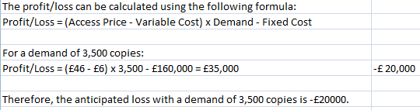

(Source: In MS Excel self created)

**Appendix 2: Sensitivity of profit to demand**

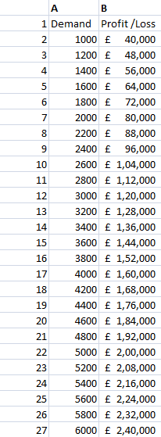

(Source: In MS Excel self created)

**Appendix 3: Price per copy that the publisher must charge to breakeven with a demand**

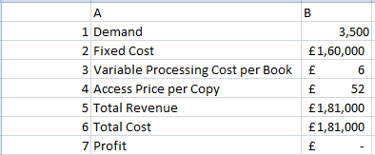

(Source: In MS Excel self created)