**RISK MANAGEMENT PLAN REPORT**

**Table of Contents**

1. Reasons for adopting change 3

2. Project monitoring and control 5

Concept of the project life cycle 5

Gantt chart 7

Work breakdown structure 8

Pert chart 8

Critical path method 8

Earned value analysis 8

3. Importance of change and quality control 9

4. Stakeholders’ Engagement 12

5. Managing resistance to change 14

6. Organization structure 16

7. Assumptions and recommendations based on findings 17

References 18

# 1. Reasons for adopting change

The flow of students in the UK has increased over the last decade. This asks the educational institutes in the UK to improve their education standards and learning practices to make the learners feel flexible with the learning process. Coventry University London (CUL) proposes the change of constructing and modifying buildings near the Liverpool Street Station to ensure better education facilities are built for the new students. This will enable the institute to cope with the inbound foreign learners effectively as the university will have lesser difficulties in accommodating space to the candidates. As per the study by Colli et al. (2022, p.45), business case identification needs to be properly done to assure the stakeholders of an ample degree of return on investments (ROI) from the project. Here, Coventry University shareholders and board members have the scope to sustain profits, improve education services, and gain positive feedback from candidates with the new building modification and construction near Liverpool Street Station.

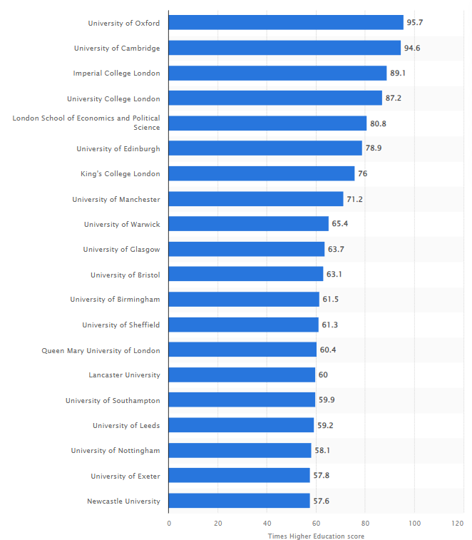

**Figure 1: Highest-rated universities in the UK in 2021**

(Source: Clark, 2022)

The learning space is not the only concern that drives the application of developing new buildings. The idea is to add value to the existing learning system as well by transforming it digitally and making learning intuitive for both local and foreign candidates. Among the several acclaimed universities in the UK, the highest rank is achieved by the University of Oxford as it shared a score of 95.7 as per Times Higher Education in the year 2021 (Clark, 2022). However, CUL expects to raise the educational standards to compete with the very best universities in the UK. According to the recent statistics, based on the merit of Research Power, Times Higher Education analysis of REF2021 has referred the university to be within the top 50%. Hence, possibilities exist to rely on the application of modern infrastructure and new facilities to escalate the education standards further. Collaboration, determination, diversity and location, innovation, and integrity are identified as the core strategic components within Coventry University. These strategic components and the 2030 strategy help the university proceed with infrastructural updates and add merit to the flow of education services. Additionally, the 42nd position is held by the university based on the rankings shared by the National Student Survey. According to the views of Santaolalla et al. (2020, p.6748), advancements in the education field have helped make the learning process mobile and independent. Hence, the construction project proposed at Liverpool Street Station will carry deliverables such as a digitally powered education facility, with sustainable energy usage, and space to fit several new candidates.

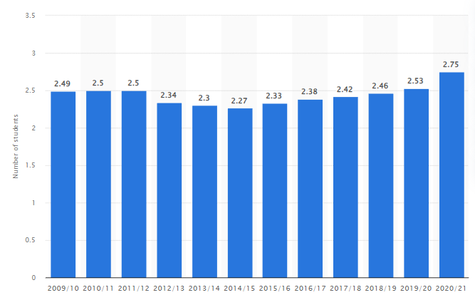

**Figure 2: Number of enrolled students in the UK from the period of 2009-2021**

(Source: Clark, 2022)

The UK is a popular destination for foreign students. As evident from reports, in the period 2020/21, near about 2.75 million students managed to enrol in higher education practices (Clark, 2022). This figure stood to be bigger than any of the numbers in previous years, hence declaring the UK universities to be popular among students from abroad. As noticed from the CUL project, the new construction facility will reduce the commute time of the students. This should lead towards better accessibility of the CUL learning premises and avoid pollution generation from long transport journeys. According to the study by Willumsen et al. (2019, p.731), scope formation and constant monitoring in a project allow the project manager to assure better success degree within a project. CUL is backed by a wide number of investors and partners that assists in delivering new project plans with ease. Hence, it is estimated that the new construction project would be a major success as it shares the scope of building and modifying infrastructural facilities near Liverpool Street Station to offer better learning space for students at CUL within the period of 7 months (Feb 2023- August 2023).

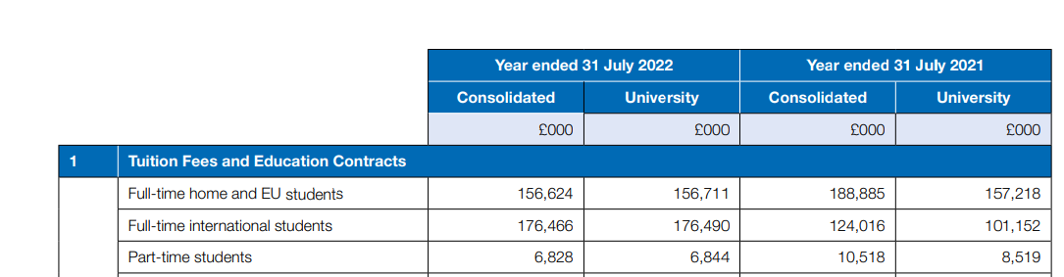

**Figure 3: Student count in the Coventry University**

(Source: Coventry University, 2023)

The project manager will be in charge of controlling the quality of the project and optimising the project actions to utilise reduce the impact of project constraints such as time and cost. As per recent statistics, Coventry University witnessed full-time international student fees to have increased from £124.0 million in the year 2020/21 to £176.5 million in 2021/22, a 42.3% hike (Coventry University, 2023). Therefore, CUL would justify the high student investments in the learning courses with the presence of new infrastructure near Liverpool Street Station. As per the views of Kim et al. (2020, p.04019035), the project initial document (PID) acts as a project document where the scope, deliverables, estimated budget, and schedule of a project are outlined. This allows the project manager to organise the project events with success.

# 2. Project monitoring and control

## Concept of project life cycle

**Figure 4: Standard project life cycle applied for the current project**

(Source: Developed from Jalaei et al. 2021)

Construction projects are prone to failure because of the risks possessed by the end of the external environment. Hence, the presence of a project life cycle needs to be there to see through the developments in a project in a structured way. As per the views of Jalaei et al. (2021, p.785), five stages in the project life cycle enable a project to be managed in an organised way and seek better success. These five stages are known as initiation, planning, executing, monitoring and controlling, and closure. These stages help identify the project scope easily, and thereafter refer to the actions required to be undertaken by the project stakeholders. The monitoring and controlling stage in the project life cycle holds enormous significance as the project manager gets the ability to adjust certain actions in the project and make the deliverables achievable. As noticed from the CUL project, the quality control of the construction project will be achieved with reliance on several project management tools. According to the study by Fridgeirsson et al. (2021, p.2345), Project Management Body of Knowledge (PMBOK) suggests suitable project management tools and knowledge areas that could be clubbed to achieve plenty of success in a project of any form or size. The essential knowledge areas needed to be covered to effectively manage a project are project integration, quality, human resources, scope, time, cost, communications, risk, stakeholder, and procurement.

PMBOK acts as a comprehensive project management methodology that permits better dealing with quality certification projects as well. As realised from the CUL project, this should help certify the project outcomes and mark the new buildings near Liverpool Street Station to be sustainable. As per the study by Yu et al. (2021, p.21), the success factors in a project stand for a competent project team, clear project goals, proper project management software, diligent planning, and effective communication with the stakeholders. According to the views of Zid et al. (2020, p.150), Gantt chart, critical path method (CPM), project management software for work breakdown structure (WBS) creation, PERT chart, and earned value analysis (EVA).

**Figure 5: Project monitoring and controlling tools**

(Source: Developed from Zid et al. 2020)

## Gantt chart

Scheduling stands to be one such aspect within projects that helps organise the project actions effectively. As per the study by Awada et al. (2021, p. 04020104), the conversion of complex project components into manageable and smaller components is possible with the utilisation of the Gantt chart. Resource overloading can be addressed in a better way with the Gantt chart, whereas the dependencies between the project tasks are established with it as well. As realised from the CUL project, the project shares a fairly smaller duration due to the timeframe of 7 months (February 2023-August 2023). This is suggestive of the fact that the activities within the project life cycle need to be properly placed with a sufficient degree of resources or else the project could deal with time management issues. According to the study by Lee & Hyun, (2019, p.04018116), the Gantt chart helps measure the progress of project activities across each of the project stages. This assures the project manager of a better and more advanced monitoring action for the project. Hence, the project manager in the CUL project could also rely on a well-planned Gantt chart to successfully execute the project.

## Work breakdown structure

The visual, hierarchical and deliverable-oriented deconstruction of a project is made possible as a result of developing a work breakdown structure (WBS). According to the views of Pellerin & Perrier (2019, p.2160), the use of a WBS in a project aids in assigning the project activities to the stakeholders in the project based on the level of expertise shared by them. This is indicative of the fact that the roles and responsibilities of the stakeholders are controlled effectively with the presence of a WBS. On the other end, the logical connection between the project stages is established via the WBS as constant tracking of the project activities assists project members and the project manager to run the project seamlessly. Since the CUL project is a short-span one, it needs an efficient WBS to promote project activities with merit, hence referring to the use of a Microsoft Project-based WSB to be suitable for the project.

## Pert chart

Pert charts in projects assist in the process of scheduling, organising, and coordinating project activities. The acronym for PERT is Project Evaluation and Review Technique, thereby reflecting it to be a viable project monitoring and controlling tool. As per the views of Ragel (2021, p.5218), the Pert chart helps recognise the interdepartmental dependency present within institutes that seek to engage in the act of responsibly organising and managing projects. As noticed from the CUL project, this feature could aid the project manager to focus extensively towards the key activities in the project and register successful outcomes.

## Critical path method

Flexible scheduling and improved accuracy are gained in a project due to the presence of the critical path method (CPM). A graphical way to view tasks, dependencies, and the critical path is referred to as the network diagram. As per the study by Ford & Lyneis (2020, p.285), prioritising the critical tasks in a project as compared to the non-critical tasks assures of using the resources successfully. Better real-time tracking of the project activities is done with the CPM, as the critical path is the longest sequence of activities performed on a network diagram while having no slack time in it. A construction project having zero slack time is unheard of as that is unlikely to happen under the influence of changing macro-environmental factors such as the fluctuation of labour costs and raw materials. Hence, if the CPM is applied for monitoring and controlling, then zero slack time needs to be assigned to the construction project, which aligns with the shorter timeframe of the project.

## Earned value analysis

Earned value analysis outlines the value of the project to the stakeholders and declares if the project has merit to finish the tasks within the stipulated budget and time. According to the views of Ippakayal & Kumthekar (2021, p.855), factors such as cost variance, schedule variance, schedule performance indicator, cost performance indicator, estimated time at completion, and estimated cost at completion are known to help calculate the EVA. As realised from the CUL project, EVA could be helpful towards the progress checking of the costs required for the set project activities. This would aid in predicting the difference shared between the actual costs and budgeted costs for the construction project. Based on the EVA, the project leads could actively change the direction of a project to meet the project scope.

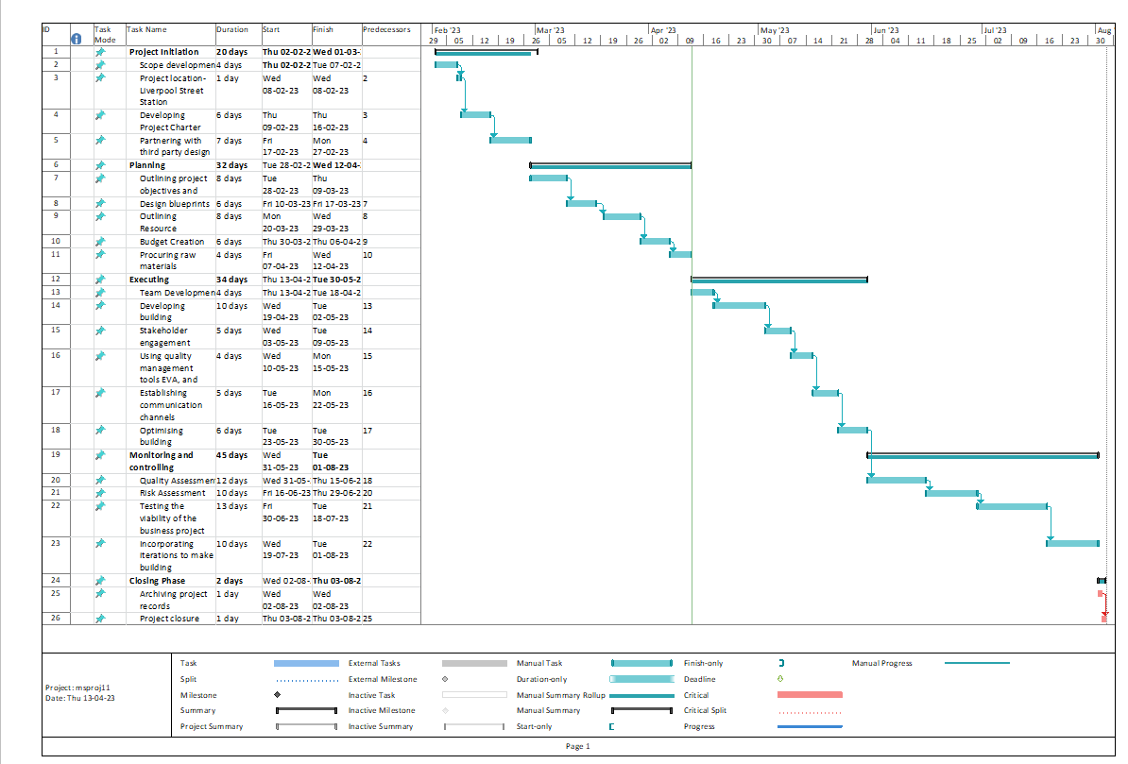

**Figure 6: Gantt chart indicating the critical path for the CUL project**

(Source: Microsoft Project)

Among the varied set of monitoring and controlling tools for project management, the Gantt chart refers to hold manifold benefits. Since modern software tools help derive sophisticated Gantt charts. The present project of CUL also relies on the Microsoft Project to deal with the WBS, critical tasks, and network diagram. This would assure that the scheduling errors are largely minimised and the overbudgeting issues are kept lower.

# 3. Importance of change and quality control

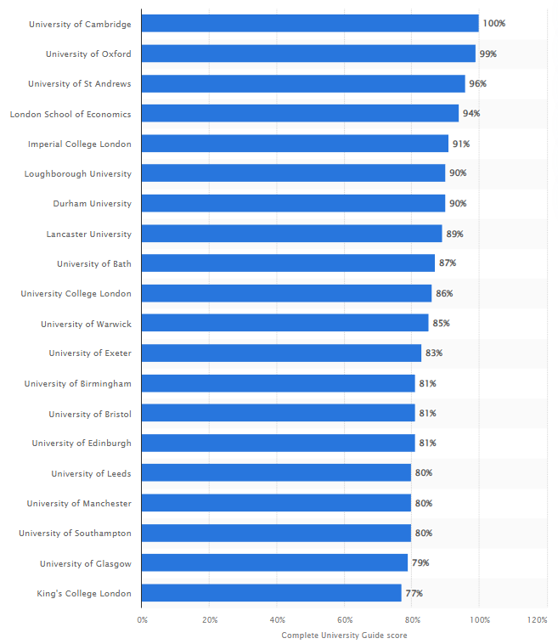

**Figure 7: Leading UK universities rank as per Complete University Guide 2021**

(Source: Clark, 2022)

Changes become a major part of any big-scale project. Since the idea here is to grow the education business of Coventry University, the focus is given towards new building development and optimisation of existing buildings near Liverpool Street Station. According to statistics, Complete University Guide’s top twenty universities include Cambridge and Oxford, but Coventry University fails to become a part of this list (Clark, 2022). Hence, there is a rush to develop new education facilities and reduce candidate transport time to deliver better quality education services. However, the project plan might change due to thorough monitoring and controlling. As per the study by Aitken & Von Treuer (2021, p.311), change management in a project is about delivering better value and restructuring the actions within the project. As noticed from the CUL project, there could be several factors that might invite changes in the project such as lack of labour force, cost overrun, scheduling delays, and legal troubles. Hence, the flexibility of the project team to cope with the changes as per situational developments needs to be high or else the project could face difficulties in achieving the set deliverables. According to the views of Bérubé & Gauthier (2021, p.15), scope creep occurs in a project when changes are made to the overall project scope. Supposedly if the CUL project is delayed or an extensive budget is required, then the project scope has to be refurbished again. This could eventually deteriorate the quality of a project unless there is the presence of quality standards such as ISO 31000 as this assists reduce the number of risks associated with cost and time. Therefore, reviewing the progress periodically and analysing the results needs to be done by the project manager to lead to valuable outcomes in the CUL project.

**Figure 8: Iron triangle theory of project management**

(Source: Developed from Duarte et al. 2019)

There are plenty of drivers for successful projects as these could be compliance with legal codes, stakeholder collaboration, the presence of skilled workers, and documentation of the project proceedings. While quality management in projects helps keep the project scope secure and meet the deliverables formed within it. As per the views of Duarte et al. (2019, p.923), the iron triangle theory is suggestive of three major project constraints that influence the quality standards of the project. Supposedly the corners of a triangle can be represented with the three constraints as scope, time, and cost, and then the quality in the middle would be affected by making changes across any of the constraints. On the other end, a high level of interdependency is established between these variables that justify the changes in the overall project quality, even if there is a slight change or poor constraint management. As realised from the CUL project, the project is susceptible from the standpoint of scheduling as excess time could be required to finish the construction project. According to the study by Almeida et al. (2021, p.457), the balance between the three constraints in a project is required to be kept for a chance to achieve successful outcomes in a project. Managing the iron triangle automatically leads towards better risk aversion in the project as well. For instance, the risk register could be used to reduce the risk possibilities arising from the three constraints.

# 4. Stakeholders’ Engagement

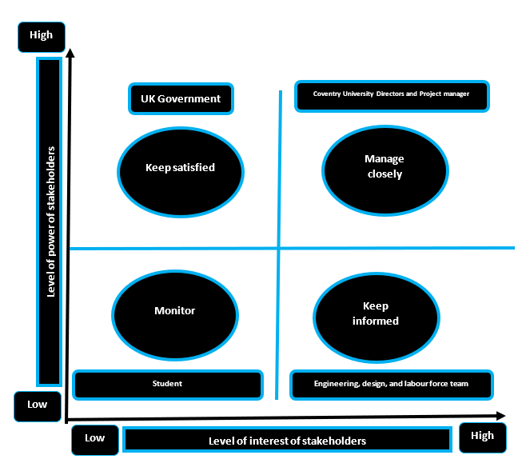

**Figure 9: Stakeholder analysis matrix**

(Source: Developed from Bernstein et al. 2020)

Managing the expectation of the external and internal stakeholders in the project becomes crucial to succeed with the project. Certain steps should be followed by the project manager to ensure better stakeholder engagement. The *major stakeholders are the Project manager, Coventry University Directors, the Government of the UK, Students, Engineer team, and the Labour force.* Therefore, to ensure sufficient engagement of these stakeholders, the use of a stakeholder map is preferred. As per the views of Bernstein et al. (2020, p.11), the Mendelow stakeholder matrix has helped reflect on the necessity to divide tasks among the stakeholder within projects based on the respective interest and power levels of the stakeholders. The stakeholder matrix of Mendelow is optimised in contemporary projects to form a stakeholder map where the four key stakeholder groups are kept informed, keep satisfied, monitored, and manage closely. As realised from the CUL project, the building modifications and construction for CUL near Liverpool Street Station would be a combined effort of the stakeholders. Hence, based on the stakeholder mapping measures, the stakeholders with the highest power and interest would be the Coventry University Directors, the UK government and the Project manager. These stakeholders will be managed closely, whereas the minimal level of power and interests is noticed for the students. Hence, the students are required to be placed in the monitor group. According to the study by Ludovico et al. (2020, p.10317), the stakeholder groups that are kept satisfied boast a strong level of power in the project as compared to a minimal level of interest. This tends to be the case for the UK government as it would be in charge of acknowledging the land required near Liverpool Street Station to the CUL to establish the new building for education. Apart from this, the project engineering team would be kept informed at all times to make sure of successful outcomes from the construction project.

Stakeholder communication planning promotes a sense of collaboration among the project participants. As per the study by Derakhshan et al. (2019, p.98), a stakeholder communication plan is a systematic way of promoting multichannel communication between the project stakeholders and ensuring a better flow of information across the project team. This results in faster decision-making and assures quicker turnaround time from any kind of detrimental spot in the project. As noticed from the CUL project, valuable engagement among the stakeholders would be possible as a result of following a dedicated stakeholder communication plan. Since the stakeholders would be properly identified before communication channels are established, it is assumed that the project stakeholder engagement would be high. Some of the actions required to keep information sharing strong in the project stand as meeting minutes, brainstorming sessions, email communications, and face-to-face meetings.

|  |  |  |  |  |  |  |
| --- | --- | --- | --- | --- | --- | --- |
| ***Stakeholder*** | ***Role*** | ***Category*** | ***Interest*** | ***Influence*** | ***Method of communication*** | ***Frequency*** |
| **1** | *Project engineer* | External stakeholders | High | Medium | Meetings | 1 week |
| **2** | *Project manager* | Internal stakeholders | High | High | Meetings | 2 weeks |
| **3** | *Coventry University Directors* | Internal stakeholders | High | High | Email | 3 weeks |
| **4** | *Labour force* | External stakeholders | Medium | Low | Meetings | 1 week |
| ***5*** | *UK government* | External stakeholders | High | High | Email | 2 weeks |

**Table 1: Stakeholder communication plan**

# 5. Managing resistance to change

The change management process is difficult if the stakeholders associated with the change are not notified of the change initiatives in a comprehensive way. To gain an adequate degree of support for a project, the stakeholders associated with the project must be made aware of the benefits possible to sustain from the change actions. As per the views of Unegbu et al. (2022, p.240), there is a presence of change-accepting and change-resisting factors based on the force field analysis of Kurt Lewin. This model justifies the need to have stronger support from the forces for change as compared to the forces against change. As noticed from the CUL project, the forces for change are represented by shareholder support, technological resources, financial resources, and student support. These forces for change help in promoting the new construction project. On the other end, the forces against change are visualised as the project duration, lack of efficient workforce, UK government, and the unfamiliar nature of the technology use among some of the professors in the CUL.

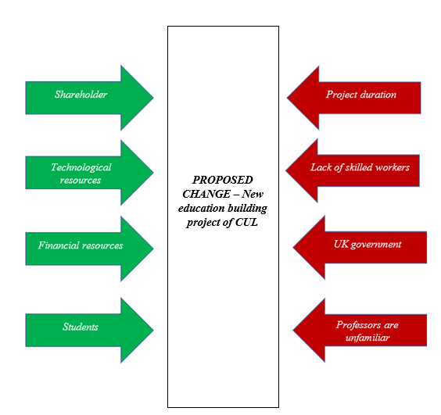

**Figure 10: Force field analysis**

(Source: Self-developed)

The change agent in the current project stands to be the CUL Directors, as there is a steady focus on expanding the educational services. Since there is the presence of a sufficient degree of funds and access to technological resources, some of the forces against change such as the labour force and support from the UK government should become in favour of the change with time. According to the study by Tang & Tang (2019, p.47), the ADKAR change management model suggests the need for awareness, desire, knowledge, ability, and reinforcement measures to be strongly followed to systematically accept changes and accelerate long-term success from the change initiatives. As realised from the CUL project, the ADKAR change management model could be followed to generate awareness among the internal workforce to make a better transition towards the change and achieve the desire to learn about the new knowledge areas. This will give the ability to extract valuable resources from the short-term gains and focus deeply towards the long-term gains such as the establishment of a new building for the educational services.

# 6. Organization structure

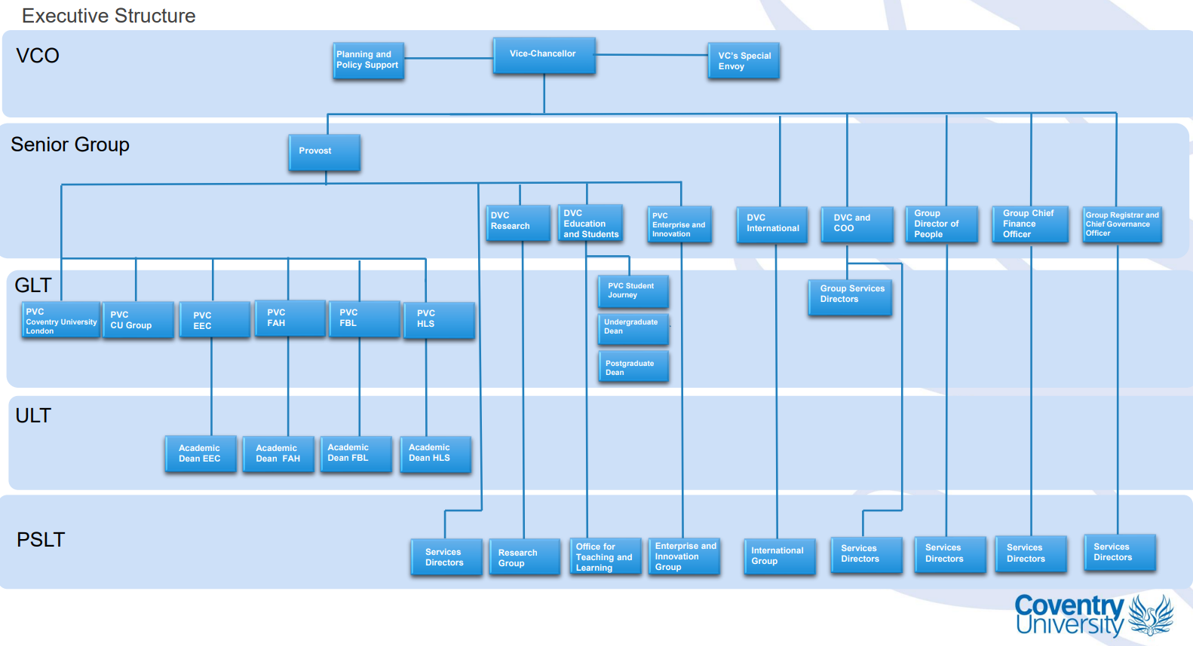

**Figure 11: Coventry University organisational structure**

(Source: Coventry University, 2023)

The organisational structure plays a decisive role in the management of project actions as WBS formation is dependent on the organisational structure to a large degree. As per the views of Fumasoli et al. (2020, p.305), the organisational structure could be of different types such as functional, matrix, divisional, team-based, network, and hierarchy. It is evident that the Coventry University Group is the parent unit of the CUL, whereas the course learning pattern is different from location to location for the university. CUL specifically has a preference for vocational-based courses. The organisational chart sees three particular divisions. These structures are known as the Executive structure, operational unit, and Coventry University Group structure. Since the divisions have separate control over resource utilisation, the presence of a divisional structure is evident in the business. A lot depends on the organisational structure such as the mode of communication and efficiency in decision-making to ensure better time management. According to the study by Aldossari et al. (2021, p.1060), plenty of flexibility, and the ability to cope with any form of change in operations become easier in a business when there is the presence of a divisional organisational structure. The staff-level workforce also gets a degree of autonomy to execute certain actions while being under the divisional organisation structure. As for the CUL project, there are possibilities that the organisational structure will fuel the customised learning approach in the new location, thereby registering better change acceptance among the workforce.

# 7. Assumptions and recommendations based on findings

The current developments help assume that the new project near the Liverpool Street Station for CUL would be a success with the effective application of the Gantt chart as a proper scheduling tool. Since the Gantt chart is one such project management tool that helps construct the WBS, and thereafter suggests the critical path, it becomes seamless for the project manager to keep track of the project actions with the Gantt chart. Quality standards are also forecasted to be better handled with the support of the Gantt chart. Apart from this, the rest of the quality control tools also hold plenty of value and should be considered alongside the Gantt chart to manage the rest of the constraints in the project such as the scope, cost, and resources. The iron triangle theory needs to be considered as a promoter for effective project management with sufficient risk management measures.

It shall be recommended to the CUL project that the use of a dedicated risk register with mitigation measures should be in place to reach the full potential of the project and develop new and modified buildings near Liverpool Street Station. A risk register helps categorise risks and prioritise them based on likelihood, severity, and impact levels (Hussain et al. 2021, p,9477). This should be sufficient enough for the project manager to structure effective actions against the risks and neutralise their presence in the project. A construction project such as this shall be offered to follow the PMBOK guide and use it to meet the knowledge areas precisely. The success rate of projects tends to rise with the application of PMBOK as it assists in documenting the project with an ample degree of detail (Montenegro et al. 2021, p.10804). Hence, if similar other projects are sanctioned by Coventry University such as the CUL project in Liverpool Street Station, the earlier project could be used as a blueprint to obtain success.

# References

Aitken, K., & Von Treuer, K. (2021). Leadership behaviours that foster organisational identification during change. *Journal of organizational change management*, *34*(2), 311-326. https://doi.org/10.1108/JOCM-01-2020-0029

Aldossari, K. M., Lines, B. C., Smithwick, J. B., Hurtado, K. C., & Sullivan, K. T. (2021). Best practices of organizational change for adopting alternative project delivery methods in the AEC industry. *Engineering, construction and architectural management*, *28*(4), 1060-1082. https://doi.org/10.1108/ECAM-03-2020-0166

Almeida, R., Abrantes, R., Romão, M., & Proença, I. (2021). The impact of uncertainty in the measurement of progress in earned value analysis. *Procedia Computer Science*, *181*, 457-467. https://doi.org/10.1016/j.procs.2021.01.191

Awada, M., Srour, F. J., & Srour, I. M. (2021). Data-driven machine learning approach to integrate field submittals in project scheduling. *Journal of Management in Engineering*, *37*(1), 04020104. https://doi.org/10.1061/(ASCE)ME.1943-5479.0000873

Bernstein, S. L., Weiss, J., & Curry, L. (2020). Visualizing implementation: contextual and organizational support mapping of stakeholders (COSMOS). *Implementation Science Communications*, *1*(1), 1-11. https://doi.org/10.1186/s43058-020-00030-8

Bérubé, J., & Gauthier, J. B. (2021). Managing projects in creative industries: a compromise between artistic and project management values. *Creative Industries Journal*, 1-20. https://doi.org/10.1080/17510694.2021.1979278

Clark, D., (2022). *Highest rated universities in the United Kingdom in 2021.* Statista. <https://www.statista.com/statistics/1091723/best-uk-universities-by-times-higher-education/>

Clark, D., (2022). *Number of students enrolled in higher education in the United Kingdom from 2009/10 to 2020/21.* Statista. <https://www.statista.com/statistics/875015/students-enrolled-in-higher-education-in-the-uk/>

Clark, D., (2022). *The Complete University Guide's top twenty universities in the United Kingdom in 2021, by overall score.* Statista. <https://www.statista.com/statistics/226832/top-twenty-universities-by-overall-score-uk/>

Colli, M., Stingl, V., & Waehrens, B. V. (2022). Making or breaking the business case of digital transformation initiatives: the key role of learnings. *Journal of Manufacturing Technology Management*, *33*(1), 41-60. https://doi.org/10.1108/JMTM-08-2020-0330

Coventry University, (2023). *Annual Report and Financial Statements.* <https://www.coventry.ac.uk/globalassets/media/global/09-about-us/key-information/financial-reports/coventry-university---audit-review-report---31-july-2022-signed.pdf>

Derakhshan, R., Turner, R., & Mancini, M. (2019). Project governance and stakeholders: a literature review. *International Journal of Project Management*, *37*(1), 98-116. https://doi.org/10.1016/j.ijproman.2018.10.007

Duarte, R., Deschamps, F., de Lima, E. P., Pepino, A., & Clavijo, R. M. G. (2019). Performance management systems for project management offices: A case-based study. *Procedia Manufacturing*, *39*, 923-931. https://doi.org/10.1016/j.promfg.2020.01.397

Ford, D. N., & Lyneis, J. M. (2020). System dynamics applied to project management: a survey, assessment, and directions for future research. *System Dynamics: Theory and Applications*, 285-314. https://doi.org/10.1007/978-3-642-27737-5_658-1

Fridgeirsson, T. V., Ingason, H. T., Jonasson, H. I., & Jonsdottir, H. (2021). An authoritative study on the near future effect of artificial intelligence on project management knowledge areas. *Sustainability*, *13*(4), 2345. https://doi.org/10.3390/su13042345

Fumasoli, T., Barbato, G., & Turri, M. (2020). The determinants of university strategic positioning: a reappraisal of the organisation. *Higher Education*, *80*, 305-334. https://doi.org/10.1007/s10734-019-00481-6

Hussain, A., Jamil, M., Farooq, M. U., Asim, M., Rafique, M. Z., & Pruncu, C. I. (2021). Project managers’ personality and project success: moderating role of external environmental factors. *Sustainability*, *13*(16), 9477. https://doi.org/10.3390/su13169477

Ippakayal, M. P. D., & Kumthekar, M. B. (2021). A Review on Earned Value Management Analysis in Construction Industry. *International Research Journal of Engineering and Technology (IRJET)*, *8*(8), 855-857. https://d1wqtxts1xzle7.cloudfront.net/72463079/IRJET_V8I8119-libre.pdf?1634191263=&response-content-disposition=inline%3B+filename%3DIRJET_A_Review_on_Earned_Value_Managemen.pdf&Expires=1681330829&Signature=cPtMIhafUz5K0-zF-a7w0UTcluLG5yGF~I7YDGe1odNVvLiEclQZnu9n0z7uSe9B8dq-3BmaHdmpySese-T7qc~DGHI2023Ke1jpSWYuT3SVrbaE3ZKKI62E2BGrSXgxep80LOzmCy9mv2Fbpy8IYfs4X9JvWWmDSEohhlYIrsLUYAq2QfFMEgzzsTGI1ilHOKjjg1H-lHLnqQCbduHKLuUwhdBdvkFS8ORq3uBFYvtfidcpTaUKov8KbwOtJEoJZj6r9m6vVFWLUS62yGu2cclKu0nagOzB0UJxeXA02z2bqhChByGbeWyh0mYdOZuH4aGjSEci7fFgE77Nvc~9LA__&Key-Pair-Id=APKAJLOHF5GGSLRBV4ZA

Jalaei, F., Zoghi, M., & Khoshand, A. (2021). Life cycle environmental impact assessment to manage and optimize construction waste using Building Information Modeling (BIM). *International Journal of Construction Management*, *21*(8), 784-801. https://doi.org/10.1080/15623599.2019.1583850

Kim, S., Chang, S., & Castro-Lacouture, D. (2020). Dynamic modeling for analyzing impacts of skilled labor shortage on construction project management. *Journal of Management in Engineering*, *36*(1), 04019035. https://doi.org/10.1061/(ASCE)ME.1943-5479.0000720

Lee, J., & Hyun, H. (2019). Multiple modular building construction project scheduling using genetic algorithms. *Journal of Construction Engineering and Management*, *145*(1), 04018116. https://doi.org/10.1061/(ASCE)CO.1943-7862.0001585

Ludovico, N., Dessi, F., & Bonaiuto, M. (2020). Stakeholders mapping for sustainable biofuels: an innovative procedure based on computational text analysis and social network analysis. Sustainability, 12(24), 10317. https://doi.org/10.3390/su122410317

Montenegro, A., Dobrota, M., Todorovic, M., Slavinski, T., & Obradovic, V. (2021). Impact of construction project managers’ emotional intelligence on project success. *Sustainability*, *13*(19), 10804. https://doi.org/10.3390/su131910804

Pellerin, R., & Perrier, N. (2019). A review of methods, techniques and tools for project planning and control. *International Journal of Production Research*, *57*(7), 2160-2178. https://doi.org/10.1080/00207543.2018.1524168

Ragel, L. J. B. (2021). Limitations of PERT/CPM in construction management planning: Inputs to mathematics in architecture education. *Turkish Journal of Computer and Mathematics Education (TURCOMAT)*, *12*(10), 5218-5223. https://doi.org/10.17762/turcomat.v12i10.5313

Santaolalla, E., Urosa, B., Martín, O., Verde, A., & Díaz, T. (2020). Interdisciplinarity in teacher education: Evaluation of the effectiveness of an educational innovation project. *Sustainability*, *12*(17), 6748. https://doi.org/10.3390/su12176748

Tang, K. N., & Tang, K. N. (2019). Change management. *Leadership and change management*, 47-55. https://doi.org/10.1007/978-981-13-8902-3_5

Unegbu, H. C. O., Yawas, D. S., & Dan-Asabe, B. (2022). An investigation of the relationship between project performance measures and project management practices of construction projects for the construction industry in Nigeria. *Journal of King Saud University-Engineering Sciences*, *34*(4), 240-249. https://doi.org/10.1016/j.jksues.2020.10.001

Willumsen, P., Oehmen, J., Stingl, V., & Geraldi, J. (2019). Value creation through project risk management. *International Journal of Project Management*, *37*(5), 731-749. https://doi.org/10.1016/j.ijproman.2019.01.007

Yu, W., Cormican, K., Wu, Q., & Sampaio, S. (2021). In whom do we trust? Critical success factors impacting intercultural communication in multicultural project teams. *International Journal of Information Systems and Project Management*, *9*(3), 21-40. https://aisel.aisnet.org/ijispm/vol9/iss3/3/

Zid, C., Kasim, N., & Soomro, A. R. (2020). Effective project management approach to attain project success, based on cost-time-quality. *International Journal of Project Organisation and Management*, *12*(2), 149-163. https://doi.org/10.1504/IJPOM.2020.106376