**ASSIGNMENT TITLE: INDIVIDUAL PROJECT MANAGEMENT REPORT**

**Executive Summary**

The PM facility of a team can ensure the business contingencies while focusing on the deployment of business outcomes. The methodologies related to project management by emphasising the merits and demerits have been considered for the report. The report has highlighted the utilisation of "waterfall methodology" and "agile methodology". These two types of methods related to PM can deploy the resources while acquiring a competitive advantage. The business resources can be optimistically managed to avoid financial constraints while facilitating the channel YouTube. The regulatory outcomes related to the Project scope, WBS, Network diagram and Gantt chart have been reviewed in this report. The scope of obtaining project control and monitoring has been evaluated in the report. The report has also highlighted the managerial dimensions while obtaining business success. The "communication plan" and "risk management plan" have been analysed in the report. Future recommendations have also been given to regulate the business objectives while deploying the project.

**Table of Contents**

Coursework 2 3

Introduction 3

Critically evaluating the methodologies related to project management by emphasising the merits and demerits 3

Reviewing the Project scope, WBS, Network diagram and Gantt chart 6

Review of Project scope 6

Critically presenting the communication plan implemented during the project 8

Developing a comprehensive risk management plan for the project 10

Critically discussing the project control system which has been adopted for the project 11

Evaluating and critically reflecting on the performance of the project 12

Critically reflecting on the project management and the future recommendations 12

Conclusion 13

References 14

# Coursework 2

# Introduction

Project management (PM) refers to the process of leading a work in a team to achieve the optimum outcomes related to a project within the identified constraints. Methodologies related to PM can ensure the predefined outcome which relies on the business and managerial contingencies. This report has focused on the project of creating a YouTube channel called "Miracle Makers" consisting of 4 videos. This project is helpful for the viewers to gain effective information before visiting London. This project is fruitful for attracting a wide range of viewers and maintaining publicity with effective inclusion strategies. The purpose of the report is to review the project scope and communication plan in order to ensure effective implementation.

# Critically evaluating the methodologies related to project management by emphasising the merits and demerits

The two types of methodology related to PM include "waterfall methodology" and "agile methodology". Waterfall methodology integrates a process of sequential development which flows like a waterfall through different phases related to a project such as analysis, development, design and testing (Thummadi & Lyytinen, 2020). According to the figure below, designing the structure of a project as per the requirements to regulate effective implementation planning can integrate the verification and deployment procedure in an effective manner. On a contradictory note, a lack of testing facilities can degrade the administration level of a project while maintaining business opportunities (Friess et al., 2020). The requirements of the project such as the formulation of four videos to attract customers and enhance the number of views can be managed with the help of effective marketing strategies. The financial requirements of the project consist of the four videos which are budgeted to be 100 pounds by the end of the year 2022. These requirements can be mitigated by ensuring the final deliverables and the completion of the project schedule. However, it is difficult for the sponsor "Coventry University-London House" to ensure financial assistance to the project with its required financial assistance.

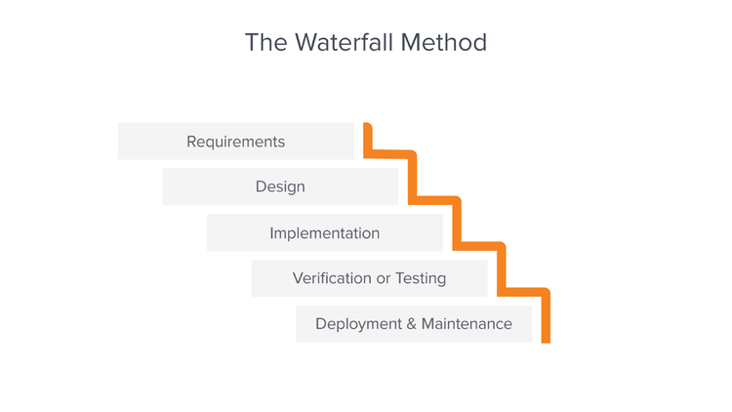

**Figure 1: The "Waterfall Method"**

(Source: Heriyanti & Ishak, 2020)

The design of the project can be ensured by the stakeholders to integrate the audio design and script finalising procedure for those videos. According to the comments of Lalmi et al., (2021), formulating an effective design with the waterfall method can ensure the effective utilisation of required resources while maintaining the role of final deliverable of a project. The implementation planning can be done by project manager 7 who is Tejashree for regulating quality assurance at a high rate. The subscribers of the YouTube channel "Miracle Makers" can ensure the financial contingency of the project while creating the channel logo. On a contradictory note, a lack of information related to the hotels and hospitality sectors while advertising the business in the videos can degrade the number of viewers who are interested in coming to London. As stated by Bousdekis et al., (2019), the testing and deployment can be done irrespective of the difficulties in order to acquire the business resources. Protocols and travel restrictions during the pandemic period can be illustrated in those videos to inform the viewers about the consequences of staying in those hotels.

***The "Agile methodology”*** of a project refers to the way which one can manage a project by splitting it up into different phases. According to the opinion of Stoddard, Gillis & Cohn (2019), constant collaboration with team members and stakeholders for continuous improvement of a project can regulate this methodology in an effective manner. According to the figure below, the agile methodology of a PM can integrate collaborative design development and implementation of resources to drive the organisational culture. The project has been designed to integrate the use of social media which can promote the new products through stronger advertising campaigns. On a contradictory note, the lack of advertisements for the target audiences can degrade the performance level of the YouTube channel in a competitive environment. However, it can be detrimental for a project to access the personal information of customers before their booking procedure (Sánchez et al., 2020). Thus, the videos are generated by informing the customers about the personal data protection facility in the business environment.

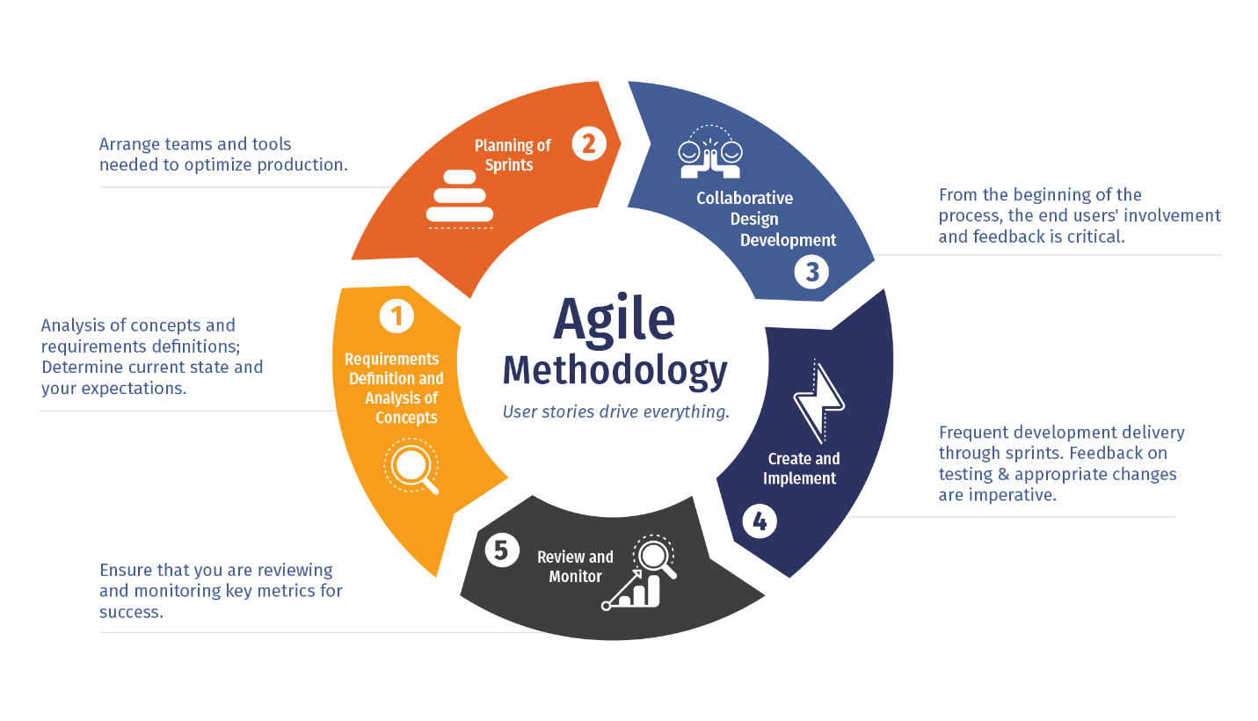

**Figure 2: Agile methodology**

(Source: Salza et al., 2019)

Arranging the tools and teams for optimising the production is effective for achieving the best objectives in a desired mode. Based on the comments of Jayawardena et al., (2023), acquiring the resources before facilitating the videos can ensure the attraction of customers to achieve project milestones. The known risks of the project include unplanned processes, travel miscellaneous, internal conflicts, budgeting and marketing strategy. On the other hand, the lack of facilitation of editing software for the YouTube channel can be a threat while rolling out the final deliverables. Agile management of the project with an extremely experienced group of administration is beneficial for reducing the risks while designing a project (Stoddard et al., 2019). The major stakeholders such as project managers, subscribers, viewers, YouTube authorities and competitors can be managed to decrease the rate of disputes in the video durations.

# Reviewing the Project scope, WBS, Network diagram and Gantt chart

# Review of the Project scope

The scheme of hotel administration was formulated and planned by pursuing the evaluation of systems stages for unforced and glassy running, as well as administration facilities in the hospitality sector. According to the opinion of Cruz Villazón et al., (2020), on the basis of distinct characteristics of a project, it can be evaluated to understand the project scope and the manual methods. System experts can acknowledge and characterise different difficulties in the manual method in the hotels throughout the project. The YouTube channel "Miracle Makers" can integrate the project scope by yielding a huge range of information and data from different hotels in both manual and computerised schemes. This is effective to advertise different viewpoints of London to tourists and visitors. The main scope of the project to integrate the creation of new channels with a budget of 100 lbs can be effective for completion of the task in the stipulated period of time.

**Reviewing WBS, Network diagram and Gantt chart**

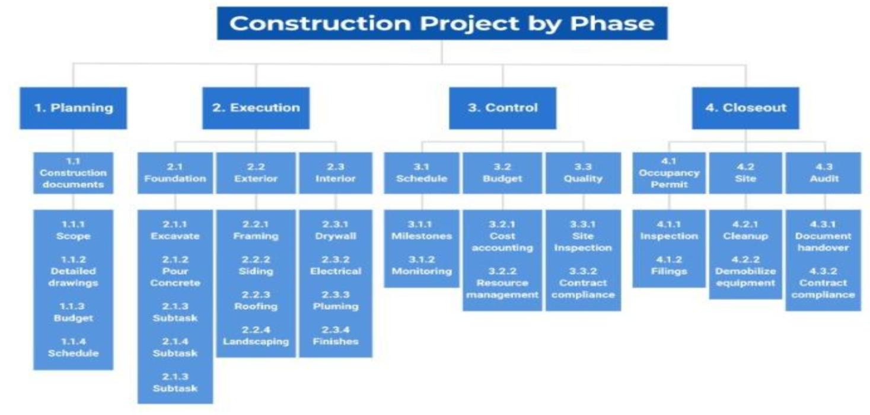

**Figure 3: WBS**

(Source: Created by Author)

The WBS of the project of facilitating the YouTube channel includes the phases such as planning, execution, control and closeout. According to the views of Kermanshachi et al., (2020), the construction of documents can include project scope and detailed drawings for formulating the budget and schedule in an efficient way. The execution stage of the project includes three dimensions such as foundation, exterior management and interior management. The exterior management of the project includes the designing of the advertisements which can be facilitated in the YouTube channel. However, the interior management can be done in order to regulate the project dimensions in an effective manner. The landscape view of the videos can attract the viewers which is beneficial to reach the target of 3K views in each video with a benefit of £214. The controlling stage of the project included three dimensions such as schedules, budget and quality management. As per the opinion of Sun et al., (2020), the quality of a project can be checked before facilitating them to the targeted audience. In this context, the quality of the video related to the project can be checked thrice before presenting them to the viewers.

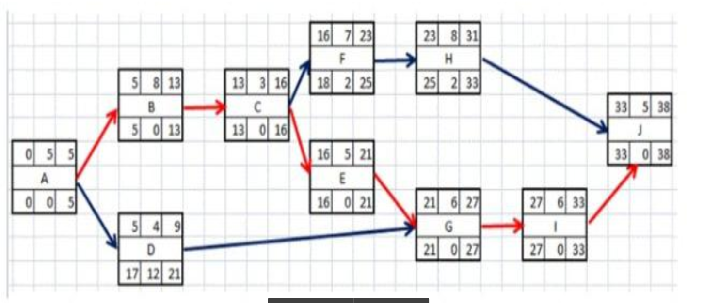

**Figure 4: Network Diagram**

(Source: Self-developed)

Cost accounting and resource management has been done by effective project controlling procedure while ensuring contract compliance. According to the views of Martinsuo, Vuorinen & Killen (2019), cost accounting of a project is a vital part to facilitate the completion of the project at a targeted amount. The close-out of the project of facilitating the YouTube channel included three stages such as occupancy permit, site information and auditing. These three stages can be regulated in an efficient way which can formulate the business objectives and the resource management processes. According to the above network diagram, the duration of 10 tasks has been divided by incorporating the predecessors. The connection between each task has depicted the workflow and task description in an effective way. As per the Gantt chart below, the system design and architecture can be prepared before the designed documentation in order to regulate structured projects. The quality testing can be done before deployment of the project to set up the production and prepare the documentation of design in an efficient way. The scheduled period of time for the project is effective in order to conduct the detailed analysis of the hotels based in London while reviewing the system.

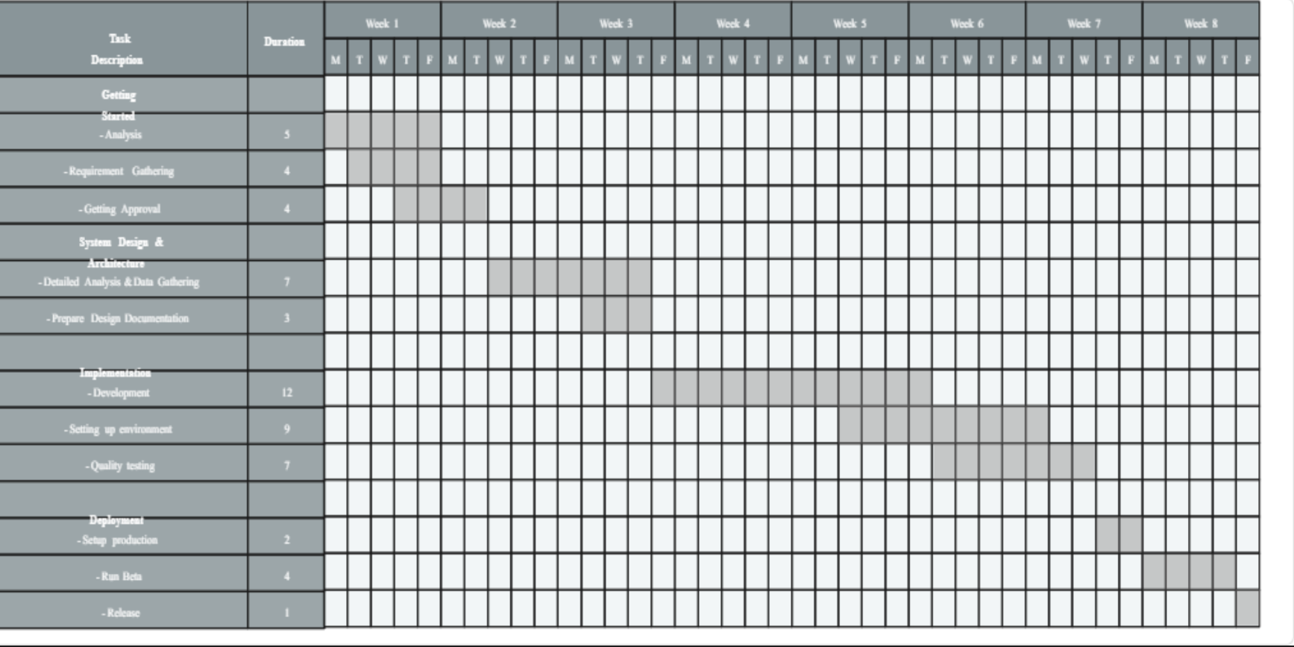

**Figure 5: Gantt Chart**

(Source: )

# Critically presenting the communication plan implemented during the project

|  |  |  |  |  |
| --- | --- | --- | --- | --- |
| **Communication goals** | **Communication method** | **Audience** | **Frequency** | **Owner** |
| Facilitating straight forward human communications | Attracting the travellers through attractive voice direction in the video | People in the age group of 25-35 | 1 week | Purna Chandra Rao |
| Communication through emails and offline meetings | Conducting and composing online meetings and emails respectively to forward the link to videos | People in the age group of 30-45 | 2 week | Rajasekhar Reddy |
| Maintaining the influence of clear and concise communication | Clear and concise descriptions of hotels and the destination sites in London | People in the age group of 50-65 | 1.5 week | Manvitha |
| Regulating communication in a professional manner | Facilitating professional guidance throughout the videos | People in the age group of 30-60 | 2 week | Sai Sandeep |
| Facilitating verbal communication through word of mouth in advertisement | Maintaining verbal communication through using word of mouth for enhancing the number of views | People in the age group of 40-65 | 3 week | Tejasree |
| Maintaining non-verbal communication through the comment box of YouTube | Voice chats and web chats can be used to reply in the comment box of YouTube in order to guide the travellers | People in the age group of 20-35 | 1 week | Sai Rajkumar |

**Table 1: Communication plan**

(Source: Created by Author)

**Analysis**

Effective communication plans can be facilitated in a project to formulate competitive advantage. As opined by Xiuwen & Razali (2021), verbal communication with the customers can be regulated when there is an effective attraction towards a subject. It is helpful for advertising the channel through emails and offline meetings. These are helpful for regulating the financial resources in a contingent manner. Leaders associated with the project can obtain the demand for facilitating the communication tools to the project manager in order to regulate active participation of viewers.

# Developing a comprehensive risk management plan for the project

|  |  |  |  |  |
| --- | --- | --- | --- | --- |
| **Identification of risks** | **Assessment of risks** | **Ensuring response planning** | **Process of monitoring and controlling** | **Reporting** |
| Lack of resource availability | Constraints in managing financial resources | Managing the resources by mitigating internal conflicts | Proper budget plan | Project manager 2 |
| Extended video durations | Lack of interests of viewers in the extended video | Upgrading the websites with the help of computers and software | Effective design and attractive editing | Project manager 3 |
| Lack of subscribers and likes | Shortage of financial resources to design the video and attract the subscribers | Ensuring effective marketing strategy by advertising the video to all media channels | Proper orientation in marketing and promotional process | Project manager 4 |
| Delay in editing | Lack of cooperation of managers in regulating the team members | Reducing the use of resources in transportation and degrading the performance of editing software | Strengthening the software related to editing | Project manager 5 |

**Table 2: Risk management plan**

(Source: Created by Author)

**Analysis**

The risk of a shortage of financial resources can be managed by reducing the cost of transportations. As opined by Levillain & Segrestin (2019), incorporation of managers in dealing with the financial risks can create hindrances in managing the project and business objectives. The interest of viewers can be obtained by regulating the display of advertisements of hotels in an attractive manner. The design of video can be optimised with the help of developers and web designers who can manage the deployment of contents as well.

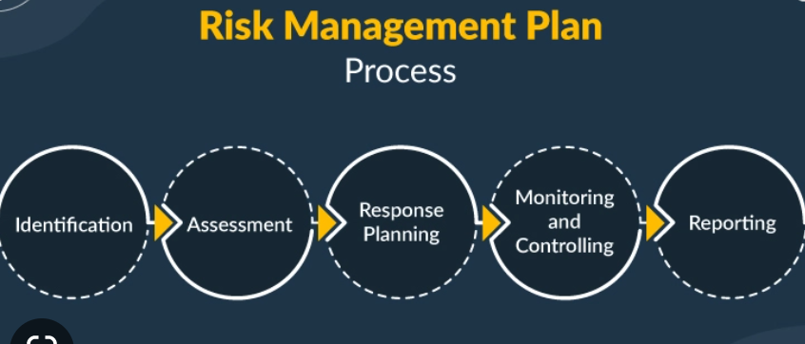

**Figure 6: "Risk management plan"**

(Source: Gurtu & Johny, 2021)

# Critically discussing the project control system which has been adopted for the project

The system of project controlling refers to the ideas which can monitor the success and control the objectives. According to the views of Armenia et al., (2019), the financial objectives can be projected while maintaining project control by the help of managerial approach. Effective control of the project can be facilitated by maintaining the project schedule in a timely manner. However, it is challenging for a manager to deal with the system regarding the project control while focusing on maintaining the business objectives. Association of managers in teamwork can integrate the development and regulate the business contingencies. Communication control can be done with tools related to communication such as the internet and emails (Alladi et al., 2020). Effective utilisation of the comment box of YouTube is beneficial for the project to communicate with the targeted audience. The opportunity to manage the promotional procedure of the hospitality sector can be considered while advertising the businesses of London in the four videos. The visualisation control of the videos can be done by the project manager in order to enhance the value of the project.

# Evaluating and critically reflecting on the performance of the project

Project had a great performance in YouTube while making the channel based on the four videos for promoting the hospitality contingencies of London. According to the views of Ngoc Thang & Anh Tuan (2020), managers can measure the performance of a project in order to formulate the business contingencies while acquiring the business resources. On a contradictory note, the lack of diversity in the hospitality sector of London has enhanced the challenges in maintaining business operations in a contingent manner. The project performance has depicted the managerial contingencies while formulating the project scope and business objectives. The issue of delay in editing can be mitigated by facilitating the ideas which can integrate the business facilities at the stipulated period of time. Performance metrics and KPIs have been measured before facilitating the videos on the internet.

# Critically reflecting on the project management and the future recommendations

The project management can be done efficiently with the help of the managers and stakeholders. The deployment of the project success depends on the efficiency of the PM while acquiring the required resources (Pereira et al., 2022). Effective project management has been done by considering the association of stakeholders while making the YouTube channel and the four videos. On a contradictory note, the financial constraints of the project as regulated by issues in maintaining project success in the existing business environment. It can be recommended that the ***crowd funding facilities*** can be considered to raise the funds related to financial assistance. Effective managerial contingency to facilitate ***communication among the stakeholders*** is effective for the project to acquire the views of targeted audiences at a high rate. The ***training facilities*** can be provided to the members associated with the project in order to ensure their contingencies while making the videos.

# Conclusion

It can be concluded that a project management depends on the managerial contingencies while acquiring the resources and maintaining project control. Communication development is an effective part of a project which can deal with the opportunities for success while presenting the project in a competitive environment. The four videos on the YouTube channel can be facilitated with an efficient managerial control which can deal with the changing demographics of the hospitality sector in London. The timeline of the project has to be regulated by the project manager to maintaining the completion of the work in the stipulated period of time. Diligence with the project performance deals with the managerial contingencies.

# 

# References

Alladi, T., Chamola, V., & Zeadally, S. (2020). Industrial control systems: Cyberattack trends and countermeasures. Computer Communications, 155, 1-8. Retrieved on: 13 April 2023 from: https://www.sciencedirect.com/science/article/pii/S0140366419319991

Armenia, S., Dangelico, R. M., Nonino, F., & Pompei, A. (2019). Sustainable project management: A conceptualization-oriented review and a framework proposal for future studies. Sustainability, 11(9), 2664. Retrieved on: 13 April 2023 from: https://www.mdpi.com/459616

Bousdekis, A., Apostolou, D. & Mentzas, G., (2019). Predictive maintenance in the 4th industrial revolution: Benefits, business opportunities, and managerial implications. IEEE Engineering Management Review, 48(1), pp.57-62. Retrieved on: 13 April 2023 from: https://ieeexplore.ieee.org/abstract/document/8930914/

Cruz Villazón, C., Sastoque Pinilla, L., Otegi Olaso, J. R., Toledo Gandarias, N., & López de Lacalle, N. (2020). Identification of key performance indicators in project-based organisations through the lean approach. Sustainability, 12(15), 5977. Retrieved on: 13 April 2023 from: https://www.mdpi.com/778340

Friess, D. A., Yando, E. S., Abuchahla, G. M., Adams, J. B., Cannicci, S., Canty, S. W., ... & Wee, A. K. (2020). Mangroves give cause for conservation optimism, for now. Current Biology, 30(4), R153-R154. Retrieved on: 13 April 2023 from: https://www.cell.com/current-biology/pdf/S0960-9822(19)31687-2.pdf

Gurtu, A., & Johny, J. (2021). Supply chain risk management: Literature review. Risks, 9(1), 16. Retrieved on: 13 April 2023 from: https://www.mdpi.com/951424

Heriyanti, F., & Ishak, A. (2020, May). Design of logistics information system in the finished product warehouse with the waterfall method: review literature. In IOP Conference Series: Materials Science and Engineering (Vol. 801, No. 1, p. 012100). IOP Publishing. Retrieved on: 13 April 2023 from: https://iopscience.iop.org/article/10.1088/1757-899X/801/1/012100/meta

Jayawardena, N. S., Thaichon, P., Quach, S., Razzaq, A., & Behl, A. (2023). The persuasion effects of virtual reality (VR) and augmented reality (AR) video advertisements: A conceptual review. Journal of Business Research, 160, 113739. Retrieved on: 13 April 2023 from: https://www.sciencedirect.com/science/article/pii/S0148296323000978

Kermanshachi, S., Safapour, E., Anderson, S. D., Goodrum, P., & Taylor, T. R. (2020). Establishment of effective project scoping process for highway and bridge construction projects. Practice Periodical on Structural Design and Construction, 25(2), 06020001. Retrieved on: 13 April 2023 from: https://ascelibrary.org/doi/abs/10.1061/%28ASCE%29SC.1943-5576.0000427

Lalmi, A., Fernandes, G., & Souad, S. B. (2021). A conceptual hybrid project management model for construction projects. Procedia Computer Science, 181, 921-930. Retrieved on: 13 April 2023 from: https://www.sciencedirect.com/science/article/pii/S187705092100291X

Levillain, K., & Segrestin, B. (2019). From primacy to purpose commitment: How emerging profit-with-purpose corporations open new corporate governance avenues. European Management Journal, 37(5), 637-647. Retrieved on: 13 April 2023 from: https://www.sciencedirect.com/science/article/pii/S0263237319300908

Martinsuo, M. M., Vuorinen, L., & Killen, C. (2019). Lifecycle-oriented framing of value at the front end of infrastructure projects. International journal of managing projects in business, 12(3), 617-643. Retrieved on: 13 April 2023 from: https://www.emerald.com/insight/content/doi/10.1108/IJMPB-09-2018-0172/full/html

Ngoc Thang, N., & Anh Tuan, P. (2020). Knowledge acquisition, knowledge management strategy and innovation: An empirical study of Vietnamese firms. Cogent Business & Management, 7(1), 1786314. Retrieved on: 13 April 2023 from: https://www.tandfonline.com/doi/abs/10.1080/23311975.2020.1786314

Pereira, J., Varajão, J., & Takagi, N. (2022). Evaluation of information systems project success–Insights from practitioners. Information Systems Management, 39(2), 138-155. Retrieved on: 13 April 2023 from: https://www.tandfonline.com/doi/abs/10.1080/10580530.2021.1887982

Salza, P., Musmarra, P., & Ferrucci, F. (2019). Agile methodologies in education: A review. Agile and lean concepts for teaching and learning: Bringing methodologies from industry to the classroom, 25-45. Retrieved on: 13 April 2023 from: https://link.springer.com/chapter/10.1007/978-981-13-2751-3_2

Sánchez, E. C., Sánchez-Medina, A. J., & Pellejero, M. (2020). Identifying critical hotel cancellations using artificial intelligence. Tourism Management Perspectives, 35, 100718. Retrieved on: 13 April 2023 from: https://www.sciencedirect.com/science/article/pii/S2211973620300854

Stoddard, M. M., Gillis, B., & Cohn, P. (2019). Agile project management in libraries: Creating collaborative, resilient, responsive organizations. Journal of Library Administration, 59(5), 492-511. Retrieved on: 13 April 2023 from: https://www.tandfonline.com/doi/abs/10.1080/01930826.2019.1616971

Stoddard, M. M., Gillis, B., & Cohn, P. (2019). Agile project management in libraries: Creating collaborative, resilient, responsive organizations. Journal of Library Administration, 59(5), 492-511. Retrieved on: 13 April 2023 from: https://www.tandfonline.com/doi/abs/10.1080/01930826.2019.1616971

Sun, Y., Yang, C., Shen, X. L., & Wang, N. (2020). When digitalized customers meet digitalized services: A digitalized social cognitive perspective of omnichannel service usage. International Journal of Information Management, 54, 102200.Retrieved on: 13 April 2023 from: https://www.sciencedirect.com/science/article/pii/S0268401219310175

Thummadi, B. V., & Lyytinen, K. (2020). How much method-in-use matters? A case study of agile and waterfall software projects and their design routine variation. Journal of the Association for Information Systems, 21(4), 7. Retrieved on: 13 April 2023 from: https://aisel.aisnet.org/jais/vol21/iss4/7/

Xiuwen, Z., & Razali, A. B. (2021). An overview of the utilization of TikTok to improve oral English communication competence among EFL undergraduate students. Universal Journal of Educational Research, 9(7), 1439-1451. Retrieved on: 13 April 2023 from: https://www.researchgate.net/profile/Xiuwen-Zhai/publication/354495862_An_Overview_of_the_Utilization_of_TikTok_to_Improve_Oral_English_Communication_Competence_among_EFL_Undergraduate_Students/links/613b263cee29a068c715addc/An-Overview-of-the-Utilization-of-TikTok-to-Improve-Oral-English-Communication-Competence-among-EFL-Undergraduate-Students.pdf