**INDIVIDUAL WRITTEN ASSIGNMENT**

**PART 1: LITERATURE REVIEW**

Table of Contents

[Introduction 3](#_Toc132209561)

[Critical evaluation of the challenging nature of the global landscape in 2023 3](#_Toc132209562)

[Challenges and Opportunities of the Industry 4](#_Toc132209563)

[Market entry mode for entering into a new market 8](#_Toc132209564)

[Recommendation 8](#_Toc132209565)

[Conclusion 9](#_Toc132209566)

[References 10](#_Toc132209567)

# Introduction

The global market is the kind of ever-changing landscape that causes both opportunities and challenges for the industry and also for investors. As a result of globalisation, various types of changes are going on simultaneously such as technological changes, communication, and also in industrialisation. In the words of Cavusgil *et al.* (2019), changing the landscape of the global markets allows small industries and business entities to enter a new market. It also allows new and small business entities to operate their trade freely all over the world. In consideration of this context, in this assignment, the researcher has taken a Small and Medium-sized enterprise in the UK named GO2 Foods Limited, primarily based in the UK. The main product range of this company is to manufacture packaged and frozen foods and distributes and wholesales the products in other retail food shops in the UK.

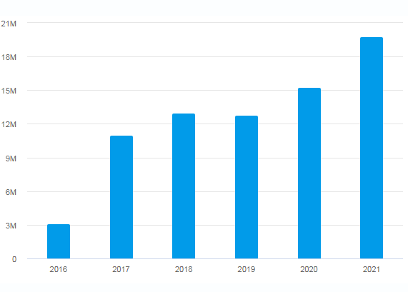

**Figure 1: Annual turnover of GO2 Foods**

(Source: Global Database, 2021)

The above graphical representation signifies that the annual turnover of the company is around 19.8 million British pounds. The number of employees of this SME is around 210 (Global Database, 2021). This company would operate and start its business in a new country such as India. Therefore, the researcher has critically evaluated the challenges and opportunities, and market entry mode to successfully establish the business of GO2 Foods in India.

# Critical evaluation of the challenging nature of the global landscape in 2023

Due to the effect of globalisation, many SMEs in the UK have started to operate their business in a new country that is in the international market. It helps them to expand and grow their business significantly. However, there are certain challenges that have been faced by the SMEs of the UK while operating their businesses in the global market. As opined by Collinson *et al.* (2020), one of the main challenges which have been considered a crucial challenge for SMEs is lack of finance. Having efficient funding and revenue is one of the most important components for SMEs to maintain consistency in business because, with the help of this factor, the company can operate its business for a long time. However, when SMEs in the UK want to start their business in other countries, inefficient funding creates a big problem for them and according to recent data it has been found that due to a lack of effective finance around 60% of SMEs fail to continue their business in the first three months (Deresky, 2022).

On the contrary, as said by Asgari *et al.* (2021), another biggest challenge for SMEs in the UK is the lack of networking opportunities. Due to a lack of R&D budget, and ineffective knowledge and skills, small companies in the UK have faced several challenges operating business in other countries. It is important for all companies to know the business practices, customer behaviours, and strategies of competitors in that new country. Without proper prior R&D, it becomes impossible for SMEs in the UK to regulate their business in other countries.

On the other hand, it has been stated by Daniels *et al.* (2021), international rules and policies regarding business have created a barrier for the SMEs in the UK in 2023 to successfully operate the business in new countries. Due to the strict rules and taxation systems of other countries, SMEs in the UK have faced heavy taxation rates and strict regulations which left no other option except for closing the business in other countries. From recent data, it has been found that in India the tax rate for foreign companies is around 40% (Sitkin and Mangion, 2020). Due to this high tax rate, most UK SMEs cannot run their business in other countries successfully.

# Challenges and Opportunities of the Industry

The challenges and opportunities of the industry can be determined by Porter’s five forces and by the Pestle analysis. Porter’s five forces can help to analyse and guide the business to increase competitive advantages in the market. This has five factors which are discussed below:

***Competitive Rivalry***

The competition is ***high*** in the case of GO2 Foods because this SME is dealing with frozen and packaged food products. There are many other competitors in the market who are selling the same products at a minimum cost. Other than that, there are many big companies who are already providing the same products at low cost in other countries such as Birds Eye UK Ltd. They have already entered the foreign market. Hence, the competition rate is high for GO2 Foods.

***Supplier power***

The bargaining power of suppliers is ***low*** because there are a sufficient number of suppliers in the food industry and GO2 Foods can select and switch to another supplier according to price and choice and preferences. Therefore, in this aspect, it can be said that the power of the supplier is low for this company.

***Buyer Power***

This factor determines the power of consumers and in the case of GO2 Foods, the bargaining power of customers is ***high*** because, in the UK, other than GO2 Foods, many other companies are selling frozen products. Therefore, there is a chance for the consumers to switch over to the other company’s products as per their choice and preferences. Maintaining the price range is one of the big factors for companies.

***Threat of new entrants***

This factor refers to the risk potential of the company. In GO2 Foods, the risk of new entrants is ***moderate*** because many companies in the UK are starting to grow their businesses in the frozen and packaged food industry. Hence, it is easier for other companies to penetrate this established market.

***Threat of substitute products***

In this segment, for GO2 Foods the threat of substitutes is ***low*** because the demand for frozen and packaged food is increasing day by day (Zhang *et al.* 2021). In other countries other than the UK, the demand for frozen foods is also enhancing. Hence, in the foreseeable future, the chance of substitution of new products is very low.

From the above discussion, it has been identified that GO2 Foods has a good opportunity to enter an international market if it can reduce the competition level with a strategic price range. PESTLE analysis helps to guide business entities and professionals to take strategic decisions for operating the business effectively.

**PESTLE Analysis of India**

***Political factor***

India has the largest democracy in the world and it runs the federal government. As per John (2019), political factors are greatly affected by the government policies of India. As a result, the business environment of India is greatly influenced by political factors. The taxation system is well developed and it is imposed by the Union govt. Privatisation is also influenced and the investment rate of foreign companies is also high. On the other hand, the UK also has a stable political condition and the government of the UK helps the SMEs to introduce their business in the new market. Hence, GO2 Foods has a high scope to enter India with its business plan because of the higher investment rate of foreign markets in India.

***Economic factor***

The economy of India is stable. In the words of McIntyre *et al.* (2022), after introducing the industrial reform policy of 1991, the reduction of industrial licensing, and increase in foreign investment has resulted in an improvement in economic factors. In the year 2022, the GDP rate of India accounted for 8.6% (Victor, 2022).

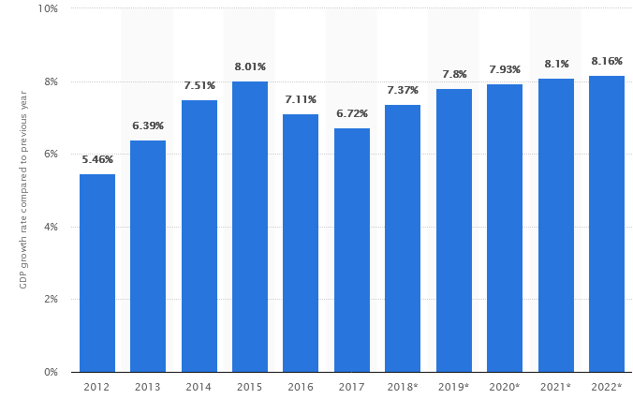

**Figure 2: GDP Growth Rate of India**

(Source: Victor, 2022)

On the other hand, the UK has also a stable economy, it is highly developed and it has a big role in international trade. The GDP rate of the UK in the year 2021 is around 7.5%.

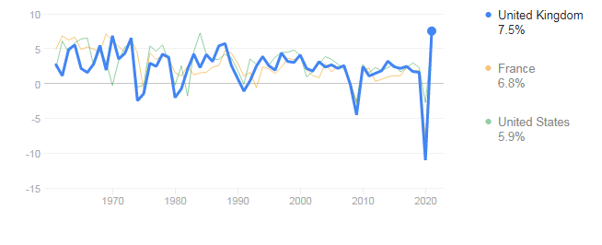

**Figure 3: GDP growth rate of the UK**

(Source: World Bank, 2022)

Therefore, from the above discussion, it can be said that GO2 Foods has a high chance to establish its business in India successfully as the high economic growth of India can help the company to maintain its consistency in business.

***Social Factor***

This factor refers to the changes that affect the business environment. In the words of Nambisan and Luo (2022), the employment rate in India is increasing day by day. Many small businesses are given the chance to the people of India to give employment effectively. On the other hand, the UK also has a high employment rate. The employment rate in the UK is around 75.7%. This higher rate of employment has created a chance for the UK to give the chance to SMEs to operate in other countries. Henceforth, GO2 Foods has a high chance to start its business in India due to the high employment rate of India. GO2 Foods can employ people from India effectively for regulating its business.

***Legal Factor***

India has a higher tax rate and for foreign companies, the tax rate is around 40% (Ojha *et al.* 2020). Other than the higher tax rate, India has very strict rules and regulations for foreign companies. On the other hand, after Brexit, the UK also follows strict policies for foreign companies to operate their business in the UK. Hence, it has created a challenge for GO2 Foods to arrange a huge amount of funds to enter an Indian Market.

***Technological Factor***

The Technological growth of India is enhancing day by day and according to data, the annual IT revenue of India in the year 2020 was around 191 billion USD (Griffin and Pustay, 2019). It has created a high chance for foreign companies to enter the market.

***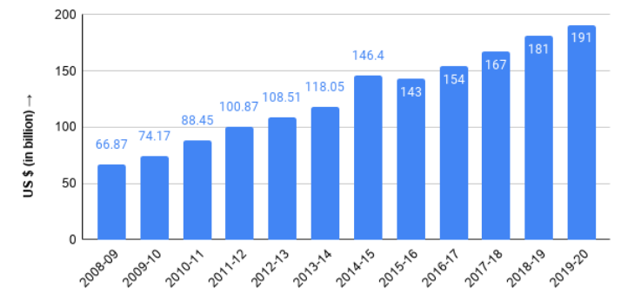***

**Figure 4: Technological growth rate of India**

(Source: Griffin and Pustay, 2020**)**

**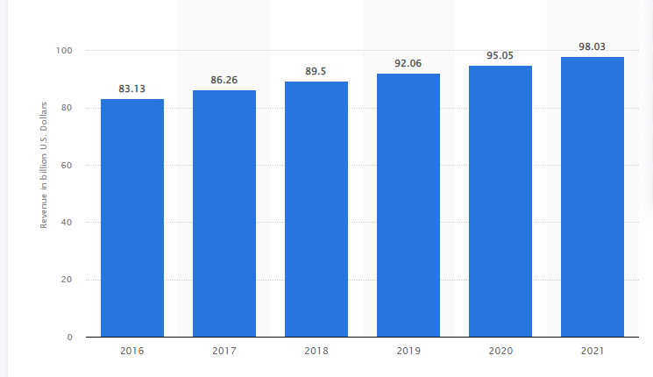**

**Figure 4: Growth rate of IT industries in the UK**

**(**Source: Statista, 2022)

On the other hand, in the UK, the annual revenue of the It sector in the year 2021, has accounted for 98 .03 billion USD. Hence, this factor has created a high opportunity for GO2 Foods to evolve its R&D process to enhance its efficiency in the foreign market of India.

***Environmental Factor***

It is another important factor for the growth of the business. As per Batas *et al.* (2022), due to industrialisation and urbanisation, the air has been adversely affected that causes health problems. In the case of the UK, the pollution rate is lower than in India. Hence, in this aspect, it has created an obstacle for GO2 foods to work in the pollution of India.

Hence, from the above discussion, it has been identified that GO2 Foods has a good opportunity to enter the market of India if it can resolve the above-mentioned challenges successfully.

# Market entry mode for entering into a new market

This factor refers to the strategy of the companies by which they can enter into the foreign company. In this aspect, GO2 Foods can apply to Wholly-owned ventures. This can help this company to hold its 100% stock at the primary stage. As it is an SME in the UK and revenue and employees are also low. Hence, when it would operate in the market in India, a wholly-owned subsidiary can help the company to diversify its products and it can also reduce its risk also. As it does not have any shareholders, therefore, there would be no obligation for GO2 Foods to its stakeholders for entering into new market.

# Recommendation

It is recommended to GO2 Foods that they can use Ansoff Matrix to apply diverse strategies while opening their business in India. It has four factors which have been described below:

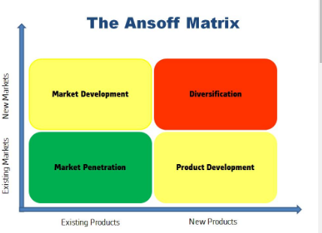

**Figure 5: Ansoff Matrix**

(Source: Clarissia, 2020)

***Market penetration*** refers to the entry into the existing market with the existing products. This can help the company to attract customers and cut down the prices. ***Product development*** refers to entering into the existing market with new products. This can help the company to expand regionally. ***Market development*** refers to the strategy by which the company can enter into a new market with its existing products. ***Diversification*** defines entry into a new market with new products (Rana and Shrivastava, 2021). In this context, GO2 Foods can apply the ***market development strategy*** which can help them to enter into a new market by reducing the price of attracting customers. It could also help to offer loyalty schemes to customers and with the help of this factor the company can increase its revenue in India.

# Conclusion

From the above discussion, it has been analysed that GO2 Foods is an SME in the UK, and it would operate in the market of India. There are various challenges such as inefficient funding, communication problems, and strict rules and policies that affect the growth of the business of SMEs. However, from Porter's forces and PESTLE analysis, it has been identified that the company has enough opportunity to regulate its business in India and it can use a wholly-owned subsidiary strategy as its marketing mode. Moreover, it is recommended to GO2 Foods it can use Market penetration as its marketing strategy.

# References

Asgary, N.H., Samii, M.V. and Varamini, H., 2021. *Global Business: An Economic, Social.* IAP.

Batas, Spiros, Olli Kuivalainen, and Rudolf R. Sinkovics. Megatrends in International Business: *Examining the Influence of Trends on Doing Business Internationally*. Springer International Publishing AG, 2022.

Clarissia, S.M.S., 2020. A study on Ansoff Matrix Technique: As a growth strategy and an adaptive learning technique adopted in the leading brand of products. *BIMS Journal of Management, p.18.*

Collinson, S., Narula, R., Qamar, A. and Rugman, A.M., 2020. *International business.* Pearson UK.

Daniels, J.D., Radebaugh, L.H., Sullivan, D.P. and Click, R.W., 2021. *International business.* Prentice Hall.

Deresky, H., 2022. International management: *Managing across borders and cultures*. Pearson Education India.

Global database 2022. *GO2 Food* Available at:[https://uk.globaldatabase.com/company/go2-foods-limited#div\_financials](https://uk.globaldatabase.com/company/go2-foods-limited" \l "div_financials) [Accessed on: 11th April, 2023].

Griffin, R.W. and Pustay, M., 2019. *International business: A managerial perspective.* Pearson Higher Ed.

John, J., WILD, W. and Kenneth, L., 2019. *INTERNATIONAL BUSINESS: The Challenges* of *Globalization,* Global Edition. Pearson Education Limited.

McIntyre, J.R., Ivanaj, S. and Ivanaj, V. eds., 2022. *The Role of Multinational Enterprises in Supporting the United Nations' SDGs.* Edward Elgar Publishing.

Nambisan, S. and Luo, Y., 2022. *The Digital Multinational: Navigating the New Normal in Global Business.* MIT Press.

Ojha, V.P., Pohit, S. and Ghosh, J., 2020. Recycling carbon tax for inclusive green growth: *ACGE analysis of India. Energy Policy, 144, p.111708.*

Rana, S. and Shrivastava, A.K. eds., 2021. *Doing Business in Emerging Markets: Progress* and Promises. Taylor & Francis.

Sitkin, A. and Mangion-Thornley, K., 2020. Absolute essentials of international business. Routledge.

Statista, 2022. *It Revenue of the UK.* Available at: <https://www.statista.com/forecasts/961413/it-revenue-in-united-kingdom>[Accessed on: 11th April, 2023].

TAMER, S., CAVUSGIL, K. and RIESENBERGER, G., 2019. INTERNATIONAL BUSINESS: The New Realities Plus Pearson Mylab Management with Pearson Etext,... *Global Edition.* PEARSON EDUCATION Limited.

Worldbank, 2022. *GDP growth of the UK.* Available at: <https://data.worldbank.org/indicator/NY.GDP.MKTP.KD.ZG?locations=GB>[Accessed on: 11th April, 2023].

Zhang, W., Ma, J. and Sun, D.W., 2021. Raman spectroscopic techniques for detecting structure and quality of frozen foods: principles and applications. *Critical Reviews in Food Science and Nutrition, 61*(16), pp.2623-2639.