**THE IMPACT OF GREEN HUMAN RESOURCES MANAGEMENT PRACTICES ON PERFORMANCE OF HEALTHCARE MANAGEMENT: A UK HEALTHCARE RESEARCH**

**Table of Contents**

Introduction and Background 4

Introduction 4

Research Questions 4

Research Aim and Objective 4

Research Background 5

Literature Review 7

Introduction 7

Conceptualizing the Green HRM and its Impact on the Performance of the health industry in the UK 7

Importance of Green HRM in the UK healthcare research 8

Benefits while Implementing Green HRM in the UK health care research 9

Challenges faced by the UK healthcare research while implementing Green HRM practices 10

Recommended strategies to mitigate the above challenges 10

Theoretical Discussion 10

Conceptual Diagram 12

Literature Gap 12

Chapter Summary 13

Methodology 13

Research Philosophy 13

Types and Sources of Data 14

Data Collection Method 14

Design and Construction 15

Rejected Methods 15

Data Analysis 15

Potential Ethical consideration 15

Chapter Summary 15

Plan of Work 16

Understanding of key deliverables and elements 16

Quality of plan structure and organisation 16

Practicality of plan. 17

References 18

# Introduction and Background

## Introduction

The main concept of Green Human Resource Management (Green HRM) is to stimulate the green behaviour of the employees of a company by implementing new policies, systems and practices so that they can develop corporate sustainability and environmental sustainability (Bahuguna, Srivastava & Tiwari, 2023). Protecting the natural environment has been considered the main priority for the HR team in the healthcare sector. The UK Healthcare sector, which is one of the most important service providers, uses substantial energy that is responsible for carbon emissions that highly affect the environment. The National Health Service in the UK is responsible for carbon dioxide emissions of around 20 million tonnes yearly and also spends around £50 million on carbon permits annually (The King’s Fund, 2023). The future of UK healthcare services will grow if they are concerned about sustainability. Hence, the healthcare sectors are adopting the Green HRM to help the healthcare employees to adopt green behaviour by allocating more resources to establish an initiative of environmental sustainability that includes recycling, water conservation, energy efficiency, sustainable mobility, and green procurement. This proposal will aim to discuss the implementation of Green HRM practices in healthcare research in the UK, and their impact on of healthcare management sustainability. This research proposal will shed light on the impact of Green HRM and its effectiveness on the performance of Management of Healthcare in the UK.

## Research Questions

* What is the impact of Green Human Resource Management that affects on the performance of UK healthcare management?
* What are the challenges faced by UK healthcare research for implementation of Green HRM practices?
* What are the potential strategies to mitigate the above issues caused by implementing Green HRM in UK healthcare management?

## Research Aim and Objective

**Aim**

This research will aim to identify the role played by Green HRM in Healthcare Management. In addition, the research will also focus on analysing the impact of Green HRM on the performance of UK healthcare management.

**Objective**

* To identify the impact of managing Green Human Resource on the performance of healthcare services in the UK.
* To understand the challenges faced by the UK healthcare research by implementing the Green HRM.
* To explore the potential strategies to mitigate the issues that are faced by UK healthcare research while implementing Green HRM.

## Research Background

The UK healthcare sector is one of the largest and most prestigious sectors in the world where millions of people are employed. As shown in the below figure, the health sector in the UK employs around 1.8 million people in the year 2022.

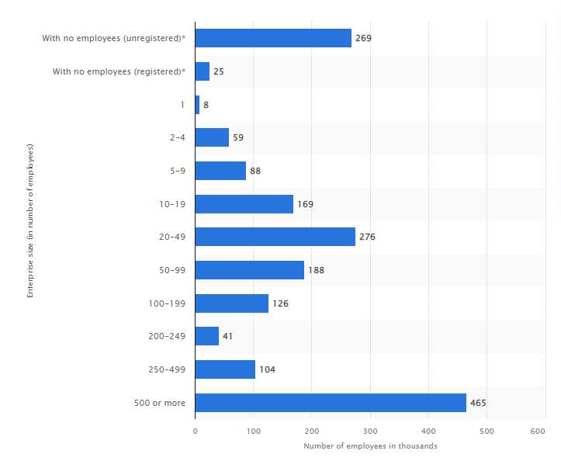

**Figure 1: Total number of employees in the health service sector in the UK**

(Source: Statista, 2022)

Because of the large manpower and their effective productivity, the revenue of the UK healthcare services has increased gradually. From the below figure, it is observed that the revenue in the UK health care services is projected to reach US$1,857.00 million in 2023 and it is assumed that the revenue of the UK healthcare services will reach US$2,370.00 million by 2027 by following an annual growth rate of 6.29% (CAGR 2023-2027)

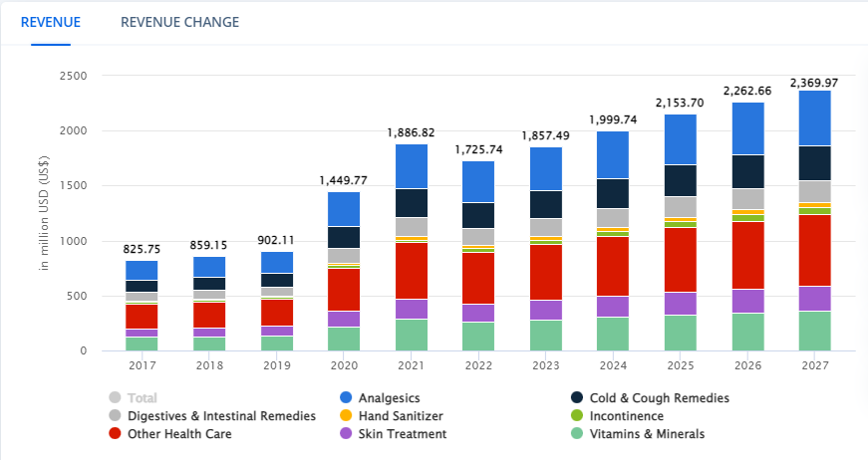

**Figure 2: Total Revenue of the UK Healthcare Sectors**

(Source: Statista, 2023)

Due to a rapid increment in the UK healthcare sectors, they face several environmental issues as a result of waste products. As per Khan et al. (2019), the healthcare sector produces a significant amount of hazardous waste that highly affects environmental sustainability. Hence, in order to resolve these environmental issues, the UK healthcare services adopt Green HRM so that the employees of these sectors are aware of environmental and corporate sustainability and establish environmentally friendly initiatives. Green HRM supports the sustainable development of the UK health sectors. Adopting the Green HRM practices in the healthcare sector helps to improve their service quality and to enhance their performance while maintaining environmental sustainability (Mousa & Othman, 2020). Adoption of Green HRM in the UK healthcare sector approaches Green recruitment, eco-friendly exercise, worker participation and reward and performance appraisal. As per Saha, Sarker & Ahmed (2020), the Green HRM techniques are used in healthcare management to maintain a safe and hygienic environment in the health centres of the UK.

# Literature Review

## Introduction

This chapter critically evaluates the role of Green HRM in UK health research and its impact on the performance of UK health care management. Hence, in this chapter, the researcher has provided a concept of Green HRM and tried to analyse the impact of Green HRM on the healthcare sectors’ performance in the UK. Additionally, the importance of Green HRM in UK healthcare research has also been discussed. The benefits and challenges of implementing Green HRM in the UK healthcare sectors and recommended strategies to mitigate those challenges are discussed in this chapter. Theories have also been discussed to create a link with this literature. The conceptual diagram and literature gap have been identified. Further, the chapter has ended with a summary.

## Conceptualizing the Green HRM and its Impact on the Performance of the health industry in the UK

Green HRM is a practice adopted by the healthcare sectors in order to encourage healthcare employees to take green initiatives for the sustainability of the environment and organization by implementing several green policies, services and practices for the employees. According to Danilwan et al. (2020), HR in the healthcare sector plays a significant role in making a sustainable organization. In order to implement sustainability, healthcare management needs support from HR. Green HRM helps the UK health sectors to enable the green goals that help to drive green practices in the UK health sectors. The below figure shows the model of Green HRM.

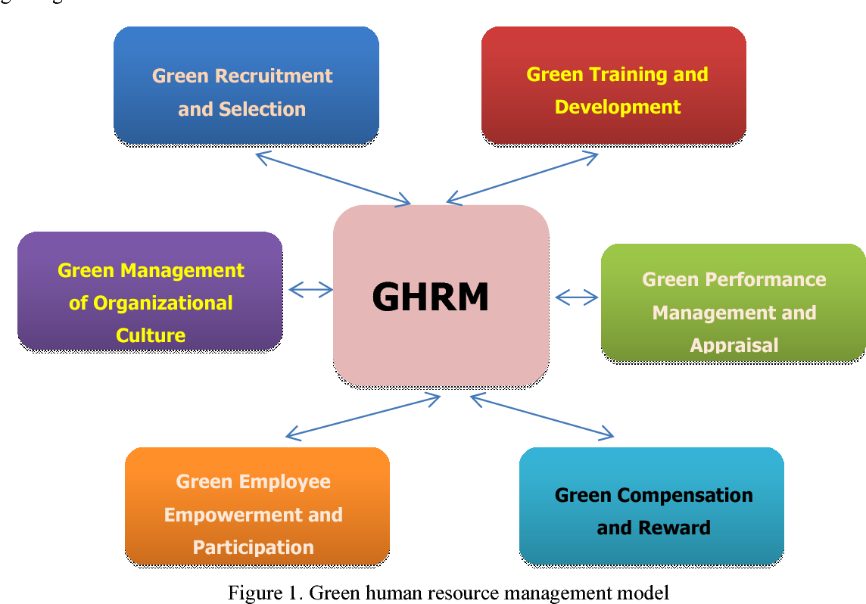

**Figure 3: Model of Green HRM**

(Source: Ari et al. 2020)

Adopting Green HRM helps the healthcare industry of the UK to expand its involvement in environmental protection issues. This practice helps to reduce the Carbon emission caused by the healthcare industry. Green HRM is a new trend of successful management that enhances the sustainable performance of health sectors by integrating environmental management (Malik et al. 2020).

## Importance of Green HRM in the UK healthcare research

Green HRM helps to encourage employees by providing training and creating awareness about the environment so that they find several ways to reduce the use of hazardous chemicals and materials in the healthcare products of the UK. This practice helps the employees to recycle products so that wasted material of UK health research can not affect the environment. The below figure shows the importance of Green HRM.

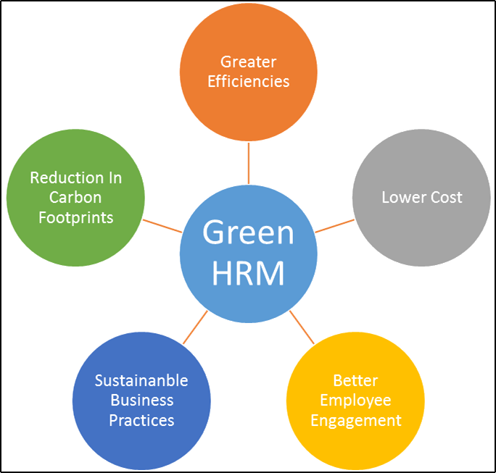

**Figure 4: Some Importances of Green HRM**

(Source: Mwita, 2019)

According to Al-Hajri (2020), Green HRM practice helps to motivate employees in healthcare sectors so that they can achieve greater efficiency and be able to reduce and eliminate ecological waste and recycle the products, procedures and tools at a lower cost.

## Benefits while Implementing Green HRM in the UK health care research

Green HRM is an eco-friendly HR initiative that helps to reduce carbon footprints through electronic filing, recycling, training, energy efficiency and many more with the help of better employee engagement and retention, lower costs and greater efficiency in UK Healthcare research. Green HRM trains employees to increase their awareness of environment-related issues and also implement laws in the UK health care research for protecting the environment (Hussain, Saifuddin & Khan, 2020). Green HRM does the environmental audit in the UK health care research so that employees are aware of waste management and pollution. Green HRM is aware of the employees of UK health care research and people from society to economically utilize the natural resources and also encourage environmentally friendly products.

## Challenges faced by the UK healthcare research while implementing Green HRM practices

The UK healthcare research faces several issues while implementing Green HRM practices. The initial cost of implementation of Green HRM in UK healthcare research is very high. Therefore, implementing Green HRM decreases the annual profit of healthcare research in the UK. Due to a lack of awareness, the employees of UK health research are not able to recognize the environmental impacts. As per M. Bublitz et al. (2019), the shortage of skilful and knowledgeable executives in UK health research impact on environmental sustainability. Green HRM practice is an effective goal to gain customer support and goodwill, but the improvements due to Green HRM is economically viable; hence, the UK healthcare research gains a competitive disadvantage.

## Recommended strategies to mitigate the above challenges

**Create Awareness**

In the UK healthcare research, the employees are not aware of environmental impacts. Hence, Green HRM can create awareness among the employees of the UK healthcare research and society people to maintain a proper environment, Green movement, recycle, properly utilization of natural resources and retain them for future generations. Providing knowledge, skills and training can help the Green HRM to minimize the environmental impact (Jehan et al. 2020).

**Sourcing Human resources**

Higher-level executives are more responsible regarding green targets and green initiatives (Saeed et al. 2019). Hence, sourcing knowledgeable and skilful individuals in UK healthcare research can help to increase the environmental consciousness in the organization.

## Theoretical Discussion

***Triple bottom line theory***

According to the Triple bottom line theory, the sustainability effort of an organization depends on measuring the environmental health, social well-being and also the financial performance rather than depending on the standard button line that is the profit or loss of an organization (Laosirihongthong et al. 2020). The measurement of a successful business has three key areas such as people, profit and planet that is shown in the below figure.

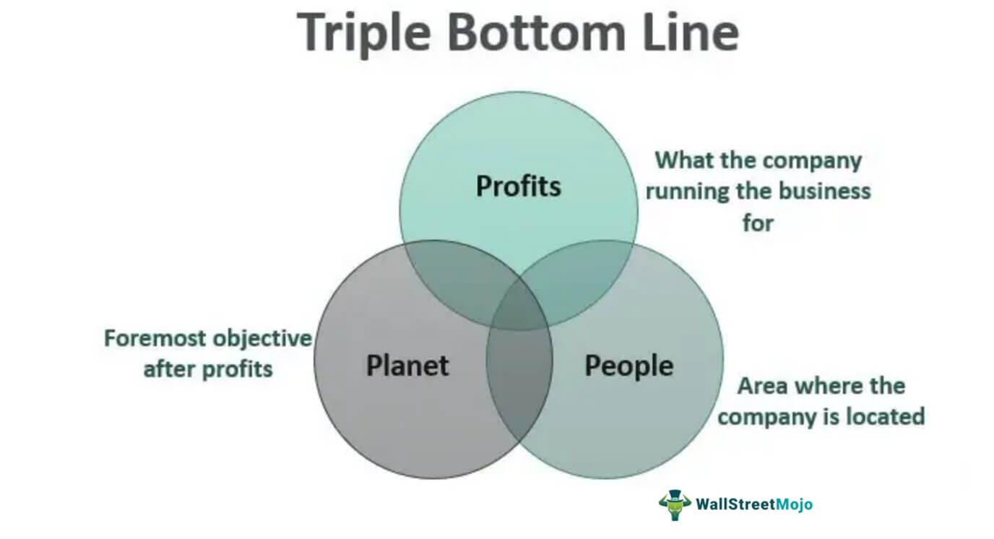

**Figure 5: Key areas of Triple Bottom Line Theory**

(Source: Sarkis, 2020)

This research will follow the Triple bottom line theory because in order to run a successful sustainable business, the UK healthcare research implements the Green HRM practice that helps to develop corporate sustainability and environmental sustainability. With the help of Green HRM, UK healthcare research measures the social and environmental impact instead of the profit and loss of a business that helps to build a sustainable environment for society.

## Conceptual Diagram

GREEN HRM

UK HEALTH CARE BUSIBUSINESS

HIGH INITIAL COST

UNEVEN COMPETITION

GREEN EMPLOYEE TRAINING

EMPLOYEE EMPOWERMENT

EMPLOYEE PERFORMANCE

SOCIAL IMPROVEMENT

GREATER EFFICIENCIES

BETTER EMPLOYMENT ENGAGEMENT

REDUCE CARBON FOOTPRINTS

**Figure 6: Conceptual Framework**

(Source: Self-made)

## Literature Gap

The previous research scholars discuss the concept of Green HRM. The importance and benefits of Green HRM are also discussed in the previous research articles and journals. However, the researchers do not provide a detailed idea about the impact of Green HRM in UK healthcare research. They also do not justify the challenges faced by the UK healthcare research while implementing Green HRM. Hence, the UK healthcare research has a lack of knowledge about Green HRM. Hence, with the help of this research, the UK healthcare research will get a detailed idea about the impact and the challenges while implementing Green HRM moreover, some potential strategies are also discussed in this research.

## Chapter Summary

This chapter emphasizes the concept of Green HRM. This practice helps to reduce the Carbon emission caused by the UK healthcare industry and enhances sustainability. Green HRM helps to increase the awareness of environment-related issues for protecting the environment's performance. The UK healthcare research faces several issues while implementing Green HRM such as higher cost, lack of awareness, knowledgeable and skilful executives and many more. This research follows the triple bottom-line theory to meet the research objectives. The previous scholars do not provide a detailed idea about the impact and challenges of Green HRM in UK healthcare research; hence, it is identified as a research gap.

# Methodology

## Research Philosophy

In this research study interpretivism philosophy will be used. The types of Research Philosophy are shown in the below figure.

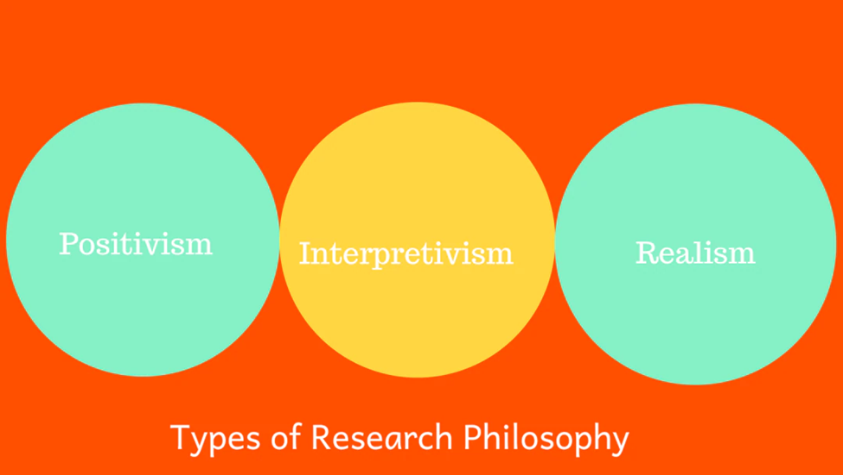

**Figure 7: Types of Research Philosophy**

(Source: Moon et al. 2019)

As per Burton et al. (2021), interpretivism philosophy helps researchers to shape environmental sustainability with the help of Green HRM which helps to influence social norms. In order to analyse both qualitative and quantitative data together, the interpretivism philosophy will be used by the researcher. Hence, it can be said that with the help of the interpretivism philosophy, researchers can identify the impact of Green HRM that affects the performance of UK healthcare research.

## Types and Sources of Data

There are two types of data collection methods shown in the below figure.

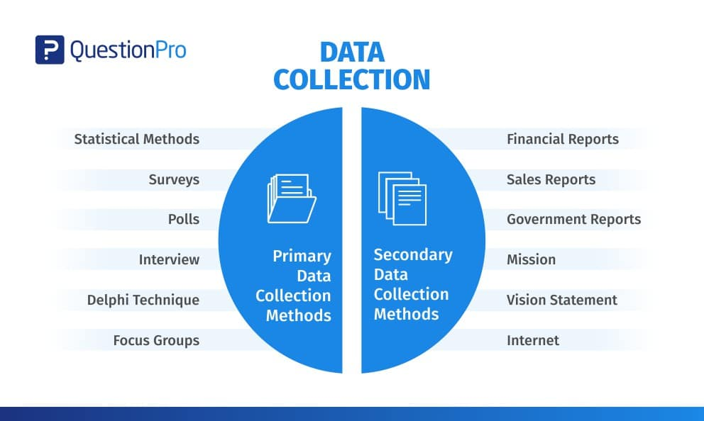

**Figure 8: Types of Data Collection Method**

(Source: Nayak & Narayan, 2019)

In order to complete this research, the researcher will collect secondary data from online journals and news articles. The secondary data helps the researcher to obtain clean and structured data in order to understand the concept of Green HRM and its impact on UK healthcare research.

## Data Collection Method

In order to meet the research objectives, the researcher will consider the secondary data collection method through various online sources such as online journals and new articles. As per Olabode, Olateju & Bakare (2019) secondary data complies with the information that is collected from already published materials to ensure the validity and reliability of the findings. Following the research area, the data has been collected through some keywords that include “Green HRM”, “Health care management”, “UK Healthcare research” and many more. With the help of inclusion and exclusion criteria, 30-40 secondary sources have been selected from Google Scholar, news articles, journals and so on published after 2019, out of which 10-15 sources have been filtered for evaluating the case study of researchers.

## Design and Construction

Here, the researcher use the Inductive approach and descriptive research design as it helps the researcher to collect data that is relevant to the research study. Hence, to obtain relative information regarding Green HRM, an indicative approach will be used by the researcher. As per Fuster Guillen (2019), descriptive research design focuses on obtaining information systematically to describe a situation. This research design will be used by the researcher because it will help to obtain information to describe the impact of Green HRM on the performance of UK health research.

## Rejected Methods

In this research study, the researcher will not use the Positivism and Realism philosophy because this research is not about the object of study and does not assume the scientific approach. The researcher does not use the deductive approach because this research does not analyse data to test the hypothesis.

## Data Analysis

In this study, with the help of thematic data analysis, the researcher will analyse the data. With the help of objectives, the researchers will identify around 6 to 10 themes according to this research study. These particular themes will be discussed with the help of a narrative approach.

## Potential Ethical consideration

As per Atlam & Wills (2020), ethics is the most significant area in research because it ensures the authenticity of the research work. In this research study, the researcher will consider the potential ethical aspect for managing data. Hence, all data are chosen from authentic sources and citations that will be used by the researcher to appraise the contribution of multiple scholars. This research study will not consider plagiarized data and outdated information.

## Chapter Summary

This chapter identifies that the researcher will use interpretivism philosophy to shape environmental sustainability with the help of Green HRM. In order to complete this research, the researcher will collect secondary data from online journals and news articles with the help of 10-15 ethical sources published after 2019. The Inductive approach and descriptive research design will be used by the researcher in order to complete this research study. However, Positivism and Realism philosophy and deductive approach has not been used by the researcher.

# Plan of Work

## Understanding of key deliverables and elements

The research will be started on 8 May 2023. The stages and movements of the research are shown in the below image.

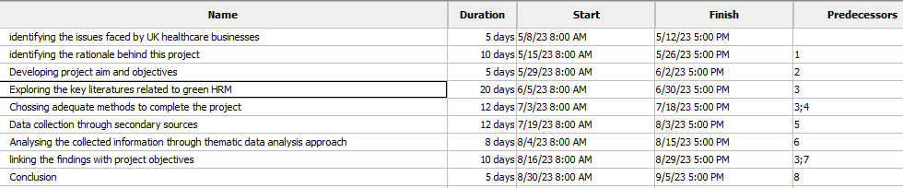



**Figure 9: Expected research Timeline**

(Source: Self-made)

The researchers will recognise the major issues encountered by UK healthcare businesses at the initial stage. The researchers will accordingly recognise the rationale behind the specific project. In the next stage, the scholars will develop appropriate research aims and objectives to accomplish the research. The key pieces of literature on green HRM will be explored by the researchers. Correspondingly, adequate research methods will be selected which are effective. The scholars will gather information by observing the secondary data collection method. Thematic data analysis process will be used and followed by the researchers to assess and examine the collected data. The final findings will be accordingly linked with the research objectives to accomplish an appropriate conclusion.

## Quality of plan structure and organisation

The plan structures will be appropriate for healthcare organisations in the United Kingdom. The organisations will be able to understand the impact as well as the significance of Green HRM practices. The organisations will accordingly understand the reasons for the challenges faced during the practices of Green HRM.

## Practicality of plan.

The findings illustrate that green HRM is beneficial for reducing the carbon footprint through electronic filing, recycling, training and energy efficiency. The findings will be able to meet the objectives of recognising the significance of Green HRM in the healthcare sector. Similarly, it is identified that the major challenges like high expenses, lack of awareness and shortage of skilled employees are faced by healthcare organisations. Thus, the objective of comprehending the challenges and their causes can be obtained by healthcare organisations through the plans.

# References

Al-Hajri, S. A. (2020). Employee Retention in light of Green HRM practices through the Intervening role of Work Engagement. *Annals of Contemporary Developments in Management & HR (ACDMHR),* 2(4), 10-19. <http://acdmhr.theiaer.org/archive/v2/v2n4/p2.pdf>

Ari, E., Karatepe, O. M., Rezapouraghdam, H., & Avci, T. (2020). A conceptual model for green human resource management: Indicators, differential pathways, and multiple pro-environmental outcomes. *Sustainability,* 12(17), 7089. <https://www.mdpi.com/2071-1050/12/17/7089/pdf>

Atlam, H. F., & Wills, G. B. (2020). IoT security, privacy, safety and ethics. *Digital twin technologies and smart cities*, 123-149. <https://www.researchgate.net/profile/Hany-Atlam/publication/332859761_IoT_Security_Privacy_Safety_and_Ethics/links/5d45d26992851cd0469f9f62/IoT-Security-Privacy-Safety-and-Ethics.pdf>

Bahuguna, P. C., Srivastava, R., & Tiwari, S. (2023). Two-decade journey of green human resource management research: a bibliometric analysis. *Benchmarking: An International Journal*, 30(2), 585-602. <https://www.researchgate.net/profile/Prakash-Bahuguna/publication/359555234_Two-decade_journey_of_green_human_resource_management_research_a_bibliometric_analysis/links/628dff7f6773462154d84e0b/Two-decade-journey-of-green-human-resource-management-research-a-bibliometric-analysis.pdf>

Burton, E., Edwards, D. J., Roberts, C., Chileshe, N., & Lai, J. H. (2021). Delineating the implications of dispersing teams and teleworking in an Agile UK construction sector. *Sustainability,* 13(17), 9981. <https://www.mdpi.com/2071-1050/13/17/9981/pdf>

Danilwan, Y., Isnaini, D. B. Y., Pratama, I., & Dirhamsyah, D. (2020). Inducing organizational citizenship behavior through green human resource management bundle: drawing implications for environmentally sustainable performance. A case study. *Journal of Security and Sustainability Issues*, 10(October), 39-52. <https://hal.science/hal-03121058/file/Danilwan_Inducing_organizational_citizenship_behavior_through_green_human_resource_management_bundle_drawing_implications_for_environmentally_sustainable_performance_A_case_study.pdf>

Fuster Guillen, D. E. (2019). Qualitative Research: Hermeneutical Phenomenological Method. *Journal of Educational Psychology-Propositos y Representaciones,* 7(1), 217-229. <https://files.eric.ed.gov/fulltext/EJ1212514.pdf>

Hussain, F., Saifuddin, Q., & Khan, I. U. (2020). Striving to implement green human resource management (GHRM) policies and practices: A Study from HR Managers Perspective (FMCG Sector). *International Journal of Management Excellence* (ISSN: 2292-1648), 14(2), 2037-2051. <https://techmindresearch.org/index.php/ijme/article/download/1131/676>

Jehan, Y., Hussai, D., Batool, M., & Imran, M. (2020). Effect of green human resource management practices on environmental sustainability. *International Journal of Human Capital in Urban Management,* 5(2), 153-164. <https://www.academia.edu/download/64519878/IJHCUM_Volume%205_Issue%202_Pages%20153-164_2.pdf>

Khan, B. A., Cheng, L., Khan, A. A., & Ahmed, H. (2019). Healthcare waste management in Asian developing countries: A mini review. *Waste management & research,* 37(9), 863-875. <https://journals.sagepub.com/doi/pdf/10.1177/0734242X19857470>

Laosirihongthong, T., Samaranayake, P., Nagalingam, S. V., & Adebanjo, D. (2020). Prioritization of sustainable supply chain practices with triple bottom line and organizational theories: industry and academic perspectives. *Production Planning & Control,* 31(14), 1207-1221. <https://gala.gre.ac.uk/id/eprint/26134/3/26134%20ADEBANJO_Prioritisation_Of_Sustainable_Supply_Chain_Practices_%28AAM%29_2019.pdf>

M. Bublitz, F., Oetomo, A., S. Sahu, K., Kuang, A., X. Fadrique, L., E. Velmovitsky, P., ... & P. Morita, P. (2019). Disruptive technologies for environment and health research: an overview of artificial intelligence, blockchain, and internet of things. *International journal of environmental research and public health,* 16(20), 3847. <https://www.mdpi.com/1660-4601/16/20/3847/pdf>

Malik, S. Y., Cao, Y., Mughal, Y. H., Kundi, G. M., Mughal, M. H., & Ramayah, T. (2020). Pathways towards sustainability in organizations: Empirical evidence on the role of green human resource management practices and green intellectual capital. *Sustainability,* 12(8), 3228. <https://www.mdpi.com/2071-1050/12/8/3228/pdf>

Moon, K., Blackman, D. A., Adams, V. M., Colvin, R. M., Davila, F., Evans, M. C., ... & Wyborn, C. (2019). Expanding the role of social science in conservation through an engagement with philosophy, methodology, and methods. *Methods in Ecology and Evolution,* 10(3), 294-302. <https://scholar.google.com/scholar?output=instlink&q=info:kM8fiEA4YPIJ:scholar.google.com/&hl=en&as_sdt=0,5&as_ylo=2019&scillfp=9920772367073759659&oi=lle>

Mousa, S. K., & Othman, M. (2020). The impact of green human resource management practices on sustainable performance in healthcare organisations: A conceptual framework. *Journal of Cleaner Production,* 243, 118595<https://e-tarjome.com/storage/panel/fileuploads/2019-11-26/154758102_gh9.pdf>

Mwita, K., 2019. Conceptual review of green human resource management practices. *East African Journal of Social and Applied Sciences,* 1(2), pp.13-20. <https://hal.science/hal-03621106/document>

Nayak, M. S. D. P., & Narayan, K. A. (2019). Strengths and weaknesses of online surveys. *Technology,* 6(7), 0837-2405053138. <https://www.researchgate.net/profile/Mudavath-Nayak/publication/333207786_Strengths_and_Weakness_of_Online_Surveys/links/61176e5a0c2bfa282a42253b/Strengths-and-Weakness-of-Online-Surveys.pdf>

Olabode, S. O., Olateju, O. I., & Bakare, A. A. (2019). An assessment of the reliability of secondary data in management science research. *International Journal of Business and Management Review,* 7(3), 27-43. <http://www.lasuerhrmjournal.com.ng/journal_publication/vol_1/article_20.pdf>

Saeed, B. B., Afsar, B., Hafeez, S., Khan, I., Tahir, M., & Afridi, M. A. (2019). Promoting employee's proenvironmental behavior through green human resource management practices. *Corporate Social Responsibility and Environmental Management,* 26(2), 424-438. <https://www.researchgate.net/profile/Imran-Khan-145/publication/328388573_Promoting_employee's_proenvironmental_behavior_through_green_human_resource_management_practices/links/5cb02178299bf120975f8b5f/Promoting-employees-proenvironmental-behavior-through-green-human-resource-management-practices.pdf>

Saha, S., Sarker, R., & Ahmed, S. M. (2020). Impact of Green Human Resource Management (GHRM) practices in garment industry: Bangladesh perspective. *International Journal of Management and Accounting*, 2(2), 22-30. <https://www.universepg.com/public/storage/journal-pdf/Impact%20of%20Green%20Human%20Resource%20Management%20(GHRM)%20practices%20in%20garment%20industry%20Bangladesh.pdf>

Sarkis, J. (2020). Supply chain sustainability: learning from the COVID-19 pandemic. *International Journal of Operations & Production Management,* 41(1), 63-73. <https://helda.helsinki.fi/dhanken/bitstream/handle/10227/402120/IJOPM_Covid_Post_Print.pdf?sequence=1>

Statista, (2022). *Number of people employed in the health and social work services sector in the United Kingdom in 2022, by enterprise size.* <https://www.statista.com/statistics/678587/united-kingdom-uk-health-and-social-work-employment-by-number-of-employees/#:~:text=Number%20of%20people%20employed%20in,UK%202022%2C%20by%20enterprise%20size&text=In%202022%2C%20there%20were%20approximately,employed%20500%20or%20more%20people>

Statista, (2023). *Health Care - United Kingdom.* <https://www.statista.com/outlook/dmo/ecommerce/beauty-health-personal-household-care/health-care/united-kingdom>

The King’s Fund, (2023). *Sustainable services: Future trends.*<https://www.kingsfund.org.uk/projects/time-think-differently/trends-sustainable-services#:~:text=Carbon%20footprint%20of%20the%20NHS,set%20to%20increase%20over%20time>

## 