**BMG814 The Digital Landscape Coursework**

**Assignment 1 - CASE STUDY ON E-SUPPLY CHAINS**

Table of Contents

Introduction 2

1. Future changes in the supply chains required in order to meet the exact needs of the customer 2

2. Describe the tools such as ‘predictive analysis’ and ‘artificial intelligence’ in the risk management in the future supply chains 4

3. Describe the implication of ‘reverse flows’ and ‘circular logistics’ in the future supply chain management processes 6

4. Describe the new technologies which can help in resolving these tricky issues. 8

Conclusion 9

References 10

# Introduction

E-Supply Chain Management (ESCM) is a combination of technologies, people and processes which ensure that products are delivered to the consumers in a cost-effective way. In this case, a comprehensive approach is applied in supply chain management to make the entire process more efficient in the future.

# Future changes in the supply chains required in order to meet the exact needs of the customer

The traditional supply chain management was a rigid system which solely focused on production of goods. The supply chain management was used as a back-office function, whereas, the modern supply chain management process is built based on the needs of the consumer (KPMG USA, 2023). It can be derived from this case study that in order to minimise the cost and achieve stability the future supply chain management needs to be able to predict the upcoming changes and prepare accordingly. The supply chain management process needs to have a more dynamic approach and rapidly evolve along with the demand of the customers in order to deliver the exact wants of the customer. As stated by Jahan and Sazu (2022), the supply chain management process might change massively in five years as technology has developed and it is easier to access data now. The industrial assets will be connected to robots to support the operators and increase efficiency in the future. Creating ecosystems of supply chains is one of the pathways to the future of the e-supply chain process. These ecosystems will be a series of interdependent processes which help bring change to the traditional methods of supply chain management.

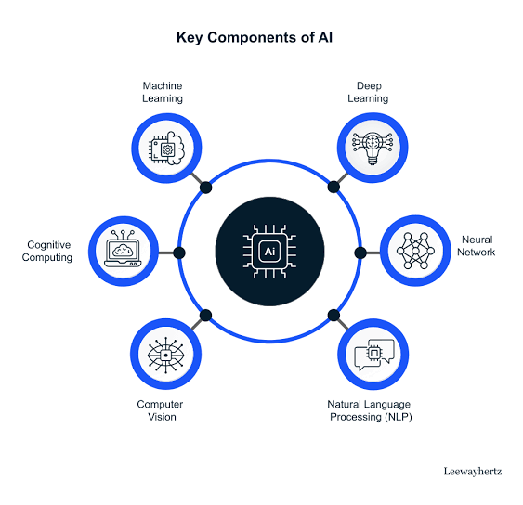

**Figure 1: key components of AI**

(Source: Jahan and Sazu,2022)

Artificial intelligence and automation are two trending technological methods, which are currently minimising human input and providing a more efficient workforce in various industries. Moreover, these technologies can be used in supply chain management to assist the employees who are in charge of the complex tasks in the supply chain process. However, AI systems are argued to require human inputs while leveraging machine learning without the need of human direction (Bhagat *et al.* 2022). These technologies are not a threat to the labourers’ positions in an industry but a method to increase work efficiency and distribute the challenging workload to the machines. According to Deloitte, 79% of the organisations which focus on a higher performance of supply chains, are able to achieve revenue growth (deloitte.com, 2023). A growing number of consumers now prioritise organisations which focus on environmental sustainability. With this, organisations need to increase awareness of this area in the supply chain management process. Determining the risks which the traditional methods are causing environmentally, more products need to switch to sustainable energy sources like hydrogen to reduce Carbon emission. Organisations need to create action plans such as WWF’s Supply Risk Towards Sustainable Sourcing Initiative (supplyrisk.org, 2023). Internet of Things is a network of objects which are wireless, digitally connected and accessible from everywhere, thus this technology can help organisations in creating the future of supply management which delivers utmost customer experience.

However, methods such as digitisation of organisations are necessary to achieve this level of supply chain. Experts believe that a supply chain which is digitised can be effectively streamlined through electronic devices, smart phones and laptops helping employees to supervise from everywhere (Kpmg.us, 2023a). However, the transition to digitisation can be a threat to the organisations as it requires the right technology to meet the consumer’s needs. The main focus of the organisations is to not only create a product, but to be able to deliver it to the customers whenever and wherever it is required. This case study has helped in determining that KPMG USA has designed a purpose-built supply chain management which provides a full-service advisory firm with a broad range of industrial and functional experience. As stated by Baldwin and Freeman (2022), the greatest risk in building a supply chain is the cost of raw materials. Organisations need to mitigate this risk of raw materials by spending less time on the low demand goods and focusing mainly on the core product.

# Describe the tools such as ‘predictive analysis’ and ‘artificial intelligence’ in the risk management in the future supply chains

The supply chain management process needs to be improved in order to meet the growth of demands of the customers. KPMG International has launched a program in collaboration with the University of Leeds to face the future changes in the supply chain management process (kpmg.com, 2023). This can be achieved through the method of productive analytics which allows the organisations to determine the level of optimal inventory while minimising the stocks. The predictive method uses sophisticated models and allows managers to analyse detailed inventory requirements divided into categories by region, usage and location. Predictive analysis uses the methods of statistical modelling combined with a study of historical data collection (supplychain-brain, 2023). The first step in this process is to create a mathematical model to represent the ongoing trends and testing forecasting models which replicates the real market threats of the future. As product price is dependent on the shipping and delivery of products, organisations can predetermine the margin of the prices involved in the supply chain management through this method (Bhagat *et al.* 2022). However, the predictive analysis method also allows the companies to forecast the future demand of the products. As stated by Bhagat *et al.* (2022), there are usually three methods of using this process such as classification model, clustering model and time series model.

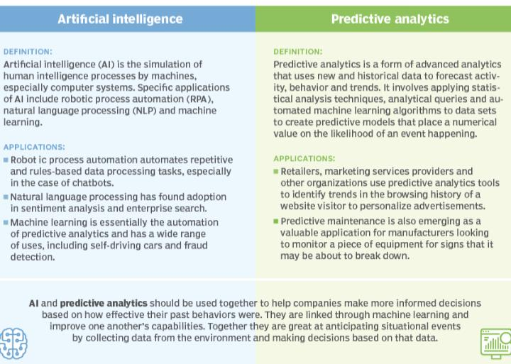

**Figure 2: difference between predictive analysis and AI**

(Source: Bhagat *et al.* 2022)

The classification model of the predictive analysis method is focused on using supervised machine learning models. Predictive models can be used to classify the consumers or prospects into distinct groups. Alternatively, this method can be useful in credit risk evaluation and fraud detection through logistic regression and neural networks. On the other hand, the clustering model is based on unsupervised models which use clustering algorithms. The common algorithms which are used include, DBSCAN (Density Based Spatial Clustering of Applications with Noise), EM (Expectation Minimisation), GMM (Gaussian Mixture Models) and Hierarchical Clustering (kpmg.com, 2023). However, although this method is used by 84% of the leaders in the market, often organisations struggle to make the data-driven decisions. Therefore, it is determined through this case study that using AI is a less risky way to enhance supply chain management (Kpmg.us, 2023a). AI-driven supply chain management tools prove to be more useful with the handling of mass data. Therefore, the newer and more advanced AI systems are capable of forecasting seasonal demand of products and even predicting or discovering new consumer habits.

AI based automation is capable of assisting timely retrieval of scheduled items from the warehouses and is also capable of reducing the cost of warehouse labours. Moreover, there are other benefits of using AI technology in the growth of supply chain management such as reduced operational cost and ensured on time delivery. As stated by Modgil *et al.* (2022), the AI system helps the entire process of supply chain management to be error free for a long time. An error free work process also reduces workplace accidents and overall costs of employee satisfaction. AI systems reduce the dependency on human efforts making the entire process of supply chain management faster ensuring on time delivery to the customers. However, there are also potential challenges in the use of artificial intelligence in the supply chain management process (Kpmg.us, 2023b). The down sides of AI include unforeseen system complexities as the systems are cloud based and require an expansive bandwidth in order to function properly and these systems can be unaffordable for small businesses. Using the AI system can also have hidden costs of employee training programmes in order to learn the techniques of using such advanced technologies.

# Describe the implication of ‘reverse flows’ and ‘circular logistics’ in the future supply chain management processes

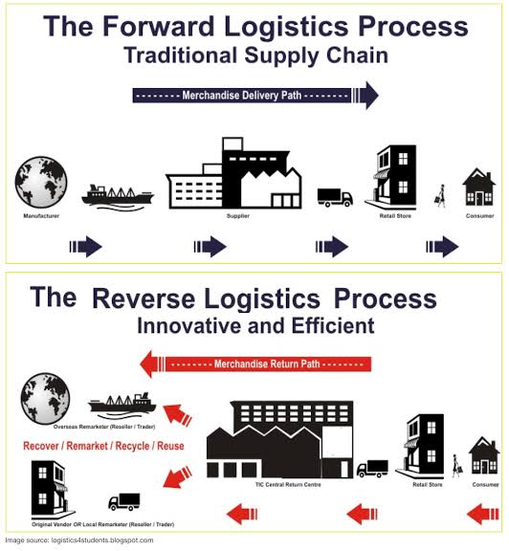

**Figure 3: the concept of forward and reverse logistics in supply chain**

(Source: inspired by the ideas of Josg *et al.* 2023)

Reverse flow or reverse logistics in supply chain include planning, implementation and controlling of the storage of goods, efficient inbound flow and all related information. The reverse supply chain refers to the process of reverse movement of goods from customer to vendors. Moreover, this process includes repair, redistribution, recovery, or warranty related activities depending on the level of damage or defect, a separate supply chain is sometimes established. Reverse logistics can be strategized in order to increase the efficiency of the supply chain management process and decrease customer dissatisfaction (ascm.org, 2023). In the post pandemic market, the logistics industry is facing difficulties such as rise of transportation costs, lack of communication, delivery delays and extended warehouse management. These challenges can be mitigated through the process of Omnichannel logistics which synchronises inventory, distribution and logistics across sales channels to successfully meet the customer demand. As commented by Joshi *et al.* (2023), Omnichannel logistics ensures that the consumers get a seamless shopping experience while also increasing sales. However, the reverse flow method can be implemented positively by organisations as well for the recycling of products (Anasoft, 2023). Recycled products are cost-effective as well as environmentally sustainable, thus focusing in this area can be beneficial for businesses.

Similarly, a circular logistics economy can be implemented as this is a process which focuses on the cycle of returning products for refurbishment, replacement and recycling. In this circular supply chain management process raw materials are used to revive the products into manufacturing operation. As a whole this entire process of collecting and aggregating products is also referred to as the aftermarket supply chain. As stated by Kazancoglu *et al.* (2022), the reverse flow is necessary to keep the flow of products at a reduced cost while it also creates value for the products which would be otherwise thrown out. The future supply chain management has to implement these circular methods to sustain in the markets. According to studies, 74% of the supply chain leaders expect this method of circular supply chain to increase profits through 2025 (forbes.com, 2023). There are five R’s of reverse logistics such as returns, recalls, repairs, repackaging and recycling. The products are firstly returned when it fails to meet expectations, is defective or has simply run its course. The next step is to repair, refurbish or re manufacture the product, the materials from the returned goods are reused to make sustainable products. The next step is to repackage the items after testing the ability of the products in order to ensure its quality.

The future supply chains can implement the synchronisation method to perform better in the future. Synchronisation is done by coordinating, managing and organising the flow of the entire supply chain (hbr.org, 2023). Products, services, finances and information is processed in such a way that it performs as a single entity. The discussed method helps in increasing the profitability of products making it more efficient and cost effective. The organisations need to map the entire path of the supply of raw materials in the supply chain, in order to implement the circular logistics method. The companies need to rethink product design and collaborate with newer pathways such as hacks to use lesser resources. As stated by Giorgi *et al.* (2022), the suppliers need to be included in the decision-making process in order to establish a successful circular strategy. The main goal of reverse logistics is to recapture the value of the used products and increase revenue; thereby the process helps in boosting the efficiency of the traditional supply chain.

# Describe the new technologies which can help in resolving these tricky issues.

Challenges which are often faced by organisations are lack of quality customer service, costing, risk management, relationship with the suppliers, lack of qualified personnel in the field and unforeseen delays in delivery. This case study focuses on the two most difficult issues such as the last mile delivery and product return issues. The last mile delivery is the final step in a product's journey as it is shifted from the warehouse to a customer's doorstep. The last delivery process where a delivery person delivers the package to the consumer is the last mile delivery (assets.kpmg.com, 2023). The issues with this process is that the customers have expectations that the delivery will be free of cost, fast, communicative and efficient, but this is the most time sensitive and expensive part of the supply chain. As stated by Ratnagiri *et al.* (2022), the process of last mile delivery lacks efficiency and majorly affects the customer satisfaction making it one of the major challenges in supply chain. The last mile delivery often fails to meet the deadlines due to inefficiency which in terms leads to cancellation of orders.

The last mile delivery issue can be resolved by dynamic route planning, in this process delivery vehicles are tracked until it finishes its delivery. Real time shipment tracking can also be done, not only by the users but also the retailers in order to determine the delivery drivers’ exact location (assets.kpmg.com, 2023). This method also helps in gaining insight about the estimated delivery time of the product. A last mile delivery solution has to be communicative and has to maintain transparency with the consumer. Offering to let the customers know about the exact reason for the delay in delivery helps in reducing customer dissatisfaction.

Product returns are also one of the greatest issues with supply chain management, as it is the set of processes which are used to track the returnable products due to specific reasons. It is also necessary for the organisations to understand the needs of the consumers in order to build a successful supply chain management (eCommerce Next, 2023). Return of products can affect the warehouse build up, as the number of returns increase; warehouses have an overload of tasks due to both inbound and outbound products lining up. A shortage of staff is also increasing as the return of products is increasing, this can be only mitigated through a proper return management plan. As build-up of returned products initiate a downward flow, it impacts the planning and inventory optimisation of the customer demand. As stated by Rozhkov *et al.* (2022), the lack of inventory also affects the entire supply chain process leading to customer dissatisfaction. There are methods to mitigate these challenges such as offering in-home pick up of the returnable products to avoid the delay of in-shop product returns; the in-home return process has reached popularity after the impact covid 19 had on the society. It can be easier for the organisations to be transparent with the customers by offering a real-time tracking of the packages. These strategies can be useful to mitigate challenges of the advanced supply chain management in the future.

# Conclusion

This case study has focused on the e-supply chain management process and the future changes it has to make in order to increase overall sustainability in the market. Therefore, this study has helped in determining the challenges of supply chain management and also helped in analysing methods to mitigate identified challenges. AI can help in the success of supply chain management through the use of powerful optimisation capabilities, improved demand capabilities and fostering a much safer work environment. AI-driven supply chain management systems are effective in canalisation and interpretation of massive datasets, thereby providing time sensitive information to the organisations.

# References

Anasoft (2023), *8 Trends in Supply Chains.* Available at: https://www.youtube.com/watch?v=WFZLpAEtdWw [Accessed on: 17/04/23]

ascm.org (2023), *What Is Reverse Logistics?* Available at: <https://www.ascm.org/lp/reverse-logistics/#:~:text=Reverse%20logistics%20refers%20to%20the,either%20the%20retailer%20or%20manufacturer> [Accessed on: 17/04/23]

Assets.kpmg.com (2023), *Last-mile-delivery-optimisation* Available at: https://assets.kpmg.com/content/dam/kpmg/lk/pdf/last-mile-delivery-optimisation.pdf [Accessed on: 17/04/23]

Assets.kpmg.com (2023), *Transport-tracker* Available at: https://assets.kpmg.com/content/dam/kpmg/xx/pdf/2018/06/kpmg-transport-tracker-june-2018.pdf [Accessed on: 17/04/23]

Baldwin, R. and Freeman, R., (2022). Risks and global supply chains: What we know and what we need to know. *Annual Review of Economics, 14*, pp.153-180.

Bhagat, P.R., Naz, F. and Magda, R., (2022). Artificial intelligence solutions enabling sustainable agriculture: A bibliometric analysis. *Plos one, 17*(6), p.e0268989.

Deloitte.com (2023), *Supply Chain leadership* Available at:https://www2.deloitte.com/us/en/pages/operations/articles/supply-chain-leadership.html [Accessed on: 17/04/23]

eCommerce Next(2023), *How The Supply Chain Enables Successful Retail And e-Commerce* Available at: https://youtu.be/8Ci5Xe3AlvM [Accessed on: 17/04/23]

forbes.com (2023), *the-circular-supply-chain-a-push-for-sustainability* Available at: https://www.forbes.com/sites/stevebanker/2021/06/29/the-circular-supply-chain-a-push-for-sustainability/ [Accessed on: 17/04/23]

Giorgi, S., Lavagna, M., Wang, K., Osmani, M., Liu, G. and Campioli, A., (2022). Drivers and barriers towards circular economy in the building sector: Stakeholder interviews and analysis of five European countries policies and practices. *Journal of cleaner production, 336,* p.130395.

hbr.org (2023), *Reverse-supply-chain*. Available at: https://hbr.org/2002/02/the-reverse-supply-chain [Accessed on: 17/04/23]

Jahan, S.A. and Sazu, M.H., (2022). The Impact of Data Analytics on High Efficiency Supply Chain Management. *CECCAR Business Review, 3*(7), pp.62-72.

Joshi, S., Sharma, M. and Chatterjee, P., (2023). Omni-Channel retailing enhancing unified experience amidst pandemic: An emerging market perspective. *Decision Making:* *Applications in Management and Engineering, 6*(1), pp.449-473.

Kazancoglu, Y., Ozbiltekin‐Pala, M., Sezer, M.D., Luthra, S. and Kumar, A., (2022). Resilient reverse logistics with blockchain technology in sustainable food supply chain management during COVID‐19. *Business Strategy and the Environment.*

KPMG USA (2023), *The Future of Supply Chain* Available at: https://www.youtube.com/watch?v=wwjzxHI92Eg [Accessed on: 17/04/23]

kpmg.com (2023), *SHAPING 2040* Available at: https://kpmg.com/xx/en/home/insights/2022/02/shaping-2040.html [Accessed on: 17/04/23]

kpmg.com (2023), *The Race To Predictive Analysis* Available at: https://kpmg.com/xx/en/home/insights/2021/05/the-race-to-predictive.html [Accessed on: 17/04/23]

Kpmg.us (2023a), *Future Supply Chain.* Available at: <https://advisory.kpmg.us/insights/future-supply-chain.html> [Accessed on: 17/04/23]

Kpmg.us (2023b), *Predictive analytics and fixed asset management.* Available at: https://advisory.kpmg.us/articles/2017/predictive-analytics-fixed-asset-management.html [Accessed on: 17/04/23]

Modgil, S., Singh, R.K. and Hannibal, C., (2022). Artificial intelligence for supply chain resilience: learning from Covid-19. *The International Journal of Logistics Management, 33*(4), pp.1246-1268.

Ratnagiri, M., O'Dwyer, C., Beaver, L.E., Bang, H., Chalaki, B. and Malikopoulos, A.A., (2022), October. A scalable last-mile delivery service: From simulation to scaled experiment. In *2022 IEEE 25th International Conference on Intelligent Transportation Systems (ITSC)* (pp. 4163-4168). IEEE.

Rozhkov, M., Ivanov, D., Blackhurst, J. and Nair, A., (2022). Adapting supply chain operations in anticipation of and during the COVID-19 pandemic. *Omega*, 110, p.102635.

Supplychain-brain. (2023), *Supply Chain 2040.* Available at: https://www.youtube.com/watch?v=zA0NbwVVJzg [Acessed on: 17/04/23]

Supplyrisk.org(2023), *SUPPLY RISK* Available at: https://www.supplyrisk.org/ [Accessed on: 17/04/23]