**CONSULTANCY REPORT FOR PARADISE HILL**

**Table of Contents**

Introduction 3

Main body 3

SWOT analysis of Paradise Hill 3

Recommendations 9

Conclusion 12

Reference list 13

# Introduction

In recent years, the hospitality and tourism industry is observed to be growing aggressively competitive which apparently creates a pressure on the enterprises to maintain an effective strategic direction and an inclination towards innovation to conquer the competitive standard adeptly. Paradise Hill is such a hotel established in the middle of 2007 that has gained adequate popularity being associated with the 5-Star hotel chain under a reputed global hotel brand. This particular hotel chain was established to cater to the expanding needs of a particular tourist market in addition to the requirements of the local corporate community. Despite initiating the business in an optimistic manner, this hotel is currently found to undergo a critical period due to the rise of several challenges and issues that disappointingly undermine the scope of accomplishing success. Thereafter, the need of taking the assistance of expert professionals is raised and thus, the Fixit Hotel Consulting Firm is hired. In essence, the central focus of this report is to develop an effective consultancy report in order to provide an explicit strategic direction to the management of Paradise Hill hotel. Hence, this report will shed light on an extensive analysis of the internal environment of the hotel by applying SWOT analysis framework in order to identify the strengths and weaknesses that the hotel is currently possessing and also further opportunities and threats that can be apocalyptic for the hotel business of Paradise Hill. Eventually, some recommendations will also be suggested to Paradise Hill for immediate mitigation of the identified problems and challenges.

# Main body

## SWOT analysis of Paradise Hill

**Strengths**

**Location**

Location is accounting for affecting the demand for a hotel to a great extent. As per the statement of Chilufya *et al.* (2019), the location of the hotel affects practically all of the leisure pursuits that visitors engage in, and a majority of their vacation plans are dependent on the hotel's connectivity and proximity. Thus, the hotel serves as a benchmark to each of the contemporary travellers. In this case, the location of the hotel Paradise Hill is massively appreciated for its geographical location as the connectivity to the other major cities alongside the railways, airports and highways is quite impressive. Moreover, both the domestic and international travellers can be captivated by the exquisite views of the station. In fact, the location where the hotel is situated shares the best features by being the center of historical tours, shopping, entertainment, vacationing and higher education as well.

**Strong workforce**

Adequate manpower or strong workforce is considered to be the greatest asset within the hospitality industry. As per the statement of Ting *et al.* (2022), the concept of strong manpower includes the well-equipped employees with relevant skills and knowledge that are able to manage a range of requirements and satisfy customers by meeting them. In this case, the recruiters of this hotel are more inclined to hire employees that possess relevant skills and knowledge adequately so that the standard of the services and the overall productivity can avoid the scope of hindrance. Based on the survey, it is observed that the employees of this hotel are massively appreciated for their product-knowledge and behaviours which assist them offering the best customer experience in turn of choosing rooms at this hotel for travel accommodation.

**Commendatory brand image and loyalty**

Commendatory brand image and brand loyalty are recognised to be one of the most significant strengths that hotel Paradise Hill seems to possess during its inception. As per the statement of Tran *et al.* (2019), brand image is significant for every modern business since it paves the way to utmost success for a company by developing a certain idea, belief and impression about a brand within the minds of customers. All the customers of Paradise Hill are requested to share their insights and experience following their stay at the hotel which is likely to be received in the form of feedback by the hotel. The responses of the survey are the testimonies of the commendatory brand image that Paradise Hill has become successful in developing by supplying exceptional customer service which includes good quality food and beverage and room amenities and services. In return, the revelation of the accomplishment of great brand loyalty is ensured by excellent ratings on the internet and repetitive purchasing behaviour.

**Weakness**

**Lack of strategic direction**

Strategic direction is a vital component for every business firm, specially for the hospitality sector as the failure of appropriate strategy adoption seems to lead a company towards severe decline or even prolonged collapse. As per the statement of Knight *et al.* (2020), the articulation of a strategic direction provides a company with a certain direction towards which the company can move and achieve adequate success by attaining business goals and objectives. Although this hotel was initiated with a proper strategy in its inception, lack of continuous investment of effort and time to improve strategies according to the requirements and trends of the global hospitality industry is the major weakness possessed by Paradise hill. Lack of appropriate strategic direction is merely accountable for hampering the sustainable growth and innumerable competitive advantage against the cut-throat industry competition. yet it is an explicit revelation of the leaders’ incompetence of making impactful decisions for the betterment of this specific hotel.

**Poor leadership**

From the case study, it is understood that the poor leadership practice is another factor lying behind the gradual decline of Paradise Hill. As per the statement of Wallerstein *et al.* (2019), while leadership is acknowledged to be the greatest force strengthening the foundation for exceptional organisational performance, poor leaders are criticised for being ineffectual in guiding followers towards a right direction and hampering the standard of organisational productivity. The vulnerability of leadership is prominent while the management of the hotel are found to conduct board meetings barely with an intention to evaluate the annual sales and the amount of generated revenue instead of focusing on sustainability, strategic orgamisational growth and competitive advantages. This contemplation indicates that the overall business of Paradise Hill is relying over such leaders that have no or lack of vision and charismatic behaviour.

**Lack of employee motivation**

Being integrated into the organisational environment, poor leadership behaviour seems to yield the situation where employees are losing motivation and becoming dissatisfied with the job. As per the statement of Sulila (2020), lack of employee motivation can be one of the most significant determinants for posing detrimental effects and restricting an organisation to achieve ultimate goal and success. The working environment at the hotel is observed to change gradually which directly affected the synergy of the employees who served Paradise Hill since the inception. A salient friction amongst the employees seems to take place as a result of dissuading leadership. Eventually, the employees fail to remain dedicated and devoted to their responsibilities, which apparently results in decreasing the level of output and the standard of organisational productivity drastically.

**Reluctance in marketing**

Robust marketing strategy is another crucial aspect deeply integrated into the ground of business success. As per the statement of Roy *et al.* (2020), marketing is perceived as an activity that involves modern businesses into the practice of promoting and spreading awareness about products and services across the markets as well as influencing the purchasing decisions of customers. This contemplation has motivated the global hospitality industry to invest a lump sum into marketing and thus, currently, the overall market size of marketing has reached $52.26 billion in 2021 (Statista, 2021).

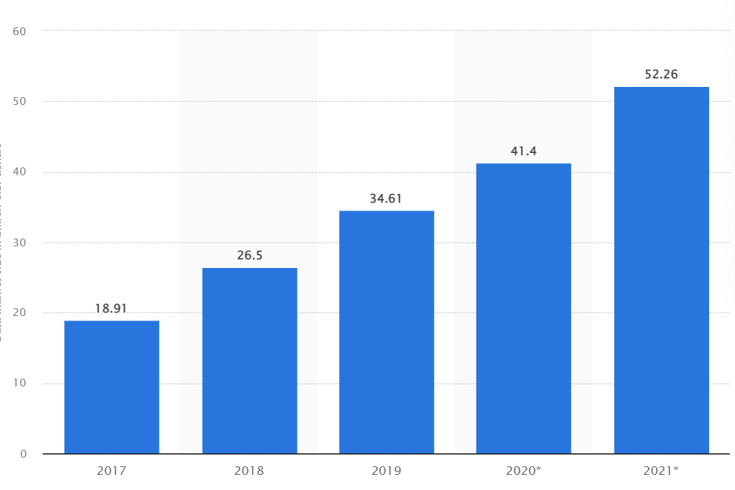

**Figure 1: Annual growth of marketing industry**

(Source: Statista, 2021)

Disappointingly, reluctance in spending adequate amounts for marketing is represented as the biggest drawback that Paradise Hill is currently possessing. It is to be noted that there is no or less participation of the concerned hotel in marketing the affiliated brand either in domestic or even in international markets.

**Poor customer service**

Providing excellent customer service is crucial in the hospitality sector considering it is occasionally the primary and the ultimate interaction that customers encounter with a firm. Despite providing exceptional customer service, this hotel nowadays seems to experience salient failure in maintaining the same standard in the similar ground. As per the statement of Ali *et al.* (2021), poor customer service is reflected while the clients are observed to receive subpar, inaccurate and unpleasant services from a company. In the case of Paradise Hill, inadequate hospitality of the front desk staff has been a source of complaints from visitors. Frequently, no staff member was readily accessible at the front desk to deal with the guest's specific needs, or the span of waiting for a customer service representative was excessively long. Moreover, the crew assigned for managing the front desk is allocated with multiple duties and thus, guests are often forced to undergo a long wait during the check-in process at the hotel. In fact, the attitudes of employees in-charge of the restaurant, the overall quality of the services regarding food and room alongside the cleanliness in the rooms are the other factors that make the guests disappointed (As given in the case study). As a result, they tend to share their experience over the internet platforms and raise negative contents.

**Opportunities**

**Sustainability**

The concept of sustainable development is a vital aspect currently dominating the hospitality industry as a whole. As per the data shared by Openaccessgovernment, (2018), the hospitality industry seems to affect the natural environment harshly as the overall waste production of the hotel industry is estimated to be 289,700 tonnes amongst which 79,000 tonnes which is 9% barely the food waste on the annual basis.

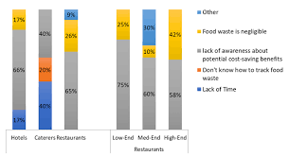

**Figure 2: Waste production by the hospitality industry on the annual basis**

(Source: Openaccessgovernment, 2018)

Being an integral part of the premium hotel chain business, it is important for Paradise Hill to focus on sustainability and its development. This approach is significant for this hotel as it restricts hotel businesses to pose detrimental effects on the environment by saving high energy consumption and usage of natural resources and also spreads awareness regarding the same across the travellers’ community and motivates them to become responsible and sustainable travellers at the same time.

**Rise in staycation trend**

Staycations have grown in popularity in recent years as more people seek for methods to unwind and rejuvenate without having to deal with the stress and expense of travelling. As the majority of the contemporary travellers require less travel and frequently include regional events and instances, staycations are also becoming more popular as a more environmentally friendly vacation option. As per the data shared by Travelpulse, (2022), 67% of millennials have already experienced the essence of staycation during and even in the post-pandemic situation.

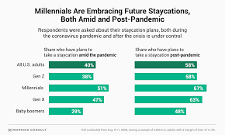

**Figure 3: Increasing demand for staycation amongst different generation**

(Source:Travelpulse, 2022)

In 2023, this trend is projected to grow exponentially as the demand for this trend is growing at a fast pace.

**Threats**

**Aggressive competition**

Over a few decades, the hotels industry across the globe is witnessing a fierce competitive standard which forces many of the hotel businesses, irrespective of their size, to struggle for survival. As per the statement of DiResta *et al.* (2020), competitive aggressiveness is the practice of forcibly introducing new items, price reductions, marketing initiatives, or similar moves in an effort to deceive rivals and gain momentary competitive benefits. In this case, it is salient that the rise of another property under the name of “Beyond Paradise” poses a major threat against Paradise Hill by increasing the competition. As per the given case study, Beyond Paradise seems to offer the facility of Spa as an additional form of entertainment to the guests alongside the advanced amenities and extraordinary customer service. Taking the transport convenience into consideration for travellers, this hotel provides shuttle services to their guests in terms of travelling to various historical destinations in towns. In fact, the employees associated with this hotel are more motivated as compared to the existing employees in Paradise Hill. Thus, this hotel is relishing a higher level of productivity and performance which gradually can help the hotel to become a key player in domestic and international markets as well.

**Higher employee turnover**

Poor employee motivation and morale is not merely responsible for increasing job dissatisfaction in the minds of the employees, yet it drives the higher degree of employee absenteeism and employee turnover considerably Skelton *et al.* (2020). Likewise, Paradise Hill is likely to witness a massive challenge due to the increasing rate of employee turnover at its workplaces which apparently poses a threat to the productivity and sustainability of the firm. The detrimental effects of employee turnover are lower productivity, increased numbers of error and the rise of complaints shared by the customers over digital platforms and social media which can affect the overall reputation of the brand harmfully.

# Recommendations

**Leadership**

After analysing the given case study, it is understood that ineffective practice of leadership makes the Paradise Hill vulnerable in accomplishing success to a great extent and thus, it requires an immediate improvement. There are several leadership theories that have been articulated and explained in order to provide a clear concept about leadership so that an individual can easily bridge the gap in similar skills by mastering it. As per the statement of Hunt and Fedynich (2019), The Great Man theory is identified to be a traditional theory which has explained that leaders are born with the skills while the contemporary theories have criticised the concept by proving that leadership can be embraced more effectively by improving the skills. In the case study, the leadership team of Paradise Hill tend to practice autocratic leadership due to which a strong communication gap is created between the employees and the leaders. As a result, the employees are found to feel less valued and not supportive. Nordin *et al.* (2020) argued that Lewin’s leadership model mentions three different styles of leadership including delegative leadership, participative leadership and authoritarian leadership.

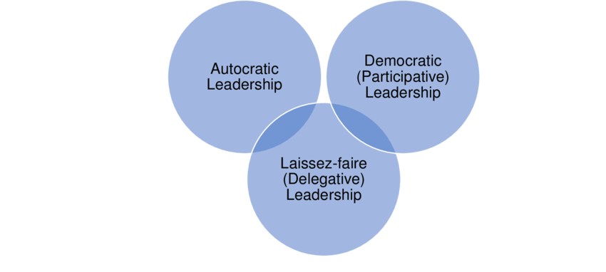

**Figure 4: Lewin’s leadership theory**

(Source: Mukhtar and Fook, 2020)

In this case, the leaders are recommended to adopt the traits of participative leadership behaviour as this specific approach assists leaders to make impactful decisions by involving all the team-members and figure out innovative solutions eventually. As a result, employees are able to feel empowered and valued which further keeps them up with great self-confidence and dedication. Moreover, a strong bond between the employees and the leaders are saliently developed.

**Employee motivation**

The given case study reveals that the concerned hotel is criticised for practicing poor employee motivation and thus, it is another aspect that requires an immediate mitigation through appropriate strategy. It is to be noted that motivating employees is the responsibility of leaders and thus, they are recommended to develop an in-depth understanding of Herzberg’s Two factor theory for improving the practice of employee motivation at the workplace of Paradise Hill. As per the statement of AbouAssi *et al.* (2021), the two factor theory is taken into account for conceptualising that job satisfaction and job dissatisfaction are the two opposite factors that perform in a circular motion. Based on this theory, it is clarified that only motivated employees can be satisfied with their job and competent to deliver outstanding performance on professional grounds. In the case of Paradise Hill, it is analysed that the hotel tends to maintain an optimistic employee motivation by offering discounts on some facilities. However, it is essential to understand that motivation can be intrigued based on several factors. As per the statement of Kollmann *et al.* (2020), offering rewards and recognition to the well-deserved employee in return for their extraordinary performance is considered to be a more effective way to motivate the employees for dedicating their hard work and devotion to the productivity standard. Apart from that, open communication and the exchange of feedback between the leaders and the team-members is identified to be another dynamic means of motivating employees. While clear communication helps employees to better understand their responsibilities to meet the common goals, exchange of feedback helps them to upgrade their skills and knowledge and broaden the scope of further professional growth. Increment in pay, incentives and promotion are the other significant forms of increasing the numbers of motivated employees in the workplace of the hotel. Nevertheless, mental and physical wellbeing of the employees are taken into account in the form of hygiene factors that also play a vital role in motivating employees and fostering job satisfaction alongside the motivating factors.

**Marketing**

Marketing beholds a major contribution to the success of a business in present days. As per the statement of Gursoy *et al.* (2022), an adequately strategic marketing aids a brand with an increased brand awareness, increased customer base and enhanced sales volume which collectively elevate the profit margin of a brand to a great extent. However, the case study underlines the neglecting tendency of the hotel towards the right marketing approach which has affected the success of the hotel business to a certain point. In this context, the hotel is suggested to adopt the omnichannel marketing tactics to extract maximum benefits. The omnichannel marketing approach assists the hotel in maintaining its omnipresence in multiple channels including offline and online platforms.

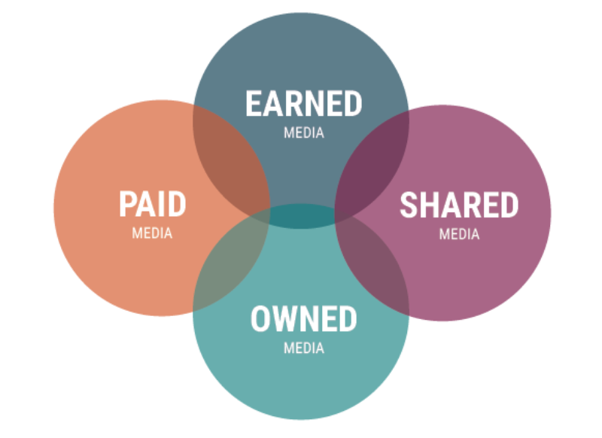

**Figure 5: PESO analysis**

(Source: https://images.squarespace-cdn.com/content/v1/5588990be4b0bb81f487f5a9/1435156142216-UUBDTWRTQ9K8QVL254NI/PESOModel)

However, the main focus should be more on utilising digital platforms such as official websites, social media and more as the majority of travellers tend to search and book rooms and tours over online platforms. In this context, a good understanding of the PESO model encourages the leaders to make impactful decisions regarding the selection of appropriate digital channels for ensuring effective marketing. As per the statement of Monras (2020), PESO introduces four dynamic marketing means that encircle paid media, earned media, shared media and owned media.

# Conclusion

In conclusion, it can be said that the thorough SWOT analysis has helped the consultancy expert to identify and assess the strengths, weaknesses of Paradise hotel and leadership, employee motivation and marketing are identified to be the major weaknesses possessed by the 5-Star hotel chain. In the course of developing an accurate consultancy report, the hotel is suggested to practice participative leadership; offering rewards and recognition, incentives, promotion to the well-deserved employee and adopting omnichannel marketing tactics to bridge the gap in leadership, employee motivation and marketing respectively.

# Reference list

AbouAssi, K., McGinnis Johnson, J. and Holt, S.B., 2021. Job mobility among millennials: Do they stay or do they go?. Review of Public Personnel Administration, 41(2), pp.219-249.

Ali, B.J., Gardi, B., Jabbar Othman, B., Ali Ahmed, S., Burhan Ismael, N., Abdalla Hamza, P., Mahmood Aziz, H., Sabir, B.Y., Sorguli, S. and Anwar, G., 2021. Hotel service quality: The impact of service quality on customer satisfaction in hospitality. Ali, BJ, Gardi, B., Othman, BJ, Ahmed, SA, Ismael, NB, Hamza, PA, Aziz, HM, Sabir, BY, Anwar, G.(2021). Hotel Service Quality: The Impact of Service Quality on Customer Satisfaction in Hospitality. International Journal of Engineering, Business and Management, 5(3), pp.14-28.

Chilufya, A., Hughes, E. and Scheyvens, R., 2019. Tourists and community development: corporate social responsibility or tourist social responsibility?. Journal of Sustainable Tourism, 27(10), pp.1513-1529.

DiResta, E.A., Williford, K.T., Cohen, A.D. and Genn, A.B., 2020. The impact of COVID-19 on your advertising and marketing campaigns. Holland & Knight Alert.

Gursoy, D., Malodia, S. and Dhir, A., 2022. The metaverse in the hospitality and tourism industry: An overview of current trends and future research directions. Journal of Hospitality Marketing & Management, 31(5), pp.527-534.

Hunt, T. and Fedynich, L., 2019. Leadership: Past, present, and future: An evolution of an idea. Journal of Arts and Humanities, 8(2), pp.22-26.

Knight, E., Daymond, J. and Paroutis, S., 2020. Design-led strategy: how to bring design thinking into the art of strategic management. California Management Review, 62(2), pp.30-52.

Kollmann, T., Stöckmann, C., Kensbock, J.M. and Peschl, A., 2020. What satisfies younger versus older employees, and why? An aging perspective on equity theory to explain interactive effects of employee age, monetary rewards, and task contributions on job satisfaction. Human Resource Management, 59(1), pp.101-115.

Monras, J., 2020. Immigration and wage dynamics: Evidence from the mexican peso crisis. Journal of Political Economy, 128(8), pp.3017-3089.

Mukhtar, N.A. and Fook, C.Y., 2020. The Effects of Perceived Leadership Styles and Emotional Intelligence on Attitude toward Organizational Change among Secondary School Teachers. Asian Journal of University Education, 16(2), pp.36-45.

Nordin, M.N.B., Mustafa, M.Z.B. and Razzaq, A.R.B.A., 2020. Headmaster Leadership Effect On Task Load Of Special Education Integration Program Teacher. Humanities & Social Sciences Reviews, 8(2), pp.451-456.

Openaccessgovernment, 2018.Available at: https://www.openaccessgovernment.org/hospitality-industry-waste/51174/#:~:text=Hotels%20%E2%80%94%20produce%20289%2C700%20tonne%20of,food%20waste%20from%20the%20sector).) [Accessed on: 17th April, 2023]

Roy, B., Kumar, V. and Venkatesh, A., 2020. Health care workers’ reluctance to take the Covid-19 vaccine: a consumer-marketing approach to identifying and overcoming hesitancy. NEJM Catalyst Innovations in Care Delivery, 1(6).

Skelton, A.R., Nattress, D. and Dwyer, R.J., 2020. Predicting manufacturing employee turnover intentions. Journal of Economics, Finance and Administrative Science, 25(49), pp.101-117.

Statista, 2021. Available at: https://www.statista.com/statistics/818754/global-marketing-data-market-size/#:~:text=Global%20marketing%20data%20market%20was,billion%20in%20the%20same%20period.[Accessed on: 17th April, 2023]

Sulila, I., 2020. The effect of discipline and work motivation on employee performance, BTPN Gorontalo. ARTIKEL, 1(4666).

Ting, C., Chan, A.Y., Chan, L.G. and Hildon, Z.J.L., 2022. “Well, I Signed Up to Be a Soldier; I Have Been Trained and Equipped Well”: exploring healthcare workers’ experiences during covid-19 organizational changes in Singapore, from the first wave to the path towards endemicity. International journal of environmental research and public health, 19(4), p.2477.

Tran, V.T., Nguyen, N.P., Tran, P.T.K., Tran, T.N. and Huynh, T.T.P., 2019. Brand equity in a tourism destination: a case study of domestic tourists in Hoi An city, Vietnam. Tourism Review.

Travelpulse, 2022.Available at: https://www.travelpulse.com/News/Features/The-Rise-of-the-Staycation .[Accessed on: 17th April, 2023]

Wallerstein, N., Muhammad, M., Sanchez-Youngman, S., Rodriguez Espinosa, P., Avila, M., Baker, E.A., Barnett, S., Belone, L., Golub, M., Lucero, J. and Mahdi, I., 2019. Power dynamics in community-based participatory research: A multiple–case study analysis of partnering contexts, histories, and practices. Health Education & Behavior, 46(1_suppl), pp.19S-32S.