**INTERNATIONAL BUSINESS AND DEVELOPMENT IMPACTS**

Table of Contents

Introduction 2

Question 1. Case Analysis: Impacts of International Business and Development in Nepal 2

Question 2: Theory on International Business and Development impacts 7

Question 3: Reflect on your views on development impacts in Nepal for international businesses. 9

Conclusion 11

Reference 12

# Introduction

International businesses in Nepal have developmental challenges which include social, economic and geographic issues. This assessment focuses on the challenges due to which globalisation of the brands are difficult in the country. The trade policies which help the countries international businesses are also explored in this study.

# Question 1. Case Analysis: Impacts of International Business and Development in Nepal

**Evaluate the major Four development challenges in Nepal**

Nepal is one of the most impoverished countries in the world; there are major challenges in the development of international businesses in the country. Four most critical challenges are, high rate of socio-political corruption in the country, deteriorating economic crisis of the country, lack of employment and high taxes and the increasing rate of poverty.

***Socio-political corruption in Nepal***

Corruption in domestic politics has increased in Nepal over the past few years, as a political crisis took place in the year 2020. During the inception of NCP there was power struggle between the political leaders of Nepal which led to internal crisis and dissolution of parliament (orfonline.org, 2023). The inter-party issues within the NCP became even more severe which caused the north, south neighbouring countries and United States to get involved in the conflict. Nepal came out of this geopolitical vortex due to the influence of other ideological positions of the political parties. Moreover, the political stability of the country reached the lowest in the year 2021, as the stability index was -0.24% (worldbank.org, 2023). Furthermore, Nepal signed the Belt and Road Initiative by China and the Millennium Challenge Corporation by the U.S. with the initiative to build better infrastructure in the country. However, this agreement led to even more political rifts in the country and consequences were severe as the geopolitical rivalry reflected the relationship with the neighbouring countries.

***Deteriorating economic crisis in Nepal***

Nepal’s economy is at a stage where it is heavily reliant on the remittances and the agriculture of the country. Overseas employees account for 9.1% of the entire gross domestic product of the country (cbo.gov, 2023). As a result of this, Nepal’s economic development and infrastructure has been slow. However, Nepal has a lower rate of living cost than other countries, due to the economic issues such as inflation, the living conditions have dropped even further. The inflation rate in Nepal has increased by 7.44% as of March 2022; the maximum level of inflation in Nepal was 30.42% (worlddata.info, 2023). The economic issues are rising as the government has no control over the increase of inflation as the country is import-dependent. As the international prices are rising Nepal is being forced to produce goods such as fuels, food and chemical fertilisers.

***Lack of employment and high taxes***

The employment rate is low in Nepal as the population of the country is rising rapidly. The population of Nepal is 30.5 Million as of April, 2023 whereas, the unemployment rate is 5.05% which has increased 0.33% from the year 2020 (worldbank.org, 2023). On the other hand, the country has 63.7% young adults under the age of 30, due to the lack of jobs 2.7% of the entire population chooses to migrate in pursuit of better opportunities. The sales tax rate of Nepal has reached 15% in 2023 which is an all time high (nepjol.info, 2023). The high rate of income taxes in terms affects the economic state of the residents. Major issues of taxation which Nepal faces include the marginally high rates of tax, low tax elasticity, lack of voluntary compliance, and the rigidity of income tax. These factors are corrupting the economic system of Nepal in a significant manner.

***Increasing rate of poverty***

Nepal is one of the most poverty-stricken and underdeveloped countries. In the year 2019, 17.4 % of the population is financially poor whereas the MPI is 0.074 (unicef.org, 2023). A major population of Nepal is deprived of housing materials, fuel, schooling and assets which prove to be a challenge to expand international business in the country. Nepal ranked as the third most corrupt country in South Asia as the inadequate supply of electricity and degrading condition of the roads in the rural areas are a major problem for the country. These are the socio-political challenges in the international business development of Nepal.

**Strategies for international businesses to mitigate the identified challenges in Nepal**

The lack of education in Nepal is affecting the entire economic system of the country. The literacy rate of the country is 71.15% (data.worldbank.org, 2023). Therefore, it is necessary to implement better educational infrastructure for the students in Nepal. Other programs such as internships, apprenticeships and career training can be useful in order to improve the literacy of the country. The government of Nepal has launched various poverty reduction activities such as subsidised ration distribution for the poverty ridden families, production input distribution for the agricultural farms (nepjol.info, 2023). The high population growth of the country is also a major challenge in the poverty reduction policies of the country. As the country’s economy is based on imported goods it is necessary to increase the internal infrastructure in order to increase the gross domestic product rate of Nepal. As stated by Cavallino & Sandri (2023), contractionary monetary policies are a popular method to reduce the supply of money within the economy of Nepal. Relaying on the solitary market or external niches can cause more issues for the country, it is necessary to explore the internal market of the country. Moreover, the challenges need to be mitigated in order to make the country’s environment profitable for international businesses. The political risks of instability can be mitigated through risk analysis methods, it is vital to research the political instabilities and infrastructural faults.

The local organisations have to invest more in the redevelopment of the country's internal structures. Understanding the markets, financial and political risks can be achieved through the local banks and governmental facilities. Furthermore, the decentralisation of the industrial activities is essential to reduce the unemployment rate of the country. As centralised activities cause fewer employment opportunities in the underdeveloped rural areas. This is a critical issue which needs long term solutions such as changes in the education system of Nepal, as well as changes in the industrial techniques and improved government policies. The country also lacks employment exchanges; as the dependency on the internally produced goods increase so does the opportunities of employment increase. As per the view of Mishra & Aithal (2023), the rate of capital formation in Nepal has to be accelerated and particularly encouraged in order to generate greater employment positions. However, population control policies also have to be implemented in order to resolve the imbalance on the country's economic and social issues. On the other hand, the income tax rates need to be reduced in Nepal as well by launching government schemes for the reduction of tax for the employees with low income rate. There are social castes and race related discrimination as well in Nepal which can cause issues for creating a diverse and inclusive workplace. As stated by Biswokarma (2023), Nepal has heavy discrimination against race and gender that needs to be reduced in order to create diverse work environments for international businesses. Awareness programs need to be held by organisations such as NGOs as a strategy to mitigate these discrimination issues.

**Evaluate Nepal’s policies towards conducting sustainable international businesses**

Nepal has adopted the Liberal trade policy in 1992; the newer Trade policy for the country was launched in 2014. The foreign trade in Nepal was directed towards a wide range of nations all over the world as Nepal became an official member of the WTO. The country has trade relations with over a hundred countries. The Nepalese government has shown interest in the establishment of an export oriented economy rather than the import based economy which is functional at present (uk.nepalembassy.gov.np, 2023). Companies have been exporting more than 90% of the produced goods from the custom, excise and sales taxes. However, the major barrier in the development of trade in Nepal is the lack of skilled force of labour. The lack of advanced technology in the country and difficult geological accessibility are some of the main barriers in the implementation of government policies in order to increase international businesses. Additionally, the limited domestic supply and high rate of importing is a difficulty. As per the view of Biswakarma & Bhandari (2023), trade policy can include all the policies which actively or passively affect the trade of goods and services of the country. The Nepalese government is intending to enhance the industrial bases as Nepal's supply is also affected by the political instability of the country. Moreover, the government policies are focused towards the extended improvement of the quality of goods and adopting appropriate trade policies.

The industrial policy of Nepal intends to create a competitive and open economy through the curtailing of the government interface. This helps in fixing the price of the products and industrial goods. On the other hand, Nepal has exported products worth 97.71 billion while also importing 1196.80 billion which has majorly affected the international business area of the country (in.nepalembassy.gov.np, 2023). However, there are other causes which affect the trade in Nepal other than the governmental policies, such as, landlockedness, lack of diversification, lack of resources, devaluation of domestic currency and political instability. The government of Nepal aims to reward the exporters who export massive amounts of Nepalese products and the major importers as it reflects on the promotion and expansion of export trade. However, the 2021 revision of the FITTA requires the foreign investors of Nepal to increase the proposed investment to 70% before the commencement of operations. The FDI facilities aim to transfer the financial resources and technology as well as other intangible assets of the country to the managerial and organisational operators of the market. Therefore, it helps in accessing the foreign markets in order to increase production of goods. The cost, technological, legal, and socio-cultural factors are main factors which help the country’s economic structure.

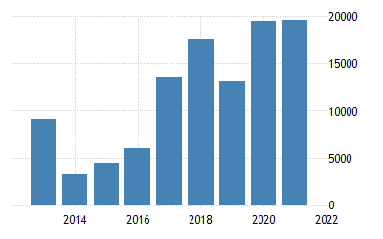

**Figure 1.1: Nepal’s FDI investment**

(Source: Dimitropoulos, 2023)

As the geographic condition is not in favour of Nepal’s international business, the country has been trading through India which itself causes the import and export prices to rise. The government is targeting to decrease the costs of crossing the border. As commented by Dimitropoulos (2023), the Nepal government is also implementing policies to open the borders in order to balance the cost effectiveness of the trading industry. However, this also poses a threat of the borders getting used by the smugglers or illegal traders. Sales taxes are levied based on the profits of the business and the retail sales, these taxes can differ between the nations. There are certain benefits of international trade in Nepal as it helps in the maximum utilisation of the resources of the country while increasing the inward flow of foreign currencies. Nepal also has bilateral trade agreements with four major countries which are Bangladesh, Pakistan, India and Sri-Lanka (nrb.org.np, 2023). The majority of Nepal’s Free Trade Agreements are with merchandise trade but lack trading in services, labour mobility and investment. However, Nepal is the largest trade partner and the largest source for the foreign trade investments. The country also provides transit for the entire third world country trade of Nepal. The government is capable of affecting the international business in a country by making changes in the tax amount, subsidies, trade regulations, interest rates licensing and the trade in general.

# Question 2: Theory on International Business and Development impacts

***Government policies for developing sustainable goals in multinational companies***

The sustainable development strategies for Nepal are based on four objectives that are effective to enhance the suitability of the businesses in multinational enterprises. Social progress and equality are the key objectives for sustainable development in multinational business in Nepal. Besides, environmental protection and conservation of natural resources are also a major part of sustainable development in multinational business companies.

***15th Plan’s Policy Orientation***

***Macroeconomic Policies***

The macroeconomic policies are effective to enhance sustainable consumption of financial resources that are effective to enhance the growth of multinational companies. The macroeconomic policies of 15th plan are effective to enhance the equity of public finance and are effective to promote the investment structure of the MNCs in Nepal (Npc.gov.np, 2023). Besides, it assists to enhance the efficiency of the economic structure in Nepal to ensure the development of multinational businesses.

***Economic Policies***

Economic policies refer to the enhancement of production and productivity by using effective investment structures. Economic policies of the fifteenth plan (Fiscal Year 2019-2023/24) are effective to maintain the business infrastructure of the MNC companies in Nepal (Npc.gov.np, 2023). This policy is effective to enhance the suitability of the environment by ensuring an effective business infrastructure that is helpful to increase the usage of environment friendly resources.

***Environment and climate change***

The environment and climate change is effective to enhance the business process of the MNCs in Nepal by utilising pollution control policies. The environment and climate change policy of the 15th Plan is effective to reduce business waste by using sustainable resources for the business process (Npc.gov.np, 2023). Furthermore, the usage of environment and climate change policy is effective in reducing the adverse effects of environmental pollution.

***Sustainable development goals in Nepal***

The usage of Nepal governmental policies for the sustainable development is effective to achieve the SDGs for the business of multinational companies. According to the views of Tripathi & Kaini (2023), the maintenance of sustainable development for the MNCs is effective to enhance the business structure accordingly. Besides, the usage of effective sustainable development policies is helpful to maintain the brand value of the MNC companies in Nepal. Fallah Shayan *et al.* (2022) have stated that, suitable development goals are effective to enhance the environmental conditions of Nepal by reducing the usage of conventional energy resources. The maintenance of environmental well being is effective to enhance the profitability of the MNCs in Nepal. Furthermore, the usage of effective sustainable goals for the MNC business of Nepal is effective to enhance the economic structure of the country. According to the views of Bhandari (2022), the maintenance of suitability includes maintenance of poverty rate, health wellbeing and clean water. The usage of 15th Plan’s Policy Orientation is helpful to maintain the sustainable development of the MNCs in Nepal. On the other hand, the maintenance of sustainable goals is helpful to maintain decent work and economic growth. The usage of sustainable development is effective to enhance the brand value of the MNC companies of Nepal by enhancing the wellbeing of the companies.

***Multilateral efforts of the MNC’s in the development of sustainable goals***

The United Nations Global Compact is a multilateral effort which provides a universal communicating policy for corporate responsibility while also providing a framework which helps by guiding the businesses regardless of its complexity or dimensions. Through the implementation of the ten principles of the UN Global Compact in the international business strategies or procedures the businesses are able to establish a culture of integrity. Moreover, it helps the companies to uphold the basic social and environmental responsibilities while also providing a background for long term progress.

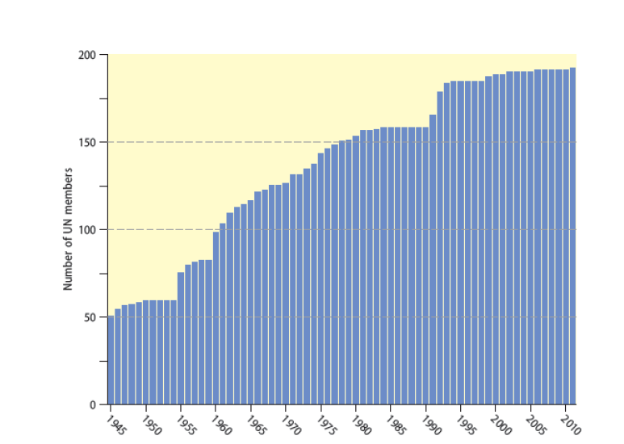

**Figure 2.1: The increase of UN members**

(Source: Gathered from lecture notes)

Multilateral agreements are negotiated between the nations which share geographic regions. Nepal has been an active member of the UN global compact; the country also participated in the UN peace support operations with the Nepali army (nepalarmy.mil.np, 2023). As this policy is a strategic initiative which supports the companies to expand globally. It also delivers commitment to ensuring that companies provide services while also maintaining the responsibilities towards the environment. Additionally, Nepal has focused on developing businesses sustainably by the SGD based need assessment costing and financing strategies and localisation guides. Nepal has maintained its sustainability by producing 0.027% of the global amount of greenhouse gas (ndi.org, 2023). The country has also pledged to achieve reduced carbon emission of zero emission by the year 2045 and increase the hydropower investment in order to save electrical damages. Therefore, these multilateral efforts make international businesses sustainable in the country.

# Question 3: Reflect on your views on development impacts in Nepal for international businesses.

I have assessed in this research based on the international business in Nepal that the country has major difficulties in the social aspects such as sudden increase of population, discrimination of gender and race leading to a lack of diversification and rising poverty. As I have researched the country I also came across issues and challenges relating to economic issues such as the high rate of inflation in the country. I have gathered the information from the lecture notes as well as scholarly articles from the Google Scholar. In this study I have also explored the aspects of Nepal being an import based country which increases the unemployment rate of the country. Nepal has gone up the rank of 94 out of the 190 economies as of 2020 (nepaleconomicforum.org, 2023). Therefore, I have also determined from this study that the country has also implemented governmental policies to improve the socio political aspects of international business. I have gathered from the lecture notes and the internet sources that the country is also lacking in the literacy rate, these factors need to be resolved to increase the sustainability of international business in the country. In my opinion, betterment in the education sector will also help in the unemployment issues of the country. Moreover, it is necessary for the country to make changes in the social sector in order to increase exporting and trading with neighbouring countries.

I have analysed from the research that one of the main issues is the import based nature of the economy of the country. In my opinion, the majority of the issues can be resolved by increasing the gross domestic product rate of the country. I have analysed that Nepal lacks in internally producing goods which affects the entire economy of the country. While conducting this research I have read journals about the International affairs of the country and came to the conclusion that the political instability has massively affected the country. I have determined from the study that Nepal has however maintained sustainability in the environmental sector as it has pledged to reduce carbon emission in a decade. Nepal has also succeeded in controlling the greenhouse gas emission of the country, in my opinion, from this aspect the country has performed exponentially. I have concluded from this research that it is possible to execute international business in this country after certain changes are implemented in order to increase sustainability. I have also explored the country's governmental policies which passively or actively affect international businesses. The strategies which can be implemented in the future, I have also tried to explore those. I have also come across information that Nepal is one of the largest trading partners despite the geographical issues it faces in the trading market. As per the view of Mahato *et al*. (2023), Nepal is one of the most poverty ridden countries in south Asia; it can be improved by strategic approach. I have conducted this research and determined that Nepal has to overcome the difficulties regarding the border and geographic condition.

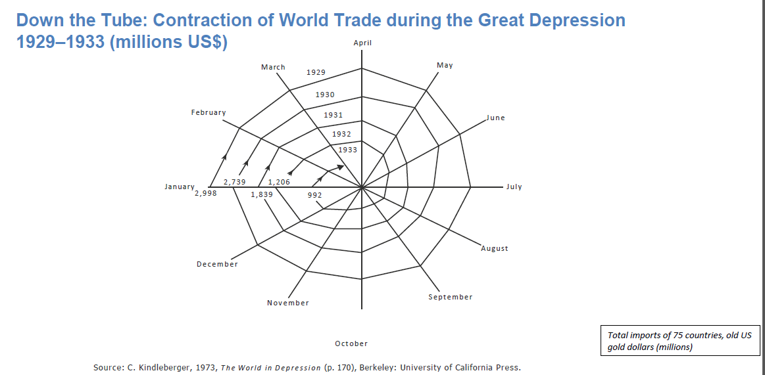

**Figure 3.1: World Trade**

(Source: Lecture Notes)

I have explored in this research that the country exports products through India which increases the overall trading cost. This sector, in my opinion, has to be resolved in order to make the entire process cost effective. I have gathered from the articles on Google Scholar that the Nepalese government has been actively putting in effort in order to open the barriers on the border. As per the view of Suwal, Gurung & Pei (2022), the implementation of an open border might increase illegal trading on the border as well. This will also help to make trading easier and less costly for the international corporations in my opinion. I have deduced that the governmental policies and multilateral policies can be useful for the sustainability goals of the country. I have discussed in this research that the macroeconomic government implemented policies can be especially useful in the sustainability increasing plan. I have also explored the economic and climate related policies in this research. I have determined that the environmental effects also needed to be taken into consideration. I have read about the UN Global Compact Nepal is an active member of this multilateral pact which helps MNCs remain responsible while also increasing the businesses profit. As stated by Chaudhary (2023), the UN Global Compact helps the business to expand in a sustainable manner. Therefore, I have deduced from this research that with a strategic approach the country can successfully conduct business internationally.

# Conclusion

It can be concluded from this research that Nepal is a developing country which needs to improve in the social and economic sectors and focus more on the internal difficulties. Therefore, it can be also concluded from this research that the country has been actively making efforts to make it more sustainable for international business.

# Reference

Bhandari, L. (2022). The relation between foreign direct investment inflows and tourism development in Nepal. *Unity Journal*, *3*(01), 65-81.Retrieved on: 19.04.2023, from: https://www.nepjol.info/index.php/unityj/article/download/43316/32796

Biswakarma, G. & Bhandari, P., (2023). Agile Practices and Their Impact on Agile Maturity Level of Software Companies in Nepal. Interdisciplinary Journal of Information, Knowledge, and Management, 18, pp.107-125. Retrieved on: 20/04/23; from: https://www.informingscience.org/Publications/5091?Type=JournalArticles&JournalID=9

Biswokarma, T., (2023). Caste Based discrimination in Nepal; Soco-economic impact. of Dalits community. TIJER-INTERNATIONAL RESEARCH JOURNAL, 10(3), pp.270-283. Retrieved on: 20/04/23; from: https://www.tijer.org/viewpaperforall?paper=TIJER2303033

Cavallino, P. & Sandri, D., (2023). The open-economy ELB: contractionary monetary easing and the trilemma. Journal of International Economics, 140, p.103691. Retrieved on: 20/04/23; from: https://pdfs.semanticscholar.org/2a03/cb2cfb24177721e4d8fce49ec154fb602570.pdf

cbo.gov (2023), Retrieved on: 20/04/23; from: https://www.cbo.gov/publication/58957#:~:text=CBO's%20projection%20of%20nominal%20GDP,projection%20of%20inflation%20in%202023.

Chaudhary, D., (2023). The implication of ‘Smart Village’in Nepal: Sustainable rural development perspective. Journey for Sustainable Development and Peace Journal, 1(1), pp.1-20. Retrieved on: 20/04/23; from: https://www.nepjol.info/index.php/jsdpj/article/view/52595

data.worldbank.org (2023), Retrieved on: 20/04/23; from: https://data.worldbank.org/indicator/SL.UEM.TOTL.ZS?locations=NP

data.worldbank.org (2023), Retrieved on: 20/04/23; from: https://data.worldbank.org/indicator/SE.ADT.LITR.ZS?locations=NP

Dimitropoulos, G., (2023). The Right to Hospitality in International Economic Law: Domestic Investment Laws and the Right to Invest. World Trade Review, 22(1), pp.90-108. Retrieved on: 20/04/23; from: https://www.cambridge.org/core/journals/world-trade-review/article/right-to-hospitality-in-international-economic-law-domestic-investment-laws-and-the-right-to-invest/3D893DEAE79F34351DFB99C261ACAB32

Fallah Shayan, N., Mohabbati-Kalejahi, N., Alavi, S., & Zahed, M. A. (2022). Sustainable development goals (SDGs) as a framework for corporate social responsibility (CSR). *Sustainability*, *14*(3), 1222. Retrieved on: 19.04.2023, from: https://www.mdpi.com/2071-1050/14/3/1222/pdf

in.nepalembassy.gov.np (2023), Retrieved on: 20/04/23; from: <https://in.nepalembassy.gov.np/trade-and-commerce/>

Mahato, P., Adhikari, B., Marahatta, S.B., Bhusal, S., Kunwar, K., Yadav, R.K., Baral, S., Adhikari, A. & van Teijlingen, E., (2023). Perceptions around COVID-19 and vaccine hesitancy: A qualitative study in Kaski district, Western Nepal. PLOS Global Public Health, 3(2), p.e0000564. Retrieved on: 20/04/23; from: https://journals.plos.org/globalpublichealth/article?id=10.1371/journal.pgph.0000564

Mishra, K. & Aithal, P.S., (2023). Building Ethical Capital through Human Resource. International Journal of Management, Technology, and Social Sciences (IJMTS), ISSN, pp.2581-6012. Retrieved on: 20/04/23; from: https://www.openacessjournal.com/abstract/1221

ndi.org (2023), Retrieved on: 20/04/23; from: https://www.ndi.org/our-stories/mobilizing-debate-sustainable-development-nepal-and-bosnia-and-herzegovina#:~:text=Nepal%20produces%20only%200.027%20percent,harmful%20effects%20of%20climate%20change

nepalarmy.mil.np (2023), Retrieved on: 20/04/23; from:https://www.nepalarmy.mil.np/page/na_in_un#:~:text=Nepal%20became%20a%20member%20of,1%2C45%2C356%20personnel%20have%20participated

nepaleconomicforum.org (2023), Retrieved on: 20/04/23; from:https://nepaleconomicforum.org/doing-business-in-nepal-needs-to-be-more-feasible/#:~:text=Nepal%20has%20jumped%20to%20an,total%20score%20of%2059.7%20points

nepjol.info (2023), Retrieved on: 20/04/23; from:https://www.nepjol.info/index.php/NCCJ/article/view/24739/20864

nepjol.info (2023), Retrieved on: 20/04/23; from:https://www.nepjol.info/index.php/rnjds/article/view/22426/19082#:~:text=The%20Government%20of%20Nepal%20has,Food%20and%20feeding%20programs%20with

Npc.gov.np, (2023). The Fifteenth Plan (Fiscal Year 2019/20 – 2023/24) Retrieved on: 19.04.2023, from: https://www.npc.gov.np/images/category/15th_plan_English_Version.pdf

nrb.org.np (2023), Retrieved on: 20/04/23; from: https://www.nrb.org.np/contents/uploads/2022/12/vol26-1_art2.pdf

orfonline.org (2023), Retrieved on: 20/04/23; from: https://www.orfonline.org/expert-speak/nepals-political-and-economic-transition/

Suwal, T.L., Gurung, S. & Pei, K.J.C., (2023). Pangolin seizures in Nepal indicate priority areas for conservation interventions. Oryx, pp.1-8. Retrieved on: 20/04/23; from: https://www.openacessjournal.com/abstract/1221

Tripathi, D., & Kaini, T. R. (2023). Nepal: Need for an Alternative Food System. *Asian Journal of Population Sciences*, 80-89. Retrieved on: 19.04.2023, from: https://www.nepjol.info/index.php/ajps/article/download/51093/38387

uk.nepalembassy.gov.np (2023), Retrieved on: 20/04/23; from: https://uk.nepalembassy.gov.np/trade-in-nepal/#:~:text=Nepal%20had%20adopted%20liberal%20trade,with%20more%20than%20100%20countries

unicef.org (2023), Retrieved on: 20/04/23; from: https://www.unicef.org/nepal/reports/nepal-multidimensional-poverty-index-2021-report#:~:text=In%202019%2C%2017.4%20percent%20of,schooling%2C%20assets%2C%20and%20nutrition

worldbank.org (2023), Retrieved on: 20/04/23; from: https://www.worldbank.org/en/country/nepal/overview

worlddata.info (2023), Retrieved on: 20/04/23; from: https://www.worlddata.info/asia/nepal/inflation-rates.php