**INTERNATIONAL MARKETING EVALUATION**

**Table of Contents**

**Introduction** 3

**Main body** 3

**An extensive analysis of the competitive landscape of Zara in the UK and also in India** 4

**A critical analysis of zara’s competitive status within two culturally diversified countries** 11

**Marketing mix 4ps** 12

**An evaluation of new market entry strategy of Zara** 16

**Conclusion** 17

**References** 18

# **Introduction**

International marketing has gradually become a popular trend as an effect of increasing inclination of modern business firms towards business internationalisation. International marketing is perceived as a set of activities that involves the firms into the process of promoting products and services across the overseas markets which are beyond the boundary of domestic markets. Likewise, Zara is a Spain-based fashion retailer that always shares its active participation in globalising its business across different overseas markets and marketing its fashionable clothes, shoes and accessories synergistically. Contemplating the current marketing strategy to be the major driver of Zara’s success in the international markets, this study is conducted for evaluating the international marketing strategy that Zara uses in culturally diverisified markets, especially in the UK and India in order to provide a clear idea of appropriate international marketing approaches to other businesses. Therefore, this study will shed light on the extensive analysis of the competitive landscape of the fashion industry in the UK and India to assess the influencing power of the competitive forces over Zara’s business in India and in the UK through the framework of Porter’s five forces. Moreover, the other international marketing activities and new market entering strategy will be evaluated through STP and marketing mix 4ps respectively.

# **Main body**

Zara is an eminent fast-fashion clothing retailer belonging to the world’s largest group of distribution, Inditex that has initiated its business from its domestic market, Spain. Over a few decades, this company has gradually become one of the largest multinational brands in the global fashion retailing market since it is currently running more than 3000 stores across 96 different countries (Forbes, 2023). In the course of Zara's international expansion, the markets of the UK and India are the most significant countries amongst others due to cultural diversification. It is to be noted that this brand has already inaugurated approximately 23 stores across the UK and in India, 21 stores are operated across 11 cities. In this course, while strategically designed international marketing practice plays a vital role in enhancing sales volume and profitability, the application of porter’s five forces is determined to provide an assistance to Zara’s marketers in making impactful decisions regarding either forming dynamic strategies against the competition or expanding organisational capacity. Porter’s five forces is a framework that includes significant competitive forces in order to provide a great clarification to the organisations regarding the immediate competitive position and future opportunities of competitive advantages (Perera, 2020). In the below section, the competitive position of Zara in both the countries like the UK and India can be evaluated through the above mentioned framework.

## **An extensive analysis of the competitive landscape of Zara in the UK and also in India**

**Potential of new entrants**

In many cases, it is witnessed that new entrants are able to pose threats against small and medium sized brands by introducing new resources and reducing the prices for products. However, the highly saturated business market of the UK creates a massive barrier for the new entrants to explore the fashion retailing market. Moreover, Zara has been successful in building massive popularity with a strong brand image. The degree of brand awareness for Zara has reached 86% in the UK while 17% of common people have been turned into potential customers of the brand (Kunst, 2023).

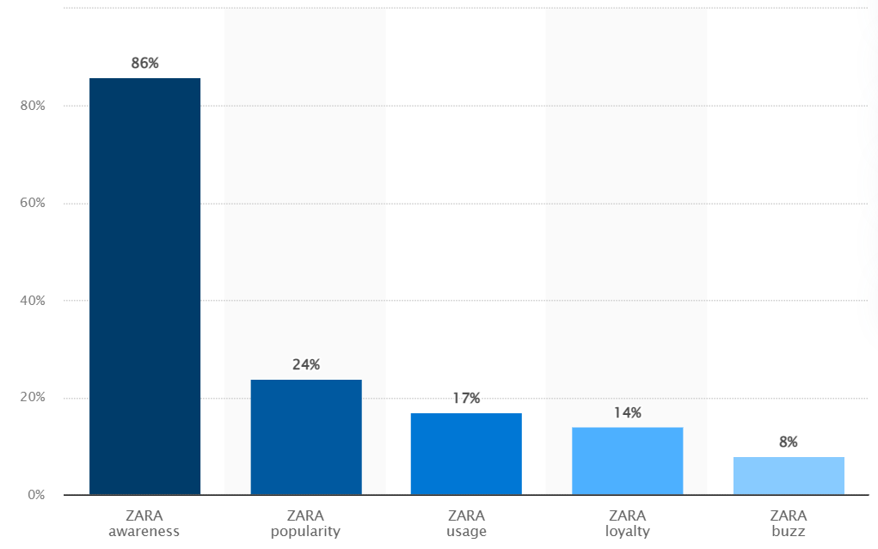

**Figure 1: Brand awareness of Zara in the UK**

(Source: Kunst, 2023)

In fact, this brand has created a benchmark in India since the degree of popularity of zara has reached the highest point in India. As per the statement of Malviya (2016), the sales growth of Zara has increased six times in India in comparison with the largest fashion brand of India, known as Louis Phillippe. In this context, it is worth mentioning that Zara has significantly mastered the facility of supply-side economy of scale in both the UK and Indian markets and becomes powerful in reducing the scope of rising threats from the end of new entrants. However, a lump sum investment in developing suitable infrastructure and adopting cutting-edge technology with an intention to cope with the existing trends is the major reason behind the failure of the majority of new entrants in the Indian fashion retailing markets.

**Risk of substitutes**

The threat of substitutes ought to be assessed in ways that consider the performance and accessibility of alternatives, the cost of switching for customers, and the likelihood of customers to switch. In the UK, the fast fashion industry has expanded its boundaries to a great extent. The UK's fashion business has grown to be the country's leading creative industry, contributing £26 billion and 800,000 employment to the economy (Britishcouncil, 2016). In 2020, the overall numbers of 34,045 organisations are considered to be the integral part of the UK fashion industry amongst which 30,035 are the retailers and 130 brands belonging to the international markets are extensively engaged in fast fashion. As a result, it can be said that the substitutes have the potential to pose a massive threat to the existence and profitability of Zara as the majority of fast fashion brands are facilitating the customers with fashionable clothes yet at lower price.

In the case of India, although the market of fast fashion is compact in contrast to the UK market, Indian fashion is significantly dominated by well-organised domestic retailers as they are able to offer many different categories, such as clothing, footwear, and home furnishings. As per the information documented by Statista (2023), the overall market size of the Indian fashion brand has been estimated to be $96.47 billion which is even projected to grow by 3.34% in 2023. Due to the inexpensive accessibility of textiles, domestic tailors can also make handcrafted or customised garments for Indian clientele which apparently increases the risk of substitutes against Zara.

**Bargaining potential of suppliers**

The degree of supplier focused attention, the significance of volume, and the likelihood of forward integration all affect suppliers' bargaining strength. As per the statement of Bhattacharjee (2019), due to their inability to capitalise on scale economies, suppliers are negatively impacted by forward integration and become formidable when they are prioritised. In particular, it can be acknowledged that When raw materials are in great demand and in limited supply, suppliers are likely to have a strong bargaining position. Few vendors dominate the UK fashion business, which is typically a result of the costly nature of raw materials. The UK has fostered 155 wholesalers of apparel and shoes in 2022, and their annual sales ranged from £5 million to £10 million (Fashionunited, 2022).

On the other hand, India's textile and garment manufacturing industries are distinguished by an exceptionally high concentration of suppliers that primarily operate independently on a limited basis and are extremely diversified. Due to their inability to achieve large-scale economies, Indian suppliers' power is reduced by these sectors' segmented format.

**Bargaining power of consumers**

Diversity and huge population are the significant factors that enable both the markets of the UK and India to attract a large number of businesses from different overseas countries. According to the data shared by Worlddata (2023), despite being a developing country, India seems to foster a larger consumer market with 1,425,776,000 population as compared to the UK that has estimated the overall population to be 67,327,000.

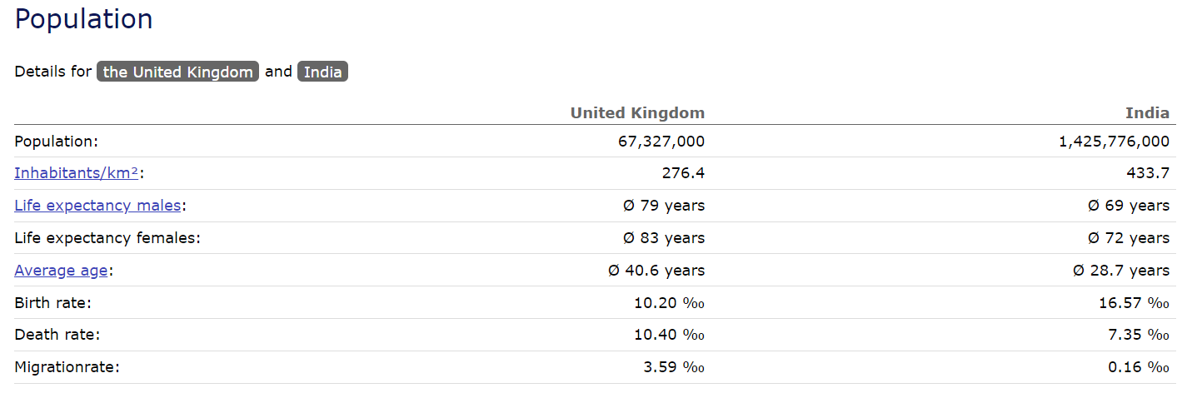

**Figure 2: Differences in population growth between the UK and India**

(Source: Worlddata, 2023)

Therefore, it is clarified that Zara, although it is likely to be optimistic regarding the enhanced sales growth in the UK and India, the bargaining power of the large consumer market can create pressure on the brand for better managing demand and supply of fashionable clothes and increasing sustenance against the competition. When there are several players with a wide range of products on the market, consumers have more negotiating power. Moreover, it is evident that despite being a high income country, 65% of consumers in the UK take the pricing factor into consideration while making decisions for purchasing products that can meet their preferences and needs while merely 12% of buyers focus on the quality that the brands offer through products (Statista, 2018).

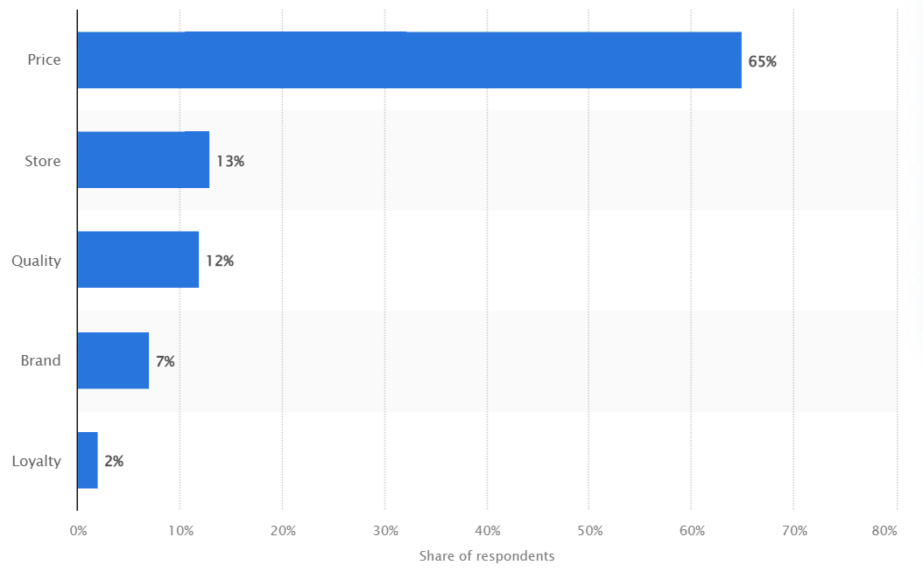

**Figure 3: Factors affecting consumer buying behaviour in the UK**

(Source: Statista, 2018)

The concept of fast fashion has been invented to facilitate the contemporary consumers with the rapid delivery of trendy and fashionable clothes within the span of two weeks or rather 30 days, yet at a lowest price. Thus, the buyers tend to evaluate the brands based on their pricing factors which further engage them to make robust decisions for buying clothes from a specific brand and turn them into loyal customers based on their repetitive buying behaviour. In that case, there is a probability for Zara to lose its potential targeted audiences due to low switching cost for consumers and also due to the tendency of earning more profits through the increase in price of trendy and fashionable clothes.

**Intensity of the competition**

Industry expansion, industry volume, competitive variety, and product variations all affect the extent to which a rivalry is intense. It is argued by Putera *et al.* (2021) that while aggressive competitiveness is responsible for reducing the scope of enhanced profit margin by prevailing over the expense of competition and makes the markets less captivating, rapid growth of a sector enables the markets to attract more businesses by providing opportunities to generate high revenues. In this context, it is worth mentioning that the existence of key players of the contemporary fast fashion sector including H&M, Forever 21, GAP, NEXT PLC, UNIQLO and some others are accounting for dominating the fashion markets of the UK and India. However, Zara has created a benchmark by leading the competitive fast fashion market of the UK by generating 22,544 million GBP in 2022 (Smith, 2022).

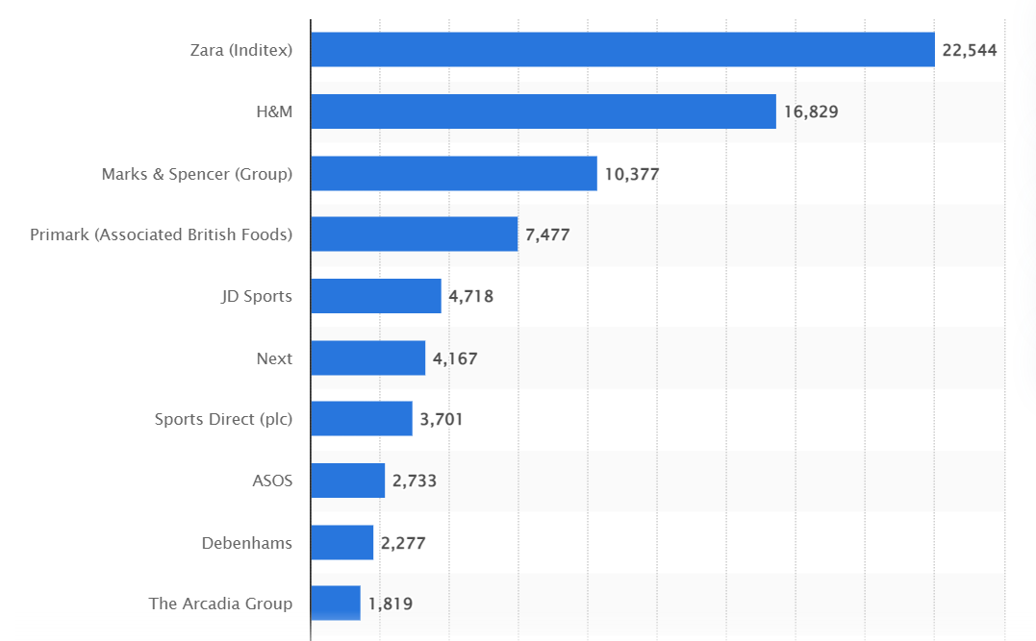

**Figure 4: Leading brands of the contemporary fast fashion industry**

(Source: Smith, 2022)

On the other hand, H&M is witnessed to dominate the fast fashion market of India with 275 crores whereas Zara has also achieved a high growth on the ground of revenue generation in India which is estimated to be 1,815 crores reveals the rapid growth of the market (Business-standard, 2022). Thus, it creates an opportunity for Zara to strengthen its leading position in this market synergistically.

## **A critical analysis of zara’s competitive status within two culturally diversified countries**

From the above mentioned analysis, it is clarified that the potential of new entrants in both the fast fashion sector is significantly low due to the highly saturated business market and the requirements of huge expenditure for the development of appropriate infrastructure and the integration of advanced technology. As a result, this factor is analysed to cast a positive impact over the expansion of Zara in the culturally diversified markets. Interestingly, the UK and India share a significant similarity in the field of threats from substitutes. The analysis has revealed that the fast fashion industry in the UK and India is huge in size and thus it beholds a major contribution to the financial and employability development of the nation. In effect, Zara witnesses innumerable risks of frequent rising of substitutes which apparently attracts contemporary consumers by offering best alternatives of fashionable clothes and lowering the pricing range that can hamper the profitability to a certain extent. However, the inflated brand value of Zara of $15 billion which is quite higher than the other leading fast fashion brand on the globe, H&M with $13 billion in 2022, enables the brand to maintain the strong relationship with its audiences and also foster authenticity and uniqueness of fashionable clothes against the substantial competition (Smith, 2022). Nevertheless, the power of suppliers in negotiation is quite different in the UK and in India. The extensive analysis of Porter’s five forces indicates that while the deficiency of raw materials and the low concentration of suppliers are the reason for Zara to undergo a challenging phase in the UK, high volume of suppliers and the adequate supply of raw materials become the success factor for Zara in India. While the huge population growth in India yields the opportunity of improving sales volume and profitability to a great extent for Zara, the influence of pricing factor on the consumer buying decisions and low switching costs makes the bargaining power of buyers powerful for Zara in the UK. Eventually, it is analysed that although the UK fast fashion industry is highly saturated by the key players, it is efficient in assisting Zara to achieve soaring competitive advantages as Zara is identified to be the most predominant brand of the UK.

## **Marketing mix 4ps**

**Product**

It is already understood that over a few decades, Zara has shared its extensive participation in the process of business internationalisation which has become the major driver of its expansion in the markets like the UK and India. An intention to cope with the culturally diversified consumer markets of the UK and India has triggered this brand to adopt product differentiation strategy. As per the statement of Yin (2022), product differentiation strategy is the process that enables an organisation to design the range of products and services in an unique manner and outperform other rivals in the competitive business market. Therefore, the brand tends to produce a wide range of fashionable clothes alongside accessories and shoes to attract and satisfy diverse customers. Prioritising the culture and traditions of each international market of the UK and India, this brand has differentiated its product range by representing the fusion of modernism with the local conventions. Zara is the brand well-known for creating the latest trends in fashion. Being an integral part of the fast fashion industry, Zara seems to launch approximately 500 designs or even more than that every time between the intervals of two weeks (Vanya, 2017). However, Malviya (2022) argued that this brand is currently offering the facility of reselling clothes to maintain the balance between fast fashion trends and sustainability.

**Price**

In the course of international marketing pricing plays an important role since it determines the degree of profitability that an organisation can earn easily. While India is considered to be a middle income country, the analysis has shown that despite being a high income developed country, approximately 67% of British people make decisions for purchasing products based on the thorough assessment of pricing factors. This consideration has influenced Zara to opt for a competitive pricing strategy. As per the statement of Wu *et al.* (2022), the practice of choosing the optimal price point to capitalise on the advantage of a product-focused or service-oriented market in relation to competitiveness is known as competitive pricing. The central idea of Zara is to facilitate the consumers of the UK and India with modern fashion trends under a great affordability. However, it can be said that competitive pricing strategy has been proven to be beneficial for Zara due to its practice of economies of scale. As a result, the acquisition of loyal customers and increasing profit margins are prominent.

**Promotion**

While most of the modern organisations tend to make adequate investments in promoting and marketing brands across global markets, less investments of resources in international marketing is embraced to be unique in Zara. As per the data served by Dixon (2023), India has ranked as the second largest country with 755 millions of active social media users while the overall headcount is calculated to be 61.67 millions in the UK by 2023.

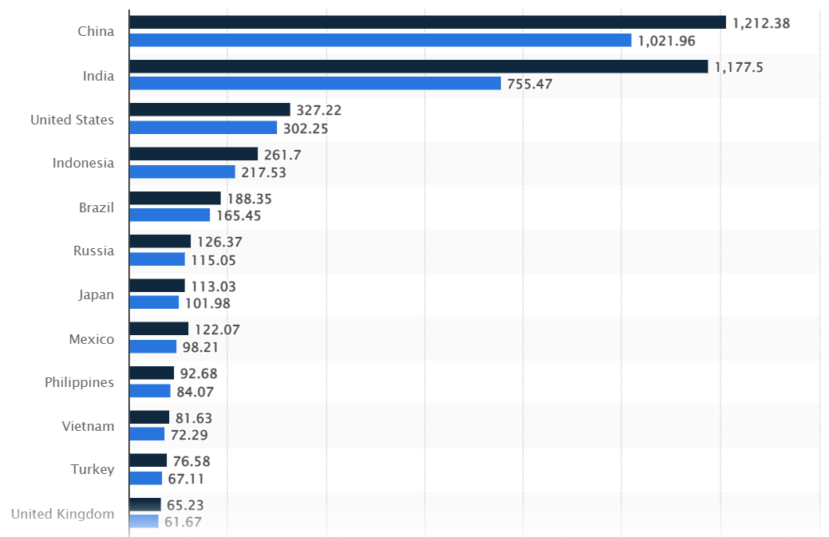

**Figure 5: Numbers of active users of Social media platforms**

(Source: Dixon, 2023)

Based on this contemplation, Zara has gradually developed its reliance over dynamic social media marketing and word of mouth instead of practicing other expensive marketing strategies such as content marketing, paid marketing and some more. On Instagram, this brand has been successful in making 59.43 millions of people and 30.89 millions of people followers on Facebook in 2022 (Smith, 2023).

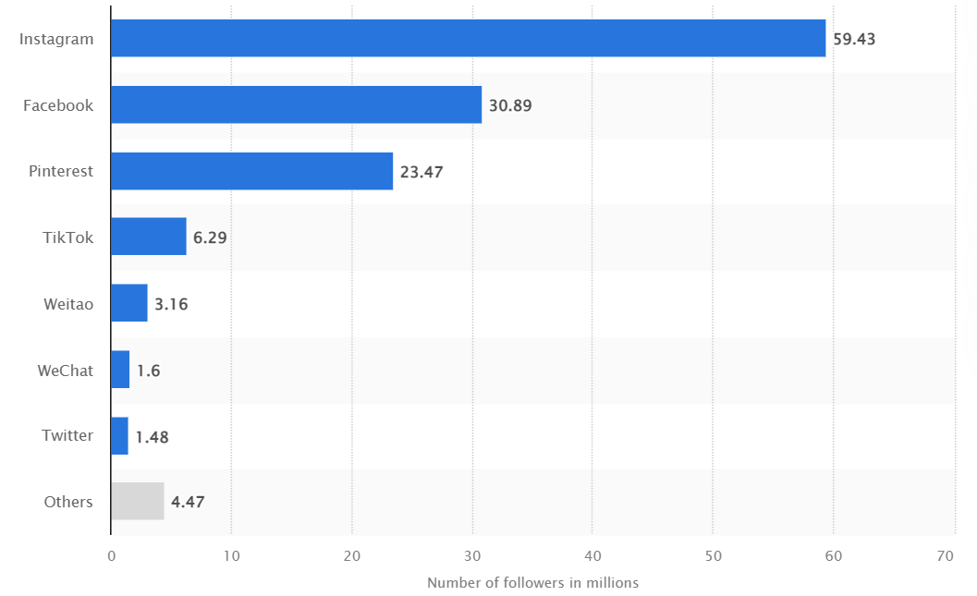

**Figure 6: Number of followers acquired by Zara over different social media platforms**

(source: Smith, 2023)

**Place**

Analysing Zara’s placement strategy, the inauguration of 3000 stores across the 96 different countries is the reflection of Zara’s tendency in terms of offering exceptional offline or in-store shopping experiences. Instead of investing in marketing tactics, Zara tends to invest more in the prime locations to deliver the best convenience of stores to its domestic and foreign customers. Therefore, this brand is running around 60 outlets in the UK and 21 outlets in India. On the other hand, this brand has developed a strong inclination towards the business model modification from brick-and-mortar approach to digitalisation. As a result, this brand is able to enter the e-commerce sector across 106 countries, amongst which the UK and India stand significantly (Wiegmann, 2017).

## **An evaluation of new market entry strategy of Zara**

In the course of international marketing, new market entry strategy shares a significant contribution to the business expansion and marketing. As per the statement of Su (2020), an appropriately strategic market entry assists businesses to remain organised while selling products and services in the international markets under precise planning and adequate processes of maintenance. In this case, the market entry strategies are evaluated to ensure the level of competitive advantages it has gained in the UK and India. Zara first invaded the fast fashion market of the UK in 1998 following the greenfield investment strategy. As per the statement of Hervas-Oliver (2022), Greenfield investment appears to be the mordernised form of foreign direct investments (FDI) which helps businesses to give shape to innovative facilities in foreign markets. Adhering to this strategy, Zara invested in purchasing lands and essential resources such as human resources and human capital to build outlets and physical stores in the UK.

On the other hand, Zara has adhered to the strategy of joint ventures during the expansion in the Indian fashion market. As stated by Malviya (2022), Zara is able to operate 21 stores in India following the development of joint ventures with and Indian well-reputed multinational business chain,Tata Group and in 2022, the brand has witnessed a notable surge in its profitability that has increased by 61% after a severe financial loss in the Covid-19.

# **Conclusion**

In conclusion, it can be said that each of the competitive forces included in Porter’s five forces are highly influential to the competitive gain of Zara in the UK and also in India. While the UK and India share similarities in the potential of new entrants, threat of substitutes; bargaining power of buyers and suppliers along with the degree of saturated market have created subtle differences between the two culturally diversified countries. In the UK and India, this brand has implemented product differentiation strategy, competitive pricing, social media advertising and both the offline and online distribution channels to gain the maximum competitive advantages. However, it followed FDI strategy and joint ventures with Tata group to enter the UK and Indian fast fashion market respectively.

# **References**

Bhattacharjee, S.S., 2019. Fast fashion, production targets, and gender-based violence in Asian garment supply chains. In *Labor, Global Supply Chains, and the Garment Industry in South Asia* (pp. 207-227). Routledge.

Britishcouncil, 2016. The power of Fashion. Available at : <https://www.britishcouncil.org/research-policy-insight/insight-articles/power-fashion#:~:text=The%20wool%20trade%20once%20accounted,the%20UK's%20largest%20creative%20industry>. [Accessed on: 15th April]

Business-standard, 2022. Zara's India revenue in FY22 rises to Rs 1,815 cr; profit at Rs 148.76 cr. Available at: <https://www.business-standard.com/article/companies/zara-s-india-revenue-in-fy22-rises-to-rs-1-815-cr-profit-at-rs-148-76-cr-122061200327_1.html> [Accessed on: 15th April]

Dixon, S., 2023. Social network users in selected countries in 2022 and 2027. Available at: <https://www.statista.com/statistics/278341/number-of-social-network-users-in-selected-countries/> [Accessed on: 15th April]

Fashionunited, 2022. UK fashion industry statistics. Available at: <https://fashionunited.uk/uk-fashion-industry-statistics> [Accessed on: 15th April]

Forbes, 2022. Profile of Zara. Available at: <https://www.forbes.com/companies/zara/?sh=7efcfba67487> [Accessed on: 15th April]

Hervas-Oliver, J.L., Belso-Martínez, J.A. and Díez-Vial, I., 2022. Multinationals’ recruiting in industrial districts. *Regional Studies*, *56*(8), pp.1320-1332.

Kunst, A., 2023. Brand profile of Zara in the UK 2022. Available at: <https://www.statista.com/forecasts/1252292/zara-fashion-online-shops-brand-profile-in-the-uk#:~:text=How%20popular%20is%20ZARA%20in,of%20people%20like%20the%20brand>. [Accessed on: 15th April]

Malviya, S., 2016. Zara posts slowest sales growth in India; stiff competition from global rivals like H&M and Gap. Available at: <https://economictimes.indiatimes.com/industry/cons-products/fashion-/-cosmetics-/-jewellery/zara-posts-slowest-sales-growth-in-india-stiff-competition-from-global-rivals-like-hm-and-gap/articleshow/53183154.cms> [Accessed on: 15th April]

Malviya, S., 2022. Inditex Trent, that runs Zara in India expands 61% during FY22. Available at: <https://economictimes.indiatimes.com/industry/cons-products/garments-/-textiles/inditex-trent-that-runs-zara-in-india-expands-61-during-fy22/articleshow/91581944.cms?utm_source=contentofinterest&utm_medium=text&utm_campaign=cppst> [Accessed on: 15th April]

Malviya, S., 2022. Inditex Trent, that runs Zara in India expands 61% during FY22. Available at: <https://economictimes.indiatimes.com/industry/cons-products/garments-/-textiles/inditex-trent-that-runs-zara-in-india-expands-61-during-fy22/articleshow/91581944.cms?from=mdr> [Accessed on: 15th April]

Perera, R., 2020. *Understanding Porter’s Five Forces Analysis*. Nerdynaut.

Putera, W., Rakib, M. and Sahabuddin, R., 2021. Competitive Advantages Influence on Marketing Performance: Study on Food and Beverage MSMEs. *The American Journal of Humanities and Social Sciences Research (THE AJHSSR*, *4*(1), pp.75-83.

Smith, P., 2022. European fast fashion brands ranked by worldwide revenue 2019. Available at: <https://www.statista.com/statistics/1094176/european-fast-fashion-brands-ranked-by-revenue/> [Accessed on: 15th April]

Smith, P., 2022. Global brand value comparison of H&M and Zara from 2010 to 2020. Availablt at: <https://www.statista.com/statistics/1071147/brand-value-comparison-of-handm-and-zara-worldwide/> [Accessed on: 15th April]

Smith, P., 2023. Number of Zara social media followers worldwide 2022, by platform. Available at: <https://www.statista.com/statistics/762313/worldwide-number-of-followers-of-zara-on-social-networks/> [Accessed on: 15th April]

Statista, 2018. Leading factors influencing consumer purchase decisions in the United Kingdom (UK), as of January 2014. Available at: <https://www.statista.com/statistics/295410/consumers-purchase-influences-in-the-united-kingdom-uk/> [Accessed on: 15th April]

Statista, 2023. Apparel-India. Available at: <https://www.statista.com/outlook/cmo/apparel/india> [Accessed on: 15th April]

Su, Y.Z., 2020. The Internationalization Strategies of Fast Fashion Clothing Retailer Brands: A Cases Study of ZARA, H&M, UNIQLO, and Gap.

Vanya, G., 2022. The Success Story of Zara: From starting with just 30 euros to owning nearly 7,000 stores today. Available at: <https://www.indiatimes.com/worth/news/the-success-story-of-zara-559147.html#:~:text=Zara%20is%20well%20known%20for,on%20schedule%2C%20new%20garments%20arrive>. [Accessed on: 15th April]

Wiegmann, A., 2017. Zara goes online in 106 more countries, shares soar. Available at: <https://www.reuters.com/article/uk-inditex-internet-idUKKCN1NC2AW> [Accessed on: 15th April]

Worlddata, 2023. Industry-relevant curriculum. Available at: <https://www.worlddata.info/country-comparison.php?country1=GBR&country2=IND> [Accessed on: 15th April]

Wu, M., Ran, Y. and Zhu, S.X., 2022. Optimal pricing strategy: How to sell to strategic consumers?. *International Journal of Production Economics*, *244*, p.108367.

Yin, Z., 2022, July. How Fast-Fashion Brands Went Viral—Taking Zara as an Example. In *2022 2nd International Conference on Enterprise Management and Economic Development (ICEMED 2022)* (pp. 538-542). Atlantis Press.