**QUALITY MANAGEMENT: ASSIGNMENT–PART 1**

**Table of Contents**

Introduction 3

Task 1: Critical evaluation of the strategic importance of TQM for Jaguar Land Rover 3

Task 2: Creation of a quality management system and linking with business objectives 7

Task 3: Quality management key trends and relationships with business Strategy 9

Conclusion 10

References 11

# Introduction

The total quality management (TQM) principles can be followed by an automobile company as Toyota pioneered the concept back in the day to be a highly productive and quality-driven approach. The current study orients around the Jaguar Land Rover automobile unit in the UK. The study aims to address the presence of TQM principles in Jaguar Land Rover and suggest the suitability of a quality management system for the automobile brand. Apart from this, key quality management trends would be discussed to interpret the efficiency within the business to cope with them.

# Task 1: Critical evaluation of the strategic importance of TQM for Jaguar Land Rover

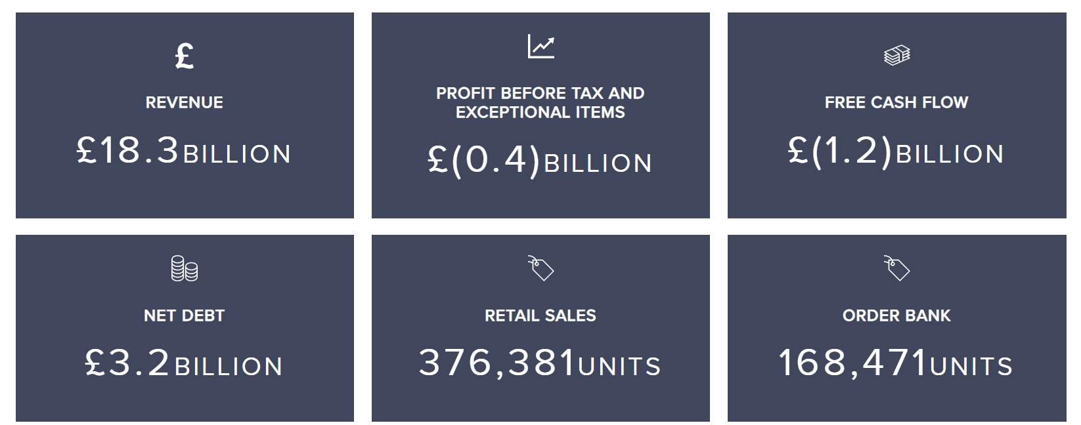

**Figure 1: Financial highlights of Jaguar Land Rover**

(Source: Jaguar Land Rover, 2023)

Developing the world's most desirable luxury vehicles remains to be the central focus of the brand as it looks to depend on quality and sustainability principles to manufacture world-class vehicles. The recent developments across Jaguar Land Rover are evident that the brand is structuring the business model with a thorough focus on quality management and greater customer satisfaction. According to the present reports, in the fiscal year 2021/2022 the company managed to generate a revenue of £18.3 billion, with a free cash flow of £1.2 billion, net debt of £3.2 billion, and retail sales of 376,381 units (Jaguar Land Rover, 2023). Since the quality standards and quality control techniques in the business share a major influence over the financial performance of the business, there is a requirement for a proper quality management framework in the business. There remains a severe need for a brand to follow the TQM principles in the business as it helps strengthen the competitive position of the brand and ensures higher productivity. As per the views of Egwunatum, Anumudu, Eze, and Awodele (2021), the major principles within TQM are seen as customer focus, process-centric approach, employee involvement, integrated system, continual efforts, fact-based decision-making, systematic flow, and relationship management. Since the automobile industry is heavily reliant on the assembly of different vehicle components, the waste generate and defects seem to be a major concern for the businesses in the industry. However, the TQM presence in the business helps deal with defects and waste and promotes bigger adaptability for the automobile brand. This helps secure an enhanced market image and amplify business success worldwide.

**Figure 2: TQM principles**

(Source: Self-developed)

The TQM concept to a large degree is similar to that of six sigma as the improvement of current processes and reduction of waste remains to be a major theme for both. Similarly, an extensive focus on customer satisfaction is a part of both approaches. As per the study by Gupta and Gupta (2022), the difference between TQM and six sigma is that the former addressed quality as conformance to internal requirements and the reduction of defects to escalate quality aligns with six sigma. As an example, the all-electric Jaguar I-PACE managed to claim the 2019 World Car of the Year, 2019 World Green Car, and 2019 World Car Design of the Year (Jaguar Land Rover, 2021). This highlighted the futuristic product development direction where the brand is headed and offers plenty of growth opportunities in the electric vehicle market. Furthermore, the brand cut short employees in a recent period to save £150 million in overhead costs.

**Figure 3: PDCA cycle for improved performance**

(Source: Self-developed)

It is seen that a stern focus on identifying, assessing, responding and monitoring risks in the business helps promote continuous improvement. Hence, having an enterprise risk management (ERM) framework embedded in operations for the brand meets the fact-based decision-making and integrated system aspects within TQM. In TQM, there are several problem-solving techniques applicable such as the plan, do, check, and act (the PDCA cycle). According to the views of Alauddin and Yamada (2019), the PDCA cycle aids in the process of recognising an opportunity to execute change, run tests, review the test results, and act based on the test results. Hence, the PDCA methodology could be applied alongside the TQM framework to enhance the work process quality on an internal and external level across a business. From an innovation and strategic management standpoint, the idea is to promote an electrifying and sustainable future. As seen from the case of Jaguar Land Rover, CO2 emission reduction targets by 2030 are set to ensure that the business achieves an ample degree of sustainability from the TQM application. As per the views of Yu, Khan and Umar (2022), circularity in a business assures of reducing, reusing, and recycling business operations. Hence, the business looking to depend on the strategic objective of manufacturing modern luxury vehicles by following a closed-loop circularity, decarbonisation of the supply chain, and better attention to the provenance of materials sourced for manufacturing. Since the process-centric approach, systematic flow, and relationship management are part of the TQM principles, then the brand should be comfortable meeting these objectives. Apart from this, the brand boasts of claiming net zero carbon by 2039. This will help in the process of benefitting from the TQM integration as well.

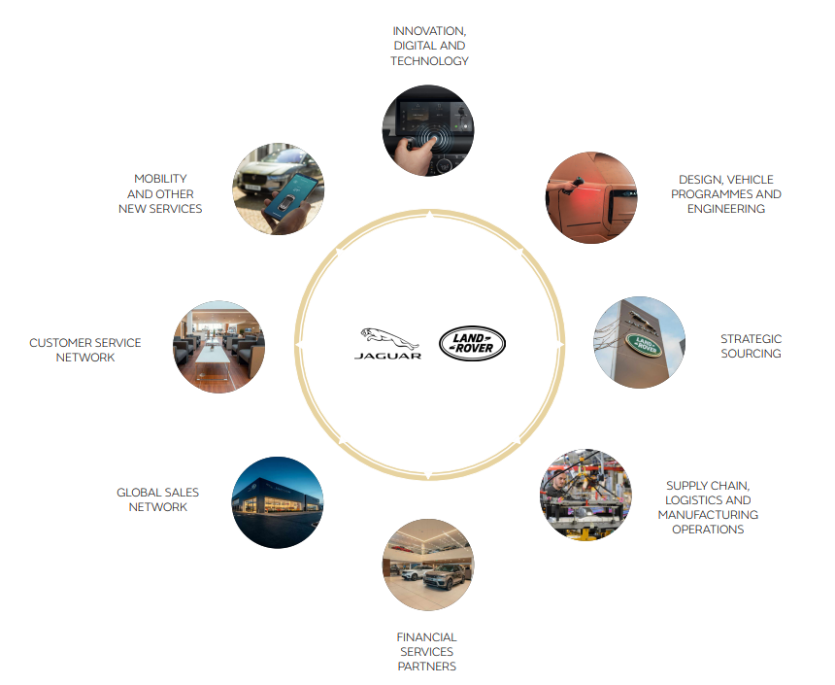

**Figure 4: Business model of** **Jaguar Land Rover**

(Source: Jaguar Land Rover, 2023)

TQM supports continuous improvements in the business to boost the overall performance of the brand. According to the study by Cai, Al Faruque, Kiziltas, Mielewski and Naebe (2021), following the megatrend to the digital wave ensures that a brand meets the customer requirements in the current day business. The automobile industry is looking for continuous improvements as it looks to serve the dynamic needs of consumers. As seen from the case of Jaguar Land Rover, an advanced Pivi Pro infotainment system in over 200,000 customer vehicles was applied in early 2022 to enhance customer satisfaction levels. This placed the brand to be one of the digital leaders in the automobile field, which aligns with the customer focus, and continual efforts principles within TQM. As per the study by Saragih, Tarigan, Pratama, Wardati and Silalahi (2020), improved employee morale, increased customer loyalty, and improved customer focus are achieved as a result of following the TQM principles in the business. As evident from the case of Jaguar Land Rover, the enormous brand value of the business helps it cope with the TQM principles in the business moving forward.

# Task 2: Creation of a quality management system and linking with business objectives

The quality management system (QMS) refers to the policies, processes, and procedures required to plan and execute actions in a business. As per the study by Rathor and Saxena (2020), the presence of ISO standards in the business justifies the quality certification and control measures in the business. According to the reports, International Automotive Task Force (IATF):16949 quality management certificate in the UK automobile industry is achieved by the company. This certification permits international-wide assurance of quality control, customer satisfaction, and meeting business goals sincerely. This also signifies that the brand has managed to retrieve accolades and certifications that elevate the brand image to a large degree. As evident from the case of Jaguar Land Rover, there is a plan for offering a pure-electric New Range Rover from the year 2024, which would be a result of flexible architectures such as Electric Modular Architecture (EMA), and Modular Longitudinal Architecture (MLA). There is an expectation that the brand would achieve 60% of pure-electric Land Rover sales by the year 2030. While QMS would help the brand gain greater efficiency and less waste generation to consistently control the business processes and promote an ample degree of success in the business in future. As per the study by Birkel and Müller (2021), the triple bottom line in the business addresses the need to meet people, planet, and profit aspects. The company looks to meet the triple bottom line as it optimises the resources to promote sustainability. As an example, the execution of the Regenerate strategy in the future and reduced energy consumption and waste in plants and offices serve the purpose of being sustainable. On the other end, QMS invites sustainability for a business, hence declaring it to be an ideal fit for the operations of the company.

The ISO standards boost the merit of QMS in modern-day businesses. According to the views of Fonseca, Cardoso and Nóvoa (2022), ISO 9001 is a certification of quality management that helps supply chain, logistics, and assembling processes become quality assured in businesses. As evident from the case of Jaguar Land Rover, the JLR Quality Management System is certified under ISO 9001 and TS 16949 since 2002 (Jaguar Land Rover, 2021). This suggested the innovation measures within the brand to be one of the leading automobile brands are actively exercised. Apart from this, there is the existence of the ISO 9001:2015 certification in the business. As per the study by Sfreddo, Vieira, Vidor and Santos (2021), compliance with international quality management standards helps register confidence among consumers from different locations. This helps in the process of marketing the products on an international level and becoming more sustainable. As seen in the case of Jaguar Land Rover, the homologation requirements aid automobile brands to secure the delivery of vehicles worldwide with an ample degree of quality. According to the views of Memon *et al.* (2019), there are several quality control tools such as flow charts, Ishikawa diagrams, checklists, Pareto charts, histograms, scattergrams, and control charts. These tools can be dynamically applied to track any flaw or error in the production process of the vehicles, thereafter assuring better quality in products. The QMS benefits from the support of these tools.

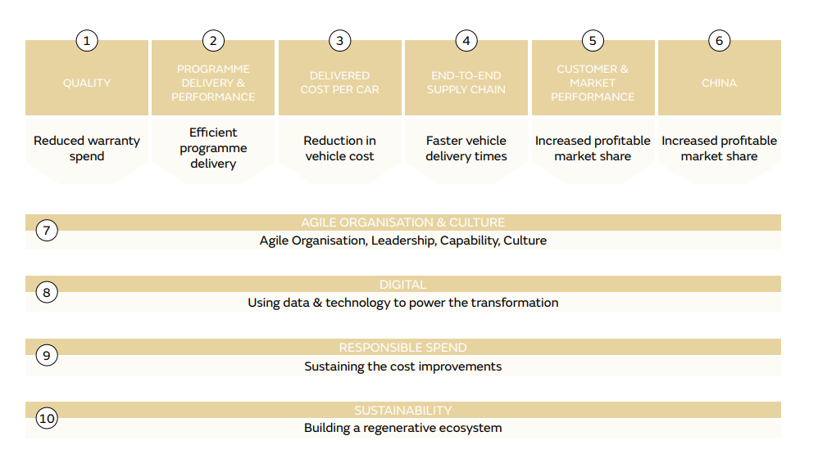

**Figure 5: Strategic objectives redefined within Jaguar Land Rover with REFOCUS**

(Source: Jaguar Land Rover, 2023)

The leading independent provider of assembly and test services for a broad range of semiconductor chips with diversified end uses are seen to be UTAC. As per evidence, Jaguar Land Rover complied with the UTAC audits with ease during weeks 34~36 across the UK manufacturing and engineering facilities. The brand has consistently focused on the idea of shaping operations with advanced technological solutions and automating the majority of the processes to become a quality-driven automobile brand. As an example, the optimised and modified IATF16949:2016 & ISO 9001:2015 certifications attained by the company have made it become the only automobile unit to possess the certification. As per the study by Shivajee, Singh and Rastogi (2019), value creation for the shareholders in a business is necessary to gain investor confidence through time and restructure the business strategy as per situational requirements. As evident from the case of Jaguar Land Rover, becoming a data-driven and agile business remains to be one of the strategic priorities as the brand developed REFOCUS TRANSFORMATION PROGRAMME to make it a part of the REIMAGINE STRATEGY that helped deliver £1.5 billion of value during FY2021/22. According to the views of Zonnenshain and Kenett (2020), QMS tends to improve business leadership, enhance the business culture, and innovate periodically in an attempt to assure that business functions are handled effectively under any given situation. Similarly, the brand has managed to reduce the warranty spend, reduce the vehicle cost, offer faster vehicle delivery, and increase profitable market share as a result of REFOCUS TRANSFORMATION PROGRAMME, which seems to promote QMS application in the business for the future.

# Task 3: Quality management key trends and relationships with business strategy

The business is making use of digital cultural development efforts in the business as it tries to optimise product manufacturing for the customers. Several trends are growing large in the field of an automobile such as reliance on decision intelligence, improving the quality of suppliers, defining the set of international business standards, and data-driven quality planning. According to the study by Souza, Corsi, Pagani, Balbinotti and Kovaleski (2022), accelerated adoption of cloud software, remote audit readiness, and enterprise quality management software (EQMS) integration are known to be the key trends in the quality management department for a contemporary business. As seen in the case of Jaguar Land Rover, dependability, quality, and reliability are maintained with diligence in the company. There are several factors consistently tracked by the company such as financial performance, customer satisfaction, market share, product quality, process improvement, and employee satisfaction to elevate the business value. According to the study by Leng *et al.* (2020), product life cycle assessment helps a business become quality driven and share optimised resource utility. As seen in the case of Jaguar Land Rover, the company has invested in the idea of REFOCUS to reduce excessive operational costs and sustain operations with quality outcomes.

As per the views of Agrawal, Wankhede, Kumar and Luthra, (2021), for the process of maintaining quality in a business, there has to be better network connectivity. A strong network for a business ensures services to the customers are delivered rapidly without any major issues. Access to a wide array of new infrastructure and resources is also made available as a result of collaboration in the business. Since software development and artificial intelligence (AI) based systems have become a major quality booster and service optimiser for customers, extensive focus is put towards it. As evident from the case of Jaguar Land Rover, it has managed to partner with NVIDIA, which represents a leader in computing and AI technology. The long-term plan for Jaguar Land Rover remains in using the NVIDIA DRIVE software-defined platform to deliver a next-generation automated driving system from the year 2025. Therefore, following the key trends in quality management should promote activities such as this for the company and invite an ample degree of success.

# Conclusion

A clear verdict can be given that Jaguar Land Rover has been adequately managing its business operations, with excellence in manufacturing quality and supplier network. Customer satisfaction has been identified to be great as a result of having certifications such as IATF16949:2016 & ISO 9001:2015. The TQM principles are met by the current business actions within the brand. Hence, an immense opportunity to scale the business and attain the strategic objectives becomes possible for the brand in future. Apart from this, the QMS application in the business has been suggested to be one such initiative that aligns with the REFOCS strategy, thereby assuring optimised financial, technological, and human resources are present in the business to succeed with the QMS.

# References

Agrawal, R., Wankhede, V.A., Kumar, A. and Luthra, S., (2021). Analysing the roadblocks of circular economy adoption in the automobile sector: Reducing waste and environmental perspectives. *Business Strategy and the Environment*, *30*(2), pp.1051-1066.

Alauddin, N. and Yamada, S., (2019). Overview of Deming criteria for total quality management conceptual framework design in education services. *Journal of Engineering and Science Research*, *3*(5), pp.12-20.

Birkel, H. and Müller, J.M., (2021). Potentials of industry 4.0 for supply chain management within the triple bottom line of sustainability–A systematic literature review. *Journal of Cleaner Production*, *289*, p.125612.

Cai, Z., Al Faruque, M.A., Kiziltas, A., Mielewski, D. and Naebe, M., (2021). Sustainable lightweight insulation materials from textile-based waste for the automobile industry. *Materials*, *14*(5), p.1241.

Egwunatum, S.I., Anumudu, A.C., Eze, E.C. and Awodele, I.A., (2022). Total quality management (TQM) implementation in the Nigerian construction industry. *Engineering, Construction and Architectural Management*, *29*(1), pp.354-382.

Fonseca, L.M., Cardoso, M.C. and Nóvoa, M.H., (2022). Motivations for ISO 9001 quality management system implementation and certification–mapping the territory with a novel classification proposal. *International Journal of Quality and Service Sciences*, *14*(1), pp.18-36.

Gupta, P. and Gupta, N., (2022). Improving organisational performance through TQM in an Indian manufacturing industry: an empirical study. *International Journal of Productivity and Quality Management*, *37*(1), pp.1-19.

Jaguar Land Rover, (2021). *JLR AWARDED IATF QUALITY MANAGEMENT CERTIFICATION.* Available from: https://teamtalk.jaguarlandrover.com/news/jlr-awarded-iatf-quality-management-certification#:~:text=The%20JLR%20Quality%20Management%20System,and%20TS%2016949%20since%(2020)02. [Accessed 27 March 2023]

Jaguar Land Rover, 2023. *ANNUAL REPORT 2022.* Available from: https://www.jaguarlandrover.com/annual-report-2022 [Accessed 27 March 2023]

Leng, J., Ruan, G., Jiang, P., Xu, K., Liu, Q., Zhou, X. and Liu, C., (2020). Blockchain-empowered sustainable manufacturing and product lifecycle management in industry 4.0: A survey. *Renewable and sustainable energy reviews*, *132*, p.110112.

Memon, I.A., Jamali, Q.B., Jamali, A.S., Abbasi, M.K., Jamali, N.A. and Jamali, Z.H., (2019). Defect reduction with the use of seven quality control tools for productivity improvement at an automobile company. *Engineering, Technology & Applied Science Research*, *9*(2), pp.4044-4047.

Rathor, S.K. and Saxena, D., (2020). Energy management system for smart grid: An overview and key issues. *International Journal of Energy Research*, *44*(6), pp.4067-4109.

Saragih, J., Tarigan, A., Pratama, I., Wardati, J. and Silalahi, E.F., (2020). The impact of total quality management, supply chain management practices and operations capability on firm performance. *Polish Journal of Management Studies*, *21*(2), pp.384-397.

Sfreddo, L.S., Vieira, G.B.B., Vidor, G. and Santos, C.H.S., (2021). ISO 9001 based quality management systems and organisational performance: a systematic literature review. *Total Quality Management & Business Excellence*, *32*(3-4), pp.389-409.

Shivajee, V., Singh, R.K. and Rastogi, S., (2019). Manufacturing conversion cost reduction using quality control tools and digitization of real-time data. *Journal of Cleaner Production*, *237*, p.117678.

Souza, F.F.D., Corsi, A., Pagani, R.N., Balbinotti, G. and Kovaleski, J.L., (2022). Total quality management 4.0: adapting quality management to Industry 4.0. *The TQM Journal*, *34*(4), pp.749-769.

Yu, Z., Khan, S.A.R. and Umar, M., (2022). Circular economy practices and industry 4.0 technologies: A strategic move of automobile industry. *Business Strategy and the Environment*, *31*(3), pp.796-809.

Zonnenshain, A. and Kenett, R.S., (2020). Quality 4.0—the challenging future of quality engineering. *Quality Engineering*, *32*(4), pp.614-626.