**DEVELOPING RELATIONSHIPS AND WORKPLACE ACHIEVEMENTS**

Table of Contents

1. Introduction 3

2. Knowledge, skills and behaviours (KSB) for HR professionals 3

Knowledge, skills 3

Behaviours 4

3. Conduct a personal skills audit and a SWOT analysis 4

Personal Skills Audit 4

SWOT analysis 5

4. Potential benefits of training and development for HR officer 6

Implementation of human relation theory 6

Effectiveness of training and development 6

Conclusion 7

Reference 8

Appendices 9

Appendix A 9

Appendix B 10

Appendix C 11

**RW A 1 - Individual Presentation on- Training and Development needs for a HR officer**

## 1. Introduction

* Training and development is effective to enhance personal development.
* HR officers can acquire knowledge regarding organisation and work process.
* Training and development is helpful to enhance knowledge, skill and behaviour.
* Training and development is essential to assess knowledge regarding the drawbacks.

Training and development is a process that helps HR officials in acquiring new knowledge regarding company and work process. The effective assessment of knowledge reading companies is effective to enhance productivity and become better leaders. The HR officials of Amazon need to participate actively in training and development sessions as it is helpful for them to enhance their personal development.

## 2. Knowledge, skills and behaviours (KSB) for HR professionals

### Knowledge, skills

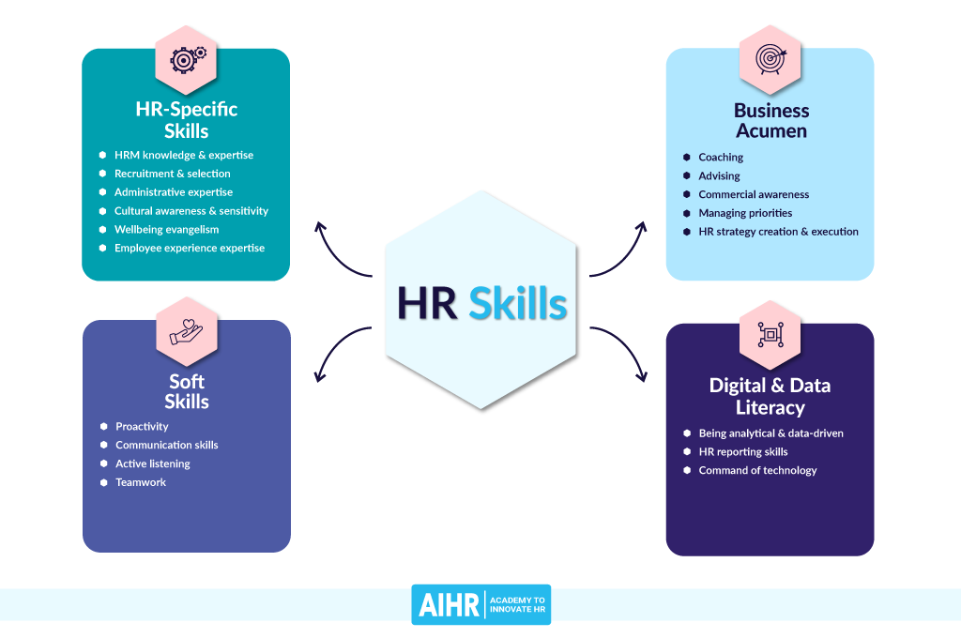

* HRM knowledge and expertise are essential factors for HR officers.
* Communication skill for HR officers to negotiate with staff and their representatives.
* Managing priorities and advising skills are significant for HR officers of Amazon.
* Developing HR planning strategies for Amazon.

The HR officers of Amazon need to enhance their HRM knowledge and expertise to ensure success of work process and maintenance of organisational growth. According to the views of Singh *et al.* (2021), HRM knowledge is helpful to assess relevant knowledge that is effective to assist Human Resource officers of Amazon. The enhancement of communication skill is a vital factor for Hr officers as it helps them to gather knowledge regarding employee satisfaction. As mentioned by Rothwell *et al.* (2020), managing priorities and advising skill is essential to ensure success of HR officers of Amazon. The skills of managing priorities is essential for a HR officer as it helps them to manage multiple tasks. Besides, skill regarding advising is an effective approach for HR officers as it helps them to encourage employees. The HR managers need to develop HR planning strategies to ensure maintenance of organisational growth.

### Behaviours

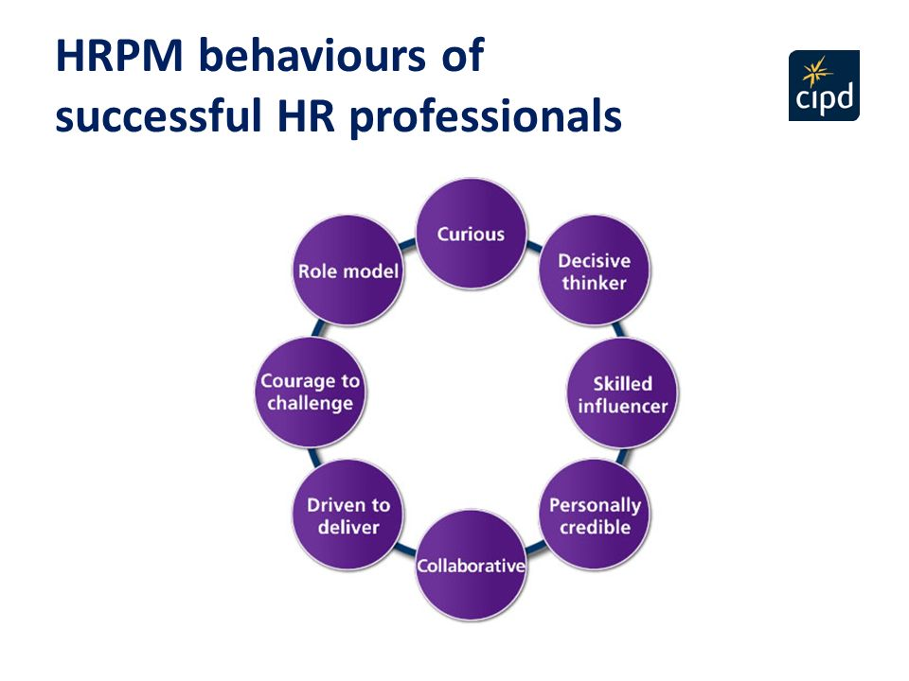

* Manage the process of recruiting staff for Amazon.
* Maintaining organisational policies to avoid workplace violations in Amazon.
* Implementing disciplinary procedures for Amazon.
* Analysing training needs for HR officers of Amazon.

The HR officers of Amazon need to have the ability to recruit potential employees for the organisation to enhance the success rate of the company. As mentioned by Anwar and Abdullah(2021), HR officers need to cherish their behaviour accordingly by considering the process of identifying potential candidates for the organisation. The maintenance of organisational policies is a vital part of HR officers that is essential to avoid workplace violations. The HR officers of Amazon need to ensure maintenance of organisational policies and need to monitor work processes accordingly. As mentioned by Leicht-Deobald *et al.* (2022), HR officers need to have the ability to maintain disciplinary procedures for employees and company officials to ensure organisational well being. The HR officers need to analyse training needs of employees to ensure personal development as a HR officer.

## 3. Conduct a personal skills audit and a SWOT analysis

### Personal Skills Audit

* Adequate knowledge regarding information technology for Amazon.
* Very good with communication skills as a HR officer of Amazon.
* Good at problem solving skills that are helpful to manage sensitive issues regarding the work process.
* Little knowledge regarding supervisory management that impacts leading qualities for Amazon.

The personal skill audit of an HR officer has highlighted adequate skills regarding information knowledge which is effective to enhance the systematic work process of Amazon. Besides, this has acquired very good knowledge regarding communication skills that are effective to analyse issues of employees of Amazon. Personal skill audit has evaluated good knowledge regarding problem solving that is effective to provide effective solutions for sensitive issues of organisation. This skill audit has analysed the drawbacks regarding supervisory management that is responsible for impact on leading qualities.

### SWOT analysis

***Strengths***

* Effective communication skills.
* Adequate knowledge regarding information technology.
* Strength in problem solving skills.
* Strength of managing multiple tasks.

As a HR officer of Amazon, effective communication skill is a strength factor as it is helpful to analyse issues of employees. As commented by Krishnan *et al.* (2019), communication skill for Hr officer is effective to enhance customer engagement rate that is essential for organisational growth. On other hand, strength regarding problem solving skills is helpful for a HR officer to provide effective solutions for employees regarding sensitive issues. According to the views of Goga *et al.* (2020), strength regarding managing multiple skills and information technology is helpful to maintain the work process of an organisation in a systematic process. As a HR officer of Amazon development of these strength factors through training and development is effective for ensuring success of organisation.

***Weakness***

* Lack of supervisory management as a HR officer.
* Lack of maintaining disciplinary activities.
* Weakness regarding time management.
* Lack of Managing priorities.

The lack of supervisory management skill in an HR officer of Amazon included issues regarding the process of managing employees regarding the work process of the company. In views of Szulc *et al.* (2021), lack of maintaining disciplinary activities creates conflicts regarding work process among employees. Besides, weakness regarding time management and lack of managing priorities is effective to increase conflicts regarding the work process of Amazon. Therefore, HR officers of Amazon need to assess training and development to enhance time management and maintaining disciplinary activities skill.

## 4. Potential benefits of training and development for HR officer

### Implementation of human relation theory

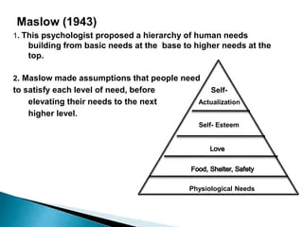

* The usage of human relation theory for development of HR officers in Amazon.
* Identify the importance of social structure for Amazon HR officers.
* Maintaining effective rules and regulations for employees of Amazon.
* Assess effective information regarding demand and expectation of employees.

The implementation of Maslow human relation theory is helpful for HR officers of Amazon as it helps to enhance understanding among employees and company officials. In views of Ishii and Kawahata (2020), usage of human relation theory is helpful to enhance knowledge regarding employees expectations and demand that is effective to enhance growth of a company. Thus, providing training to employees emphasis on this concept HR managers in Amazon might be able to retain success and progress accordingly.

### Effectiveness of training and development

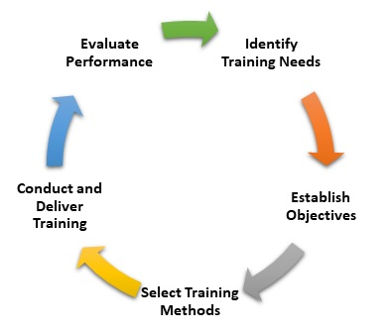

* Training and development sessions are helpful to identify drawbacks of HR officers in Amazon.
* Training and development for HR officials is helpful for Amazon to retain top talent.
* Process and approaches of training an HR of Amazon.

Training and development for HR officers of Amazon is effective to enhance drawbacks of individuals by identifying weakness factors. According to the views of Alzoubi (2022), the training and development process is essential to enhance the work process of a company by enhancing understanding regarding the process. Training and development is helpful to retail top talent that is effective to increase potentiality of the work process.

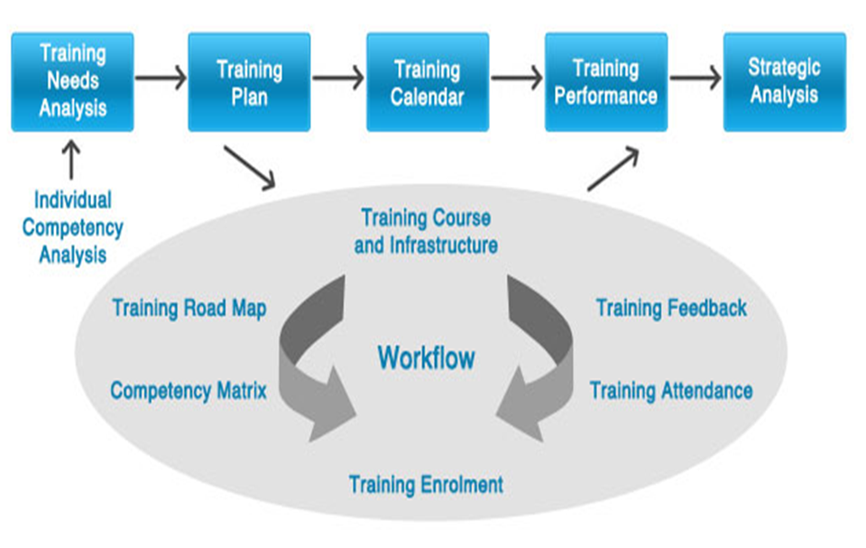

* Training development for HR officers of Amazon is effective to analyse employee demand.
* Training and development is effective for HR officers of Amazon to ensure proper employee hiring.
* Training and development for HR officers in Amazon is essential to discuss openly about organisational issues.

The usage of training and development for HR officers of Amazon is effective to discuss organisational issues to ensure effective solution. As mentioned by Aburumman *et al.* (2020), usage of training and development is helpful to enhance employee satisfaction rate. Moreover, training and development process for HR officers of Amazon is helpful to maintain organisational success of Amazon.

# Conclusion

* Training and development is effective to enhance the KSB for HR professionals of Amazon.
* Training and development is helpful for identifying the drawbacks of HR officers.
* Training and development is effective for future improvisation.

The training and development process for the HR officers is effective to enhance the work process of Amazon. The identification of the drawbacks regarding the work process is possible by arranging effective training and development processes. Training and development is effective to enhance the professional factors of HR officers.

# Reference

Aburumman, O., Salleh, A., Omar, K. and Abadi, M., (2020). The impact of human resource management practices and career satisfaction on employee’s turnover intention. *Management Science Letters*, *10*(3), pp.641-652.

Alzoubi, H.M., (2022). The effect of electronic human resources management on organizational health of telecommunications companies in Jordan. *International Journal of Data and Network Science*, pp.429-438.

Anwar, G. and Abdullah, N.N., (2021). The impact of Human resource management practice on Organizational performance. *International journal of Engineering, Business and Management (IJEBM)*, *5*.

De Visser, E.J., Peeters, M.M., Jung, M.F., Kohn, S., Shaw, T.H., Pak, R. and Neerincx, M.A., (2020). Towards a theory of longitudinal trust calibration in human–robot teams. *International journal of social robotics*, *12*(2), pp.459-478.

Goga, A.J., Tërstena, A. and Jashari, B., (2020). Improving the efficiency of human resources with the use of new technologies and reorganization process. *International Journal of Research in Business and Social Science (2147-4478)*, *9*(1), pp.31-38.

Ishii, A. and Kawahata, Y., (2020). Theory of opinion distribution in human relations where trust and distrust mixed. In *Intelligent Decision Technologies: Proceedings of the 12th KES International Conference on Intelligent Decision Technologies (KES-IDT 2020)* (pp. 471-478). Springer Singapore.

Krishnan, I.A., Ching, H.S., Ramalingam, S. and Maruthai, E., (2019). An Investigation of Communication Skills Required by Employers from the Fresh Graduates. *Pertanika Journal of Social Sciences & Humanities*, *27*(2).

Leicht-Deobald, U., Busch, T., Schank, C., Weibel, A., Schafheitle, S., Wildhaber, I. and Kasper, G., (2022). The challenges of algorithm-based HR decision-making for personal integrity. In *Business and the Ethical Implications of Technology* (pp. 71-86). Cham: Springer Nature Switzerland.

Rothwell, W.J., Lindholm, J., Yarrish, K.K. and Zaballero, A.G., (2020). The encyclopedia of human resource management.

Singh, S.K., Mazzucchelli, A., Vessal, S.R. and Solidoro, A., (2021). Knowledge-based HRM practices and innovation performance: Role of social capital and knowledge sharing. *Journal of International Management*, *27*(1), p.100830.

Szulc, J.M., McGregor, F.L. and Cakir, E., (2021). Neurodiversity and remote work in times of crisis: lessons for HR. *Personnel Review*.

# Appendices

## Appendix A

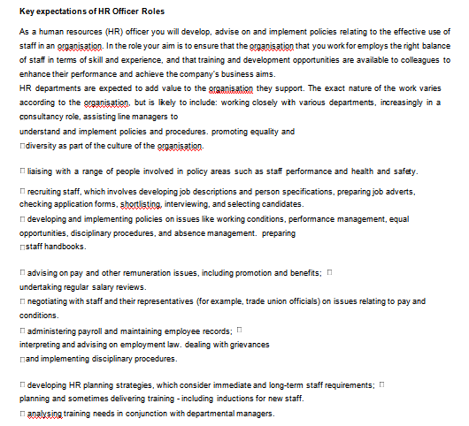

## Appendix B

|  |  |
| --- | --- |
| **Strengths**  What do you do well?  What unique resources can you draw on? What do others see as your strengths? | **Weaknesses**  What could you improve?  Where do you have fewer resources than others?  What are others likely to see as weaknesses? |
| * Effective communication skills. * Adequate knowledge regarding information technology. * Strength in problem solving skills. * Strength of managing multiple tasks. | * Lack of supervisory management as a HR officer. * Lack of maintaining disciplinary activities. * Weakness regarding time management. * Lack of Managing priorities. |
| **Opportunities**  What opportunities are open to you? What trends could you take advantage of?  How can you turn your strengths into opportunities? | **Threats**  What threats could harm you? What is your competition doing?  What threats do your weaknesses expose to you? |
| * Analyses issues of employees of Amazon. * Enhance customer engagement rate for Amazon. * Maintain the work process of an organisation in a systematic process. * Maintain time effectiveness of the work process in Amazon. | * Issues regarding the process of managing employees regarding the work process of Amazon. * Creates conflicts regarding work process among employees of Amazon. * Decrease employee engagement in Amazon. * Create issues regarding multiple task control. |

## Appendix C

|  |
| --- |
| **Name** |
| **Job role:** Human Resource Officer |

|  |  |  |  |  |
| --- | --- | --- | --- | --- |
|  | **Very good** | **Good** | **Adequate** | **Little or no experience** |
| **Information Technology** | | | | |
| Use Microsoft Office  Word |  |  |  |  |
| Use Excel spreadsheet |  |  |  |  |
| Use a Database |  |  |  |  |
| Use specialist  HR software |  |  |  |  |
| Use the internet |  |  |  |  |
| Use e-mail |  |  |  |  |
| Use PowerPoint |  |  |  |  |

|  |  |  |  |  |
| --- | --- | --- | --- | --- |
|  | **Very good** | **Good** | **Adequate** | **Little or no experience** |
| **Communication Skills** | | | | |
| Drafting contracts of  employment |  |  |  |  |
| Taking notes of  disciplinary hearings |  |  |  |  |
| Write reports |  |  |  |  |
| Produce material to  support presentations |  |  |  |  |
| Delivering a training  session |  |  |  |  |
| Resolving  disputes/complaints |  |  |  |  |
| Interviewing |  |  |  |  |
| Advising on HR issues |  |  |  |  |

|  |  |  |  |  |
| --- | --- | --- | --- | --- |
|  | **Very good** | **Good** | **Adequate** | **Little or no experience** |
| **Problem solving skills** | | | | |
| Make good use of verbal reasoning skills, able to handle complex data and make selective use of  information |  |  |  |  |
| Explore more than  one solution in order to solve a problem |  |  |  |  |

|  |  |  |  |  |
| --- | --- | --- | --- | --- |
| Consider the ideas of others to help  solve problems |  |  |  |  |

|  |  |  |  |  |  |
| --- | --- | --- | --- | --- | --- |
| **Supervisory Management** | | | | | |
| How much experience have you had in your role? |  |  | < 1 month | 1-3 months | > 3 months |
|  | | |
| How many people have you managed at any one time? | None | | | 1-5 | Above 5 |

|  |  |
| --- | --- |
| **I declare that the information given in this form is true** | |
| **Signed** |  |
| **Date** |  |