**DEVELOPING PEOPLE LEADERSHIP AND CAPABILITIES**

**ASSIGNMENT PART 1 - GROUP WORK**

**PRODUCT WITH EMBEDDED PRESENTATION**

**Table of Contents**

Introduction 3

Description of Project 3

Analysing two leadership challenges including a resolution 4

Contextual Explanation for the Challenge 5

Justifying leadership skills as well as behaviours for overcoming the challenge 6

Theories and models for mitigating leadership challenges from a project 8

Democratic leadership theory 8

4C’s risk management model 9

Affiliative leadership theory 9

Conclusion 10

References 11

# Introduction

The study has been demonstrating a real-world case for the implementation of a clear understanding of leadership issues and the impacts of project managers on managing complex situations. A clear explanation of the challenges in the project is discussed in this study. The effective strategic development in the leadership for the management of the issues is determined. The ***“HS2 tunnelling”*** is selected as a real-world project of the UK where several potential risks are included. A description of the potential risk factor and solutions for those issues are implemented in this paper. Implementation of the theoretical understanding helps in the effective management of the leadership challenges that arise in the HS2 project.

# Description of Project

The “HS2” is identified as an innovative improvement of the railway services in the UK where the longest tunnel route (16 Km) is developed in the UK. The high-speed tunnelling support will establish a connection between ***“London and Crewe”*** and expected construction will be started in 2024 (Hs2, 2023). The expected amount of the tunnel construction is “2.7 million cubic metres” material and work has been started in the year 2022. The project developed with a “sustainability aspect” where reduction of the carbon emission is the main targeted aspect of the project. The estimated cost of the whole project is ***“£106 billion”*** which is included in the “HS2 project” which connects the biggest cities in the UK (HS2 Limited, 2022). Therefore, the project will provide beneficiaries in the transportation process of the UK.

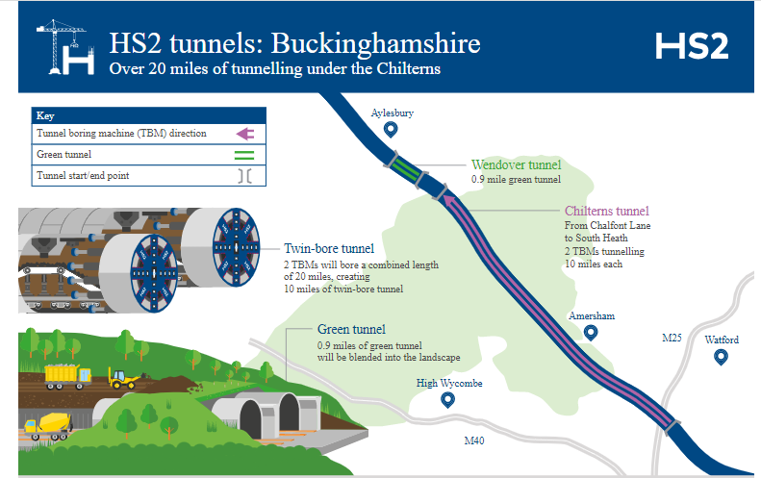

**Figure 1: HS2 Tunnelling**

(Source: Hs2, 2023)

Improvement of transportation and connectivity in the cities of the UK and sustainability development in transportation is the main targeted aspect of this project. The BBC provides information about the benefits of the HS2 project such as ***“economy-boosting and sustainability”*** (Bbc News, 2023). The project will be expected in 2033-2045 and the whole project will be completed in three phases.

# Analysing two leadership challenges including a resolution

The above discussion shows the possible benefits of the developing HS2 project whereas several leadership challenging factors are present which raise complications for project management. The leadership challenges of HS2 projects are developed due to ***“skills shortages, staff turnover and protester activities”*** (HS2 Limited, 2022). The possible leadership challenges are listed below,

***“Losing Talent in leadership teams”***

HS2 Ltd applied ***“People Strategy – Skilled for Success”*** in the year 2018 and created a “capability Roadmap” for the management of talent. On the other hand, in the competitive market of the UK lack of sources in the talent Pool creates complications for project development. A lack of talent in the leadership creates a skill gap in the project which impacts the success of the project (Hs2 Ltd, 2023). The “HS2 Tunneling” project applied “organisational leadership” where segmentation is done for effective collaboration among the workers. In project development applied leadership is “people, business, relationship and entrepreneurial” leadership. As per the view of Wilson (2020), the lack of skill of ***“enterprise, functional and team leaders”*** reduced success in the project creation challenges in employee management. Therefore, complications and lack of appropriate leadership style selection or skill gaps create challenges for the HS2 project.

Improvement of the ***“HS2 Leadership Framework'' can*** help in the management of the challenges raised due to the presence of the lack of skill of the leaders. Application of the “transformational leadership style” and recruitment procedure improvement helps in the management of the leadership challenges in the HS2 project (Podkolinski, 2021). The suggestive strategy related to leadership skill improvement with the use of training and an appropriate recruitment process would help the project for overcoming the issues.

***“Likelihood of catastrophic incident”***

The complicity of the “HS2 project” increasing challenges related to leadership management for mitigation of “Catastrophic incidents”. As an example, ***“significant harm, delay to the programme and loss of confidence”*** will be the possible risk developed due to the lack of management of leaders (Singh, 2021). Therefore, risks associated with the programme safety are developed with the presence of the identified risk factor. The potential risk of the HS2 project is identified where a lack of environment management due to complex project delivery is identified. In the construction of the tunnel, appropriate logistic management is required for the appropriate supply of resources where the risk of “Catastrophic incidents” developed complications for health management by the leaders (Ciric *et al.* 2020). However, health risks and insecurity risks in the project development enhanced the risk of the leadership management in the project.

HS2 project has engaged with ***“SHWeLT”*** for effective management of the supply chain risk factor and the engagement may help in the management of the complications faced by leaders. It is expected appropriate skill enhancement of the leadership with training programme development and improvement of the leadership ability helps to solve the issues (Lippitt *et al.* 2019). Therefore, appropriate risk assessment and identification of the suggestive approach for the management of the HS2 projects will help to overcome the leadership challenges.

# Contextual Explanation for the Challenge

The examined leadership challenges are associated with several potential challenges while developing the HS2 project. Lack of ***“supply chain capacity”*** is a potential challenge which rises with the leadership complications in the HS2 project (Hs2, 2023). The issue is developed due to resource shortages as huge amounts of material (2.7 million cubic metres) are needed for the successful implementation of the expected project development. The issues related to the cost impact on the infrastructure management of the project where lack of issues of the leaders due to fewer talent impacts negatively on the project.

*Explanation of lack of leadership*

Skill gaps among the workers and associated leaders are examined as a serious challenging factor for the development of the HS2 project. In the selected project, “technical, financial, and environmental concern” are examined as the risk factor which enhances the challenges of the leadership (Podkolinski, 2021). The lack of abilities of the leaders for handling team speciality in the responsibility of “Team leader” is examined. On the other hand, an analysis of the responsibility of ***“enterprise leaders”*** figured leadership and strategic goals for HS2 (Hs2, 2023). Hence, the inability of the leaders and the lack of skill of the workers enhance challenges for the management of the people's leadership and stakeholder management.

The leadership framework included “functional leaders” where flexibility, cross-matrix influencing and collaboration development are present. Besides this, the lack of talent in the functional leaders creates potential functional barriers to the management of the HS2 project (Lippitt *et al.* 2019). Lack of abilities in team management creates issues in handling teams for innovative construction for HS2 projects. Inclusion of the political events for controlling changes creates complications in project management where higher opportunities for project control are examined. Therefore, the lack of skills of the leaders constantly impacts the overall project management.

*Explanation of challenges for “catastrophic incident”*

In the development of the HS2 project higher risk of “catastrophic incidents” is identified as related to time and workers health management. As per the view of Wilson (2020), communication and team engagement is required for overcoming “catastrophic incident” management. In HS2 projects risk of lack of skill of the leaders is identified which raises complications for managing projects related to project management. Communication gap creation, rising complication for sharing information about resources management (human and physical). On the other hand, “stakeholder management” of the HS2 projects is needed where lack of support of the leaders raises the chances of failure in the project. As stated by Ciric *et al.* (2019), “Workplace accidents, Falls, injuries, construction accidents and medical mistakes” are some possible catastrophic injuries that are identified in the HS2 project. Therefore, the presence of the identified challenges raises implications for leaders to handle the project work of the HS2. The challenges related to the project development are examined due to the lack of effectiveness in the implemented leadership style of the HS2 tunnelling project.

# Justifying leadership skills as well as behaviours for overcoming the challenge

Leadership plays a crucial role in an organisation which helps a project manager to fulfil a project by overcoming all the severe and general challenges of a respective project. HS2 tunnelling is one of the potential projects in London which is basically a construction project for railway extension (Learninglegacy.hs2.org.uk, 2023). In this project, managers or leaders of the project may face different project issues. From those issues, two challenges may have stopped the growth of the respective project, in front of stakeholders. For instance, "losing challenges from the respective team" and "catastrophic incidents" are the potential challenges which can reduce the value of the project. Due to overcome these two potential challenges, project managers of the respective project need to have adequate decision-making skills, conflict management skills, communication skills, and EI (Emotional Intelligence). Apart from these skills, leaders need to maintain passion and behaviour which is appropriate for a challenging scenario.

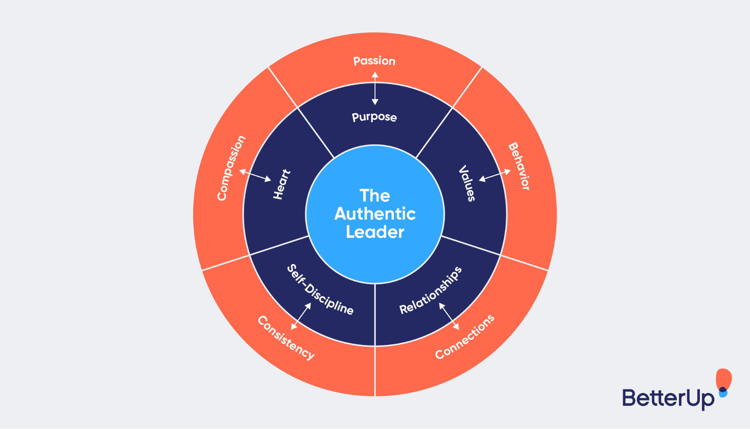

**Figure 2: Leadership skills for the overcome challenge**

(Source: STeFAN and Nazarov, 2020)

Self-discipline, values, and relationship management are some of the techniques which support leaders or project managers to reduce or overcome challenges from a project. For instance, due to having adequate communication skills, leaders can reach each stakeholder and can know their personal issues regarding the workplace and project. After knowing all the necessary requirements of staff like remuneration, upskilling training session and others. On the other hand, due to improper behaviour among leaders, they are sometimes unable to combat challenges in an efficient manner (Hatcher, 2020). In this context, leaders have adequate communication and team management skills. Based on the present days, approximately, 65% of workers try to change their project due to demotivation and inadequate remuneration (Colvin *et al.* 2021). In this context, focusing on team management through adequate remuneration, and negotiating the health and safety benefits of staff, the project can reduce the chances of talent retention in the project.

In a project, there is a range of catastrophic risks like health and hygiene risks, financial risks, employee risks, waste management risks and others in a project. In this context, leaders need to have adequate risk management skills which help leaders to manage organisational risks in the earliest manner (Shonhadji and Maulidi, 2022). Managing health and safety risks from the project, managers can reduce unnecessary delays in project completion which help leaders to deliver projects in front of stakeholders within the stipulated time. Apart from the health risks to employees, employees sometimes conduct different employee strikes which reduce the ethical values of the project in the present competitive market. Furthermore, by emphasising conflict management skills, leaders can reduce all workplace conflicts and employee strikes which are the general risks in a project.

Hence, communication skills, conflict management skills, decision-making skills, and risk management skills are some of the potential skills which help managers of a project combat project risks from a respective project. Apart from these skills, leaders need to have adequate leadership behaviours which maintain the challenging mentality in the mind of leaders. By maintaining honest behaviour, and a challenging mentality with collaborative behaviour, leaders can mitigate organisational risks in an effective manner (Maalouf, 2019). Hence, project managers of the respective project HS2, need to have effective communication skills and risk management skills as well as a challenging mentality which enriches the balance in leadership practice and provides high-end project outcomes to stakeholders.

# Theories and models for mitigating leadership challenges from a project

## Democratic leadership theory

Democratic leadership is one of the crucial factors which help an organisation or a project to find maximum success from a project plan. In certain circumstances, due to improper leadership, leaders are unable to engage employees in the workplace or project and are also unable to enrich the staff retention and motivation rate (Mahadi *et al.* 2020). In this context, democratic leadership has focused on influence, motivation, decentralised decision making and simulation.

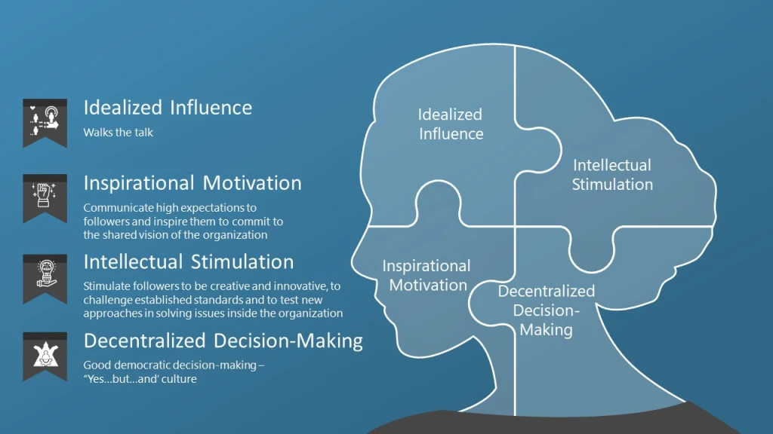

**Figure 3: Democratic leadership**

(Source: Eizaguirre and Parés, 2019)

In certain circumstances, due to a lack of motivation among staff, they try to change their jobs and which maximises the staff turnover for a project. As a result of this staff turnover, managers are unable to retain talented staff in the workplace which creates constraints in project handover. In this context, democratic leaders retain employees through idealised influence as well as inspirational motivation. In this context, leaders of the HS2 Tunnelling project need to influence staff regarding organisational goals and objectives and return them to the project process. By allowing the staff in the decision-making, managers can maximise the working motivation among staff which enriches the level of productivity along with creativity among employees of the respective project.

## 4C’s risk management model

Risks are some inseparable parts of a project which make different barriers in the project which raise a question mark on project management strategies. Based on the present day, risk management is one of the potential demands of leaders which enrich organisational success. However, some traditional models are sometimes unable to detect project risks based on the present day. In this context, the 4C's risk management model can play a crucial role in order to enhance the risk management of a project (Hong *et al*. 2019). This framework has focused on different phases and different risks based on these phases. Detection, analysis, treatments and evaluation are the key parts of the 4C’s risk framework.

During the session, leaders of the HS2 project use the 4C's framework regarding managing project risks, managers can identify upcoming risks in the earliest manner and after detection, take the appropriate intervention to mitigate the risks. This framework supports a project in the project continuity plan as well as in crisis management which reduces the project constraints from the venture. In order to use this 4 C's framework, an organisation not only reduces risks from a project but also can manage the ISO 31000 management standards (Pascarella *et al.* 2021). This standard guided an overall project in order to enrich project development and deliver a high-end project to service users.

## Affiliative leadership theory

The affiliative leadership approach is one of the positive and fruitful leadership styles which has emphasised building staff trust, improving employee morale, making an effective team, strong guidance and conflict management as well as, reducing workplace stress. While an organisation can face some risks like organisational conflicts, financial risks and others, the affiliative theory not only reduces conflicts but also improve employee morale in a similar manner.

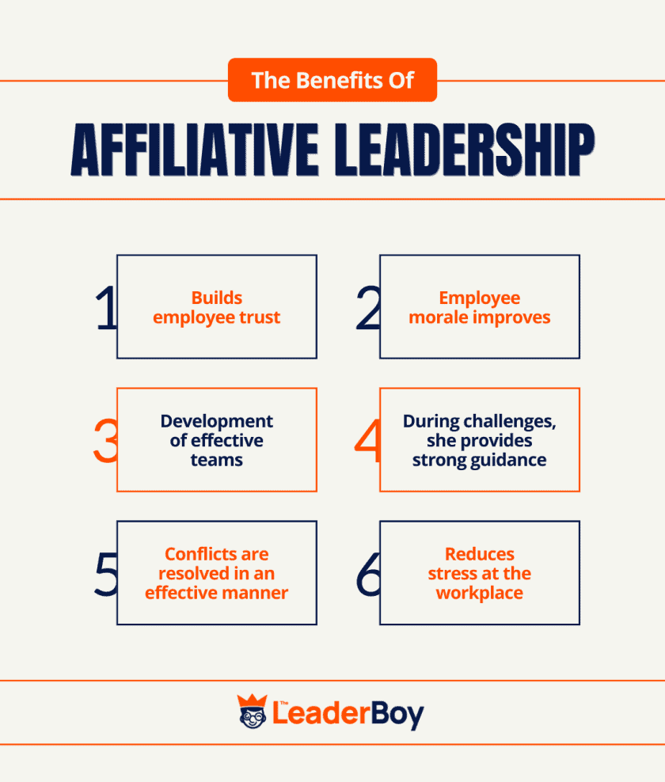

**Figure 4: Affiliative leadership**

(Source: Partnerships, 2022)

Apart from improving employee morale, the affiliate leaders deliver strong and positive guidance to employees. These leadership aspects support the HS2 project to manage the project team in an appropriate manner. In this context, finding adequate guidance from leaders, and improving morale among employees, leaders or managers of the respective project has fulfilled the project in a successful manner.

# Conclusion

Project management helps an organisation to maximise competitive advantages and implement new changes in the firm. For instance, the HS2 project has enriched the railway of London which helps service users of the place to find more efficient railway services. However, project managers need to face different challenges like staff turnover, general risks like financial risks, workplace conflict and others. In this context, democratic leadership, affiliative leadership, and 4C's risk management can reduce risks from a venture. Apart from the leadership framework, leaders need to have adequate leadership skills like conflict management skills, communication skills, risk management mentality and positive behaviour among leaders. These skills along with behaviours among leaders of the HS2 project can decrease the upcoming risk from the respective project.

# References

Bbc News (2023). HS2: What is the route, when will it be finished and what will it cost? [online]. Available from: https://www.bbc.com/news/uk-16473296 [Accessed 25 April 2023].

Ciric, D., Lalic, B., Gracanin, D., Tasic, N., Delic, M. and Medic, N., (2019). Agile vs. Traditional approach in project management: Strategies, challenges and reasons to introduce agile. [Online] *Procedia Manufacturing*, *39*, pp.1407-1414.

Colvin, C.J., Hodgins, S. and Perry, H.B., (2021). Community health workers at the dawn of a new era: 8. Incentives and remuneration. [Online] *Health Research Policy and Systems*, *19*, pp.1-25.

Eizaguirre, S. and Parés, M., (2019). Communities making social change from below. Social innovation and democratic leadership in two disenfranchised neighbourhoods in Barcelona. [Online] *Urban Research & Practice*, *12*(2), pp.173-191.

Hatcher, W., (2020). A failure of political communication not a failure of bureaucracy: The danger of presidential misinformation during the COVID-19 pandemic. [Online] *The American Review of Public Administration*, *50*(6-7), pp.614-620.

Hong, J.H., Kim, B.C. and Park, K.S., (2019). Optimal risk management for the sharing economy with stranger danger and service quality. [Online] *European Journal of Operational Research*, *279*(3), pp.1024-1035.

HS2 Limited. (2022). About HS2 [online]. Available from: https://learninglegacy.hs2.org.uk/about-hs2/ [Accessed 25 April 2023].

Hs2 Ltd (2023). Leadership Framework. [online]. Available from: https://assets.hs2.org.uk/wp-content/uploads/2021/06/Leadership-Framework.pdf [Accessed 25 April 2023].

Hs2, 2023. High Speed Two (HS2) homepage [online]. Available from: https://www.hs2.org.uk/building-hs2/tunnels/tunnel-drives/chiltern-tunnel/#:~:text=The%20Chiltern%20Tunnel%20is%20the,used%20to%20create%20the%20tunnel. [Accessed 25 April 2023].

Learninglegacy.hs2.org.uk (2023), About the HS2 Programme. [Online] Available from: https://learninglegacy.hs2.org.uk/about-hs2/ [Accessed: 25th April 2023]

Lippitt, P., Dunwoody, A. and Charlson, A., (2019), August. Planning for waste minimisation and resource efficiency in HS2. In *Proceedings of the Institution of Civil Engineers-Waste and Resource Management* (Vol. 172, No. 3, pp. 65-75). [Online] Thomas Telford Ltd.

Maalouf, G.Y., (2019). Effects of collaborative leadership on organizational performance. [Online] *International Journal of Multidisciplinary Research and Development*, *6*(1), pp.138-144.

Mahadi, N., Woo, N.M., Baskaran, S. and Yaakop, A.Y., (2020). Determinant factors for employee retention: should I stay. [Online] *International Journal of Academic Research in Business and Social Sciences*, *10*(4), pp.201-213.

Partnerships, B.F., (2022). Administrative Leadership In academia, 105 Affiliative leadership, 64 Afghan families, 92 Afghan government, 86. [Online] *Academic leadership*, *5*, p.63.

Pascarella, G., Rossi, M., Montella, E., Capasso, A., De Feo, G., Botti, G., Nardone, A., Montuori, P., Triassi, M., D’auria, S. and Morabito, A., (2021). Risk analysis in healthcare organizations: Methodological framework and critical variables. [Online] *Risk Management and Healthcare Policy*, pp.2897-2911.

Podkolinski, J., (2021), February. HS2 railway, UK–the hybrid bill. In *Proceedings of the Institution of Civil Engineers-Transport* (Vol. 174, No. 1, pp. 59-66). [Online] Thomas Telford Ltd.

Shonhadji, N. and Maulidi, A., (2022). Is it suitable for your local governments? A contingency theory-based analysis on the use of internal control in thwarting white-collar crime. [Online] *Journal of financial crime*, *29*(2), pp.770-786.

Singh, S., (2021). Use of sustainability assessments (BREEAM and CEEQUAL) on the HS2 project. In *High Speed Two (HS2): Infrastructure Design and Construction (Volume 2)* (pp. 231-239). [Online] ICE Publishing.

STeFAN, T.A.L.U. and Nazarov, A.D., (2020), November. Challenges and competencies of leadership in Covid-19 Pandemic. [Online] In *Research technologies of pandemic coronavirus impact (RTCOV 2020)* (pp. 518-524). Atlantis Press.

Wilson, T., (2020). Built heritage on HS2 Phase 1 North: quantifying, managing, monitoring, mitigating, innovating. [Online] *The Archaeologist*, (111), pp.22-24.