**INDIVIDUAL ASSIGNMENT OF PROJECT MANAGEMENT ON HAKLO PROJECT**

Table of Contents

1.0 Reﬂection 2

a. Skills as well as knowledge 2

b. Reﬂection on the skills 3

2. New Project Management Processes at Haklo 3

a. Proposal 3

b. Project Scheduling Tools 7

c. Project Budget Creation 8

3. Application of Project Management 9

a. Project Charter: “A new type of designed robot as an educational fun toy”. 9

b. Project Plan with Resources 12

c. Project Management Responses 13

Reference list 16

# 1.0 Reﬂection

## a. Skills as well as knowledge

***Technical abilities, collaboration with the team, and excellent communication skills*** are all necessary for a project coordinator to create this area of the HAKLO product, and they are all valued as highlighted information. The manager, in my opinion, should ideally have a complete understanding of automation, including its theories, engineering, and architecture. To make sure that the robot satisfies the specific standards, it must be able to collaborate with developers, engineers, or other skilled workers (Tam, *et al.* 2020). Moreover, managerial abilities like ***resource management*** must be linked to knowledge of project management rules and processes. They must be able to set project goals, create timetables and budgets, assign resources, track development, and guarantee that the work is done on schedule and within the allocated budget.

**Figure 1: Management skills**

(Source: self-created)

Teamwork skills deal with ***communication skills*** among team members is necessary for collaboration with effective teamwork. The project manager needs to assemble and oversee a group of specialists from many fields, ensuring that they collaborate efficiently towards a single objective. To make sure, the project manager must be able to interact efficiently with the team, decision-makers, and clients (Swart, *et al.* 2022). As a result, the manager of the team charged with developing a new kind of robot for children's future ought to be able to foster and support original thought and invention. Also, they must be able to control the budget and make sure the project is sustainable financially. ***Risk management skills*** involve a certain amount of risk and the project manager will be able to recognize prospective risks, evaluate their significance, and design mitigation techniques.

## b. Reﬂection on the skills

I would like to mention my preferences for teamwork skills. I can also say that working abilities can help to do market research on educational products more, through this demand for STEM products can be highlighted (Swart, *et al.* 2022). As Haklo tries to recover from its financial decreases, the product designing capabilities of the team members should be enhanced with the help of materials skills. Managers can do prototypes for charging team members on the segment of children's education more like moving toys like animals, from which children can learn.

I grounded over board meetings will help to boost communication skills. Staff training skills would give access to the manager to finding risks and with the help of “Haklo clean” developing ideas manager can release the extra burden and safely make mapping technology of educational toys (Tam, *et al.* 2020). I ought to figure out that the senior role as a manager can enforce resource allocation in the right way which would bring better planning and innovative performance through this project execution. Proper work allocation can help team workers in the documentation that would connect previous project details too for measuring the rate of success in controlling cost to execution.

# 2. New Project Management Processes at Haklo

## a. Proposal

**Project management ideas**

Haklo can benefit from project management by clearly defining the aims and objectives of the "Haklo Free" project, such as producing a ***multi-functional educational robot toy*** for children. This will assist the team in remaining focused and aligned throughout the lifespan of the project. Effective project planning may assist Haklo in completing the "Haklo Free" project on schedule, under budget, and to the needed quality standards (Thesing, *et al.* 2021). Breaking down the project into manageable tasks, assigning duties and dates, and identifying potential risks and concerns will all be part of this process. This can also help Haklo manage its resources successfully, such as people, time, and money, figuring cartoon characters, etc. This will entail assessing the talents and experience necessary for the project and ensuring that resources are efficiently allocated to guarantee the project's success.

It will guarantee that the team collaborating on the "Haklo Free" project has open lines of interaction and collaboration. This will entail holding frequent project meetings, reporting on progress, and dealing with any difficulties or obstacles that occur (Sandbank, *et al.* 2020). This will aid them in efficiently managing business stakeholders, which include consumers, suppliers, and investors. This will entail identifying and interacting with stakeholders throughout the lifespan of the project to ensure that their requirements and expectations are satisfied.

**Stakeholder Management Importance**

Individuals or groups with an interest or concern within the project or business have been referred to as stakeholders. Workers, consumers, vendors, regulators, shareholders as well as the general public can all be included. Identifying customers, recognizing their requirements and wants as well as establishing methods to interact & interact with them are all part of effective stakeholder management. Stakeholder management has been significant in the case of Haklo for various reasons (Dörrenbächer, *et al.* 2022). For starters, it may aid in meeting the requirements and expectations of important stakeholders. This can lead to greater support and cooperation from stakeholders, which can in turn enhance the success of the business. Furthermore, stakeholder management may aid in the identification of prospective company risks and opportunities (Swart, *et al.* 2022). It could help Haklo to anticipate and respond to changes in the market and regulatory environment. Finally last but not the least, effective stakeholder management can enhance the reputation and social responsibility of Haklo, which can lead to improved relationships with stakeholders and increased profitability.

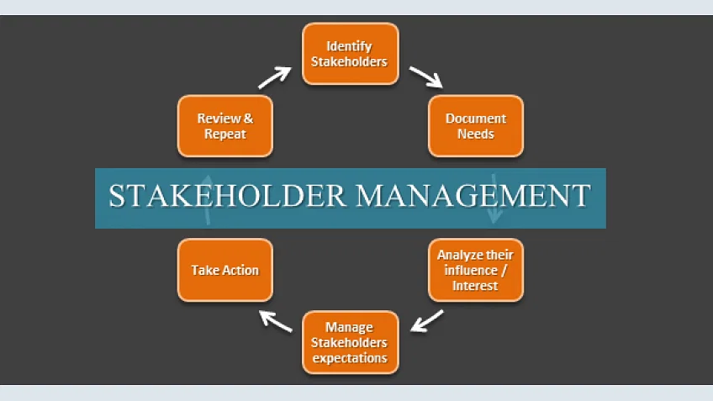

**Figure 2: Stakeholder management approaches**

(Source: https://www.simplilearn.com/ice9/blog)

In the direction of developing a stakeholder approach for Haklo, the first step is to identify key stakeholders (Cheng, *et al.* 2020). This can be done through a stakeholder mapping exercise, which involves identifying all potential stakeholders and assessing their level of interest and influence on the business. Once key stakeholders are identified, the next step is to understand their needs and expectations. This can be done through stakeholder engagement activities such as surveys, interviews, and focus groups.

Based on the information gathered, Haklo can develop strategies to engage and communicate with stakeholders. For example, regular meetings and updates can be provided to employees and investors to ensure they are kept informed about the business (Swart, *et al.* 2022). Customer feedback can be obtained through surveys and social media channels to ensure that their needs are being met. Suppliers can be engaged through regular communication and partnership agreements. Regulatory bodies can be engaged through compliance with relevant regulations and standards.

**Significance of risk management**

Effective risk management ensures that potential risks are identified, analyzed, and addressed proactively to avoid potential negative impacts on the project. A robust risk management approach can help project teams to manage uncertainties and mitigate risks, making the project more successful (Willumsen, *et al.* 2019). For Haklo's product development projects, a risk management approach should be adopted to identify and mitigate risks throughout the project lifecycle.

The very first stage is to identify possible hazards to the project. Technical, functioning, monetary, governing, as well as ecological problems are all potential causes of risk. The risk identification process should involve all stakeholders, including project team members, suppliers, customers, and end-users (Alves-Oliveira, *et al.* 2021). Once determined possible risks must be based on their likelihood of incidence therefore their possible effect is on the project. Risks with higher probability and impact should be given more attention and resources for mitigation. After identifying and assessing risks, appropriate risk mitigation strategies should be developed. Risk prevention, transferring risk, risk mitigation, as well as risk acceptance are examples of risk management methods (Sandbank, *et al.* 2020). To make certain that the risk reduction plan stays successful; it must be evaluated as well as modified regularly.

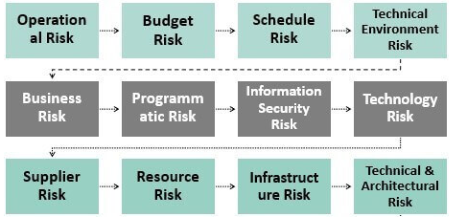

**Figure 3: Risk management options**

(Source: https://www.wallstreetmojo.com)

The risk management plan should be communicated to all stakeholders, and appropriate measures should be taken to implement the plan. The project team should be trained in risk management techniques, and regular risk assessments should be conducted to identify new risks that may arise (Tam, *et al.* 2020). Finally, risk monitoring and control should be an ongoing process throughout the project. The project team should track risks, assess their effectiveness, and adjust risk mitigation strategies as necessary.

## b. Project Scheduling Tools

Project scheduling tools like MS Project are useful for planning projects because they provide a visual representation of the project timeline as well as assist to manage and track project activities (Sepasgozar, *et al.* 2019).

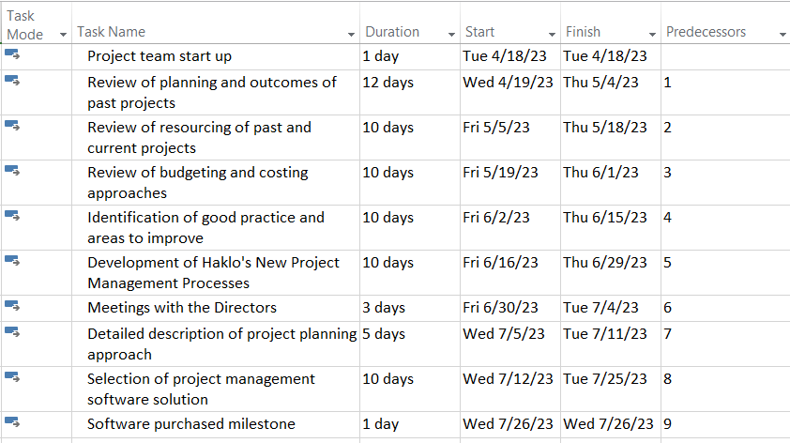

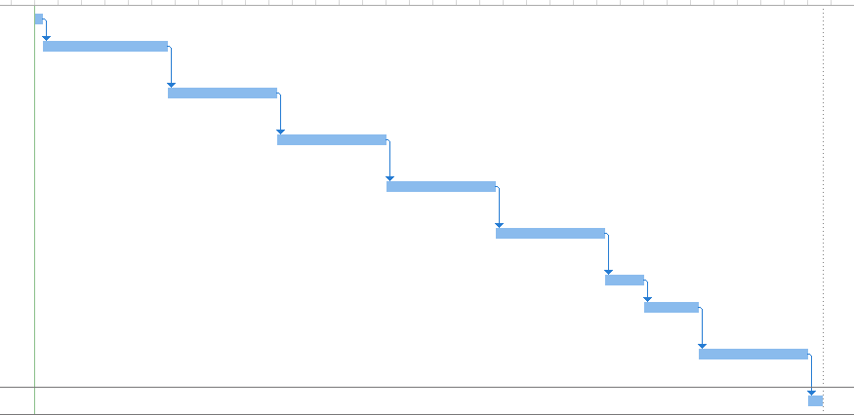

**Figure 4: Gantt chart**

(Source: Self-created)

In this Gantt chart, each activity is represented by a bar, with its start and end dates indicated on the chart. The length of the bar reflects how long the action lasted (Tereso, *et al.* 2019). The critical path denotes the longest sequence of tasks in the execution process that need to be performed for the project to be finished on a deadline.

In the Haklo case study, the project team start-up activity only requires one day, whereas the review of planning and outcomes of past projects activity requires 12 days (Pnevmatikos, *et al.* 2022). The project manager can distribute the right assets for every task using scheduling tools, ensuring that the project is finished on schedule as well as within budget.

## c. Project Budget Creation

| **Task** | **Duration** | **Resources** | **Cost** |
| --- | --- | --- | --- |
| Project team start-up | 1 day | SPM, C1, C2, A1, A2 | £6,900 |
| Review of planning and outcomes of past projects | 12 days | SPM, C1, C2, A1, A2 | £114,000 |
| Review of resourcing of past and current projects and work allocation | 10 days | SPM, C1, A1 | £46,500 |
| Review of budgeting and costing approaches used on past and current projects | 10 days | SPM, C2, A2 | £46,500 |
| Identification of good practices and areas to improve from past projects | 10 days | SPM, C1, C2, A1, A2 | £57,000 |
| Development of Haklo's New Project Management Processes | 10 days | SPM, C1, C2, A1, A2 | £57,000 |
| Meetings with Directors | 3 days | SPM, A1 | £20,550 |
| A detailed description of the project planning approach and metrics | 5 days | SPM, C1, C2, A1, A2 | £35,250 |
| Selection of project management software solution | 10 days | SPM, C1, C2, A1, A2 | £57,000 |
| Software purchased (milestone) | N/A | N/A | £100,000 |

Project software can assist with identifying cost variances, enabling managers to make informed decisions about how to adjust budgets and schedules as necessary (Pnevmatikos, *et al.* 2022). To generate the overall budget report for the Haklo case study can be used in a table format to summarize the costs associated with each task as well as a Gantt chart to illustrate the duration and dependencies of each task (Bertel, *et al.* 2019).

# 3. Application of Project Management

## a. Project Charter: “A new type of designed robot as an educational fun toy”.

**Scope**

After considering this new segment of the project students can promote their knowledge of the programming language tasks' nature, which requires investigative learning. This robotic idea can encourage kids to think beyond the box. More particularly, the students picked up "Scratch language" under the surveys on the situation of coding issues (Cheng, *et al.* 2020). Not only that, a robotic curriculum in a school over a week can bring more Creative Thinking in students. For this customization of stakeholders is done on the project execution of a total budget of £2800000. Considering social media issues along with the creative manager role this project

**Goal**

The main aim of the project is to deal with new “Haklo-free” ideas for generating an innovatively designed robot as an educational development for students.

**Objective**

The objectives are,

* To encourage ER sources with the help of STEM for better designing.
* To develop learning programs with cartoon characters to present this robot to calibre knowledge for children.
* To build exploration with the planning of resources and the roles of managers for the mapping technology system.

**Stakeholder analysis**

The stakeholders involved in the development and launch of Haklo Free would include the ***Board of Directors, Product Design Director, Marketing and Sales Director, developers, potential customers (parents, and children), and influencers (cartoon characters).***

| ***Type of stakeholders*** | ***Their roles and impact*** |
| --- | --- |
| ***Board of Directors*** | The Board of Directors would ensure effective communication and collaboration among the stakeholders. Additionally, the project sales and marketing director can adopt a proactive communication approach (Dörrenbächer, *et al.* 2022). The team can create a project communication plan that outlines the communication channels, frequency, and format of communication for each stakeholder group**.** |
| ***Product Design Director*** | In this segment, designers would emphasise the making of new robotics and home products, with new ideas involving mapping and robotics (Pnevmatikos, *et al.* 2022). And according to our designer's knowledge, an investment of 1 hour would be essential and enough both for making a good experience of product designing. |
| ***Marketing and Sales Director*** | To prevent excess inventory and late deliveries, managers might collaborate with the manufacturing team to make sure that now the availability corresponds to the anticipated demand (Ordóñez *et al.* 2021). The Advertising and Sales Manager can collaborate only with the design group to choose the machine's ideal pricing point. To choose the pricing that maximizes earnings and sales, they can take into account elements like production costs, a relevant cost, and the recognized worth of the object. |
| ***potential customers*** | Children's choices and passions could be influenced by animated characters. The likelihood of a robot succeeding may be increased if it is made to imitate a well-known fictional character. On the other hand, Parents can be the group most likely to get the machines for their kids at home, parents are key stakeholders (McStay, and Rosner, 2021). They'll be searching for a play gadget that will be entertaining and captivating but also secure and instructive. |
| ***influencers*** | Robotics must be built with characteristics that make it simple to use and operate to satisfy the demands and demands of parents (Ordóñez *et al.* 2021). |

**Communication approaches**

* **Interactive communication**

Among the most widely used methods for communicating with stakeholders is email. Its advantages include automatic messaging, material customization, and analytics on open & retention rates (Swart, *et al.* 2022). As a result, managing interactions with each stakeholder is quite successful. To notify investors of the most important facts from the previous week, consider using a monthly summary. Updating on the expenditures, pictures, the week's news, contact details, the following stages, high-level design documents, and more may be included.

* **Presentation**

They can be found online or in person. The Internet has the distinctive bonus of the ability to swiftly and efficiently reach broad geographic areas. The manager therefore can opt for video PowerPoint slides (McStay, and Rosner, 2021). Once the team members and manager will be online, downloading the slides and emailing them to the other stakeholders would be possible so they can access them whenever they want.

## b. Project Plan with Resources

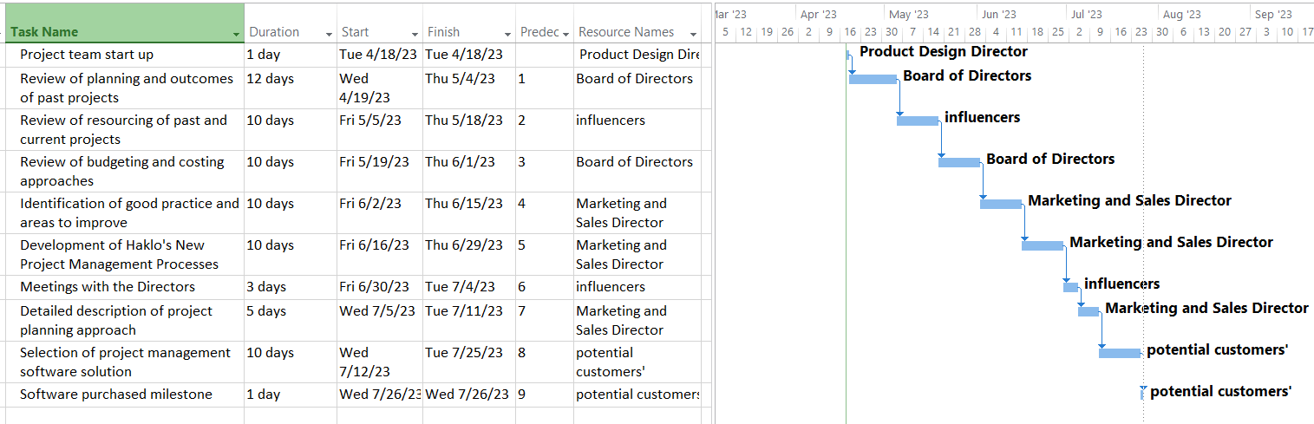

**Figure 5: Gantt chart**

(Source: MS-project)

The above Gantt chart represents the project plan of this new project. By looking at the Gantt chart it can be seen that the total duration of this project has been considered 60 days. The resources have been properly distributed based on the tasks of the project. The graphical representation will help to understand the task durations very easily. In addition to this, the starting date and the ending date of each task are there.

## c. Project Management Responses

**Scenario 1: *“A new social media platform is released that is very popular”***

**Repercussions:**

Launching a new social media platform can have various implications for the success of the "Haklo Free" digital media campaign. If the new social media platform is very popular, it could either work in favor of or against the campaign. If the newly launched social networking site is popular as well as the "Haklo Free" campaign's target demographic is also engaged in it, the advertising department may use this chance to advertise the service to a larger audience (Clauss, *et al.* 2020). To reach more people, the group might produce content that is optimized for the new platform as well as employ paid advertising. This might end up in greater marketing exposure and engagement. On the other hand, if the new social media site is not prominent within the "Haklo Free" campaign's target demographic, the marketing team might have to rethink its strategy (Bampasidis, *et al.* 2021). They might need to find new channels or venues where their target audience is more engaged and allocate resources accordingly.

**Response and Management:**

In response to the first scenario, the marketing team can perform market research to determine the popularity of the new social media site among their target demographic. This research will assist the team in understanding how they can use this platform to reach more individuals. The team may generate content that is optimized for the new platform based on the findings. Text, photos, or videos can all be used to create this content (Rohm, *et al.* 2019). To reach a larger audience on the new platform, the team can employ sponsored advertising. Sponsored postings, display adverts, and influencer marketing are examples of this.

**Figure 6: Advertising techniques**

(Source: self-created)

**Scenario 2: *“The software/technology that you selected is not working and keeps crashing and causing errors”***

**Repercussions:**

When launching a digital media campaign, the technology, and software that the campaign relies on are critical to its success. If the software or technology that the team has selected is not working correctly, it can have severe repercussions on the campaign's success. If the team's chosen software or technology fails to function properly, the campaign's launch date may be pushed back (McStay, and Rosner, 2021). This might have an impact on other marketing operations and lead to missed chances. If the group's chosen equipment or technology isn't working appropriately the campaign's ability to produce the intended outcomes may suffer. This can lead to resource waste and a negative influence on the brand's reputation.

**Response and Management:**

In response to the second situation, the marketing team can collaborate with their technical partners to determine the problem with the program or technology that is causing it to crash or generate problems. Meanwhile, the team may devise a backup plan to guarantee that the campaign can still go live on schedule (Dörrenbächer, *et al.* 2022). This might include changing the campaign's approach to working around the issue or employing other software or technology that is available. The team can communicate with stakeholders such as the project sponsor as well as additional members of the marketing group to keep them aware of the problem as well as the attempts being made to remedy it (Yang, 2022). Once the problem has been found the team may collaborate with their technical partners to resolve it and guarantee that the program or technology is functioning properly. Bug fixes, upgrades, and other technical solutions may be included.

# Reference list

**Journals**

Alves-Oliveira, P., Arriaga, P., Paiva, A. and Hoffman, G., 2021, March. Children as robot designers. In *Proceedings of the 2021 ACM/IEEE International Conference on Human-Robot Interaction* (pp. 399-408).   
Bampasidis, G., Piperidis, D., Papakonstantinou, V.C., Stathopoulos, D., Troumpetari, C. and Poutos, P., 2021. Hydrobots, an Underwater Robotics STEM Project: Introduction of Engineering Design Process in Secondary Education. *Advances in Engineering Education*.

Bertel, L.B., Brooks, E. and Dau, S., 2019. Developing Robot-Supported Inclusive Education (ROSIE): A Play-Based Approach to STEM Teaching and Inclusion in Early Childhood Education. In *Proceedings of the 13th Conference of the European Science Education Research Association (ESERA)*. University of Bologna.

Cheng, Y.W., Wang, Y., Yang, Y.F., Yang, Z.K. and Chen, N.S., 2020. Designing an authoring system of robots and IoT-based toys for EFL teaching and learning. *Computer Assisted Language Learning*, *34*(1-2), pp.6-34.

Clauss, T., Niemand, T., Kraus, S., Schnetzer, P. and Brem, A., 2020. Increasing crowdfunding success through social media: The importance of reach and utilisation in reward-based crowdfunding. *International Journal of Innovation Management*, *24*(03), p.2050026.

Dörrenbächer, J., Ringfort-Felner, R., Neuhaus, R. and Hassenzahl, M. eds., 2022. *Meaningful Futures with Robots: Designing a New Coexistence*. CRC Press.

McStay, A. and Rosner, G., 2021. Emotional artificial intelligence in children’s toys and devices: Ethics, governance and practical remedies. *Big Data & Society*, *8*(1), p.2053951721994877.

Ordóñez y Revuelta, M.E., Rodríguez Mincey, D.N., Nogaró, J. and Rivera, R.G., 2021. Quality of Life Marketing, Innovation and Change Management: The Rasti Robotics and Education Team. *Applied Social Marketing and Quality of Life: Case Studies from an International Perspective*, pp.319-330.

Pnevmatikos, D., Christodoulou, P. and Fachantidis, N., 2022. Designing a Socially Assistive Robot for Education Through a Participatory Design Approach: Pivotal Principles for the Developers. *International Journal of Social Robotics*, *14*(3), pp.763-788.

Rohm, A.J., Stefl, M. and Saint Clair, J., 2019. Time for a marketing curriculum overhaul: Developing a digital-first approach. *Journal of Marketing Education*, *41*(1), pp.47-59.

Sandbank, M., Bottema-Beutel, K., Crowley, S., Cassidy, M., Dunham, K., Feldman, J.I., Crank, J., Albarran, S.A., Raj, S., Mahbub, P. and Woynaroski, T.G., 2020. Project AIM: Autism intervention meta-analysis for studies of young children. *Psychological bulletin*, *146*(1), p.1.

Sepasgozar, S.M., Karimi, R., Shirowzhan, S., Mojtahedi, M., Ebrahimzadeh, S. and McCarthy, D., 2019. Delay causes and emerging digital tools: A novel model of delay analysis, including integrated project delivery and PMBOK. *Buildings*, *9*(9), p.191.

Swart, K., Bond-Barnard, T. and Chugh, R., 2022. Challenges and critical success factors of digital communication, collaboration and knowledge sharing in project management virtual teams: a review. *International Journal of Information Systems and Project Management*, *10*(4), pp.84-103.

Tam, C., da Costa Moura, E.J., Oliveira, T. and Varajão, J., 2020. The factors influencing the success of on-going agile software development projects. *International Journal of Project Management*, *38*(3), pp.165-176.

Tereso, A., Ribeiro, P., Fernandes, G., Loureiro, I. and Ferreira, M., 2019. Project management practices in private organizations. *Project Management Journal*, *50*(1), pp.6-22.

Thesing, T., Feldmann, C. and Burchardt, M., 2021. Agile versus waterfall project management: decision model for selecting the appropriate approach to a project. *Procedia Computer Science*, *181*, pp.746-756.

Willumsen, P., Oehmen, J., Stingl, V. and Geraldi, J., 2019. Value creation through project risk management. *International Journal of Project Management*, *37*(5), pp.731-749.

Yang, W., 2022. Artificial Intelligence education for young children: Why, what, and how in curriculum design and implementation. *Computers and Education: Artificial Intelligence*, *3*, p.100061.