**OIL AND GAS INDUSTRY**

Table of Contents

Oil and gas industry 3

Market Overview 4

The biggest hindrance to the growth of the oil and gas industry 4

Ways for mitigating those challenges 5

Oil and Gas industry statistics 6

Top 5 Oil and Gas companies (by Revenue) 6

Reporting standards used by the companies 7

Industry Segmentation 8

Size of the Oil and Gas industry market by region (in billion USD) 8

ExxonMobil 8

Upstream: 8

Downstream: 8

Chemicals: 9

Business Segments and Disaggregated revenue 9

Royal Dutch Shell 9

Integrated Gas: 9

Upstream: 10

Downstream: 10

Chemicals: 10

Chevron 11

Upstream: 11

Downstream: 11

Chemicals: 11

BP 12

Upstream: 12

Downstream: 12

Rosneft: 12

Other businesses and corporate: 12

Exploration & Production: 13

Gas, Renewables & Power: 13

Refining & Chemicals: 13

Marketing & Services: 14

Merger & Acquisition 14

Number of Oil and gas M&A deals globally during the period 2016-21 15

Global M&A by sector for the period 2016-21 15

ExxonMobil 15

Royal Dutch Shell 16

Chevron 16

BP 17

TotalEnergies 17

Sustainability 17

ExxonMobil 17

Royal Dutch Shell 18

Chevron 18

BP 18

TotalEnergies 19

References 20

# Oil and gas industry

The oil and gas business is a global industry that encompasses the discovery, extraction, refinery, and distribution of petroleum products such as crude oil and natural gas. The sector is vital to meeting the world's energy demands and is a significant contributor to the global economy. Oil and gas are petroleum-based substances found under the earth's surface, most commonly in subsurface reservoirs (Sircar *et al.* 2021). The extraction of these resources necessitates large investments in technology and infrastructure, as well as trained labor. Oil and gas are extracted and transported to refineries where they are processed into a variety of goods such as gasoline, diesel, jet fuel, and other petroleum-based products. The oil and gas sector is complicated and competitive, with several corporations operating in various regions of the world. It is also confronted with several environmental and regulatory issues, including worries about climate change, pollution, and safety. Despite these issues, the sector is still an important part of the global energy mix and will likely stay so for the foreseeable future.

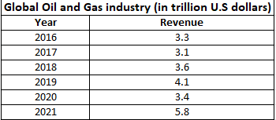

**Table 1: Global Oil and gas industry size for 2016-21**

(Source: MS Excel)

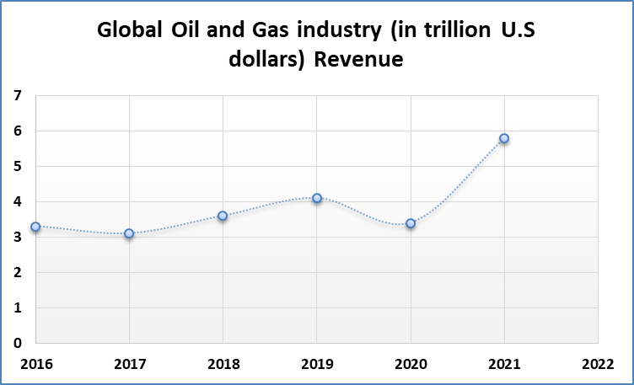

**Figure 1: Global Oil and gas industry**

(Source: MS Excel)

# Market Overview

## The biggest hindrance to the growth of the oil and gas industry

Several concerns threaten the oil and gas industry's development and profitability. Among the most difficult problems are:

* Increasing regulatory scrutiny: To safeguard the environment and limit carbon emissions, governments throughout the world are tightening rules on the oil and gas industry (Lu, Huang, Azimi and Guo, 2019). These rules have the potential to raise costs and limit access to resources.
* Volatile oil and gas prices: Movements in worldwide supply and demand, geopolitical events, and other variables cause considerable volatility in oil and gas prices. This might make it difficult for businesses to plan their investments and manage their cash flows.
* Competition from alternative energy sources: Alternative energy sources are placing pressure on fossil fuel demand. This may influence the oil and gas industry's long-term survival.
* Infrastructure constraints: The oil and gas sector needs substantial infrastructure, such as pipelines, refineries, and storage facilities. Building and maintaining this infrastructure, however, may be expensive, and it may attract criticism from local populations and environmental groups.
* Access to resources: Companies may confront difficulties in acquiring new reserves and exploiting current ones as oil and gas deposits grow increasingly difficult to access.
* Addressing these issues would need creative solutions as well as a readiness to adapt to shifting market conditions.

# Ways for mitigating those challenges

There are various ways in which the oil and gas business might alleviate its challenges:

**Investing in technology:**

The business sector can invest in innovative technology to decrease costs, boost efficiency, and lessen the environmental effect of its operations (Alsaba, Al Dushaishi and Abbas, 2020). Investing in renewable energy sources such as solar and wind, as well as carbon capture and storage technology, is part of this strategy.

**Engaging with stakeholders:**

To resolve concerns and establish confidence, the sector can work with neighbors, environmental organizations, and other stakeholders. Conducting environmental and social impact studies, collaborating with communities, and disseminating information about the industry's activities are all examples of this.

**Diversifying operations:**

Companies may diversify their activities to lessen their dependency on oil and gas while also expanding into new sectors such as renewable energy and petrochemicals.

**Collaborating with governments:**

The sector may collaborate with governments to create laws that strike a balance between environmental protection and economic growth (Nguyen, Gosine and Warrian, 2020). This might involve investing in R&D to create new technology that can help cut carbon emissions.

**Prioritizing safety:**

To reduce accidents and safeguard employees and the environment, the industry may emphasize safety in its operations. This might involve putting in place strong safety practices, investing in training and education, and adhering to industry norms and laws.

**Building resilient infrastructure:**

Companies may invest in robust infrastructure that can resist natural disasters like hurricanes and earthquakes. Building subterranean storage facilities or engineering pipes to endure adverse weather conditions are examples of this (Hanga and Kovalchuk, 2019).

By implementing these actions, the oil and gas sector may alleviate its issues while still playing an important part in addressing the world's energy demands.

# Oil and Gas industry statistics

## Top 5 Oil and Gas companies (by Revenue)

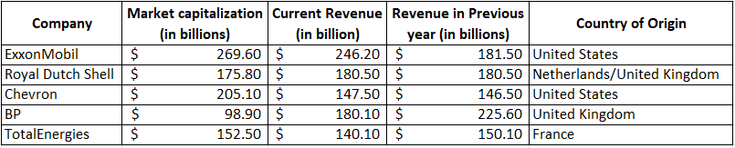

**Table 2: Top 5 oil and gas companies**

(Source: MS Excel)

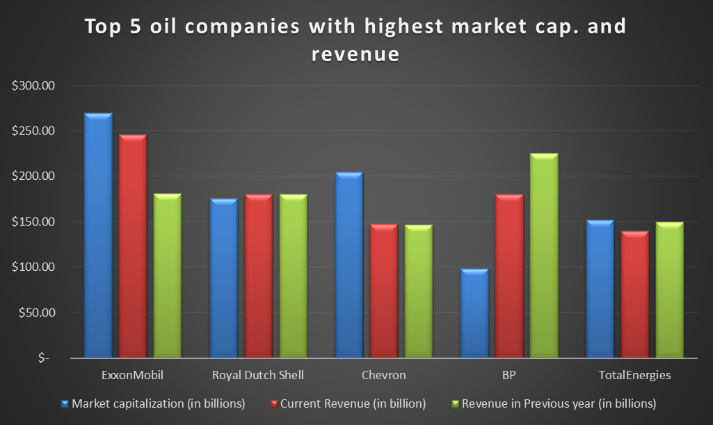

**Figure 2: Top5 oil and gas companies**

(Source: MS Excel)

## Reporting standards used by the companies

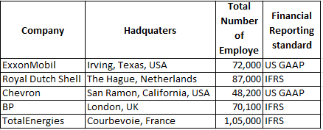

**Table 3: Reporting Standards used by the companies**

(Source: MS Excel)

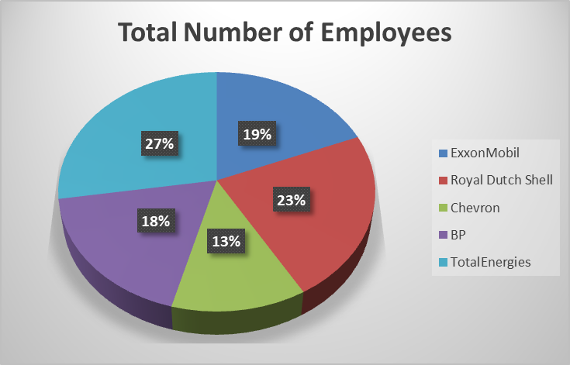

**Figure 3: Number of Employees**

(Source: MS Excel)

# Industry Segmentation

## Size of the Oil and Gas industry market by region (in billion USD)

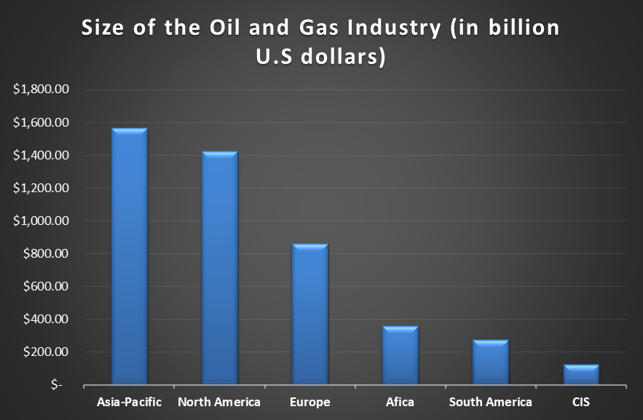

**Figure 4: Size of the industry by region**

(Source: MS Excel)

**Industry segmentation**

# ExxonMobil

## Upstream:

This segment involves the exploration, development, and production of crude oil and natural gas.

## Downstream:

This segment involves refining crude oil into petroleum products such as gasoline, diesel, and lubricants, as well as marketing and selling these products to customers.

## Chemicals:

This section is responsible for the production and sale of petrochemicals such as olefins, aromatics, and polyethylene (Obeidat, Al Bakri and Elbanna, 2020).

ExxonMobil made a total revenue of $246.2 billion in 2020, according to its revenue structure. For the same year, below is a breakdown of revenue by segment:

## Business Segments and Disaggregated revenue

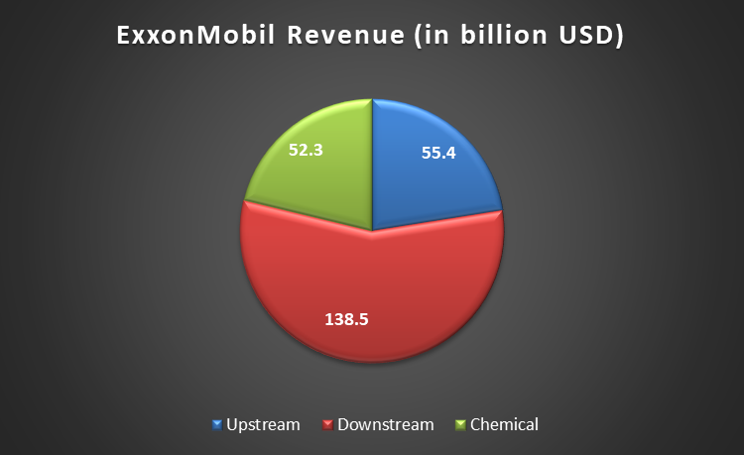

**Figure 5: Revenue structure of ExxonMobil**

(Source: MS Excel)

**Industry segmentation**

# Royal Dutch Shell

## Integrated Gas:

This segment involves the exploration, development, and production of natural gas and the liquefaction and transportation of liquefied natural gas (LNG).

## Upstream:

This segment involves the exploration, development, and production of crude oil, natural gas, and natural gas liquids.

## Downstream:

This division is responsible for refining crude oil into petroleum products including gasoline, diesel, and lubricants, as well as marketing and selling these goods to clients (Orazalin, Mahmood and Narbaev, 2019).

## Chemicals:

This segment involves the manufacturing and marketing of petrochemicals, such as olefins, aromatics, and polyethylene.

As for the revenue structure of Royal Dutch Shell, the company generated a total revenue of $180.5 billion in 2020.

**Business Segments and Disaggregated revenue**

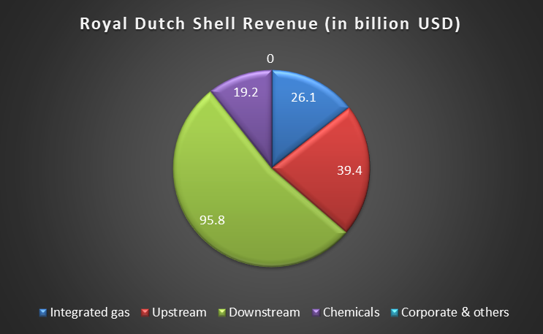

**Figure 6: Revenue structure of RDS**

(Source: MS Excel)

**Industry segmentation**

# Chevron

## Upstream:

This segment involves the exploration, development, and production of crude oil, natural gas, and natural gas liquids.

## Downstream:

This segment involves refining crude oil into petroleum products such as gasoline, diesel, and lubricants, as well as marketing and selling these products to customers (Abboud and Betz, 2021).

## Chemicals:

This segment involves the manufacturing and marketing of petrochemicals, such as olefins, aromatics, and polyethylene.

As for the revenue structure of Chevron, the company generated a total revenue of $146.5 billion in 2020.

**Business Segments and Disaggregated revenue**

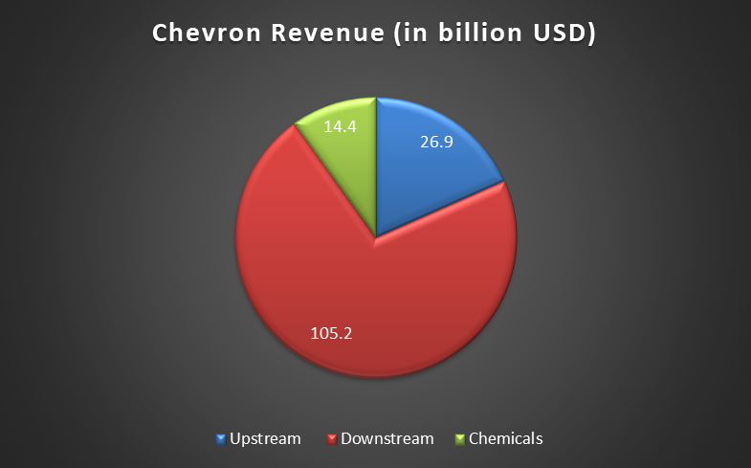

**Figure 7: Revenue structure of Chevron**

(Source: MS Excel)

**Industry segmentation**

# BP

## Upstream:

This segment involves the exploration, development, and production of crude oil, natural gas, and natural gas liquids.

## Downstream:

This segment involves refining crude oil into petroleum products such as gasoline, diesel, and lubricants, as well as marketing and selling these products to customers (Vilela, Oluyemi and Petrovski, 2019).

## Rosneft:

This division includes BP's 19.75% ownership in Rosneft, a Russian oil and gas firm.

## Other businesses and corporate:

This segment involves BP's interests in alternative energy, shipping, and technology, as well as corporate functions such as finance, legal, and human resources.

As for the revenue structure of BP, the company generated a total revenue of $180.1 billion in 2020.

**Business Segments and Disaggregated revenue**

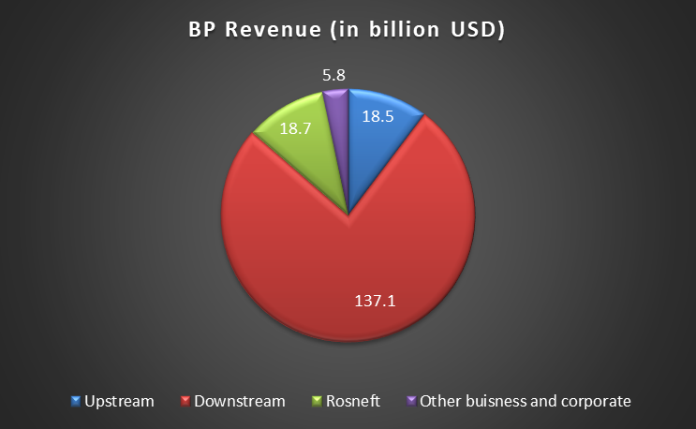

**Figure 8: Revenue structure of BP**

(Source: MS Excel)

**Industry segmentation**

**TotalEnergies**

## Exploration & Production:

This segment involves the exploration, development, and production of crude oil, natural gas, and natural gas liquids.

## Gas, Renewables & Power:

This segment involves the production, marketing, and distribution of natural gas and electricity, as well as the development and operation of renewable energy projects such as solar and wind power (Koroteev and Tekic, 2021).

## Refining & Chemicals:

This division is responsible for refining crude oil into petroleum products like gasoline, diesel, and lubricants, as well as making and marketing petrochemicals like polyethylene, polypropylene, and PVC.

## Marketing & Services:

This category markets and sells petroleum goods such as gasoline, diesel, and lubricants, as well as related services like car washes and convenience stores.

As for the revenue structure of TotalEnergies, the company generated a total revenue of $143.4 billion in 2020. Here's a breakdown of revenue by segment for the same year:

**Business Segments and Disaggregated revenue**

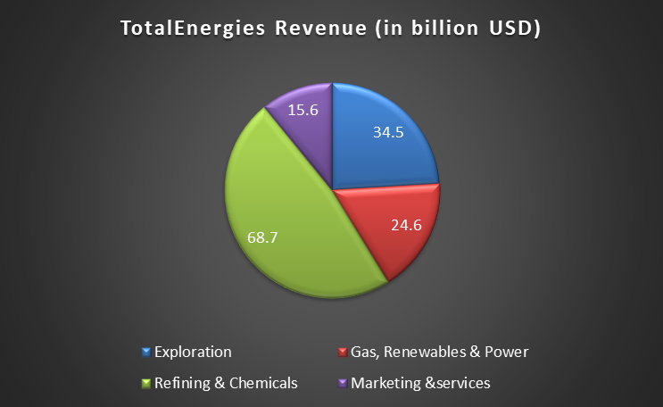

**Figure 9: Revenue Structure of TotalEergies**

(Source: MS Excel)

# Merger & Acquisition

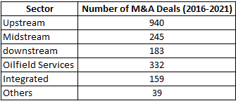

**Table 4: M&A deals data for O&G industry form 2016 to 2021**

(Source: MS Excel)

# Number of Oil and gas M&A deals globally during the period 2016-21

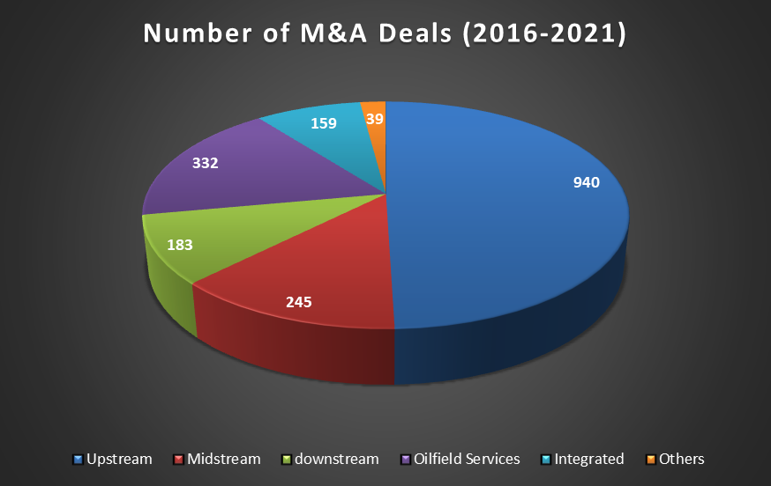

**Figure 10: M&A Deals from 2016 to 2021**

(Source: MS Excel)

# Global M&A by sector for the period 2016-21

## ExxonMobil

From 2016 through 2021, ExxonMobil, one of the world's top oil and gas firms, was involved in many notable mergers and acquisitions. Here are a few of the more prominent offers:

ExxonMobil paid $2.5 billion for InterOil, a business focusing on the exploitation of natural gas resources in Papua New Guinea (Hajizadeh, 2019). This acquisition strengthened ExxonMobil's standing in the Asia-Pacific area. ExxonMobil purchased over 250,000 acres in the Permian Basin, one of the most prolific oil and gas-producing regions in the United States, in 2017. The $5.6 billion transaction allowed ExxonMobil to increase its position in the region. ExxonMobil announced the purchase of PT Federal Karyatama, an Indonesian lubricant maker, in 2018. This acquisition aided the company's lubricant business expansion in Indonesia, a major growth area. These transactions highlight ExxonMobil's strategy of extending its activities in important countries and markets while also enhancing its position in the oil and gas sector.

## Royal Dutch Shell

From 2016 through 2021, Royal Dutch Shell, a global oil and gas firm, was involved in some notable mergers and acquisitions. Here are a few of the more prominent offers:

Royal Dutch Shell paid $52 billion for BG Group, a natural gas firm, in 2016. This acquisition aided Shell in expanding its natural gas output and increasing its foothold in the liquefied natural gas (LNG) market. Shell announced the acquisition of NewMotion, a Dutch business that specializes in electric car charging systems, in 2017. Shell was able to expand its offering in the burgeoning market of electric car charging infrastructure as a result of this purchase (Rezvani and Hudson, 2021). Shell purchased Sonnen, a German business that manufactures domestic energy storage devices, in 2019. This acquisition allowed Shell to increase its foothold in the rapidly increasing renewable energy and energy storage markets. These transactions highlight Shell's objective of diversifying its activities and entering new sectors, notably in natural gas, electric car charging, and renewable energy.

## Chevron

From 2016 through 2021, Chevron, a worldwide oil firm, was involved in several notable mergers and acquisitions. Here are a few of the more prominent offers:

Chevron paid $5 billion for Noble Energy, a business focusing on oil and gas exploration and production in the United States, in 2020. Chevron was able to increase its foothold in the Permian Basin and other critical regions of the United States as a result of this transaction. Chevron announced the $33 billion acquisition of Anadarko Petroleum, a firm focusing on oil and gas exploration and production, in 2019. Chevron was able to enhance its oil and natural gas output and extend its activities in the Gulf of Mexico as a result of this transaction. Chevron paid $600 million for a 75% share in Puma Energy, a firm focusing on the transportation and retailing of petroleum-based goods in Latin America. Chevron was able to extend its activities in the region and enhance its position in the downstream sector as a result of this purchase. These transactions show Chevron's strategy of growing its activities in important areas and markets while increasing oil and natural gas output.

## BP

From 2016 through 2021, BP, a worldwide oil and gas firm, was involved in some notable mergers and acquisitions. Here are a few of the more prominent offers:

In 2018, BP announced the acquisition of BHP Billiton's shale oil and gas assets in the United States for $10.5 billion. This acquisition enabled BP to extend its foothold in the United States and enhance its oil and natural gas output. BP purchased Chargemaster, the UK's leading electric car charging firm, in 2018. This acquisition enabled BP to broaden its offering in the rapidly expanding industry of electric car charging infrastructure (Tewari, Dwivedi and Biswas, 2021). BP announced the purchase of a 9% share in Eni, an Italian multinational oil and gas business, for $250 million in 2016. This acquisition aided BP in strengthening its upstream position and expanding its influence across Europe.

## TotalEnergies

From 2016 through 2021, TotalEnergies, a French multinational oil and gas firm, was involved in several notable mergers and acquisitions. Here are a few of the more prominent offers:

TotalEnergies paid €950 million for Saft, a French battery company, in 2016. TotalEnergies was able to increase its portfolio in the energy storage industry as a result of this purchase. TotalEnergies announced the $7.45 billion acquisition of Maersk Oil, a Danish oil and gas firm, in 2017. TotalEnergies was able to improve its position in the North Sea and boost its oil and gas output as a result of this transaction. TotalEnergies announced the $8.8 billion acquisition of Anadarko's African assets in 2019. TotalEnergies was able to grow its position in Africa and enhance its oil and gas output in the area as a result of this transaction.

# Sustainability

## ExxonMobil

ExxonMobil has taken many initiatives to address CSR and sustainability. The firm has invested in R&D to reduce emissions and boost energy efficiency, and it has established goals to minimize GHG emissions in its operations. ExxonMobil has also introduced safety, diversity, and community participation programs. The corporation has received recognition for its sustainability initiatives, including inclusion in the Dow Jones Sustainability Index and the list of the 100 Best Corporate Citizens published by Corporate Responsibility Magazine.

## Royal Dutch Shell

Several initiatives have been made by Royal Dutch Shell to enhance sustainability and CSR. The corporation has established goals to minimize greenhouse gas emissions, invest in renewable energy, and improve operational energy efficiency. Shell has also developed safety and environmental safeguards, as well as initiatives to help local communities and promote education, health, and social inclusion. The corporation has received recognition for its sustainability initiatives, including inclusion in the Dow Jones Sustainability Index and the list of the 100 Best Corporate Citizens published by Corporate Responsibility Magazine.

## Chevron

Chevron has made many initiatives to enhance CSR and sustainability. The corporation has established targets to minimize GHG emissions and invest in clean energy sources, as well as implemented energy-efficiency measures in its operations. Chevron has also created initiatives to help local communities, as well as to promote education, health, and environmental protection. The corporation has received recognition for its sustainability initiatives, including inclusion in the Dow Jones Sustainability Index and the list of the 100 Best Corporate Citizens published by Corporate Responsibility Magazine.

## BP

BP has taken several efforts to address the issues of sustainability and CSR. The firm has established a target of being a net-zero corporation by 2050, and it has made investments in renewable energy, low-carbon technology, and carbon capture and storage. BP has also adopted safety and environmental safeguards, as well as initiatives to help local communities and promote education, health, and social inclusion. The corporation has received recognition for its sustainability initiatives, including inclusion in the Dow Jones Sustainability Index and the list of the 100 Best Corporate Citizens published by Corporate Responsibility Magazine.

## TotalEnergies

Regarding sustainability and CSR, TotalEnergies has taken many actions. The corporation has established goals for reducing greenhouse gas emissions from its activities and has invested in renewable energy, such as solar and wind power. TotalEnergies has also put in place steps to enhance energy efficiency and decrease its environmental effect, as well as programs to help local communities and promote education, health, and social inclusion. The corporation has received recognition for its sustainability initiatives, including inclusion in the Dow Jones Sustainability Index and the list of the 100 Best Corporate Citizens published by CSR Magazine.

# References

Abboud, A. and Betz, M.R., 2021. The local economic impacts of the oil and gas industry: Boom, bust and resilience to shocks. *Energy Economics*, *99*, p.105285.

Alsaba, M.T., Al Dushaishi, M.F. and Abbas, A.K., 2020. A comprehensive review of nanoparticles applications in the oil and gas industry. *Journal of Petroleum Exploration and Production Technology*, *10*, pp.1389-1399.

Hajizadeh, Y., 2019. Machine learning in oil and gas; a SWOT analysis approach. *Journal of Petroleum Science and Engineering*, *176*, pp.661-663.

Hanga, K.M. and Kovalchuk, Y., 2019. Machine learning and multi-agent systems in oil and gas industry applications: A survey. *Computer Science Review*, *34*, p.100191.

Koroteev, D. and Tekic, Z., 2021. Artificial intelligence in oil and gas upstream: Trends, challenges, and scenarios for the future. *Energy and AI*, *3*, p.100041.

Lu, H., Huang, K., Azimi, M. and Guo, L., 2019. Blockchain technology in the oil and gas industry: A review of applications, opportunities, challenges, and risks. *Ieee Access*, *7*, pp.41426-41444.

Nguyen, T., Gosine, R.G. and Warrian, P., 2020. A systematic review of big data analytics for oil and gas industry 4.0. *IEEE access*, *8*, pp.61183-61201.

Obeidat, S.M., Al Bakri, A.A. and Elbanna, S., 2020. Leveraging “green” human resource practices to enable environmental and organizational performance: Evidence from the Qatari oil and gas industry. *Journal of Business Ethics*, *164*, pp.371-388.

Orazalin, N., Mahmood, M. and Narbaev, T., 2019. The impact of sustainability performance indicators on financial stability: evidence from the Russian oil and gas industry. *Environmental Science and Pollution Research*, *26*, pp.8157-8168.

Rezvani, Z. and Hudson, P., 2021. How do middle managers really make decisions within the oil and gas industry?. *Safety science*, *139*, p.105199.

Sircar, A., Yadav, K., Rayavarapu, K., Bist, N. and Oza, H., 2021. Application of machine learning and artificial intelligence in oil and gas industry. *Petroleum Research*, *6*(4), pp.379-391.

Tewari, S., Dwivedi, U.D. and Biswas, S., 2021. A novel application of ensemble methods with data resampling techniques for drill bit selection in the oil and gas industry. *Energies*, *14*(2), p.432.

Vilela, M., Oluyemi, G. and Petrovski, A., 2019. A fuzzy inference system applied to value of information assessment for oil and gas industry. *Decision Making: Applications in Management and Engineering*, *2*(2), pp.1-18.