**Academic year and term: 2022/2023 – Semester 2 (Spring)**

**Module title: Financial Performance Management**

**Type of assessment: Summative assessment – Individual Report 3,500 words (100% weighting)**

Table of Contents

1.0 Introduction 3

1.1 Company history, size, and number of employees 3

1.2 Why they are similar and in the same industry 3

2.0 Part 1 Financial Performance Using Ratio Analysis 4

2.1 Liquidity ratio analysis 4

2.2 Leverage ratio analysis 5

2.3 Critical discussion of the findings & comparative evaluation 7

3.0 Part 2 Balanced Scorecard of Amazon 9

4.0 Part 3 Impact of the Coronavirus Pandemic on financial performance 13

4.1 Impact on financial performance 13

4.2 Impact on non-financial Performance 15

5.0 Conclusion 15

References 17

Appendices 19

# 1.0 Introduction

## 1.1 Company history, size, and number of employees

One of the biggest cloud computing and online retailers in the world is Amazon. The business was established in 1994, and Seattle, Washington, is where its headquarters are, according to its official website. Amazon had more than 1.3 million employees as of 2021. There are both full-time and part-time employees working for the business, along with contractors (Amazon (2020).

A series of grocery stores, cheap department stores and hypermarkets are all run by the international retail company Walmart. The business was established in 1962, and Bentonville, Arkansas serves as its corporate headquarters, according to its official website. Almost 2.2 million people are employed at Walmart worldwide as of 2021. There are both full-time and part-time individuals working for the business. Walmart is larger in size compared to Amazon in terms of both company size and employees (Walmart, 2022).

## 1.2 Why they are similar and in the same industry

Both Walmart and Amazon are regarded as part of the retail sector, more specifically the e-commerce and brick-and-mortar divisions. The competitive forces within an industry can be analyzed using Porter's Five Forces methodology. **Firstly,** because of the high start-up costs and established market competitors, the threat of new entrants in the retail industry is relatively minimal. **Secondly,** because of the scale and negotiating ability of big retailers like Amazon and Walmart, suppliers have relatively little negotiating power. **Thirdly,** because there are so many options on the market, consumers have a fair amount of bargaining power. **Fourthly,** the threat of alternatives is modest because comparable products are offered by a variety of sellers. **Lastly,** the retail industry's vast player base has led to a high level of intense competition (Mind Tools 2023).

As a result, Amazon and Walmart are direct competitors in the market because they both deal with similar competitive factors in the retail sector.

# 2.0 Part 1 Financial Performance Using Ratio Analysis

## 2.1 Liquidity ratio analysis

**Table 1: Liquidity ratio analysis of Amazon and Walmart for 2021 & 2022**

| **Input data For liquidity ratios** | **Amazon** | | **Walmart** | |
| --- | --- | --- | --- | --- |
|  | **2021** | **2022** | **2021** | **2022** |
| Current Assets | 161580 | 146791 | 90067 | 81070 |
| Current liabilities | 142266 | 155393 | 92645 | 87379 |
| Inventories | 32640 | 34405 | 44949 | 56511 |
| Cash | 36220 | 53888 | 17741 | 14760 |
|  |  |  |  |  |
| Liquidity ratios | 2022 | 2021 | 2021 | 2022 |
| Current ratio (current assets/current liabilities ) | 1.1357598 | 0.94464358 | 0.972173 | 0.9277973 |
| Quick ratio (current assets-inventories)/current liabilities | 0.9063304 | 0.72323721 | 0.486999 | 0.28106296 |
| Cash ratio (cash/current liabilities) | 0.2545935 | 0.34678525 | 0.191494 | 0.16891931 |

1. **Liquidity ratio analysis of Amazon and Walmart for 2021 & 2022**

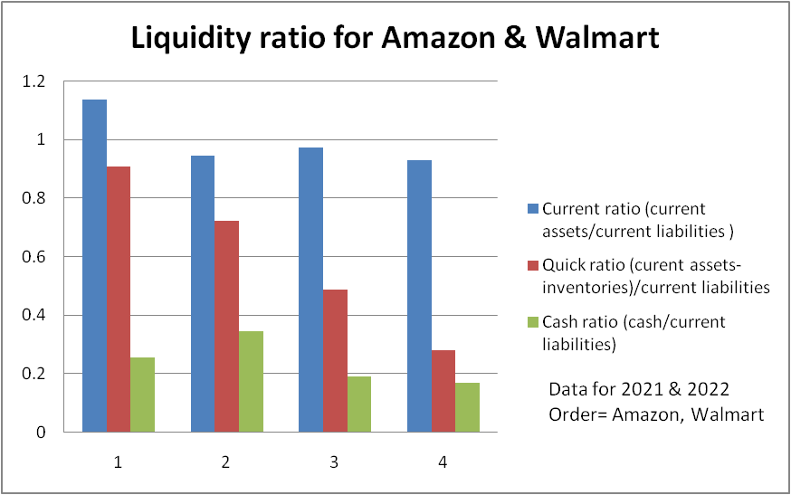

## 2.2 Leverage ratio analysis

**Table 2: Leverage ratio analysis of Amazon and Walmart for 2021 & 2022**

| **Input data For Leverage ratios** | **Amazon** | | **Walmart** | |
| --- | --- | --- | --- | --- |
|  | **2021** | **2022** | **2021** | **2022** |
| Total debt | 48744 | 67150 | 77616 | 70797 |
| Total Equity | 138245 | 146043 | 87531 | 91891 |
| Total Assets | 420549 | 462675 | 252496 | 244860 |
| EBIT (operating income) | 24879 | 12248 | 22548 | 25942 |
| Interest Expenses | 1809 | 2367 | 2194 | 1836 |
|  |  |  |  |  |
| **Leverage ratios** | **2021** | **2022** | **2021** | **2022** |
| Debt to Equity ratio (Total debt/total equity) | 0.352591414 | 0.459796087 | 0.886725846 | 0.770445419 |
| Debt to capital ratio (Total debt/total equity+total debt) | 0.260678436 | 0.314972818 | 0.469981289 | 0.435170387 |
| Equity Multiplier (Total assets/total equity) | 3.042055771 | 3.168073786 | 2.884646582 | 2.664678804 |
| Interest coverage ratio (EBIT/total interest expenses) | 13.75290216 | 5.174482467 | 10.27711942 | 14.12962963 |

1. **Leverage ratio analysis of Amazon and Walmart for 2021 & 2022**

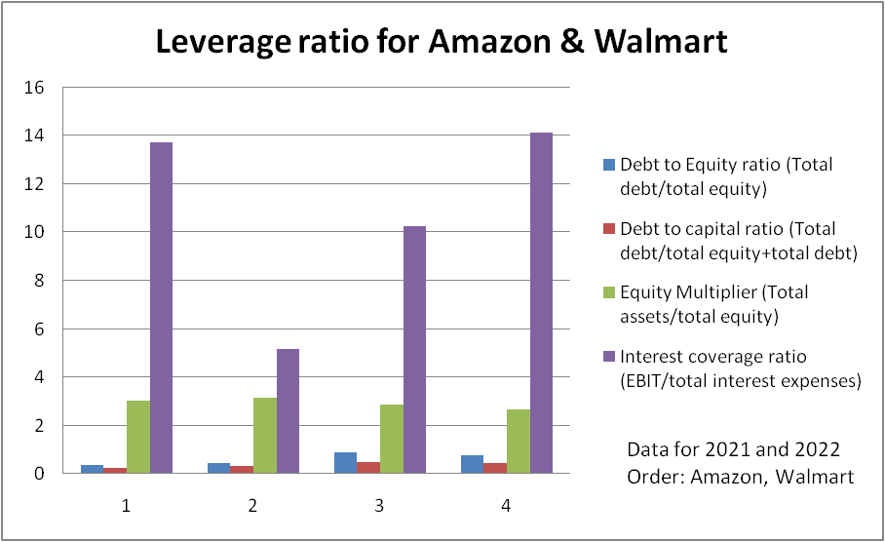

## 2.3 Critical discussion of the findings & comparative evaluation

**In terms of liquidity**

Amazon and Walmart's liquidity ratios for the years 2021 and 2022 offer some insight regarding the financial health information of the companies. The liquidity ratios group is used to determine a company's capacity to quickly turn assets into cash in order to satisfy short-term obligations.

The current ratio measures a company's capacity to cover its short-term obligations with its current assets by dividing current assets by current liabilities. From the analysis prepared in the report, it can be seen that Amazon's current ratio increased from 0.94 in 2021 to 1.14 in 2022 which indicated that the company is now better able to satisfy its short-term obligations (Berk and DeMarzo, 2017). Walmart's current ratio, which was 0.97 in 2021, dropped to 0.93 in 2018, indicating that it may face difficulties to pay the short-term debt due to decreased capacity to turn assets into cash.

The quick ratio gives a more cautious picture of a company's liquidity and is derived by deducting inventory from current assets and dividing the result by current liabilities. Amazon's Quick ratio increased from 0.72 in 2021 to 0.91 in 2022, which indicates a higher capacity to fulfil its short-term obligations without using inventories. Walmart may face issues with liquidity as its quick ratio dropped from 0.49 in 2021 to 0.28 (Goel, 2016).

The cash ratio, which is determined by dividing cash by current liabilities, is used to assess the capacity of a business to pay its immediate debts completely with cash. The cash ratio of Amazon dropped from 0.35 in 2021 to 0.25 in 2022, which indicates that it may have to depend more on other assets to pay its short-term liabilities (Goel, 2016). Walmart's cash ratio also decreased, from 0.19 in 2021 to 0.17 in 2022, which suggests that it may find it difficult to satisfy its short-term obligations entirely with cash.

Overall, compared to Walmart, it can be evaluated that Amazon is in a better position equipped with liquidity to satisfy its short-term obligations since its liquidity ratios have increased or stayed unchanged in 2022 (Samonas, 2015). Walmart, on the other hand, may experience liquidity problems as a result of a fall in its liquidity ratios in 2022. ***[Referred to Appendix 1 & 2]***

**In terms of leverage**

The liquidity ratio is a financial measure that is used to assess a company's capacity to use its current assets to fulfil its short-term liabilities. It indicates how well a business can swiftly turn its current assets—like cash, accounts receivable, and inventory—into cash to cover its current liabilities (such as accounts payable, short-term loans, and taxes) (Atrill and McLaney, 2018). In 2021 and 2022, Amazon's debt-to-equity ratio is lower than Walmart's. Walmart's debt-to-equity ratio is 0.8867 in 2021 compared to Amazon's 0.3526. Walmart's ratio had dropped to 0.7704 in 2022, while Amazon saw an improvement to 0.4598. From the same, it can be stated that compared to Walmart, Amazon has been able to retain a lower amount of debt relative to equity. On the other hand, In both years, Amazon's debt-to-capital ratio has been lower than Walmart's. Walmart has a ratio of 0.4700, while Amazon has 0.2607 in 2021 as derived from the calculations. Walmart's ratio dropped to 0.4352 in 2022, while Amazon's grew to 0.3150. This shows that compared to Walmart, Amazon relied less on debt financing.

In both years, Amazon's equity multiplier is greater than Walmart's. Walmart's ratio is 2.8846 in 2021 compared to Amazon's 3.0421. Walmart's ratio dropped to 2.6647 in 2022, while Amazon's grew to 3.1681. This shows that Amazon is more leveraged than Walmart and that a larger percentage of its assets are financed by debt. While the same has been beneficial in generating more return to shareholders, it can be evaluated that fixed payment obligations (such as interest payment) of Amazon can increase compared to Walmart which may decrease the profitability of Amazon.

In both years, Amazon's interest coverage ratio is higher than Walmart's. Walmart's ratio was 10.2771 in 2021 compared to Amazon's 13.7529. The ratio percentage climbed of the company Walmart had climbed to 14.1296 in 2022, while Amazon's ratio declined to 5.1745. This can be used to make an evaluation that as compared to Walmart, Amazon is better able to cover its interest costs out of operational revenues. Overall, based on the analysis above, it can be evaluated that Amazon is in a stronger financial situation compared to Walmart in terms of leverage (Samonas, 2015). Amazon has less debt and has relied less on debt financing, which makes them more able compared to Walmart to pay its interest costs. ***[Referred to Appendix 1 & 2]***

# 3.0 Part 2 Balanced Scorecard of Amazon

Four key aspects are taken into account by the balanced scorecard: financial, customer, internal company operations, and learning and growth. Each of these goals may be defined and measured with its assistance, and it makes sure that every component of the organisation is in line with the company's strategic goals. The BSC is frequently used to translate the mission and strategy of an organisation into measurable objectives and outcomes that can be monitored and assessed over time. In order to measure the organization's financial success, including revenue growth, profitability, and return on investment, the BSC takes a financial perspective (Kaplan, 2010). The retention, loyalty, and satisfaction rates of customers are calculated from their point of view. The internal business process perspective is used to assess the efficacy and efficiency of the organization's operations. The learning and growth method places a primary emphasis on the organization's human and capital resources, including employee development, technology, and innovation. The BSC assists companies in making data-driven decisions and adjusting their strategies as necessary to meet their objectives by monitoring and tracking performance across several dimensions. The development of the Balance Scorecard can be done here from the perspective of Amazon as follows:

| **Dimensions** | **Objectives** | **Measures** | **Targets (goals)** | **Initiatives** |
| --- | --- | --- | --- | --- |
| **Financial** | Maintain a healthy financial position and revenue ensure sufficient cash, increase shareholders' equity value, and reduce the cost of operations. | Increase in the Operating profit (EBIT) which has reduced in 2022;  Reduce the amount of debt which can decrease the expenses like interest expenses and can increase profitability overall;  Reduce the number of liabilities which is reflected in the ratio analysis presented in the above section (Amazon 2022). | Increase the current and quick ratio to at least 1.2 and 1;  Reducing debt to equity ratio to 0.4 from the figure of 0.46 in 2022;  Increase the source of revenue and decrease the amount of debt by payment of the same;  Increase the cash ratio by generating cash through an increase in EBIT;  Increase the interest coverage ratio to around 10% which has decreased near 6% in 2022 | The initiatives towards cost control measures are necessary which will decrease the unnecessary costs for Amazon and will increase EBIT which can in turn increase the revenue and interest coverage ( Salterio, 2012).  Further, Amazon needs to consider the repayment of long-term debt which can decrease the liability from the balance sheet and can reduce fixed costs like interest expenses. |
| **Customer** | While the vision, mission, and strategies of Amazon have been ***“customer obsession rather than competitor focus, passion for invention, commitment to operational excellence, and long-term thinking. Amazon strives to be Earth’s most customer-centric company, Earth’s best employer, and Earth’s safest place to work”***, the objective of a balanced scorecard approach in this perspective will be to offer the best services to the customers through customer satisfaction, retention, and loyalty (Amazon 2020). | Offer faster and more reliable delivery of the products through the use of Amazon Go, Same day delivery, and others;  Increase the range of products in different categories where the increase of renowned brands over local and new brands is necessary;  Increase the product information quality measures and reporting of the same through the use of different industrial benchmarks;  Offer quality guidance and personalized recommendations through the feedback and review of the customers (Bleier et al., 2019). | Increase the number of customers of Amazon Prime membership, development of fulfilment centres in different areas, and use technologies like robotics and drones in packaging and delivery services which can ensure faster delivery and increased customer satisfaction.  Increase in the branded and quality products through the publication of quality reports from different perspectives and customer feedback which can help a prospective customer choose their products.  Increase in the efficiency of customer care services through the use of AI-powered chatbots, voice support, quick and hassle-free return and exchange of products, and others. | The initiatives to increase the use of technologies like a drone, AI, robotics, and others in the packaging and delivery of products is necessary to increase customer satisfaction and fulfil their vision of customer obsession. Additionally, the improvement in customer care service, product listing, product quality information, and others like personalized recommendations and customer reviews can be offered more widely to increase customer satisfaction (Ives et al., 2019). |
| **Internal Process** | Improve the working conditions of the customers which had faced several criticisms from different newspaper reports and others (Kelly, 2021);  Improvement in employee engagement and employee turnover rate as Amazon has the highest turnover rate among Fortune 500 companies;  Streamlining the process of decision-making which can reduce the delays in business decisions;  Improve data privacy and security to reduce the leakage of customer data. | Taking necessary initiatives for employee well-being through offering proper working conditions, better leave availability, increased facilities to customers like shopping discounts and rewards, flexible work schedules, and others can increase employee morale and reduce turnover.  Tightening of data security protocols, anti-theft measurements, and secure payment gateway through trusted service providers.  Making a proper decision-making system which can ensure power to line and divisional managers (Busco and Quattrone, 2015). | To reduce employee turnover and increase customer satisfaction,  To increase data safety and privacy,  To improve the decision-making ability of the different managers. | Initiatives regarding data protection protocols, employee wellbeing initiatives with career development opportunities, and better decision-making are to be taken. |
| **Learning & growth** | Provide more training programmes, workshops, and courses for employees to develop new skills, become familiar with cutting-edge technologies, and keep up with market trends;  Encourage learning by setting up programmes where experienced workers can mentor and instruct fresh colleagues;  Encourage employees to share their expertise and experiences to foster a culture of lifelong learning (Amazon, 2022). | Develop programmes that help people gain new skills, like the Amazon Technical Academy, which trains non-technical staff to help them move into technical roles.  Amazon made plans to invest $1 billion in leadership training programmes for staff members in 2021, with a focus on inclusion, equity, and diversity (Amazon 2021). Such programs can help Amazon to improve the overall learning and growth of the organization. | To reduce employee turnover which affects the learning process,  To upskill the employees through different training programs,  To promote a culture of learning by encouraging employees to share their experiences and ideas. | The initiatives regarding learning & development such as the Leadership development program of $ 1 billion for 300000 employees and others are necessary. Further, fostering a culture of learning and growth is also necessary. |

# 4.0 Part 3 Impact of the Coronavirus Pandemic on financial performance

## 4.1 Impact on financial performance

According to a Forbes report, a spike in the demand for online shopping during the pandemic caused Amazon's Q1 2020 earnings to exceed forecasts. The business also had to pay for greater cleaning and safety precautions, as well as a $4 billion investment in COVID-19-related projects, in order to protect its workers and clients. According to CNBC, Amazon beat forecasts for its third quarter of 2020 results, with net sales rising by 37% to $96.1 billion and net income rising by 197% to $6.3 billion. The company blamed the pandemic-related rise in online purchasing as well as the expansion of its cloud computing and advertising operations for outstanding results. Amazon's financial performance was significantly impacted by the COVID-19 outbreak. Lockdowns and other social isolation measures caused a boom in internet shopping, which benefitted Amazon significantly. Amazon reported a net income of $5.2 billion for the second quarter of 2020, up from $2.6 billion for the same time in 2019 (Palmer, 2020). This was mostly brought on by the rise in popularity of cloud computing services and online commerce, which are Amazon's main industries. The evidence of the same can be seen from the consolidated income statement of the company for 2020 to 2022. The operating expenses have increased to $501735 from $363165 in 2020 where the increase has been 27.65%. As a result of the same, it can be seen the operating profit had decreased to $12248m from $24178m in 2022 and the net loss has been reported. Nonetheless, Amazon also had certain difficulties as a result of the pandemic. The business had to invest a lot of money in putting safety precautions in place for its employees, such as supplying personal protective equipment and stepping up cleaning and sanitizing efforts.

The company suffered from higher costs and decreased profit margins as a result.

Amazon's net sales during the second quarter of 2020, which totalled $88.9 billion, were up 40% from the same period in 2019, according to ResearchFDI. Regarding COVID-19's effect on Amazon's financial performance, it has been widely stated that the pandemic significantly boosted the company's earnings. Due to lockdowns and other social segregation measures, more individuals started purchasing online, which caused Amazon's revenues to soar. The company's financial records indicate that Amazon's net sales in 2020 climbed 38% over the prior year to reach $386 billion. Moreover, it more than doubled from $11.6 billion in 2019 to $21.3 billion in 2020, the company's net income. It's crucial to remember, though, that the pandemic also had detrimental repercussions on Amazon's business, including supply chain disruptions, higher expenditures for safety precautions, and increased employee benefit costs. Concerns have also been raised on how Amazon's dominance may affect small enterprises and workers in the retail industry. Operating income for the business rose by 89% to $5.8 billion (Takefman, 2022). The increasing demand, however, also resulted in supply chain interruptions and higher expenses for keeping delivery obligations.

## 4.2 Impact on non-financial Performance

As per the report by UNI Global (2020), Amazon exactingly held 50% of the U.S. e-commerce market, which during the crisis of COVID-19, demand for some services, like home grocery delivery, increased by around 90% while the traditional grocery stores had become temporarily closed in many countries. As a result, traffic to Amazon.com increased by as much as 20%. On the other hand, the internal system of Amazon like working conditions and others was shattered and they faced a lot of criticism. As per the own research of the report, More than 19,000 instances of Covid-19 among Amazon employees had been documented in just the United States as of October 2020. The research also says that due to underreporting and Amazon's lack of transparency, the actual number of occurrences is probably far higher (Cardinaels and Veen-Dirks, 2010).

The report describes the high number of cases as well as the inadequate safety precautions and worker support during the epidemic. For instance, the report claims that many employees lacked access to personal protective equipment (PPE) or were not given enough time to wash and sanitize their hands. The report also emphasizes the high levels of pressure and stress that employees experienced as a result of the pandemic's heightened demand and production goals. On the other hand, a contrary view can be experienced from the report of CNBC by Palmer (2020), Amazon has received plaudits for how it responded to the pandemic, putting in place a number of safeguards to ensure the health and security of both its workers and consumers. This has involved stepping up cleaning and sanitization efforts, putting social distancing policies in place in warehouses and distribution hubs, and equipping staff with personal protective equipment.

# 5.0 Conclusion

From the development of the analysis of the present report, it can be concluded that Amazon and Walmart have been identical competitors and belong to the same industry of online retail. From the use of Porter's five force analysis, it can be stated that there have been the same issues like competition and buyers' bargaining power which can affect both of them. In terms of the financial ratios analyzed in the present report, it can be stated that Amazon has been in a better position in terms of liquidity and leverage which can enable them to generate higher Interest coverage and pay off its liabilities. On the other hand, Walmart has been able to increase the performance of the company significantly in terms of generating higher revenue whereas the same has decreased by around 5% for Amazon. From the approach of Balanced Scorecard by Kaplan (2010), it can be stated that there have been some strategic priorities like improvement of working conditions of the employees, and increase employee wellbeing, including the concepts of training and leadership development as the $1bn Leadership Development Program announced in 2021. Moreover, Amazon needs to work on the areas of customer satisfaction through the use of technologies and initiatives like drones and robotics and a same-day delivery approach through Prime membership which can increase delivery efficiency. Lastly, from considering the impact of Covid 19 on financial and non-financial performance, it can be concluded that the revenue and profit have increased significantly although the increase in expenses has resulted in a decrease in performance.

# References

Amazon (2020) About Amazon, US About Amazon. Available at: https://www.aboutamazon.com/ (Accessed: April 4, 2023).

Amazon (2020) Who we are: Amazon, US About Amazon. US About Amazon. Available at: https://www.aboutamazon.com/about-us (Accessed: April 4, 2023).

Amazon (2021) Our upskilling commitments, US About Amazon. US About Amazon. Available at: https://www.aboutamazon.com/workplace/upskilling-commitments (Accessed: April 7, 2023).

Amazon Annual report: <https://s2.q4cdn.com/299287126/files/doc_financials/2023/ar/Amazon-2022-Annual-Report.pdf>

Atrill, P., McLaney, E.J. (2018). Management Accounting for Decision Makers. Pearson.

Berk, J. and DeMarzo, P. (2017). Corporate Finance. Pearson, 3rd edition, Chapter 2.

Bleier, A., Harmeling, C.M. and Palmatier, R.W., 2019. Creating effective online customer experiences. Journal of marketing, 83(2), pp.98-119. Doi: <https://doi.org/10.1177/0022242918809930>

Busco, C., Quattrone, P. (2015). Exploring how the balanced scorecard engages and unfolds:

Articulating the visual power of accounting inscriptions. Contemporary Accounting Research, 32(3), 1236-1262.

Cardinaels, E., van Veen-Dirks, P. (2010). Financial versus non-financial information: the impact of information organization and presentation in a balanced scorecard. Accounting, Organizations and Society, 10(6), 568–578.

Goel, S. (2016). Financial ratios. First edn. New York.

Ives, B., Cossick, K. and Adams, D., 2019. Amazon Go: disrupting retail?. Journal of Information Technology Teaching Cases, 9(1), pp.2-12. Doi; <https://doi.org/10.1177/2043886918819092>

Kaplan, R.S. (2010). Conceptual foundations of the balanced scorecard. Working Paper 10-074.

Kelly, J. (2022) A hard-hitting investigative report into Amazon shows that workers' needs were neglected in favor of getting goods delivered quickly, Forbes. Forbes Magazine. Available at: https://www.forbes.com/sites/jackkelly/2021/10/25/a-hard-hitting-investigative-report-into-amazon-shows-that-workers-needs-were-neglected-in-favor-of-getting-goods-delivered-quickly/ (Accessed: April 4, 2023).

Mind Tools (2023) Porter's Five Forces - The Framework Explained, MindTools. Available at: https://www.mindtools.com/at7k8my/porter-s-five-forces (Accessed: April 4, 2023).

Samonas, M. (2015). Financial Forecasting, Analysis, and Modelling. John Wiley & Sons. Chapter 2.

Salterio, S.E. (2012). Balancing the scorecard through academic accounting research: opportunity lost? Journal of Accounting and Organizational Change, 8(4), 458–476.

Walmart (2023) About Walmart, Corporate. Available at: https://corporate.walmart.com/about (Accessed: April 4, 2023).

Walmart annual report: <https://s201.q4cdn.com/262069030/files/doc_downloads/LatestReports/WMT-FY2022-Annual-Report.pdf>

# Appendices

**Appendix 1: Excerpts of Annual report of Amazon**

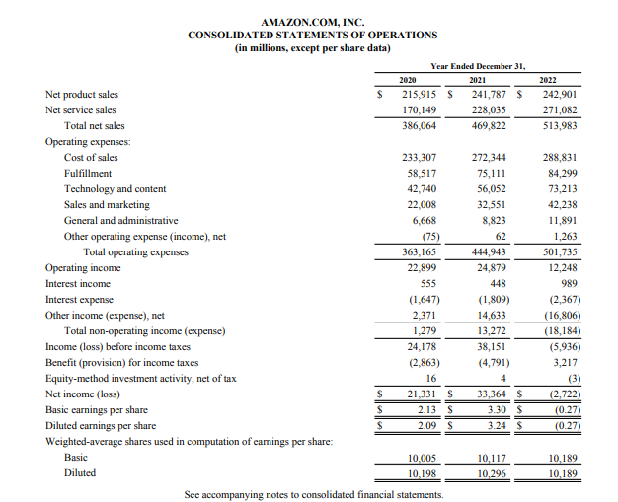

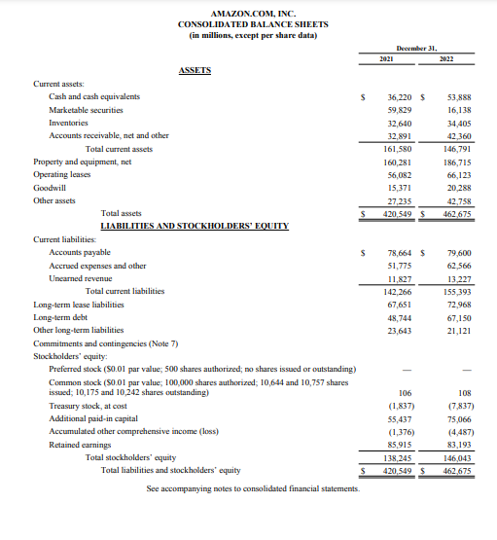

(Source: Annual report)

**Appendix 2: Excerpts of Annual report of Walmart**

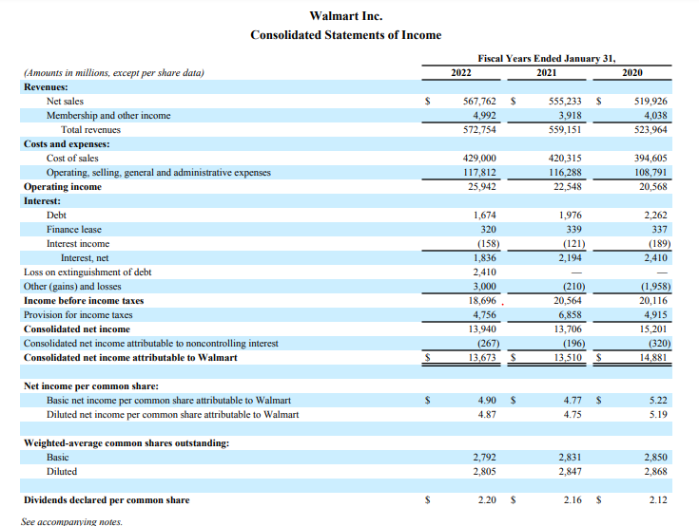

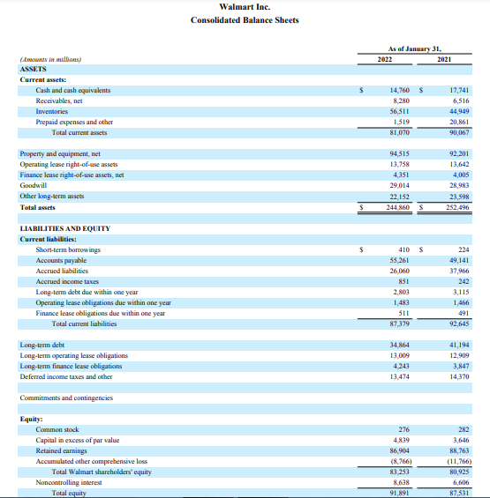

(Source: Annual report)