**An Introduction to Numeracy, Data & IT**

**Table of Contents**

Assignment One: Draft Formative Task Submission 3

Question 1 3

Question 2 3

Question 3 3

Question 4 4

Question 5 4

Question 6 4

Question 7 5

Question 8 5

Question 9 5

Question 10 6

Assignment Two: Final portfolio submission 7

Question 2 7

Question 3 9

Question 4 10

Question 5 12

Question 6 14

Question 7 16

Question 8 16

References 18

# Assignment One

## Question 1

|  |  |
| --- | --- |
| Ali (A) | 802 |
| Brian (B) | 940 |
| Catya (C) | 50 |
| Total Votes  (A+B+C) | 1792 |

**Table 1: Computation of Total Votes**

(Source: Self-Created)

## Question 2

|  |  |
| --- | --- |
| Alex (A) | 802 |
| Barbara (B) | 940 |
| Clive (C) | 50 |
| Difference (B-C) | 890 |

**Table 2: Computation of Difference**

(Source: Self-Created)

## Question 3

|  |  |
| --- | --- |
| Bookshelf width | 42 |
| Book width | 5/8 |
| (In decimal) | 0.625 |
| Thus, the Number of Books  Bookshelf width / Book width | 67 |

**Table 3: Computation of the number of books**

(Source: Self-Created)

## Question 4

|  |  |
| --- | --- |
| Value 1 | 0.11 |
| Value 2 | 0.5 |
| Value 3 | 2/5 |
| In decimal | 0.4 |
| Value 4 | 0.12 |
| Value 5 | 1/8 |
| (In decimal) | 0.125 |

**Table 4: Adjustments of the given figures**

(Source: Self-Created)

**Solution**: 0.11, 12%, 1/8, 2/5, 1/2

## Question 5

|  |  |
| --- | --- |
| Apple price (per Kg) | £4 |
| Apples purchased (Kg) | 10 |
| Total Cost (Unit * price) | £40 |
| Total Payment made  (30 percent off) (Total cost - 100-30/100) | £28 |

**Table 5: Computation of total payments**

(Source: Self-Created)

## Question 6

|  |  |
| --- | --- |
| Value provided | 0.63 |
| Derived Value (56 percent of 0.63) | 0.35 |

**Table 6: Computation of percentage**

(Source: Self-Created)

## Question 7

|  |  |
| --- | --- |
| Pair of Shoes (price) | £40 |
| Discount allowed | 12.00% |
| Discount allowed in price (12% of 40) | £5 |
| Thus, the sale price of the shoes  (Shoe price - Discount in price) | £35 |

**Table 7: Sale price computation**

(Source: Self-Created)

## Question 8

|  |  |
| --- | --- |
| Washing Machine (Discounted Price) | 850 |
| Discount percentage | 25.00% |
| Original Price (100+25/100 * 850) | 1062.5 |

**Table 8: Computation of the original Price**

(Source: Self-Created)

## Question 9

|  |  |
| --- | --- |
| Value 1 | 301 |
| Value 2 | 285 |
| Value 3 | 20 |
| Value 4 | 351 |
| Value 5 | 35 |
| Value 6 | 205 |
| Value 7 | 311 |
| Value 8 | 25 |
| Value 9 | 45 |
| Value 10 | 310 |
| Value 11 | 301 |
| Value 12 | 305 |
| Total | 2494 |
| Mean (Total/ Number of Values = 2494/12) | 207.83 |

**Table 9: Computation of Mean**

(Source: Self-Created)

## Question 10

|  |  |
| --- | --- |
| Amounted Deposited by Yuliyana (P) | 3000 |
| Time (Year) (n) | 2 |
| Rate (R) | 2.00% |
| Total Amount P(1+R/100)^n | 3001.20 |

**Table 10: Representing the computation of the compound interest**

(Source: Self-Created)

# Assignment Two

## Question 2

The reflection of the present study has been provided below based on my personal development in mathematical skills precisely the integers, fractions and decimals throughout the development of the present module:

*Description*

In the development of the present assignment tasks regarding integers, fractions and decimals in my study of "An introduction to numeracy, data and IT" I have been significantly challenged in terms of learning the appropriate usage of Microsoft Excel software. On completion of the present assignment, I have had the opportunity to solve mathematical problems that are based on addition, subtraction, and percentage computation of various numerical figures, rearrangement of numerical figures in descending orders and the application of the compound interest on a given problem. However, the greatest challenge I have faced in this regard is to conduct the computation by using Microsoft Excel software by utilizing the formula as per the respective problems. However, upon the completion of the assignment as per the requirements of the problems I have been able to improve my technical skills in terms of the usage of Microsoft Excel for the computation of numerical values. Considering my achievement in learning about integers, fractioning and computation of percentages and the usage of Microsoft Excel for the computation of the mentioned problems I can deduce that I have been successful in meeting my objective from learning this particular module.

*Feelings*

Prior to the initiation of the present assignment, I was feeling unsure of the outcome regarding the present assignment and my capability to complete the assignment based on Microsoft Excel. However, my feelings during the commencement of the present assignment and after the completion of the assignment have changed drastically as now I feel that I have taken up an excellent opportunity to not only explore a computer software that can aid in my future growth but improve my mathematical problem-solving skills in the process. While conducting the study and solving the problems of mathematics I have experienced stress while solving problems such as compound interests. However, after the completion of the arithmetical problems I was quite happy with my performance as I have learnt to work with integers, fractions and decimals and utilize such figures for serving the solution to the given problems of the present study. Although I have been able to complete the present assignment and I am feeling happy about it, I am also concerned about how my performance will be evaluated by my instructor in case of appropriate application of the numerical formula.

*Evaluation*

From the entire experience of learning from the module on numeracy, data and Information Technology I can deduce that I have experienced mixed experiences which can be categorized as both good experiences and bad experiences. The things which can be considered as good are the completion of the mathematical problem in the hand from which I have learnt and improved my skills regarding the subject. Upon the completion of each problem, I have been motivated to take the next one as a challenge to overcome. My bad experiences in this regard are the usage of Microsoft Excel, in which I cannot be considered an expert. Each computation of the problems should have been easier and less time-consuming as I had to look up the usage and application of the formula from Google Images in accordance with the respective problems as provided by the assignment. I had to face the issue of chart creation in terms of the Excel sheet brought. This also brings MS Excel, to be undertaken and it makes the analysis skills required to sharpen.

*Analysis*

Upon closer view of the situation which I have described while conducting my present assignment regarding numeric, data and IT, I have evaluated that the mathematical calculator of the given problems has been challenging to solve specifically in the case of problems related to the compound interest. I believe that the practising of the arithmetic problems related to compound interest have been inadequate from my end and this was reflected during the development of the present assignment. This has not been the case for other mathematical problems in other chapters such as percentages and statistical chapters such as mean. As suggested by authors practice acts as an essential tool for maintaining a similar consistency level for subjects such as mathematics for students. Furthermore, I have also mentioned the challenges that I have faced in developing the assignment using Microsoft Excel. Upon closer view of the situation, I believe that the challenge has been prominent in my case for developing the assignment by using the software due to a lack of knowledge and skills in advanced Microsoft Excel which is evident in the present scenario. Therefore, I can successfully deduce as per my understanding that I need to work on the development of my IT skills especially in the areas of Microsoft Excel. Furthermore, I can also deduce that I need to pay special attention to the practice of the arithmetic chapter on compound interest for ensuring fluency in solving arithmetic problems on the subject.

*Conclusion*

Therefore, from the present reflection on my own learning regarding the module, I can conclude that I have delivered a performance which enabled me to gain both knowledges of mathematics and improve my computer skills. I have found that my skills in Microsoft Excel have been successfully deduced in terms of developing fluency in Arithmetic problems. This has helped me to undertake assignments with a better percentage and also gain knowledge on the statistical chapters. On for the notes I have also acknowledged that my inadequacy in compound interest has laid to certain mathematical issues which can be improved with the consistency of practice.

*Action Plan*

In order to have better knowledge of advanced Excel in undertaking quantitative aptitude learning, I should improve my critical reasoning skills. Critical reasoning in terms of the logical analysis of the aptitude problems and also the various areas of situational judgement should be studied. In order to better learn this kind of quantitative aptitude analysis, I require courses built on arithmetic skills. Within a period of 6 months, the foundational learning is to be taken. Along with the courses; it is very important that I should develop some self-learning style. Quantitative aptitude books would help me to gather much knowledge on part-time. Not taking is a very useful method that will be considered in this kind of skills enhancement.

## Question 3

|  |  |  |  |  |  |
| --- | --- | --- | --- | --- | --- |
| **Beijing 2022 Winter Olympics Medal Table (Top 10 Countries)** | | | | | |
| **Order** | **National Olympics**  **Committee** | **Gold** | **Silver** | **Bronze** | **Total** |
| 1 | Norway | 16 | 8 | 13 | **37** |
| 2 | Germany | 12 | 10 | 5 | 27 |
| 3 | People's Republic of China | **9** | 4 | 2 | 15 |
| 4 | United States of America | 8 | 10 | 7 | 25 |
| 5 | Sweden | 8 | 5 | 5 | 18 |
| 6 | Netherlands | 8 | 5 | 4 | 17 |
| 7 | Austria | 7 | **7** | 4 | 18 |
| 8 | Switzerland | 7 | 2 | 5 | 14 |
| 9 | ROC | 6 | 12 | 14 | 32 |
| 10 | France | 5 | 7 | **2** | 14 |

**Table 11: Top 10 NOCs of Beijing 2022**

(Source: Self-Created)

**a.** The value required is 15 - (4+2) = 9

**b.** The value required is 18 - (7+4) = 7

**c.** The value required is 14 - ( 5+ 7) = 2

**d.** The value required is 16 + 8 + 13 = 37

**e.** As presented in the spreadsheet

## Question 4

**a.**

|  |  |
| --- | --- |
| **Total medal earnings** |  |
| Norway | 37 |
| ROC | 32 |
| Germany | 27 |
| United States of America | 25 |
| Sweden | 18 |
| Austria | 18 |
| Netherlands | 17 |
| People's Republic of China | 15 |
| Switzerland | 14 |
| France | 14 |

**Table 12: Total medal earnings presented in a descending order**

(Source: Self-Created)

As shown in the above table it can be stated that the total medal earnings table for the NOC has been sorted in a descending order The steps for representing the descending orders are as follows:

* Step 1: The first step is to represent the data in a tabular form where the various data of total medal earnings are presented against the names of the respective NOC for Beijing 2022.
* Step 2: The second step is to select the heading row of the data table that can be utilized for the identification of each column for sorting the data.
* Step 3: The third step is visiting the data tab and finding the filter option under “sort & filter” which will add the filter option in the heading row cells.
* Step 4: The fourth and final step is selecting the filter option in the cell above numeric values in the total medal earnings and clicking selecting “Sort Z to A” for descending order representation.

**b.**

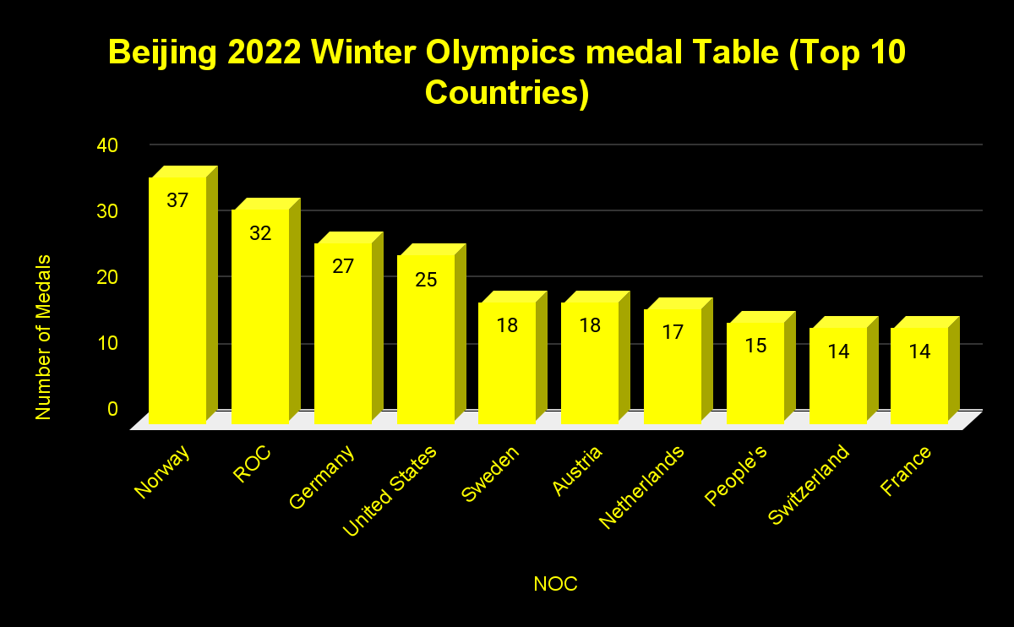

**Figure 1: Graphical representation of the Top 10 NOCs in Beijing 2022**

(Source: Self-Created)

## Question 5

**a.**

The representation of data will be presented by utilizing a combo chart, which is a combination of a bar graph for presenting the number of bronze and a line diagram representing the number of silver medal winnings in the Beijing 2022 Olympics.

**b.**

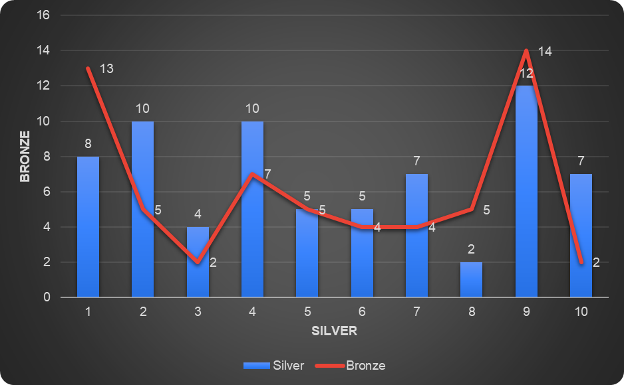

**Figure 2: Correlation between Bronze and Silver (Graphical Representation)**

(Source: Self-Created)

Correlation between the Beijing 2022 silver and bronze medal earnings has derived a value worth 0.6026113991, which can be considered as closer to one. The above graph, therefore, represents that the correlation between bronze and silver medal earnings is positive but inconsistent.

**c.**

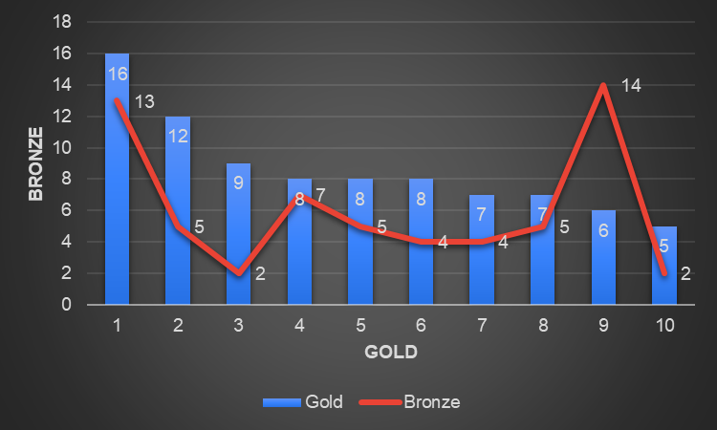

**Figure 3: Correlation between bronze and gold (Graphical Representation)**

(Source: Self-Created)

The correlation of the above graph also reveals that the gold medal winnings have been experiencing a decreasing trend as shown as a bar graph, the line graph representation denoting the number of bronze medal winnings shows an irregular trend. The correlation between the two is 0.3853634516 which can be considered as a value that is closer to one, denoting a positive correlation yet a weaker correlation.

## Question 6

a)

By considering the questions that have been provided to gather information on customer feedback on organisational efficiency the respective questions will impact on the following unreliable results. These are as follows:

* Age: Age is an important factor in terms of gauging the customer segment of the company which the company caters to majorly as depicted in the customer feedback gathering. The error and bias in the age group data that has been gathered in the survey of the company will produce undesirable data that will not solve the issue regarding the customer experience rendering the survey data to be useless.
* Agreement on whether the support team requires further training: Faults in the mentioned survey question will lead to the organisation acting on wrongful data. If the requirement of training is relevant in the particular situation the company will lose customers as the training requirement of the support staff will not be executed by the company based on the faulty feedback. The opposite in the present scenario will lead to wastage in the cost incurrence of the company.
* Time spent on the website: Similar to the previous question the faulty feedback to the questions will be leading to the implementation of the feedback. Perception of a faulty website will incentivise the company to allocate costs for website development while neglecting a faulty website will lead to less online engagement of the company and negative perception growth of the customers for the company.
* Complaint about customer service team: The complaint about the customer service team question faults will lead to the company’s efficiency in addressing the customer's complaint. Customer retention will also be impacted when the data here is unreliable leading to customer loss for the company.
* Customer service and reliability of products: Customer service and reliability and feedback are considerably affected due to the faulty feedback to the mentioned survey question as it will determine whether the company should be investing in improvements in the mentioned organisational areas (Winstone and Carless, 2019).

b) The present population which is to be considered for the survey of Richard’s organisation is expected to be 80% of the customers that are occupied in the market segment.

c) Random sampling is categorised as a sampling method which encompasses each of the samples having an equal probability of being considered for the process of sampling (Nguyen *et al*., 2021). The sampling that has been chosen on a random basis is meant to produce results without the presence of any potential biases. The process of random sampling is therefore also known as probability sampling as it introduces the element of randomisation for the process of sampling.

d) The random sampling in the present scenario for Richards organisation will be beneficial for its implementation without the presence of any bias for the business organisation.

e) The exact issue cannot be derived by the orgasmatron of the Richard organisation as the entire feedback cannot be considered for addressing and improving the customer experience of the company along with the presence of any minority subgroups that have been experiencing issues regarding the customer service of the company.

## Question 7

|  |  |
| --- | --- |
| a) Summation:  (SUMIF(C4:C13,"S*",D4:D13)) | 15 |
| b) Average: (AVERAGEIF(F4:F13,"<10",D4:D13)) | 8 |
| c) Count: (COUNTIF(E4:E13,">=10")) | 3 |

## Question 8

a)

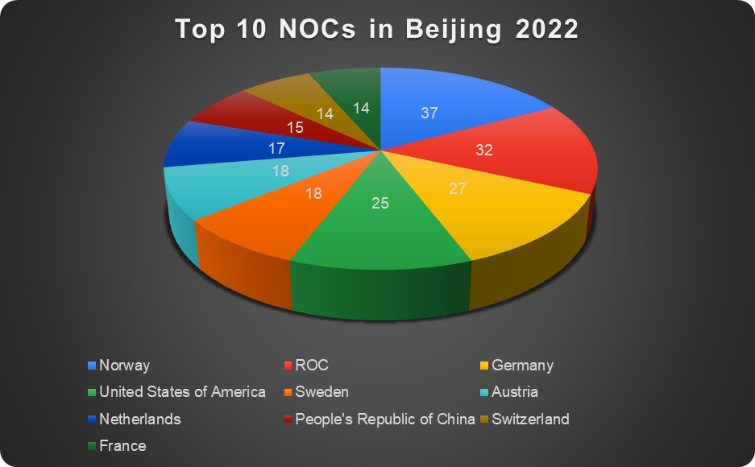

**Figure 4: Top 10 NOCs in Beijing 2022**

(Source: Self-Created)

b)

Considering the above representation of the data that has been presented in the above graph regarding the top 10 NOCs of Beijing 2022 has shown the largest percentage of total medal winnings for the country of Norway, ROC and Germany as the top 3 NOCs. These highest percentages of the three countries have been evident in the present scenario as these three NOCs have exhibited the highest counts of the total medal winnings which for Norway is 37, ROC is 32 and Germany is 27. The total number of Olympic medal winnings has been converted into percentages in the above graph among which the three mentioned NOCs have the highest percentages.

The second justification for the lower scores is in the countries such as Switzerland, the People's Republic of China and France which are only 6.5%, 6.9% and 6.5% respectively for the percentage. The lower percentage is related to the lower number of total medal winnings for the three mentioned NOCs. The number of medals is 15 for the People's Republic of China and 14 for Switzerland and France. Therefore, the lower number of medals is reflected as the percentage of the medals earned among the total percentage of the 10 NOCs as represented in the above pie chart diagram.

# References

Nguyen, T.D., Shih, M.H., Srivastava, D., Tirthapura, S. and Xu, B., 2021. Stratified random sampling from streaming and stored data. *Distributed and Parallel Databases*, *39*, pp.665-710.

Vaske, J.J., 2019. *Survey research and analysis*. Sagamore-Venture. 1807 North Federal Drive, Urbana, IL 61801.

Winstone, N. and Carless, D., 2019. *Designing effective feedback processes in higher education: A learning-focused approach*. Routledge.