**ASSIGNMENT A - PREPARE AN OUTLINE BUSINESS CASE FOR A RENEWABLE ENERGY PROJECT**

Table of Contents

1. Project Environment Analysis 3

2. Project scheduling and organization (Gantt, CPA & RACI) 20 marks 3

3. Financial forecasting (cash flow, Payback period, NPV) 20 marks 5

4. Operational management (WBS, Risk register) 20 mark 6

5. Stakeholder management (at least 3 key stakeholders) 7

Reference List 9

# 

# 1. Project Environment Analysis

|  |  |
| --- | --- |
| **Strength**   * The utilization of rich solar resources * Rich resources of land and space * Application for suitable pv solar system | **Weakness**   * Renewable energy investment from the government has been low. * Insufficient knowledge of environmental and social benefits**.** |
| **Opportunity**   * Can increase awareness for Changing climate. * Increased gap between demand and energy supply**.** | **Threat**   * The dominant situation of fossil fuel * Discontinuity on policies related to energy transfer |

**Table 1: SWOT**

(Source: Self-created)

**Speaker Note:**

The richness of solar resources exhibits depreciated remarkable advantages for this project in terms of finding potential. Compared to traditional power generation methods that use fossil fuels, PV solar power generation requires more land per unit capacity (Ahmed*et al.* 2020). For instance, a 1 MW solar PV system that uses polycrystalline PV modules needs around 1 hectare of land. The large bulk of investment must be a weakness for this PV Solar power project. Rising consumption is of energy deficit energy trade more. Large-scale adoption of solar PV may inevitably clash with the interests of the major fossil fuel-based electricity generators.

# 2. Project scheduling and organization (Gantt, CPA & RACI) 20 marks

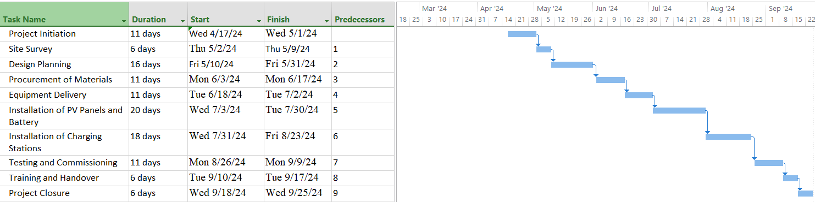

**Figure 1: Gantt chart**

(Source: Self-created)

**Speaker Note:** By effectively managing time with tasks, the project can achieve its goals while minimizing any negative impacts on the project (Suhanda and Pratami, 2021). CPA would connect from the site survey to the installation of PV panels and battery then closure to the project.

|  |  |  |  |  |
| --- | --- | --- | --- | --- |
| **Task** | **Responsible (R)** | **Accountable (A)** | **Consulted (C)** | **Informed (I)** |
| **Project Initiation** | Project Manager | Finance Manager | Team Members | Stakeholders |
| **Site Survey** | Mechanical Eng | Electrical Eng | Transport Eng | Team Members |
| **Design Planning** | Electrical Eng | Mechanical Eng | Transport Eng | Team Members |
| **Procurement of Materials** | Supply Chain | Finance Manager | Project Manager | Team Members |
| **Equipment Delivery** | Supply Chain | Project Manager | Finance Manager | Team Members |
| **Installation of PV Panels and Battery** | Electrical Eng | Mechanical Eng | Transport Eng | Team Members |
| **Installation of Charging Stations** | Electrical Eng | Mechanical Eng | Transport Eng | Team Members |
| **Testing and Commissioning** | Electrical Eng | Mechanical Eng | Transport Eng | Team Members |
| **Training and Handover** | Electrical Eng | Project Manager | Finance Manager | Team Members |
| **Project Closure** | Project Manager | Finance Manager | Team Members | Stakeholders |

**Table2: RACI**

(Source: Self-created)

**Speaker note**: RACI Matrix has highlighted each role of their terms denotes who is responsible for project management in their actions (Dai*et al.* 2022)**.**

# 3. Financial forecasting (cash flow, Payback period, NPV) 20 marks

|  |  |
| --- | --- |
| **Electricity Generated** | 1000000 units |
| **Electricity Stored** | 10000 units |
| **Electricity cost** | £151500 |
| **Cash Flow** | £5338500 |
| **Payback period** | £9.365926758 |
| **NPV** | £51914179.93 |

**Table 3: Financial forecasting**

(Source: Self-created)

**Speaker Note:**

Electricity Generated = 200,000 units / 0.2 = 1,000,000 units

Electricity Stored = 10,000 units

Assuming an electricity price of £0.15 per unit, the total electricity cost for the project will be = (Electricity Generated + Electricity Stored) * £0.15 = £151500

**Cash Flow**

Cash Flow = Total Revenue - Total Costs = £6,000,000 - (£500,000 + £10,000 + £150,150) = £5338500

**Payback Period**

Payback Period = Capital Cost / Annual Cash Flow = 9.37 years.

**NPV**

NPV = (Cash Flow / (1 + Discount Rate)^20) - Capital Cost = (£5338500/ (1 + 0.08)^1) + (£5338500 / (1 + 0.08)^2) + ... + (£5338500 / (1 + 0.08)^20) - £500,000 = £51914179.93

# 4. Operational management (WBS, Risk register) 20 mark

**WBS**

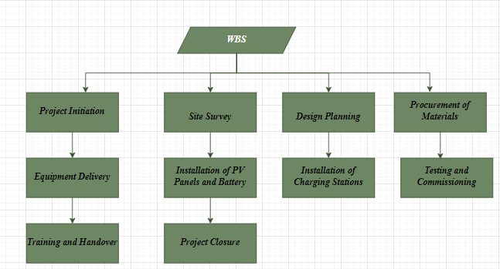

**Figure2: WBS**

(Source: Self-created)

**Speaker Note:**

The above figure is for WBS structure will be the main task-based activity that will enforce the project faster (Wang, 2020).

**Risk registration**

|  |  |  |  |
| --- | --- | --- | --- |
| **Risk** | **Probability** | **Severity** | **Mitigation** |
| Delays in equipment delivery | High | Medium | A lot of alternate suppliers and maintain regular communication with team members to ensure timely delivery. |
| Changes in government policies | Low | High | Monitor government policies and develop contingency plans to adapt to changes. |
| Technology obsolescence | Medium | High | Regularly evaluate new technologies and plan for regular updates. |
| Power outages | Low | High | Implement backup power solutions |

**Table 4: Risk registration**

(Source: Self-created)

**Speaker Notes**: By identifying and planning for potential risks, the project team can minimize the likelihood and impact of negative events and ensure the project's success**.**

# 5. Stakeholder management (at least 3 key stakeholders)

* Identification of stakeholder ***(Government, Employees, Investors)***
* Developing their activity
* Forecasting of budget and planning support
* Management plan and progress

**Speaker Note:**

For PV installation and battery storage installation, it will be necessary to identify customers, investors, local communities, government, suppliers, employees, etc (Martinsuo and Ahola, 2022). Employees like mechanical engineers, electrical, transport, and finance engineers will help to robust the work procedures perfectly. Engagement activities like surveys, focus groups, and meetings would bring concern over project progress.

# Reference List

**Journals**

Ahmed, R., Sreeram, V., Mishra, Y. and Arif, M.D., 2020. A review and evaluation of the state-of-the-art in PV solar power forecasting: Techniques and optimization. *Renewable and Sustainable Energy Reviews*, *124*, p.109792.

Suhanda, R.D.P. and Pratami, D., 2021. RACI matrix design for managing stakeholders in project case study of PT. XYZ. *International Journal of Innovation in Enterprise System*, *5*(02), pp.122-133.

Dai, H., Li, N., Wang, Y. and Zhao, X., 2022, March. The Analysis of Three Main Investment Criteria: NPV IRR and Payback Period. In *2022 7th International Conference on Financial Innovation and Economic Development (ICFIED 2022)* (pp. 185-189). Atlantis Press.

Wang, J., 2020. Construction of risk evaluation index system for power grid engineering cost by applying WBS-RBS and membership degree methods. *Mathematical Problems in Engineering*, *2020*.

Martinsuo, M. and Ahola, T., 2022. Multi-project management in inter-organizational contexts. *International Journal of Project Management*, *40*(7), pp.813-826.