**CONTEMPORARY ISSUES IN ACCOUNTING**

Table of Contents

Introduction 3

Discussion 3

Conclusion 7

References 8

Appendices 10

Appendix 1: Financial and Management Accounting 10

Appendix 2: Agency theory 11

# Introduction

The concept associated with contemporary issues in accounting relates to the presence of different issues in the global sphere that affects the business environment and accounting practice of a business. The presence of contemporary issues within an accounting process or financial management of business affects the contemporary environment of a firm. Therefore in this context, an essay is presented on the concept related to a contemporary issue in accounting involving financial and management accounting. Theoretical discussion is illustrated in the essay associated with F&M accounting followed by a critical evaluation regarding the value of the accounting process added with the identification of different contemporary issues in accounting.

# Discussion

***Concept of Financial and Management Accounting***

Accounting is mainly the approach to sharing, processing and measuring financial data regarding the business. In this context, it has been observed that the managers of the firms have utilised three main types of accounting processes considering *“financial accounting”, “cost accounting” and “management accounting”*. As opined by Weetman (2019), “financial accounting” in this aspect defines the process of reporting, analysing, and documenting each transaction of the organisation to disclose the financial stability of the firm. The guidelines for reporting and documenting financial information have been set by *“Financial Accounting Standards Board (FASB)”*.

On the other hand, management accounting explores the internal financial performance based on which the managers can make effective decisions with appropriate financial information. According to Cescon*et al.* (2019), “management accounting” also referred to as “managerial accounting” has provided insights into financial information in terms of costing and valuation which has helped managers in decision-making. Thus, it can be proclaimed that managerial accounting is mainly focused on the internal side of the firm by reflecting the product costs and valuation of the firm whereas financial accounting refers to the interpretation of overall financial data in terms of profitability, assets and liabilities through financial statements.

***Importance of Management Accounting Compared to Financial Accounting in running business***

The accounting process is crucial for every business in terms of its essentiality for planning, decision-making, and evaluating the financial health of the firm. In this context, it can be defined that financial accounting has quite different from management accounting as both provide different proactive solutions to the management. As commented by Dyson and Franklin (2020), financial accounting is mostly important in any running business as it provides insights into the financial health of the firm through which the managers can evaluate the current financial position. In addition to that, the concerned process helps the accountant to record, process, and audit the financial transactions along with re-evaluation of the business budgeting and spending. However, management accounting assists running businesses with both financial and non-financial information by forecasting the market and framing proper plans for future operations (Daniel *et al.* 2020). Furthermore, it enables the organisation to raise overall efficiency by ensuring resources for maintaining sustainability.

Hence, the aforementioned discussion explains the significance of financial accounting in comparison with management accounting. It can be proclaimed based on the analysis that both accounting process is crucial to running businesses where financial accounting helps in recording and disclosing financial transactions and management accounting enables in controlling the operations to increase organisational efficiency. In addition to that, it has also been explored that the management accountant has mainly focused on short-term growth strategies to examine financial soundness (CIMA, 2023). In contrast to that, financial accountants comply with the established formats for preparing reports by focusing on long-term financial strategies (CIPFA, 2023). Thus, it signifies that management accounting is differentiating features from financial accounting; however, both are crucial for running businesses to plan future operations, enhance efficiency and record transactions to explore financial viability to the audience***[Refer to Appendix]***.

***Theoretical evaluation to understand financial and management accounting***

***Financial accounting theory***

The theory of financial accounting mainly focuses on the aspect of “Why” in accounting that pertains to the reason behind selecting an appropriate way of transaction and performing accounting activity in a certain way. In the words of Bao *et al*. (2020), the financial accounting theory introduces certain courses related to what and how accounting is performed and its implication towards the framing of a financial statement. The theory presents facts regarding the need for financial accounting in business that includes the identification of uncertainty and encountering problems related to information asymmetry.

It has been observed that one of the key aspects related to accounting mainly includes the transmission of financial information and undertaking that information towards making an informed decision in business and investment. The presence of this fact regarding accounting is found to be relevant in the context of understanding contemporary issues in accounting. As per Dumay and Guthrie (2019), accounting contemporary issues emerge from advancing development and maintaining the capital market through treating different contemporary issues such as computation of annual depreciation, inventory valuation and many others. Therefore such prevailing conditions taking place in business can be examined through the creation of resilient financial reporting that includes asymmetry information about finance about supply and demand and acts as a regulatory body that guides towards framing financial statements within an organisation. However, the purpose of financial reporting is different in varied contexts based on accounting bodies such as providing financial information, identification of potential investors or making an informed decision concerning the utilisation of resources within the business.

***Agency theory***

Agency theory is a management accounting theory that is developed on the principle of explaining and resolving issues taking place between business principles and their agents. As opined by Vitolla *et al.* (2020), in the agency theory the prime objectives revolve around the creation of structure between the two main conflicting objectives and maximising welfare. Agency theory primarily works on two different aspects first is the difference in risk aversion and the difference in business goals. The theory lays greater emphasis on maximising the welfare of the principle and its associated agent in the business. However, to accomplish this objective certain problem tends to unfold such as agents' utility action is based on disutility action and principal wealth ***[Refer to appendix 2].***

The theory presented is relevant in the context of identifying the cause of the contemporary issue in accounting acting as a global issue within the business environment. In the words of Moerman and van der Laan (2022), some of the major contemporary issues that are present concerning management accounting include overtime premiums, development costs, treatment of goodwill and many others. Thus the emergence of such contemporary issues in accounting tends to develop due to conflicts arising between the principles and their associated agents. The presence of such challenging aspects and utility functions leads to the creation of resulting outcomes affecting the accounting practice of the business.

***Explanation of the value of F&M accounting process***

The process associated with financial accounting involves the collection, organising and communication of the financial aspect of a business. According to Leitner *et al.* (2021), the financial accounting process mainly includes the preparation of a financial statement of a company for people that are accountable to the business such as investors, customers, suppliers and creditors. Conversely, management accounting relates to the creation of accounting statements for making management decisions. One of the prime differences between financial and management accounting is that FA mainly supplies accounting information and MA helps in undertaking decisions. The differences existing between these two accounting aspects also lead to the derivation of differences in the perspective of value.

FA provides detailed and accurate financial information that tends to measure the solidarity of the business and the value attained in this aspect involves obtaining accurate information about business financial performance that also includes information about taxes. In the words of Roychowdhury *et al.* (2019), in FA the sorting of financial information takes place in three different statement formats including an income statement presenting data about profit & loss, a balance sheet covering information about all financial status and cash flow delivering the flow of finance in a period. Thus the presentation of information in such a diverse context provides value to the business in terms of making the business financially available at different levels. In addition, it also helps in communicating information that serves the accounting needs of the company

The introduction of FA within a business is not only helpful in terms of maintaining the financial part of the business rather it also adheres towards forming a business process with due compilation and regulation in order to avoid any legal challenges. Contemporary issues within a business emerge with the lack of familiarity with accounting needs and compliance action (Biddle *et al.* 2022). Therefore to avoid any such kind of contemporary issues in accounting the presence of FA regulates business action with proper business conduct and prevents the occurrence of any legal and auditory issues.

On the other hand, the implementation of an MA also tends to provide a certain degree of value to a business by providing estimated information that is likely to occur within a business. As per Schaltegger *et al*. (2022), MA is aimed towards managing information and making well-integrated information. Projection of information is a crucial aspect of a business and MA delivers value to the business by providing estimated information about the area of improvement and the area of benefits. In addition, tax professionals and investors associated with a business also get benefits in terms of accessing the performance of the organisation. One of the main activities related to MA includes the presentation of both financial and non-financial information about the business. Under such prevailing planning of the forecast budget, an effective decision-making process takes place with MA. As stated by Wolf *et al.* (2020), the decision-making process with an MA takes place through the presentation of graphs, charts and visual presentation that takes place in the detailed analysis of the information. Thus the presentation of information in such an aspect improves the performance of the business by detecting the problem at the early stage and forming strategic management decisions based on information obtained from MA. therefore it can be attained in the contemporary business environment the presence of both F&M accounting is beneficial to a business in adding value service that reduces issues in accounting.

***Evaluation of the current contemporary issues affecting accounting discipline***

In the field of business, the introduction of accounting principles tends to face a certain degree of challenge that is affecting the accounting disciples of the current market. Some of the major contemporary accounting issues identified is maintaining a steady ***cash flow***. As per Leskinen *et al*. (2020), companies in the current business environment are moving ahead quickly to ramp liquidity through the implementation of cost containment that deferred planned investment. Thus under such prevailing conditions efficiency in terms of managing account receivable gets reduced followed by the accounts payable process leading to unsteady cash flow. The introduction of ***cloud-based technology*** is also emerging as a challenge in the accounting discipline and affects those individuals or businesses that prefer traditional in-person accounting. According to Ball and Nikolaev (2022), there is a gradual shift in the accounting process with the introduction of cloud-based technology to perform accounting work and consulting with clients. The derivation of such improved technology affects the business performance of the business that does not adopt cloud-based technology.

The ***introduction of new accounting standards and regulatory changes*** is also identified as a major challenge as there is an implementation of different phases of accounting principles and standards (Baskerville and Grossi, 2019). Some of the major changes in law include PPP loans and future business stimulus packages. Therefore the emergence of all the contemporary accounting challenges taking place at the global level results in creating a resulting impact on the financial and management accounting performance of a business.

# Conclusion

The conclusion derived after evaluating the essay based on the notion of the contemporary issue of accounting is that in the current business environment management of finance is a crucial part of a business in order to undertake a strategic decision. The presentation of the theoretical perspective related to finance and accounting provides a view regarding the formation of a relationship between theories with those of contemporary accounting issues. Moreover, the presence of certain issues in the business related to accounting has affected contemporary business performance.

# References

Bao, Y., Ke, B., Li, B., Yu, Y.J. and Zhang, J. (2020). Detecting accounting fraud in publicly traded US firms using a machine learning approach. *Journal of Accounting Research*, 58(1), pp.199-235.

Cescon, F., Costantini, A. and Grassetti, L. (2019).Strategic choices and strategic management accounting in large manufacturing firms.*Journal of Management and Governance, 23*(3), pp.605-636.

CIMA (2023).*FRS 102 - a comprehensive refresher - Module 1 - principles and presentation*. Available at: https://www.cimaglobal.com/Events/Events/Mastercourses/Technical-skills/Financial-accounting-and-reporting1/FRS-102---a-comprehensive-refresher---Module-1---principles-and-presentation2/ [Accessed 18 April 2023].

CIPFA (2023).*Certificate in Management and Financial Accounting.* Available at: https://www.cipfa.org/qualifications/professional-accountancy-qualification/certificate-in-management-and-financial-accounting [Accessed 18 April 2023].

Daniel, T., Mahazi, K. and Mayanja, S.N. (2020).Management Accounting Information and Decision Making of Not-for-Profit Organisations in Rwanda.*Science Journal of Business and Management, 8*(3), pp.141-148.

Dumay, J. and Guthrie, J. (2019). Reflections on interdisciplinary critical intellectual capital accounting research: Multidisciplinary propositions for a new future. *Accounting, Auditing & Accountability Journal*.

Dyson, J. and Franklin, E. (2020) *Accounting for non-accounting students (10th Ed.).* Pearson Education Limited: Harlow.

Leitner-Hanetseder, S., Lehner, O.M., Eisl, C. and Forstenlechner, C. (2021). A profession in transition: Actors, tasks and roles in AI-based accounting. *Journal of Applied Accounting Research.*

Moerman, L. and van der Laan, S. (2022). Accounting for and accounts of death: Past, present and future possibilities. Accounting History, 27(1), pp.6-23.

Roychowdhury, S., Shroff, N. and Verdi, R.S. (2019). The effects of financial reporting and disclosure on corporate investment: A review. *Journal of Accounting and Economics*, 68(2-3), p.101246.

Vitolla, F., Raimo, N. and Rubino, M. (2020). Board characteristics and integrated reporting quality: An agency theory perspective. *Corporate Social Responsibility and Environmental Management*, 27(2), pp.1152-1163.

Weetman, P. (2019). *Financial and management accounting.*Pearson UK.

# Appendices

## Appendix 1: Financial and Management Accounting

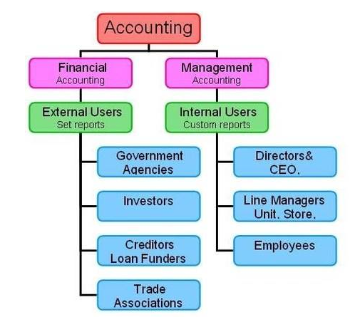

(Source: Influenced by Weetman, 2019)

## Appendix 2: Agency theory

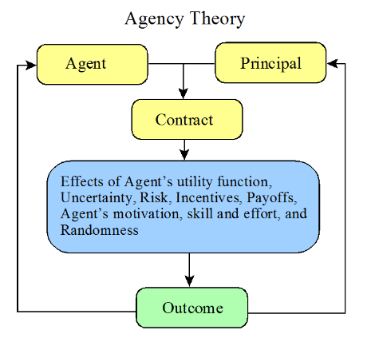

(Source: Vitolla *et al.* 2020)