**BRAND ANALYSIS AND MANAGEMENT**

Table of Contents

Introduction 2

Part 1: Brand Analysis 2

1. Brand introduction 2

2. Brand portfolio 3

3. Brand elements 4

4. Brand equity 6

5. Brand mantra 8

Part 2: International market analysis 8

SLEPT analysis of three culturally distinct market which the brand could potentially enter 8

Competitor analysis for each market 12

Part 3: Strategy for market entry 15

1. Selection and justification of new market entry 15

2. Recommendation of market entry strategy 16

3. Recommendation for standardisation 17

4. Intended POP and POD 18

Conclusion 19

Reference List 20

# Introduction

Brand Analysis and marketing is the process that evaluates the company’s branding strategy and methods. It gets involved in getting the company’s identity and personality to make the message that is required to be sent to potential clients. The brand that is chosen in this research is “Pharmacy2u” and it is trying to expand in three distinct markets in China, UAE and Singapore. The company is targeting the Asian regions market especially to focus on the target market of Shanghai, Dubai and Singapore. It is a pharmacy company that takes online orders from any pharmacy and its profit before tax stood at almost 100000 in the financial year ending 31st March 2021.

The company would announce in the same metric amounting to a loss of 7.2 million GBP for the financial report. The brand analysis of the company would be made for the context of the study to determine the specification of the company and its capabilities to expand in three distinct markets of three different nations. An international market analysis would be made for the company about the expansion in three different locations. SLEPT analysis will be made for three distinct markets for the brands that the company might have the potential to enter. Competitor analysis for each market will be made for the company. The strategy for the market entry of the company with the new market entry and recommendation of the market entry strategy will be made.

# Part 1: Brand Analysis

## Brand introduction

Pharmacy2U is undertaken to be the nation’s top leader in pharmacy delivery. This is brought in connection with the delivery as over 7000,000 patients in UK borders. This is contributed towards the award winning service made to the patients with home-delivery model. This company has been trusted by the NHS since 2001. It is brought in connection with the industry leading clinical accuracy made on the model. The General Pharmaceutical Council makes the regulations brought under the pharmacy channels. Starting from the COVID-19 vaccinations to the flu vaccination, these are also covered by the brand. It makes the health and prescription service coverage to be included within the online doctor consultation. The prescription service as provided with On-Off and Repeat are made with an objective to give the higher emphasis on the health and wellness of patients. With more than 1.5 million of the covid 19 vaccinations, this makes the company to have a higher reliable value in the market. Care Quality Commission and the General Pharmaceutical Council are made to bring the company value with better brand goodwill.

## Brand portfolio

* Brand promise-Pharmacy2U is considered to bring a new transformative model into the pharmaceutical framework. This has been brought in connection with the patents putting higher focus on the innovation of the medical supply chain. This is a mobile pharmacy that has gained the attention of the patients and the aged care facility service providers. The brand is highly oriented towards providing healthy and happy living for the patients.
* Brand personality-Brand perception is much more enhanced in terms of the KPMG award for 1st place in the customer experience excellence. This is supported by the Gold recognition in the European Contact Centre and Customer Service AwRD.
* Facts and symbols-The company has much higher brand transparency which can be felt as from the showcasing of the results in online websites. The management of the company makes the strategy to make the homepage of the website to give all the necessary information which will be deemed suitable for the company value. 92% of patients are found to collaborate with the company for further treatment. While 91% out of the patients group rate the service as good. Brand community channels with the physical evidence are provided through online reviews in all social media outlets. This is made with registration of the accounts with Facebook, Instagram, Pinterest, Youtibe and LinkedIn. 88% of the patients recommend the company services to the fiend or relative (). 92% feel that there is a condition to bring the contact and easier form of availability into the picture.

## Brand elements

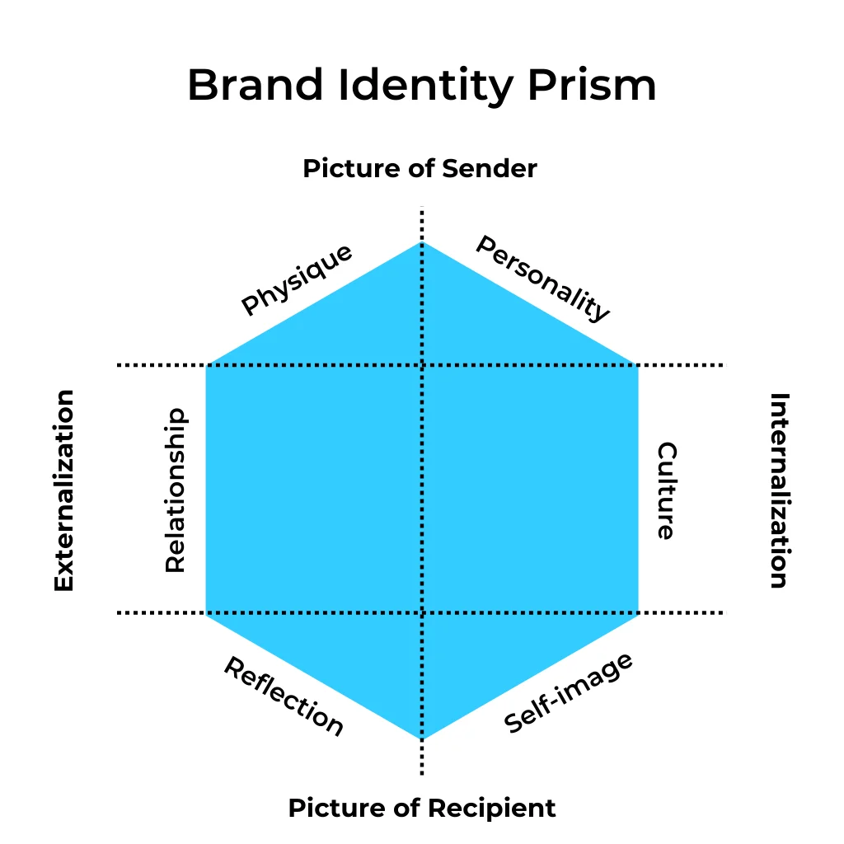

|  |  |  |
| --- | --- | --- |
| ***Picture of Sender*** | ***Physique*** | The logo is designed with blue colour that exemplifies peace and a symbol of trust. It also makes the healthy living standard to be posed to the audience by creating a minimalist approach on the blog and website. Communication is made with the audience-centric messages on healthy lifestyle and innovations. The patients are generally children to elderly age gap. The service is oriented towards higher propensity of the market to serve the patients from infants to the senior citizens. |
|  | ***Personality*** | The brand personality originated with respect to the trust and reliability of receivers. Clients and the patients involved in the supply chain are much oriented towards higher efficiency in the service. This also makes the |
| ***Internalisation*** | ***Culture*** | The priority is based towards patient health and safety. It is brought with the service team operating under the specialist requirements. Support to patients is made in consideration with the phone and the mail usage. Orders are taken in plenty to ensure that the accessibility value is made. Vaccination clinics operate within the 15-020 minutes for every client. It also allows qualified healthcare professionals to be involved in time booking scenarios. |
| ***Picture of recipient*** | ***Self-image*** | Brand is much more reciprocated towards patients' happiness with the processing of prescription. Team always engages with conversation to the suppliers and the patients. It also makes the sharing of updates to be provided in emergency hours. |
|  | ***Reflection*** | Brand is oriented towards transformation that makes the development to bring higher revolution from the 1700s. Fully trained professionals that make the booking of vaccinations to be made within 2-3 minutes. It also gives the available dates and slots based on the current schedule. |
| ***Externalisation*** | ***Relationship*** | NHS Government protocols are taken, that makes the company look after the well-being and staff. It also makes the dispensing of the medication to be made with the help under social distancing situations. Sincere support extended to the patients as well a the under-developing communities found in the overall consideration of the patients well-being. |

## Brand equity

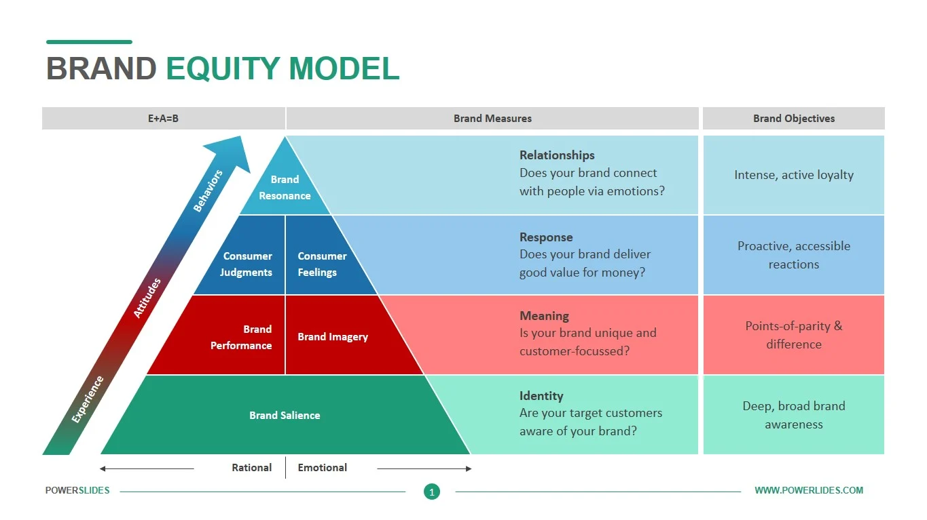

|  |  |
| --- | --- |
| ***Brand salience*** | The future pharmacy consideration has been brought in line with the transformation in medical culture. This is made with the history of pharmacy undergoing a huge evolution in transporting medicine and prescriptions to the customers. The pharmacy community as built by the company makes sure that all the patients are treated well. Innovation brought by the pharmacists in the company makes the key challenges in transportation to be sorted. |
| ***Brand performance*** | Online doctor service under the Pharmacy2U framework is based on the scheduled visits that are made from a person-to-person model. It also makes the medical profits from the NHS Prescription Service be based on terms of the medical condition throughout delivery arrangements. However the confidentiality is conducted with online consultations provided in connection with the free door delivery.  Such kind of internet-based pharmacy model is made in connection with the affordability value to the patients. Features of perception synchronisation as made into the framework of the product portfolio, the company is found to be bringing 20 vaccination sites on UK borders. This also makes the outstanding customer experience to be in connection with the telecommunication sportal made. Partnerships with RingCentral Contact Centre, allows the patients to get higher accessibility into the framework. |
| ***Brand imagery*** | Free Delivery of the patient service is one of the prime areas that will be considered in connection with the medication facility brought. It also makes the patient’s time to be saved and brought with the dispensing costs approval. On the other hand, the switch to the repeat preparation service would be made in line with the award-winning technology by the company. However, the pharmacy care makes the medication gaining ability to be convenient as a brand symbol. |
| ***Consumer feelings and judgements*** | It not only provides the patients with clinical pharmacy information that will be involved in primary care. The brand however faces shortfalls in terms of the secondary care not being taken for full coverage. Although, the brand is taken to be consulted for a lot of NHS Health Promotion Campaigns yet the policy makers generally consider the long-term plan. This makes the plan to be involved with the ‘Stay Well’ campaign undertaken through the driving ambition. Pharmacies generally don’t reimburse, but the brand is much more oriented towards the opportunity that makes the online pharmacy operations to be performed with rewards. Repeat prescriptions are actually made with higher emphasis on the choice of the online solutions made to the doctor. This is brought to the notice of offering the frontline services to patients with a monthly switching model. In terms of the subsidiary operations in government hospitals, the private online consultations are brought with much focus on the general practitioners to be engaged in a community. |
| ***Brand resonance*** | The long-term care plan is made by the brand in consideration with high-street pharmacy culture. This is brought in line with the potential total savings as made in terms of the innovation brought through new services into the chain. Facilitated personalised care is brought through the [performance of the episodic healthcare service as made in terms of neighbourhood health hub. One of the biggest achievements of the company is found to be in terms of the maximisation of the online opportunities with multiple checks into the verification process. The prescription modelling is based on 24 hours of the medicine recovery with the doctor consultation. |

## Brand mantra

“Healthier and Happy living”

The brand is influenced towards making the visibility to be much higher and bringing the understanding of the online care to patients. This is communicated with the objective of digital pharmaceutical channel to be made in connection with the development. The financial perspective of the brand value in the market is influenced in terms of the local pharmacy cure to be opted. 23% of the clients in the pharmacy channels of the company are oriented towards popularity value. This is brought in connection with the buzz to be at 15% only. However, it has been found that the usage of the application has been reduced to 17%.

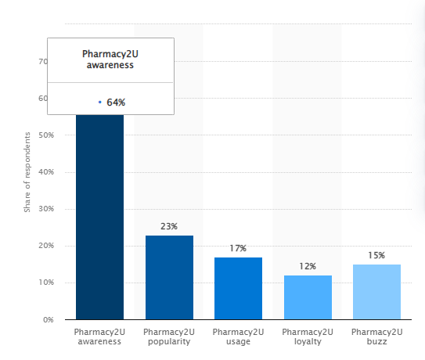

# Part 2: International market analysis

## SLEPT analysis of three culturally distinct market which the brand could potentially enter

SLEPT analysis of the culturally distinct market of Shanghai, Dubai and Singapore for the expansion of the company ***“Pharmacy2u”*** in the potential market of those countries like China, UAE and Singapore. SLEPT analysis is the external environment expansion of the market, where the potentiality of the brand is determined based on a few criteria.

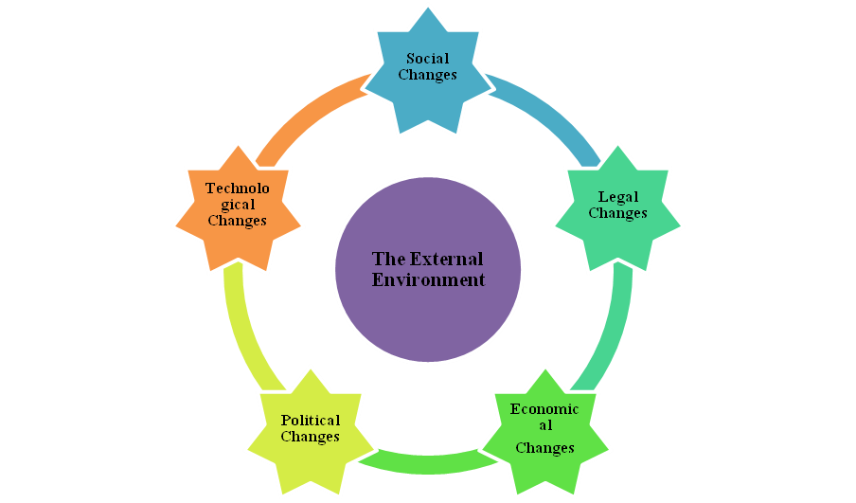

**Figure: SLEPT analysis**

(Source: Self-Created)

● **Social Changes**

***Shanghai***

Shanghai is located in China where the brand has the potential to expand because many people in China are old and weak enough to meet the medicine to cure any disease. China is a country where the pandemic had just outbreak in 2020 giving a chance for the pharmacy company to expand in that market to their business switch to full potential (Saha and Roberts, 2020). China has few scientists and skilled workers who know the pharmacy thus creating customer benefits to identify the medicine and give to the customers.

***Dubai***

Social benefits that the company would get from Dubai are the kind of people benefit that they would get from the medicine business. Dubai Health Authority would help to manufacture and sell the pharmaceutical medicine thus the company would take a certain approach to make the business quite more beneficial for the company. People in Dubai are very advanced to import medicine from other countries and they take medicine frequently because of old age and the effect of the pandemic that has spread from China.

***Singapore***

In Singapore, the market would be open for the very weak and old people, because they require medicine frequently. Singapore is a country to be instigated by the government to make the pharmacy business a priority so that the government can earn huge revenue from this pharmacy business (Yansen *et al*., 2023). People are addressed socially about the expansion of the business and the new discount and benefit the company is offering in expansion for the business.

● **Legal Changes**

***Shanghai***

The legal changes or factors of Sanghai are based on the province to be granted by the local law-making powers of the body. The Land Regulations laws of Shanghai would be implemented for the business. The company needs to buy and register land they would be addressed properly for the business to do in Shanghai. Dual-party government systems with the People's Republic of China are certain laws of Shanghai that would be implemented in the business.

***Dubai***

Dubai is a country in the UAE, where the country follows every type of Islamic law to do any business or make a startup for the business. Islamic laws are very much sensitive so people in Dubai never promise anything in public by swearing. The company would be levied with ***“The Pharmacy Act, 1948”*** of Dubai regulations to regulate the profession of pharmacy business in the country. The act thus provides the control of advertisement and publication of any new medicines that would be beneficial for the public and the possible remedies alleged with medicinal qualities.

***Singapore***

While the business tries to expand in Singapore the government of Singapore adheres to the laws of certain businesses related to pharmacy. ***“Registration of Pharmacists Act 1951”*** and ***"Sale of Drugs Act 1952"*** are the most prominent laws and regulations of Singapore for doing any pharmacy business. This law depicts that any new pharmacy business in Singapore needs to be registered with the Singapore government (Adwal and Baghel, 2019). The company is a drug-selling company thus the company would be further levied by the laws of the Sale of Drugs Act and sell only the registered drugs prescribed by any medical practitioner.

● **Economic Changes**

***Shanghai***

The economic changes regarding the financial factors of Shanghai are the GDP factors of China is 4.47 trillion Yuan. The GDP growth of Shanghai might increase from 7% to 10% each year and thus have been linked with the ratings of increasing the economic values of the government in earning revenues through a pharmacy (Kumar *et al*., 2023). The unemployment rate and per capita income of China are very high thus if the business gets started in Shanghai, the unemployment rate of China would decrease.

***Dubai***

Dubai is a country of doing business for many companies because it is a trading company and the country welcomes every trade and business to operate their business in the country. The GDP growth of the UAE is increasing by 3.92% each year. The rate of growth from 2020 to 2021 is 8.87%. The current GDP of Dubai is 503.9 billion USD and thus the country thinks if any new business can expand in this country then that would increase by 8.87% till 2023.

***Singapore***

The economy of Singapore is very high as the fifth largest Southeast Asian country from the 38th largest in the world in terms of GDP. The productivity rate of the country to be measured is rated very high. The pharmacy business of the company would be granted as an asset for the country (Kusumi *et al*., 2022). The GDP expansion for the company would be expected to grow 4.1% every year and an expectational growth of 8.7% expansion from 2022 to 2023. The per capita income of the country is 10.4% with the unemployment rate identified as moderate.

● **Political Changes**

***Shanghai***

The political factors of Shanghai are controlled by government bodies only and it is thus further monitored through the Shanghai Municipal Corporation. It is the leading organisation or political body to control any such local organisation or business that is trying to expand from other countries. This would be working for the company in creating core leadership of the political bodies that are operated in Shanghai (Thomas *et al*., 2021). All business activities are controlled by the political bodies of the Communist Party of China and are not permitted with the civil rights that are made to entail.

***Dubai***

There are no such political parties in Dubai, but the country has seven emirates operating and uniting certain monarchies in the nation. ***“Ajman”***, ***“Fujairah”***, ***“Sharjah”***, ***“Umm al-Qaiwain”***, ***“Abu Dhabi”***, ***“Ras al-Khaimah”*** and ***“Dubai”*** to be operating for the business that is governed by the Emir and its administration (Yuan *et al*., 2021). Dubai is a Persian Gulf country thus following political factors that are operated by the government or the monarchies directed by each part of Dubai.

***Singapore***

The political factors of Singapore entail the framework to be working as a federal representative of a democratic constitutional monarchy (Regin *et al*., 2022). ***“Lee Hsien Loong”*** is the head of the nation and the Prime Minister of Singapore. The country thus operates every policy to be regulated and passed by the PM of the country.

● **Technological Changes**

***Shanghai***

After the breakdown of the pandemic in China, the country has become accustomed to the latest technologies and adopted the pharmacy business to grow the latest priority. ***“Plasma etching machine technology for chip making”***, ***“a new drug to treat Alzheimer's disease named GV-971”*** and ***“advanced equipment for medicinal imaging”*** is identified as the best technology of Shanghai to be used for pharmacy business.

***Dubai***

Dubai is considered to be a city of technology, where the country always focuses on new technology and innovation. The implementation of massive ***“Internet of Things”, “Data analytics”, “blockchain technologies” and “Artificial Intelligence”*** thus acquire the latest technological changes of the country to be adapted while the company would expand in Dubai (Marmat *et al*., 2020). UAE is already integrating AI features and has ambitious plans with the latest AI features. Thus the government diversified the nations of any new business to use AI-featured technologies.

***Singapore***

Singapore is an advanced country thus if the pharmacy company expands in the market of Singapore, then it would experience "***digital payment systems”***, ***“5G technologies”***, ***“blockchain technologies”***, ***“robotic process automation”*** and ***“virtual reality”***. The company has enough potential to enter the market and thus has skilled workers accustomed to the latest technologies.

## Competitor analysis for each market

Competitor analysis is referred to as the process of identifying the competitors' strategy to be marked as not the industry in researching and with different marketing strategies. It can be made by the information to be extracted with the point of comparison that would be required to identify the company's strengths and weaknesses. This would be taken to understand the strengths and weaknesses of the company in comparison to each competitor.

***Shanghai***

● **Strengths**

The strength of the company lies in the pricing strategy that would be providing the same product as other competitors. **“Pharmacy2u”** is an online pharmacy delivery company or pharmacy supplier, thus they present their advertisement strategy in the company's portal and website for advertisement purposes. In Shanghai, the company will be tied up with many hospitals so that the brand would be promoted in different hospitals and healthcare centres.

● **Weakness**

The weakness of the company is that they have several competitors in China and due to a lack of skilled labourers those who know medicinal requirements would lag the company behind other competitors (PHARMACY2U, 2023). “Phlo Technologies” and "Sinopharm Group" are the latest competitors for “Pharmacy2u” as their expansion would fall in Shanghai.

● **Market Share**

The market share of the company would be taken as almost 17% of the people in Shanghai will use online pharmacy users in the UK company (King et al., 2021). This means that 64% of those who are aware of the brand thus will use 27% of the market share that the company generates from the UK.

● **Pricing**

The cost of every medicine is very pocket friendly for “Pharmacy2u” to be operated in Shanghai. They are operating as a skimming pricing strategy to be offered with an introductory price to the market as they would be new in the Shanghai market and then gradually the price may increase. Every type of oral medicine is much less than drugs taken as an injection.

***Dubai***

● **Strengths**

The strength of the company in Dubai is their acquiring and being accustomed to the latest technologies in delivering medicines. The company is an online medicine supplier thus latest technology would help the company to have added advantage against competitors.

● **Weakness**

The company has the least weakness compared to its competitors. In Dubai due to lack of a workforce skilled with the latest technologies would be the greatest weakness for the company. The competitors of “Pharmacy2u” in Dubai would experience every type of technology thus if “Pharmacy2u” does not adopt new technologies then they will lag. “Medpharma”, “Pharmax” and many more are pharmaceutical companies in Dubai.

● **Market Share**

The market share of “Pharmacy2u” in Dubai would be much more due to the usage of the latest technologies by the company. The company provides round o clock delivery of drugs with a market share of revenue of 15% per day that is participated with financing. The people of Dubai will use the latest technology to order from pharmacies almost 27% are online and few others would purchase offline drugs.

● **Pricing**

The cost of every medicine is very much appropriate for the people in Dubai to order pharmacy online (Paolone et al., 2022). The company would deliver medicine instantly as soon as they got the order. They use a skimming pricing strategy so that a loyal customer base would get created initially for the business. The price of vaccination will be high compared to any oral drugs.

***Singapore***

● **Strengths**

The strength of the company lies in the least workforce in Singapore. The company is very much concerned about the number of drugs that they keep in the market to have relative strength in education for the business (PHARMACY2U, 2023). The company thus has the lowest strength in manufacturing the drugs and the highest strength in delivering the drugs on time to customers.

● **Weakness**

The weakness of the company is the practising of the latest technologies to be done by the workforce of the company. The company would experience competitors in Singapore such as “GlaxoSmithKline (GSK)” and “Chugai Pharmaceutical Co.”. Lack of a proper workforce and skilled workers with knowledge of the latest technologies is the main weakness of the company.

● **Market Share**

The market share of the company is estimated to be 18% of online users buying medicines and the rest are offline users (PHARMACY2U, 2023). A total potential of 6.56 million USD of market share thus gets generated from medicine supply and the company earns a huge share of 7.87% of share each yeast from online medicine delivery and 3.45% of online medicine purchase.

● **Pricing**

The pricing strategy for the company is thus a skimming strategy the company follows with the brand thus starting their business in Singapore (PHARMACY2U, 2023). Every such medicine would be of such low price as new customers in Singapore and then the price would increase gradually. Oral drugs seem pocket friendly and any such vaccinated drugs are a little bit higher than oral drugs.

# Part 3: Strategy for market entry

## Selection and justification of new market entry

Pharmacy2U is a successful online pharmacy based in the UK that has been involved in plotting the electronic transfer of perception. With its repetition for Innovation and customer satisfaction, the pharmacy is well-positioned to expand its business and establish a presence in a new market. One such market that has a presence and opportunity for Pharmacy2U is Singapore.

Singapore is a highly developed country with a strong economy and an established Healthcare system. The country has a population of over 5.7 million people with an increase in the number of them seeking medical services and products online. In recent years Singapore has witnessed a significant shift towards E-Commerce with government activity through encouraging the growth of digital businesses (Kavanagh et al., 2022). This presents an opportunity for Pharmacy2U to enter the Singaporean market and leverage its expectation online for machine service to cater to the growing demand and the healthcare product and services to the country for the Welfare of society and people.

One of the key reasons for a pharmacy to enter the Singaporean market is the potential for growth. The Singaporean Healthcare market is estimated to be worth around 29 million dollars with a projected annual growth rate of 9.8% from 2018 to 2023. This presents a significant opportunity for pharmacies to expand their business and capture a share of the market in Singapore. Additionally, Singapore is a highly connected country with a high rate of Internet and smart penetrations. The present is an opportunity for pharmacies to leave their existence in digital platforms to Carter to the growing demand for online health care services.

From the above conclusion it can be said that Pharmacy2U has a strong reputation for Innovation and customer satisfaction making it position to expand its business to the established presence in New Markets. Singapore's growing Healthcare market's favourable regulatory environment and high rate of interest and smartphone generation makes it an attractive market for pharmacies to enter. With its is in online pharmacy service pharmacy to you has the potential to capture a significant share of the market and established itself as a leading provider of healthcare services in Singapore.

## Recommendation of market entry strategy

Before entering a new market it is important to have a clear strategy to ensure a successful launch and long-term success in the country. Four Pharmacy2U entry into Singapore and market licensing strategy with the local distributor and agent is recommended as the company has to open an online E-Commerce Medical Store (Hu, 2021). The Government of Singapore has instructed a restrictive recommendation for the medical owner as it is the sense of life and human being.

Licensing is a common strategy used by businesses to enter any new market. It involves entering into a contractual agreement with a local company or individual to use intellectual properties such as Trademark patents and copyright in exchange for a fee of royalty. This approach allows the licensing company to benefit from local companies' knowledge of the market and established distribution channels while the company benefits from the use of licensing companies' intellectual property (Peckham, 2023).

In Pharmacy2U's case, licensing with local distributors and agents would allow the company to leverage the local distributors knowledge of the Singaporean market established relationship with the Healthcare provider and customer and distribution channel. It would also provide the pharmacy to you with the opportunity to expand its reach in the market without having an investment in establishing a physical presence in the country.

Under this licensing strategy, Pharmacy2U could licence its intellectual property including its brand software and operating system to a local distributor or agent in Singapore. The local distributor or agent would be responsible for establishing and managing a local network of Pharmacy Healthcare providers and patients. They are also responsible for managing marketing sales and customer support. Pharmacy2U would provide the necessary training support to the local distributor or agent to ensure that they can effectively use the intellectual property and operate in line with its brand standard. The licensing agreement would include performance-based clauses to ensure that the local distributor or agent meets the agreed-upon target and quality standard. Overall eye sensing strategy with local distributors and Agents would provide Pharmacy2U with the opportunity to enter the Singaporean market with a lower risk lower investment. It would allow the company to benefit from local distributors' established network market knowledge and customer relationships. It would also provide pharmacy to you and build a customer base without having to invest in physician presence in the country.

The topic concludes that a licensing strategy with a local distributor and agent is a recommended market entry strategy for Pharmacy2U to enter the Singaporean market. It would allow the component to leverage the local distributors, and enable established network market knowledge and customer relationship while also providing Pharmacy2U with the opportunity to establish a presence in the market and build a customer base without having to invest in establishing a physical presence in the country.

## Recommendation for standardisation

Differential leadership through service extension is a strategy that can help Pharmacy2U stand out in the highly competitive Healthcare market and needs to develop as per customer demand. To ensure consistency and efficiency in complementing this strategy it is recommended that the pharmacy to you standardise its leadership practices and Service Delivery across all reasons. The first step towards standardisation is today to find the key leaders and services that deliver standards that will be implemented across all regions. This can be achieved by conducting a comprehensive analysis of the organisation's culture, and current practices and benchmarking against best practices in the industry. The leadership practices can include hiring and training standards for managers and team leaders' performance management systems and communication strategies. Service delivery standards can include a standard operating procedure for pharmacy operation Quality Assurance system and customer service protocols.

Leadership practices and Service Delivery standards have been defined by pharmacy you can develop a comprehensive training program for all employees to ensure that they understand they are able to understand and can implement these practices and standards in real base life. The training program should be designed to Cater to different communication skills, customer service skills and standard operating procedures. To ensure that the standards are being made pharmacy to you can implement a monetary and evaluation system to track performance and identify areas for improvement this can include the regular audit of Pharmacy operation customer satisfaction surveys and performance reviews of managers and team leaders. Finally, the pharmacy can establish a culture of continuous improvement where employees are encouraged to provide feedback and suggestions for improvement. This can be achieved through regular Town Hall meeting feedback mechanisms and employee engagement initiatives. Standard digestion of leadership practices and services delivery standards is critical for Pharmacy2U to effectively implement differential leadership group services extension start strategy. By defining and implementing this standard Pharmacy2U can ensure consistency and efficiency in its operation, improve customer satisfaction and stand out in the highly competitive healthcare market.

## Intended POP and POD

The Point of Parity for Pharmacy2U is its online pharmacy model that offers patients a convenient way to manage their medication and assess their health service remotely (Bandivadekar, 2022). This includes perception refill consultation with Healthcare professionals and home delivery of medication.

The Point of Differentiation for a pharmacy to you is its focus on differential leadership through service extension. This means that Pharmacy2U not only provides the basic service of an online pharmacy but also goes beyond these to provide additional services that differentiate it from other computers. Monitoring of chronic conditions and access to the networking of HealthCare professionals (Pharmacy2U, 2023). Another beautiful pharmacy to you is its complement to patient privacy and security. With its online platform, Pharmacy2U takes measures to ensure that patient information is protected and kept confidential at all times. This can include secure online communication channels, encryption data and other data protection regulations.

Overall the POP of Pharmacy2U is the online pharmacy model while the pod is focused on differential leadership through service Extension and commitment to patient privacy and security. These points of private parity and differentiation help Pharmacy2U stand out in the competitive Healthcare market while also meeting the basic need expectation of patience (Pharmacy2U, 2023). Why maintaining and building on these strange Pharmacy2U can continue to group its customer base and expand services in the future. Pharmacy2U is to effectively implement differential leadership group services extension start strategy. By defining and implementing this standard Pharmacy2U can ensure consistency and efficiency in its operation, improve customer satisfaction and stand out in the highly competitive healthcare market (Elvidge, 2020). To ensure consistency and efficiency in complementing this strategy it is recommended that the pharmacy to you standardise its leadership practices and Service Delivery across all reasons. The first step towards standardisation is today to find the key leaders and services that deliver standards that will be implemented across all regions.

# Conclusion

From the above topic and based on the discussion made so far, it can be concluded that the research would be beneficial for the company “Pharmacy2u” which they would try to expand due to its brand analysis and reputation. It is a pharmacy company that has achieved significant improvements and operational efficiency that have lowered the costs of medicines for the benefit and well-being of patients. As a result of the progression, the company is trying to expand globally and is likely to target Asian countries for its expansion. They will expand in the market of Shanghai location, Dubai location and Singapore location for their expansion. In part 1, the brand analysis of the company had been made for the brand “Pharmacy2u” to determine the potentiality of the company and whether it can be expanded on any such international market. Brand equity, brand elements, brand portfolio and brand mantra of the company are given. In part 2, an International market analysis of the company had been made by analysing the three distinct markets and thus proper SLEPT analysis had been made. Competitor analysis for each market has been made in the context of the brand. In part 3, the selection and justification of new market entry for the brand and recommendation of the market entry strategy had been given. Recommendations for standardisation and intended POP and POD for the company are highlighted for the new market entry strategy.

# Reference List

Adwal, S.K. and Baghel, R., 2019. Price variation in different brands of anticancer drugs available in the Indian pharmaceutical market: a cost analysis study. *Int J Basic Clin Pharmacol*, *8*(4), p.642.

Bandivadekar, S.S., 2022. Online Pharmacies–A New Prescription for Health in India.

Elvidge, S., 2020. AMR and diagnostics: pointing the way to better infection control. Evaluation, 14, p.34.

Hu, Y., 2021. Private and Common Property Rights in Personal Data. SAcLJ, 33, p.173.

Kavanagh, O.N., Courtenay, A., Khan, F. and Lowry, D., 2022. Providing pharmaceutical care remotely through medicines delivery services in community pharmacy. Exploratory Research in Clinical and Social Pharmacy, 8, p.100187.

King, J., Koppenhafer, L. and Madrigal, R., 2021. Look, puppies! a visual content analysis of required risk statements embedded in direct-to-consumer pharmaceutical advertising. *Journal of Public Policy & Marketing*, *40*(1), pp.45-61.

Kumar, A., Krishna, S.H., Chandrasekhar, S., Vssavi, M., Venkatrayulu, C. and Alvi, A.I., 2023. Pharmaceutical Product Life Cycle Management Strategies in the Contemporary scenario. *Journal of Pharmaceutical Negative Results*, pp.512-516.

Kusumi, E., Murayama, A., Kamamoto, S., Kawashima, M., Yoshida, M., Saito, H., Sawano, T., Yamashita, E., Tanimoto, T. and Ozaki, A., 2022. Pharmaceutical payments to Japanese certified haematologists: a retrospective analysis of personal payments from pharmaceutical companies between 2016 and 2019. *Blood Cancer Journal*, *12*(4), p.54.

Marmat, G., Jain, P. and Mishra, P.N., 2020. Understanding ethical/unethical behaviour in pharmaceutical companies: a literature review. *International journal of pharmaceutical and healthcare marketing*, *14*(3), pp.367-394.

Paolone, F., Cucari, N., Wu, J. and Tiscini, R., 2022. How do ESG pillars impact firms’ marketing performance? A configurational analysis in the pharmaceutical sector. *Journal of Business & Industrial Marketing*, *37*(8), pp.1594-1606.

Peckham, S., 2023. Evaluation of Government Commitments made on the digitisation of the NHS.

Pharmacy2U (2023) Online doctor, Pharmacy2U. Available at: https://www.pharmacy2u.co.uk/onlinedoctor/ (Accessed: April 16, 2023).

Pharmacy2U (2023) Pharmacy2u Limited, Pharmacy2U Limited - Care Quality Commission. Available at: https://www.cqc.org.uk/location/1-496259606/inspection-summary (Accessed: April 16, 2023).

PHARMACY2U, 2023. “PHARMACY2U Reports 'Dramatically Improved' Financial Results for 2020/21” (*C+D*) <https://www.chemistanddruggist.co.uk/CD135460/Pharmacy2U-reports-dramatically-improved-financial-results-for-202021> accessed April 15, 2023

Regin, R., Rajest, S.S., Shynu, T. and Steffi, R., 2022. The Influence that the Advertising of Pharmaceuticals has on the Economy. *Central Asian Journal Of Social Sciences And History*, *3*(10), pp.1-18.

Saha, A. and Roberts, H., 2020. Pharmaceutical industry’s changing market dynamics. *International Journal of the Economics of Business*, *27*(2), pp.159-175.

Thomas, S., Jadeja, A., Vaghela, K. and Shreevastava, R., 2021. Investigating the consumers attitude toward brand and purchase intention within the context of cause-related marketing campaigns for a pharmacy product. *International Review on Public and Nonprofit Marketing*, pp.1-18.

Yansen, E., Sijabat, R., Bernato, I. and Widjaja, A.W., 2023. The Role Of Personal Brand Orientation And Brand Orchestration In Social Commerce. *Journal of Pharmaceutical Negative Results*, pp.2860-2875.

Yuan, J., Lu, Z.K., Xiong, X. and Jiang, B., 2021. Lowering drug prices and enhancing pharmaceutical affordability: an analysis of the national volume-based procurement (NVBP) effect in China. *BMJ Global Health*, *6*(9), p.e005519.