**HEALTH PROMOTION AND HEALTH DEVELOPMENT: SUMMATIVE ASSIGNMENT**

**Table of Contents**

Question 1: Analysis of the Health Belief Model 3

Introduction 3

Analysis of the health belief model 3

Application of health belief model on diabetic patients 5

Conclusion 7

References 9

Question 2: Implementation of a nutrition intervention program 11

Introduction 11

Logical Framework Approach 11

Conclusion 13

References 15

Question 3a: Usage of technology to diagnose and monitor cardiovascular conditions 16

Introduction 16

Usage technologies to monitor and diagnose cardiovascular conditions 16

Conclusion 19

References 20

# Question 1: Analysis of the Health Belief Model

## Introduction

The “Health Belief” model is mainly used by health practitioners to explain the inaccessibility of preventive health services among people. This model is also deemed crucial in explaining the behaviour of patients regarding the adoption of health protection. Being developed in the early 1950s, this model was first implemented by various social scientists within the US Public Health service domain to determine the reasons behind the failure of people in adopting proper disease prevention routines. The core factors behind failing to attend requisite screening tests for ensuring early detection of diseases were also identified with the help of this theory. This report aims to critically analyse the health belief model, underlining the key benefits and drawbacks gained in using this framework to determine patients’ healthcare behaviour. Specific examples of the application of this model for diabetic patients has also been provided.

## Analysis of the health belief model

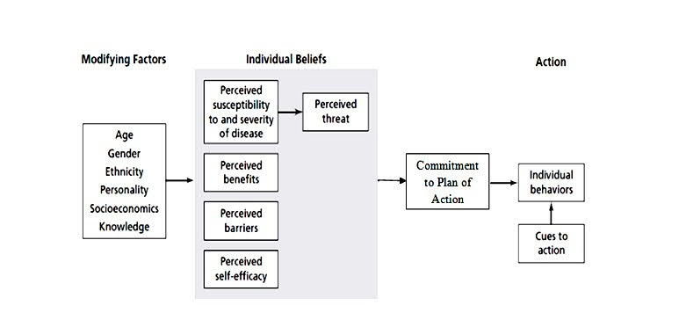

**Figure 1: The Health Belief Model**

(Source: Pourhaji*et al.* 2020)

The Health belief model is largely used among healthcare providers to accurately identify the different forms of responses obtained from patients concerning core disease symptoms and compliance with key medical treatments. According to this model, the likelihood of an individual adopting treatment behaviour is dependent on the individual's belief in the personal threat posed by certain diseases (Sulat*et al.* 2018). Additionally, the likelihood is also heavily dependent on a person’s belief towards the effectiveness of recommended health behaviour in effectively treating the identified disease (Daragmeh *et al.* 2021). In this regard, it can be stated that the health belief model is mainly derived from behavioural and psychological theories of health that specifically state two core components of health-based behaviour (Fall *et al.* 2018). The foremost desire involves the desire among individuals to avoid any form of illness and to effectively get well if already ill. The second desire involves a belief that a particular health action will prevent an illness that has been identified.

The core backbone of this theoretical model is based on determining an individual’s course of action based on the perceptions developed on the key benefits and barriers that are related to a recommended health behaviour. Accordingly, this model comprises six specific constructs, being perceived susceptibility, perceived severity, perceived benefits, perceived barriers, cue to action and self-efficacy. Perceived susceptibility refers to an individual’s subjective perception based on the risk of acquiring an illness (Green *et al.* 2020). Perceived severity defines a person’s feelings regarding the severity of contracting a certain illness. This feeling of severity is largely dependent on various considerations regarding the medical and social consequences of the identified disease. Following this, perceived benefits refer to the perception of individuals towards the effectiveness of various health actions available for dealing with the identified disease (Walrave *et al.* 2020). The acceptance of a recommended health behaviour depends on the evaluation made towards both perceived susceptibility and perceived benefit.

Perceived barriers refer to the feelings of an individual towards possible obstacles that can be faced while conducting a recommended health action. This perception is essentially dependent upon a person’s feelings of barrier and cost/benefit analysis. Cue to action is defined as the stimulus developed among individuals to undertake a decision towards adopting a certain recommended health action (Karimy*et al.* 2021). Following this, the aspect of self-efficacy is defined as the level of an individual’s ability to perform a health behaviour. On account of these constructs, the health belief model can be used across both individual and programme levels of healthcare. Additionally, this model can also be applied to a wide range of health behaviours, related to different kinds of health ailments.

Using this health behaviour model enables health practitioners to focus on a wide range of health needs within a specific population. The health belief model is also determined as an effective framework that allows proper health interventions to be developed for different population groups (Mercadante and Law, 2021). Another key benefit of this health model involves considering the non-homogenous nature of individuals across respective population groups. In this regard, this particular health model is widely used among health practitioners and researchers in activities based on health promotion. However, this model has numerous drawbacks as well, primarily involving poor consideration placed towards the complexity of health behaviour change processes. Additionally, the influence of different social constructs was not included in previous versions of the model and hence, forms another disadvantageous factor faced while implementing the model.

The health belief model also fails to take into account the various habitual behaviours of an individual. These behavioural aspects heavily influence the decision-making processes undertaken by individuals while adopting a certain health action. Individual behaviours performed based on non-health-related causes, for example, social acceptability, are also not taken into account by this health model (Jeihooni and Rakhshani, 2019). Additionally, the prohibition or promotion of recommended health actions is largely dependent upon various economic and environmental factors, with such factors being given poor consideration by the health belief model. Another key drawback involves the model placing the assumption that every individual has equal accessibility to a set amount of information on a certain illness. Overall, the health belief model is mostly descriptive and does not provide any explanatory strategy for changing health-related actions.

## Application of health belief model on diabetic patients

The health belief model can be readily applied to patients suffering from diabetes and would help in demonstrating the effectiveness maintained by diabetes patients in adopting the recommended health actions. This particular model has been deemed suitable for describing self-care behaviour among individuals diagnosed with diabetes. In this regard, it can be stated that a high level of perception based on the severity of the disease, coupled with a low perceived barrier to self-care, improves the need for adopting self-care activities among diabetes patients. Diabetes is a growing health issue on a global scale, with the fastest growth rates mainly observed among low and middle-income nations (Standl *et al.* 2019). The key lifestyle factors that increase the chances of acquiring diabetes involve low physical activity, sedentary lifestyles, and ageing.

A recent study has assessed the role of perceptions towards diabetes and related self-care practices among patients. According to the findings generated, nearly a 48% variance has been described as related to self-care practice among diabetes patients (Melkamu *et al.* 2021). This indicates that a relatively good predictor of self-care has been demonstrated within the study population. Overall, it was determined that the tendency of self-care practices among diabetic patients is considerably low. Herein, usage of the health belief model helped in determining the key factors that were associated with the self-care practices among the patients, mainly involving perceived severity, perceived barrier, perceived benefits, and self-care.

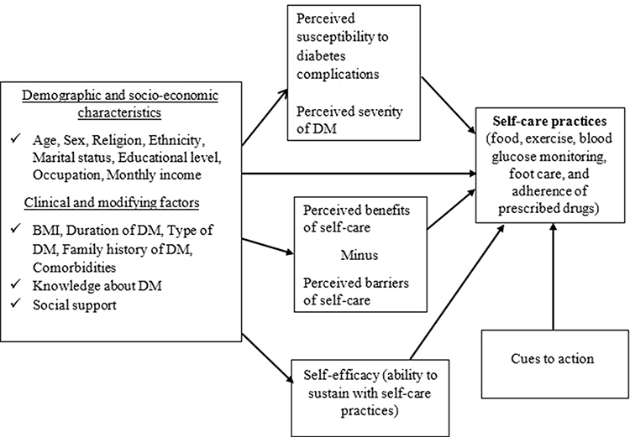

**Figure 2: Health Belief Model for assessing self-practice among diabetic patients**

(Source: Inspired by Melkamu *et al.* 2021)

Patients having diabetes face higher risks related to death and disability upon the development of chronic diabetic complications (CDC). These complications mainly include diabetic retinopathy, diabetic nephropathy, and cardiovascular diseases. In this regard, Jiang *et al.* (2021) stated that annual or biennial screening is useful and is globally recommended as a cost-effective way for reducing mortality and morbidity due to diabetes. However, the research has identified a low compliance rate of CDC screening among clinicians. In response, the research has used the health belief model to determine the key factors to be considered for developing effective intervention measures for diabetic patients through proper CDC screening compliance. As per the findings generated, knowledge has been determined to place an indirect influence on a patient's CDC screening behaviour. Accordingly, this behaviour is specifically justified through perceived susceptibility, perceived barriers, perceived benefits, and self-efficiency.

Self-care management has been determined to be routine-based lifetime behaviour for diabetic patients that play a significant role in successfully controlling various forms of diabetes complications while preventing cost overruns. In this regard, different health-related behaviours, being part of self-care management, are determined through health and illness beliefs, with such being dependent on an individual’s knowledge regarding the illness. By applying the health belief model to identify the health behaviour of diabetic patients, Khosravizadeh *et al.* (2021) found that “perceived benefits” form the strongest dimension while “perceived sensitivity” forms the weakest dimension. In response, the study has recommended policy makers in the field of hygiene and non-communicable disease control to focus on improving patients’ awareness of the respective disease being contracted, including diabetes. Additionally, the dimension based on “perceived sensitivity” is stated to require greater emphasis, facilitated via conducting training classes and using the appropriate technological infrastructure.

Various other studies have determined the importance of the health belief model and its usefulness in preventing diabetes among people via providing appropriate training and increasing awareness regarding the disease. The study by Afrasiabi *et al.* (2022) states that the willingness of people to participate in disease prevention, early diagnosis and treatment of a particular disease is largely dependent on the individual’s understanding of the risk posed by the disease. Accordingly, this research considered the health belief model as the most comprehensive framework that can be used in preventing type-2 diabetes among a selected population group. The findings suggest that the factors including perceived barriers, perceived self-efficacy and knowledge are the primary predictors of diabetes prevention behaviours among respective patients. Another study by Hu *et al.* (2022) used the health belief model to determine the key predictors of self-care behaviour among patients suffering from type 2 diabetes. The findings generated suggest that the factors based on perceived severity, barriers and benefits are the key factors that affect self-care behaviours among type 2 diabetic patients. In response, proper health education for patients has been recommended.

## Conclusion

This study summarises the key benefits provided by the health belief model in determining the behaviour among patients to follow recommended health actions for identified diseases. Additionally, various drawbacks of applying this model in determining patient behaviour have also been discussed. Following this, the health model has been applied to diabetic patients while referring to relevant literature sources. Findings among respective literature have commonly stated that factors based on perceived susceptibility, perceived barriers and benefits, and knowledge influence the behaviour of diabetic patients to take up preventive health actions. Furthermore, factors including self-efficacy and perceived sensitivity have also been determined to be key determinants of patient behaviour among certain specific literature.

# References

Afrasiabi, F., Aeen, F.B. and Jahromi, M.K., (2022). Applying the health belief model in identifying individual understanding towards prevention of type 2 diabetes. *International Journal of Public Health*, *11*(4), pp.1267-1272.

Daragmeh, A., Sági, J. and Zéman, Z., (2021). Continuous intention to use e-wallet in the context of the covid-19 pandemic: Integrating the health belief model (hbm) and technology continuous theory (tct). *Journal of Open Innovation: Technology, Market, and Complexity*, *7*(2), p.132.

Fall, E., Izaute, M. and Chakroun-Baggioni, N., (2018). How can the health belief model and self-determination theory predict both influenza vaccination and vaccination intention? A longitudinal study among university students. *Psychology & health*, *33*(6), pp.746-764.

Green, E.C., Murphy, E.M. and Gryboski, K., (2020). The health belief model. *The Wiley encyclopedia of health psychology*, pp.211-214.

Hu, Y., Liu, H., Wu, J. and Fang, G., (2022). Factors influencing self-care behaviours of patients with type 2 diabetes in China based on the health belief model: a cross-sectional study. *BMJ open*, *12*(8), p.e044369.

Jeihooni, A.K. and Rakhshani, T., (2019). The effect of educational intervention based on health belief model and social support on promoting skin cancer preventive behaviors in a sample of Iranian farmers. *Journal of Cancer Education*, *34*, pp.392-401.

Jiang, L., Liu, S., Li, H., Xie, L. and Jiang, Y., (2021). The role of health beliefs in affecting patients’ chronic diabetic complication screening: a path analysis based on the health belief model. *Journal of Clinical Nursing*, *30*(19-20), pp.2948-2959.

Karimy, M., Bastami, F., Sharifat, R., Heydarabadi, A.B., Hatamzadeh, N., Pakpour, A.H., Cheraghian, B., Zamani-Alavijeh, F., Jasemzadeh, M. and Araban, M., (2021). Factors related to preventive COVID-19 behaviors using health belief model among general population: a cross-sectional study in Iran. *BMC Public Health*, *21*, pp.1-8.

Khosravizadeh, O., Ahadinezhad, B., Maleki, A., Vosoughi, P. and Najafpour, Z., (2021). Applying the health belief model and behavior of diabetic patients: A systematic review and meta-analysis. *Clinical Diabetology*, *10*(2), pp.209-220.

Melkamu, L., Berhe, R. and Handebo, S., (2021). Does patients’ perception affect self-care practices? The perspective of health belief model. *Diabetes, Metabolic Syndrome and Obesity: Targets and Therapy*, pp.2145-2154.

Mercadante, A.R. and Law, A.V., (2021). Will they, or Won't they? Examining patients' vaccine intention for flu and COVID-19 using the Health Belief Model. *Research in Social and Administrative Pharmacy*, *17*(9), pp.1596-1605.

Pourhaji, F., Delshad, M.H., Tavafian, S.S., Hidarnia, A. and Niknami, S., (2020). Factors predicting the oral health behaviors of the Iranian students in the District 1 Tehran, Iran. *Brazilian Journal of Oral Sciences*, *19*, pp.e206579-e206579.

Standl, E., Khunti, K., Hansen, T.B. and Schnell, O., (2019). The global epidemics of diabetes in the 21st century: Current situation and perspectives. *European journal of preventive cardiology*, *26*(2_suppl), pp.7-14.

Sulat, J.S., Prabandari, Y.S., Sanusi, R., Hapsari, E.D. and Santoso, B., (2018). The validity of health belief model variables in predicting behavioral change: A scoping review. *Health Education*, *118*(6), pp.499-512.

Walrave, M., Waeterloos, C. and Ponnet, K., (2020). Adoption of a contact tracing app for containing COVID-19: A health belief model approach. *JMIR public health and surveillance*, *6*(3), p.e20572.

# Question 2: Implementation of a nutrition intervention program

## Introduction

Planning nutrition intervention has involved prioritising the diagnosis of nutrition, consultation with ADA’s nutrition practice, and determining the patient-focused outcomes for every nutrition diagnosis. In the opinion of Riley *et al.* (2020), the program of nutrition intervention for undernourished children as well as to develop nutritional status and monitor it. Scaling up Nutrition is a unique movement founded on the principle that every person has the right to good nutrition and food. The approach of the logical framework for SUN is analytical and systematic planning processes used for project planning and associate evaluation and monitoring systems. As cited by Tumilowicz *et al.* (2019), the logical framework and its approach is a proper analytical process as well as it is set to be used for supporting the project management and planning of SUN. It is the power to communicate necessary elements for NGOs succinctly and clearly throughout the entire project cycle. As per the view of Bentley *et al.* (2020), the nutrition intervention selection has been driven by nutrition diagnosis. The strategy of nutrition intervention is selected for changing the nutritional intake or behaviour to support service and care.

## Logical Framework Approach

|  |  |  |  |  |
| --- | --- | --- | --- | --- |
| **Project Description** | **Intervention logic** | **Objectively variables indicators of achievements** | **Sources and means of verification** | **Assumptions** |
| **Goal** | To help with clarifying the objectives as well as to translate them towards the expected effect hierarchy to evaluate. A Public health Nutrition officer was hired to implement the intervention program to mitigate the malnutrition prevalence among the children (Li *et al.* 2020). | The indicators such as wasting, stunting, underweight and overweight are being used for measuring the nutritional imbalance. and Anthropometric measurements for assessing the development and growth, especially in children, are widely used for these nutritional indicators. | The rural community in India are the major source of these indicators. All the foods are in nutrient-rich that includes vegetables and fruits. | Competition, customers, technology, economy, social conditions as well as the resources are some common external factors to influence on the SUN (Mkambula *et al.* 2020). |
| **Purpose** | Improving growth is a mindset that can be used in the SUN organisation to develop its objective in the nutrition among children. | Food availability, sufficient food access, food supply stability, and cultural acceptability are some major indicators needed for the NGOs for their food security (Sarma *et al.* 2021). | Common nutrition information sources have been identified such as family members, the internet, television, books, and friends. | The beneficiary's obligation to the Bpifrance has an outcome with the repayable beneficiaries' agreements. It is responsible for allocating the funding to finance and protect related expenditures. |
| **Outputs** | Reduce around 20% of the child malnutrition in just two years.  Around 149 million children were estimated to be frozen.  The initiation of exclusive breastfeeding and early breastfeeding improved. | Percentage of children who eat three times in a day with the animal sources at least once (Ruel-Bergeron *et al.* 2019).  Percentage of the children to initiate breastfeeding within the first hour. | The MSNP baseline and the MNH register | The availability of all foods is in deficit areas. |
| **Activities** | Children's nutrition has several basic functions such as it provides energy, and contributes to the overall body structure, and the chemical processes. | **Means:** Implementation is the execution of a plan, method, or idea for doing something for the children. The implementation of the issues regarding SUN organisation is an action that should follow preliminary thinking. | Action information of SUN is caused by operation and activity regarding the working process, while information is communicated just when status has been applied without any kind of operations (Tumilowicz *et al.* 2019).  **Costs:** The total budget is around $20,000 and it is targeted to mitigate child malnutrition prevalence. | The action precondition of SUN has been made before the action execution and the action effect in children nutrition has been achieved after the action execution. |

**Table 1: Logical Framework Approach**

(Source: Self-developed)

Every indicator should have been associated with the verification means for indicating what and where information on objective achievement can be found. In the opinion of Riley *et al.* (2020), SUN is committed to understanding good nutrition which is the perfect investment in the near future. The political leaders of this organisation agree to engage all local and central sectors of the government's effort to develop nutrition. As per the view of Mkambula *et al.* (2020), the intervention of nutrition by SUN has set the intended actions for changing all kinds of nutritional aspects individually. This could range from the “nutrient administration” to the implementation of a nutrition program.

## Conclusion

From the above discussion, it can be concluded that logical framework for SUN is analytical and systematic planning processes used for project planning and associate evaluation and monitoring systems. The indicators of objective variables show the significant characteristics of performance and objectives that are expected for being reached as quality, quantity, location, and time frame. he main function of SUN is to mobilise the resources and as well support nutrition implementation for being in line with the strategic plans and nutrition policy.

# References

Bentley, M.R., Mitchell, N. and Backhouse, S.H., (2020). Sports nutrition interventions: A systematic review of behavioural strategies used to promote dietary behaviour change in athletes. *Appetite*, *150*, p.104645.

Li, L., Sun, N., Zhang, L., Xu, G., Liu, J., Hu, J., Zhang, Z., Lou, J., Deng, H., Shen, Z. and Han, L., (2020). Fast food consumption among young adolescents aged 12–15 years in 54 low-and middle-income countries. *Global health action*, *13*(1), p.1795438.

Mkambula, P., Mbuya, M.N., Rowe, L.A., Sablah, M., Friesen, V.M., Chadha, M., Osei, A.K., Ringholz, C., Vasta, F.C. and Gorstein, J., (2020). The unfinished agenda for food fortification in low-and middle-income countries: quantifying progress, gaps and potential opportunities. *Nutrients*, *12*(2), p.354.

Riley, K., Sulo, S., Dabbous, F., Partridge, J., Kozmic, S., Landow, W., VanDerBosch, G., Falson, M.K. and Sriram, K., (2020). Reducing hospitalizations and costs: a home health nutrition‐focused quality improvement program. *Journal of Parenteral and enteral Nutrition*, *44*(1), pp.58-68.

Ruel-Bergeron, J.C., Hurley, K.M., Kang, Y., Aburto, N., Farhikhtah, A., Dinucci, A., Molinas, L., Fune, W.L.S., Mitra, M., Phuka, J. and Klemm, R., (2019). Monitoring and evaluation design of Malawi’s Right Foods at the Right Time nutrition program. *Evaluation and program planning*, *73*, pp.1-9.

Sarma, H., D’Este, C., Ahmed, T., Bossert, T.J. and Banwell, C., (2021). Developing a conceptual framework for implementation science to evaluate a nutrition intervention scaled-up in a real-world setting. *Public health nutrition*, *24*(S1), pp.s7-s22.

Tumilowicz, A., Ruel, M.T., Pelto, G., Pelletier, D., Monterrosa, E.C., Lapping, K., Kraemer, K., De Regil, L.M., Bergeron, G., Arabi, M. and Neufeld, L., (2019). Implementation science in nutrition: concepts and frameworks for an emerging field of science and practice. *Current developments in nutrition*, *3*(3), p.nzy080.

# 

# Question 3a: Usage of technology to diagnose and monitor cardiovascular conditions

## Introduction

Electrocardiogram is the most common process to monitor cardiovascular disease. The “HeartFlow '' is a new technology, which makes the entire process to be tested for all kinds of heart issues easier for patients (Khan and Algarni, 2020). At present time, several technologies are used for diagnosing as well as monitoring cardiovascular conditions. Cardiovascular is the main cause of early death for most men. As per the view of Tan *et al.* (2021), Cardiac technology has been used for diagnosing such effects of congenital heart and heart attack disease. All the technologists of cardiovascular perform ultrasound tests on the heart and they are called echocardiographers or “cardiac sonographers”.

## Usage technologies to monitor and diagnose cardiovascular conditions

Cardiovascular disease remains a global health concern with a large burden economically. Around 33% of deaths are attributed to cardiovascular disease (Wongvibulsin *et al.* 2019). During the angiogram of diagnosis, the x-ray has dye flows by catheter on the arteries. Cardiac technology has been used for diagnosing situations like the heart attack effect, as well as the disease of the congenital heart.

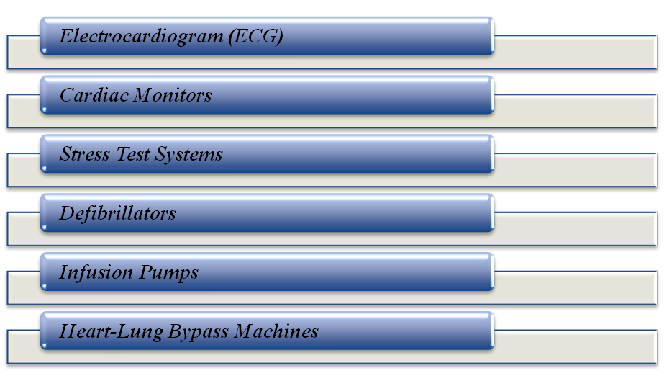

**Figure 3: Usage technologies for diagnosing and monitoring cardiovascular conditions**

(Source: Influenced by Avila, 2019)

***Electrocardiogram (ECG)***

The ECG is generally used with some of the other tests to assist monitor and diagnose conditions that affect the heart. This could be used for investigating the possible symptoms of heart issues such as palpitations, chest pain, shortness, and dizziness of breath. There are multiple ways that an ECG could be carried out. The tests involved attaching some small sensors that have electrodes to the arm, chest, and legs. In the opinion of Avila, (2019), the signal-averaged ECG is the largest research technique but it is used occasionally for assessing the cardiac death risk. This is a painless and very common test that is used to rapidly detect heart issues and also monitor the entire heart rate. The use of the ECG could be expanded from heart rate which is a crucial rhythm for monitoring and interpreting complex arrhythmias.

***Cardiac Monitors***

The cardiac event monitor is a specific device that is used to control or record the electrical activity of the heart. The technology of this device is based on the pager size and this has recorded the rhythm and heart rate. This device is well used at the time it requires some long-term symptoms monitoring that are occurring on a daily basis. According to Bernstein *et al.* (2021), cardiac monitoring is continuous monitoring in the emergency setting of every patient’s “cardiac activity”. It identifies the proper condition, which may be needed for emergency intervention. Cardiac monitoring has been observed by the heart-by-heart monitor and it helps to discover the “cardiac arrhythmias” that might present to assist in determining the proper heart health. Cardiac output is blood ejected volume by every ventricle, and it is a product of heart rate and stroke volume.

***Stress Test Systems***

The stress test shows how the heart works during physical activity. This is also called a “stress exercise test”. However, exercise has made a heart pump as hard as well as faster and this test could show the issues regarding the blood flow in the heart. In the opinion of Brawner *et al.* (2021), stress tests are used for diagnosing ``coronary artery disease” and irregular heart rhythm to help doctors make plans for the treatment process. As per the view of Abrahamovych *et al.* (2020), this test is commonly used for finding the actual cause of all the symptoms, which may be heart problems. The test as well could help diagnose heart conditions such as CAD (coronary artery disease) Angina. During the cardiac test, it would be to walk on a treadmill or on a cycle on an exercise bike until reaching the “target heart rate” which is nearly 85% heart rate predicted with age (Health, 2023). Most doctors recommend a fasting period for this stress test. Generally, it is safe and easier to do the stress test without a full belly.

***Defibrillators***

This device sends off an electric pulse as well as a shock to the heart for restoring a normal heartbeat. Doctors use this device to prevent arrhythmia which is an uneven heartbeat that could be fast or slow. According to Kovacs *et al.* (2019), Defibrillation is the use of electric current for assisting the heart's return to a normal rhythm. AEDs are being used for receiving someone from cardiac arrest. It generally occurs at the time any kind of heart disruption causes a fast heartbeat. An external Defibrillation device is computerised, and it is used for restarting the heart, which stops the beating or may beat as quickly. This device or technology worked by shocking the heart back in the actual action. In the opinion of Mehdi *et al.* (2019), Defibrillation could save a life if any patient is in cardiac arrest. This particular device has an electrical charge, which stops the abnormal rhythm of the heart so the heart could get its normal rhythm.

***Infusion Pumps***

The infusion pump is a kind of device that is used in administering medication or in the treatment medication for high blood pressure. Generally, there are three major pumps as a displacement pump positive, the peristalsis pump, and the peristaltic linear pump (Bacon and Hoffman, 2020). However, the medication has been used for heart failure treatment in the short term. It also has the world by establishing a strong heartbeat by relaxing certain vessels of blood. There are several infusions for patients with blood pressure. However, nitroprusside, nicardipine, fenoldopam, phentolamine, enalaprilat, hydralazine, labetalol, nitroglycerin, and esmolol are some major infusions used for blood pressure patients (Taylor and Jones, 2019). Digoxin has helped to enhance the pumping strength of the heart and also it slows down the heart rate. In the opinion of van der Sluijs*et al.* (2019), “Gravity infusion devices” is a very common IV system that is used for patients most of the time. This particular system uses gravity for delivering the medication and makes it low-cost and simple.

***Heart-Lung Bypass Machines***

This machine is a kind of “cardiopulmonary bypass” or “heart-lung” machine. It takes over the jobs of the lungs and heart in a patient. As per the view of Bender *et al.* (2022), the job of this machine is to add oxygen to the blood and remove the CO2 from the blood and therefore pumping to refresh the blood in the body. In the opinion of Rance *et al.* (2019), mostly this machine is used in serious procedures, which need the heart for being stopped. This machine might be used in a person who actually requires respiratory or heart support for the reason of non-surgical. According to Freitas Leal *et al.* (2020), “Heart-Lung Bypass Machines” allow the doctor to stop the heart while maintaining blood circulation. This has consisted of a pump that specifically functions as a heart that replaces the lungs. A Cardiovascular perfusionist has operated this machine and they are also responsible for any kind of issues with this machine. There are some risks also from using this machine such as bleeding after the surgery, blood clots, surgical injury in phrenic nerve, and reduced heart and lung function.

## Conclusion

From the above question, it can be concluded that ECG has reflected what is actually happening in various areas of the heart and it as well helps to recognize and identify any kind of issues with heart rate rhythm. ECG has reflected what is actually happening in various areas of the heart and it as well helps to recognize and identify any kind of issues with heart rate rhythm. Digoxin has helped to enhance the pumping strength of the heart and also it slows down the heart rate.

# References

Abrahamovych, M., Abrahamovych, O., Fayura, O., Fayura, L. and Tolopko, S., (2020). The effect of oxidative stress on the AUTONOMIC nervous system in patients with liver cirrhosis. *Georgian Med News*, *298*, pp.94-99.

Avila, C.O., (2019). Novel use of Apple Watch 4 to obtain 3-lead electrocardiogram and detect cardiac ischemia. *The Permanente Journal*, *23*.

Bacon, O. and Hoffman, L., (2020). System-level patient safety practices that AIM to reduce medication errors associated with infusion pumps: an evidence review. *Journal of Patient Safety*, *16*(3 1 Suppl), p.S42.

Bender, M., Längin, M., Reichart, B., Mokelke, M., Radan, J., Neumann, E., Michel, S., Ellgass, R., Cowan, P.J., Wolf, E. and Abicht, J.M., (2022). Overcoming perioperative inflammation as a hurdle for successful preclinical orthotopic cardiac xenogeneic transplantations–particular in regard of the mandatory use of heart‐lung machines. *Xenotransplantation*, *29*(3), p.e12749.

Bernstein, R.A., Kamel, H., Granger, C.B., Piccini, J.P., Sethi, P.P., Katz, J.M., Vives, C.A., Ziegler, P.D., Franco, N.C., Schwamm, L.H. and Acosta, I., (2021). Effect of long-term continuous cardiac monitoring vs usual care on detection of atrial fibrillation in patients with stroke attributed to large-or small-vessel disease: the STROKE-AF randomized clinical trial. *Jama*, *325*(21), pp.2169-2177.

Brawner, C.A., Ehrman, J.K., Bole, S., Kerrigan, D.J., Parikh, S.S., Lewis, B.K., Gindi, R.M., Keteyian, C., Abdul-Nour, K. and Keteyian, S.J., (2021), January. Inverse relationship of maximal exercise capacity to hospitalization secondary to coronavirus disease 2019. In *Mayo Clinic Proceedings* (Vol. 96, No. 1, pp. 32-39). Elsevier.

Freitas Leal, J., Vermeer, H., Lazari, D., van Garsse, L., Brock, R., Adjobo‐Hermans, M. and Bosman, G., (2020). The impact of circulation in a heart–lung machine on function and survival characteristics of red blood cells. *Artificial Organs*, *44*(8), pp.892-899.

Health, S.V.H. (2023). *St Vincent’s Heart Health*. [online] www.svhhearthealth.com.au. Available at: https://www.svhhearthealth.com.au/procedures/tests/exercise-stress-test#:~:text=During%20your%20cardiac%20exercise%20stress [Accessed 20 Apr. 2023].

Khan, M.A. and Algarni, F., (2020). A healthcare monitoring system for the diagnosis of heart disease in the IoMT cloud environment using MSSO-ANFIS. *IEEE Access*, *8*, pp.122259-122269.

Kovacs, B., Reek, S., Krasniqi, N., Eriksson, U. and Duru, F., (2019). Extended use of the wearable cardioverter-defibrillator: which patients are most likely to benefit?.*Cardiology Research and Practice*, *2018*.

Mehdi, B., Kaveh, H. and Ali, V.F., (2019). Implantable cardioverter-defibrillators in patients with ESRD: complications, management, and literature review. *Current Cardiology Reviews*, *15*(3), pp.161-166.

Rance, G., Arney, D., Srey, R., Goldman, J.M. and Zenati, M.A., (2019). Establishing a Ventilator–Heart Lung Machine Communication Bridge to Mitigate Errors when Weaning from Bypass. *The Journal of Extra-corporeal Technology*, *51*(1), p.38.

Tan, L., Yu, K., Bashir, A.K., Cheng, X., Ming, F., Zhao, L. and Zhou, X., (2021). Toward real-time and efficient cardiovascular monitoring for COVID-19 patients by 5G-enabled wearable medical devices: A deep learning approach. *Neural Computing and Applications*, pp.1-14.

Taylor, M.A. and Jones, R., (2019). Risk of medication errors with infusion pumps: a study of 1,004 events from 132 hospitals across pennsylvania. *Patient Safety*, *1*(2), pp.60-69.

van der Sluijs, A.F., van Slobbe-Bijlsma, E.R., Goossens, A., Vlaar, A.P. and Dongelmans, D.A., (2019). Reducing errors in the administration of medication with infusion pumps in the intensive care department: A lean approach. *SAGE Open Medicine*, *7*, p.2050312118822629.

Wongvibulsin, S., Martin, S.S., Steinhubl, S.R. and Muse, E.D., (2019). Connected health technology for cardiovascular disease prevention and management. *Current treatment options in cardiovascular medicine*, *21*, pp.1-15.