**MANAGING ACROSS CULTURES**

**Executive Summary**

This report discusses cross-cultural management in the organisations and the impacts of the cultural diversity in the businesses. The report also consists of comparison of international management and cross-cultural management. Moreover, the report explores theories regarding the cultural management in organisations and implies the theories based on effectiveness. The identified issues of global organisations in cooperation with cross cultural team members and its significant impact in decision making has been described. Furthermore, the issue affecting the organisational relationship amongst cross cultural team members are also explained.

**Table of Contents**

Introduction 3

Is international management the same as cross cultural management? Prepare a report discussing this question in the relevance of culture to issues of organisational behaviour and management 3

Cross-Cultural Management 4

Implementation of Effective Cross-Cultural Management 5

Trompenaars & Hampden-Turner's Seven Dimensions of Culture Theory 7

International Management 7

Max Weber’s Bureaucratic Theory 9

In a globalised world, organisations have to adapt, organise a report that identifies the key issues faced in understanding cultural difference, 10

Effects on Leadership and Motivation 11

Effects on Communications and Negotiating 12

Hofstede cultural model 13

Identified issues affecting decision making and organisational relationships of cross-cultural teams 14

Conclusion 16

Reference 17

# Introduction

Cross Cultural management is a management style which includes the study of the impacts of the societal culture on the managers and organisational management styles. The purpose of this report is to analyse the cultural orientations of individual organisations and explore the impacts of it on various businesses.

**Part 1**

# Similarities between cross cultural management and international management along relevance of culture to issues of organisational behaviour and management

Cross cultural management and international management are separate concepts however; both methods are useful in managing the diversity of a workplace. These management methods can be interchangeable in certain circumstances in order to increase communication in a diverse workplace. Cross cultural management primarily focuses on mitigating through the differences in cultures; this process also helps in increasing efficiency and enforcing teamwork in a workplace. On the other hand, international management is used to conduct the businesses of an organisation in more than one country. As per the view of Abdyrakhmanova and Poór (2022), international management helps in providing guidance in the complexities of international markets, logistical issues, international customs and laws. This method prioritises the circumstantial changes which influence the internal and external businesses of an organisation. Moreover, cross cultural management can be a part of a successful international management as internationally shifting the functions of an organisation requires communication with the individuals of the country.

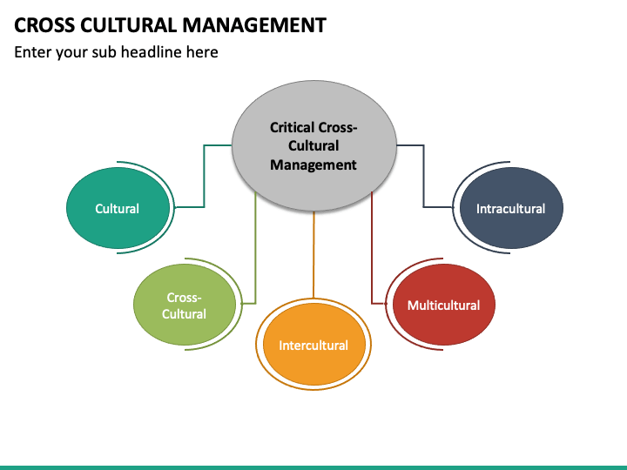

**Figure 1: Critical Cross-Cultural Management**

(Source: Siram et al., 2023)

## Cross-Cultural Management

The cross cultural management helps in the maximisation and development of skills for the employees as individuals from different backgrounds work together in a diverse workplace environment. As stated by Siram et al., (2023), effective implementation of cross cultural management creates a positive brand reputation as well motivating more individuals to join the workforce. A multicultural set of employees need to be trained in order to function as a team from which the organisation benefits the most. Effective cross-cultural management helps the organisations to recruit ideal employees from different cultural backgrounds. Extensive organisational behaviour and culture majorly depends on properly planned and executed cross cultural management. A work environment which lacks cross-cultural management will inevitably face a decline in employee retention. As commented by Lilia (2022), cross cultural management reduces safety issues in an organisation and employees tend to feel respected regarding personal diversity. This management style ensures that the workplace is inclusive which in terms helps improve the innovation and creativity of the employees as it allows employees to express individual opinion.

Moreover, this method helps in increasing employee engagement and also resolves the issues of management. As employees feel more connected to each other the teamwork increases resulting in motivation and positive collaboration. On the other hand, successful cross-cultural management causes the organisation to reach a wider range of customers as a diverse range of employees help in approaching customers from different countries. As commented by Zarei et al., (2022), the cultural issues of management include issues regarding religion, ethnicity, education, organisational behaviour and sexual orientation or gender identity of an individual. However, it is a critical process which has to be implemented in a strategic manner as there are various challenges in the implementation method. Tools such as training, language classes, gathering knowledge and a clarity of strict goals help in the process.

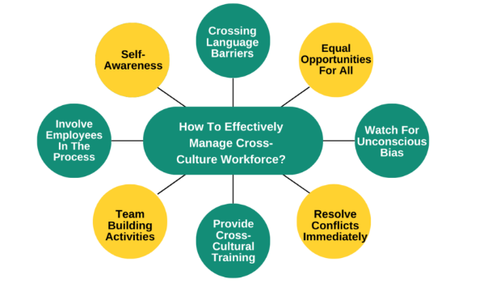

**Figure 2: Implementation of Cross-Cultural Management**

(Source: Lilia, 2022)

## Implementation of Effective Cross-Cultural Management

The first step of implementing cross-cultural management is to increase awareness in the employees in order to identify the issues which the organisation is facing in regards to the diverse work environment. Self awareness is essential as it ensures that the managers are aware that cultural factors are becoming issues in the extensive functional teamwork of the organisation. An individual aware of the cultural biases and discrimination will put in efforts in order to implement active change in the situation. As commented by Hu et al., (2023), cross-cultural differences become visible from the personal backgrounds of each individual. The language, accent, behaviour of an individual is influenced by the place, race, origin, religion and climate related differences. The second step in the implementation of an effective cross-cultural management is crossing the communication related barriers such as language barriers. As language or accent of an individual can greatly affect the communication factors and affect the teamwork it has to be mitigated. This issue can be mitigated through the implementation of language training and seminars in a workplace.

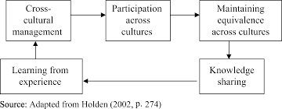

**Figure 3: Cycle of Cross-Cultural Management**

(Source: Matthews, 2023)

In this case an example of The Walt Disney Company Limited can be given as the company has managed to enforce cross-cultural management successfully. Disney maintains a diverse workforce which includes 57% White, 20% Hispanic or Latino and 12% African American employees (impact.disney.com, 2023). It can be determined from the diverse workforce of Disney that working with a diverse workforce also requires the management to offer equal rights and opportunities for all the employees. The company has to be considerate towards the employees and enforce the same regulations for the workers without partial judgement. Therefore, equality is the third step in the successful implementation of cross-cultural management in an organisation. As stated by Matthews (2023), favouritism in the workplace can happen unintentionally, thus, it is the management's responsibility to ensure that the judgement of employees are strictly performance based. On the other hand, it is necessary to resolve the cultural issues regarding miscommunication immediately to avoid further misunderstanding in the future. The most effective way to implement cross-cultural management is to reprimand the offender in order to resolve the issue and ensure that future instances are avoided. One of the major steps which are often neglected by the organisations is providing cross-cultural training in a diverse workplace. This is a preventive step which needs to be implemented before the issues arrive and miscommunication interferes with the workflow of the organisation.

Organisations can also effectively use this management through team building indoors and outdoors activities such as field trips and picnics for the workers to get along with each other. Moreover, the inclusivity in the workplace has to be increased in order to properly function in a diverse work environment. Capegemini is a UK based information technology consulting company which prioritises gender equality in the workplace as the company has 40% women in departmental teams and 30% women executives (capgemini.com, 2023). These changes in an organisation enforce equality and reduce the negative competition between individuals enhancing the performance of the organisation. However, there are theories which can be followed in order to implement cross-cultural management in an organisation, such as Trompenaars & Hamden-Turner's Seven Dimensions of Culture.

## Trompenaars & Hampden-Turner's Seven Dimensions of Culture Theory

Trompenaars and Hampden-Turner have stated that cultural dimension actively consists of seven different dimensions. The first dimension is the universalism versus particularism which relates to the extent to which the formal rules and methods are influential on relationships and circumstances. As stated by Fox and Bourgeois (2022), the seven dimensions of Trompenaars and Hampden-Turner’s theory are useful for organisations in order to understand the complexities of cultural differences. Universalistic cultures maintain formal rules whereas the particularistic culture functions based on the requirements of the circumstances. As stated by Riggle (2022), the individualism of this theory discusses the cultures which are primarily focused on self improvement of an individual. On the other hand, collectivistic cultures function based on the collective improvements of the society.

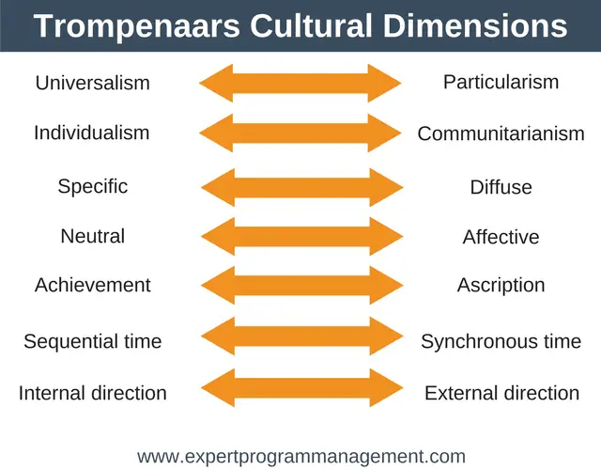

**Figure 4: Trompenaars & Hampden-Turner's Seven Dimensions of Culture**

(Source: Fox and Bourgeois, 2022)

The achievement versus ascription dimension of this theory states that the tolerance of a particular culture and the distribution of power are interconnected. The status among the individuals is similar to the Hofstede theory of power dimension in an organisation. On the other hand, the specific versus diffuse dimension of this theory provides understanding of the extent to which the personal and professional lives of the employees are interconnected. This theory provides necessary insight for cross-cultural management in an organisation.

## International Management

International management is appropriate for the organisations which are expanding the business globally and launching in a different country. This management process focuses on methods which help in the creation of a hierarchical order in the internal functions of a company. This hierarchical order is created involving the operating individuals of separate countries so as to adhere to the local laws, regulations and cultural or traditional differences. As stated by Lew et al., (2023), international management can be divided into three approaches such as ethnocentric, polycentric and geocentric. The management issues which can be mitigated through this management style include, foreign legal requirements, international finance and currency related matters, cross cultural communications and global strategy. Moreover, this management method is useful for the various categories of international businesses such as import or export businesses, independent agents, and expansion of multinational corporations. As per the view of Belderbos et al., (2022), international management strategy can be used as a globalisation strategy as it covers more areas of circumstances of an organisation. As cross-cultural management only focuses on the internal communicative issues of an organisation, it lacks the ability to manage the business in overseas or global expansion.

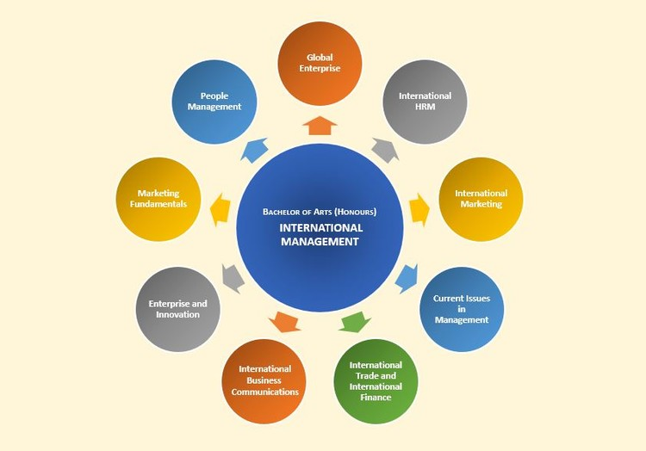

**Figure 5: International Management**

(Source: Belderbos et al., 2022)

The effectiveness of international management methods can be witnessed in the UK based retail company Walmart. The company has expanded through distribution facilities in Canada, Chile, China, Mexico, Central America and South Africa. The organisation has expanded to over 179 facilities in the year 2022 with the implementation of international management (walmart.com, 2023). One of the major benefits of implementing the international management style in an organisation is that the complicated process can be significantly simplified. The complexities of shifting a business through the international borders and commencing successful functions are the positive sides of this management style. However, there are theories of international management which can help in understanding and implementing the process such as Max Weber bureaucratic theory.

## Max Weber’s Bureaucratic Theory

This theory includes two vital elements of understanding organisations by structuring the system into a hierarchy of clearly defined roles which helps to administer an organisation and its members. The principles of hierarchy and discipline are discussed in this theory as bureaucratic organisations follow the instructions of the authorities. According to this theory bureaucracy is an institution which helps an organisation to function in a highly formalised and impersonal manner. As commented by Langer (2022), the bureaucracy structure helps in the development of clear goals, rules and regulations which helps the authority to regulate the organisation. The bureaucracy theory of Max Weber helps in specialisation of labour, impersonality of application of the rules, well defined hierarchical order within an organisation and a formal set of rules and regulations.

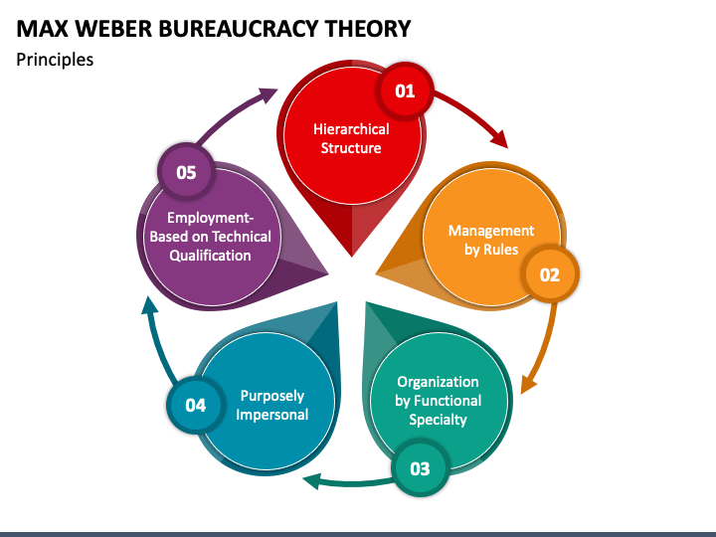

**Figure 6: Max Weber’s Bureaucratic Theory**

(Source: Langer, 2022)

This theory can be implemented in the international management of an organisation in order to maintain the traditional structure of the company while expanding internationally. In the traditional bureaucratic organisation the subordinates are expected to follow through the detailed rules which help in maintaining order in the internal functions of the business. However, this theory has faults as well, as it does not allow the employees to express the needs of the employers making the organisation non-inclusive. As commented by Raghimi et al., (2022), features of a bureaucratic organisation are that the internal rules and regulations are maintained by the authorities of the organisation which makes it easier for these organisations to conduct businesses internationally. The organisations can be up-focused or in-focused; an up focused company prioritises the stockholders, boards and institution. On the other hand, in-focused organisations prioritise on the internal affairs of the company and goals of the company.

**Part 2**

**Key issues in understanding cultural difference**

There are barriers in the global organisations regarding the understanding of cultural differences. As the organisations have to continually adapt to the new changes and inclusive thinking process majority of the workers struggle to understand the need of this process. As per the view of Qodirova (2022), cultural differences require massive understanding so as to communicate and implement teamwork. The key issues faced by the organisations which affect the extensive management of the company are

Ethnocentrism affects the management of cross-cultural teams is a difficult and complex process as it requires particular styles of management. Accepting cultural differences can be challenging for individuals which has to be considered in the management process. Ethnocentrism happens as the individuals implicitly believe that the harboured perspective is the only right decision. As commented by Maclean (2022), ethnocentrism creates a conflict of interest which affects the work ethics and environment of an organisation. It is one of the key issues faced by an organisation, thus it is essential to resolve this issue in order to overcome the cultural barriers.

Stereotyping is one of the most common issues that come up in building an understanding of cultural differences. As commented by Wamoyi et al., (2022), majority of individuals accept the societal norms which are pre-existent and oversimplified; this poses a challenge for gaining an insight of the need to reduce cultural differences. Stereotypes can be witnessed in racial, cultural and gender related biases, these factors can cause conflict in an organisation.

Language is a huge barrier which causes the organisations to face difficulties regarding communication, resulting in misunderstanding and mistakes in the functions of the company. This issue can only be mitigated through preventive measures such as language training programs for the employees as required. As per the view of Ayton et al., (2022), as language is a major barrier for the communicative businesses it is necessary that the employees are trained to understand the native speakers. However, it is also essential to provide equal opportunities and career progression for the employees regardless of whether the employee is a native speaker.

## Effects on Leadership and Motivation

Cultural differences can majorly influence the leadership and motivation in an organisation as it causes discrimination between the employees. As per the view of Huertas-Valdivia et al., (2022), leadership is a process which helps an organisation function properly by guiding the workers towards a central goal. As leaders are the primary motivators of employees this also affects the employee motivation in an organisation. The cultural differences such as the eastern culture focus on mutual respect whereas western cultures prioritise more direct methods of communication. In the different cultures around the world body language also varies; certain body language or gestures might be offensive whereas in other cultures it is respectable. As per the view of Kurniasih et al., (2022), cross-cultural leadership is becoming an increasingly necessary method as the organisations are expanding businesses globally. Different cultures require cultural leaderships such as Asian Cultural leadership holds a collectivist perspective however, African cultural leadership believes in traditional demographics. The values of different cultures also affect the leadership and management of the organisations.

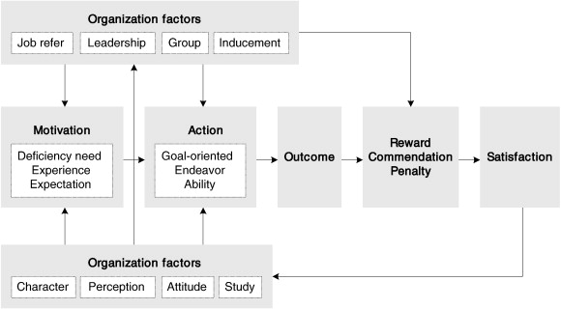

**Figure 7: Effects of Cultural Difference in an Organisation**

(Source: Kurniasih et al., 2022)

As western cultures prioritise the financial factors more than the personal factors similarly, the African culture focuses on the personal matters of the employees more. In cases where the leadership of the organisation holds cultural biases against the employees, the motivation of the employees decline massively. As commented by Saptura and Mahaputra (2022), discriminating employees based on the cultural, traditional and personal preferences costs the organisation decline in retention of employees. The structural framework of an organisation breaks due to the lack of understanding of cultural differences. The decision making of the employees also depends on the level of respect the individuals receive from the authorities of an organisation. As commented by Sutardi et al., (2022), one of the main objectives of a successful leadership is to motivate and guide the employees towards the organisational goals of the company. Moreover, the organisations have to negotiate with the employees in order to be understanding of the employees in favour of being uncooperative of cultural differences as well as the victims of discrimination. Similarly, it is essential that the organisations implement the process after carefully analysing the problems caused by cultural differences.

## Effects on Communications and Negotiating

Cross-cultural differences can affect the negotiation process of an organisation as the employees tend to feel uncertain about the discriminative behaviours received from co-workers. Understanding the power distribution of an organisation helps in the communication and negotiation of the employees. Executives and government officials are able to negotiate with the organisations as the workers agree on one central goal thus it is essential to overcome the cultural differences in order to function as an institution.

## Hofstede cultural model

The Hofstede model of cultural differences can be useful in the case of organisational communication and negotiation. This theory states that the cultural differences can be measured through six dimensions of the Hofstede Model of cultural differences. The dimensions are individualism-collectivism, short term-long term orientation, restraint-indulgence, power distance index, and masculinity-femininity and uncertainty avoidance index. As per the view of Beaulieu and Jimenez‐Gomez (2022), the effects of communication and negotiation can be evaluated with the use of the Hofstede model. The first dimension of the theory of individualism-collectivism states that certain cultures focus on the individual interests whereas other cultures prioritise the collective advancement of the organisation or the society. On the other hand, the short term and long term orientation proves the extent to which the company bases its goals on time sensitivity. Short term oriented organisations prioritise the short term improvement and goals whereas long term oriented organisations focus on the long term outcomes of the actions.

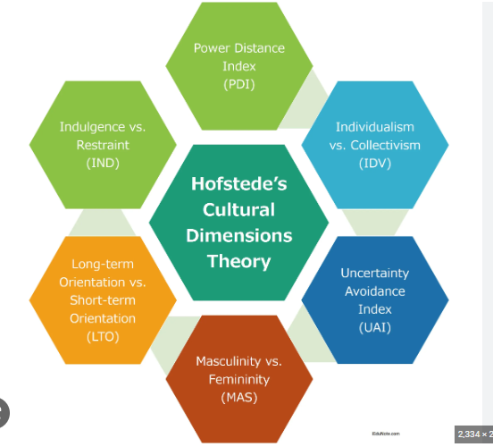

**Figure 1: Hofstede Model**

(Source: Lehe *et al.* 2022)

The power distance is also one of the main dimensions of the Hofstede model which determines the power distribution in an organisation. Cultures with strong power distance imply strict rules for the employees which the employees abide by. As commented by Lehe et al., (2022), the Hofstede model provides an insight on the effects of different cultural characteristics which affects an organisation. On the other hand, the uncertainty avoidance index of the Hofstede theory determines the uncertainty tolerance of a culture. Certain cultures accept uncertainty as a part of organisational structure whereas; certain organisations have low tolerance for uncertain future which affects the functions of the organisation.

An effective communication process is the primary focus of reducing the cultural difference in an organisation in order to increase the negotiation of the company. The term negotiation refers to a strategic discussion of resolving a misunderstanding in an organisation. The negotiation is the integral part of the parties of conflict resolving the issues for better teamwork. Negotiation can take place between two individuals of an organisation or more than one authoritative figure. However, the negotiation process has to be executed by maintaining inclusivity and allowing the participants to freely state the individual concerns. Preparing, exchanging information, bargaining and ultimately closing the deal are the steps in which a negotiation is conducted. As commented by Haines-Delmont (2022), preparing before a negotiation is essential as the offender has to be self aware in order to make amends and resolve the conflict. However, after the negotiation process is commenced successfully the involved parties have to clarify the root causes of issues regarding the cultural differences which caused the conflict. Reaching an agreement is possible for the individuals in an organisation which can help resume the regular functions and communication in a team putting the diverse skills of the workers for the betterment of the company.

## Identified issues affecting decision making and organisational relationships of cross-cultural teams

Management across cultures determines that organisations need to overcome several barriers of globalisation. In order to overcome the barriers, global organisations need to continually adapt to changes in the environment and exclusively operate through understanding the cultural differences. Furthermore, it can be determined that the identified issues of understanding cultural differences for global organisations has a major impact on decision making and on building organisational relationships with cross cultural teams. Based on the study of Sarwar et al., (2020), cross-cultural teams include individuals who belong from multiple cultures and different perspectives. Therefore, each culture majorly impacts the decision making of individuals. Hence, due to the variety of people in cross-cultural teams, it tends to majorly create complications in interests, which further has an incredible potential to damage organisation in relationships.

One of the major issues that affect decision-making of cross-cultural teams is the language barrier and stereotypical behaviour. According to the study of Wang et al., (2019), language barrier has the major potential of creating miscommunication and issues in cross-cultural teams which further affects organisations to get expected outcomes. Hence, in this case, it can be determined that difference in languages creates an issue to effectively communicate with team members and conveying perceptions and ideas to get expected outcomes. Moreover, stereotypical behaviour and mentality of individuals in a cross-cultural team majorly impacts the leadership and motivation of the other team members. As per the view of Joseph and Gaba (2020), motivation in leadership is the major component of an organisation which drives productivity and effective outcomes to perceive growth. Therefore, the barrier of stereotypical mentality in individuals majorly creates a bias which complicates the process of decision making.

Ethnocentrism also has an impact in decision making of cross-cultural teams due to the individual's superior personality. Furthermore, it creates an email that puts pressure on the cross cultural thing members to come into an equalised decision that can majorly help organisations to meet its goal. As opined by Mahmoud et al., (2021), cross cultural team members have different motivational levels and different perceptions, which drive their productivity and interest in accomplishing tasks. Therefore, with different perceptions and motivation levels it majorly affects the decision making of the team members to accomplish mutual goals. Additionally, it can also be identified that understanding the differences in cross cultural team members and distinguishing the major factors that affect decision making is important. For instance, major companies in the UK like Burberry, Morissons, Sainsbury and many more have undertaken diversification strategies to effectively manage talent acquisition and to get the benefit of accommodation of individuals from different cultures.

Organisations that have team members who belong from cross cultures can have a major impact in the decision making process and building an effective organisational behaviour. Based on the study of Peña-García et al., (2020), the majority of the individuals tend to build effective relationships and interconnection with individuals who belong from the same cultures. Thus, in this case, it can be determined that individuals from different cultures find it difficult to match their perspectives with their team members in order to build an effective relationship. According to the study of Nguyen et al., (2019), communication and interconnected relationships are the two major components which drive productivity and accelerate sustainability of the employees in the organisation. Therefore, with the major difference in cultures and beliefs it creates a deliberate complication between team members, which affects relationships amongst the co-workers.

Organisations need to effectively implement communication strategies and interconnected relationships in order to support progress of the team members. Based on the study of Gagné et al., (2019), employee engagement is an important part of organisations which determines success through individual improvement of skills. Therefore, in the case of a significant gap in communication can majorly impact the relationships of the cross-cultural team members. Thus, it can also affect decision making massively which further helps organisations to come up with mutual decisions. According to the study of Caputo et al., (2019), Cross cultural team members need to effectively appoint certain guidelines and organisations need to implement training for their team members to overcome conflicts. Proper monetization is necessary for organisations in order to mitigate conflicts of cross-cultural team members that can majorly affect the decision-making process. According to the theory of Hofstede it has also been identified that organisations need to have a long-term orientation and multi-generational view to make effective decisions for the present and the future of the organisation.

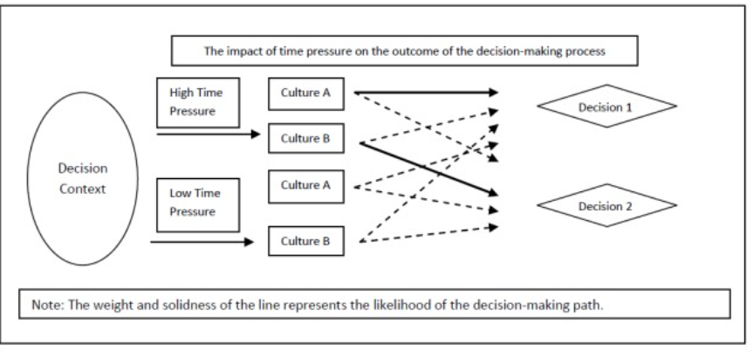

**Figure 3: Cross-cultural differences in decision-making**

(Source: Wang et al., 2019)

# Conclusion

The study concludes that cross-cultural management has similar detriments as international management and both implies effective and modern, cultural and replications that helps organisations to increase their efficiency in operating business in the complex environment. Moreover, the study also determines the issues of management and organisational behaviour, which creates further complications in leadership and motivation. It has also been identified that organisations with cross-cultural team members face significant issues due to language barriers in stereotypical mentality in communicating and negotiating along with the decision-making process.

# Reference

Abdyrakhmanova, K. and Poór, J., (2023). The role of emotional intelligence and cross-cultural adjustment on job performance of self-initiated expatriates with origins from Central Asian countries. Journal of Eastern European and Central Asian Research (JEECAR), 10(2), pp.326-338.

Ayton, D., Braaf, S., Jones, A., Teede, H., Gardam, M., Bergmeier, H. and Skouteris, H., (2022). Barriers and enablers to consumer and community involvement in research and healthcare improvement: Perspectives from consumer organisations, health services and researchers in Melbourne, Australia. Health & Social Care in the Community, 30(4), pp.e1078-e1091.

Beaulieu, L. and Jimenez‐Gomez, C., (2022). Cultural responsiveness in applied behavior analysis: Self‐assessment. Journal of Applied Behavior Analysis, 55(2), pp.337-356.

Belderbos, R., Lokshin, B., Boone, C. and Jacob, J., (2022). Top management team international diversity and the performance of international R&D. Global Strategy Journal, 12(1), pp.108-133.

capgemini.com (2023), *Diversity and Inclusivity* Available at: https://www.capgemini.com/gb-en/about-us/crs/diversity-and-inclusion/ [Accessed on: 28.04.23]

Caputo, A., Ayoko, O.B., Amoo, N. and Menke, C., (2019). The relationship between cultural values, cultural intelligence and negotiation styles. Journal of Business Research, 99, pp.23-36.

Fox, B. and Bourgeois, J., (2022). Cross-Culturalism and the Application of Leadership Education in Mainland China. Journal of Leadership Education, 21(1).

Gagné, M., Tian, A.W., Soo, C., Zhang, B., Ho, K.S.B. and Hosszu, K., (2019). Different motivations for knowledge sharing and hiding: The role of motivating work design. Journal of Organizational Behavior, 40(7), pp.783-799.

Haines‐Delmont, A., Bracewell, K. and Chantler, K., (2022). Negotiating organisational blame to foster learning: Professionals’ perspectives about Domestic Homicide Reviews. Health & Social Care in the Community, 30(5), pp.e2818-e2826.

Hu, L., Filieri, R., Acikgoz, F., Zollo, L. and Rialti, R., (2023). The effect of utilitarian and hedonic motivations on mobile shopping outcomes. A cross‐cultural analysis. International Journal of Consumer Studies, 47(2), pp.751-766.

Huertas-Valdivia, I., González-Torres, T. and Nájera-Sánchez, J.J., (2022). Contemporary leadership in hospitality: a review and research agenda. International Journal of Contemporary Hospitality Management, (ahead-of-print).

impact.disney.com (2023), *Diversity Inclusion* Available at: https://impact.disney.com/diversity-inclusion/[Accessed on: 28.04.23]

Joseph, J. and Gaba, V., (2020). Organizational structure, information processing, and decision-making: A retrospective and road map for research. Academy of Management Annals, 14(1), pp.267-302.

Kurniasih, D., Setyoko, P.I. and Saputra, A.S., (2022). Public Health Center Performance during Covid-19 Pandemic: What are The Contribution of Knowledge Sharing, Work Motivation, Transformational Leadership and Organizational Citizenship Behavior?. Journal of Industrial Engineering & Management Research, 3(6), pp.148-168.

Langer, J., (2022). Bureaucracy and the Imaginal Realm: Max Weber, Rationality and the Substantive Basis of Public Administration. Perspectives on Public Management and Governance, 5(2), pp.122-134.

Lehe, F.G., Tabrizi, N. and Sharepour, M., (2022). Effect of Hofstede cultural dimensions on citizens' satisfaction with tourism activities (Case study: Babolsar city). Tourism Management, 17(58), pp.9-38.

Lew, Y.K., Zahoor, N., Donbesuur, F. and Khan, H., (2023). Entrepreneurial alertness and business model innovation in dynamic markets: international performance implications for SMEs. R&D Management, 53(2), pp.224-243.

Lilia, B., (2023), February. NEW VECTORS OF CROSS-CULTURAL RESEARCH. In The 4 th International scientific and practical conference “Scientific research in the modern world”(February 9-11, 2023) Perfect Publishing, Toronto, Canada. 2023. 665 p. (p. 415).

Maclean, M., (2022). Influencing peace: The impact of ethnocentrism in United Nations peacekeeping operations.

Mahmoud, A.B., Reisel, W.D., Fuxman, L. and Mohr, I., (2021). A motivational standpoint of job insecurity effects on organizational citizenship behaviors: A generational study. Scandinavian journal of psychology, 62(2), pp.267-275.

Mathews, G., (2023). A Cross-Cultural Study of Mask-Wearing During the Covid-19 Pandemic: Comparing China, Japan and the USA. Etnoantropološki problemi/Issues in Ethnology and Anthropology, 18(1), pp.51-76.

Nguyen, T.M., Nham, T.P., Froese, F.J. and Malik, A., (2019). Motivation and knowledge sharing: a meta-analysis of main and moderating effects. Journal of Knowledge Management.

Peña-García, N., Gil-Saura, I., Rodríguez-Orejuela, A. and Siqueira-Junior, J.R., (2020). Purchase intention and purchase behavior online: A cross-cultural approach. Heliyon, 6(6), p.e04284.

Qodirova, D., (2022). THE BENEFITS AND CHALLENGES OF CULTURAL DIVERSITY IN EDUCATIONAL SETTING. Science and innovation, 1(B6), pp.241-244.

Raghimi, A., Pouriani, M.H. and Mohseni Tabrizi, A., (2022). Qualitative Analysis of the Status of Bureaucracy in Iran based on Weber’s Viewpoint. IAU International Journal of Social Sciences, 12(4), pp.67-80.

Riggle, N., (2022). Toward a communitarian theory of aesthetic value. The Journal of Aesthetics and Art Criticism, 80(1), pp.16-30.

Saputra, F. and Mahaputra, M.R., (2022). Effect of job satisfaction, employee loyalty and employee commitment on leadership style (human resource literature study). Dinasti International Journal of Management Science, 3(4), pp.762-772.

Sarwar, H., Ishaq, M.I., Amin, A. and Ahmed, R., (2020). Ethical leadership, work engagement, employees’ well-being, and performance: a cross-cultural comparison. Journal of Sustainable Tourism, 28(12), pp.2008-2026.

Siram, J., Hedge, N., Singh, R. and Sahoo, U.K., (2023). Cross-cultural studies of important ethno-medicinal plants among four ethnic groups of Arunachal Pradesh, Northeast India. Ethnobotany Research and Applications, 25, pp.1-23.

Sutardi, D., Nuryanti, Y., Kumoro, D.F.C., Mariyanah, S. and Agistiawati, E., (2022). Innovative work behavior: A strong combination of leadership, learning, and climate. International Journal of Social and Management Studies, 3(1), pp.290-301.

walmart.com (2023), *Walmart* Available at: https://www.walmart.com/ [Accessed on: 28.04.23]

Wamoyi, J., Ranganathan, M., Mugunga, S. and Stöckl, H., (2022). Male and female conceptualizations of sexual harassment in Tanzania: The role of consent, male power, and social norms. Journal of interpersonal violence, 37(19-20), pp.NP17492-NP17516.

Wang, J., Cheng, G.H.L., Chen, T. and Leung, K., (2019). Team creativity/innovation in culturally diverse teams: A meta‐analysis. Journal of Organizational Behavior, 40(6), pp.693-708.

Zarei, H., Yazdifar, H., Nasseri, A. and Dahmarde Ghaleno, M., (2022). The fit between GLOBE cultural dimensions, budget transparency and performance management across emerging economies. International Journal of Emerging Markets.