**INDIVIDUAL REPORT**

**CFPBUS006 - INTEGRATED PROFESSIONAL SKILLS IN THE DIGITAL AGE**

**Executive Summary**

The report is based on the professional skills of the digital age. The quick growth of technology has now changed multiple lives. The defining specification of the digital age is based on organised communication, lives, society function, and learning to some extent by using ICTs. ICT has changed the specific way that an organisation could conduct the operation, especially during the Covid-19 pandemic as ICT has enabled overall businesses for delivering customer services. The internet has offered multiple opportunities to society and businesses for pursuing their goals and objectives. Digital marketing helps all businesses to advertise their services and products at search and social channels at a budget cost.

Table of Contents

Introduction 3

Research Informed Literature 3

Discussion 3

Two Different Web Conferencing Tools with Features Comparison and Contrast 3

Evolution of Cloud Computing and Storage 7

Identification of Security and Privacy Challenges 9

Benefits and Limitations of the local internet of Russia during the Russia and Ukraine Conflict 9

Profession Practice Skills- ICT, Communication, and Numeracy 10

Conclusion 11

References 12

# Introduction

In modern business, ICT (Information and Communication Technology) has played a significant role in organisational performance development. In organisational communication, web conferencing has been used widely. The quick growth of technology has now changed multiple lives. This is a tech-savvy era named the digital age or information age. This digital age has allowed information to be widespread in such matters as seconds. The features of the digital age have included everything that concerns information transmission and electronic storage. Using and finding information on the internet has communicated professionally and socially by use of messaging, social media, and email. The defining specification of the digital age is based on organised communication, lives, society function, and learning to some extent by using ICTs. The purpose of this study is to discuss integrated professional skills along with implementing cloud computing. Using digital devices, a student could browse the internet as well as utilise social media, email, networking, blog posts, and discussion boards.

# Research Informed Literature

Define subjects or issues, choose an appropriate search tool, and build the search query. Information retrieval is a searching science for the information in a document. The search process was developed to align the feelings, thoughts, and actions about the students' and employees' experiences as they are engaged with different research process phases. It is generally accepted that three major search types are available to develop the literature such as navigational searches, transactional searches, and informational searches. Modern search engines are capable of determining the search types that are based on the search quarry and entered in the search quarry.

# Discussion

## Two Different Web Conferencing Tools with Features Comparison and Contrast

ICT has changed the specific way that an organisation could conduct the operation, especially during the Covid-19 pandemic as ICT has enabled overall businesses for delivering customer services. It also enhanced collaboration, enabled the working as well as helped people for surviving during the lockdown (Tohara, 2021). In terms of conducting the entire business operation during the lockdown Microsoft and Zoom are the two most used technologies to collaborate, communicate, or conduct entire business operations. The specifications of Microsoft and Zoom are as followed,

***Microsoft***

The name of the video conferencing tool of Microsoft is Microsoft Teams. It is the ultimate messaging app for any organisation for a workplace for their real-time communication and collaboration, meetings, app, and file sharing, as well as the occasional emoji. This video conferencing app by Microsoft has video, audio, and screen-sharing features. In the opinion of Starkey, (2020), it is one of the crucial ways for collaborating with the whole team. In terms of creating a new team, it will have four specific team types for choosing such as PLC (Professional learning community), class, staff, and others.

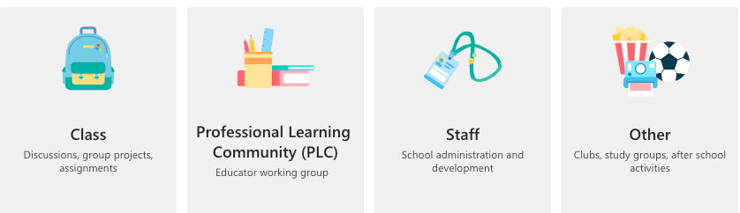

**Figure 1: Types of Teams in Microsoft Teams**

(Source: Influenced by Starkey, 2020)

Every team shares a similar makeup of posts, channels, and files, and each team coil has an audio call meeting, video call meeting, schedule meeting, as well as more. Moreover, each of these four teams has unique features and permission. There is some information about the unique permission and features.

|  |  |  |  |  |
| --- | --- | --- | --- | --- |
| **Types** | **Details** | **Members/Owners** | **Permissions** | **Unique Features** |
| Class | Students and teachers collaborate on assignments, projects, groups, and more (Singh and Awasthi, 2020). | Students are generally team members, while teachers are team owners | Teachers moderate the conversations and who particularly could be posted. Students are given permission in a certain area (Kristóf, 2020). | Class notebooks, grades, assignments, and class folders |
| PLC | Educators collaborate in such of professional learning such as academic departments, business professionals | Educators and employers from the team is joined in the Microsoft Team (Correia *et al.* 2020). | All participants share similar read-write permission. | OneNote notebook |
| Staff | Staff departments and staff leaders are collaborating together. | All the staff leaders are the team owners as well as add some staff members as the team members. | Every staffing leader controls the posting settings, while staff members have been writing the permission in a certain area (Sobaih*et al.* 2021). | Staff Notebook |
| Other | Staff and student faculties are collaborating in interest clubs and groups. | Any kind of combination of faculty, students, and staff could form a particular team as well as additional members (Singh and Awasthi, 2020). | All team members to share similar permission to read-write unless team owners have altered the settings. | OneNote notebook |

**Table 1: Features of Microsoft Team Video and Audio Conferencing**

(Source: Self-developed)

***Zoom***

This video conferencing tool allows an individual to work and meet together as productively as face-to-face at a time meeting in-person is not possible. It makes the meeting remotely more human than necessary to help users stay and feel connected (Sobaih*et al.* 2021). Zoom creates a video conferencing tool to build for human teams and it keeps the operations running as smoothly as overall teams collaborate.

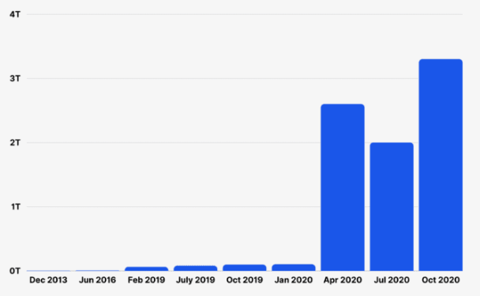

**Figure 2: Annual meetings on Zoom increase**

(Source: Influenced by Sobaih*et al.* 2021)

***Global and simple video conferencing***

Zoom has offered a user-friendly conferencing service and they made this straightforward and fast to start the meeting. As per the view of Muawanah*et al*. (2021), the video meetings could now support up to 1000 various video attendees, and it's showing as many as 49 on screen at a similar time. It could be as well choosing who directly displayed, making a particular panel for the meeting, webinar, and presentation. The audio support and the HD video also make it likely that each person on call could hear as clearly with very minimum audio drops or disruptions.

***Advanced tool to deliver messages***

Most companies have one single meeting to deliver the message to the entire team. However, there is always someone who could not make it. As cited by Archibald *et al.* (2021), Zoom ensures that no one has missed the message even if they could not attend the original meeting. This platform has native features designed for making each message useful and accessible. Any meeting could be recorded for further viewing however, if the entire business uses to recur the webinars for revenue or training generation, it could set up a system to start as automatically and run by the recorded presentation.

## Evolution of Cloud Computing and Storage

Cloud computing was a ground-breaking discovery in the digital age. All the users could access remotely data that is particularly present on the clouds, which belongs to a similar organisation or maybe multiple organisations. Cloud storage is one type of “computer data storage”, in that all data is stored in an off-site location service. In the opinion of Yeshua-Katz *et al.* (2023), the Internet is beneficial and could make life more convenient. It is largely used in marketing, business management, purchasing, production, selling, every management in accounts, and other activities.

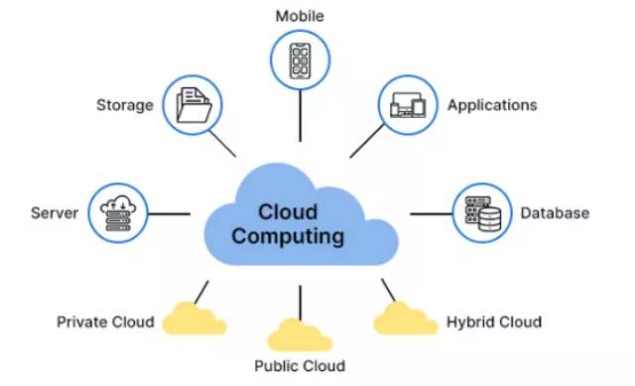

**Figure 3: Cloud Computing Features**

(Source: Influenced by Yeshua-Katz *et al.* 2023)

Digital marketing: with the help of the internet, any organisation could use websites, social media, search engines, and emails, to promote its services and products on digital platforms. Digital marketing helps all businesses to advertise their services and products at search and social channels at a budget cost.

Business automation: This is more necessary in complicated and highly necessary work. In this process, every business work, task, and operation is programmed into software that could run the entire business automatically (Riedl, 2022). This could as well reduce the high risk of human work and encourage the robotic interface that would enhance overall productivity and decrease the maintenance expanse of a big team.

Online business opportunities: The Internet has provided an immense opportunity to enhance a business online. However, the Internet as well offers different opportunities such as web development, e-commerce, digital marketing, content writing, affiliate marketing, and publishing.

***Advantages of Cloud Computing***

Cost savings is the largest benefit of cloud computing, and it helps to save on “substantial capital costs” as this does not require any kind of investment of physical hardware. Moreover, it would not require trained personnel for maintaining the hardware. In the opinion of Namasudra (2021), managing and buying equipment are done by the cloud service provider. On the other hand, cloud computing has offered a competitive edge over all the competitors. As cited by Afzal and Kavitha, (2019), high speed is another benefit of cloud computing, and it allows all people to deploy its service as rapidly in fewer clicks. The fast development has always allowed for getting the required resources for the system in just a few minutes.

***Disadvantages of Cloud Computing***

In cloud computing all data is stored in the cloud and these data are accessed by using the internet. According to Butt *et al.* (2020), the lack of internet connectivity would not be able to access this data. However, there are no other options for accessing data from the cloud. The Vendor lock is the largest disadvantage issue when transferring the vendors provided various platforms. As per the view of Neicu*et al.* (2020), the providers of cloud computinghaveimplement perfect security standards for storing significant information. However, before adopting the special cloud technology, it should be aware that it will pass such sensitive information regarding the organisation to third parties.

***Suitability of Cloud Computing***

Cloud Computing is a perfect advantage for cloud computing that assists access to the latest applications without spending any money or time on the installation. The total storage concept was being repurposed by eliminating the requirement for all kinds of active management by users. Cloud Computing has offered multiple opportunities to society and businesses for pursuing their goals and objectives (Singh and Awasthi, 2020). However, the internet helps every business to connect with its customers. This has reduced some threats of internal threat that may be individuals or groups with access to BSAT as a job to misuse.

***Application of Cloud Computing***

Cloud computing has served a specific organisation from investing hassle in verifying any IT resources by supplying needed computing infrastructure, resources, and platforms on the go. According to Sun, (2019), cloud Computing offers multiple applications in different business fields such as entertainment, data storage, management, education, social networking, GPS, and art. The crucial types of this Cloud computing model available are “IaaS (Infrastructure as a Service)”, “Paas (Platform as a Service)”, and “SaaS (Software as a Service)”. Cloud computing has allowed storage as well access to all data such as images, files, videos, and audio on cloud storage. In big data, the shorting of business data volume locally needs more space and costs.

## Identification of Security and Privacy Challenges

Most security analysts have claimed human error is the largest challenge to data privacy as well as security. The privacy regulations have been protecting every user from having information shared with their third party without knowledge or consent. As cited by Shamshirband*et al.* (2020), the typical privacy and security threats have included social and phishing engineering, card or personal data misuse or theft, hacking, and malware. Two high threats could have an adverse impact on the personal information of any of the e-commerce websites which are generally phishing attacks.

Cyber security is a major challenge faced by any organisation during their online session. This challenge has come in multiple forms such as phishing attacks, ransomware, malware attacks, and many others. Cybersecurity is critical because this jas protects all data categories from damages and theft (Keshta and Odeh, 2021). This includes some sensible data, “protected health information”, “personally identifiable information” and more. The primary objective of cyber security is protecting an organisation from cyber threats as well as ensuring the integrity, confidentiality, and also availability of systems and data. NMAP, known as a network mapper, is an open-source tool that is particularly used to scan networks. This specific tool is useful for discovering the hosts.

## Benefits and Limitations of the local internet of Russia during the Russia and Ukraine Conflict

Digital technologies have played a crucial role, if not decisive, in the entire Russia-Ukraine conflict. However, cyberattacks have increased as overall conflicts escalate. Social media and big tech platforms onparticular services supply and provide direction on the impact of ground situations. Such emerging technologies like cryptocurrencies have found some new applications. The entire sanctions would impact the development of e-commerce and technologies (Ferrag*et al.* 2020). The Ukraine war has started on various levels on the ground as well similarly in cyberspace. The political climate has presented a high possibility for the entire cyberattacks to escalate and control beyond the overall conflict in the war. Russia is in line with such aggressive decisions for putting such nuclear forces on high alert.

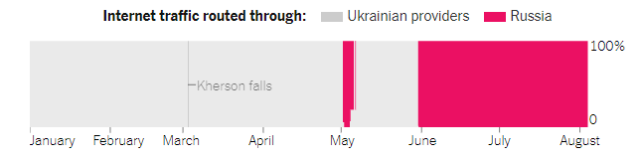

**Figure 4: Internet traffic diverted by Russia**

(Source: Influenced by Mariotti, 2022)

Ukraine experienced a widespread outage of power after Russia strikes and it caused around a 50% reduction in the traffic on the internet in Ukraine. This particular disruption has lasted nearly one and a half days and further emphasises the overall ongoing conflict's impact on the infrastructure of Ukraine. On the other hand, Alyukov, (2022), asserted that, in Russia, the overall internet censorship has been enforced on the basis of multiple laws and by multiple mechanisms. Diverting traffic by the Russian network has made it too easy for censoring the invaded population (Mariotti, 2022). Russian authorities have rerouted the internet data from Kherson by Russian networks. They had blocked access to Instagram, Facebook, and Twitter and to Ukrainian news sites of independent information.

The restriction of internet access is part of the “Russian authoritarian playbook”, which is to be replicated further if it takes more of the Ukrainian territory. However, digital tactics are as well put on those areas in the grip of the large digital surveillance and censorship apparatus (GEORGE and GEORGE, 2022). In this apparatus, Russia is able to track digital communication and web traffic, spread propaganda as well as manage the news that reaches people.

# Profession Practice Skills- ICT, Communication, and Numeracy

The ICT professionals conduct the plan, research, write, design, provide advice, test, and develop the information technology. This has helped all the people to communicate cheaper and faster as compared to ever before. It also means that all people have some information at finger trip as compared to any human history. As cited by Hong *et al.* (2020), communication in any workplace is crucial as it has boosted overall employee morale, productivity, engagement, and satisfaction. It is also a major for much better team cooperation and collaboration. Everyday activities such as counting, talking about sizes, and looking at shapes could assist children to enhance their numeracy skills.

# Conclusion

From the above discussion, it can be concluded that using the information on the internet has communicated professionally and socially by the use of messaging, social media, and email. Microsoft and Zoom are the two most used technologies to collaborate, communicate, or conduct the entire business operations. Microsoft Teams is the ultimate messaging app for any organisation for a workplace for their real-time communication and collaboration, meetings, app, and file sharing. The advanced tool has native features designed for making each message useful and accessible. In conclusion, the internet is beneficial and could make life more convenient. The internet has offered multiple opportunities to society and businesses for pursuing their goals and objectives. Digital marketing helps all businesses to advertise their services and products at search and social channels at a budget cost. Cloud Computing is a perfect advantage for cloud computing that assists access to the latest applications without spending any money or time on the installation.

# References

Afzal, S. and Kavitha, G., (2019). Load balancing in cloud computing–A hierarchical taxonomical classification. *Journal of Cloud Computing*, *8*(1), p.22.

Alyukov, M., (2022). Making sense of the news in an authoritarian regime: Russian television viewers’ reception of the Russia–Ukraine conflict. *Europe-Asia Studies*, *74*(3), pp.337-359.

Archibald, M.M., Ambagtsheer, R.C., Casey, M.G. and Lawless, M., (2019). Using zoom videoconferencing for qualitative data collection: perceptions and experiences of researchers and participants. *International journal of qualitative methods*, *18*, p.1609406919874596.

Butt, U.A., Mehmood, M., Shah, S.B.H., Amin, R., Shaukat, M.W., Raza, S.M., Suh, D.Y. and Piran, M.J., (2020). A review of machine learning algorithms for cloud computing security. *Electronics*, *9*(9), p.1379.

Correia, A.P., Liu, C. and Xu, F., (2020). Evaluating videoconferencing systems for the quality of the educational experience. *Distance Education*, *41*(4), pp.429-452.

Ferrag, M.A., Shu, L., Yang, X., Derhab, A. and Maglaras, L., (2020). Security and privacy for green IoT-based agriculture: Review, blockchain solutions, and challenges. *IEEE access*, *8*, pp.32031-32053.

GEORGE, D.A.S. and GEORGE, A.H., (2022). Potential Risk: Hosting Cloud Services Outside the Country. *International Journal of Advanced Research in Computer and Communication Engineering*, *11*(4), pp.5-11.

Hong, J., Thakuriah, P.V., Mason, P. and Lido, C., (2020). The role of numeracy and financial literacy skills in the relationship between information and communication technology use and travel behaviour. *Travel Behaviour and Society*, *21*, pp.257-264.

Keshta, I. and Odeh, A., (2021). Security and privacy of electronic health records: Concerns and challenges. *Egyptian Informatics Journal*, *22*(2), pp.177-183.

Kristóf, Z., (2020). International trends of remote teaching ordered in light of the Coronavirus (COVID-19) and its most popular video conferencing applications that implement communication. *Central European Journal of Educational Research*, *2*(2), pp.84-92.

Mariotti, S., (2022). A warning from the Russian–Ukrainian war: avoiding a future that rhymes with the past. *Journal of Industrial and Business Economics*, *49*(4), pp.761-782.

Minhas, S., Hussain, T., Ghani, A., Sajid, K. and Pakistan, L., (2021). Exploring students online learning: A study of zoom application. *Gazi University Journal of Science*, *34*(2), pp.171-178.

Mu'awanah, N., Sumardi, S. and Suparno, S., (2021). Using Zoom to support English learning during Covid-19 pandemic: Strengths and challenges. *JurnalIlmiahSekolah Dasar*, *5*(2), pp.222-230.

Namasudra, S., (2021). Data access control in the cloud computing environment for bioinformatics. *International Journal of Applied Research in Bioinformatics (IJARB)*, *11*(1), pp.40-50.

Neicu, A.I., Radu, A.C., Zaman, G., Stoica, I. and Răpan, F., (2020). Cloud computing usage in SMEs. An empirical study based on SMEs employees perceptions. *Sustainability*, *12*(12), p.4960.

Riedl, R., (2022). On the stress potential of videoconferencing: definition and root causes of Zoom fatigue. *Electronic Markets*, *32*(1), pp.153-177.

Shamshirband, S., Fathi, M., Chronopoulos, A.T., Montieri, A., Palumbo, F. and Pescapè, A., (2020). Computational intelligence intrusion detection techniques in mobile cloud computing environments: Review, taxonomy, and open research issues. *Journal of Information Security and Applications*, *55*, p.102582.

Singh, R. and Awasthi, S., (2020). Updated comparative analysis on video conferencing platforms-zoom, Google meet, Microsoft Teams, WebEx Teams and GoToMeetings. *EasyChair Preprint*, *4026*, pp.1-9.

Singh, R. and Awasthi, S., (2020). Updated comparative analysis on video conferencing platforms-zoom, Google meet, Microsoft Teams, WebEx Teams and GoToMeetings. *EasyChair Preprint*, *4026*, pp.1-9.

Sobaih, A.E.E., Salem, A.E., Hasanein, A.M. and Elnasr, A.E.A., (2021). Responses to Covid-19 in higher education: Students’ learning experience using microsoft teams versus social network sites. *Sustainability*, *13*(18), p.10036.

Starkey, L., (2020). A review of research exploring teacher preparation for the digital age. *Cambridge Journal of Education*, *50*(1), pp.37-56.

Sun, P.J., 2019. Privacy protection and data security in cloud computing: a survey, challenges, and solutions. *IEEE Access*, *7*, pp.147420-147452.

Tohara, A.J.T., (2021). Exploring digital literacy strategies for students with special educational needs in the digital age. *Turkish Journal of Computer and Mathematics Education (TURCOMAT)*, *12*(9), pp.3345-3358.

Yeshua-Katz, D., Shapira, S., Aharonson-Daniel, L., Clarfield, A.M. and Sarid, O., (2023). Matching digital intervention affordances with tasks: The case of a zoom and WhatsApp mental health intervention for seniors during the COVID-19 pandemic. *Health Communication*, *38*(3), pp.499-511.