**BPP Coursework Cover Sheet**

|  |  |
| --- | --- |
| Programme | Msc Management |
| Module Name | CUSTOMER EXPERIENCE STRATEGY |
| Student Reference Number  (SRN) |  |
| Assessment Title | COURSEWORK ASSESSMENT |
| Schedule Term | Term-2 |
| Report/Assignment Title | Summative Assessment- Coca Cola |

|  |
| --- |
| Declaration of Original Work:  I hereby declare that I have read and understood BPP’s regulations on plagiarism and that this is my original work, researched, undertaken, completed and submitted in accordance with the requirements of BPP School of Business and Technology.  The word count, excluding contents table, bibliography and appendices, is **2500** words.  Student Reference Number: Date: |

By submitting this coursework you agree to all rules and regulations of BPP regarding assessments and awards for programmes.

Please note that by submitting this assessment you are declaring that you are fit to sit this assessment.

BPP University reserves the right to use all submitted work for educational purposes and may request that work be published for a wider audience.

**CUSTOMER EXPERIENCE (CX) STRATEGY OF COCA COLA**

**Executive Summary**

This report has highlighted the concept of omnichannel marketing that is helpful to enhance the customer engagement rate of the company. This report has evaluated the role of interaction and customisation in omnichannel marketing by analysing the relevance of interaction and personalisation. Furthermore, this reporter has described the Omnichannel strategy for Coca-Cola. The importance of seamlessness has also been evaluated in this report with a brief description of Coca-Cola. The strategies of the company to maintain the success of omnichannel marketing in the markets of the UK has also been explained in this report.

The customer journey map developed suggests that after being awarded by the advertisements a significant push for buying the products can be observed despite the product (Sprite) being relatively oil in the market. This means that the company has a good degree of reputation in the market. Thus, evaluating the CX performance matrix, only CES and NPS is suggested considering the evaluation of current circumstances only. Evaluating and comparing the CSF determinants of CX, it is found that Coca-Cola has a better CSF implementation than Dyson therefore altogether proving that CX of Coca-Cola is fairly positive.

Table of Contents

1. The Importance of Customer Experience 5

2. Consumer Persona Creation 6

3. Mapping the Customer Journey 7

3.1 Customer experience and its importance 7

3.2 Customer journey map of Coca-Cola 7

4. Omnichannel Marketing 9

4.1 Concept of Omnichannel Marketing 9

4.2 Role of interaction and customization in omnichannel marketing 10

4.3 Identification of different marketing channels used for Coca-Cola 10

4.4 Discussion of Seamlessness in Omnichannel Marketing 11

4.5 Omnichannel strategy for Coca-Cola 11

4.6 Seamless customer journey of Coca-Cola 11

5. CX Performance Metrics 12

5.1 Different CX performance metrics 12

5.2 Two chosen CX matrices 13

6. CX Processes in Different Industries 13

6.1 CX critical success factors and their implementation 13

6.2 Comparison 14

7. Conclusion 15

References 16

# 1. The Importance of Customer Experience

A positive customer experience is a way to stand out from all the competitors. In terms of creating a solid customer experience, understanding the whole journey of a customer is most important. It should be thought that the customer journey map will help to understand all touch points with the customers (Guo and Wen 2021). Customer satisfaction is also important as this illustrates whether the overall customer base's high customer satisfaction has led to much better customer retention and a stronger brand reputation. However, customer satisfaction with low scores is also important for making affordable business sometimes. Customer service is frequently separate from the sales role, and it is used for handling any kind of technical issues or complaints. According to Tien *et al.* (2019), Coca-Cola has recognized that putting all the customers first is a requirement and it needs a holistic customer experience view. Customer experience has played a significant role to drive the overall business of Coca-Cola successfully.

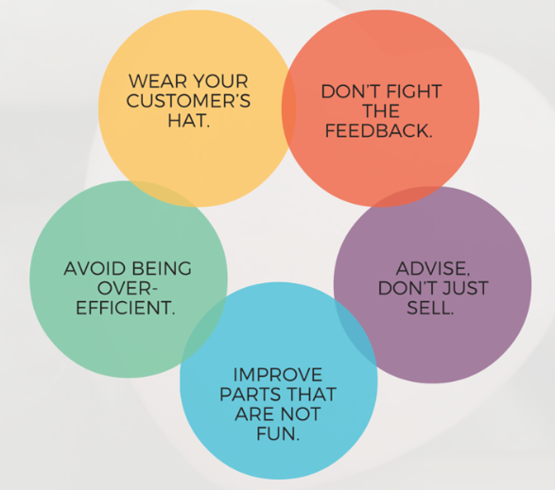

**Figure 1: Importance of the Customer Experience**

(Source: Influenced by Hamacher and Buchkremer, 2022)

The brand identity of Sprite is clear and sharp as it cuts through conveys and noise confidence as the iconic brand. The CX of Coca-Cola is to engage its audience as well as generate the proper content that they could share. This has become a part of the brand experience of Coca-Cola. The product Sprite of Coca-Cola designed a specific marketing strategy as content-based for driving inspires purchases, consumer conversation, and developing the brand value. In the opinion of Hamacher and Buchkremer (2022), storytelling is a strong tool for use within Coca-Cola organisations, just like for the target audience. Trending and tracking customer complaints or concerns to facilitate corrective action development is the major customer service of Coca-Cola. Engagement, discovery, and delivery are three major components for the CX of Coca-Cola and its product Sprite in the UK. Coca-Cola has been follow-up with its internal stakeholders for ensuring the timely closure of all issues.

# 2. Consumer Persona Creation

The consumer persona of Coca-Cola is fictional that represents specific target customers. There are two targets looked at in Coca-Cola and those are primary and secondary. The primary target of this brand is youth customers aged between 18 to 25 years old, while the secondary market is composed of most people aged between 25 to 40 years old.

|  |  |  |  |  |
| --- | --- | --- | --- | --- |
| **Key Consumer Persona:** Younger Customers aged between 10 to 25 years. | | | | |
| ***Demographics and Story*** | ***Profile*** | ***Motivations for Usage*** | ***Goals for Usage*** | ***Solve pain points*** |
| Coca-Cola strives for its gender equity (50% are men and 50% are women) in its customers. Family and marital status have not mattered, although most of the customers are students as well as family oriented. | All youth aged between 18 to 25 years would be major customers purchasing the product Sprite of Coca-COLA. | Sprite is motivated by a tasty drink desire to succeed (Zhavoronkova *et al.* 2020). Using celebrities for advertising has motivated customers to drink Coca-Cola product. | The goal of Sprite and Coca-Cola for its customers is to refresh the whole world to make a difference (Liu, 2021). | The high sugar of Sprite is harmful to the health and decreases the sugar quantity and is the solution to the pain point of Sprite. |

**Table 1: Consumer Persona of Coca-Cola and its Product Sprite**

(Source: Self-created)

# 3. Mapping the Customer Journey

## 3.1 Customer experience and its importance

A customer journey can be considered as the sum of experiences that a customer has to go through while interacting with a brand or an organisation. Thus, customer journey is the sum of a customer’s own experiences. On the other hand, customer experience is the result of interactions a customer has with a brand or a company (Hoyer *et al.* 2020). The main importance of customer journey evaluation in developing customer strategy is that it allows CX related teams to identify the main factors and points influencing the customers. Without a proper understanding of the customer journey, it is difficult to evaluate customer experience and thus further process of brand development is hampered. The same can be considered for Coca-Cola and their product Sprite.

## 3.2 Customer journey map of Coca-Cola

|  |  |  |  |  |  |
| --- | --- | --- | --- | --- | --- |
| **Stages** | **Awareness** | **Consideration** | **Decision Making** | **Buying** | **Loyalty generation** |
| **Activities** | View online ads, watches social media campaigns, hears from friends | Wants to know more about sprite as a product, compares pricing and quality | Comes to a decision of purchasing the product if seems better than others | Purchases the product for the first time. Consume it and make a final decision of further buying | The products are suitable and economically friendly. Makes another purchase and shares their positive experience |
| **Feelings and needs** | Interested yet hesitant | Curious and excited | Excited | Excited | Satisfied |
| **KPIs** | Number of people reached | New medias advertised on | Clarity of information | Correct pricing | Customer satisfaction score |
| **Potential opportunities for improvement** | Awareness campaigns can be largely concentrated on social media | Providing clarity of information delivery to the customer about the Sprite product | Providing fewer options in the same category of products can help the customer makes their choices easier | Providing better products in a relatively reasonable rate | Provide feedback opportunities to the customer for further documentation and improvement. |

**Table 2: Customer Journey mapping**

(Source: Self-developed)

# 4. Omnichannel Marketing

## 4.1 Concept of Omnichannel Marketing

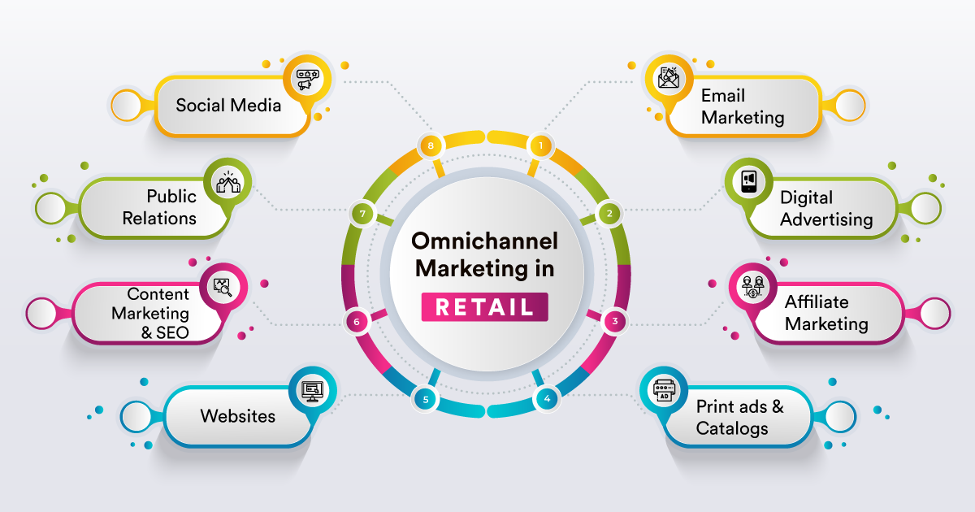

**Figure 2: Concept of Omnichannel Marketing**

(Source: Influenced by Beknazarova, 2022)

Omnichannel marketing refers to approaches of marketing across multiple channels that are effective for profitability and brand image. According to views of Beknazarova (2022), omnichannel marketing includes a strategy that is helpful to engage customers through different touch points. for instance, Coca-Cola can achieve more availability among their customer base by using omnichannel marketing strategy. Besides, usage of omnichannel marketing is essential to boost up sales of products such as Sprite in the UK market.

## 4.2 Role of interaction and customization in omnichannel marketing

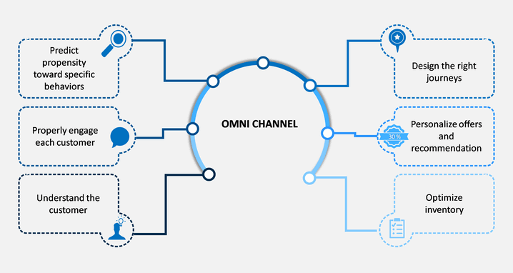

**Figure 3: Role of interaction and customization in omnichannel marketing**

(Source: Influenced by Lopes *et al.* 2021)

Interaction is helpful to maintain the same experience across all marketing channels of omnichannel marketing. In views of Lopes *et al.* (2021), usage of interaction for omnichannel marketing is helpful to maintain coordination between online and online channels. It is helpful to ensure customer satisfaction. On other hand, customization for omnichannel is helpful to identify individual buyer’s needs that are effective to maintain brand values of the company. As mentioned by Hickman *et al.* (2020), usage of customisation for omnichannel marketing is helpful to enhance customer satisfaction by providing products that consider market demand. Therefore, as a multinational company Coca-Cola needs to use customisation and interaction to ensure success of omnichannel marketing.

## 4.3 Identification of different marketing channels used for Coca-Cola

The marketing channels that are helpful for marketing of Coca-Cola are such as vending and mass merchandisers. As a multinational provider of beverage Coca-Cola did their marketing by using channels such as vendors, food stores and mass merchandisers. The company officials of Coca-Cola need to enhance the marketing process by taking help from local vendors of UK markets. Furthermore, Coca-Cola uses social media marketing through platforms such as Twitter, Facebook, Instagram and YouTube (Coca-colacompany.com, 2023). Moreover, for intense marketing Coca-Cola uses an inclusive pattern of employee selection to enhance marketing by taking ideas from local people of the UK.

## 4.4 Discussion of Seamlessness in Omnichannel Marketing

Seamlessness in omnichannel marketing refers to a marketing approach that is effective to provide purchasing satisfaction to customers. According to the views of Rodríguez-Torrico*et al.* (2023), seamlessness for omnichannel marketing is a key point to maintain customer satisfaction that is effective for the brand image of a company. Besides, seamlessness in omnichannel marketing helps customers to switch their marketing channels without any conflicts. The maintenance of seamlessness for omnichannel marketing of Coca-Cola is helpful to enhance interaction of users with company officials.

## 4.5 Omnichannel strategy for Coca-Cola

The usage of social media platforms is the main marketing approach of Coca-Cola as it helps to engage huge numbers of customers easily. The social media platforms like Facebook, Instagram and YouTube are main marketing channels of Coca-Cola to enhance customer base in UK markets. The usage of omnichannel strategy have increased customer base of Coca-Cola up to 12.08 million due to wide providence of different purchasing channels (Statista.com, 2023). The usage of inclusivity is also an effective omnichannel strategy of Coca-Cola regarding products such as Sprite.

## 4.6 Seamless customer journey of Coca-Cola

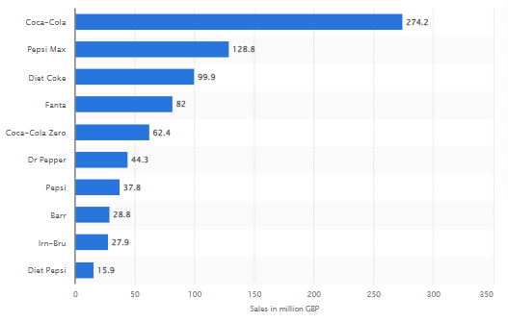

**Figure 4: Seamless customer journey of Coca-Cola**

(Source: Statista.com, 2023)

The usage of inclusive employee engagement and marketing strategy is the vital reason behind the seamless customer journey of Coca-Cola. The usage of seamless customer journey has increased the revenue of Coca-Cola up to 274 million British pounds (Statista.com, 2023). The seamless customer journey of Coca-Cola has been a helpful process to enhance the customer engagement rate due to the presence of multiple purchasing channels.

# 5. CX Performance Metrics

## 5.1 Different CX performance metrics

There can be a variety of performance matrices that are used for evaluating customer experience depending on the environment. Among them four most common and key CX Performance Metrics includes customer satisfaction survey (CSAT), Customer efforts scores (CES), Net promoter Score (NPS) and Customer Churn Rate.

Customer satisfaction surveys or CSATs are surveys considered subjecting the general customers about their own satisfaction rate with the products or service. It is a matrix that businesses generally use to understand the degree of satisfaction of the customers about a particular product or service. In this case, direct responses from customers helps to determine the values of satisfaction on a direct or primary evaluation basis (Holmlund *et al.* 2020). However, the effectiveness of this may vary based on the availability of information in public. If the survey answers are available publicly, then negative feedback from some customers can affect the decision making of the other customers. Alternatively, ethically considered end-to-end encrypted surveys are more secure and the companies only have authority to know all the answers. With CSAT thus a primary evaluation of customer experience can be done.

In the case of Net Promoter Score (NPS) determination, customers can act as advocates in the decision making of improving the product or service. With Net Promoter Score, brands not only can understand the level of satisfaction of the customers but also the pervasiveness of the customers towards the brand (Baquero, 2020). Through NP scores, the business can identify loyal customers who can become their unofficial brand-ambassadors. They can identify those who will recommend the brands to others. In this case, a survey is also done through which the business can know what the customers think about them. Direct questions such as, likeliness of one recommending the brand, are involved along with a scoring option. Thus, a relatively clear picture of customer consideration is achieved through NPS.

Customer Effort Scores (CES) are used by businesses to understand the level of effort required by a customer to attain a product or service. CES scoring is also performed by conducting a survey, however after initial interactions (Agag *et al.* 2023). This is useful when an organisation wants to find out the overall experience of the customers after using the product or service. Analyzing the importance of efforts taken can measure the company’s effectiveness in delivering the overall products or service. Lastly, Customer Churn Rate helps to identify the percentage of customers no longer using the product or service (Çelik and Osmanoglu, 2019). This helps to understand the level of loss of customers incurred by the company.

## 5.2 Two chosen CX matrices

Coca-Cola is an already established brand with Sprite being a well-established product in the market. Customers are already satisfied with the product and thus customer satisfaction survey or CSAT is largely irrelevant in this case. If the company has a steady number of customers, then Churn Rate determination is also not completely relevant unless a sudden complaint in fall of quality or other matters arises. The company can use this opportunity to minimise the effort needed by customers therefore indicating an analysis of Customer efforts scores (CES) (Gährs and Knoefel, 2020). Similarly, for a continuation of word-spreading of the brand a Net promoter Score (NPS) evaluation is also recommended for the company.

# 6. CX Processes in Different Industries

## 6.1 CX critical success factors and their implementation

The critical success factors that determine customer experience includes the degree of customer requirement fulfilment, prices of the products or service, their accessibility, brand’s value and experience. The more a brand or organisation is able to mitigate customer requirements and needs, the more positive customer experience it can generate. Prices are also critical in generating positive customer response. Thus, competitors try to provide better services or products with as minimal pricing as possible to attract attention. One of the major CSF determinants of CX is the accessibility and availability of the products and services (Ishengoma*et al.* 2022). If a product or service is not easily available or accessible in a particular region, the brand or company is subjected to negative customer experience in that region. Lastly brand value also plays an immovable role. Internationally acclaimed and positive brand value organisations tend to drive an already positive customer experience. On the other hand, the more experienced a brand is, the better customer experience it can provide.

Thus, the implication of these factors is determined by the degree of presence of positive aspects of these factors in the environment. For employing customer requirements, real-time feedback communication with the customers is essential. With the establishment of a feedback communication a quicker process of mitigating the customer demands can be made possible. The pricing has to follow a competitive pricing strategy to tackle the competitors in the market and to present best pricing to the customers at the same time. For determining accessibility and availability of the products and services, a complete geographic evaluation and supply chain management restructuring have to be considered. Improving brand value is a long-term process and involves all the above positive changes to be done. Finally, experience is gathered through years of operations and the more experienced a brand is the better it can generate customer loyalty and satisfaction.

## 6.2 Comparison

|  |  |  |
| --- | --- | --- |
| **CSF factors** | **Coca-Cola** | **Dyson** |
| **Customer requirements** | Coca-Cola practices a content-based marketing strategy and has a larger variety of products based on customer needs. Spite definitely serves as a well-demanded product for the company | The product category Dyson ventures upon is electronics, yet their product variety is limited. They are not able to deliver all electronic products, yet vacuum cleaners are their best products and have a good number of requirements. |
| **Prices** | As Coca-Cola markets fast-food products having significant competitors, they implement competitive pricing for a better outcome. | Dyson on the other hand provides premium quality products targeting premium markets. Thus, they occupy only upper and upper-middle class as a part of implementing price as their CSF. |
| **Accessibility and availability** | The accessibility and availability of Sprite as a soft drink is vast and thus as a CSF element Sprite is able to generate a good CX for Coca-Cola | Dyson’s vacuum cleaner is not as widely available as Coca-Cola’s Sprite product due to its premium pricing and less demand. Thus, this CSF factor acts as a negative aspect of CX for Dyson. |
| **Brand value** | Coca-Cola has an international brand value developed due to its wider range of products. Sprite as an individual product also adds brand value as a part of CSF in the company. | Dyson is valued as a premium brand and also has a worldwide brand value. However, Dyson’s brand value is limited to a relatively smaller group of population than Coca-Cola’s due to its choice of product. |
| **Experience** | Coca-Cola was established in 1892 and has about 130 years of experience (Coca-colacompany.com, 2023). Their product sprite was launched in 1961. Thus, they have huge experience in running the product market. | Dyson, however, has 30 years of experience only being established in 1991. Their experience with vacuum cleaner products is 1993 (Phcvacuumservice.co.uk, (2023). Thus, product-based experience is relatively low than Coca-Cola’s |

**Table 3: Comparison between Dyson and Coca-Cola in their CSF factors**

(Source: self-developed)

# 7. Conclusion

Based on the evaluation, it is clear that Coca-Cola’s CX strategy regarding their product Sprite is effective. The demographics suggest that the youth are the target audience of the product and their desire for tasty drinks are the motivators of the brand value. Despite that, the high sugar content of the product is harmful for the individuals. Yet the demand for the products is significant in the market. This is proven by significant loyalty generation for the products in the customer journey map. Due to this loyalty the CX matrix suggested CES and NPS. Comparing the CSFs of Coca-Cola and Dyson, it is found that the former has a much better implemented CSF for their CX generation.

# References

Agag, G., Durrani, B.A., Shehawy, Y.M., Alharthi, M., Alamoudi, H., El-Halaby, S., Hassanein, A. and Abdelmoety, Z.H., (2023). Understanding the link between customer feedback metrics and firm performance. *Journal of Retailing and Consumer Services, 73*, p.103301.

Baquero, A., (2022). Net Promoter Score (NPS) and Customer Satisfaction: Relationship and Efficient Management. *Sustainability, 14(4)*, p.2011.

Beknazarova, S.S., (2022). OMNI-CHANNEL MARKETING. *Galaxy International Interdisciplinary Research Journal*, *10*(4), pp.472-474.

Çelik, O. and Osmanoglu, U.O., 2019. Comparing to techniques used in customer churn analysis. *Journal of Multidisciplinary Developments, 4(1)*, pp.30-38.

Coca-colacompany.com, (2023). *OUR COMPANY*. Available at: https://www.coca-colacompany.com/company[Accessed on: 14.04.2023]

Coca-colacompany.com, (2023). *Since its birth at a soda fountain in downtown Atlanta, Georgia, in 1886, Coca-Cola has been a catalyst for social interaction and inspired innovation [online].* Available at: https://www.coca-colacompany.com/company/history#:~:text=and%20inspired%20innovation.-,Since%20its%20birth%20at%20a%20soda%20fountain%20in%20downtown%20Atlanta,social%20interaction%20and%20inspired%20innovation. [Accessed on: 10 April, 2023]

Gährs, S. and Knoefel, J., (2020). Stakeholder demands and regulatory framework for community energy storage with a focus on Germany. *Energy Policy, 144,* p.111678.

Guo, X. and Wen, M., (2021), December. Research on Competitive Strategy of Coca-Cola Company. In *2021 3rd International Conference on Economic Management and Cultural Industry (ICEMCI 2021)* (pp. 2879-2885). Atlantis Press.

Hamacher, K. and Buchkremer, R., (2022). Measuring online sensory consumer experience: Introducing the online sensory marketing index (OSMI) as a structural modeling approach. *Journal of Theoretical and Applied Electronic Commerce Research*, *17*(2), pp.751-772.

Hickman, E., Kharouf, H. and Sekhon, H., (2020). An omnichannel approach to retailing: demystifying and identifying the factors influencing an omnichannel experience. *The International Review of Retail, Distribution and Consumer Research*, *30*(3), pp.266-288.

Holmlund, M., Van Vaerenbergh, Y., Ciuchita, R., Ravald, A., Sarantopoulos, P., Ordenes, F.V. and Zaki, M., (2020). Customer experience management in the age of big data analytics: A strategic framework. *Journal of Business Research, 116,* pp.356-365.

Hoyer, W.D., Kroschke, M., Schmitt, B., Kraume, K. and Shankar, V., (2020). Transforming the customer experience through new technologies. *Journal of interactive marketing, 51(1)*, pp.57-71.

Ishengoma, F., Mselle, L. and Mongi, H., (2022). An empirical study of critical success factors for the adoption of m-government services in Tanzania. In *Smart Trends in Computing and Communications: Proceedings of SmartCom 2021* (pp. 11-20).

Liu, S., (2021). A Report on Strategic Analysis and Recommendations of Coca-Cola. *International Journal of Frontiers in Sociology*, *3*(17).

Lopes, J.M., Sousa, A., Calçada, E. and Oliveira, J., (2021). A citation and co-citation bibliometric analysis of omnichannel marketing research. *Management Review Quarterly*, pp.1-34.

Phcvacuumservice.co.uk, (2023). *History of the Dyson Company[online].* Available at: https://www.phcvacuumservice.co.uk/history-of-the-dyson-company/ [Accessed on: 10 April, 2023]

Rodríguez-Torrico, P., San José Cabezudo, R., San-Martín, S. and TraboldApadula, L., (2023). Let it flow: the role of seamlessness and the optimal experience on consumer word of mouth in omnichannel marketing. *Journal of Research in Interactive Marketing*, *17*(1), pp.1-18.

Statista.com, (2023). *Cola brands of Coca-Cola ranked by number of consumers*. Available at: https://www.statista.com/statistics/312797/leading-cola-brands-of-coca-cola-in-the-uk-by-number-of-users/[Accessed on: 14.04.2023]

Statista.com, (2023). *Retail sales revenue of the leading carbonate brands in convenience stores in the United Kingdom (UK) in 2022*. Available at: https://www.statista.com/statistics/1194496/leading-carbonated-drink-brands-retail-sales-revenue-uk/#:~:text=In%202022%2C%20the%20leading%20carbonated,of%20sales%20revenue%20in%202022.[Accessed on: 14.04.2023]

Tien, N.H., Vu, N.T. and Tien, N.V., (2019). The role of brand and brand management in creating business value case of Coca-Cola Vietnam. *International Journal of Research in Marketing Management and Sales*, *1*(2), pp.57-62.

Zhavoronkova, G., Miziuk, S. and Zhavoronkov, V., (2020). The influence of transnational corporations on the economy of developing countries (Contemplating the example of how the Coca–Cola Company influences the economy of Ukraine). *Science. Business. Society.*, *5*(1), pp.9-13.