**BUSINESS CREATION AND INNOVATION**

**Table of Contents**

Introduction 2

Identification of the innovation and analysis of the product 2

Identification targeted customers 4

Commercialisation strategy and launch plan based on similar recent cases in the industry 5

Conclusion 7

Reference list 8

# Introduction

The key aim of this report is to identify innovation in any organisation particularly focusing on the manufacturing or service sector. It will also help in evaluating the underlying innovative product, along with determining the targeted customers and drawing up a commercialisation strategy which will be based on a plan made in accordance with a recent case studies in the industry. The company which has been selected for this project is AIRA which has introduced smart glass for visually impaired people three years ago. The smart glasses help the visually impaired person to get a view of the area in which they are operating with the help of these smart glasses. The project will also provide an overview of similar products innovated by other companies in the industry and will help in analysing their commercialisation strategy.

# Identification of the innovation and analysis of the product

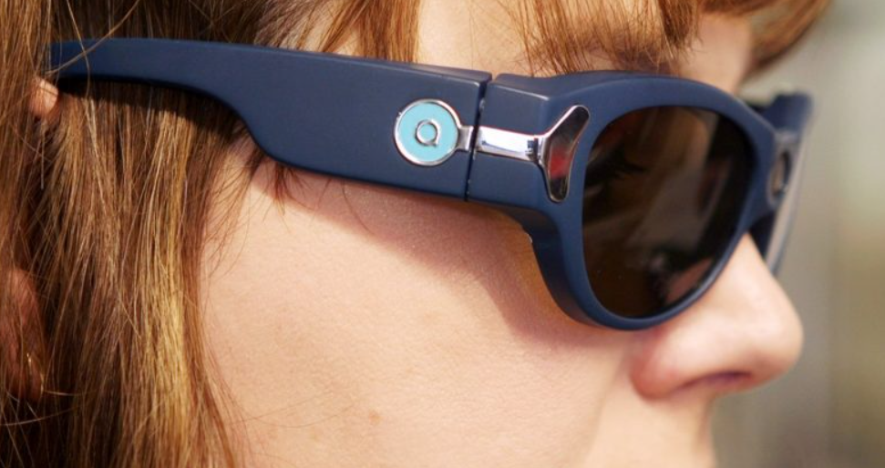

**Figure 1: AIRA Horizon Glasses**

(Source: My blind spot, 2018)

The smart glasses offered by AIRA provide sighted guidance to blind people. The product developed by AIRA aims at providing independence to visually impaired people. Aira has partnered with Envision, a Netherland-based company which is involved in developing apps for smartphones in order to develop a unique combination with assistive technology which helps in enhancing the independence of blind people in various ways. Envision, which is involved in the development of apps for smartphones has integrated with Google Glass which enables visually impaired users to get audio descriptions of images or texts which the point of the camera to with the help of computer vision, AI tools and video calls along with the help of sighted guidance (Niever *et al.*, 2019). Aira has generally developed a human assistant who will provide guidance to visually impaired persons. The technology offered by the company reduces the dependency on human beings by blind persons. The smart glasses offered by Aira provide live streaming of footage with the help of a glass camera to the agent of the company who can provide verbal instructions to the end users of the product. The company's guide can provide them with directions as well as describe to them the local scenes in which they are operating. It is a combination of the hardware manufacturing company and the app-based solution which helps the impaired users get their desired output regarding the view of the local area (Schepers *et al.*, 2022).

The smart glasses offered by Aira aim at integrating 120-degree angle cameras which provide the guide with a fuller landscape of the user's environment. The guides do not have to instruct its user to turn their heads in different directions to get a view of the other side. The usage of a 120-degree live streaming camera it provides a different advantage to the end users. Aira uses Google Glass and Bluetooth devices for integrating with its users with the help of apps. It offers its custom glasses in the market which is known as Horizon. These glasses named Horizon were introduced in the year 2018. The service provided by Aira works like a virtual mode of reality games, which has its real-life streaming in the eyes of the agent. The comprehensive technology platforms offered by Aira makes it possible for low-vision individuals and blind person to attain greater independence and flexibility in urban areas. The system developed by Aira aims at making the best use of smart glasses, cloud technology and internet technology to offer a customised solution to visually impaired individuals(Sun and Yin, 2020).

The platform used by Aira is dependent on pairing up with usable smart glasses data accessible smartphones. The users of smart glasses can connect with a live agent associated with Aira who will provide an overall view of the area where a visually impaired person is moving. The smart glasses help in connecting with the live agents of the company with the usage of some unique algorithms. As and when the agent accepts the user's request, the agents can use their dashboard to view what the user can see. This helps the agent in providing live updates through the usage of Google Maps, GPS navigators and various street viewing apps. The smart glasses also enable the users with the help of face and object recognition, to estimate distance, warn about barriers and others.

# Identification targeted customers

Identification of targeted customer groups is an important factor which needs to be focused on before innovating or designing any product. Identifying the target customer group will help in designing and manufacturing goods and services which will be able to meet up the requirements of their targeted customers. This will also help in estimating the volume of production which is made in a certain area. This will help the company in minimising the company's unsold stocks. Proper identification of the needs and demands of the customer will enable the company to offer products to targeted customers as per their requirements which will help the company in improving its market (Ascarza *et al.*, 2018). This process of identifying targeted customers will meet up the requirements of its customers, which will lead to the improvement of the brand image of the company. This undertaking of this process will also allow the company to meet up its profit objectives with an improvement in sales figures. This will help the company's business to sustain itself in the long run.

The mainly targeted customers for Aira are visually impaired and blind individuals. The smart glasses developed by Aira help in fulfilling their objective and providing them independence. Aira has innovated these smart technology-based tools by keeping in mind its identified customer base who are generally lower-vision individuals, who have generally become dependent on other people. These smart solutions have been developed by the company in order to provide independence to their identified consumer groups. Identifying its targeted customers Aira has helped the company to provide smart solutions to its consumers (Dash *et al.*, 2019). Enabling these smart glasses to the targeted customer has resulted in companies ' growth and better brand position in the global scenario. This process of identifying it is targeting customers has helped the company to collaborate with various technological giants which has resulted in better innovation for the companies. Henceforth, it can be said that the proper identification process adopted by Aira had a positive impact on the company (Bilgihan and Choi, 2018).

# Commercialisation strategy and launch plan based on similar recent cases in the industry

Commercialisation strategy refers to those strategies which are adopted by a company or business in order to achieve its goals and objectives which are maximising its sale, increasing profit, maximising its market share and others. In order words it can be said that commercialisation is a process which aims at providing a variety of products to the identified target customers of the company. It aims at offering new and innovative products to the customers which will provide a firm with a competitive edge over the others operating in the industry (Kunamaneni, 2022).

Commercialisation aims at increasing the accessibility of the company's product to the customer. This is undertaken by application of a series of processes which includes producing the product, distribution process, marketing and selling the products. This also includes providing after-sales service to customers which is customer support. A commercialisation strategy is an important process which can be adopted by companies in order to solve the problems of new products. The commercialisation process also aims at making new products and services available and accessible to general customers. This helps the company to increase its scale of production and sales, which will ultimately lead to the fulfilment of the objectives of the company (Zeng *et al*, 2019).

Companies innovate and create new products with an aim to meet the unanswered demands of customers. The companies create products which focus on fulfilling the clients' requirements. They undertake production processes with an aim of eradicating consumer problems and focusing on product feasibility, production costs, and ways to make the products accessible and available through various commercialisation strategies. The various advantages of commercial strategies are:

* It provides a better choice of products and services to customers.
* It helps in improving the Return On Investment of the company
* It helps in undertaking an effective production process.
* It helps in reducing the public expenditure of the company.

The commercialisation strategy to be adopted by Aira is that the leading smart glass can collaborate with various eye hospitals in the country that will introduce the company's product to visually impaired customers. Aira can collaborate with various eyewear shops that are offering eye care products and services to its customers. The company can set up stores by making ties with various shopping mall giants which will allow Aira to set up its stores according to the accessibility of its targeted customers. Aira can adopt Mckinsey’s Strategic horizons in order to attain its organisational objectives which have been described below:

*Identifying Core business*

Identifying core business helps in identifying the activities which are closely associated with the development of the business operations. This refers to the general business activities which are undertaken by a company to earn revenue. The main purpose of setting up Aira was to provide information about the surroundings to visually impaired persons (Ranđelović and Radosavljević, 2018).

*Identifying alternate strategy*

This function of commercialisation strategy helps a company in identifying alternative courses of action which can be adopted by the company to expand or increase its market presence. This helps in finding other suitable business opportunities for the company. As Aira is involved in the business of providing technology-based solutions to visually impaired people. It can also start offering various technological gadgets like hearing aid solutions to persons with hearing problems. This may help Aira to enter into new avenues of business. By bringing innovative solutions for the customers Aira would be able to increase its market penetration.

I*mproving supply chain*

Aira can adopt AI tools in order to bring efficiency to the supply chain process. This will help Aira to source raw materials easily and help in offering products and services to customers at their convenience. This will help a company like Aira to improve its brand position which will ultimately lead to the attainment of profit objectives by the company (Sharma *et al.*, 2020).

Apple has also made its presence in the eyewear industry by introducing smart eyewear solutions for its customers. Apple is a global technology service provider. It has improved its market presence by providing eyewear solutions keeping in mind the needs and requirements of its identified customer group. Innovation brought into its product line of Apple will help it in expanding its business horizons. Apple is offering smart eyewear solutions to its customers and these products include Arki. Arki is a product which has been developed by Apple and helps to visualise 3D objects in enhanced reality which can help to view, share and communicate with the customers' designs with clarity. The introduction of Arki has helped in attaining the commercialisation strategy. Apple can familiarise its products with its targeted customers who are younger. These technologically advanced tools will help the customers increase their application in their work-related. Through the introduction of various technologically advanced tools, the company will be able to attain its growth objectives. Adoption of this innovative process will help the company like Apple to penetrate the world market.

# Conclusion

The project aimed at discussing business creation and innovation which are the essential functions of any company. The above discussion concludes regarding the innovation made by Aira in its eyewear segment by offering smart eyeglasses which aim at providing independence to the visually impaired and blind individuals. The report also analyses the identification of target customers and their benefit to the company. The last part of the report aims at concluding the commercial strategy which can be adopted by Aira to enhance its market presence. The last part of the project has also discussed a similar innovative product introduced by Apple which is another eyewear product which is known as smart eyeglasses. It has also emphasised the commercial strategy which can be adopted by Apple to increase its market presence.

# Reference list

Ascarza, E., Neslin, S.A., Netzer, O., Anderson, Z., Fader, P.S., Gupta, S., Hardie, B.G., Lemmens, A., Libai, B., Neal, D. and Provost, F., 2018. In pursuit of enhanced customer retention management: Review, key issues, and future directions. *Customer Needs and Solutions*, *5*, pp.65-81.

Bilgihan, A., Seo, S. and Choi, J., 2018. Identifying restaurant satisfiers and dissatisfiers: Suggestions from online reviews. *Journal of Hospitality Marketing & Management*, *27*(5), pp.601-625.

Dash, R., McMurtrey, M., Rebman, C. and Kar, U.K., 2019. Application of artificial intelligence in automation of supply chain management. *Journal of Strategic Innovation and Sustainability*, *14*(3), pp.43-53.

Kunamaneni, S., 2022. Bioplastics innovation: commercialization strategies for polyethylene furanoate (PEF) and polyhydroxy alkanoates (PHA). *Biofuels, Bioproducts and Biorefining*.

Niever, M., Marthaler, F., Kosejian, M., Hahn, C.H. and Albers, A., 2019. The Future of Innovation Coaching in Product Engineering: A Systematic Approach to Deriving the Future Competence Profile and Its Development Through Strategic Potential Identification. In *CERC* (pp. 299-310).

Ranđelović, A.S., Milojević, R. and Radosavljević, M., 2018. Identification and analysis of key business process management factors. *Economic Themes*, *56*(1), pp.57-78.

Schepers, J., de Vries, J., Raassens, N. and Langerak, F., 2022. The innovative work behavior of external technology experts in collaborative R&D Projects: Uncovering the role of multiple identifications and extent of involvement. *Journal of Product Innovation Management*, *39*(6), pp.797-823.

Sharma, R., Kamble, S.S., Gunasekaran, A., Kumar, V. and Kumar, A., 2020. A systematic literature review on machine learning applications for sustainable agriculture supply chain performance. *Computers & Operations Research*, *119*, p.104926.

Sun, Y., Wu, L. and Yin, S., 2020. Green innovation risk identification of the manufacturing industry under global value chain based on grounded theory. *Sustainability*, *12*(24), p.10270.

*This company's technology 'sees' for blind entrepreneurs:* My blind spot 2018. *My Blind Spot | My Blind Spot - Inspiring Accessibility For All*. Available at: https://myblindspot.org/2018/10/mbs-statement-on-aira-intuit-and-two-blind-brothers/ (Accessed: April 21, 2023).

Zeng, X., Li, M., Abd El‐Hady, D., Alshitari, W., Al‐Bogami, A.S., Lu, J. and Amine, K., 2019. Commercialization of lithium battery technologies for electric vehicles. *Advanced Energy Materials*, *9*(27), p.1900161.