**INDIVIDUAL LAUNCH PLAN**

**Executive summary**

This report describes the strategy for the launch of an upcoming product, a customized cap, which is intended to give consumers access to one-of-a-kind, customized caps which enable them express their uniqueness and sense of style. The launch date, communication channels, positioning of the brand, company and advertising objectives, marketing mix, budget, metrics, and controls, time-scaled strategy, marketing message, and investment/funding/budget are all included in the report. The customized cap will go on sale beginning on June 1, 2023. The internet, email marketing, as well as a press release will be the main means of communication during the product launch. The emphasis of the product will be on offering clients distinctive and customized caps which allow them display their personality and sense of style. The company's identity for the customized cap will be established around the ideas of personalization and originality. The product launch's business goals include acquiring 500 clients and reaching a target profit of 50 thousand dollars in the initial six months. Through focused marketing efforts, the marketing goals are to raise brand awareness, create interest as well as demand, and boost sales. A variety of cap shapes and colours are available, and they can be personalized with the customer's text or logo as part of the marketing mix, which also contains product, price, promotion, and place. The cost will be reasonable compared to other products of a similar nature. Advertising on social media, email marketing, as well as influencer marketing will all be used for promotion. The main distribution channels will be online marketplaces and shops. The launch will have a $10,000 budget, which will pay for marketing, product development, and launch costs. Web analytics, social networking metrics, as well as sales data will be used to track the effectiveness of the marketing initiatives, and adjustments will be made depending on performance to maximise outcomes. The time-scaled plan will be created using a Gantt chart, and it will cover all of the important launch-related tasks and milestones, such as product development, marketing initiatives, and launch events. The customized cap's advertising slogan is "Express Your Style, Make It Personal". All marketing channels will leverage this message to communicate the unique selling point of the product. The University of Hertfordshire Business School will make the investment and provide the cash for the launch.

Table of Contents

1.0 Introduction 3

2.0 The new product with design and feature 3

3.0 Business model canvas for the new product 3

4.0 Type of ownership 4

5.0 Stakeholder analysis 5

6.0 Launch plan 5

6.1 Date and channels of interaction for the announcement 7

6.2 Positioning strategies 7

6.3 Business and marketing objectives 8

6.4 Marketing mix 8

6.5 Budget, measures, and controls 8

6.6 Period -scaled plan 9

7.0 Creative highlight message 9

8.0 Budget 9

9.0 Conclusion 9

Reference list 11

# 1.0 Introduction

The University of Hertfordshire Business School has commissioned the team to create an effective marketing launch plan which will promote the effective introduction of this innovation to the market after determining a need for a new product or service. This report provides a complete launch strategy with a business model, ownership structure, stakeholder analysis, marketing goals, budget, as well as schedule, along with strategic concepts for the newly introduced product. Apart from that, this assignment will cover investment, funding, and budget considerations and give a unique social media promotional strategy for the newly launched product or service. With the help of this study, the University of Hertfordshire business School will be able to successfully launch a new product or service on the market.

# 2.0 The new product with design and feature

The newly created product is the customized cap. The customized cap is a baseball cap which could be customized with the customer's preferred name or emblem. The cap is composed of premium materials and is offered in a variety of hues and designs to accommodate various tastes. The customized cap's features and design were chosen to specifically cater to the target market's needs. High-quality components that are both long-lasting and cosy to wear are utilized to create the cap (Montoya-Weiss *et al*. 1994). Adults and kids can use the cap because it can be adjusted to accommodate various head sizes. Customers can select a cap that matches their individual style because it comes in a variety of colours and styles. The University of Hertfordshire Business School's alumni and supporters, as well as students, faculty, and staff at universities are the main target markets for the customized cap. The customized design of the customized cap is its unique selling point. The cap can be personalised with the customer's preferred name or logo, making it an exclusive and personalised item not provided by other stores. The target market, who values uniqueness and exclusivity, will find the cap appealing due to this customized aspect.

# 3.0 Business model canvas for the new product

The Business Model Canvas is a tactical tool which helps in the visualisation and analysis of a business model's essential components. The Business Model Canvas for the customized cap product is:

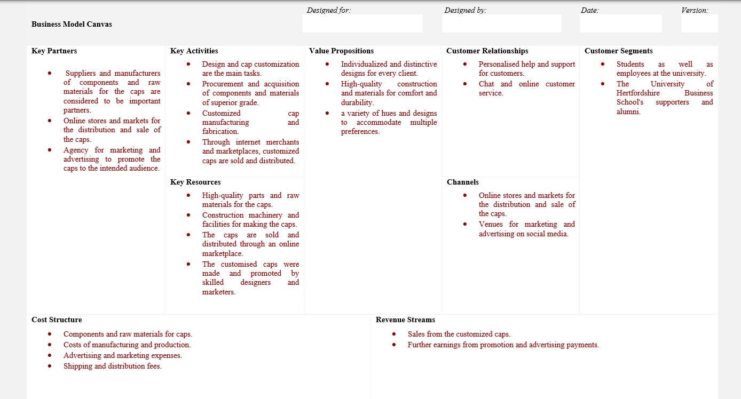

# 4.0 Type of ownership

A sole proprietorship, joint venture, corporation, and limited liability company are all acceptable forms of ownership for the new product, the customized cap. The number of company establishments, desired amount of liability protection, and tax consequences of the business will all affect the decision of ownership structure. For a small enterprise, a jv as well as sole proprietorship could be adequate, whereas a corporation and LLC could be better suited for a business that needs liability protection or is expected to grow. It is best to choose the ownership structure with the help of legal as well as financial experts.

# 5.0 Stakeholder analysis

A power-interest grid can be utilized to conduct an analysis of stakeholders for the novel product, the customized cap (Federo *et al*. 2020). On the basis of their effect and stake in the outcome of the project, this grid aids in identifying stakeholders. The University of Hertfordshire Business School as well as internet merchants are instances of high power and high interest stakeholders which call for attentive control and engagement. High-power but low-interest stakeholders, like some manufacturers and suppliers, can need surveillance but not serious engagement. Customers and designers are examples of low power but high interest stakeholders who could need to be included and communicated with in order to gain support. Stakeholders with low influence and little interest, like some suppliers, might only need a little attention. To maximise the success of the product, the power-interest grid aids in prioritising stakeholder interaction and management tactics.

# 6.0 Launch plan

Launch Plan for Customized Cap:

|  |  |  |  |  |  |  |  |  |
| --- | --- | --- | --- | --- | --- | --- | --- | --- |
| **Date of launch** | **Communication Channel** | **Brand and Positioning** | **Business and Marketing Objectives** | **Marketing Mix** | **Budget, Measures, and Controls** | **Time-Scaled Plan** | **Creative Promotional Message** | **Investment/Funding/Budget** |
| June 1, 2023 | Social media, email marketing, press release | Built around personalization and individuality | Achieve target revenue of $50,000 and acquire 500 customers | Product: range of customizable cap styles and colors; Price: competitive with similar products on the market; Promotion: social media advertising, email marketing, and influencer marketing; Place: primarily online retailers and marketplaces | Budget: $10,000; Measures and Controls: track performance through web analytics, social media metrics, and sales data; adjust campaigns based on performance | Develop a Gantt chart with key activities and milestones for the launch, including product development, marketing campaigns, and launch events | "Express Your Style, Make It Personal" | Investment and funding provided by the University of Hertfordshire Business School; Budget: $10,000, covering product development, marketing, and launch expenses |

## 6.1 Date and channels of interaction for the announcement

May 1, 2023, is the proposed day for the announcement of the new product's introduction. The announcement will mostly be communicated through press releases, email marketing, and social media (Danaher and Dagger, 2013). To connect with the target consumers and create anticipation for the release of our customised cap product, we will make use of our social media profiles, email list, and media outlets.

## 6.2 Positioning strategies

The customized cap, a newly launched product, will be positioned and branded with an emphasis on individuality and customization. The product will be positioned to give consumers distinctive, personalized headwear that let them show their personality and sense of style (Kalafatis *et al*. 2000). The company's name will be enhanced to appeal to individuals who respect individuality and style. The message in this situation will be that clients can convey themselves in a distinctive and personalized way with the product, showcasing their uniqueness. The company will be marketed as a high-end alternative for anyone looking for a distinctive and personalized product which is not offered in the mainstream market.

## 6.3 Business and marketing objectives

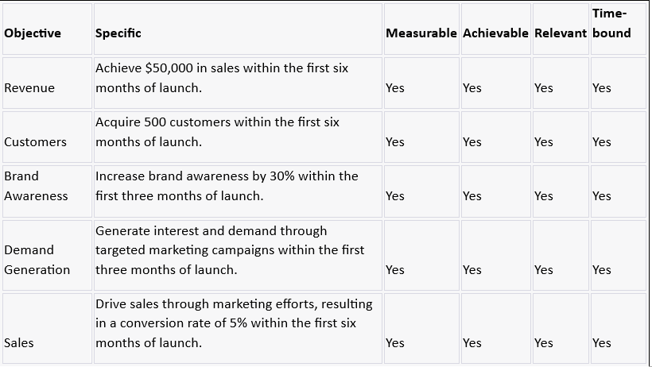

## 6.4 Marketing mix

The new product will have a product, price, promotion, and place marketing mix. The finished result will be a cap that can be customised with the client's wording or logo. The cost will be reasonable compared to other products of a similar nature. Advertising on social media, email marketing, as well as influencer marketing will all be used for promotion. The vital distribution channels will be online shops and markets. By utilizing the marketing mix, we will be able to provide a distinctive and personalized product to our target market while also ensuring competitive pricing, focused advertising, and practical distribution process.

## 6.5 Budget, measures, and controls

* The new customized cap launch will have a $50,000 budget. The costs associated with product development, marketing initiatives, and launch events will be covered by this budget.
* We will use sales statistics, social media measurements, and web analytics to assess the effectiveness of the marketing strategies. We'll keep tabs on the quantity of website visits, online interaction, email opens, rates of click-through, conversion rates, and earnings.
* To enhance outcomes, the campaigns will be managed on the basis of performance. Meetings are going to be held on a regular basis to assess the launch's progress and pinpoint potential enhancement places (Dominici, 2009). The major performance metrics will be compiled in a monthly report that will also offer insights into potential future campaigns.

## 6.6 Period -scaled plan

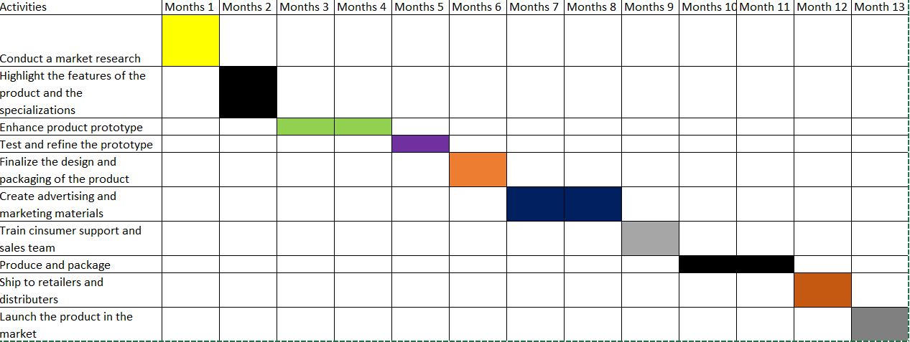

# 7.0 Creative highlight message

"***Show off your personal style! With our new customizable caps, you can express your individual personality. Make it yours and stand distinct from the crowd. Get hold of one of our limited-edition caps right away! Customizable caps that let you "#ExpressYourStyle #MakeItPersonal***”.

# 8.0 Budget

The University of Hertfordshire Business School will make the investment and offer the cash for the new service (Dahana, 2020). The launch will have a $10,000 budget, which will pay for marketing, product enhancement, and launch costs. The money will go towards creating and manufacturing the product, creating and putting into action marketing strategies, and organizing the debut event. Constant expense monitoring and performance-based marketing strategy adjustments will ensure effective budget management and enhance returns.

# 9.0 Conclusion

In conclusion, the introduction of the customized cap provides a fascinating chance to profit from the expanding trend of customization in the fashion business. We hope to increase interest in and demand for the product through the use of social media, email advertising, and press releases, generating a goal income of $50,000 in the initial 6 months of services. Confidence is related to the achievement of this product launch since it has a carefully thought-out marketing mix, budget, metrics, and controls. We will be able to accomplish our goals and build the brand in the market with the assistance of the University of Hertfordshire Business School's investment and launch funding.

# Reference list

Dahana, M.A., 2020. Analysis of The Budget Planning Process and Budget Execution Process. European Journal of Business and Management Research, 5(4).

Danaher, P.J. and Dagger, T.S., 2013. Comparing the relative effectiveness of advertising channels: A case study of a multimedia blitz campaign. Journal of Marketing Research, 50(4), pp.517-534.

Dominici, G., 2009. From marketing mix to e-marketing mix: a literature overview and classification. International journal of business and management, 4(9), pp.17-24.

Federo, R., Ponomareva, Y., Aguilera, R.V., Saz‐Carranza, A. and Losada, C., 2020. Bringing owners back on board: A review of the role of ownership type in board governance. Corporate Governance: An International Review, 28(6), pp.348-371.

Kalafatis, S.P., Tsogas, M.H. and Blankson, C., 2000. Positioning strategies in business markets. Journal of Business & Industrial Marketing, 15(6), pp.416-437.

Montoya-Weiss, M.M. and Calantone, R., 1994. Determinants of new product performance: A review and meta-analysis. Journal of product innovation management, 11(5), pp.397-417.