**WATER HEALTH PROTECTION**

**Table of Contents**

Introduction 3

Explaining the meaning of “Water Wise” 3

Problem regarding water health protection 4

Elucidating the water health protection perspective 4

Evaluating the monitoring or surveillance system to mitigate the issues 6

Analysing London’s water regulation as well as Policies 7

Comparing the water policies of London with national standards like WHO, SDG and other areas of water regulations 9

Conclusion 12

References 13

# Introduction

Water health protection is determined as actions for safeguarding and maintenance of the use of water with the management of the contribution of water resources. The study has examined the problems associated with “water health protection”. Besides this, the meaning of “water wise” is described in the study for the development of a clear understanding of water health protection. The water health protection procedure and support system based on the policies of London are implemented in this discussion. Supportive legislation for management of the weather health protection issues is discussed in this study with mitigation support from WHO and SDGs.

# Explaining the meaning of “Water Wise”

Habits of water-wise are defined as the use of water in a wise manner and saving the excess use or wastage of water. In addition, the elements effectively adopting lower supplements of water are identified as water-wise plants (Wang and Luo, 2021). Therefore, less wastage of water is known as the belief of the water-wise. Several examples of water-wise activities in the household are repairing the leakage water pipe and recycling polluted pipelines. Avoidance of the activity is polluting water and paying for effective water service showing the procedure for being water-wise. According to the view of Potgieter *et al.* (2020), “Conserve Water” as Waterwise behaviour helps in the conservation of the environment. Hence, management of the excessive use of water sources and avoidance of wastage of water is known as the concept of “water Wise”.

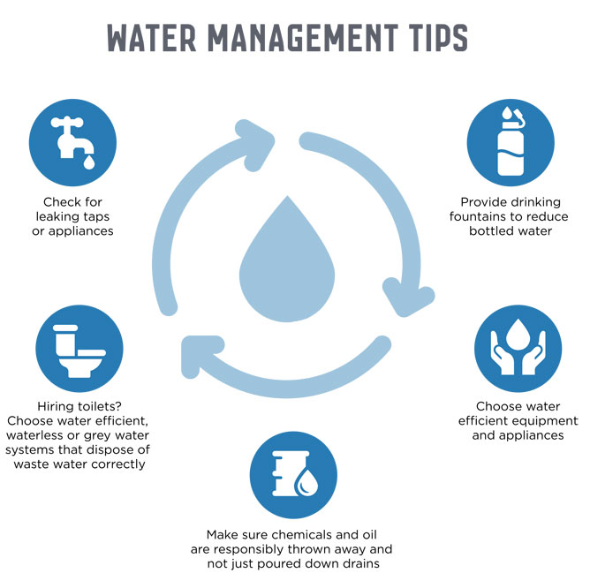

**Figure 1: Concept of “water-wise”**

(Source: Wang and Luo, 2021)

Wastage of water is identified as the main challenging factor for the management of water-wise behaviour. ***“Respecting water and life”*** is the main targeted aspect of the “water wise” which helps in the avoidance of excessive water use (Potgieter *et al.* 2020). However, adoption of the water waste reduction behaviour by raising awareness about the concept of “water-wise” helps in the management of water wastage.

# Problem regarding water health protection

The concept of ***“water safety and quality”*** established by WHO can be related to the beliefs of “water health protection”. WHO has shed light on several diseases which developed due to lack of sanitation which impacts the quality of the water. As an example, contaminated water where water health is interrupted is caused by ***“cholera, diarrhoea, dysentery, hepatitis A, typhoid and polio”*** (Who.int, 2023). However, human health is seriously impacted by problems arising from the lack of water health protection. As stated by Golden Kroner *et al.* (2019), three common problems or issues related to water health are ***“water pollution, wastage and low sanitation”*** which affect the health protection of the water systems. Additionally, economic and social factors are affected due to the presence of serious complications related to water health protection which is seen in the UK.

A huge amount of water wastage caused barriers to the "water-wise" concept which was examined in London. In 2023, the population of London used ***“2.6 billion litres per day”*** whereas, each day in the UK up to “3 billion” clean water was wasted (London.gov.uk, 2023). The risk of water pollution is similarly examined in the water of the county which caused problems related to “water health protection”. Besides this, ***“lack of awareness”*** about water-wise concepts and ignorance of the community increased the risk for “water health protection” in the selected country (Gannon *et al.* 2019). Lack of management of the water supply resources raises the risk of contamination which is severely seen in the low economic countries. Therefore, lack of management along with ignorance of the local government enhanced problems regarding water pollution management or similar context.

The water health crisis is seen all over the world which results in health complications for individuals. In the year 2022, up to ***“771 million people”*** are identified as suffering from the safe water crisis (Water.org, 2022). Therefore, the lack of safe water access and higher pollution are identified as serious issues seen related to health problems.

# Elucidating the water health protection perspective

Identification of a set of activities for the management of the health complications faced by the individual due to the water crisis is identified as “water health protection”. Improvement of the quality of the water sources helps in the health protection of individuals by management of the activities. According to the view of Li and Wu (2019), ***“communicable disease control; emergency preparedness, resilience and response (EPRR); and environmental public”*** are included as the three domains under health protection. Water crises and pollutants are causing several disease impacts on the health of the community where water health protection helps in the management of the complications. Besides this, the protection of “surface water health” helps in the management of community diseases caused by contaminated water (Igwegbe *et al.* 2021). Therefore, the application of the strategies support for management of the health of human beings with the establishment of “water-wise” behaviour.

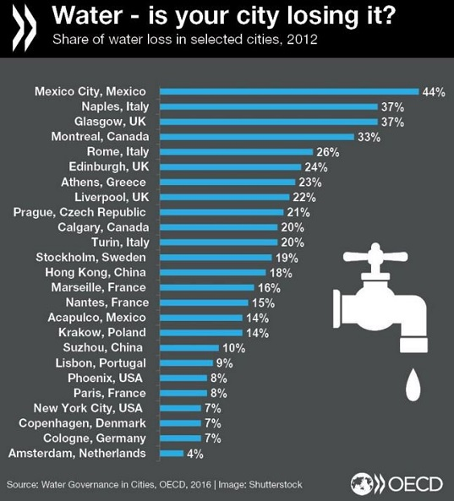

**Figure 2: Amounts of water waste in global cities**

(Source: Water.org, 2022)

Protection of surface water provides benefits to environmental health “Public health protection” applications are effectively helpful. WHO has implemented “SDG 6”, ***“Ensure access to water and sanitation for all”*** for water health protection at the community level (Who.int, 2023). The suggestive strategy for the protection of water health is the avoidance of harmful material disposal in the water sources for reduction of the water pollution. On the other hand, the development of “community awareness” is effectively helpful for volunteering communities to avoid water wastage. According to Li and Wu (2019), the perception of the water quality or health included “organoleptic preferences, chemical and microbiological contaminants, and perceived risks”. Therefore, management of the identified risk factors helps in the management of the complex issues of water health management.

Safeguarding the water sources is needed for the reduction of the health risk factors and management of the hazardous agent causing health issues in the community. One possible water protection strategy is "improvement of the quality and sources of drinking" which helps in the health protection of the community (Gannon *et al.* 2019). In addition, the management of water sources with effective safeguarding helps in the health protection of the water sources which improves the health of the water uses and community users. Therefore, the use of the “chemical and physical methods” helps in the determination of possible contamination in the water sources.

# Evaluating the monitoring or surveillance system to mitigate the issues

Monitoring and surveillance are crucial methods which are potentially important for scientists and researchers who help society to measure water pollution in a greater way. On the other hand, due to a lack of monitoring or measuring water pollution, the society and population are unable to identify the recent scenario of water health (Santos *et al*. 2021). Water pollution measurement is one of the potential factors and using this method, scientists and researchers identify the level of water pollution and aware individuals of the water health. There are different types of water health surveillance or monitoring processes like chemical monitoring, biological monitoring, physical monitoring, and technology implementation. By focusing on these monitoring or surveillance systems, scientists can measure the recent parameters of water health.

**Physical monitoring**

The physical monitoring process is one of the easiest ways to know the actual water quality. Focusing on sensory observations, including odour, water appearances, and steam bank composition, individuals can measure water health in an appropriate manner. Emphasising depth, water flow and stream width, individuals can detect recent parameters of water health. In this context, by recording colours of water, turbidity, dissolved solids, total solids, and suspended solids and detecting the changing colours and odours, researchers can identify water parameters. Detecting the presence of iron and manganese in water, scientists can monitor parameters and water health in a similar manner.

**Chemical monitoring**

The chemical water monitoring process is one of the potential and traditional "water quality" indicators which individuals mostly utilise. Monitoring the dissolved oxygen, temperature, pH balance, and nutrients, researchers have monitored water's parameters in an adequate manner (Hsiao and Sung, 2020). The "surface water chemistry" is another direct and potential indicator which is the effects of acid rain. There are some networks which monitor as well as measure surface water chemistry and the effects of chemicals in the water. This chemical monitoring process has provided long-term and valuable information on the ecosystem in aquatic health and analysed the ways the water bodies respond in order to change the chemical or "acid causing emissions".

**Biological monitoring**

Biological monitoring is the traditional process of water monitoring or surveillance systems. This process ensures the evaluation of recent conditions of habitants who live underwater like fishes and other different macroinvertebrates. Focusing on the biological monitoring process, scientists and individuals can find a useful tool which elucidates the present health parameters and condition of the aquatic or freshwater system. This process also assesses as well as monitoring the physical as well as chemical variables in these environments. Biomonitoring along with bioanalytics is an inseparable part of the water health monitoring process. This water monitoring process crucially assesses the present condition or status of water. Apart from that, the biomonitoring process utilises organisms that are characterised by "particular vulnerabilities to contaminants" (Garg *et al.* 2022). In order to collect data on water pollution, scientists and researchers forecast the impact of water pollution on individuals in a society.

**Technological innovations**

Technological innovations are one of the potential factors which help researchers as well as stakeholders to detect present scenarios of water health in the easiest manner. In this context, satellite imagery Earth Observation, remote sensing and smart sensors support scientists as well as individuals to identify all the activities which occurred in water like melting wastes from industry and activities of aqua animals and others (Elmustafa and Mujtaba, 2019). These technologies help individuals to detect the parameters of water in a tech-based, cost and time effective as well as and error-free manner. Hence, focusing on technology or digital innovation, chemical monitoring, and biological monitoring process, scientists and researchers have detected the present scenario of water pollution and its adverse impacts on society. After knowing different parameters along with the level of water pollution, individuals can maximise their water health awareness which positively impacts society.

# Analysing London’s water regulation as well as Policies

The water system of London is managed with sufficient water supply from “Thames, Lake Huron and Lake Erie”. The concept of “sustainable water sources” are applied in the city where ***“groundwater replenishment, Greywater recycling and rainwater harvesting”*** are included (Lecture). The treatment plants provide effective sources of water supply in London which is made up of “1620 kilometre” pipelines. The annual basic quality testing is done by the government of London for the protection of water health and to provide quality support to the local people. ***“The London Plan 2021”*** is developed for effective management of the use of water where ***“105 litres or less per person per day”*** is identified as the consumption amount (London.gov.uk, 2022). The plan is improved in the year 2024 when “WRMP24” for the identification of expected water resources use for the next 50 years. Therefore, the application of the measured plans helps the community people for effective water health management besides the presence of the water protection regulations.

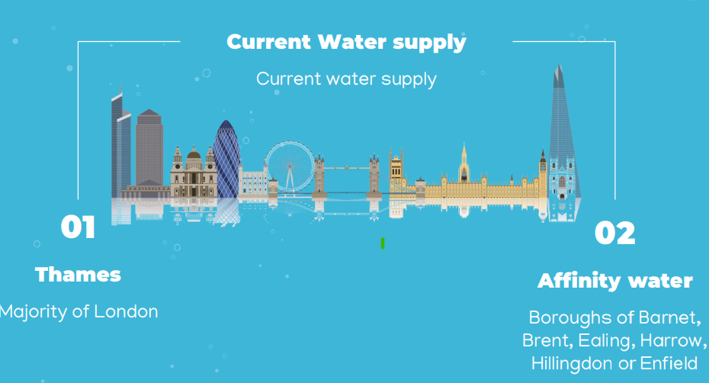

**Figure 3: Water supply in London**

(Source: Lecture)

The strategic solutions for water use are implemented by the government of London which is known as SROs. The plan for water use is implemented based on ***“Policy 5.15”*** which determined the amounts of water used in the residential development of the city (London.gov.uk, 2022). The water use and contamination protection Acts are applicable in London. As an example, the ***“Water Industry Act 1991”*** is the improved form of ***“The Water Act 1989”*** which developed with the duties of the sewerage and water company for quality services (London.gov.uk, 2023). In addition, the beliefs of the policy help in the safeguarding and quality improvement of the water source supplies in London. Therefore, the effective regulatory services of the government of London provide opportunities for improvement of the issues related to the use of “water sources”.

The developed SROs (strategic resource options) are established for water recycling, transfer and reservoirs for management of the wastage. Besides this, ***“The Trading and Procurement Code”*** is established by the water use controlling bodies for effective management of the services in London included in the regulations or policy support in London (Water.org, 2022). In the city “Municipal Act, 2001” is followed for establishing beliefs of “water by law” where charges and sources for water use in the city are described. Therefore, the regulations are followed in the city for the management of the charges associated with water resource use. “Sections 80, 81 and 437” are applied for the management of the supply of water in London whereas low-density use of the residential work is examined in the inclusion of the regulations. Hence, the water supply systems in the city are effectively managed with accuracy in the regulation and government legislation policy support.

# Comparing the water policies of London with national standards like WHO, SDG and other areas of water regulations

London is one of the most crucial and well-known cities in the UK which has crucially focused on its "water pollution" process. Emphasising water health, the Government of London along with the UK government has made and promoted some policies and strategic interventions in the domestic society. For instance, policy number 5.15 has entailed the water use and supplies policy (London.gov.uk, 2023). According to the policy, each person in London can use more or less 105-litre water per day which reduces the extreme water consumption from society (London.gov.uk, 2023). Apart from this policy, the Government also promoted the water resources programme which not only reduces the chances of freshwater pollution but also reduces the health issues of water habitats. On the other hand, sometimes due to a lack of implementation process, a policy may be unable to fetch maximum success. In this context, the "London Water" strategy plays a crucial role and it supports increasing water efficiency and decreasing water shortage and pollution in society. This London water strategy helps the city of London to combat environmental issues from the country and fulfil all the demands of water by tackling all the water problems.

London has maintained water health through different potential frameworks. In this context, the British Government has entailed that, the UK and London Government need to emphasise water policy which supports the country along with the city to find a sustainable water policy in an effective manner. Water companies in the UK have provided or delivered a public service to service users to maintain a modern standard of guide to the use of water by communities. In this context, the "Water Act 1991" plays a crucial role and concrete the water policies which help to manage water health in an appropriate manner (Ofwat.gov.uk, 2023). Apart from the local Governments and the UK government, the national standard authorities like WHO, UN and others have emphasised water health. Due to maintain water health and knowing the water parameters, the above-mentioned national authorities have promoted different rules and regulations which have delivered a fruitful framework regarding water health.

WHO (World Health Organisation) is one of the national bodies which also focuses on water health and security. Based on the present days, the amount of drinking water has decreased day by day which can make a potential water threat in future days (Zhang *et al*. 2020). In this context, the water policies and regulations support a society to combat water pollution and reduce issues from the health of surface water. WHO has proposed a range of guidelines like “drinking water quality guidelines”, “water sanitisation and hygiene”, “policy or action to improve the small water supply chain” and others (Who.int, 2023). These policies not only maintain the international norms regarding the quality of water but also reduce water pollution issues around the globe.

Emphasising "sanitisation and water use", the national authority has an emphasis on human health which is interrelated with water pollution. Due to an improper sanitisation process and inadequate waste management, water has been infected severely which maximises the chances of human health issues in the global society. Hence, following the guidelines of the "water sanitation and hygiene" policy by the WHO, individuals can enrich their awareness regarding water health and reduce water pollution from society (Who.int, 2023). Apart from the WHO, and local Governments of the UK and other countries around the globe, the UN (United Nations) has also made water policy to enrich the water health framework.

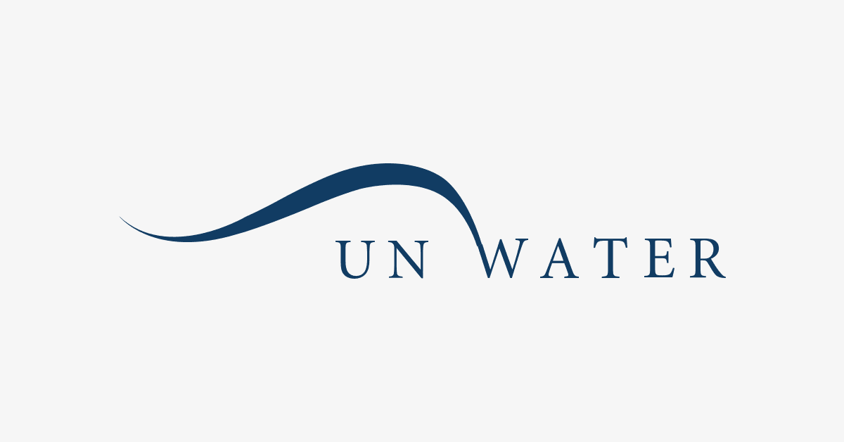

**Figure 4: UN Water policy**

(Source: Unwater.org, 2023)

The UN is one of the other national public organisations which has focused on water policies along with procedures. The UN water policy has focused on “UN-Water informs policies by identifying emerging issues and developing collaborative responses". As per the guidelines of the UN-Water policy, water costs need to be properly maintained by local Governments and it needs to be affordable. As per the "United Nations Development Programme (UNDP)" the water costs need not exceed 3% of the household income (Unwater.org, 2023). As a result of this, the US and other countries' stakeholders can find fresh water or drinking water within a stipulated cost.

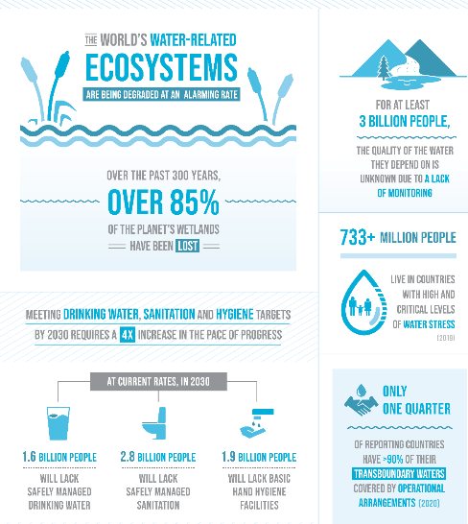

**Figure 5: Ensuring water sanitisation and sustainable water facilities**

(Source: Sdgs.un.org, 2023)

The UN water policy has emphasised water health which helps society to maintain water health in an effective manner. The United Nations has promoted some sustainable goals in order to protect the environment from any kind of hustle. In this context, water is one of the inseparable parts of nature and this is one of the natural resources which delivered SDG (Sustainable Development Goals) on water consumption and pollution. As per empirical evidence, the 6th goal of the SDG is "clean water and sanitisation" (Sdgs.un.org, 2023). Focusing on the water sanitisation goals, the UN delivers sustainable and resilient ways to protect water health in a similar manner and find better health along with hygiene in society.

# Conclusion

Water is one of the golden natural resources which help individuals in society to find a way to spend a life in a healthy way. However, based on the present day, water pollution and water shortage are some of the potential social threats which directly and indirectly affect human health. In this context, by focusing on water surveillance or monitoring systems, and maintaining some policies along with regulation of local and national authorities, a country as well as the globe can combat water pollution and also can maintain water health in an appropriate manner.

# References

Elmustafa, S.A.A. and Mujtaba, E.Y., (2019). Internet of things in smart environment: Concept, applications, challenges, and future directions. *World Scientific News*, *134*(1), pp.1-51.

Gannon, B.M., Wei, Y., MacDonald, L.H., Kampf, S.K., Jones, K.W., Cannon, J.B., Wolk, B.H., Cheng, A.S., Addington, R.N. and Thompson, M.P., (2019). Prioritising fuels reduction for water supply protection. *International Journal of Wildland Fire*, *28*(10), pp.785-803.

Garg, A., Yadav, B.K., Das, D.B. and Wood, P.J., (2022). Improving the assessment of polluted sites using an integrated bio-physico-chemical monitoring framework. *Chemosphere*, *290*, p.133344.

Golden Kroner, R.E., Qin, S., Cook, C.N., Krithivasan, R., Pack, S.M., Bonilla, O.D., Cort-Kansinally, K.A., Coutinho, B., Feng, M., Martínez Garcia, M.I. and He, Y., (2019). The uncertain future of protected lands and waters. *Science*, *364*(6443), pp.881-886.

Hsiao, S.J. and Sung, W.T., (2020). Building a fish–vegetable coexistence system based on a wireless sensor network. *IEEE Access*, *8*, pp.192119-192131.

Igwegbe, C.A., Aniagor, C.O., Oba, S.N., Yap, P.S., Iwuchukwu, F.U., Liu, T., de Souza, E.C. and Ighalo, J.O., (2021). Environmental protection by the adsorptive elimination of acetaminophen from water: A comprehensive review. *Journal of Industrial and Engineering Chemistry*, *104*, pp.117-135.

Li, P. and Wu, J., (2019). Drinking water quality and public health. *Exposure and Health*, *11*(2), pp.73-79.

London.gov.uk (2023), *Policy 5.15 Water use and supplies*. Available at: https://www.london.gov.uk/programmes-strategies/planning/london-plan/past-versions-and-alterations-london-plan/london-plan-2016/london-plan-chapter-five-londons-response/pol-14 [Accessed on: 25.04.2023]

London.gov.uk, (2022). Water Efficiency in New Developments. Available at: https://www.london.gov.uk/who-we-are/what-london-assembly-does/questions-mayor/find-an-answer/water-efficiency-new-developments#:~:text=The%20London%20Plan%202021%20contains,in%20commercial%20development%2C%20and%20through [Accessed on: 25.04.2023]

London.gov.uk, (2023). Water. Available at: https://www.london.gov.uk/programmes-strategies/environment-and-climate-change/climate-change/climate-adaptation/water-resources#:~:text=In%20London%20we%20use%20more,Hall%2026%20times%20every%20day. [Accessed on: 25.04.2023]

Ofwat.gov.uk (2023), *National legislation*. Available at: https://www.ofwat.gov.uk/regulated-companies/ofwat-industry-overview/legislation/#:~:text=The%20Water%20Industry%20Act%201991,Services%20Regulation%20Authority%20(Ofwat)). [Accessed on: 25.04.2023]

Potgieter, M.S.W., Faisal, A., Ikram, A. and Burger, M.C., (2020). Water-wise hand preparation–the true impact of our practice: A controlled before-and-after study. *South African Medical Journal*, *110*(4), pp.291-295.

Santos, J.I., Vidal, T., Gonçalves, F.J., Castro, B.B. and Pereira, J.L., (2021). Challenges to water quality assessment in Europe–Is there scope for improvement of the current Water Framework Directive bioassessment scheme in rivers?. *Ecological Indicators*, *121*, p.107030.

Sdgs.un.org (2023), *Ensure availability and sustainable management of water and sanitation for all.* Available at: https://sdgs.un.org/goals/goal6 [Accessed on: 25.04.2023]

Unwater.org (2023), *Inform Policies.* Available at: https://www.unwater.org/about-un-water/what-we-do/inform-policies [Accessed on: 25.04.2023]

Wang, X.C. and Luo, L., (2021). Water-wise cities and sustainable water systems: Current problems and challenges. *AND SUSTAINABLE WATER SYSTEMS*, p.25.

Water.org, (2022). A Health Crisis. Available at: https://water.org/our-impact/water-crisis/health-crisis/ [Accessed on: 25.04.2023]

Who.int (2023), *Water Sanitation and Health*. Available at: https://www.who.int/teams/environment-climate-change-and-health/water-sanitation-and-health/water-safety-and-quality/drinking-water-quality-guidelines [Accessed on: 25.04.2023]

Who.int, (2023). Drinking-water. Available at: https://www.who.int/news-room/fact-sheets/detail/drinking-water#:~:text=Water%20and%20health,individuals%20to%20preventable%20health%20risks. [Accessed on: 25.04.2023]

Zhang, Q., Xu, E.G., Li, J., Chen, Q., Ma, L., Zeng, E.Y. and Shi, H., (2020). A review of microplastics in table salt, drinking water, and air: direct human exposure. *Environmental Science & Technology*, *54*(7), pp.3740-3751.