**MANAGERIAL PERSPECTIVE ON GENDER STEREOTYPES AND THEIR IMPACT ON WOMEN'S CAREER PROGRESSION**

**Table of Contents**

Introduction 3

Conceptual discussion 5

Theoretical Discussion 7

Policy Critique 9

Factors of various gender stereotypes and lineage 11

Effect of Gender stereotypical practices on Women in the Workplace 12

Recommendation to resolve the issue for sustainable development 14

Conclusion 15

References 16

# Introduction

Gender stereotyping is a common practice that has been observed in the workplace environment in diversified social structures. It is the preconception about attributes and characteristics that men and women have to bear with the establishment of unfair beliefs (Breda *et al.* 2020). Stereotypical Practices in the Workplace shape managerial behaviour have established the organisational culture with patriarchial expectations and have developed discrimination practices against women to attain career growth. This practice has decreased the opportunity for women to attain a senior management position and has acted as a barrier to the progress of women.

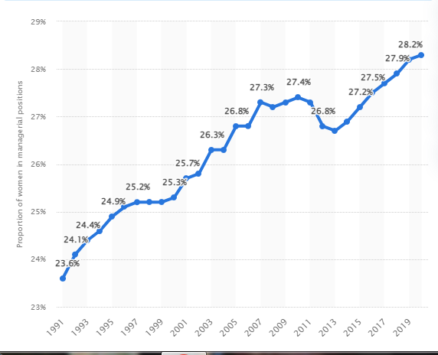

**Figure 1: Proportion of women in the managerial aspect**

(Source: Statista, 2020)

It has been evaluated from the above graph that in the year 2020 women's participation in managerial positions worldwide increased to 28.3% whereas it was 23.6% in the year 1991 (Statista, 2020). Though women nowadays are much welcomed to participate in the decision-making process and monitoring of the organisational operations in many of the modernised social environments yet the percentage of men and women in the managerial notion is not similar. This has ensured the fact that women are under-representatives at all levels of decision-making worldwide. Regarding evaluating the position of women in leadership and management positions, a survey has ensured that more women are leaving their workplaces being harassed by the new pipeline problems (Voss, 2021). Many of the women have faced issues like micro aggressions that have underpinned the authority about the hardships of women for decision making in advance. Moreover, many of the women are likely to be reported for their characteristics of being parents and did not get the support of employee wellbeing in comparison to men. 40% of the women associated with managerial activity have provided the review that their DEI is not being acknowledged (McKinsey, 2022). It eventually ends up stretching the leadership of women and 43% of women leaders are burned out in comparison to 31% of men at this managerial level. In search of flexible work environment women seeks different work culture which is not impacted by the stereotypical attributes of behaviour.

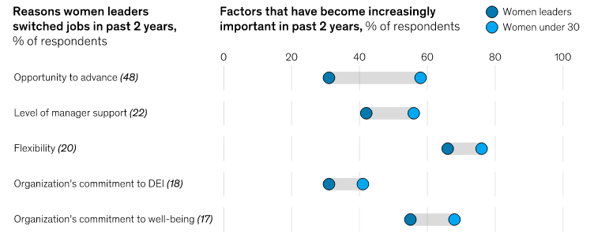

**Figure 2: Reasons behind women leaders to switch jobs**

(Source: McKinsey, 2022)

The above data has evidenced the fact that women leaders are switching their jobs over the last 2 years due to a lack of opportunities for career growth, less support from the management team, poor flexibility in the work environment, and less appreciation for DEI compared to men and poor commitment for women employee wellbeing (McKinsey, 2022). Stereotypical behaviour has shaped the workplace culture to such an extent that many women face not only biased decisions but also being bullied for their race, sexual orientation and aspects of identity.

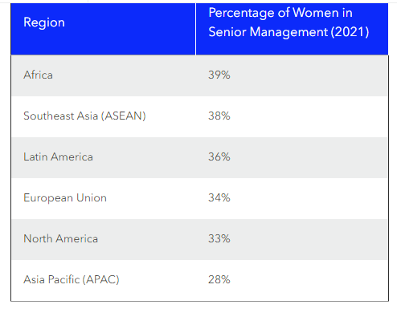

**Figure 3: Women in management**

(Source: Catalyst, 2023)

The graphical data, however, shows that in Africa 39% of the women are associated with senior management, 38% participation of women is observed in southeast Asia, 36% in Latin America, 34% in European Union and 33% in North America whereas the lowest ratio is observed in the Asia Pacific which is 28% (Catalyst, 2023). In the year 2020-21, a survey evaluated that men dominated at the senior management level in Australia, India, South Korea, Russia and Pakistan. Gender stereotyping has dominated the work culture and has deprived women to attain the process of career development and are harassed regardless of their organisational position. It has led women to face stress in the work environment and has been undergoing high levels of mental dissatisfaction and illness. It is the gender bias behaviour of the colleagues that have made women demotivated and demoralised to continue their work (Vong *et al.* 2019). However negative aspiration in the workplace for women has undermined their aspiration for success and the study, therefore, has demonstrated the conceptual discussion and policy critique based on gender Stereotypes and their impact on women's career progression in senior management.

# Conceptual discussion

In the words of Matud, López-Curbelo, and Fortes, (2019) gender is the socially developed norm that has identified girls, boys, men and women and other gender identities based on the psychological, social, cultural and behavioural aspects. It is a social construct that changes its perspective according to changes in society over time. In its very close reference comes the word sex which indicates the biological discrimination between men and women with physical distinctions and reproductive functions (Cirillo *et al.* 2020). Thus they are distinct concepts but in many societies, it enforces the notion that men and women are based on their physical characteristics whereas gender resembles identities, expressions, and societal roles of individuals.

Gender however has been defined as binaries and the people who have not been identified with the binaries may be defined to be non-binaries which include bigender, gender neutral and gender fluid. Gender roles in various societies are found to be rigid in comparison to others and are continuously changing with the stereotype shift over time. In this regard, Grissom and Reyes (2019) have stated that gender stereotypes are the viewpoint and perspective of people about the qualities, interests, and diversified actions of men and women that are commonly used to describe gender roles. Therefore it can be ensured that gender identity refers to the psychological notion of the individual represented as being male and female.

According to WHO, gender is a social construct that is different in various sociocultural practices and can be changed accordingly. Gender has a complex relationship between physical and mental health. WHO has highlighted the fact that the practice of gender stereotypes and stigmas has designed the healthcare experiences of the individual (Chang, and Yang, 2021). It eventually shapes the pathway for career and accountability with the inclusivity of the health system throughout the world. It eventually shapes the aspect of who an individual is feeling and how they express themselves to the outside world.

The conception of gender is based on five notions that include relation, hierarchy, contextual historical and institutional notions. It has been examined from the social behaviour that when a child is being born, they are tough with appropriate norms and behaviours that the social people want them to act throughout (Sanders, Turner and Metzler, 2019). It has been taught how an individual should interact with the opposite individual belonging to different sex within the household, community and even in workplaces. Any individual who is found to be misfitted in the established social norm, they have to face social stigma, different social exclusion and discriminatory practices that affect their psychological status and career development. International human rights have documented a definition of gender in article 3 that has explained that it has a socially constructed role and behavioural activity that the society feels is appropriate for men and women (UN.Org, 2022). This attribute and relationship are being developed by the social construct and are being learned through the socialisation process. Thus the major conception of gender is that it is the expectation of society from the individual and its decided values and norms for men and women in the given context.

Gender may appear to be a complicated idea but eventually, once biological discrimination is common every day among men and women being challenged, it has made it easier to understand gender. It is not necessarily being defined by the biological sex but is being internalised by the members of society. It varies across time and culture of diversified social construct that appreciates the stereotypical attributes with patriarchal expectations (Rosen and Nofziger, 2019). This has led to discrimination and violence mainly being faced by the weaker gender segmentation which is identified to be women being deprived of the opportunity for progress in career development.

# Theoretical Discussion

***Social role theory for gender stereotypes***

In the words of Schneider and Bos (2019), social role theory has been developed with an argumentative notion that gender stereotypes are being developed from the division of labour in the workplace as being characterised by society. It has been observed in many Western countries that men’s performances in the higher rank has been appreciated and are paid high for higher status. On the opposite side, there is a disproportionate opportunity for the nurturant role of female staff has created a stereotype in their behavioural aspect with men and communication with women.

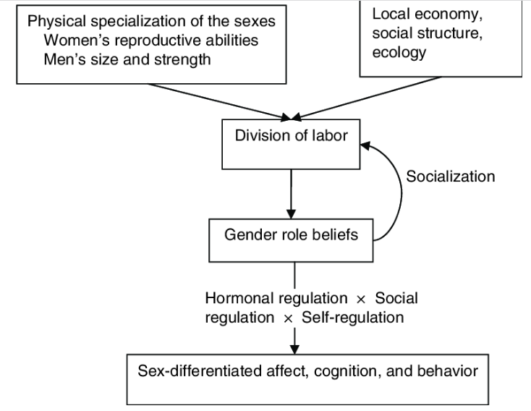

**Figure 4: Social role theory**

(Source: Schneider and Bos, 2019)

Stereotypical behaviour shapes the organisational structure and has developed expectations from men and women in different ways. In this regard, the social role theory plays a crucial role in establishing interaction of all the contexts and addressing assertive power-related behaviour (Mac Giolla and Kajonius, 2019). The theory has developed the notion that women can act more communally in general in comparison to men and should hold a less instrumental approach towards work. The application of the theory can trace the socialisation process and can somewhat impact personality development through their participation in diversified and complex social norms. Thus the social role theory is significant in analysing the role of stereotyped behaviour in the workplace that has restricted women to attain managerial positions for career growth.

***Cognitive Theory of Stereotypes for management practices***

According to Hall *et al.* (2019), the stereotype is a cognitive process that involves the association of characteristics within a group eventually justifying the reaction of the individual towards people of other groups. Cognition is the process of inputting information into the mind and focusing on the development of particular behavioural norms. It is related to nurturing the stereotypical aspect as a stereotype is the primary notion of their historical origin. It is the socialisation process of contact with experience that fosters the cognitive process that strengthens the behavioural norms.

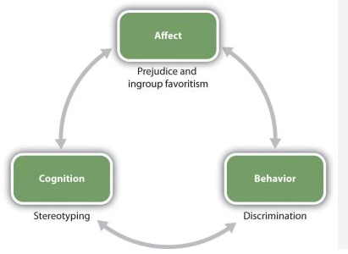

**Figure 5: Stereotype in the aspect of cognitive theory**

(Source: Cristofaro, 2020)

The cognition process of the individual is activated in each developing stage where the socialisation process automates the stereotypical attributes being controlled by the processing stage. The application of the cognitive theory of stereotype assists in understanding the social codes and can assist in understanding the mental categorisation of individuals. Thus it can be utilised to demonstrate the fact that it has deprived women to attain managerial positions in comparison to men due to patriarchal expectations in the workplace and brought barriers in the career progression of women being victims of stereotypical behaviour.

# Policy Critique

***Gender Stereotypes and Feminism***

The valuable decisions of an individual based on the duties and responsibilities of an individual are influential through the early stage of an individual. The application of the Gender Schema theory suggests that the disparity in gender roles is influenced due to the cultural values at the workplace. In the words of Dray *et al.* (2020), the ***Gender Schema theory*** explains the belief and knowledge of gender are based on the information and approaches of their past existence. Thus it can be identified that the existence of gender stereotypes in society or the workplace is reluctant upon the belief that the attributes of an individual are characterised on a certain level that is taught as a perspective and belief that makes the differences between male and female in the society or the workplace. For instance, one such difference that is being identified in the workplace is the gender pay gap.

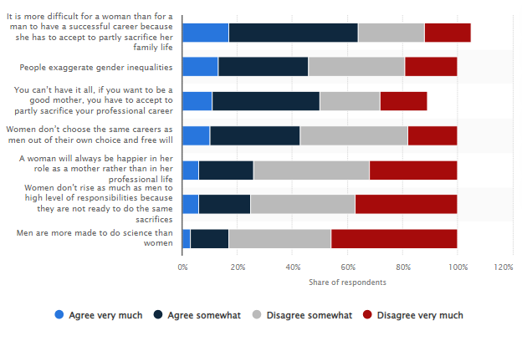

**Figure 6: Stereotypes of consequences faced by women in G7 countries**

(Source: Statista, 2022)

From the above figure, it can be identified that 17% of the women have considered that the notion of sacrificing their career for the family influences their decision in career progression (Statista, 2022). 11% of the women also agree that society considers that in order to be a good mother, women need to sacrifice their careers. This notion explains that the gender stereotype in society is thus influential in building a gap between men and women and it also acts as a barrier to career progression for women.

The root cause of feminism in society has been developed upon those gender stereotypes that have been acting as a barrier to women in their career progression. In the words of Malinowska (2020), there are different specified waves of feminism that have been acting upon different values in the workplace. The implication of third-wave of feminism is thus against the notion of masculinity seeking liberty, equal institutional reform against gender discrimination and many more, thus the prominent movement of feminism aims towards bringing a positive side with a view to provide equal opportunity to both men and women for their contribution towards the work rather than on the gender biases.

## Factors of various gender stereotypes and lineage

In terms of analysing the various components of gender stereotypes, various factors have been evaluated that have influenced the development of individual thinking and organisational setting. It has been identified that biological variants and cognitive processes have played a crucial role in confronting the gender stereotypical attributes that are being rooted throughout the evaluation of society.

***Individualised factor***

Individuals have developed behavioural facts and the physical disparities of the individuals have led towards the establishment of stereotypical behaviours. In the words of Wessel, Ellerich-Groppe and Schweda (2021), it is the aspect when an individual assumes certain standards and values in terms of shaping the way towards discrimination of behaviour according to colour, race, age, marital status, education and nationality. It has developed the aspect that perceptually distinctive features of individuals act as the foundation for stereotypical attributes. Classification is based on multiple variants that become prevalent where people have attained the opportunity to perceive newly evolved information received from a similar axis of categorization pushing the start of the stereotyping process. This has resulted in the outcome of the managerial perspective that women employees face social restrictions and prejudices as a result of being classified based on gender impeding their professional capabilities.

***Cognition factors***

Gender discrimination is imputed in the human brain and are being profoundly rooted in the evaluation of society. It has been observed that while processing the information about injecting social behaviour, it is the general tendency of individuals to verify the injected stereotypical idea with personal observation and investigation. Cognition is the factor that processes the gathered information from the socialisation process and personal observation and helps to recognise, understand and revise what they have heard, seen and verified throughout the cognition process (Martin and Slepian, 2021). It has led individuals to grow with a static and generalised perspective of what they learned and act accordingly in the work environment. It has brought the opportunity to practise stereotypical behaviour in the organisational setting and becomes judgemental by enrolling prejudices and inequality practices. Cognitive factor thus ensures stereotypical actions are being processed by a variety of memory mechanism and has shaped the behavioural aspect. Female employees are being judged based on their gender and certain expected norms associated with irrespective of their talents impeding their advancement.

***Family as a Factor***

Individual behaviour is influenced by its upbringing and thus family is the essential factor that has even contributed to nurturing stereotypical perspectives. In the infant stage, a girl child is taught to play with dolls and kitchen utensils whereas boys are taught to play with toy cars and cricket bats. This has imputed the concept to them that there are certain behavioural norms that society expects as the standard of behaviour and has regained their social interaction and behaviour. Thus it has been observed that gender stereotypes are learned in the early stage where family is the major pillar to input a child’s personality development. Girls and boys are being treated differently by their parents and family members and have unknowingly injected gender stereotypical connections in the growing stage of the child (Wang *et al.* 2019). Hence, they started to conceptualise the standard and practise them unconsciously at the professional stage to maintain a distinctive interaction process with male and female employees.

***Socio-cultural factor***

Stereotypical behaviour is entirely shaped by the social norms and the cultural practices of the social background of the individual. Individuals are developed in a patriarchal society where the participation of men is acknowledged and females face barriers to attaining career growth. Females are determined to be the weaker section of society and it has been generalised by the stereotypical aspect that they can be blamed for any misconduct in the organisation (Hessami and da Fonseca, 2020). It has brought negative experiences for women in the workplace and they have observed that there are biased attitudes toward male employees and fewer promotional offers to female employees. Thus it is the socio-cultural factor that has impacted the career growth of employees in the professional field.

## Effect of Gender stereotypical practices on Women in the Workplace

The duties and morality of the men and women in an organisation are the crucial areas that influence the decision of the organisation towards the treatment. In the words of Arora-Jonsson *et al.* (2019), an organisation's values are inclined towards taking the right and valuable decision when it comes to providing equal importance to both men and women in the organisation. However, it can be identified that gender stereotypes have been the common factor upon which biased decisions perpetually hamper the working environment. Upon understanding the concept of gender stereotypes, biases at the workplace influence the behaviour of the men or women working in an organisation. As per Lee *et al.* (2019), benevolent biases in the organisation are a considerably prejudiced form of biases expressed on assumption or belief. In this context, it can be identified that the foremost challenge a woman has to face in their career progression is the belief in restrictions based on assumptions that they have a family or she is a mother and cannot contribute more to the organisation.

A gender pay gap report in the US has resulted that 61% of women are paid differently as they are women and based on assumptions that they cannot make up to the contribution as much as the men in the organisation (Aragao, 2023). It explains the notion of the society upon which the influential decisions inclining more towards men can be observed. It can also be observed that gender biases also make an important factor in the decisions and outcomes of the organisation. It can be observed that gender biases are the tendency to give preferential treatment to one of the genders irrespective of their contribution. The outcome of the gender biases includes the gender pay gap, implicating sexism, and inequality which hamper the corporate culture. It can be identified that gender biases are a perspective of the organisation that supports gender stereotypes upon which the policy or regulation are being adhered in the organisation.

The outcome depending on the course of actions is considered to be the chosen value that creates gender biases in the organisation. In the words of Arora *et al.* (2021), ***congruency theory*** suggests that the organisation depends on cognitive understanding built on communication between the different levels of management, for instance, it can be identified that the trait of men with that of women is considered to be the main reason behind the differences in the organisation. For instance, it can be identified that only 36% of the senior roles in the organisation are occupied by women while only 14% of the firms are majorly owned by females (Statista, 2022). Thus it can be stated that the gender stereotypes in the organisation for women are considered to be the major reason behind the uneven distribution of power in the organisation.

## Recommendation to resolve the issue for sustainable development

The organisation needs to be oriented on the contribution of the employees associated with them rather than on making biased outcomes based on gender stereotypes. Therefore, it can be observed that the priority of the contribution can be valued at identifying the mutual understanding between the men and women based on their contribution rather than on gender biases. Therefore, in order to address gender disparity, the elimination of gender stereotypes needs to be the concerned place for the organisation. In the words of Stephens *et al.* (2020), a clear line of communication to understand the situation of women in the organisation can be useful to understand the concern of their decisions regarding their issues or providing them with equal opportunities which include fair compensation or promotion procedures based on the contribution or their dedication to the work.

The value of equal importance in the organisation becomes an important element in the organisation as it defines the cultural norms of the organisation (Azeem *et al.* 2021). Henceforth, in order to attain the organisational goals, it becomes important for the organisation, to recognise the responsibilities equally rather than based on gender stereotypes. In this aspect, it becomes duly important for the management to support the functional value for both men and women grounding on their decisions that can provide value to the organisation. Hence, it can be considered that the formulation of gender equality policy and set of standards needs to be consistently provided to provide valuable outcomes towards women in the workplace. It is important to understand, the voluntary participation of men and women has equal distribution to the society or the organisation and hence, it becomes an important aspect to support the valuable outcome based on their contribution.

Valuing transparency in the workplace can reduce gender disparity by providing a clear vision of the organisation's working procedures. It also becomes important for the organisation to maintain transparency with the assistance of a clear line of communication made with integrity and honesty with the employees as it helps the company to communicate freely with each other (Wan *et al.* 2020). It is more of a multifaceted solution that provides a mutual outcome to both the organisation and the staff associated with the organisation. Thus it becomes an important factor for the organisation to support the changes and thus provide equal value to the employees within the organisation setting. Recognising gender norms can be beneficial for the organisation to support the equal distribution of values as it becomes easier for the organisation to bring positivity to the work culture. In the words of Moldavska and Welo (2019), women representatives in the field can provide equal values towards sustainable growth. Hence it becomes important for an individual to understand the needs of women associative to understand the complexities of sustainable starts. The formulation of growth within the organisation can be worked upon by providing equal value to the employees in the organisation irrespective of their gender. Thus it can become an important aspect towards eliminating gender biases within the organisation setting. Hence, it can be stated that the valuable outcome from gender equality, cultivates the valuable outcome for the organisation as well as helps in reducing gender disparity which can contribute more towards the organisation's success.

# Conclusion

It can be summarised from the above discussion that gender stereotypes are hardships and prejudices that might have decreased over time yet have preconceptions that continue to impede the career progress of women. It has been observed from the global survey that only 28.2% of females are representatives of senior management which much low in comparison to men is working in diverse work fields. Females face unexpected behavioural issues and have an increased tendency to switch jobs in search of an inclusive and flexible work environment. The conceptual discussion has ensured that gender is the social belief that develops expectations from individuals to respond in a certain way. The theoretical discussion has demonstrated that social role theory and cognitive norms can be effective in analysing the aspect of stereotypical behaviour from a managerial perspective in the organisational setting. It has been detected from the policy critique that factors such as individual, family, cognitive process and socio-cultural aspects have shaped the stereotypical practices among individuals in the workplace. From the above discussion, it can be identified that gender stereotypes in the organisation have reluctantly impacted the organisation. The vulnerability of the impact has been valued as the demonstrated factors that have been impacting the organisation. In regard to the changes in the organisation, it has become an important place to enforce those men and women should be provided with equal opportunities where societal roles and values need to be included as the place of contribution. The apprentices based on the stereotypical behaviour that defines that they should carry a less instrumental approach towards work need to be eliminated from society. Thus it becomes the primary notion for the organisation or the society towards women to provide them with equal apprentices that can be valued equally within the organisation setting.

# References

Aragao, (2023). *Gender pay gap in U.S. hasn’t changed much in two decades.* Available at: <https://www.pewresearch.org/fact-tank/2023/03/01/gender-pay-gap-facts/> (Accessed on 13th April 2023).

Arora, N., Prashar, S., Tata, S.V. and Parsad, C., (2021). Measuring personality congruency effects on consumer brand intentions in celebrity-endorsed brands. *Journal of Consumer Marketing*.

Arora-Jonsson, S., Agarwal, S., Colfer, C.J.P., Keene, S., Kurian, P. and Larson, A.M., (2019). SDG 5: gender equality–a precondition for sustainable forestry. *Sustainable development goals: their impacts on forests and people,* pp.146-177.

Azeem, M., Ahmed, M., Haider, S. and Sajjad, M., (2021). Expanding competitive advantage through organizational culture, knowledge sharing and organizational innovation. *Technology in Society, 66*, p.101635.

Breda, T., Jouini, E., Napp, C. and Thebault, G., (2020). Gender stereotypes can explain the gender-equality paradox. *Proceedings of the National Academy of Sciences*, *117*(49), pp.31063-31069.

Catalyst, (2023). *Women in management*. Available at: <https://www.catalyst.org/research/women-in-management/> (Accessed on 13th April 2023).

Chang, C.H. and Yang, F., (2021). How gender stereotypes impact health information seeking intention: insights from an implicit association test. *Cogent Social Sciences*, *7*(1), p.1999614.

Cirillo, D., Catuara-Solarz, S., Morey, C., Guney, E., Subirats, L., Mellino, S., Gigante, A., Valencia, A., Rementeria, M.J., Chadha, A.S. and Mavridis, N., (2020). Sex and gender differences and biases in artificial intelligence for biomedicine and healthcare. *NPJ digital medicine*, *3*(1), p.81.

Cristofaro, M., (2020). “I feel and think, therefore I am”: An Affect-Cognitive Theory of management decisions. *European Management Journal*, *38*(2), pp.344-355.

Dray, K.K., Smith, V.R., Kostecki, T.P., Sabat, I.E. and Thomson, C.R., (2020). Moving beyond the gender binary: Examining workplace perceptions of nonbinary and transgender employees. *Gender, Work & Organization, 27*(6), pp.1181-1191.

Grissom, N.M. and Reyes, T.M., (2019). Let’s call the whole thing off: evaluating gender and sex differences in executive function. *Neuropsychopharmacology*, *44*(1), pp.86-96.

Hall, E.V., Hall, A.V., Galinsky, A.D. and Phillips, K.W., (2019). MOSAIC: A model of stereotyping through associated and intersectional categories. *Academy of Management Review*, *44*(3), pp.643-672.

Hessami, Z. and da Fonseca, M.L., 2020. Female political representation and substantive effects on policies: A literature review. *European Journal of Political Economy*, *63*, p.101896.

Lee, N., Madotto, A. and Fung, P., (2019), August. Exploring Social Bias in Chatbots using Stereotype Knowledge. In *WNLP@ ACL* (pp. 177-180).

Mac Giolla, E. and Kajonius, P.J., (2019). Sex differences in personality are larger in gender equal countries: Replicating and extending a surprising finding. *International Journal of Psychology*, *54*(6), pp.705-711.

Malinowska, A., (2020). Waves of Feminism. *The international encyclopedia of gender, media, and communication, 1*, pp.1-7.

Martin, A.E. and Slepian, M.L., (2021). The primacy of gender: Gendered cognition underlies the big two dimensions of social cognition. *Perspectives on Psychological Science*, *16*(6), pp.1143-1158.

Matud, M.P., López-Curbelo, M. and Fortes, D., (2019). Gender and psychological well-being. *International journal of environmental research and public health*, *16*(19), p.3531.

McKinsey, (2022). *Women in workplace*. Available at: <https://www.mckinsey.com/featured-insights/diversity-and-inclusion/women-in-the-workplace> (Accessed on 13th April 2023).

Moldavska, A. and Welo, T., (2019). A Holistic approach to corporate sustainability assessment: Incorporating sustainable development goals into sustainable manufacturing performance evaluation. *Journal of Manufacturing Systems, 50*, pp.53-68.

Rosen, N.L. and Nofziger, S., (2019). Boys, bullying, and gender roles: How hegemonic masculinity shapes bullying behavior. *Gender Issues*, *36*(3), pp.295-318.

Sanders, M.R., Turner, K.M. and Metzler, C.W., (2019). Applying self-regulation principles in the delivery of parenting interventions. *Clinical child and family psychology review*, *22*, pp.24-42.

Schneider, M.C. and Bos, A.L., (2019). The application of social role theory to the study of gender in politics. *Political Psychology*, *40*, pp.173-213.

Statista, (2020). *Women in managerial position worldwide*. Available at:<https://www.statista.com/statistics/1259478/women-in-managerial-positions-worldwide/#:~:text=As%20of%202020%2C%20women%20accounted,23.6%20of%20managers%20were%20women> (Accessed on 13th April 2023).

Statista, (2022). *Share of respondents from G7 who agree on stereotypes about women in 2021.* Available at:<https://www.statista.com/statistics/1219071/stereotypes-about-women-among-the-g7-countries/> (Accessed on 13th April 2023).

Statista, (2022). *Workplace gender gap worldwide in 2020, by type.* Available at: <https://www.statista.com/statistics/1212189/workplace-gender-gap-worldwide-by-type/#:~:text=According%20to%20the%20Global%20Gender,firms%20had%20majority%20female%20ownership>. (Accessed on 13th April 2023).

Stephens, K.K., Jahn, J.L., Fox, S., Charoensap-Kelly, P., Mitra, R., Sutton, J., Waters, E.D., Xie, B. and Meisenbach, R.J., (2020). Collective sensemaking around COVID-19: Experiences, concerns, and agendas for our rapidly changing organizational lives. *Management Communication Quarterly, 34*(3), pp.426-457.

UN. Org, (2022). *Universal declaration of Human rights*. Available at: <https://www.un.org/en/about-us/universal-declaration-of-human-rights#:~:text=Article%203,liberty%20and%20security%20of%20person> (Accessed on 13th April 2023).

Vong, S., Ros, B., Morgan, R. and Theobald, S., (2019). Why are fewer women rising to the top? A life history gender analysis of Cambodia’s health workforce. *BMC health services research*, *19*, pp.1-9.

Voss, B.L., (2021). Documenting cultures of harassment in archaeology: a review and analysis of quantitative and qualitative research studies. *American Antiquity*, *86*(2), pp.244-260.

Wan, P., Chen, X. and Ke, Y., (2020). Does corporate integrity culture matter to corporate social responsibility? Evidence from China. *Journal of Cleaner Production, 259*, p.120877.

Wang, L., Zheng, Y., Li, G., Li, Y., Fang, Z., Abbey, C. and Rozelle, S., 2019. Academic achievement and mental health of left-behind children in rural China: A causal study on parental migration. *China Agricultural Economic Review*.

Wessel, M., Ellerich-Groppe, N. and Schweda, M., (2021). Gender stereotyping of robotic systems in eldercare: An exploratory analysis of ethical problems and possible solutions. *International Journal of Social Robotics*, pp.1-14.