**UNDERSTANDING AND LEADING CHANGE**

Table of Contents

Scenario and Activity 1: 3

A brief overview of two companies 3

Review those examples of organisational change and their impact on its business operations. 3

Organisational change is driven by both internal and external factors 4

Analyse drivers for change and types of organisational change 7

Change can affect leadership and individual behaviour in both organisations 8

Critically evaluate the long-term implications of change on organisational behaviour. 10

Scenario and Activity 2 12

Forces for Change: 12

Force field analysis can be used to understand the influence of driving and resisting forces 14

Recommend change leadership approaches and models to change initiatives for given situations 17

Analyse the use of leadership approaches and models for given situations. 17

Critically analyse leadership approaches and models to understand drivers and resisting forces 18

Reference list 19

# Scenario and Activity 1:

## A brief overview of two companies

An important American airline that provides domestic and international travel is Delta Carriers. The COVID-19 pandemic significantly reduced passenger demand, which resulted in a decline in Delta Air Lines' income. To reduce expenses and retain its financial health, the airline had to implement a variety of actions, including shrinking the size of its fleet, halting flights to specific destinations, and decreasing its employees (Anderson, 2019). The organisational change was necessary at Delta Air Lines as a result of changes in the external environment, such as travel restrictions and a decline in passenger demand. The association is required to alter its hierarchical structure, strategy, and operational procedures to achieve its aims.

The Ford Motor Company is a multinational manufacturer and designer of SUVs, trucks, and automobiles. The COVID-19 pandemic resulted in lower revenue and sales for Ford Motor Company. The company had to take several measures, including reducing its workforce, suspending production at some plants, and reducing its capital expenditures, to cut costs and maintain its financial stability (Appio *et al.* 2019). The need to adapt to changes in the outside environment, such as a decline in vehicle interest and disruptions to the production network, was the driving force behind the hierarchical shift at Portage Engine Organization.

## Review those examples of organisational change and their impact on its business operations.

**Delta Air Lines:**

The organisational changes that Delta Air Lines implemented due to the COVID-19 pandemic had a significant impact on its business operations. The reduction in workforce and fleet size enabled the organisation to reduce costs and improve operational efficiency (Arbour and Riley, 2019). The association was likewise ready to focus on its central business and further develop its tasks thanks to the suspension of trips to specific areas. However, these shifts also harmed the organisation. The reduced workforce and remote work options decreased employee engagement and output.

**Ford Motor Company:**

The organisational changes that Ford Motor Company implemented due to the COVID-19 pandemic had a significant impact on its business operations. The reduction in workforce and capital expenditures enabled the organisation to reduce costs and improve operational efficiency (Babich, 2019). Due to the suspension of production at specific plants, the company was also prepared to concentrate on its core business and expand its tasks. Nonetheless, these shifts likewise adversely affected the association (Bavishi *et al.* 2020). The diminished labour force and remote work choices diminished representative commitment and results.

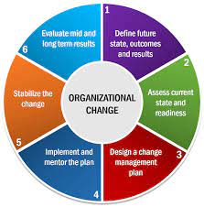

**Figure 1: Types of organisational shares**

(Source: https://www.tinypulse.com,)

## Organisational change is driven by both internal and external factors

**Burke-Litwin Model:**

The Burke-Litwin model is a widely used framework for analysing organisational change. It identifies twelve factors that influence organisational performance and change. These factors are grouped into two categories: transformational and transactional. The transformational factors are external and include mission and strategy, leadership, organisational culture, and external environment (Bellouin et al. 2019). The transactional factors are internal and include structure, systems, management practices, work climate, and individual needs and values.

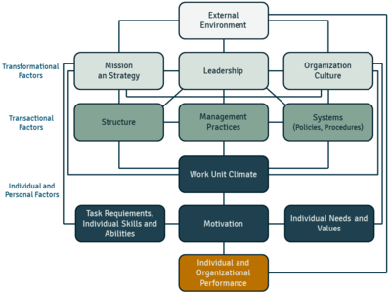

**Figure 2: Burke-Litwin Model**

(Source: https://ceopedia.org,)

**Drivers of Change for Delta Air Lines:**

The drivers of change for Delta Air Lines can be analysed using the Burke-Litwin model as follows:

**Transformational Factors:**

Mission and Strategy: The COVID-19 pandemic was the main driver of change for Delta Air Lines. The organisation had to adapt to the changing external environment by suspending flights to certain destinations and reducing its fleet size.

Organisational Culture: The remote work arrangements and reduced workforce led to a change in the organisational culture at Delta Air Lines (Bocken et al. 2019). The focus shifted to operational efficiency and cost reduction.

* External Environment: The COVID-19 pandemic was the primary driver of change for Delta Air Lines, and it had a significant impact on the external environment of the organisation. The reduction in demand for air travel and increased safety protocols resulted in a need for the organisation to adapt to the changing environment.

**Transactional Factors:**

* Structure: The reduction in fleet size and suspension of flights to certain destinations led to a change in the organisational structure at Delta Air Lines.
* Systems: The organisation had to adapt its systems to the changing external environment by implementing safety protocols and reducing capacity.
* Management Practices: The management practices at Delta Air Lines had to be adapted to the changing external environment (Cameron and Green,2019). The focus shifted to cost reduction and operational efficiency.
* Work Climate: The remote work arrangements and reduced workforce led to a change in the work climate at Delta Air Lines.

**Drivers of Change for Ford Motor Company:**

**The drivers of change for Ford Motor Company can be analysed using the Burke-Litwin model as follows:**

**Transformational Factors:**

* Mission and Strategy: The COVID-19 pandemic was the main driver of change for Ford Motor Company (Clayton, 2020). The organisation had to adapt to the changing external environment by suspending production at certain plants and reducing capital expenditures.
* Leadership: The leadership at Ford Motor Company played a critical role in implementing the changes necessary to survive the pandemic. The leadership team had to make difficult decisions regarding workforce reduction and cost-cutting measures.
* Organisational Culture: The remote work arrangements and reduced workforce led to a change in the organisational culture at Ford Motor Company. The focus shifted to operational efficiency and cost reduction.
* External Environment: The COVID-19 pandemic was the primary driver of change for Ford Motor Company, and it had a significant impact on the external environment of the organisation (Cohen et al. 2020). The supply chain disruptions and reduced demand for automobiles resulted in a need for the organisation to adapt to the changing environment.

**Transactional Factors:**

* Structure: The suspension of production at certain plants led to a change in the organisational structure at Ford Motor Company.
* Systems: The organisation had to adapt its systems to the changing external environment by implementing safety protocols and reducing production capacity.
* Management Practices: The management practices at Ford Motor Company had to be adapted to the changing external environment (Deszca et al. 2019). The focus shifted to cost reduction and operational efficiency.

## Analyse drivers for change and types of organisational change

**Delta Air Lines:**

**Drivers for change:**

At Delta Air Lines, the primary drivers of change were external factors like the COVID-19 pandemic's decrease in demand for air travel, the need to comply with health and safety regulations, and the suspension of flights to certain destinations (Dobson and Douglas, 2020). The organisation was constrained by these external factors to modify its tasks and decision-making to maintain its seriousness and guarantee the safety of its representatives and customers.

**Types of organisational change**:

The majority of Delta Air Lines' organisational change was planned because the company needed to make strategic decisions to concentrate on its core business while reducing its workforce and fleet size (Farahnak et al. 2020). However, there might have been emergent aspects of the change, like the need to quickly adapt to the changing external environment.

**Initiated or imposed change:**

The majority of Delta Carriers' changes were initiated by the association, which exercised control over its decisions to focus on its core business and reduce its workforce and armada size (Fleischmann et al. 2020). However, it is possible that some aspects of the change were imposed, such as the requirement to abide by health and safety regulations imposed by the government.

**Ford Motor Company:**

**Drivers for change:**

External factors like the COVID-19 pandemic's reduction in automobile demand, supply chain disruptions, and the need to adhere to health and safety regulations were the primary drivers of change at Ford Motor Company (Foretz et al. 2019). Because of these outside factors, the association had to adjust its tasks and dynamics to diminish the effect of store network interruptions on its business activities and guarantee the security of its clients and representatives.

**Types of organisational change:**

The majority of the organisational change at Ford Motor Company was planned because the company needed to make strategic decisions to focus on its core business and cut back on its workforce and capital expenditures. However, there might have been emergent aspects of the change, like the need to quickly adapt to the changing external environment.

**Initiated or imposed change:**

The majority of Ford Motor Company's transformation was initiated by the company, which exercised control over its decisions to concentrate on its core business and reduce capital expenditures and workforce (Hanelt et al. 2023). However, it is possible that some aspects of the change were imposed, such as the requirement to abide by health and safety regulations imposed by the government.

## Change can affect leadership and individual behaviour in both organisations

**Delta Air Lines:**

**Leadership:**

The leadership of Delta Air Lines had to quickly adjust to the changing environment and make decisions quickly to cut costs while simultaneously ensuring the safety of its employees and customers to remain competitive. The pioneers needed to talk to representatives and customers about the changes in activities and make sure that they were done well and successfully.

**Individual behaviour:**

The change at Delta Air Lines may have had multiple effects on individual behaviour. It's possible that employees' morale and motivation were impacted as a result of concerns about their future career prospects and job security (Jansson and Hofmockel, 2020). In any case, the need to adjust to the changing climate and add to the outcome of the association might have likewise spurred a few workers.

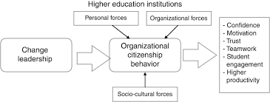

**Figure 3: Organisational change and its impact**

(Source: https://www.emerald.com,)

**Ford Motor Company:**

**Leadership:**

To cut costs and focus on its core business while also adapting to the changing environment, the Portage Engine Organization had to make crucial decisions (Manning and Curtis 2019). Leaders needed to communicate effectively with employees and suppliers to ensure that the operational changes were carried out in a way that was both efficient and effective.

**Individual behaviour:**

Individual ways of behaving may have been impacted in different ways by Passage Engine Organization's change. It's possible that employees' morale and motivation were impacted as a result of concerns about their future career prospects and job security (Masson-Delmotte et al. 2021). In any case, the need to adjust to the changing climate and add to the outcome of the association might have likewise spurred a few workers.

**Minimise negative impacts of change on organisational behaviour**

Communication: During authoritative change, viable correspondence is fundamental. Representatives ought to be educated about the explanations behind the change and what it will mean for them by pioneers in standard and open correspondence (Nordhaus, 2019). This may be beneficial for motivation, uncertainty, and anxiety

**Positive:**

Improved work satisfaction and productivity can result from persuasive correspondence, which can reduce employee anxiety, and vulnerability, and inspire men.

**Negative:**

Especially during times of rapid change, effective communication can take time and a lot of effort from leaders.

Training and Development: Associations can give preparation and advancement chances to assist workers with adjusting to new jobs and obligations. Workplace contentment and resistance to change may both benefit from this.

**Positive:**

Preparing and advancement open doors that can increment worker abilities and information, prompting better work execution and efficiency.

**Negative:**

Training and development can be expensive and time-consuming, and may not be effective if the change is sudden or unexpected.

## Critically evaluate the long-term implications of change on organisational behaviour.

**Positive implications:**

Changes in an organisation can have a positive impact on employee satisfaction and motivation, innovation, productivity, and performance (Sattler et al. 2019). it may result in a more adaptable and enduring organisation that is better prepared to respond to upcoming opportunities and challenges.

**Negative implications:**

Authoritative change can likewise prompt unfortunate results like expanded pressure, uneasiness, burnout among representatives, expanded turnover, and diminished confidence. Additionally, it may result in resistance to change, which may further disrupt the operations of the organisation.

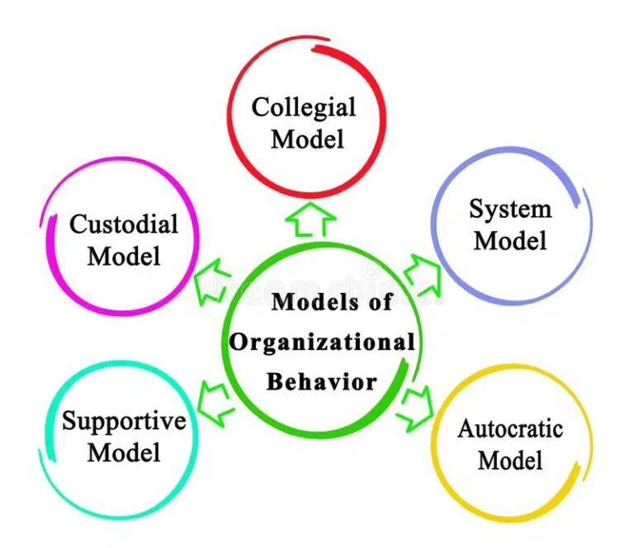

**Figure 4: Organisational behaviour model**

(Source: https://legalpaathshala.com,)

**Impact on culture:**

The culture of an organisation can be impacted by organisational change, which can have long-lasting effects. Values, beliefs, and norms can shift as a result of changes in leadership, structure, and procedures. If it is not handled properly, this can result in cultural clashes and a decrease in employee motivation and morale.

**Impact on employees:**

Employees may experience significant changes. The change may make employees feel anxious or stressed, which may make it harder for them to do their jobs well. It may also have an impact on their career prospects and job security (Schewel, 2020). To lessen the negative effects of change, businesses must offer employees assistance and resources.

**Impact on customers and stakeholders:**

Hierarchical change can likewise affect clients and partners. Changes in item contributions, evaluating, or client assistance can affect client dependability and fulfilment. It can likewise affect the association's standing and associations with partners.

The long-term implications of change on organisational behaviour can be significant and varied. While change can lead to positive outcomes such as improved performance and productivity, it can also have negative consequences such as increased stress, resistance, and decreased morale.

**The following recommendations can be made to minimise the negative impacts:**

* Communicate successfully: During times of change, communication that is open and honest is essential. The reasons for the change, the timetable, and the expected outcomes ought to be made abundantly clear to leaders. This will build employee trust and reduce rumours and misunderstandings.
* Include workers: Employees should be as involved as possible in the change process. This can be accomplished by conducting surveys, focus groups, and regular feedback sessions (Tapley et al. 2019). Employee participation in decision-making and problem-solving can also help to reduce resistance and increase buy-in.
* Assist: For employees, change can be stressful and disruptive. Associations ought to offer help assets like directing, preparing, and instructing to assist workers with adapting to the change. The negative effects on productivity and employee well-being will be reduced as a result of this.

# Scenario and Activity 2

## Forces for Change:

1. The COVID-19 Epidemic: The Coronavirus pandemic fundamentally affects the aeronautics business, including Delta Carriers. The pandemic has prompted a reduction popular of air travel, bringing about critical misfortunes for the carrier. To lessen the pandemic's impact, Delta Air Lines has had to modify its business practices and strategies.
2. Developments in technology: Delta Air Lines must keep up with technological advancements to remain competitive in the rapidly changing aviation industry.
3. Needs of the customer: Clients are turning out to be seriously requesting and anticipating an elevated degree of administration from carriers (Woolway et al. 2020). To maintain its position in the market, Delta Air Lines must adapt to shifting customer demands.

**Forces against Change:**

1. Protection from change: Representatives and administrators might oppose change because of anxiety toward vulnerability, employment misfortune, or absence of confidence in authority.
2. Culture in the workplace: Delta Carriers has serious areas of strength for a culture, which can be trying to change. The culture emphasizes customer service, dependability, and safety.
3. Norms and regulations: The flying business is profoundly controlled, and Delta Aircraft needs to agree with administrative necessities, which can restrict the speed of progress.

**Change Leadership Approaches and Models:**

1. Adaptive management: Delta Air Lines has overcome the difficulties of the COVID-19 pandemic by employing adaptive leadership. Agility, resiliency, and the capacity to adapt to change are emphasised in adaptive leadership.
2. Model of Lewin for Change Management: Delta Air Lines has successfully implemented changes by utilising Lewin's model (Yoder-Wise, P.S. and Sportsman, 2022). The model emphasizes moving to a desired state, refreezing the new state, and creating a sense of urgency.
3. Eight-step change model by John Kotter: Delta Air Lines has successfully implemented change by utilising Kotter's model. The model places an emphasis on establishing a vision for change, building a coalition, and creating a sense of urgency.

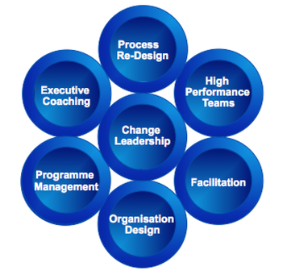

**Figure 5: Organizational change leadership model**

(Source: https://www.corumconsultancy.com,)

**Impact on Leadership Decision-Making:**

The powers for and against change can essentially affect the authority dynamic in associations. The COVID-19 pandemic has forced leadership at Delta Air Lines to modify its operations and strategies to lessen its impact. Nonetheless, protection from change and hierarchical culture can make it difficult to execute changes successfully, and administrative prerequisites can restrict the speed of progress (Hayes, 2022).To effectively overcome these obstacles and drive change, the leadership of Delta Air Lines has utilised adaptive leadership and change management models like Lewin's model and Kotter's 8-step model. By making a need to get going, building an alliance, and laying out a dream for change, Delta Carriers' initiative has had the option to effectively carry out changes and adjust to the difficulties of the flight business.

## Force field analysis can be used to understand the influence of driving and resisting forces

Because it had a significant impact on the aviation industry, the COVID-19 pandemic was a major catalyst for change for Delta Air Lines. Delta Air Lines' business operations were negatively impacted by the pandemic's impact on air travel. Delta Air Lines had to make a few changes to lessen the impact of the pandemic.

**Driving forces:**

1. External factors like the COVID-19 pandemic and its impact on the aviation industry caused a decline in air travel and a reduction in the organisation's revenue.
2. The need to adjust to changes in client conduct and inclinations, like a shift towards a web-based booking and contactless travel choices.
3. the necessity of offering novel goods and services, such as the introduction of a brand-new premium economy class, to maintain market competition.

**Resisting forces:**

1. Employee resistance stemmed from employees' reluctance to accept shifts in their work roles and environment out of fear of job loss.
2. The company struggled to make investments in innovative technology due to financial constraints.
3. The opposition from the association's way of life and design, made it try to execute changes that conflicted with the laid-out standards and practices.

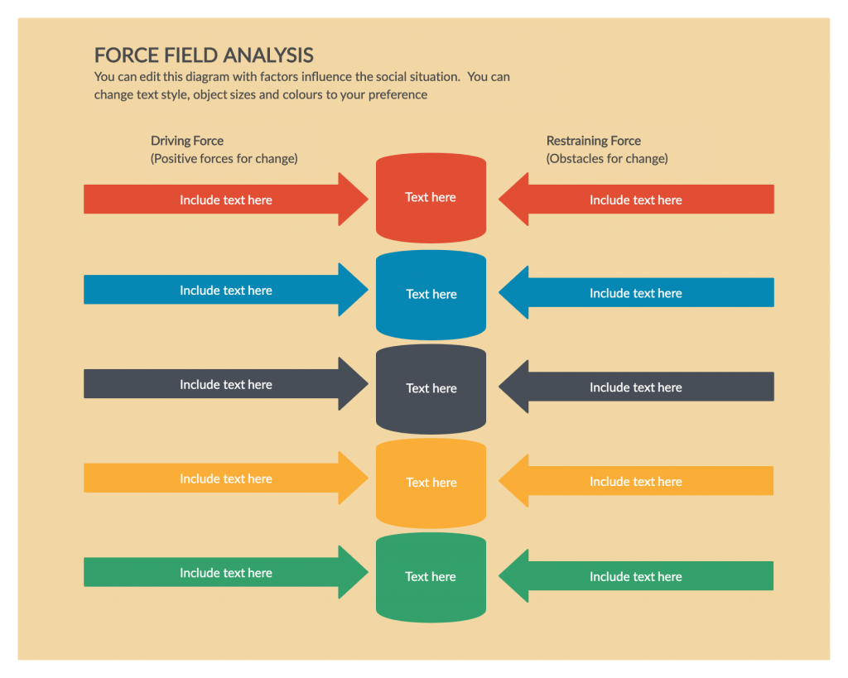

**Figure 6: force field analysis**

(Source: https://creately.com,)

The driving and contradicting powers impact the authority dynamic in affiliations. Trailblazers need to perceive and assess the different powers and cultivate systems to let the antagonistic result free from contradicting powers while using the primary purposes to achieve the best chance. Delta Air Lines' management had to make difficult decisions to cut costs by reducing capacity and furloughing employees. They additionally needed to put resources into new advances and administrations to stay aware of the evolving market.

The ADKAR model, Kotter's 8-Step Change Model, and Lewin's Change Management Model are three models of change leadership that can help leaders manage change effectively. The three phases of Lewin's Change The Executives Model are as per the following: changing, thawing, and freezing again (Lavallee et al, 2020). To prepare the organisation for change, the model says that leaders must unfreeze the current state, implement the change, and then refreeze the new state to make it permanent. In Kotter's 8-Step Change Model, making a need to keep moving, shaping a strong alliance, fostering a dream for change, imparting the vision, giving others the position to follow up on the vision, creating momentary successes, merging additions and achieving more change, and laying out new methodologies as a component of the association's way of life is fundamental stages. There are five phases to the ADKAR model: care, need, data, limit, and backing.

## Recommend change leadership approaches and models to change initiatives for given situations

1. Participation and communication: The reasons for the change, the benefits of the change, and how the change will be implemented should all be made clear to employees and other stakeholders by Delta Air Lines (Kanehisa *et al.* 2022). To get the buy-in and commitment of stakeholders and employees, they should engage. This approach will assist with lessening opposition and increment support for change.
2. Leadership that can change things: The practice of transformational leadership entails inspiring and motivating employees to realise the organisation's vision. Delta Carriers ought to take on this initiative methodology by making an unmistakable vision of the ideal future state, putting forth objectives, and motivating representatives to pursue accomplishing those objectives.

## Analyse the use of leadership approaches and models for given situations.

A transformational leadership approach was one type of leadership strategy utilised by Delta's leadership. Ed Bastian, CEO of Delta, presented a crystal clear vision for the company's future and established objectives that were consistent with that vision. He additionally inspired representatives to pursue this vision and urged them to contemplate answers for the difficulties looked by the organisation. Employees' sense of purpose and commitment were fostered through this strategy, which was crucial to overcoming the pandemic's obstacles.

One more administration approach that was utilised by Delta's initiative was a nimble methodology. Delta immediately adjusted to the changing conditions of the pandemic by carrying out new approaches and techniques to guarantee the security of travellers and representatives (Kanehisa, 2019). The organisation additionally executed innovations and cycles to work with remote working and virtual joint efforts. This approach permitted Delta to be adaptable and make acclimations to the change interaction on a case-by-case basis.

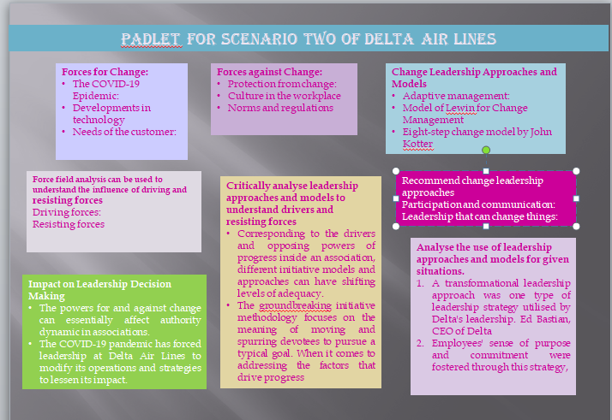

**Figure 7: Padlet for Delta Airlines**

(Source: Self-created)

## Critically analyse leadership approaches and models to understand drivers and resisting forces

Corresponding to the drivers and opposing powers of progress inside an association, different initiative models and approaches can have shifting levels of adequacy. In this section, I will discuss two approaches to administration, specifically the revolutionary authority approach and the possibility authority approach, which are comparable to the forces driving and opposing progress.

The groundbreaking initiative methodology focuses on the meaning of moving and spurring devotees to pursue a typical goal. When it comes to addressing the factors that drive progress, such as a hope for the future or the need to adapt to changing conditions, this strategy can be persuasive (O'Cathain et al. et al. ). By inspiring and motivating their followers, transformational leaders can instil a sense of purpose and commitment in them. This can assist with beating protection from change.

In any case, it's conceivable that the groundbreaking authority approach will not be as compelling at managing protection from change, like an absence of confidence in authority or a feeling of dread toward the unexplored world. Employees might get the impression that the leaders aren't paying attention to their concerns or that the future vision isn't realistic. To address these contradicting powers and gain representative help, it could be important to embrace a more participative initiative style in such examples.

# Reference list

**Journal**

Anderson, D.L., 2019. *Organization development: The process of leading organizational change*. Sage Publications.

Appio, F.P., Lima, M. and Paroutis, S., 2019. Understanding Smart Cities: Innovation Ecosystems, technological advancements, and societal challenges. *Technological Forecasting and Social Change*, *142*, pp.1-14.

Arbour, K.C. and Riely, G.J., 2019. Systemic therapy for locally advanced and metastatic non–small cell lung cancer: a review. *Jama*, *322*(8), pp.764-774.

Babich, N., 2019. How VR in education will change how we learn and teach. *Recuperado el*, *18*.

Bavishi, C., Maddox, T.M. and Messerli, F.H., 2020. Coronavirus disease 2019 (COVID-19) infection and renin angiotensin system blockers. *JAMA Cardiology*, *5*(7), pp.745-747.

Bellouin, N., Quaas, J., Gryspeerdt, E., Kinne, S., Stier, P., Watson‐Parris, D., Boucher, O., Carslaw, K.S., Christensen, M., Daniau, A.L. and Dufresne, J.L., 2020. Bounding global aerosol radiative forcing of climate change. *Reviews of Geophysics*, *58*(1), p.e2019RG000660.

Bocken, N., Boons, F. and Baldassarre, B., 2019. Sustainable business model experimentation by understanding ecologies of business models. *Journal of Cleaner Production*, *208*, pp.1498-1512.

Cameron, E. and Green, M., 2019. *Making sense of change management: A complete guide to the models, tools and techniques of organizational change*. Kogan Page Publishers.

Clayton, S., 2020. Climate anxiety: Psychological responses to climate change. *Journal of anxiety disorders*, *74*, p.102263.

Cohen, J., Zhang, X., Francis, J., Jung, T., Kwok, R., Overland, J., Ballinger, T.J., Bhatt, U.S., Chen, H.W., Coumou, D. and Feldstein, S., 2020. Divergent consensuses on Arctic amplification influence on midlatitude severe winter weather. *Nature Climate Change*, *10*(1), pp.20-29.

Deszca, G., Ingols, C. and Cawsey, T.F., 2019. *Organizational change: An action-oriented toolkit*. Sage Publications.

Dobson, G.J. and Douglas, G., 2020. Who would do that role? Understanding why teachers become SENCos through an ecological systems theory. *Educational Review*, *72*(3), pp.298-318.

Farahnak, L.R., Ehrhart, M.G., Torres, E.M. and Aarons, G.A., 2020. The influence of transformational leadership and leader attitudes on subordinate attitudes and implementation success. *Journal of Leadership & Organizational Studies*, *27*(1), pp.98-111.

Fleischmann, S., Mitchell, J.B., Wang, R., Zhan, C., Jiang, D.E., Presser, V. and Augustyn, V., 2020. Pseudocapacitance: from fundamental understanding to high power energy storage materials. *Chemical Reviews*, *120*(14), pp.6738-6782.

Foretz, M., Guigas, B. and Viollet, B., 2019. Understanding the glucoregulatory mechanisms of metformin in type 2 diabetes mellitus. *Nature Reviews Endocrinology*, *15*(10), pp.569-589.

Hanelt, A., Bohnsack, R., Marz, D. and Antunes Marante, C., 2021. A systematic review of the literature on digital transformation: Insights and implications for strategy and organizational change. *Journal of Management Studies*, *58*(5), pp.1159-1197.

Jansson, J.K. and Hofmockel, K.S., 2020. Soil microbiomes and climate change. *Nature Reviews Microbiology*, *18*(1), pp.35-46.

Manning, G. and Curtis, K., 2019. *The art of leadership*. McGraw-Hill Education.

Masson-Delmotte, V., Zhai, P., Pirani, A., Connors, S.L., Péan, C., Berger, S., Caud, N., Chen, Y., Goldfarb, L., Gomis, M.I. and Huang, M., 2021. Climate change 2021: the physical science basis. *Contribution of working group I to the sixth assessment report of the intergovernmental panel on climate change*, *2*.

Nordhaus, W., 2019. Climate change: The ultimate challenge for economics. *American Economic Review*, *109*(6), pp.1991-2014.

Sattler, T., Zhou, Q., Pollefeys, M. and Leal-Taixe, L., 2019. Understanding the limitations of cnn-based absolute camera pose regression. In *Proceedings of the IEEE/CVF conference on computer vision and pattern recognition* (pp. 3302-3312).

Schewel, K., 2020. Understanding immobility: Moving beyond the mobility bias in migration studies. *International Migration Review*, *54*(2), pp.328-355.

Tapley, B.D., Watkins, M.M., Flechtner, F., Reigber, C., Bettadpur, S., Rodell, M., Sasgen, I., Famiglietti, J.S., Landerer, F.W., Chambers, D.P. and Reager, J.T., 2019. Contributions of GRACE to understanding climate change. *Nature climate change*, *9*(5), pp.358-369.

Woolway, R.I., Kraemer, B.M., Lenters, J.D., Merchant, C.J., O’Reilly, C.M. and Sharma, S., 2020. Global lake responses to climate change. *Nature Reviews Earth & Environment*, *1*(8), pp.388-403.

Yoder-Wise, P.S. and Sportsman, S., 2022. *Leading and Managing in Nursing E-Book*. Elsevier Health Sciences.

Allan, B.A., Batz-Barbarich, C., Sterling, H.M. and Tay, L., 2019. Outcomes of meaningful work: A meta‐analysis. *Journal of management studies*, *56*(3), pp.500-528.

Hayes, J., 2022. *The theory and practice of change management*. Bloomsbury Publishing.

Sesana, E., Bertolin, C., Gagnon, A.S. and Hughes, J.J., 2019. Mitigating climate change in the cultural built heritage sector. *Climate*, *7*(7), p.90.

Lavallee, J.M., Soong, J.L. and Cotrufo, M.F., 2020. Conceptualizing soil organic matter into particulate and mineral‐associated forms to address global change in the 21st century. *Global change biology*, *26*(1), pp.261-273.

Kanehisa, M., 2019. Toward understanding the origin and evolution of cellular organisms. *Protein Science*, *28*(11), pp.1947-1951.

O'Cathain, A., Croot, L., Duncan, E., Rousseau, N., Sworn, K., Turner, K.M., Yardley, L. and Hoddinott, P., 2019. Guidance on how to develop complex interventions to improve health and healthcare. *BMJ open*, *9*(8), p.e029954.