**BIO4315 Health Protection**

**SUMMATIVE ASSESSMENT**

**EFFECTS OF NANOPLASTICS ON WATER**

Table of Contents

Introduction 2

Concept of Nanoplastics 2

Mechanism of Nanoplastic as a Source of Chemical Pollution 3

Statistics of Nanoplastics towards causing Global Water Pollution 6

State-of-the-art Technical and Scientific Approach towards Reducing Nanoplastic-based Pollution 8

Relevant Policy Implication for reduced Nanoplastic-based Pollution 14

Possible Future Recommendations 16

Conclusion 17

References 18

# Introduction

Chemical pollution can be mainly referred to as any kind of contamination caused within the environment due to chemicals that are not found naturally. Chemical pollution is known to have devastating impacts on the overall balance of the Earth’s ecosystem. In this context, this study aims to explore the environmental impacts of chemical pollution caused by nanoplastics. Appropriate scientific descriptions have been provided to determine the key chemical components within the material that cause the reported environmental impacts. Furthermore, appropriate statistical evidence specifically related to water pollution has been provided. Key state-of-the-art technological and scientific approaches undertaken to mitigate nanoplastic pollution have been described. Additionally, relevant policy implications for reducing nanoplastic pollution have been identified as well. Based on this, appropriate future recommendations have been provided to control nanoplastic pollution and associated impacts.

# Concept of Nanoplastics

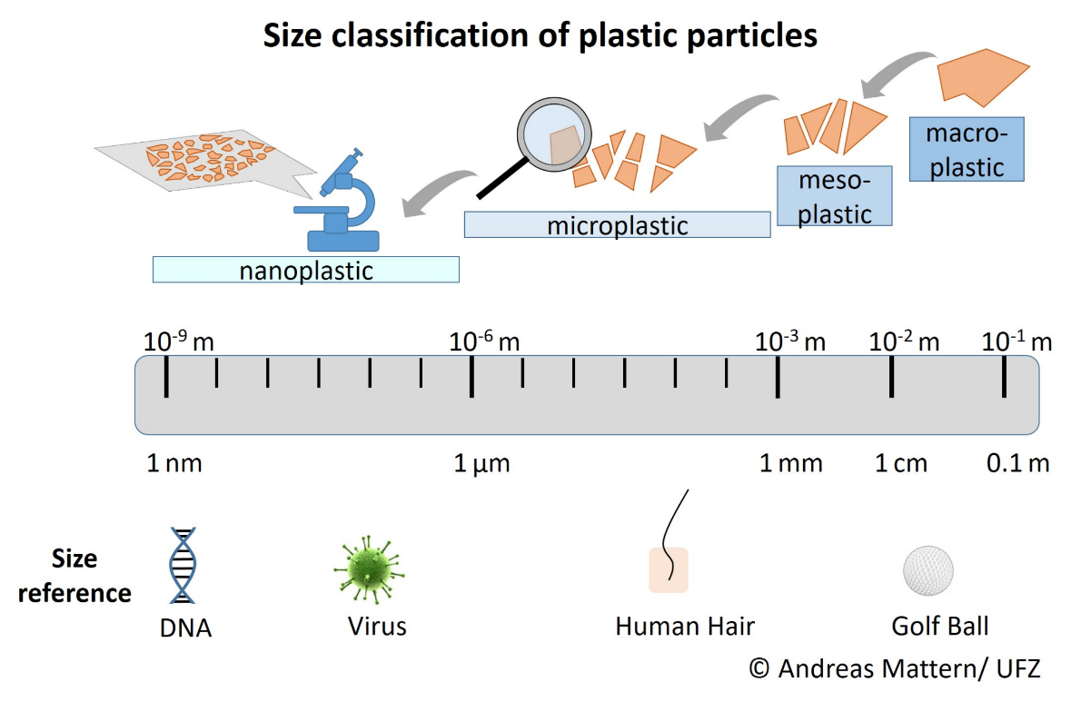

**Figure 1: Size classification of plastic particles**

(Source: DaNa, 2023)

Nanoplastics are formed due to varied forms of plastic contamination, prevalent within the aquatic environment. Nanoplastics are primarily defined as synthetic polymers having dimensions ranging from 1 nm to 1 μm (Lai *et al.* 2022). The presence of nanoplastics within different kinds of aquatic environments is identified as the main vector of toxic contaminants and related issues. Similar to microplastics, nanoplastics are also determined to be associated with various forms of dangerous chemical agents and substances, thereby leading to potential hazards. Nanoplastics can mainly cause contamination within the water environment through the transportation of different harmful pathogens and desorption of toxic chemicals (Tran *et al.* 2022). Additionally, nanoplastics can also readily absorb toxic substances, including antibiotic agents and heavy metals.

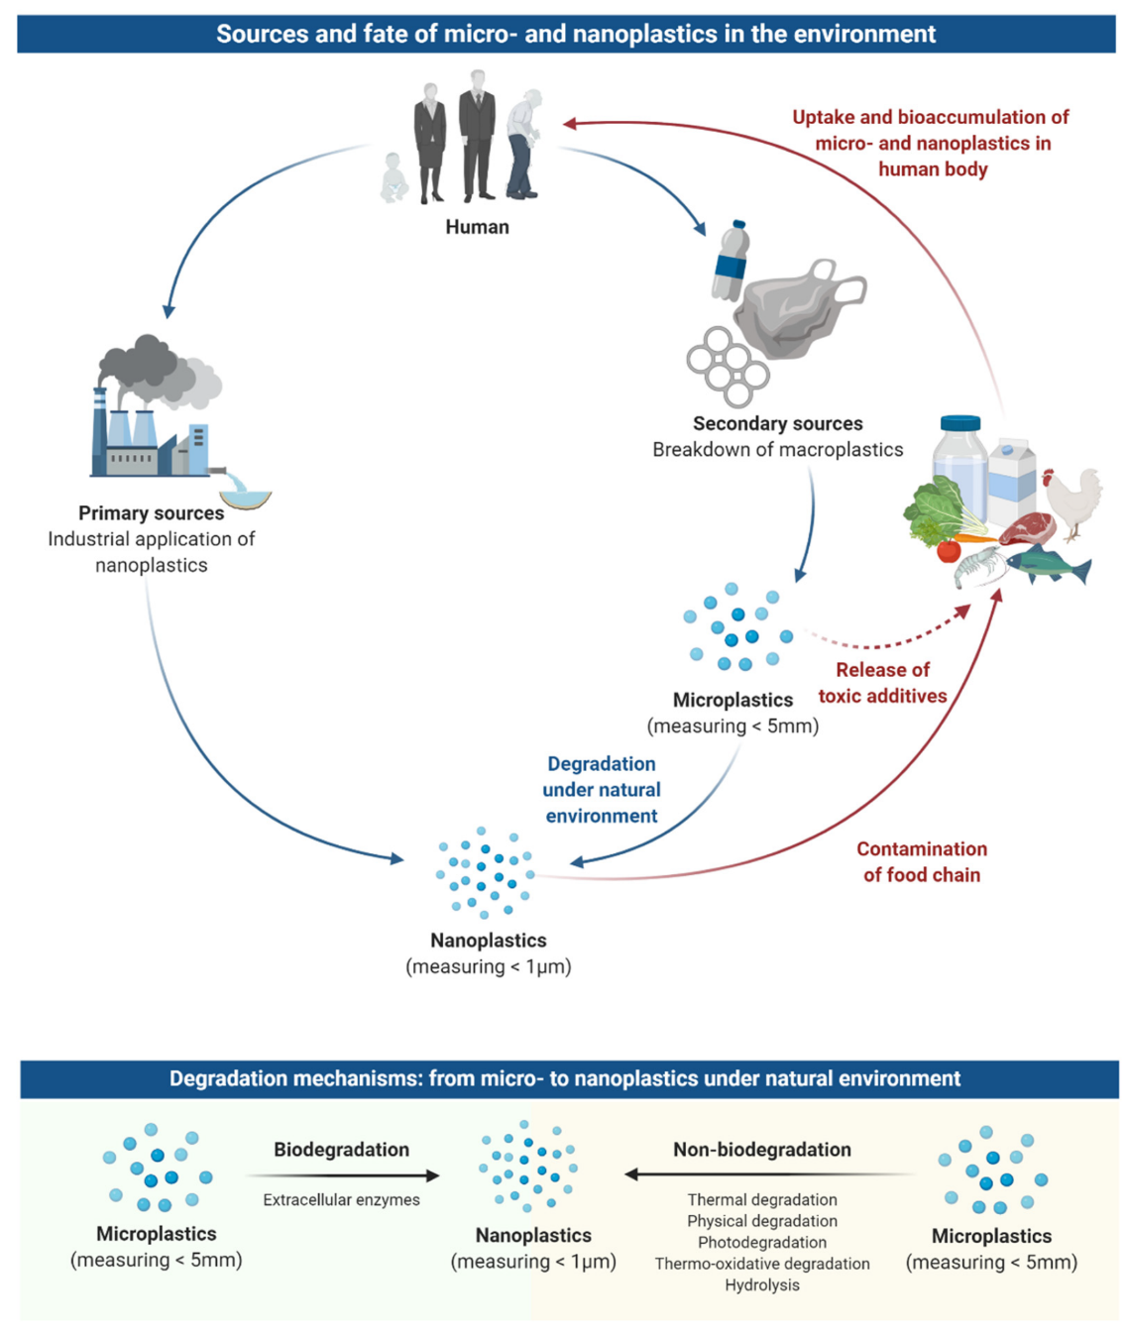

**Figure 2: Source of nanoplastic and nanoplastic pollution**

(Source: Yee *et al.* 2021)

# Mechanism of Nanoplastic as a Source of Chemical Pollution

Longer nanoplastic exposure in the environment could result in accumulation and ingestion by the aquatic organism. Nanoplastic exposure could provoke the immune cells of the human body to secrete cytokines as major inflammation initiators. Its response is particular to certain polymers as well as particle shapes. In the opinion of Shen *et al.* (2019), plastic particles that range between 1μm to 5 mm that could be considered microplastic, while less than 1 μm are considered nanoplastics. Nanoplastic is the tiny synthetic polymers that are found in the environment and drinking water and food. “TEM (Transmission electron microscopy)” is an important technique to characterize electron microscopy. This technique has a high potential for nanoplastics characterization. As per the view of Jeong *et al.* (2018), its measurement could as well be performed in a high vacuum that is less than 10-4 Pa. The insulating coating of carbon or metal is frequently required for developing the quality.

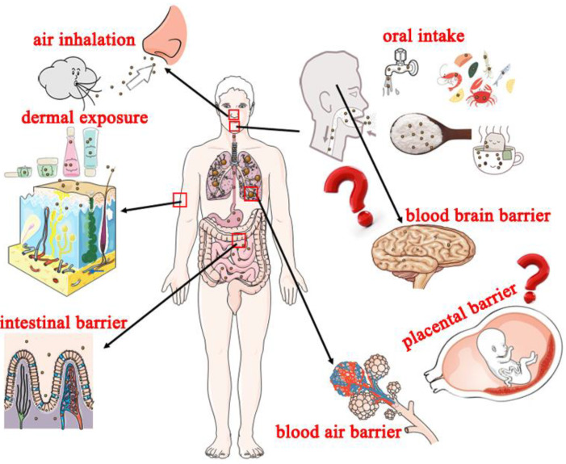

**Figure 3: Routes of potential exposure and adverse effect of the nano plastics in the human body**

(Source: Influenced by Shen *et al.* 2019)

The plastic particles of nanoplastic range between 1 nm to 1 μm that represent the emerging and relevant topic in food science and environmental science. Nylon, acrylic, and polyester microfibers are being released from the synthetic textiles to water with an average of 7360 fibres/ m-2/ L-1 (Okoye *et al.* 2022). Humans are now subjected to long-term exposure to the entire nano plastic at a low concentration. Generally, nano-plastic enters water bodies through sewage treatment plants, domestic waste, stormwater, and more (Jeong *et al.* 2018). Chemical variation has been found in the STPs that include polystyrene, polyethylene, and polypropylene which tend to float while PVC and PET are likely to sink due to density.

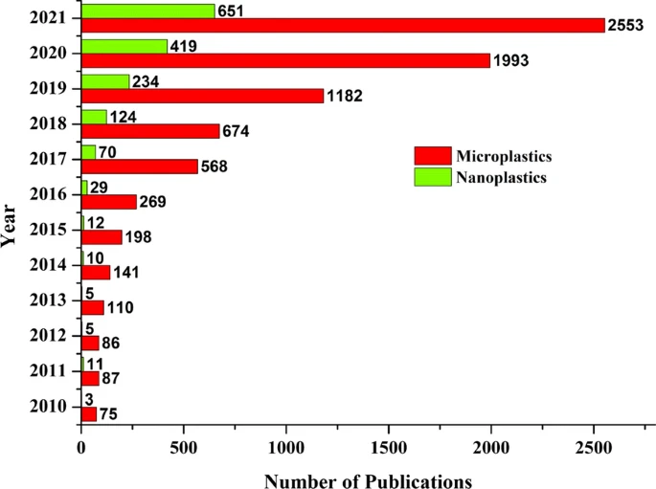

**Figure 4: Publication number of nano plastics compared with Microplastics**

(Source: Influenced by Jeong *et al.* 2018)

The primary source of the nano plastic may relate to releases from applications and products in that nanoplastics are being used in emissions to the environment during the life cycle of the product. In the opinion of de Souza Machado *et al.* (2018), most polymers undergo the same thermal treatments in the life cycle of the product. There are multiple medical applications that include the nano capsules and nanosphere, polymeric nanoparticles, used for drug delivery that is “biodegradable solid liquids”. Nanomaterials are reached in the land that has the potential for contaminating the soil as well as migrating towards ground and surface water (Ch, 2023). All the particles in wastewater effluents, solid wastes, and direct discharges could transport to the aquatic system by rainwater and wind runoff.

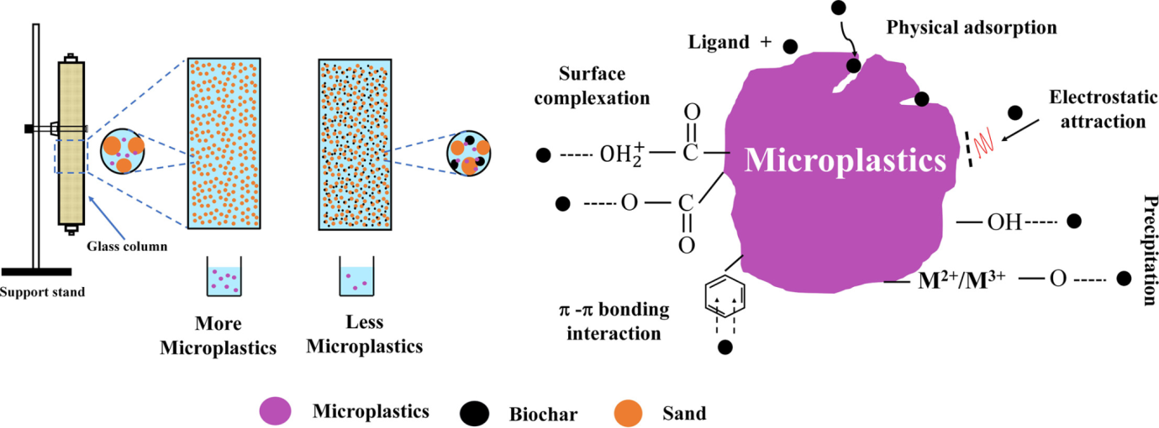

**Figure 5: Adsorptive behaviour of nanoplastic by the biochar**

(Source: Influenced by Machado*et al.* 2018)

The abundance of nanoplastic in the natural ecosystem is a major global challenge because all these plastics are particles that originate from marine-based and land-based activities. These are vastly present in freshwater, marine, and terrestrial ecosystem. As per the view of Yu *et al.* (2022), this could be reduced significantly by different methods such as chemical, biological, and physical techniques. However, biochar is adsorbent of low-cost that is considered an effective material as well as its application is also efficient ecologically for inorganic and organic remediation pollutants. All nano plastics are characterized by high surface area, high mechanical resistance, low density, and solid hydrophobicity.

# Statistics of Nanoplastics towards causing Global Water Pollution

Nanoplastics are more prone to cause water contamination on account of being highly hazardous to aquatic creatures. This can be mainly accounted for by the fact that nanoplastics can easily cross through cell membranes owing to microscopic dimensions (Li *et al.* 2022). Therefore, the presence of nanoplastics is considered to be highly harmful to every kind of creature, mainly aquatic creatures. Recent reports have stated the high possibility of nanoplastic presence within tap water. This possibility would lead to highly hazardous health impacts being faced by people, primarily causing inflammation upon ingestion. Common methods of plastic removal from water are determined to be highly ineffective for nanoplastic. Accordingly, greater challenges to separate nanoplastics would be possibly faced if the substance is found within tap water.

Nanoplastic pollution on a global scale is mainly contributed by two main sources, including primary plastic waste and secondary plastic derivatives. In this regard, primary plastic wastage mainly involves nanomedicine, nanoimaging, and personal care products. On the contrary, secondary plastic wastage is mainly generated from the disintegration of plastics due to physical, biological and chemical forces. Additionally, tire wear and laundry wastewater, identified as the most common sources of microplastic, are also identified as possible sources of nanoplastic pollution (An *et al.* 2020). In the case of tire wear, it has been determined that nearly 30% of an entire tire weight is emitted to the environment in the form of microplastics and nanoplastics. Related findings also show that tire wear particles were second-ranked with a 17.1% proportion of every form of identifiable microplastic (Lai *et al.* 2022). Therefore, tire wear can be determined as one of the primary forms of nanoplastic emission.

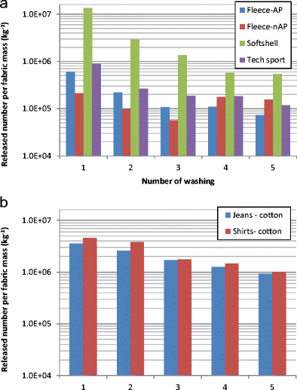

**Figure 6: Nanoplastic generation from fabric wash water**

(Source: Lai *et al.* 2022)

In addition to nanoplastics, laundry wastewater is also determined to be one of the most prominent sources of nanoplastic emission. Mainly originating from household washing of clothes, plastic fibres have been detected among the most common sources of nanoplastics and microplastics (Ma *et al.* 2021). In this context, microfibers, one of the most primary sources of micro and nanoplastics, mainly appear in the first wash wastewater of cotton textiles and microfibers. Accordingly, the annual emission of microfibers due to polyester and cotton textile wash water has been projected to be 565,000 kg each year (Lai *et al.* 2022). Therefore, studies are placing increasing focus to explore this particular source of nanoplastics.

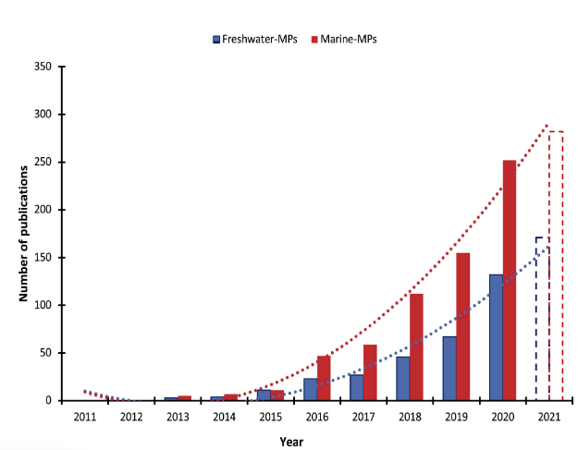

**Figure 7: Estimated micro- and nano-plastic particles in marine and freshwater ecosystems**

(Source: Benson *et al.* 2022)

Plastic pollution, mainly involving micro and nanoplastics, has been rising at an alarming rate in recent years. According to reports, around 80% of ocean plastics, causing nanoplastic contamination, are mainly generated from land while the rest are from different marine sources (Yee *et al.* 2021). Additionally, the recent pandemic has led to heavy production of various single-use covid-masks. Improper disposal of these masks has also been determined as one of the primary causes of nanoplastic pollution. On an annual basis, mismanaged plastic waste generated from various land-based activities is estimated to enter the ocean by an amount of 12.7 million metric tons (Benson *et al.* 2022). In addition, plastic debris from various anthropogenic sources within both marine and freshwater environments is expected to increase, mainly due to disposed fishing equipment including fishing lines, nets, plastic lures and ropes.

# State-of-the-art Technical and Scientific Approach towards Reducing Nanoplastic-based Pollution

***Nuclear Technology for Controlling Plastic Pollution (NUTECH)***

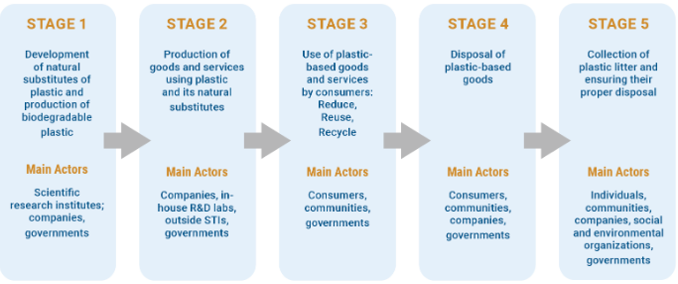

**Figure 8: Stages of Fighting plastic pollution**

(Source: IAEA, 2022)

Technological advancement has aided in developing multidirectional usage of different technologies and nuclear technologies have been key to solving various issues. Concerns for pollution from nano plastic have been increasing due to increasing amount of plastic disposal on land as well as water. Application of NUTEC has been aimed at aiding in reducing plastic pollution through usage of nuclear as well as techniques derived through nuclear technologies (IAEA, 2022). Different types of radiation technologies are used in industrial activities for performing various activities. Technologies such as gamma, as well as electron beams, can be used for reducing wastes generated from plastic and polymers (IAEA, 2022). Reusable products, for instance, fillers can be developed from recycled plastics with help of nuclear technologies. Fuel can be produced from waste plastics by breaking down plastic using irradiation technologies (Zhao *et al.* 2022). Apart from this, radiation procedures can also be used for replacing polymers based on petroleum with biodegradable polymers (IAEA, 2022). This can be significant for reducing impacts of using plastic for industrial purposes.

***Social Media***

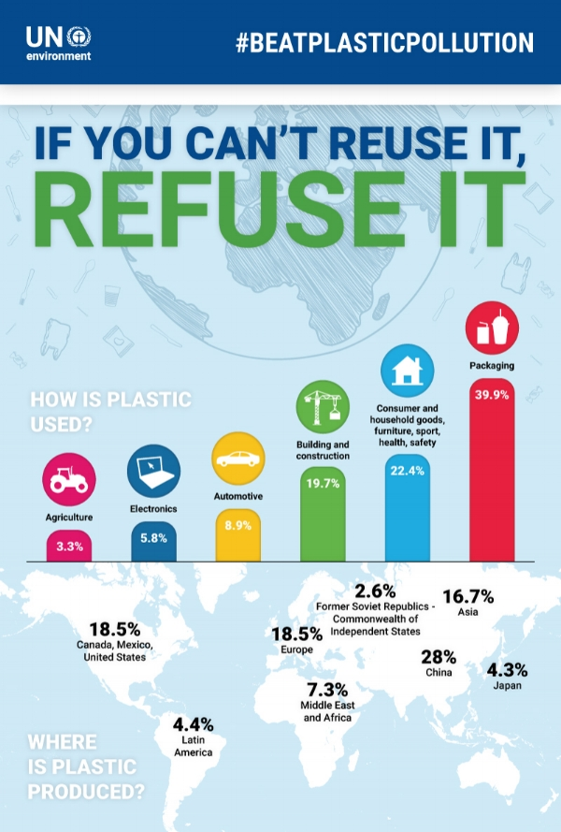

**Figure 9: Social Media Campaign of #BeatPlasticPollution**

(Source: UNEP, 2022)

Social media is being used by people extensively across the globe and time spent on social media platforms is increasing rapidly. Awareness about environmental sustainability can be spread among a large number of individuals within a very short amount of time using social media platforms. Various organisations such as UNEP have participated in social media campaigns such as #BeatPlasticPollution (UNEP, 2022). These campaigns are being developed and implemented on different social media platforms including Twitter, Instagram, and Facebook for spreading awareness about plastic pollution. Along with this, individuals are also becoming aware of steps that are required to be taken as a part of their responsibility for preventing plastic pollution. Awareness about different categories of plastic waste including agricultural, packaging, automotive as well as electronic is being developed among people through social media campaigns (UNEP, 2022). People are also becoming able to share their opinions about roles and responsibilities performed by them towards prevention of plastic pollution. Hence, it can be said that social media platforms are playing a crucial role in fighting plastic pollution.

***Satellite Observation***

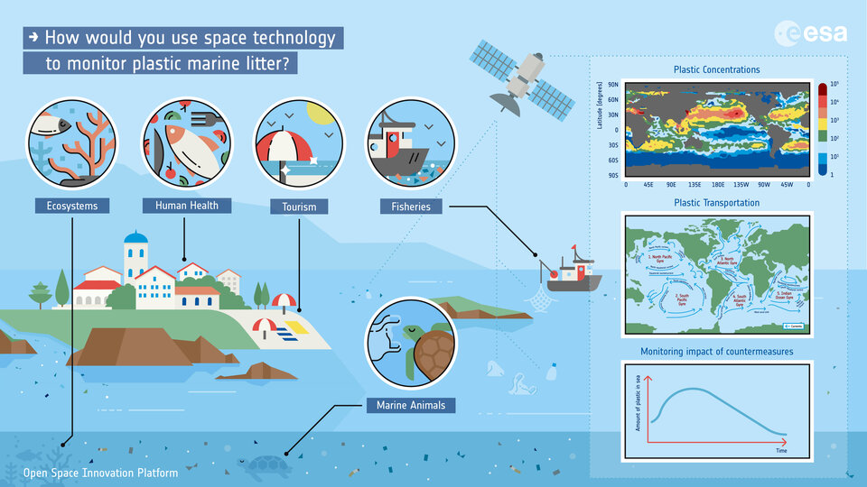

**Figure 10: Sensing of plastic in ocean using satellite observation**

(Source: ESA, 2022)

Satellite imaging has aided in advancement of various activities which include defence as well as tracking of natural resources. European Space Agency (ESA) has initiated using satellite technologies for analysing ocean bodies to track plastic pollution (ESA, 2022). Satellite imaging is being used for tracking ocean bodies having a higher concentration of plastic waste. Based on the findings from the satellite imaging clean-up operations are being performed for reducing amount of plastic waste in ocean bodies. This is a significant strategy for tracking vast ocean bodies with help of satellites in an autonomous manner. This procedure would have otherwise taken a large amount of time and resources due to vastness of ocean bodies.

***Artificial Intelligence***

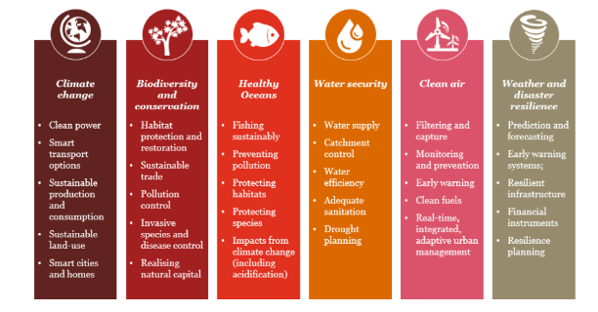

**Figure 11: Actions toward pollution reduction by PwC using AI**

(Source: ITUNews, 2022)

Advanced technologies such as Artificial Intelligence (AI) and Machine Learning are being used for developing solutions to multidirectional issues. PwC has focussed on developing interventions using AI against environmental pollution. Enhanced ability of AI engines for analysing information and developing decisions based on them are being utilised by organisations for solving issues (ITUNews, 2022). Scientists are utilising AI engines for analysing information about plastic pollution and developing solutions for preventing them. Apart from this, AI technologies are being used for developing technologies that aid in reducing pollution levels. Hence, implementation of AI technologies has become significant for reduction of pollution from nano plastic.

***Data visualisation using Big Data technology***

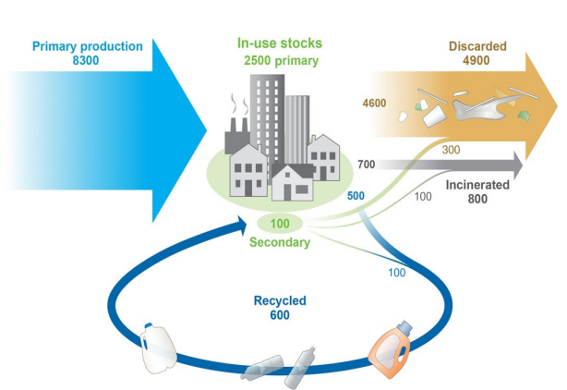

**Figure 12: Example of Data visualisation for identification of plastic waste**

(Source: IAEA, 2022)

Visual representation of crucial information is key to solving issues and defining different aspects of an issue. Big data technology is being used extensively for storing and sharing crucial information across a wide area among organisations as well as within organisations. Implementation of Machine learning as well as data visualisation helps in development of better decisions (Chatzimparmpas *et al.* 2020). Resources available on Earth are being tracked using Big Ddata technology and information stored in Big data is accessed by organisations. This information can aid in analysing impacts of plastic pollution and identifying of most affected resources through plastic pollution (Jepsen and Bruyn, 2019). This is significant for aiding organisations aiming at reducing plastic pollution.

***Blockchain technology***

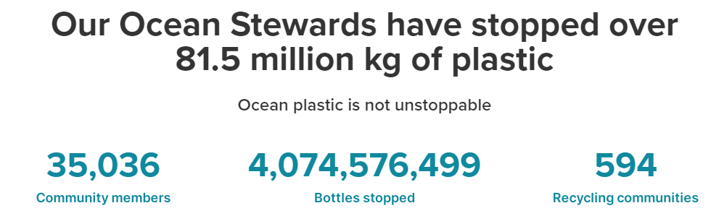

**Figure 13: Ocean Stewardship Program of PlasticBank**

(Source: (PlasticBank, 2023)

Blockchain technologies can be used in various ways for aiding in the process of reducing nano plastic pollution. Blockchain technologies are used for storing and sharing crucial information. Secured tokens of blockchain are used by PlasticBank, which is associated with rewarding individuals for recycling plastic. Blockchain technology is used for enabling individuals for sharing information about their plastic recycling. Amount of plastic that has been prevented to reach the ocean through their Stewardship program is 81.5 million kg (PlasticBank, 2023). Apart from this, other organisations are also using blockchain technologies in different ways for reducing plastic pollution. For instance, UNFCCC has developed a Climate Chain Coalition which includes more than 80 organisations associated with reducing plastic pollution using blockchain technologies (UNCC, 2022). Hence, it can be said that usage of blockchain technologies has become significant in reduction of nanoplastic pollution.

# Relevant Policy Implication for reduced Nanoplastic-based Pollution

A wide range of global and national policies have been undertaken to reduce the current extent of nanoplastic pollution across both land and aquatic environments. Various policy frameworks have also been suggested across different research studies in this regard. For instance, Syberg *et al.* (2022) stated that a circular economy is essential for ensuring a reduction in plastic pollution. Reduction in plastic pollution, therefore, would ensure a reduction in overall nano and microplastic generation, thus effectively mitigating nanoplastic pollution. The study further states that conducting certain forms of sustainable activities, including recycling, can effectively lead to increased contamination due to nanoplastic generation. Therefore, through adopting a circular economy framework, extended producer responsibility has been suggested for sustainable plastic production, thereby reducing pollution levels significantly.

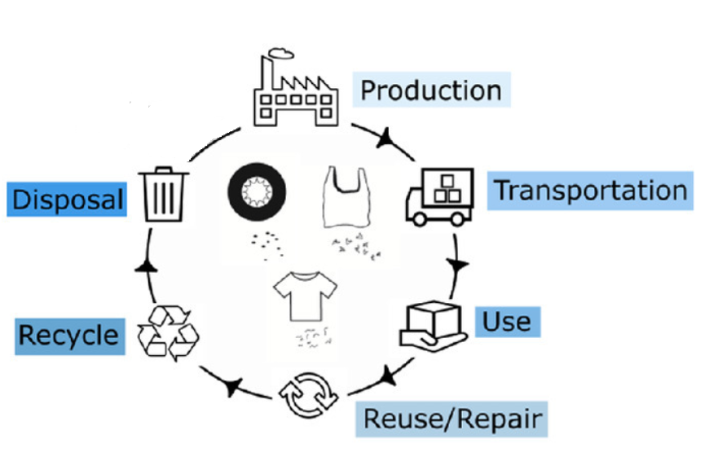

**Figure 14: Circular economy in plastic waste reduction**

(Source: Syberg *et al.* 2022)

The global increase in plastic pollution has directly led to the development and implementation of various regulatory policy initiatives for the purpose of effectively reducing environmental and health impacts. However, even though a considerable degree of regulatory activity has been observed within the field of plastic, the actual risks of plastic pollution on the environment are still debated. Accordingly, this indicates a certain form of implication regarding the extent to which the current regulatory policies are evidence-based. Nevertheless, the study by Nielsen *et al.* (2023) states that every initiative undertaken with respect to different regulatory policies is essentially evidence-based.

Each of the initiatives is determined to be backed by proper scientific studies regarding sources of plastic pollution and resulting ecological impacts. One prominent example of such an initiative involves the ban on plastic bags in Toronto, Canada starting in 2013 (). The development of the Bioeconomy Committee in Canada, in 2011 was also a key initiative undertaken to develop bioeconomy across local regions. Examples from the UK can also be considered, involving the formation of the Industrial Biotechnology Special Interest Group (IB-SIG). This group is focused on investing in innovative and relevant chemical engineering research based on biorefining technologies.

Policies based on microplastics and nanoplastics are determined to have poor consideration towards pollution caused across agricultural lands, with such being mediated through sewage and plastic-coated fertilisers. In this context, the development of proper policy standards and related governance-based measures are deemed to be essential. In response to increasing amounts of marine litter, the United Nations Environmental Assembly of the United Nations Environment Programme (UNEP) adopted various resolutions (Usman *et al.* 2022). The primary aim of these resolutions is to control marine contamination due to plastics, microplastics and nanoplastics. Accordingly, these resolutions are determined to emphasise the urgent need for proper policies to mitigate marine litter from different forms of plastics (Usman *et al.* 2022). Furthermore, the need to further fortify the current science-policy interfaces has also been highlighted through these resolutions.

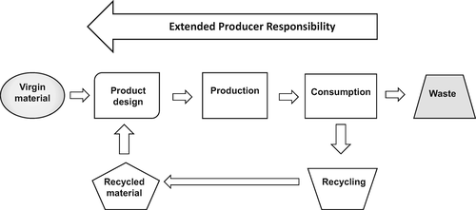

**Figure 15: EPR as a policy toward creating a circular economy**

(Source: Almroth and Eggert, 2019)

A wide range of policies has been identified to have faced implications for plastic recycling. However, the complexity of plastic materials makes recycling these materials highly challenging. The chemical additives used in plastic production are deemed to be problematic for policies involving recycling programs, with these programs further reducing material quality and increasing safety concerns. In addition, implications have also been faced in terms of EPR, focused on increasing product responsibility. EPRs require producers to effectively finance the collection, recycling and safe disposal of products (Almroth and Eggert, 2019). However, to lower costs, producers share EPR costs among other firms, in turn reducing incentives for eco-design. This causes a further need to be generated based on individual producer responsibility

# Possible Future Recommendations

Controlling plastic and nanoplastic pollution and the resulting impacts requires effective policy interventions, involving proper monitoring processes. The knowledge regarding proper policy and regulatory decisions against plastic pollution has been determined to be insufficient. Additionally, poor efforts are readily observable across the implementation of proper mitigation actions and assessment of the overall outcome of such actions. In this context, Bank *et al.* (2021) have proposed a policy framework based on a global monitoring system for plastic pollution, allowing proper data to be gathered for environmental and societal assessments. The majority of the focus has been mainly placed towards monitoring aquatic ecosystems. Besides delivering and integrating new information, the proposed system is also expected to drive effective policy development.

# Conclusion

This study focuses on determining the core causes and impacts of nanoplastic pollution, specifically within the marine environment. Accordingly, the concept of nanoplastic has been defined with appropriate illustrations. The core scientific mechanism of nanoplastic that leads to contamination issues has been defined as well. Following this, key statistics regarding prime sources of nanoplastics have been described, alongside stating the implicative emergence of nanoplastic pollution across aquatic environments. Appropriate statistical figures have been provided that back the aforementioned discussion. Key technologies and scientific methods currently in use to mitigate nanoplastic pollution have been defined. Additionally, the main policy implications found in the context of nanoplastic pollution have also been critically underlined. Finally, appropriate future recommendations have been provided to properly facilitate nanoplastic pollution control in the future.

# References

Almroth, B.C. and Eggert, H., (2019). Marine plastic pollution: sources, impacts, and policy issues. *Review of environmental economics and policy*, *13*(2). pp.317-326.

An, L., Liu, Q., Deng, Y., Wu, W., Gao, Y. and Ling, W., (2020). Sources of microplastic in the environment. *Microplastics in terrestrial environments: Emerging contaminants and major challenges*, pp.143-159.

Bank, M.S., Swarzenski, P.W., Duarte, C.M., Rillig, M.C., Koelmans, A.A., Metian, M., Wright, S., Provencher, J.F., Sanden, M., Jordaan, A. and Wagner, M., (2021). Global plastic pollution observation system to aid policy. *Environmental Science & Technology*, *55*(12), pp.7770-7775.

Benson, N.U., Agboola, O.D., Fred-Ahmadu, O.H., De-la-Torre, G.E., Oluwalana, A. and Williams, A.B., (2022). Micro (nano) plastics prevalence, food web interactions, and toxicity assessment in aquatic organisms: a review. *Frontiers in Marine Science*, *9*, p.291.

Ch, P., 2023. Ray, H. Yu, PP Fu. *J. Environ. Sci. Health C Environ. Carcinog. Ecotoxicol. Rev*, *27*(1), pp.1-35.

Chatzimparmpas, A., Martins, R.M., Jusufi, I., Kucher, K., Rossi, F. and Kerren, A., (2020), June. The state of the art in enhancing trust in machine learning models with the use of visualizations. In *Computer Graphics Forum* (Vol. 39, No. 3, pp. 713-756).

DaNa, (2023). *Nanoplastic in the environment.*Available at: https://nanopartikel.info/en/basics/cross-cutting/nanoplastic-in-the-environment/ [Accessed on: 24 April, 2023]

de Souza Machado, A.A., Kloas, W., Zarfl, C., Hempel, S. and Rillig, M.C., (2018). Microplastics as an emerging threat to terrestrial ecosystems. Global change biology, 24(4), pp.1405-1416.

ESA (2022). *The Discovery Campaign on Remote Sensing of Plastic Marine Litter.*  Available at: https://www.esa.int/Enabling_Support/Preparing_for_the_Future/Discovery_and_Preparation/The_Discovery_Campaign_on_Remote_Sensing_of_Plastic_Marine_Litter [Accessed 10 April. 2023].

IAEA (2022). *NUclearTEChnology for Controlling Plastic Pollution*  Available at: https://www.iaea.org/sites/default/files/21/05/nuclear-technology-for-controlling-plastic-pollution.pdf [Accessed 10 April. 2023].

ITUNews (2022). *8 ways AI can help save the planet.*  Available at: https://news.itu.int/8-ways-ai-can-help-save-the-planet/ [Accessed 10 April. 2023].

Jeong, C.B., Kang, H.M., Lee, Y.H., Kim, M.S., Lee, J.S., Seo, J.S., Wang, M. and Lee, J.S., (2018). Nanoplastic ingestion enhances toxicity of persistent organic pollutants (POPs) in the monogonont rotifer Brachionuskoreanus via multixenobiotic resistance (MXR) disruption. Environmental science & technology, 52(19), pp.11411-11418.

Jepsen, E.M. and de Bruyn, P.N., (2019). Pinniped entanglement in oceanic plastic pollution: a global review. *Marine Pollution Bulletin*, 145, pp.295-305.

Lai, H., Liu, X. and Qu, M., (2022). Nanoplastics and human health: hazard identification and biointerface. *Nanomaterials*, *12*(8), p.1298.

Li, Y., Wang, Z. and Guan, B., (2022). Separation and identification of nanoplastics in tap water. *Environmental Research*, *204*, p.112134.

Ma, J., Chen, F., Xu, H., Jiang, H., Liu, J., Li, P., Chen, C.C. and Pan, K., (2021). Face masks as a source of nanoplastics and microplastics in the environment: quantification, characterization, and potential for bioaccumulation. *Environmental Pollution*, *288*, p.117748.

Nielsen, M.B., Clausen, L.P.W., Cronin, R., Hansen, S.F., Oturai, N.G. and Syberg, K., (2023). Unfolding the science behind policy initiatives targeting plastic pollution. *Microplastics and nanoplastics*, *3*(1), p.3.

Okoye, C.O., Addey, C.I., Oderinde, O., Okoro, J.O., Uwamungu, J.Y., Ikechukwu, C.K., Okeke, E.S., Ejeromedoghene, O. and Odii, E.C., (2022). Toxic chemicals and persistent organic pollutants associated with micro-and nanoplastics pollution. Chemical Engineering Journal Advances, p.100310.

PlasticBank (2023). *Stop plastic before it reaches the Ocean.* Available at: https://plasticbank.com/ [Accessed 10 April. 2023].

Shen, M., Zhang, Y., Zhu, Y., Song, B., Zeng, G., Hu, D., Wen, X. and Ren, X., (2019). Recent advances in toxicological research of nanoplastics in the environment: A review. Environmental pollution, 252, pp.511-521.

Steenmans, K., Taylor, P. and Steenmans, I., (2021). Blockchain technology for governance of plastic waste management: where are we?.*Social Sciences*, 10(11), p.434.

Syberg, K., Nielsen, M.B., Oturai, N.B., Clausen, L.P.W., Ramos, T.M. and Hansen, S.F., (2022). Circular economy and reduction of micro (nano) plastics contamination. *Journal of Hazardous Materials Advances*, *5*, p.100044.

Tran, H.T., Lesage, G., Lin, C., Nguyen, T.B., Bui, X.T., Nguyen, M.K., Nguyen, D.H., Hoang, H.G. and Nguyen, D.D., (2022). Activated sludge processes and recent advances. *Current Developments in Biotechnology and Bioengineering*, pp.49-79.

UNCC (2022). *How can Web3 help climate action?* Available at: https://unfccc.int/blog/block-by-block [Accessed 10 April. 2023].

UNEP (2022). *CAMPAIGN.*  Available at: https://www.unep.org/events/campaign/100-days-beatplasticpollution-cleanseas [Accessed 10 April. 2023].

Usman, S., AbdullRazis, A.F., Shaari, K., Azmai, M.N.A., Saad, M.Z., Mat Isa, N. and Nazarudin, M.F., (2022). The Burden of Microplastics Pollution and Contending Policies and Regulations. *International Journal of Environmental Research and Public Health*, *19*(11), p.6773.

Yee, M.S.L., Hii, L.W., Looi, C.K., Lim, W.M., Wong, S.F., Kok, Y.Y., Tan, B.K., Wong, C.Y. and Leong, C.O., (2021). Impact of microplastics and nanoplastics on human health. *Nanomaterials*, *11*(2), p.496.

Yu, C., Zeng, H., Wang, Q., Chen, W., Chen, W., Yu, W., Lou, H. and Wu, J., (2022). Multi-omics analysis reveals the molecular responses of Torreya grandis shoots to nanoplastic pollutant. Journal of Hazardous Materials, 436, p.129181.

Zhao, X., Korey, M., Li, K., Copenhaver, K., Tekinalp, H., Celik, S., Kalaitzidou, K., Ruan, R., Ragauskas, A.J. and Ozcan, S., (2022). Plastic waste upcycling toward a circular economy. *Chemical Engineering Journal*, 428, p.131928.